Fundamentals of Information technology
Desk200

Module 5
Chapter 6 Understanding and Assessing Hardware: Evaluating Your System
Module topics are:
- To buy or to upgrade?
- Evaluating your system:
  - - CPU
  - - RAM
  - - Storage devices
  - - Video output
  - - Sound systems
- System reliability
Moore’s Law, describes the pace at which CPUs (central processing units)—the small chips that can be thought of as the “brains” of the computer—improve. Named for Gordon Moore,
To determine whether your computer system has the right hardware components to do what you ultimately want it to do, you need to conduct a system evaluation
These subsystems include the following:
• CPU subsystem
• Memory subsystem (the computer’s random access memory, or RAM)
• Storage subsystem (hard drive and other drives)
• Video subsystem (video card and moni- tor)
• Audio subsystem (sound card and speakers)
• Ports

Evaluating the CPU Subsystem
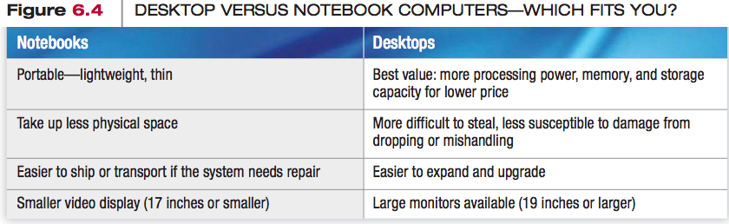
Your computer’s central processing unit (CPU or processor) is critically important because it processes instructions, performs calculations, manages the flow of information through a computer system, and is responsible for turning raw data into valuable information through processing operations. The CPU is located on the motherboard, the primary circuit board of the computer system.

Types of processors on the market including Intel processors (such as the Corefamily with the i7, i5, i3, and the Centrino line.

The CPU is comprised of two units: the control unit and the arithmetic logic unit (ALU).
- The control unit coordinates the activities of all the other computer components.
- The ALU is responsible for performing all the arithmetic calculations (addition, subtraction, multiplication, and division).

Every time the CPU performs a program instruction,
- First, it fetches the required piece of data or instruction from RAM, the temporary storage location for all the data and instructions the computer needs while it is running.
- Next, it decodes the instruction into something the computer can understand.
- Executes the instruction and stores the result to RAM before fetching the next instruction.
This process is called a machine cycle.
The primary distinction between CPUs is processing power

A core is a complete processing section from a CPU embedded into one physical chip.
How quickly the processor can work (called its clock speed) and the amount of immediate access memory the CPU has (called its cache memory)
Hyperthreading provides quicker processing of information by enabling a new set of instructions to start executing before the previous set has finished.

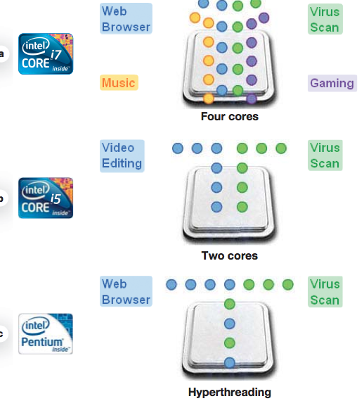
How do I pick the fastest processor?
CPU performance also is affected by the amount of cache memory and the speed of the front side bus (FSB).
Cache memory is a form of random access memory that is more accessible to the CPU than regular RAM.

There are several levels of cache memory. These levels are defined by a chip’s proximity to the CPU.
- Level 1 cache is a block of memory that is built onto the CPU chip for the storage of data or commands that have just been used.
- Level 2 caches is located on the CPU chip but is slightly farther away from the CPU, or it’s on a separate chip next to the CPU and therefore takes somewhat longer to access. Contains more storage area than does level 1

- Level 3. Again, this level of cache is slower for the CPU to reach but larger in size.

Another factor that impacts overall performance is the FSB speed. The front side bus (FSB) connects the processor (CPU) in your computer to the system memory. The faster the FSB is, the faster you can get data to your processor.
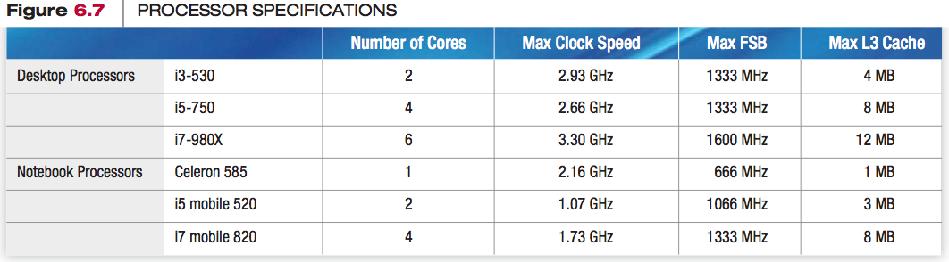
Benchmarks are measurements used to compare CPU performance between processors.

The percentage of time that your CPU is working is referred to as CPU usage.

Evaluating RAM: The Memory Subsystem
Random access memory (RAM) is your computer’s temporary storage space.
RAM is an example of volatile storage.
When the power is off, the data stored in RAM is cleared out.
Nonvolatile storage devices for permanent storage of instructions and data when the computer is powered off. ROM memory, for example, holds the critical startup instructions.
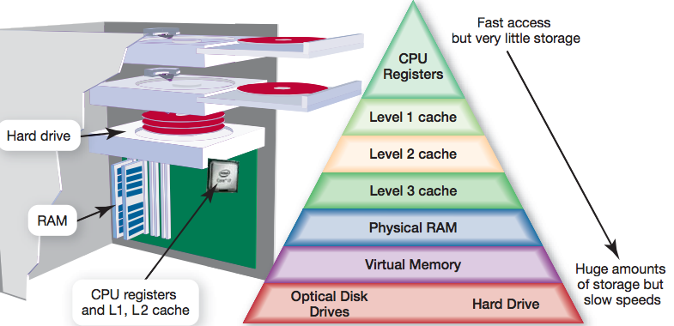
RAM used most often comes in the form of double data rate 2 (DDR2) memory modules. Double data rate 3 memory (DDR3), which has an even faster data transfer rate, is seen in high- performance systems.
Other types of RAM may have been used, including dynamic RAM (DRAM), static RAM (SRAM), and synchronous DRAM (SDRAM). RAM appears in the system on memory modules (or memory cards), small circuit boards that hold a series of RAM chips and fit into special slots on the motherboard

The amount of RAM that is actually sitting on memory modules in your computer is your computer’s physical memory.

The memory that your operating system uses is referred to as kernel memory.

Is there a limit to how much RAM I can add to my computer? Every computer has a maximum limit on the amount of RAM it can support. A motherboard is designed with a specific number of slots into which the memory cards fit, and each slot has a limit on the amount of RAM it can hold.

The Hard Drive
With storage capacities exceeding 2 terabytes (TB), a hard drive has the largest storage capacity of any storage device.
The hard drive’s access time, the time it takes a storage device to locate its stored data and make it available for processing, is faster than that of other permanent storage devices, like optical drives.
Solid state drives (SSD) offer even faster access times. A solid state drive (SSD) uses the same kind of memory that flash drives use, but whereas flash drives have access times of about 1 ms, SSD drives can reach data in only a tenth of that time (around 0.1 ms).
This speed of transfer is referred to as data transfer rate.
A hard drive is composed of several coated round, thin plates of metal stacked on a spindle. Each plate is called a platter.
How is data stored on a hard drive?
These 0s and 1s are bits (or binary digits) and are the smallest pieces of data that computers can understand.

How do hard drives compare for speed?
There are several types of hard drives. Integrated Drive Electronics (IDE), which is also called parallel advanced technology attachment (PATA),
Serial Advanced Technology Attachment (Serial ATA) hard drives use much thinner cables, and can transfer data more quickly than IDE drives.

Many external hard drives use a USB 2.0 port to connect, which limits the transfer rate
of data to 400 Mbps.
The USB 3.0 standard has raised that limit to 5 Gbps (5,000 Mbps).
RAID technology. RAID (redundant array of independent disks) is a set of strategies for using more than one drive in a system.

Optical Storage
Optical drives are disc drives that use a laser to store and read data.
Data is saved to a compact disc (CD), digital video disc (DVD), or Blu-ray disc (BDs) within established tracks and sectors, just like on a hard drive.
All forms of optical media come in prerecorded, recordable, and rewritable formats.

CD-ROM, DVD-ROM, and BD-ROM discs—are read-only optical discs,
CD-R, DVD-R, and BD-R allow data to be written (saved or burned) to them.
Read/writeable formats such as CD-RW, DVD-RW, and BD-RE are available.
Speeds are listed on the device’s packaging.
- CD-RW drive may have speeds of 52X32X52X, meaning that the device can record data at 52X speed, rewrite data at 32X speed, and play back data at 52X speed.
- For CDs, the X after each number represents the transfer of
150 KB of data per second. For example, a CD-RW drive with a 52X32X52X rating records data at 52 times 150 KB per second, or 7,800 KB per second.

Evaluating the Video Subsystem
How video is displayed depends on two are available your video card and your monitor

Video Cards
A video card (or video adapter) is an expansion card that is installed inside your system unit to translate binary data into the images you view on your monitor.

They include ports that allow you to connect to different video equipment such as the DVI ports for digital LCDs, HDMI ports to connect to high-definition TVs or gaming consoles, lower-resolution S-video ports for connecting your computer to a TV, and Super VGA ports for CRT and analog LCD monitors.

Video cards include their own RAM, called video memory.
Is a GPU different from a CPU?
The graphics processing unit (GPU) performs the same kind of computational work that a CPU performs. However, a GPU is specialized to handle 3-D graphics and image and video processing

Basic video processing is sometimes integrated into the motherboard.
The video card also controls the number of colors your monitor can display.
The num- ber of bits the video card uses to represent each pixel (or dot) on the monitor, referred to as bit depth,
A 4-bit video card displays 16 colors, the minimum number of colors your system works with
Most video cards today are 24-bit cards, displaying more than 16 million colors. This mode is called true color mode

Sound Cards
What does the sound card do?
A sound card, is an expansion card that attaches to the motherboard inside your system unit.
The 3D sound technology advances sound reproduction beyond traditional stereo sound where the human ear perceives sounds as coming from the left or the right of the performance area
However, 3D sound is not surround sound.
Surround sound is a type of audio processing that makes the listener experience sound as if it were coming from all directions.
The current surround sound standard is from Dolby.

Evaluating System Reliability
Over time, even normal use can cause your computer to build up excess files and to become internally disorganized.
What can I do to ensure my system performs reliably?
- Clean out your Startup folder.
- Clear out unnecessary files.
- Run spyware and adware removal pro- grams.
- Run the Disk Defragmenter utility on your hard drive.

My system crashes often during the day. What can I do?
- Check that you have enough RAM,
- Make sure you have properly installed any new software or hardware.
- If you see an error code in Windows, visit the Microsoft Knowledge Base (support.microsoft.com), an online resource for resolving problems with Microsoft products.

