Fundamentals of Information technology
Desk200

Module 4
Chapter 5

Module topics are:
- System software
- Categories of operating systems (OS)
- OS role in:
  - Providing user interaction
  - Managing the processor
  - Managing memory
  - Managing hardware
  - Interacting with application software
  - Starting the computer
- Desktop and window features
- OS role in keeping desktop organized
Utility programs
System Software Basics
Application software is the software you use to do everyday tasks at home and at work. System software is the set of programs that helps run the computer and coordinates instructions between application software and the computer’s hardware devices.

What does an operating system do? The operating system (OS) is a group of programs that controls how your computer system functions. The OS manages the computer’s hardware, including the processor (also called the central
processing unit, or CPU),
System software also includes utility programs. A utility program is a small program that performs many of the general house- keeping tasks for the computer, such as system maintenance and file compression.
Apple’s Mac OS and Microsoft’s Windows replaced DOS because these systems allowed a single user to multitask, or to perform more than one process at a time.

Types of Operating Systems
Machinery that is required to perform a repetitive series of specific tasks in an exact amount of time requires a real-time operating system (RTOS). This type of operating system is a program with a specific purpose, and it must guarantee certain response times for particular computing tasks;

What kind of operating system controls a simple cell phone? Simple cell phones are separate, single-function devices; they only require operating systems that perform one task at a time.
What is UNIX? UNIX is a multiuser; multitask operating system used as a network operating system, primarily with mainframes, although it is also often found on PCs.

What other kinds of computers require a multiuser operating system?
A mainframe is responsible for storing, managing, and simultaneously processing data from all users. Mainframe operating systems fall into the multiuser category.

Operating Systems for Mobile Devices
Operating Systems for Personal Computers
The 32-bit version is built for computers that have up to 4 GB of RAM. For those systems with more than 4 GB of RAM, a 64-bit version is required.
The combination of operating system and processor is referred to as a computer’s platform. For example, Microsoft Windows operating systems are designed to coordinate with a series of processors from Intel Corporation and Advanced Micro Devices (AMD),
A utility called Boot Camp, available with the newest version Mac OS X Snow Leopard, allows you to run Windows on a Mac while also running OS X

In the case of running two versions of Windows, or a Windows–Linux setup, you just need to separate the hard drive into different sections (called partitions) and install the second operating system in the new partition.

Linux is an open source operating system designed for use on personal computers and as a network operating system.

What the Operating System Does

- It provides a way for the user to interact with the computer.
- It manages the processor, or CPU.
- It manages the memory and storage.
- It manages the computer system’s hardware and peripheral devices.
- It provides a consistent means for software applications to work with the CPU.

The User Interface
How does the operating system control how I interact with my computer?
The operating system provides a user interface that enables you to interact with the computer.
A menu driven interface is one in which you choose commands from menus displayed on the screen.
Microsoft Windows and Mac OS use a graphical user interface, or GUI (pronounced “gooey”).

Processor Management
Why does the operating system need to manage the processor?
The operating system assigns a slice of its time to each activity that requires the processor’s attention. The OS must then switch among different processes millions of times a second to make it appear that everything is happening seamlessly.

When you tell your computer to print your document, the printer generates a unique signal called an interrupt that tells the operating system that it is in need of immediate attention.
Every device has its own type of interrupt, which is associated with an interrupt handler, a special numerical code that prioritizes the requests.
The operating system processes the task assigned a higher priority before processing a task that has been assigned a lower priority. This is called preemptive multitasking.

Memory and Storage Management
Why does the operating system have to manage the computer’s memory?
As the operating system coordinates the activities of the processor, it uses RAM as a temporary storage area for instructions and data the processor needs

Does the amount of RAM on a system control the type of OS I get?
4GB or 8GB
What happens if my computer runs out of RAM?
The operating system borrows from the more spacious hard drive. This process of optimizing RAM storage by borrowing hard drive space is called virtual memory. The operating system swaps out from RAM the data or instructions that have not been recently used and moves them to a temporary storage area on the hard drive called the swap file (or page file). If the data or instructions in the swap file are needed later, the operating system swaps them back into active RAM and replaces them in the hard drive’s swap file with less active data or instructions. This process of swapping is known as paging.

Hardware and Peripheral Device Management
How does the operating system manage the hardware and peripheral devices?
Each device attached to your computer comes with a special program called a device driver that facilitates communication between the hardware device and the operating system

The devices whose drivers are included in Windows are called Plug and Play devices. Plug and Play (PnP)
Application programming interface (API)—that application software needs in order to interact with the OS

The Boot Process: Starting Your Computer
When you turn off your computer, RAM is wiped clean of all its data (including the OS)
How does the computer know what to do when you turn it on if there is nothing in RAM? It runs through a special boot process (or start-up process) to load the operating system into RAM.
The term boot, from bootstrap loader (a small program used to start a larger program),

What are the steps involved in the boot process?
- The basic input/output system (BIOS) is activated by powering on the CPU.
- The BIOS checks that all attached devices are in place (called a power-on self-test or POST).
- The operating system is loaded into RAM.
- Configuration and customization settings are checked.

Safe mode is a special diagnostic mode designed for troubleshooting errors. When the system is in Safe mode, only essential devices such as the mouse, keyboard, and monitor function

The Desktop and Windows Features
The desktop is the first interaction you have with the operating system and the first image you see on your monitor
Organizing Your Computer: File Management
An additional function of an operating system is to enable file management, which entails providing organizational structure to the computer’s contents.
What exactly is a file? Technically, a file is a collection of related pieces of information stored together for easy reference. Files can represent an entire application, a Web page, a set of sounds, or an image. Files are stored on the hard drive, a flash drive, or another permanent storage medium
A folder is a collection of files
A library is a collection that gathers files from different locations and displays them as if they were all saved in a single folder, regardless of where they are actually physically stored.

C: drive is the top of the filing structure of the computer system and is referred to as the root directory
Tiles view: Displays files and folders as icons in list form.
Details view: The most interactive view. Files and folders are displayed in list form
List view: Another display of icons and names that are even smaller than in Tiles view.
Small and Medium Icons views:
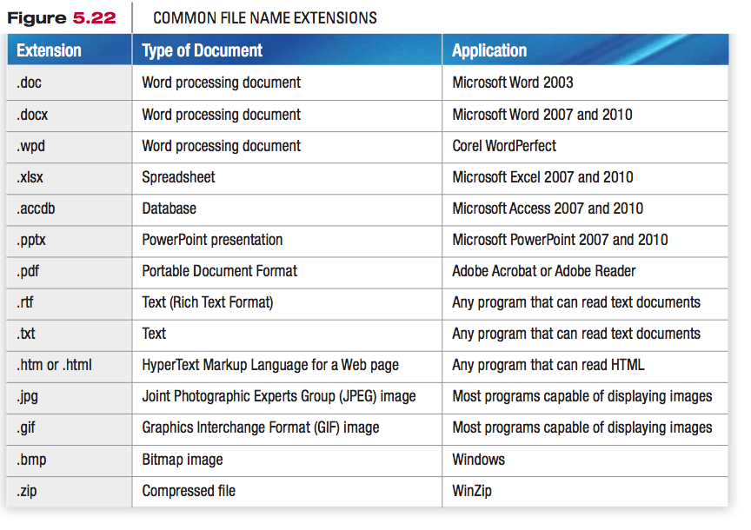
Notice that there are backslash characters (\) in between the drive, primary folder, subfolders, and file name. This backslash character, used by Windows and DOS, is referred to as a path separator. Mac files use a colon (:), whereas UNIX and Linux files use the forward slash (/) as the path separator.
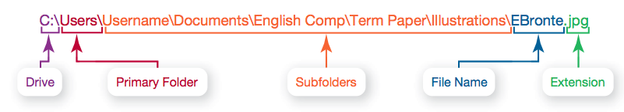
Utility Programs
How does file compression
work? Most compression programs look for repeated patterns of letters and replace these patterns with a shorter placeholder.
System Maintenance Utilities
Are there any utilities that make my system work faster? Disk Cleanup is a Windows utility that cleans, or removes, unnecessary files from your hard drive.
Recycle Bin as well as temporary files
What else can I do if my system runs slowly?
Windows Disk Defragmenter regroups related pieces of files on the hard drive, thereby allowing the OS to work more efficiently.
How do I diagnose potential errors or damage on my storage devices?
Error-checking, once known as ScanDisk, is a Windows utility that checks for lost files and fragments as well as physical errors on your hard drive.
How can I check on a program that has stopped running? If a program has stopped working, you can use the Windows Task Manager utility to check on the pro- gram or to exit the nonresponsive program.
System Restore and Backup Utilities
Is there an undo command for the system?
System Restore that lets you roll your system settings back to a specific date when everything was working properly. A system restore point, which is a snapshot of your entire system’s settings, is made every week and prior to certain events, such as installing or updating software
Every time
you start your computer or install a new application or driver, Windows automatically creates a system restore point
Accessibility Utilities
• High Contrast: Allows you to select a color scheme setting in which you can control the contrast between text and background.
Magnifier: A utility that creates a separate window that displays a magnified portion of the screen.
Narrator: A very basic speech program that reads what is on screen,
On-Screen Keyboard: Displays a keyboard on the screen.
Windows Speech Recognition: An effective tool that allows you to dictate text and control your computer by voice.

