MARKETING RESEARCH MIDTERM NOTES
MARK 302 W13

CHAPTER 1: ROLE OF MARKETING IN MANAGEMENT DECISION MAKING

Marketing: The process of planning and executing the conception, pricing, promotion, and distribution of ideas, goods, and services to create exchanges that satisfy individual and organizational objectives.

Marketing Research: It is the planning, collection, and analysis of data relevant to marketing decision making and the communication of the results of this analysis to management.
It is the function that links the consumer, customer, and public to the marketer through information that is used to identify and define marketing opportunities and problems; generate, refine, and evaluate marketing actions; monitor marketing performance; and improve understanding of marketing as a process.
Marketing research specifies the information required to address these issues, designs the method for collecting information, manages and implements the data collection process, analyzes the results, and communicates the findings and their implications.

The Marketing Concept
The Marketing Concept is composed of three tenets which are interrelated:
- Consumer Orientation: Identification of and focus on the people or firms most likely to buy a product and the production of a good or service that will meet their needs most effectively.
- Goal Orientation: A focus on the accomplishment of corporate goals; a limit set on consumer orientation.
- Systems Orientation: The creation of systems to monitor the external environment and deliver the desired marketing mix to the target market

Scientific Approaches
Logical Positivism
- Dominant ‘epistemology’ today - a set of beliefs about the nature of science
- Asserts that knowledge is best generated by empirical research, controlled experiments, logical analysis of data
- Claims that scientists can be disinterested observers of nature who pursue knowledge for its own sake
- Key values: Empiricism, skepticism, tentativeness (theories must be falsifiable), publicness
- Leads to the question: Is physics still a science?

Humanistic Perspective
- Competing epistemology - science should produce knowledge that serves people, not knowledge for its own sake
- Also: people are best understood in their natural environments, not in laboratories
- Also: scientists are not just observers, objectivity is impossible
- However, this is still a marginal view

The Scientific Method
Has led to progress over the last 5000 years
- Start with a hypothesis (educated guess)
- Test the hypothesis, discard it if necessary and formulate another hypothesis - e.g., germ theory of disease
- Even if a hypothesis is supported, it is not ‘proven’ because a better theory may come along
- Of course, some ‘theories’ have a LOT of support – evolution

The Three Critical Roles of Marketing Research
Descriptive: The gathering and presenting of statements of fact
Diagnostic: The explanation of data or actions (impacts, cause and effect, what changes are for the best, etc.
Predictive: The specification of how to use descriptive and diagnostic research to predict the results of a planned marketing decision (How can the firm best take advantage of opportunities as they arise in the ever-changing marketplace)

Return on Quality: Management objective based on the principles that
- The quality being delivered is at a level desired by the target market
- The level of quality must have a positive impact on profitability

Paramount Importance of Keeping Existing Customers
An inextricable link exists between customer satisfaction and customer loyalty. Long-term relationships are grounded in the delivery of service and value. Customer retention pays big dividends for firms. Powered by repeat sales and referrals, market share grows. Costs fall because firms spend less funds and energy attempting to replace defectors. Steady customers are easy to serve because they understand the modus operandi and make fewer demands on employee’s time. A firm’s ability to retain customers also drives job satisfaction and pride, which leads to higher employee retention. In turn, long-term employees acquire additional knowledge that increases productivity. The ability to retain customers is based on an intimate understanding of their needs. This knowledge comes primarily from marketing research.

Marketing Strategy for Customer Retention
A plan to guide the long-term use of a firm’s resources based on its existing and projected internal capabilities and on projected changes in the external environment. It is also the development of the means by which the firm will position itself in the eyes of the consumer while determining the best course of action to meet the firm’s objectives.

Social Media and UGC
- More people participating in social media
- User-generated content is unsolicited, candid, and passionate many times
- Millions of comments a day about products/brands
- Fifty-six percent of social media users check Facebook once a day

Types of Research Studies
Applied Research
Aimed at solving a specific, pragmatic problem – better understanding of the market place, determination of why a strategy or tactic failed, or reduction of uncertainty in management decision making. E.g. should the price be raised 40 cents? What name should Toyota select for a new sedan? What commercial has a higher level of recall?

Applied Research Types:
- Programmatic: Research conducted to develop marketing options through market segmentation, market opportunity analyses, or consumer attitude and product usage studies. Arises from management’s need to obtain a marketing overview periodically. Current information is needed to develop viable marketing options. E.g. Has its target market changed and if so, how? Does the market exhibit any new segmentation opportunities? Do some segments appear to be more likely candidates than others for the firms marketing efforts? What new product or service opportunities lie in the various segments?
- Selective: Research used to test decision alternatives. ). Conducted after several viable options have been identified by programmatic research. If no alternative is clearly superior, product managements will wish to test several alternatives. However, selective research may be required at any stage of the marketing process. E.g. During the development of advertising copy, when various product formulations are being evaluated, or when entire marketing programs are being assessed (as in test marketing).
- Evaluative: Research done to assess program performance. The need for this research arises when the effectiveness and efficiency of marketing programs must be evaluated. It may be integrated into programmatic research when program changes or new options are demanded because of present performance.

Basic (or Pure) Research
Research aimed at expanding the frontiers of knowledge rather than solving a specific, pragmatic problem. It is conducted to validate an existing theory or learn more about a concept or a phenomenon. It helps us understand more the world in which we live. The findings cannot be implemented by managers in the short-run. E.g. testing a hypothesis about high-involvement decision-making or consumer information processing. Most results are reported in journals.

Decision to Conduct Marketing Research
Reconsider conducting marketing research under the following circumstances:
- The resources are lacking to do proper research
- Managers cannot agree on what they need to know to make a decision
- The opportunity has passed
- The decision as already been made, or will not be made
- The research results might not be useful to management
- Decision-making information already exists
- The research cost outweighs the benefits of the research
- You do not have the time to do the research right
- The research results will likely only be shelved

The Internet Impact
Positive Aspects of Internet Surveys:
- Enables rapid access to information
- Fosters easier executing of follow-up and longitudinal studies
- Enables management to respond quickly to customers’ needs
- Can dramatically reduce data collection and overall costs
- One can quickly publish, report, disseminate research results
- Has transformed secondary data collection
- Enables personalization of surveys
- Facilitates quick survey response/analysis capabilities
- Produces higher response rates
- Ability to contact the hard-to-reach
- Rapid development and real time reporting
- Ability to change the research focus quickly

Negative Aspects of Internet Surveys:
- The sample might not be representative of the population
- Ease of use might lead to over-surveying your audience
- Not everyone has Internet access or good connection speed.

Development of Marketing Research: Understanding the Historical Context
Inception – Pre-1900
- Harrisburg, PA - first research survey in 1824
- Mail surveys introduced in 1895 with 10% response rate

Early Growth – 1900-1920
- Curtis Publishing started first research department in 1911
- Recall measures and scaling introduced

Adolescent Years - 1920-1950
- A.C. Nielsen begins research in 1922
- 1940s focus groups and random sampling begins
- After WWII, social scientists get involved

Mature Years - 1950-Present
- Change from seller’s market to buyer’s market is key
- Market segmentation techniques develop
- 1960s predictive and descriptive mathematics employed
- 1990s OTC software enables masses to analyze data

CHAPTER 2: MARKETING RESEARCH INDUSTRY AND RESEARCH ETHICS

The Marketing Research Industry Members
Consumer and industrial goods and services producers
Firms such as Kraft, Ford, etc.

Media companies
Advertising agencies, public relations companies, sales promotion firms, direct marketing firms.

Syndicated service firms
Marketing research data gathering and reporting firms which collect data if general interest to many firms but for no one firm in particular (anyone can buy the data they collect). They are prominent in the media audience field and retail sales data

Online tracking firms
Online activities whose data is sold to firms to be used for targeted advertising

Custom research firms
Marketing research consulting firms which do customized marketing research projects that address specific problems for individual clients

Field service firms
Firms that collect data only, on a subcontract basis, for corporate marketing research departments, ad agency research departments, custom research firms, or syndicated research firms

Specialized service firms
Firms that provide specialized support services to the marketing research industry (such as samples or analysis)

Others
Government agencies, university research bureaus, individual university professors, and database providers.

The Marketing Research Industry Structure
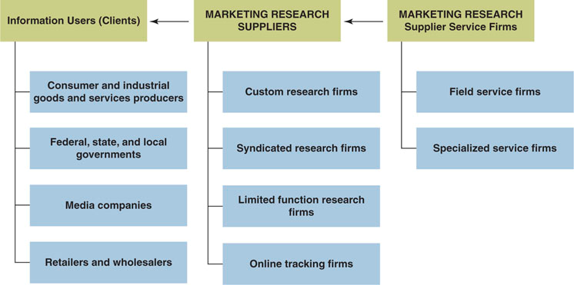

Primary Information Users (Client Organizations)
Consumer and Industrial Goods and Services Producers
Producers of goods and services are the ultimate users of the research data. Their primary business is the sale of products and services. They use marketing research data on an ongoing basis in a variety of ways to support the marketing decision-making process such as:
- To determine how various target groups will react to alternative marketing mixes
- To evaluate the ongoing success of operational marketing strategies
- To understand what costumers and noncustomers are saying about their brands and competing brands
- To assess changes in the external, or the uncontrollable, environment and the implications of those changes for their product or service strategy
- To identify new target markets
- To measure the quality of customers service and level of satisfaction
- To more effectively target their promotion

Media Companies
Concerned with getting the right message to the right target market. These may obtain data from custom or syndicated research firms and in some cases may conduct the research themselves

Retailers and Wholesalers
In the highly competitive retail market, understanding the customer is paramount. Firms want to understand their customer’s level of satisfaction, the reasons for the satisfaction or dissatisfaction, and what they can do to improve.

Manufacturers
Producing the right product at the right price points and ensuring both dealer and customer satisfaction.

Federal, State, and Local Governments

Marketing Research Suppliers
Custom, syndicated, and limited function (only do one thing, e.g. focus groups or online research firms) marketing research firms represent the front line of the research industry. They sell research services, design research studies, analyze the results, and make recommendation to their clients.

Marketing Research Supplier Service Firms
These firms service the research industry. Services range from software providers, to providers of samples, to large online panel providers to the marketing research industry.

Top 10 Marketing Research Firms
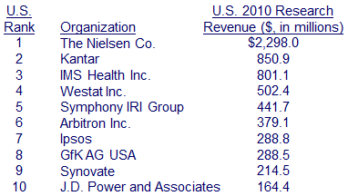

Note from the teacher: IMS health: collect data from pharmacies for pharmaceutical sales representatives to know if they’ve been effective or not. Also permits to know which sales rep are effective and which aren’t doing much. Since these reps don’t bring back orders, IMS lets them know what the doctors have been prescribing and so then make their sales efforts more effective

Research Suppliers
Nielsen’s Two Divisions:
- Consumer Watch (Such as measurement of audiences)
- Consumer Buy (Information on purchases)

Custom Research Firms
Companies that carry out customized marketing research to address specific projects for corporate clients

Syndicated Service Research Firms
Companies that collect, package, and sell market research data to many firms
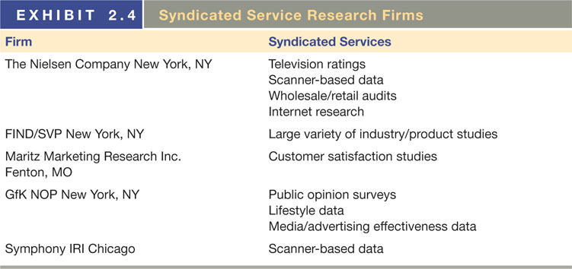

Limited-Function Research Firms
Companies that specialize in one or a few activities, such as industry-specific
Research Panel: Group of individuals who agree to participate in a series of research studies over time

Marketing Research Supplier Service Firms
- Field Service Firm: Companies that only collect survey data for corporate clients or research firms
- Sampling Firms: Generate samples
- Software Firms: Sell software for analysis
- Other Service Companies: Consulting, magazines, and directories

Users of Marketing Research
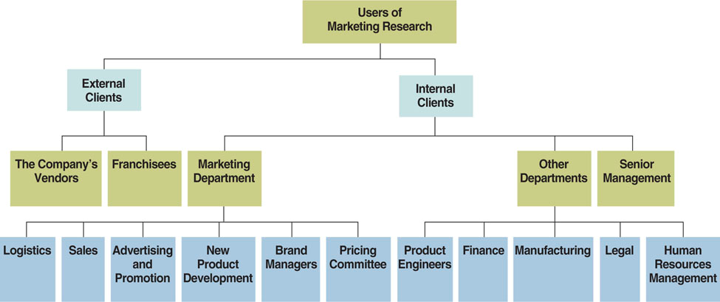

External Clients
Vendors
Manufacturers are moving into strategic partnerships with their vendors in order to implement just-in-time manufacturing. These partnerships are formed by two or more firms with unique skills and resources to offer a new service for clients, provide strategic support for each firm, or in some other manner create mutual benefits. These alliances are based on fully integrated manufacturer-supplier logistics systems that get the component to the assembly line just when it is needed. The result is little or no raw materials inventory and significantly reduced carrying costs. The backbone of this system is shared information. Within the framework of strategic partnering, marketing research information is fed back to a manufacturer’s suppliers when consumers voice opinions about a component on the manufacturer’s customer satisfaction surveys.

Franchisees
Most major franchisers of consumer’s goods and services provide marketing research data to their franchisees. The most common way of gathering data is from mystery shoppers. Franchisers also share information to support certain recommendations or actions on behalf of their franchisees.
Internal Clients
Marketing Managers
Use research data more than any other group of managers. Research helps decide on a target market and define which users in that market are the heaviest ones.
- New product development managers are among some of the heaviest users of marketing research. From qualitative research techniques that generate product ideas to concept testing, product prototype testing, and then test marketing, marketing research is the key to creating a new product.
- Marketing research also plays an important role in the distribution function. It is used to choose locations for new stores and to test consumer reactions to internal store design fixtures and features.
- Within larger organizations, pricing decisions are usually made by committees composed of representatives from marketing, finance, product, and perhaps other departments.

Top Management
Use research in order to raise market share, profits, and shareholder value. They look at marketing research for strategic guidance. (E.g. should the firm start a new line or not?)

Other Internal Users
Repositioning research helps financial managers forecast revenue spurts from older products. Human resources may use research in order to ensure a good company image with employees. The legal department may get help in court from research.

Strategic Partnering
- Appropriate use of synergy between partners
- Personal compatibility greatly enhances effectiveness
- Sharing the same visions and goals is important
- About half of large MR firms engage in strategic partnering
- Can greatly improve productivity and customer service
- Will help the company to target its resource more effectively

Danger Signals when Evaluating a Supplier
- Magic techniques—If you don’t understand it, don’t buy it.
- Guaranteed solutions—Beware of prophets or know-it-alls.
- Price Variance—Never choose a research company based on the lowest prices.

Get the Most from the Research Partnership
- Build a relationship
- Set forth clear objectives
- Look in on the research while it is in process
- Insist that the supplier present the results to all your key people in one room at one time.
The last step is so people can ask questions and get clarifications -teacher
The marketing research industry was hurt by the recent recession. Sales and employment dropped for the first time in many years. Client organizations began insourcing to save money. At the same time, clients were also seeing strategic partnerships with research suppliers. This has led many client firms to reduce the number of suppliers they use.

Marketing Research Ethics
- Ethics are moral principles or values generally governing the conduct of an individual or group.
- Ethics is not a one-way relationship as all parties are responsible for maintaining and fostering ethical standards and conduct.
- If you are concerned about a research supplier, contact research associations to vet suppliers.

Ethical Theories
Deontology
People should adhere to their obligations and duties when analyzing an ethical dilemma

Utilitarianism
The choice that yields the greatest benefit to the most people is the choice that is ethically correct. (Ability to predict the consequences of an action)

Casuist
Comparing a current ethical dilemma with similar ones and their outcomes. (Current ethical dilemma with examples of similar situations)

Unethical Behavior by Suppliers
Low-Ball Pricing
Quoting an unrealistically low price to secure a firm’s business and then using some means to substantially raise the price

Allowing Subjectivity into the Research (Advocacy Studies)
Research suppliers must avoid using biased samples, misusing statistics, ignoring relevant data, and creating a research design and the goal of support a predetermined objective. Advocacy studies are studies commissioned by a company or industry for public relations purposes or to advocate or prove a position.

Abusing Respondents
Lengthy interviews, information too personal, selling private confidential data, etc.

Selling Unnecessary Research
Trying to push more focus groups, etc. on a client even though he doesn’t need them

Violating Client Confidentiality
Sharing information about a client’s business activities or the results of a client’s project (The consulting industry is a gray area)

Black Box Branding
Branded research products that cannot disclose exactly how they work. This tendency has risen due to competitive pressures that force organizations to seek new ways to differentiate their product offerings from those of their competitors and from the fact that private products can charge more than services being used around publicly offered products.

Unethical Behavior by Clients
- Requesting Bids When a Supplier Has Been Predetermined
- Requesting Bids to Obtain Free Advice and Methodology; (such as sample surveys, etc.) and possibly even bringing them to cheaper suppliers or straight to field service suppliers
- Making False Promises for future studies if good prices are given now
- Requesting Proposals without Authorization from higher levels
- Retailer Ethics – car dealerships etc.

Unethical Behavior by Field Service Providers
- Using Professional Respondents
- Failing to Properly Validating the Data
- Using Others’ Research as Original Work
- Overstating Qualifications or Inflating References

Respondent’s Rights
- Right to Choose to Participate
- Right to Safety
- Right to Be Informed
- Right to Privacy

Debrief is especially for experiments more than surveys. In an experiment, you will often use deception. (You sort of have to in order to avoid biases). But at the end, you have to inform the consumer about what it is really about. (Teacher)

Safe Harbor Program
Notice, Choice, Onward Transfer, Access, Security, Data Integrity, Enforcement

CHAPTER 3: STEPS IN THE RESEARCH PROCESS

The Problem Definition Process
- Recognize the problem or opportunity
Can the problem become opportunity?

- Find out why the information is being sought
Clear ideas and questions

- Understand the decision making environment
Examine cultural and bureaucracy issues

- Use the symptoms to help clarify the problem
Determine cause and effect relationships

- Translate management problem to marketing research problem
Management support is key

- Determine whether the information already exists
Have you researched other research?

- Determine whether the question can be answered
Are the objectives clear and realistic?

- State the research objectives
Include timetable and responsible party

Situational Analysis: Studying the decision-making environment within which the marketing research will take place

The Decision-Making Environment

Exploratory Studies
Preliminary research conducted to increase understanding of a concept, to clarify the exact nature of the problem to be solved, or to identify important variables to be studied.

Purposes
- Define Terms
- Clarify Problems
- Develop Theories
- Establish Priorities
- Gain General Information

Exploratory research can take several forms: pilot studies, experience surveys, secondary data analysis, pilot studies case analysis and focus groups. As a researcher moves through the exploratory research process, a list of marketing research problems and subproblems should be developed.

Pilot Studies
Surveys using a limited number of respondents and often employing les rigorous sampling techniques than are employed in large, quantitative studies.

Experience Surveys
Discussions with knowledgeable individuals, both inside and outside the organization, who may provide insights into the problem.

Secondary Data Analysis
Secondary data is data that has been gathered for some purpose other than the one at hand.

Case Analysis
Reviewing information from situations that are similar to the current one. (Important to always determine relevancy)

Focus Groups

Use Intranets
Find relevant information inside an organization with many departments and past research
Marketing Research Problem
A statement specifying the type of information needed by the decision maker to help solve the management decision problem and how that information can be obtained efficiently and effectively.

Marketing Research Objective
A goal statement, defining that specific information needed to solve the marketing research problem.

Management Research Problem
A statement specifying the type of managerial action required to solve the problem.

Research Hypothesis
A conjectural statement about a relationship between two or more variables that can be tested with empirical data. A claim or argument about your theory of what is causing “X” that you will research to prove or disprove. E.g. “Sales are declining because of competition”

Research Question
Questioning what the researcher wants to learn – without making a claim about what might be causing the issue at hand. E.g. “We don’t know why sales are declining, so let’s research the problem to find out.”

Marketing Research Process 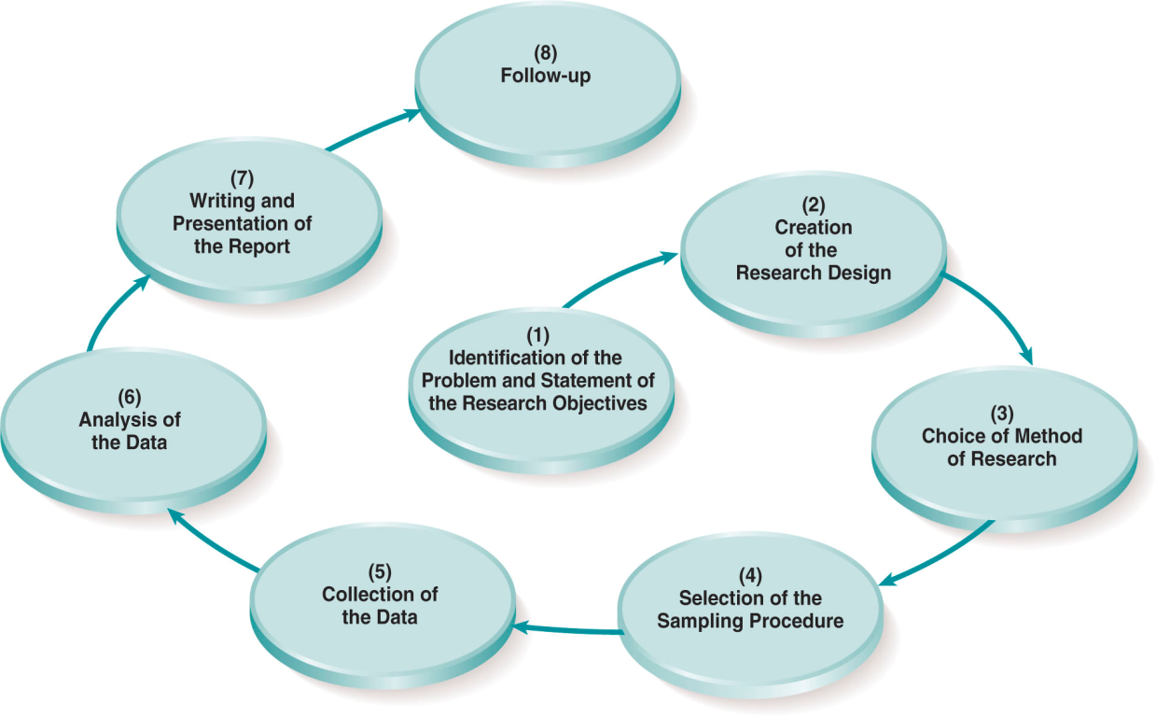

- Problem definition and statement of objectives
Does it involve hypothesis or just a statement?

- Creation of the research design
Exploratory, descriptive, casual, planning, implementing, controlling

- Choice of research method
Primary / secondary – survey, focus groups, experiments, etc.

- Sampling section / plan
Probability vs. non-probability, sample size

- Data collection
Personal, telephone, mail, internet, etc.

- Data Analysis
Level & scope must be determined early

- Write and present the research report

- Follow-Up
Were recommendations followed? Is more research needed?
(1) From a Management Problem to a Marketing Research Problem
Management Decision Problem
A statement specifying the type of managerial action required to solve the problem.

Management Research Problem
A statement specifying the type of information needed by the decision maker to help solve the management decision problem and how that information can be obtained efficiently and effectively.

Marketing Research Objective
A goal statement defining the specific information needed to solve the marketing research problem.

(2) Marketing Research Design
The plan to be followed to answer the marketing research objectives. The researcher develops a structure or framework to answer a specific research problem/opportunity.

It is the detailed blueprint used to guide the research study towards its objectives including what and how you will conduct the research study.

Descriptive Research Studies
Answer the, who what, where, when and how questions. It is used when one wants to gain a better understanding of the specifics or details the research issue.

Purpose
- Confirm Theories
- Brand Loyalty Measure
- Describes Population
- Build Customer Profile
- Gain Specific Information

Cross-Sectional Surveys
One time snapshots of a population using the same survey and a different sample
Longitudinal Surveys
Identify market trends using the same survey and the same sample, but also tracking panels and groups.

Causal Research Studies
Research studies that examine whether the value of one variable causes or determines the value of another variable.

Purpose
- Confirm Theories
- Identify Cause & Effect
- Relationships Among Variable

Dependent Variable
A symbol or concept expected to be explained or influenced by the independent variable. One affects the dependent variable by manipulating the independent variable deemed to be associated with the dependent variable

Independent Variable
A symbol or concept over which the research has some control and that is hypothesized to cause or influence the dependent variable.

Concomitant Variation
The degree to which a presumed cause and a presumed effect occur or vary together.

Temporal Sequences
An appropriate causal order of events.

Spurious Association
A relationship between a presumed cause and a presumed effect that occurs as a result of an unexamined variable or set of variables.
(3) Choosing a Research Method (Different Time and Money Constraints)
Survey Research
Research in which surveys (personal, telephone, mail or Internet) are used to obtain facts, opinions, and attitudes from respondents.

Observation Research
Typically descriptive research that monitors respondents’ actions without direct interaction.

Experiments
Research to measure causality, in which the researcher changes one or more independent variables and observes the effect of the changes on the dependent.

Other Qualitative Research
Research such as focus groups, secondary data analyses, and case studies.

(4) Sampling Procedure
Probability Sampling
A subset of the population that can be assumed to be a representative cross section of the population because every element in the population has a known non-zero chance of being selected.

Nonprobability Sampling
A subset of the population in which the chances of selection for the various elements in the population are not precisely known.

Sample Size Needed

The client’s budget (time and money) may have a significant impact on the sample procedure decisions. The population or universe of interest must be defined before deciding to use either a probability or nonprobability sample. Probability samples allow the researcher to estimate how much sampling error is present in a given study.
(5) Collecting the Data
Survey
- Interviewer
  - In person
  - telephone
- No interviewer
  - Mail
  - Internet

Observation
- In person
- Machine

Experiments

(6) Analysis of the Data
Use a variety of quantitative and qualitative analytical techniques. Interpret and draw conclusions from the mass of collected data.

(7) Writing and Presenting the Report
Important to:
- Judge the Quality of a Report
- Use the Internet to Disseminate Reports
- Prepare a written and oral presentation to include the research objectives, methodology, key findings, limitations, acknowledgements, conclusion, and recommendations. The oral report may be more important than the written because it can motivate the clients to read the report or not.

(8) Follow Up
- Will the findings be used?
- Why will they be used or why not?
- It is best to minimize any conflict between the marketing department and other departments in the organization.
- This stage is also used for the marketing research firm to identify areas in which they can improve the research techniques they used for the specific project.

Teacher Notes
Cause and effect relationships are sometimes ‘seen’ where they don’t exist – e.g., tennis players are very superstitious about what wins them games. (e.g. wearing particular socks)
Randomness is deceptive – Apple’s shuffle (made it more random to not be random – some songs won’t come back up all the time)

Beating the Market
Leonard Koppett’s system revealed in 1978 – by end of January, could predict whether stock market would be up or down for the year. He claimed it had already worked for 11 years. It worked from 1979 to 1989, got it wrong in 1990, then it worked again from 1991 until 1998. Correct for 18 out of 19 years!

Skill vs. Luck
Bill Miller of the Legg Mason Fund beat the S&P 500 index or 15 straight years from 1991. Time – ‘greatest money manager of the 90’s’. It never happened in 40 years - odds of happening by chance 32,768 to 1.

What Question to Ask?
32,768 to 1 are the odds only if you asked this question in 1991: What are the odds that Bill Miller will beat the market for the next 15 years?
But here’s a better question: What are the odds that some fund manager (out of >1000) in the last 40 years – from 1970 on (not just 1991) - will beat the market for a period of 15 years or longer by pure chance?

The Research Request
An internal document used by large organizations that describes a potential research project, its benefits to the organization, and estimated costs; it must be formally approved before a research project can begin.
It includes:
- Action - Decision makers determine what action will result from the research
- Origin - Clarify/state the origin of the problem that necessitated the research
- Information - Decision maker should detail questions to be answered
- Use - How each piece of the research will be used should be detailed
- Targeting - Determine which groups will be targeted for the research
- Logistics - Determine how the research will be done - time & budget are key
- Comments - Additional information that is relevant to the project

The Request for Proposal (RFP)
A solicitation sent to marketing research suppliers inviting them to submit a formal proposal, including a bid.
It includes:
- The background of the research problem or issue
- The goals and objectives of the hiring firm
- The methodology the firm wants you to follow - sometimes with your input
- The scope and timetable of the work to be performed
- The total project cost
- Instructions like the report format, whether they want you to present it, etc.

Marketing Research Proposal
A document developed, usually in a response to an RFP, that presents the research objectives, research design, time line and cost of a project

Includes:
- Title Page
- Statement of the Research Objectives
- Study Design
- Areas of Questioning
- Data Analysis
- Personnel Involved
- Specifications and Assumptions
- Services
- Cost
- Timing
Areas of Questioning: List of survey topics based on research objectives
Services: Who is designing it, client, supplier, etc.

Benefits of Research Proposal
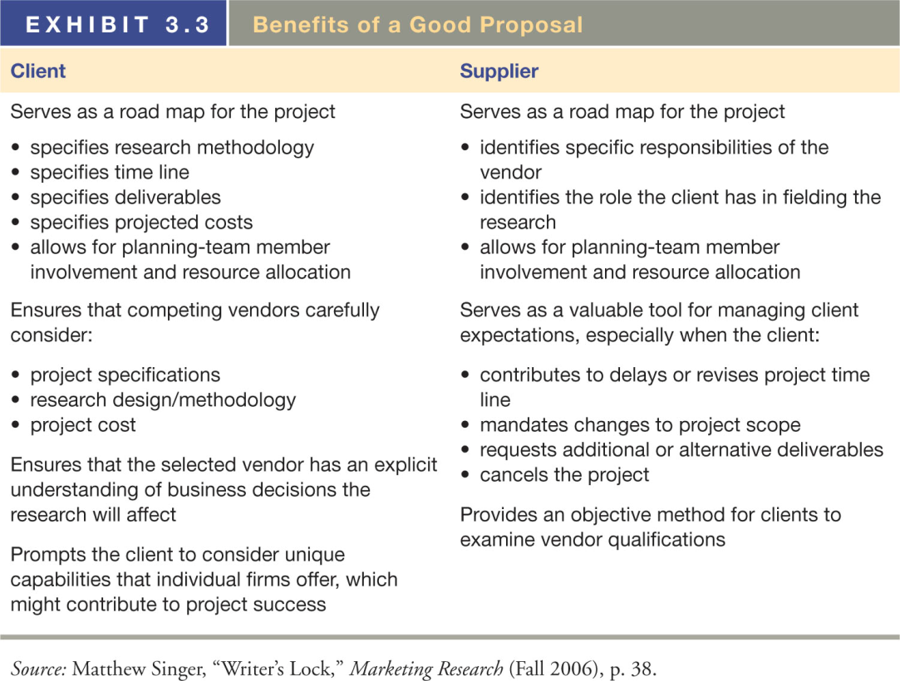
CHAPTER 4: USING SECONDARY DATA

Secondary Data
Data than have been previously gathered.
Advantages
- Can help to clarify or refine the issue or problem
- Might provide a solution to a research problem
- Might provide primary data research alternatives
- Can alert the researcher to other problems
- Provides background information enhancing research credibility
- Usually less expensive and faster to gather
- Teacher: Availability, cost, speed – eliminates sampling, data collection, obtains information may not be otherwise accessible

Disadvantages
- Lack of Availability
Might not be any available data on your topic
- Lack of Relevance
Data might be outdated
- Inaccuracy
Might be biased - intentionally or unintentionally
Questionable source
- Insufficiency
Not enough information exists
- Teacher: Not designed specifically to meet researchers’ needs, may be outdated, may have inappropriate units of measurement, may need data conversion, uncertain accuracy, may need to cross-check

Primary Data
New data gathered to help solve the problem under investigation.

Assessing Secondary Data
- Who gathered the data?
- What was the purpose of the study?
- What information was collected?
- When was the information collected?
- How was the information collected?
- Is the information consistent with other information?

Limitations of Secondary Data
Lack of availability, lack of relevance, inaccuracy, insufficiency

Fact Finding Objective
Identification of consumer behaviour for a product category

Trend Analysis
Market tracking: The observation and analysis of trends in industry volume and brand share over time

Environmental Scanning
Information gathering and fact-finding that is designed to detect indications of environmental changes in their initial stages of development. E.g., monitoring teen trends, or ‘cool hunting’

Model Building Objective
Developing descriptive or predictive equations to specify relationships between variables
- Estimating market potential for geographic areas
- Forecasting sales – using moving average (time series) or regression methods
- Analysis of trade areas and sites
  - Trade Areas: Sales & Marketing Management’s ‘Buying Power Index’ based on retail sales, population, income
  - Site Analysis: selecting the best location based on traffic data and trade area data – e.g., using ‘gravity models’
  - Index of retail saturation: calculating the balance between retail demand and supply – to cover rents and expenses, many retailers need $200 per sq. foot in sales
Internal Databases
A collection of related information developed from data within the organization (e.g. sales activities)

Database Marketing
Marketing that relies on the creation of a large computerized file of customers’ and potential customers’ profiles and purchase patterns to create a targeted marketing mix

Key Features of Internal Databases
- Creation of large - up to date - computerized file
- Can include current, past, or potential customers
- Might be focused on demographic / purchase behaviors
- Development of customer profile results
- Should enable one to generate direct marketing mailers /e-mails targeted at specific customers based on their buying behavior
- Can be used to collect customer information from your Web site
- Should be organized to enable you to search the database using queries
- Should be compatible with database software that will enhance analysis

Neural Network
A computer program that mimics the processes of the human brain and thus is capable of learning from examples to find patterns in data

Data Mining
The use of statistical and other advanced software to discover non-obvious patterns hidden in a database. Some Applications Include: Customer acquisition, customer retention, customer abandonment, market basket analysis.

Acquisition
Discover customer attributes that predict their responses to special offers and communications. The attributes are then matched to noncustomers

Retention
Discovers those who might leave

Abandonment
Discover which do not deserve promotion

Market Basket Analysis
Identifies associations among product purchases in POS transactions

Data Mining Objective
- Using scanner data, retailers know which products deserve shelf space
  - They can track margins, coupon elasticity, display elasticity
  - They know which products to display together
- Retailers now have more channel power – so they demand slotting fees to fatten margins
- Uses: market basket analysis, customer discovery, sequence discovery

Data Mining Applications
Automated analysis of large volumes of data to uncover patterns among customers and products
- Just too much data available to rely only on classical methods
  - Neural networks - one type of data mining
- Unique insights from scanner data/panel data
  - Osco drugstore ‘market baskets’ had diapers and beer
  - Premium brands display greater price elasticity than economy brands
  - Small market share brands in ‘double jeopardy’ – they have fewer customers, who each buy less

Behavioral Targeting
Using online and offline data to understand a consumer’s habits, demographics, and social networks in order to increase the effectiveness of online advertising

Marketing Research Aggregators
A company that acquires, catalogues, reformats, segments, and resells reports already published by large and small marketing research firms.
It’s a 100 million dollar business that is growing about 6 percent a year. Their role is growing because their databases of research reports are getting bigger and more comprehensive -and more useful- as marketing research firms get more comfortable using resellers as a sales channel. Meanwhile, advances in web technology are making the databases easier to search and deliveries speedier. And aggregators are slicing are repackaging research reports into narrower, more specialized sections for resale to better serve small and medium sized clients who often cannot afford to commission their own studies or buy full reports – essential nurturing a new target marketing for the information
Research aggregators are indirectly tapping new markets for traditional research firms. Selling smaller chunks of data at a lower price point is putting big research firms results into the hands of small and medium sized business clients who often cannot afford to spend more than a few hundred dollars for a report

Key Tools in Information Management
Geographic Information Systems – GIS
A computer-based system that uses secondary and/or primary data to generate maps that visually display various types of data geographically.
It provides both a means of maintaining geographic databases and a tool capable of complex spatial analysis to provide information for a decision support system.
A geographic database can store and provide access to corporate data, such as customer locations, facilities, logistic routes, and competitors. Helps maximize location choices
Advantages: Cost has fallen, ease of business-related analysis, can be transmitted over the internet easily.

Decision Support Systems – DSS
An interactive, personalized information management system designed to be initiated and controlled by individual decision makers
The DSS must be interactive (gives results to simple instructions), flexible (it can sort, regroup, total, average and manipulate data in different and in the best ways), discovery-oriented (probe for trends, isolate problems, ask new questions) and easy to learn and use
Managers use a DSS to conduct sales analyses, forecast sales, evaluate advertising, analyze product lines, and keep tabs on market trends and competitor’s actions. It not only allows managers to ask “what if” questions but enables them to view any given slice of the data.

Battle for Privacy
Identity Theft and Government Action
Federal Laws:
- Gramm-Leach-Bliley Act (Financial Services Act)
- Health Insurance Portability and Accountability Act
- The Fair Credit Reporting Act (FCRA)
- The Children’s Online Privacy Protection Act (COPPA)
State Laws:
- California’s Notice of Security Breach Law

A Possible Problem:
Getting paid to give up your privacy

Secondary Data Distribution
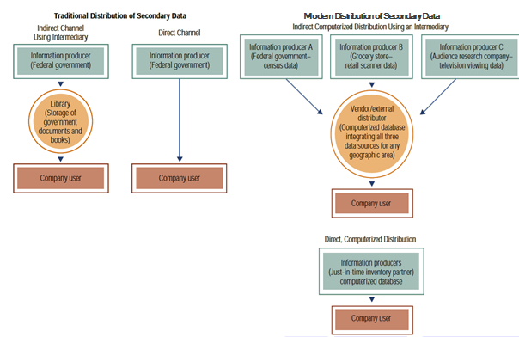

Single-Source Data
- Diverse types of data offered by a single company such as Nielsen Scantrack and IRI (iriworldwide.com/)
- Data are usually integrated on the basis of a common variable such as geographic area or store

Competitive Intelligence
- An emerging field: obtaining information using legal means, and protecting yourself from economic espionage
- Reverse engineering and tracking hiring activity used among other tools – company web sites also monitored

Teacher Diagrams
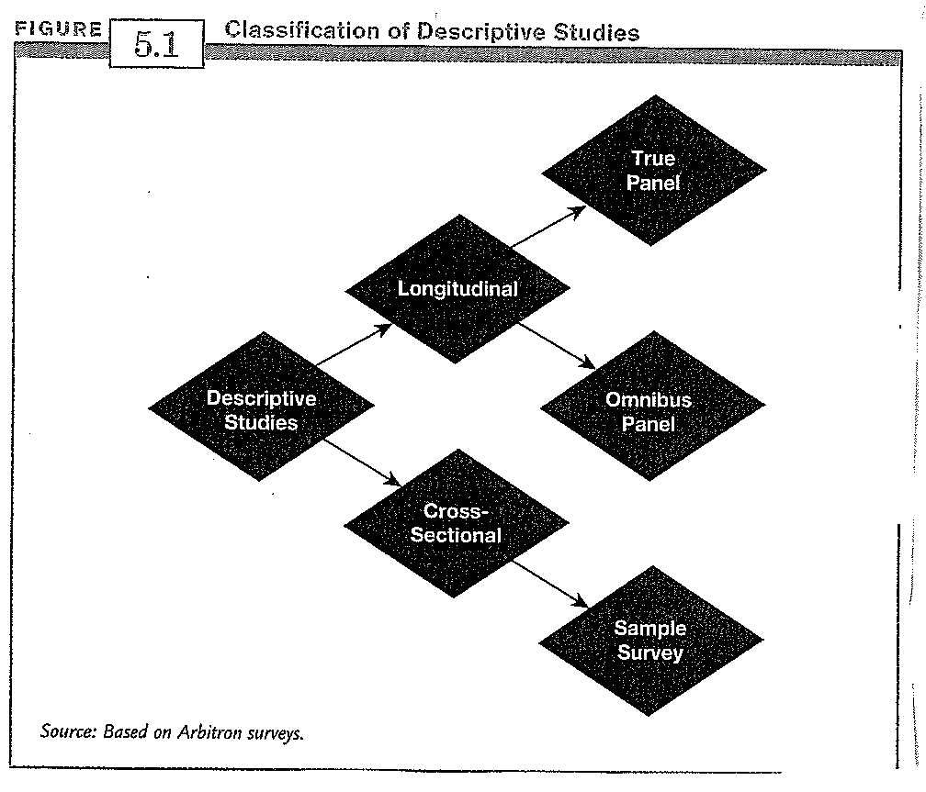

Longitudinal Over Years
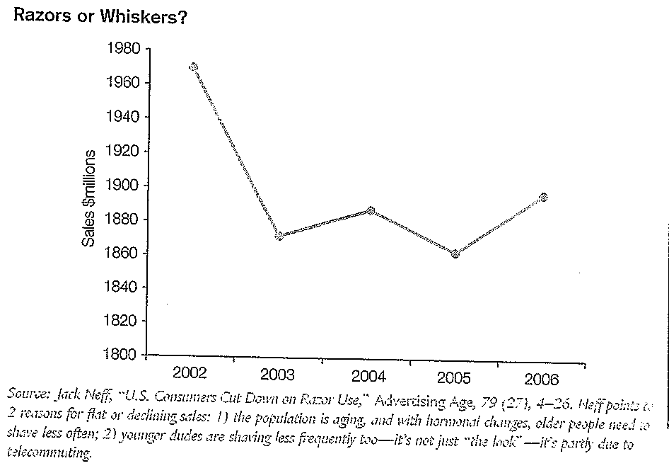

Longitudinal Over Seconds
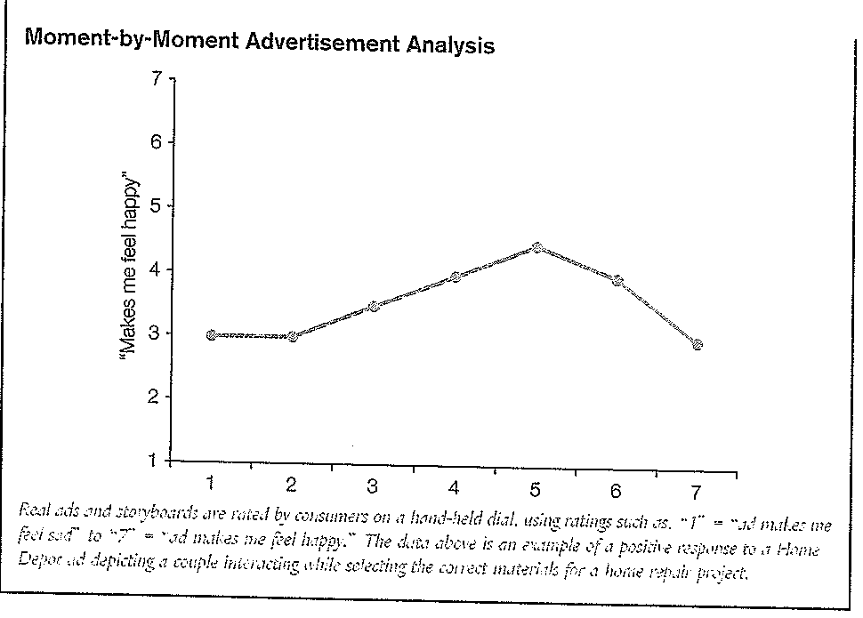

Transition Matrix
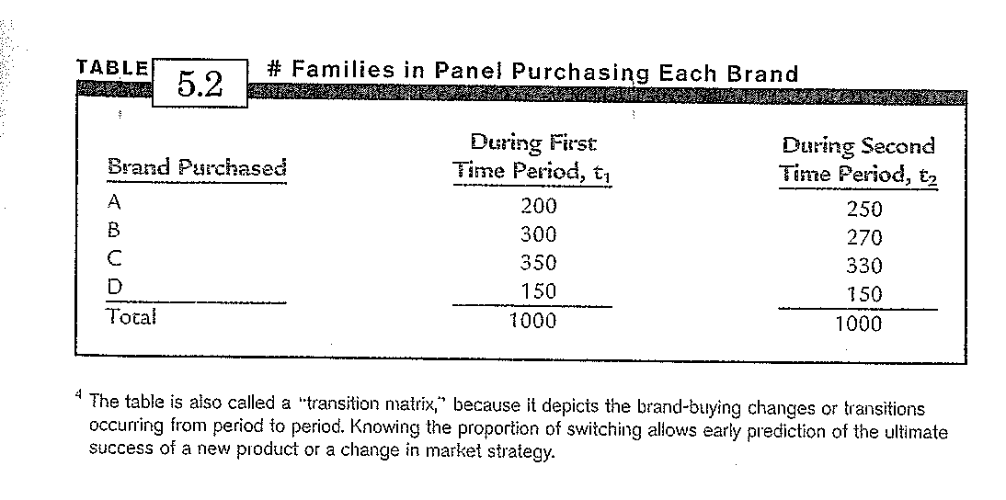

Brand Switching Matrix or ‘Turnover Table’
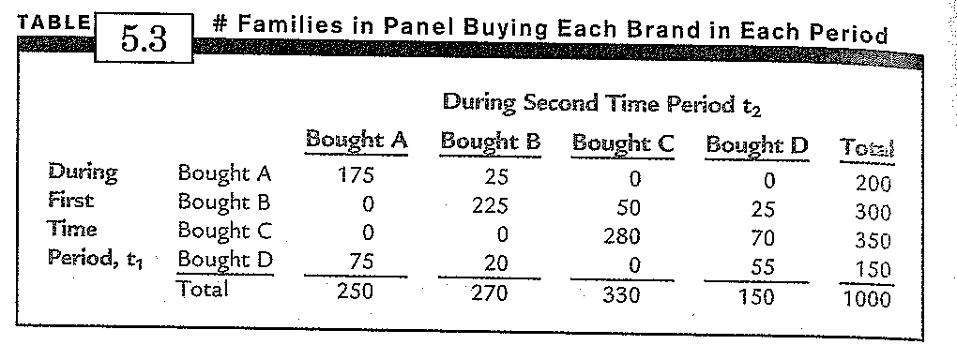

Brand Loyalty
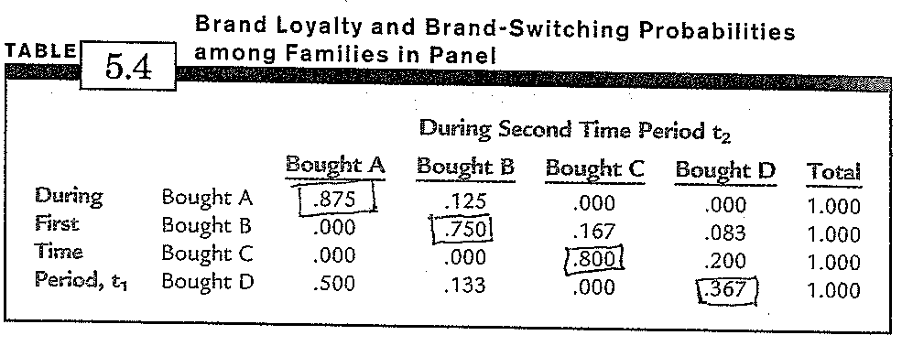
CHAPTER 5: FOCUS GROUPS, DEPTH INTERVIEWS, AND OTHER NON-QUANTITATIVE RESEARCH METHODS

Qualitative
Research whose findings are not subject to quantification or quantitative analysis. Its research conclusions are not based on precisely, measurable statistics but on more subjective observations and analysis.

Quantitative
Research that uses mathematical analysis. Typically research analysis is done using measurable and numeric standards.

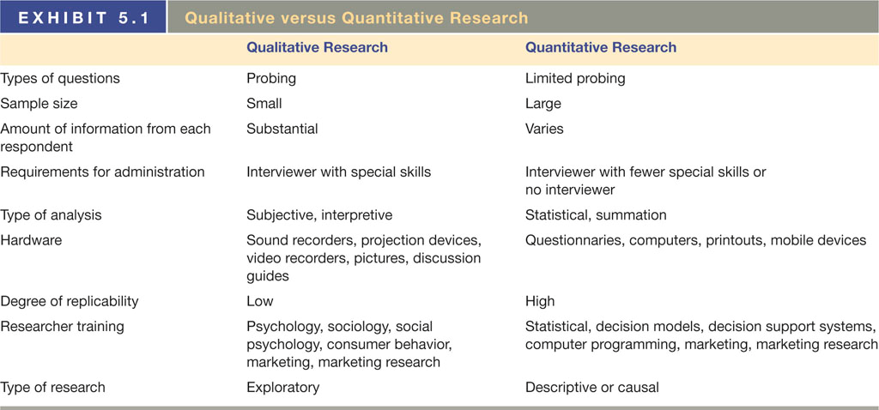

Advantages of Qualitative Research
Initial research conducted to clarify and define the nature of a problem - over $4 billion a year spent on qualitative research (-Teacher)
- Cheaper and quicker than quantitative
- Offers in-depth understanding of consumers
  - Consumers use ‘quality cues’ - colour, suds; roaches are like men who eat and run!
  - It makes consumer input more vivid for managers
- It provides insights and raises issues for quantitative research
  - Can learn which questions to ask in survey
  - Not a substitute for quantitative, a complement

Disadvantages of Qualitative Research
- Not Replicable, Violates Scientific Method
  - Samples always small and non-representative, sometimes very badly so
- Subjective
  - Results of a focus group/depth interview dependent on skills and interpretation of the moderator
  - With a different set of 8 individuals, might come to the opposite conclusion
- Can’t Pick Up on Small Differences in Target Market
  - E.g., effects of prices with ’99’ endings, different segments of population

General Limitations of Qualitative Research
1. Attitudinal, perception, and belief differences revealed during qualitative research might not be easily measure. Quantitative research will more precisely measure these differences.
2. Qualitative research is often not statistically representative of the general population. Although qualitative results might give you a good idea about the population, they do not allow you to precisely gauge the populations’ responses based on the limited sample typical of qualitative research.
3. Anyone can purport to be an expert.

Factors to Consider in Qualitative Research
- Time / budget
- How the research results will be used
- Product / service tangibility
- Research goals & objectives
- Participant availability and willingness
- Desired analysis sophistication
- Whether quantitative research follows

Focus Groups
A group of eight to 12 participants who are led by a moderator in an in-depth discussion on one particular topic or concept.

Characteristics of Focus Groups
- Good for idea generation, brainstorming, and understanding customer vocabulary
- Can be helpful in gaining insight to motives, attitudes, perceptions
- Can reveal needs / likes & dislikes / prejudices driven by emotions
- Group Dynamics. The moderator must manage this factor deftly
- Unstructured, free-flowing interview with small group – usually 6 to 10
- Group dynamics stimulate better discussion than individual interviews
- Widely used, 750+ focus group facilities in U.S, 550,000+ groups worldwide each year
- Need ‘typical’ yet articulate participants, similar to each other (e.g. same gender), avoid ‘professional’ respondents
- Moderators must be skilled, curb dominating members, stimulate discussion, use a discussion guide
- As much art as science

Advantages of Focus Groups
- Provide immediacy and impact
  - Cheap, and fast - can execute in a week, unlike a survey
  - Seeing actual customers talk is very persuasive for clients and employees

Disadvantages of Focus Groups
- Recruiting is not easy
  - Group may not be typical, even multiple groups not representative of population
- Respondents may want to look good to others (pantyhose example) or be dominating or shy
  - Convincing – but may give managers false confidence

Focus Group Steps
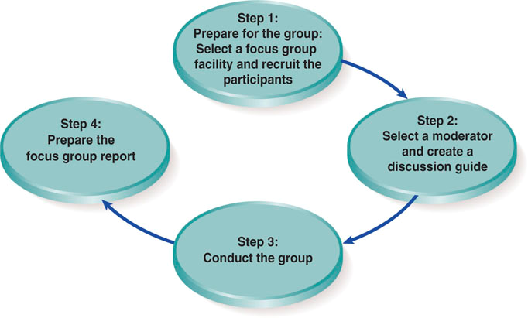
1a. Decide on the key focus group objectives
1b. Use secondary research to hone questions
1c. Select focus group facility and participants
1d. Begin recruiting after deciding on participant incentives
2a. Select a moderator
2b. Develop a moderator guide to chart flow of focus group
3. Conduct the focus group - generally about two hours
4a. Review the video tape and analyze the results
4b. Prepare a written report

Conducting a Focus Group
Participants
Selection process:
- Potential opinion leaders are best
- Participants must be screened for relevance to the topic

Facility
A research facility consisting of a conference room or living room setting and a separate observation room with a one-way mirror or live audiovisual feed.

Moderator
A person hired by the client to lead the focus group; this person should have a background in psychology or sociology or, at least, marketing.
Create moderator's guide to include:
- Timetable for each topic, clear goals/questions to be answered
- Strategy for keeping group on task / focused
- Managing the group dynamics is critical

Build Rapport as a Moderator:
- Smile – make a connection with individuals
- Get physical – recognizable acknowledgement such as a handshake or dialog
- Turn on the charm – make an extra effort to respond warmly
- Offer empathy – if there are problems or concerns, address these issues
- Be real – make actions sincere without phoniness or lies
- Mind the details – include logistics such as mentioning where food, drink, and bathrooms; make sure everyone is comfortable
- Come to complete closure – make comments final and say firm goodbyes

What Makes a Good Moderator:
- Genuine interest in people
- Acceptance and appreciation for the differences in people
- Good listening skills
- Good observation skills
- Interest in a wide range of topics and the ability to immerse themselves in the topic
- Good oral and written communication skills
- Objectivity; remaining open to the ideas and feelings of others
- Sound knowledge of the basic principles, foundations, and applications of research, marketing, and advertising
- Flexibility; the ability to think on your feet
- Good attention to detail and organizational ability
- Discussion Guide: Written outline of topics to be covered during a focus group discussion. Usually three stages:
- Rapport is established, rules of group interaction are explained, and objectives are given.
- Moderator attempts to provoke intensive discussion
- Summarizing significant conclusions and testing the limits of belief and commitment

(Focus group length and the client’s role are also important parts)

New Trends in Focus Group Methods
- Instant Analysis: Moderator debriefing, offering a forum for brain-storming by the moderator and client observers.
- Today, a formal focus group report is typically a PowerPoint presentation.
- Video Transmissions: Online
- Panels: Same people over an approximate six-month period. They are carefully chosen candidates.
- “Prosumers”— Marketing Professionals Used as respondents.

Other Qualitative Methods
Depth Interviews (IDIs)
One-on-one interviews that probe and elicit detailed answers to questions, often using non-directive techniques to uncover hidden motivations

Pros:
- Group pressure is eliminated
- Respondent feels important and truly wanted
- Respondent attains a heightened state of awareness
- Encourages the revelation of new information
- Respondents can be questioned at length to reveal feelings and motivations
- Individual interviews allow greater flexibility to the direction of questioning
- The interviewer becomes more sensitive to nonverbal feedback
- A singular viewpoint can be obtained without influence from others
- Interviews can be conducted anywhere
- Can understand how individuals do things – e.g., learn to cook with recipes
- Good for sensitive topics – e.g., abortion

Cons:
- Costs in terms of time and money
- Less client involvement
- Do not cover much material in one day
- Do not allow for a group discussion and resolution
- Some respondent reactions cannot be generated from a one-on-one session

Respondent Types:
- The Digresser
- Problem: cannot stay on-topic
- Solution: nip the problem in the bud; explain that the respondent will benefit from keeping their responses brief

- The Withholder
- Problem: overly brief; opposite of the digresser
- Solution: Continue to probe the withholder; ask follow-up questions

- The Ruminator
- Problem: spends several minutes digesting and coming up with responses to questions
- Solution: similar approach taken with the digresser; explain that the respondent will benefit from keeping their responses brief; show the ruminator the amount of questions that need to be answered

Other Qualitative Methods
Hermeneutic Research
Research that focuses on interpretation through conversations

Delphi Method
It involves a number of rounds of data collection. In the classical Delphi procedure, the first round is unstructured, in order to allow individual experts relative freedom to identify and elaborate the pertinent issues from their point of view. These issues are then consolidated by the researcher into a structured questionnaire

Projective Tests
Techniques that tap into respondents’ deepest feelings by having them project those feelings into an unstructured situation.
Examples:
- Word Association Test
- Analogy
- Personification
- Sentence and Story Completion Test
- Cartoon Tests and Photo Sorts
- Customer Drawings
- Storytelling
- Third Person Technique
Laddering

Culture Code Approach – Clotaire Rapaille
- Products have to be in line with the ‘code’ that was imprinted early in childhood
- Reasons for buying are not rational, buying is dictated by the ‘reptilian brain’ – reasons are made up later when justifying purchase

Motivation Research – Ernest Dichter
- Based on Freudian psycho-analysis
  - E.g., women’s motivations for baking, men’s motivations for buying convertibles

The Future of Qualitative Research
Because consumer behavior has emotional and subconscious content, qualitative research will continue to be used. Respondents verbalize their emotions and feelings best by indirect communication techniques, so focus groups will grow in importance
CHAPTER 6: METHODS OF SURVEY RESEARCH

Why is Survey Research so Popular?
The need to know why. For example, why did they buy or not buy a particular brand? What did they like or dislike about it? Who or what influenced them?
The need to know how. How did they make the decision? What time period passed? What did they examine or consider? When and where was the decision made? What do they plan to do next?
The need to know who. Who is the person from a demographic or lifestyle perspective? Information on age, income, occupation, marital status, stage in the family life cycle, education, and other factors is necessary for the identification and definition of market segments.

Survey Research Error Types
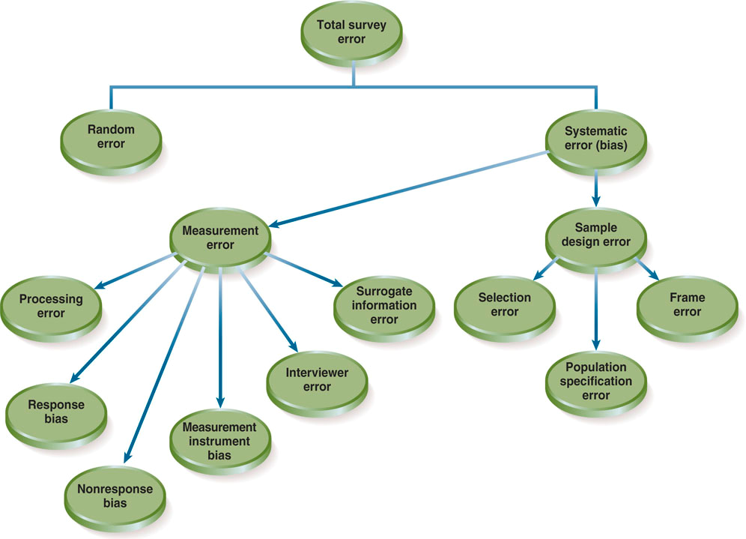
Random Error or Random Sampling Error:
- Error that results from chance variation.

Chance Variation:
- The difference between the sample value and the true value of the population mean.

Systematic Error or Bias:
- Error that results from problems or flaws in the execution of the research design; Sometimes called non-sampling error.

Sample Design Error:
- Systematic error that results from an error in the sample design or sampling procedures.

Systematic Error: 3 Types of Sample Design Error
Population Specification Error
Results from incorrectly defining the population or universe from which a sample is chosen

Selection Error
Results from incomplete or improper sampling procedures or when sampling procedures are not followed

Frame Error
Results from an incomplete or inaccurate sampling frame (The list of population elements or members from which units to be sampled are selected)

-

Measurement Error
Systematic error that results from a variation between the information being sought and what is actually obtained by the measurement process.

Surrogate Information Error
Error that results from a discrepancy between the information needed to solve a problem and that sought by the researcher. Relates to general problems in the research design, particularly failure to properly define the problem.

Measurement Errors
Interviewer Error or Interviewer Bias
Error that results from the interviewer’s influencing – consciously or unconsciously – the answers of the respondent. The dress, age, gender, facial expressions, body language or tone of voice of the interviewer may influence the answers given by some or all respondents. This type of error is caused by problems in the selection and training of interviewers or by the failure of interviewers to follow instructions. Another kind of interviewer error takes place when deliberate cheating happens (e.g. falsifying survey results). The procedures developed by the researcher must include safe-guards to ensure that this problem will be detected. (Call backs used, the problem is more acute with sensitive issues)

Measurement Instrument Error
Error that results from the design of the questionnaire or measurement instrument; also known as questionnaire bias.

Processing Error
Error that results from the incorrect transfer of information from a survey document to a computer.

More Survey Research Errors
Nonresponse Bias
Error that results from a systematic difference between those who do and those who do not respond to the measurement instrument. (Are those who did respond to the survey systematically different than those who did not respond?)

Refusal Rate
Percentage of persons contacted who refuse to participate in a survey. This is the opposite of the cooperation rate. With these rates 60% and rising, this is a real problem – self-section may play a big role.

Processing Error
Error that results from the incorrect transfer of information from a survey document to a computer – this is not likely with phone or web surveys. May also come from incorrect coding.

Response Bias
Error that results from the tendency of people to answer a question incorrectly through either deliberate falsification or unconscious misrepresentation. (NOT the opposite of the non-response bias). Questions may be misunderstood, may tax memory, or there may not be an underlying attitude on the subject. Other sources of response bias:
- acquiescence bias (yea saying)
- extremity bias (using only the endpoints on scales)
- auspices bias (being influenced by survey sponsor
- social desirability bias (desire to appear smart and normal and open minded)
- situational factors

Deliberate Falsification
People purposefully give untrue answers to questions (to wish to appear intelligent, not reveal embarrassing information, to conceal personal information)

Unconscious Misrepresentation
May occur because of question format, question content, or various other reasons.

SEE TEXTBOOK PAGE 157 FOR TYPES OF ERRORS AND STRATEGIES TO MINIMIZE THE

Survey Types
Door-to-Door
  - Interviews conducted face to face with customers in their homes.
  - Pros - direct customer contact, can demonstrate products, responses rates still good.
  - Cons - expensive, bad image, liability, safety issues.

Executive Interviews
  - Industrial equivalent of door-to-door interviewing.
  - Pros - talking with decision maker is valuable, can have complicate questioning.
  - Cons - hard to get decision maker, might not be reflective of the population.

Mall-Intercept Interviews
  - Face-to-face interviews conducted by intercepting people at high traffic locations.
  - Pros - direct customer contact, can test products, human interaction.
  - Cons - expensive, not always representative of the population, bad image.

Central Location Telephone Interviews
- Interviews conducted by calling respondents from a central location.
- Pros - good segmentation, can verify respondent as right person.
- Cons - cost, response rates slipping, need to have short surveys.

Computer Assisted Telephone Interviews (CATI)
- Central-location telephone interviews in which interviewers enter respondents’ answers directly into a computer.
- Pros - data can be directly entered into computer, can have complicated skip patterns, data entry errors rare.
- Cons - computer glitches, need interviewer training, the equipment can be expensive.

Cell Phone Surveys
- Pros - not too expensive, high rate of reaching people.
- Cons - dropped calls terminate survey, survey should be brief, low response rates as people on the move.

Self-Administered Questionnaires
- Questionnaires filled out by respondents with no interviewer present.
- Pros - respondents can take their time, good response rates.
- Cons - respondents often take a long time; researcher might overcomplicate the survey since respondents have more time.

Mail Surveys
- Ad hoc / cross sectional and mail panels / longitudinal - (See following slide).
- Pros - not too expensive, can get targeted mailing lists, can have longer questionnaires.
- Cons - low response rates, mailing list often out of date, not sure who completed the survey, manual data entry common.

E-mail - Internet
- Pros - cheap, direct access, can get quick information, can download results can contact hard-to-reach people, good responses rates for web.
- Cons - response rates low (or e-mail); can’t verify responder; security issues not always representative of the population.

Cross Sectional vs Longitudinal
Cross Sectional Surveys
- Are one time snapshots of population
- Use the same survey & different sample

Longitudinal Surveys
- Identify market trends
- Use the same survey & same sample
- Same respondents resampled over time
- Use tracking panels & groups

Which Method Should We Use?
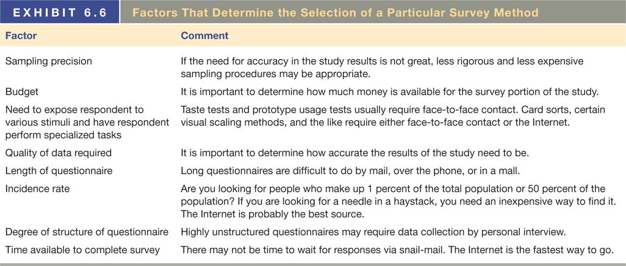

Quality of Data
Validity (degree to which measure provides an accurate reading of whatever the researcher is trying to measure) and Reliability (Consistency with which a measure produces the same results with the same or comparable populations)

Preferred questionnaire length in order: 6-10, tie 2-5 and 11-15, no ideal length, 16-25, less than 2, not sure, 26+

Structure
Extent to which a questionnaire follows a set sequence or order, has a predetermined wording of questions, and relies on closed-ended (MC) questions.

Strengths and Weaknesses of Survey Methods
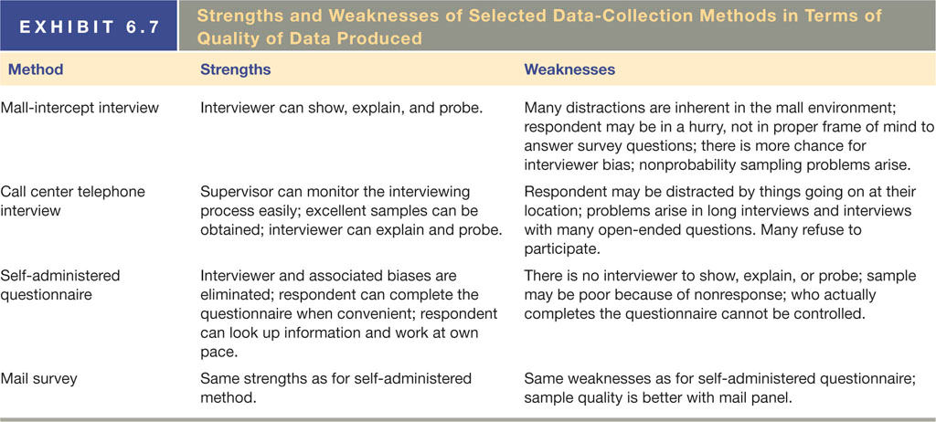

How Can We Increase Response Rates?
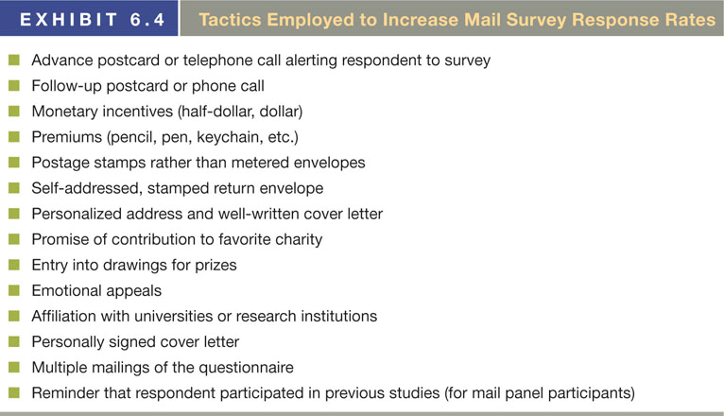

Accessing the Population: Two Critical Concepts
Incidence Rate
The percentage of people or households in the general population that fit the qualifications to be sampled.

Cooperation Rate
The percentage of qualified persons contacted who agree to complete the survey.

Marketing Research Interviewer
- The interviewer is a vital link in the marketing research process.
- Interviewers don’t get paid much, usually.
- Fringe benefits are minimal.
- Sometimes considered the weakest link in the process.
- Their skill and pay levels are being addressed by the Marketing Research Association.

CHAPTER 7: USING THE INTERNET FOR MARKETING RESEARCH

Online Secondary Data Resources
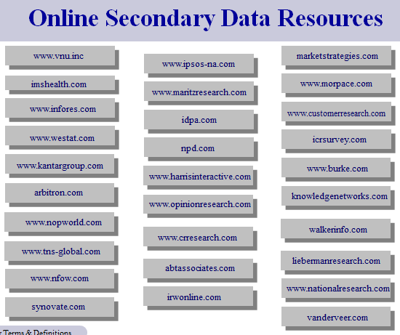
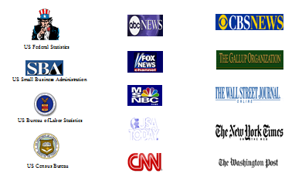

Newsgroup
An Internet site where people can read and post messages devoted to a specific topic. When finding a particular newsgroup:
- Connect to the internet in your usual way.
- Open your newsreader program.
- Search for the topic of interest.
- Select the newsgroup of interest.
- Begin scanning messages.

(There’s also blogs and periodical, newspaper, and book databases)

Evaluating Web Pages
- What does the URL tell you?
- Is it someone's personal page?
- Where might you go to corroborate Web findings?
- Look for links that might lead to source data.
- Are sources documented with footnotes?
- Why and when was the Web page created?
- Who created it – what are their motivations / qualifications?

Cookie: A text file placed on a user’s computer in order to identify the user when she or he revisits the Web site.

Online Focus Groups
Advantages
- Low costs & no geographic barriers
- It can be executed quickly, but can last longer (in a time-extended online group)
- It is good for generating fresh ideas / brainstorming
- It can enhance other data collection methods
- Participants provide valuable information for the next research phase
- Respondents may be more open than in traditional groups, shyness easier to overcome
- Can reach hard-to-reach populations easier
- Efficient client-moderator interaction

Disadvantages
- There is a loss of group, hands-on, dynamic
- The interpretation is subjective
- Some kinds of external stimuli eliminated - can’t handle a prototype, get tactile input
- Projective techniques are less effective
- Security - you don’t know who is at the computer
- Non-verbal inputs will be generally/often missed
- Attention to the topic - participants often drift
- Loss of direct client observational involvement
- Often misused as representative the population
- Exposure to external stimuli stymied
- Role and skill of moderator is not often fully realized

Best Practices in Online Focus Groups
- Evaluate your source of recruits carefully.
- Over-recruit
- Offer a good incentive to ensure a high participation rate.
- Require full participation for incentive payment.
- Take advantage of the ability to efficiently interview large numbers of respondents, but don’t overdo it.

2 types of online focus groups
- Real-Time Online: live, interactive
- Time-Extended Online: over a few days, on a forum

Web Community
Carefully selected group of consumers who agree to participate in an ongoing dialogue with a corporation

Controlling the Panel
- Online panel providers must have effective ongoing management of their panel to ensure a high level of quality.
- Ensuring a growing supply of engaged, active panel members is a constant goal of every panel provider.
- Incentives are often offered to maintain and grow the number of members.
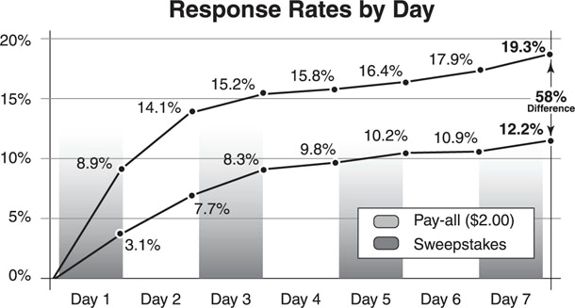

Managing Online Panels – Open & Closed
OPEN Online Panel Recruitment
- Anyone can self-select
- Be wary of ‘professional survey takers’

CLOSED Online Panel Recruitment
- Only pre-validated individuals invited

Respondent Cooperation
- Varies a lot but panel response rate is relatively good

Controlling the Panel
- Frequency controls, protect privacy, no selling
- Recruit continuously to keep it fresh and avoid attrition

Survey Research on the Internet
Advantages
- Rapid deployment, real-time reporting – surveys are potentially broadcasted to thousands and results are viewed instantly by corporate clients
- Reduced costs – low data collection costs; solicitations can grow in volume with little added cost
- Ready personalization – results in only pertinent questions being asked
- High response rates – take less time than other forms of surveys; surveys are taken at the respondents’ convenience
- Ability to contact the hard-to-reach – allows for busy professionals to take surveys on their own time
- Simplified and enhanced panel management – are built and maintained at less cost and time than traditional panels

Disadvantages
- Misrepresentation – Cannot be used in all countries
- Unrestricted Internet sample – Anyone who wishes to complete the questionnaire may do so; problems arise if the user can access the questionnaire over and over
- Too Broad – Difficulty may occur in gathering data for smaller/local companies; this data might not be possible to collect on the Internet
- Lack of “callback” – there is no way to clarify open-ended responses
- Programming errors – can cause problems when taking the questionnaire or processing data collected
- Lack of bandwidth – some respondents cannot download photos or complete the survey in a timely fashion
- Some Research Difficult - customer satisfaction, unaided awareness, sub-populations like elderly who are less likely to use the Internet (see p. 208)

Formatting a Survey for Success
- Radio Buttons
- Drop-Down Boxes
- Checkboxes
- Fill-in Boxes
- Fancier vs. less Fancy

Methods of Conducting Online Surveys
- Web Survey Software
- Use good strategies to gain survey completions
- Survey design and web hosting sites

Commercial Online Panels
Group of individuals who agreed to receive invitations to do online surveys from a particular panel company such as eRewards or SSI. The panel company charges organizations doing surveys for access to the panel. Charges are usually so much per survey depending on survey length and the type of people being sought for the survey. The panel company controls all access to the members of its panel

Panel Management Issues
- Traditional Panel Recruitment
- Open Online Panel Recruitment
- Closed Online Panel Recruitment
- Respondent Cooperation
- Controlling the Panel

Open Online Panel Recruitment
Any person with internet access can self-select to be in a research panel (benefit of building a panel quickly with people who are internet-savvy and responsive to online advertising. Drawback in the lack of control over who is recruited – see professional survey takers)

Closed Online Panel Recruitment
Inviting only prevalidated individuals or those with shared known characteristics to enroll in a research panel

Mobile Internet Research: The Next Step
Approximately 76% of all consumers in the U.S. and Western Europe have Internet access on their mobile devices, and about one-third of those use it. It is a new channel for marketing research, but due to its limitations, traditional online research will be the channel of choice for most survey research.
Interactive Marketing Research Organization
A new organization dedicated to the development, dissemination, and implementation of interactive marketing research concepts, practice, and information. IMRO’s initial efforts focused on spam and the misuse of personal data.

CHAPTER 10: THE IMPORTANCE OF PROPER MESUREMENT

Measurement Process
Measurement
The process of assigning numbers or labels to persons, objects, or events in accordance with specific rules for representing quantities or qualities or attributes.

Rule
The guide, method, or command that tells a researcher what to do.

Constructs
Specific types of concepts that exist at higher levels of abstraction.
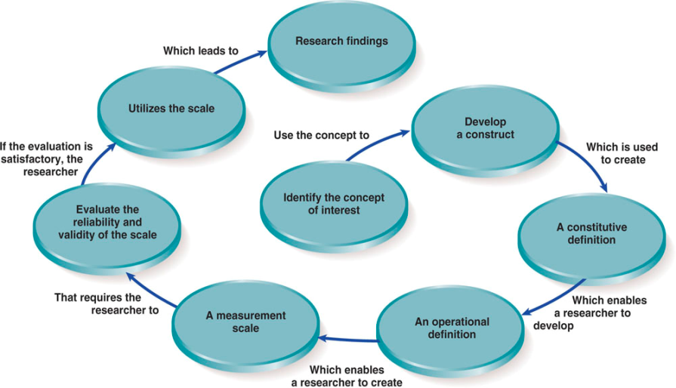
Concepts (Step 1)
- Abstract ideas

Constructs (Step 2)
- Theoretical, abstract, inferred – not directly observable
- Examples: emotional intelligence, deal proneness

Constitutive or theoretical definition (Step 3)
- Defines what the construct is and what it is not, the ‘domain’ of the construct
- Ex: Deal proneness is being responsive to financial incentives when purchasing products

Operational Definition (Step 4)
- Specifies operations necessary to measure a concept
- Deal proneness is being responsive to price cuts, coupons and larger product sizes for the same money, but not to gifts (premiums)

Levels of Measurement
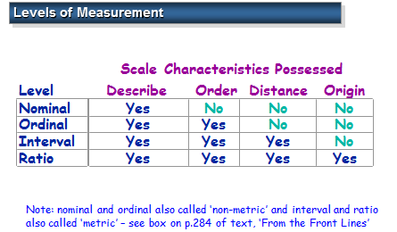

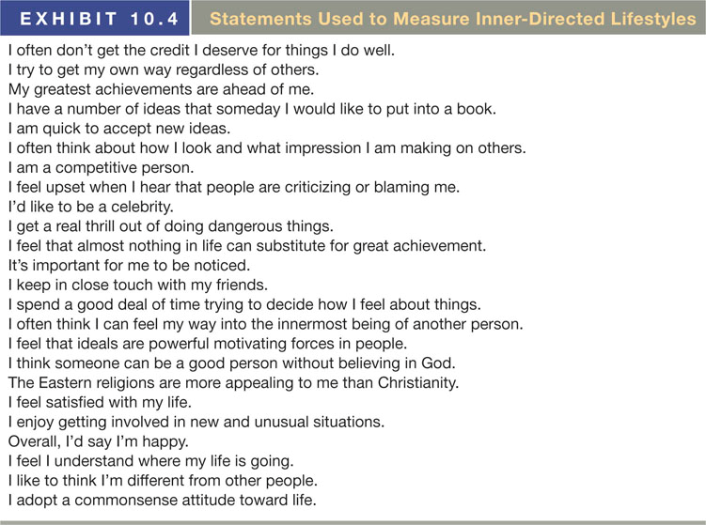

Nominal
Scales that partition data into mutually exclusive and collectively exhaustive categories.

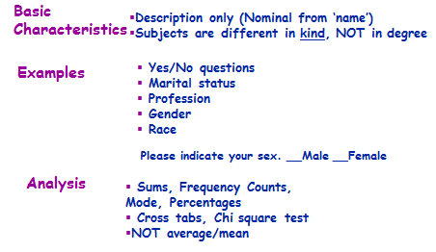

Classification Type Data:
- Yes or no questions
- Nouns in general
- Gender
- Race / Ethnicity
- Occupation
- Text open-ended questions

Analysis Approach:
- Cross tabulations / Percentages
- Sums and frequency counts
- One can’t tell the relative value of responses

Ordinal
Scales that maintain the labeling characteristics of nominal scales and have the ability to order data.
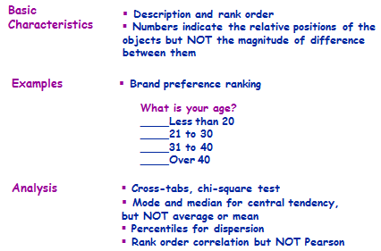
Comparison Type Data
- One a “1 to 10” scale
- Age, income, etc. as ranges
- Red, blue, green
    - if each rated from 1 to X

Analysis Approach
- Standard deviation, variance, kurtosis
- Descriptive statistics - mean, median, mode
- Sums and ranged frequency counts
- Correlation
- Can tell the relative value of responses and can tell the distance between responses

Interval
Scales that have the characteristics of ordinal scales, plus equal intervals between points to show relative amounts; they may include an arbitrary zero point.
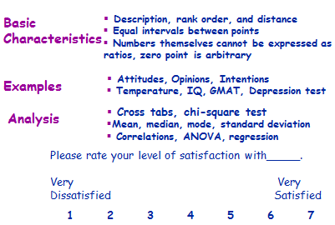
Comparison Type Data
- One a “1 to 10” scale
- Age, income, etc. as ranges
- Red, blue, green
  - if each rated from 1 to X

Analysis Approach:
- Standard deviation, variance, kurtosis
- Descriptive statistics - mean, median, mode
- Sums and ranged frequency counts
- Correlation
- Can tell the relative value of responses and can tell the distance between responses

Ratio
Scales that have the characteristics of interval scales, plus a meaningful zero point so that magnitudes can be compared arithmetically.
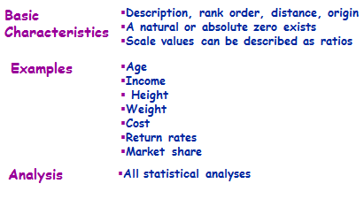

Flat Numeric Type Data
- Age = 50 (not an age range)
- Income = $25,000 (not an income range)
- Number of children: ________

Analysis Approach:
- Standard deviation, variance, kurtosis
- Descriptive statistics - mean, median, mode
- Sums and ranged frequency counts
- Pearson correlation, regression
- Can tell the relative value of responses and can tell the distance between responses and how they relate to zero

Vocabulary
Attribute
A single characteristic or fundamental feature of an object, person, situation, or issue

Item
Synonymous with ‘question’ or ‘variable’, for example:
High Quality 1 2 3 4 5 Low Quality

Measure
A single item (variable, question) OR a set of items (variables, questions) measuring a construct – see ‘role ambiguity’, Ex. 10.2

Scale (Step 5)
A multi-item (or ‘index’ or ‘composite’ or ‘sum-score’) measure created by adding up answers to several items

The Truth about What Respondents Say
- Sometimes respondents don’t tell the truth; sometimes they are willing to reveal it.
- Sometimes consumers claim more than they know; sometimes they are just confused.
- Sometimes consumers don’t know why they buy the brands they buy.
- Consumers not only have opinions, they have passions.
- This list is a fine example of why it is difficult to ask respondents questions and get the truth. Also, this points out why psychology and sociology are important areas of study for marketing research.

Reliability & Validity (Step 6)
Reliability
Degree to which measures are free from random error and, therefore, provide consistent data. The extent to which the survey responses are internally consistent.

Validity
Degree to which what the researcher was trying to measure was actually measured.

Measurement = Accuracy + Errors
A researcher must determine whether any of the remaining seven sources of measurement differences are producing random or systematic error
- A true difference in the characteristic being measured (two different people say different things)
- Differences due to stable characteristics of individual respondents (high maintenance, aggressive, high standards, etc.)
- Differences due to short-term personal factors (mood swings, fatigue, etc.)
- Caused by situational factors (Distractions, etc.)
- Resulting from variations in administering the survey
- Due to the sample of items included in the questionnaire (design)

Sensitivity
A measure’s ability to accurately measure variability in stimuli or responses
- Multi-item scales are more sensitive: a single 7-point item can put people into 7 categories, but a 3 item scale can put people into 18 categories (scores from 3 to 21)

Testing Reliability
Test and Retest
The ability of the same instrument to produce consistent results when used a second time under conditions as similar as possible to the original conditions.

Stability
Lack of change in results from test to test.

Equivalent Form
Ability of two very similar forms of an instrument to produce closely correlated results. (Same subjects)

Internal Consistency
- The ability of an instrument to produce similar results when used on different samples during the same time period to measure a phenomenon.
- Assesses equivalence by assessing the homogeneity of a set of items, or how well they ‘hang together’
- Used to be checked by the split-half technique, splitting the items into 2 halves, looking at the correlation
- Now done with Cronbach’s alpha (when all scale items have equal intervals) or the KR-20 method

Spilt Half Technique
A method of assessing the reliability of a scale by dividing the total set of measurement items in half and correlating the results.

Testing Validity
Face
The degree to which a measurement seems to measure what it is supposed to measure.
- Weakest form of validity
- Do questions/items in scale make sense, seem logical? Are they clear?
- Measure of residency status: Are you a Canadian citizen?

Content
The representativeness, or sampling adequacy, of the content of the
measurement instrument.
- Degree to which the measure or scale covers the entire domain of the construct, and nothing else
- ‘Store ambience’: scale includes items asking about return policies and store hours, but not about décor

Criterion Related
The degree to which a measurement instrument can predict a variable that is designated a criterion.

Construct
The degree to which a measurement instrument represents and logically connects, via the underlying theory, the observed phenomenon to the construct.

Predictive
The degree to which a future level of a criterion can be forecast by a current measurement scale.
Predict criterion variable at a different time.
A purchase intent scale should be a good predictor of future purchases of new products

Concurrent
The degree to which another variable, measured at the same point in time as the variable of interest, can be predicted by the measurement instrument.
An ECG should be able to tell if there are blocked arteries in the heart

The measure should behave according to the theory behind the prediction; 2 Kinds:
Convergent
The degree of correlation among different measures that purport to measure the same construct.(The measure (e.g., ‘Social Ad Skepticism’) is moderately correlated with an older measure of negative attitude to advertising in general – as it should be)

Discriminant
The measure of the lack of association among constructs that are supposed to be different. ( The measure (e.g., ‘Social Ad Skepticism’) is not highly correlated with a measure of general cynicism)

*Reliability is an essential but not a sufficient condition for a measure to be valid
- Does repeat purchase constitute brand loyalty?
- Is a presidential debate a good way to select a President?
- Does the ‘net promoter’ score measure consumer sentiment better than customer satisfaction surveys (Case 10.2, GE)?

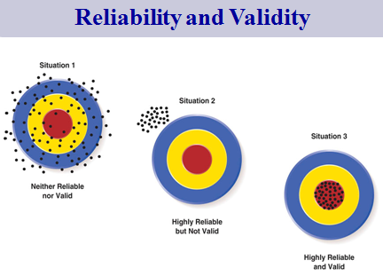
Putting Measurement to Work
- Any measurement that does not hold an individual responsible is not an effective metric.
- No one should ever be held responsible for a measurement that they cannot influence.
- The importance of a measurement is determined by how high in an organization it is consistently reviewed.
- Every measurement must have clear and rational goals.
- If a “carrot and stick” is not clear, measurement will fall into disuse.

CHAPTER 11: ATTITUDE MEASUREMENT

Attitude & Predicting Behaviour
Attitude
Enduring organization of motivational, emotional, perceptual, and cognitive processes with respect to some aspect of a person’s environment
Factors to determine if research findings will predict behavior:
- Involvement of the consumer
- Attitude measurement
- Effects of other people
- Situational factors
- Effects of other brands
- Attitude strength

- Attitudes are ‘hypothetical constructs’
  - Not directly observable but measurable through indirect indicators - verbal expression or behaviour
  - E.g., price sensitivity, propensity to complain

- Attitudes can be positive or negative: a continuum

- Attitude-to-behaviour consistency often low
  - Affected by many factors: consumer involvement, measurement problems, effect of other people, etc.

Attitude Links
- The more favorable the attitude, the higher the incidence of product usage.
- The less favorable toward a product, the more likely they are to stop using it.
- The attitudes of the “never tried” people tend to be distributed around the mean of a normal distribution.
- Attitudes vary depending on what they are based on (use of the product or just promotion about a product).
Sometimes consumers buy/use products even if the attitude is negative toward those products. For example, medicines for illnesses, text books for college students, and other “unsought” goods/services.

Importance of Levels of Measurement
- Determines what you can say about subjects
  - E.g., whether you can use means and s.d.’s
  - Can’t do most statistical tests unless data is metric

- Normally, use highest level – metric (interval and ratio)
  - Can collapse from ratio or interval to ordinal: e.g., can collapse age in years into young/middle-aged/old
  - But can’t go from ordinal to interval or ratio

- Nominal and ordinal have some advantages
  - Easier to construct, easier for subjects to answer
  - May be best option when looking for choice among alternatives

What are Scales For?
Scaling
Procedures for assigning numbers (or other symbols) to properties of an object in order to impart some numerical characteristics to the properties in question.

Scaling Approaches
- Unidimensional: Measures only one attribute of a concept, respondent, or object.
- Multidimensional: Measures several dimensions of a concept, respondent, or object.

Types of Measurement Scales
Non-comparative Scale
Scales in which judgment is made without reference to another object, concept, or person.

Comparative Scale
Scales in which one object, concept, or person is compared with another on
a scale.

Graphic Rating Scales
Measurement scales that include a graphic continuum, anchored by two extremes
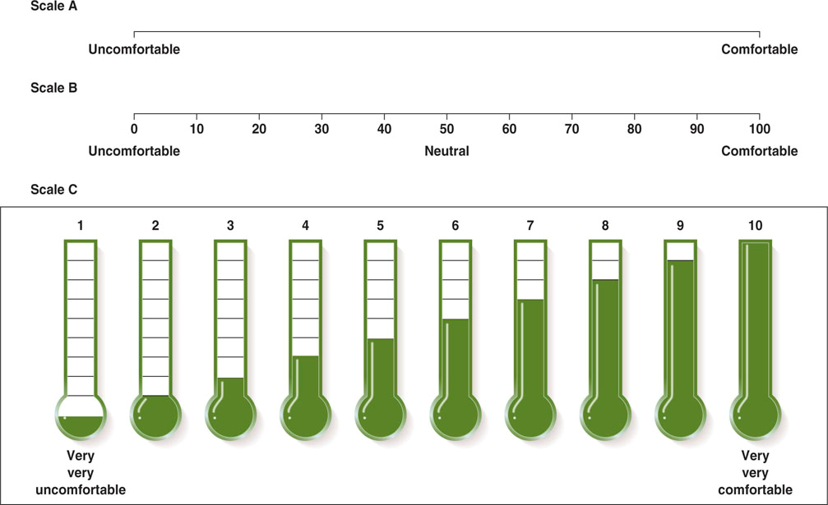
Pros
- Can be constructed easily
- Simple to use
- They enable a researcher to discern fine distinctions, assuming that the rater has adequate discriminatory abilities.

Cons
- Overly extreme anchors tend to force respondents towards the middle of the scale.
- Some research has suggested that such scales are not as reliable is itemized rating scales

*Numerical data obtained from the scales are typically treated as interval data
*Often used when interviewing children (e.g. three smiley faces)

Itemized Rating Scales
The respondent selects an answer from a limited number of ordered categories.
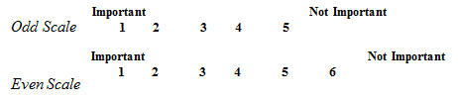
Pros
- Easy to construct and administer
- The definitive categories found in itemized rating scales usually produce more reliable ratings

Cons
- Do not allow for the fine distinctions that can be achieved in a graphic rating scale

Select Itemized Rating Scales (What characteristics are you measuring?)
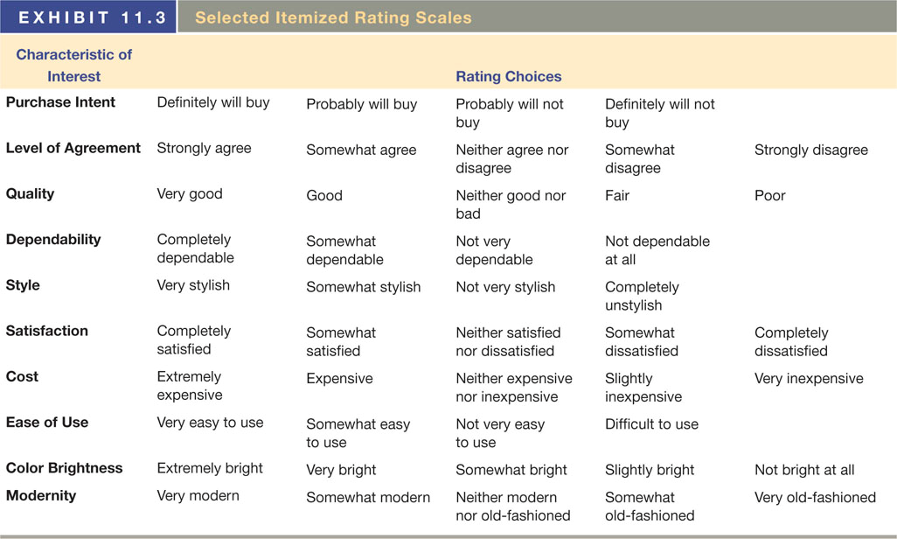
One-Stage vs Two-Stage Format
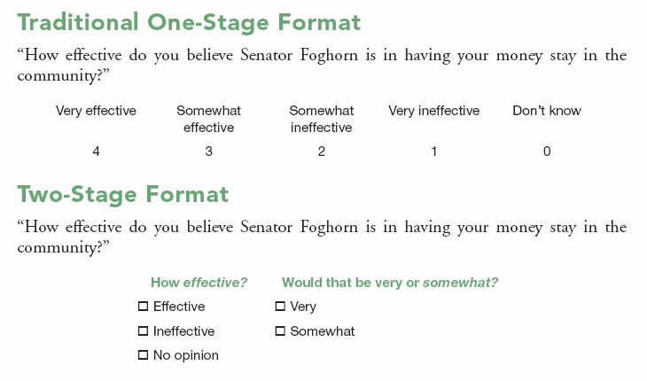

Rank Order Scale
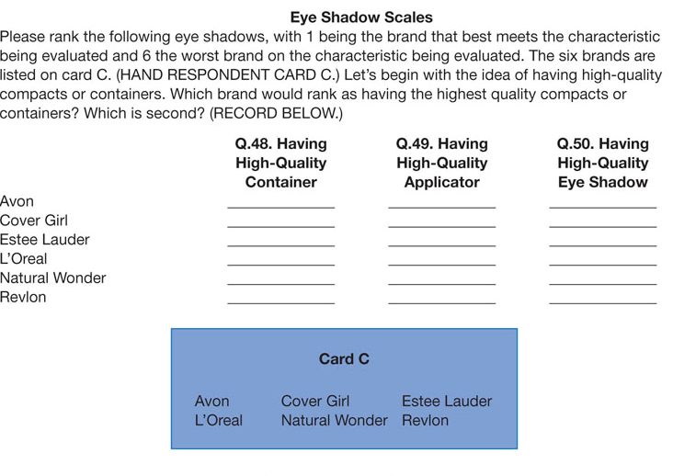

Pros
- Easy to use
- Gives ordinal measurements of the items evaluated.
- Instructions are easy to understand and the process typically moves at a steady pace.
- Some researchers claim that rank-order scales force respondents to evaluate concepts in a realistic manner

Cons
- If all of the alternatives in a respondent’s choice set are not included, the results could be misleading. The concept being ranked may be completely outside a person’s choice set, thus producing meaningless data.
- The scale gives only ordinal data (we don’t know how far apart they are, etc.).
- The researcher does not know why the person ranked the way they did

Paired Comparison
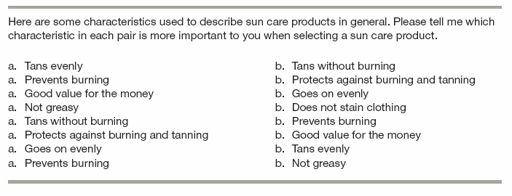

Pros
- Easier for people to select one item from a set of two than to rank a large set of data.
- The problem of order bias is overcome (no pattern in the ordering).

Cons
- Because all possible pairs are evaluated, the number of paired comparisons increases geometrically as the number of objects to be evaluated increases arithmetically. Thus, the number if objects to be evaluated should remain fairly small to prevent interviewee fatigue

Customer Sum Scale
Measurement scales that ask the respondent to divide a given number of points, typically 100, among two or more attributes, based on their importance to him or her.

Pros
- Shows ranking assigned to objects as well as relative magnitude of each alternative. If the respondent perceives two characteristics to have equal value, he or she can so indicate.

Cons
- Respondent may have difficulty allocating the points to total 100 if there are a lot of characteristics or items (Most researchers feel like 10 is the limit)

Semantic Differential Scale
Measurement scales that examine the strengths and weaknesses of a concept by having the respondent rank it between the dichotomous pairs of words or phrases that could be used to describe it; the means of the responses are then plotted as a profile or image.

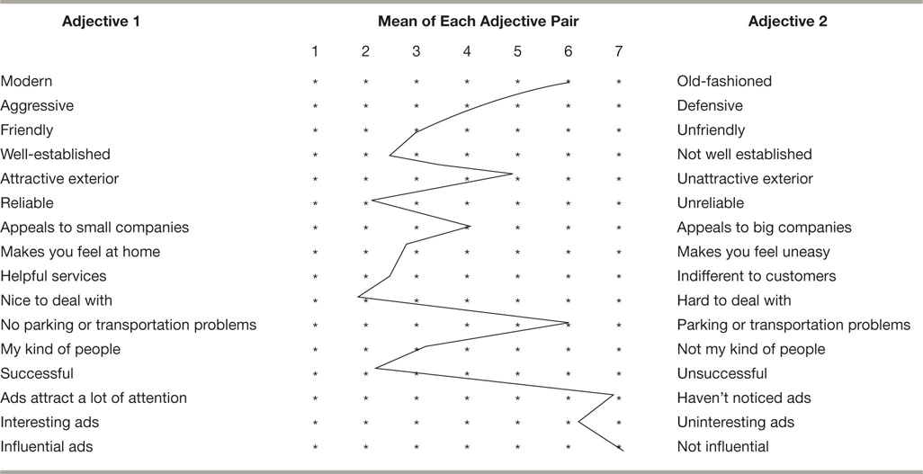

Pros
- Quick and efficient means of examining the strengths and weaknesses of a product or company image versus those of the competition.
- More importantly, however, the semantic differential has been shown to be sufficiently reliable and valid for decision making and prediction in marketing and the behavioral sciences.
- It has proved to be statistically robust (generalizable from one group of subjects to another) when applied to corporate image research. This makes possible the measurement and comparison of images held by interviewees with diverse backgrounds
Cons
- Lack of standardization. It is a highly generalized technique that must be adapted for each research problem.
- The number of divisions on the semantic differential scale also presents a problem. If too few divisions are used, the scale is crude and lacks meaning; if too many are used, the scale goes beyond the ability of most people to discriminate. (Researchers found 7 points the best).
- Another disadvantage is the halo effect. The rating of a specific image component may be dominated by the interviewees overall impression of the concept being rated. Bias may be significant if the image is hazy in the respondent’s minds. To partially counteract the halo effect, the researcher should randomly reverse scale adjectives so that all the “good” ones are not placed on one side and the negatives ones on the other to facilitate analysis.

Staple Scale
Measurement scales that require the respondent to rate, on a scale ranging from +5 to -5, how closely and in what direction a descriptor adjective fits a given concept.
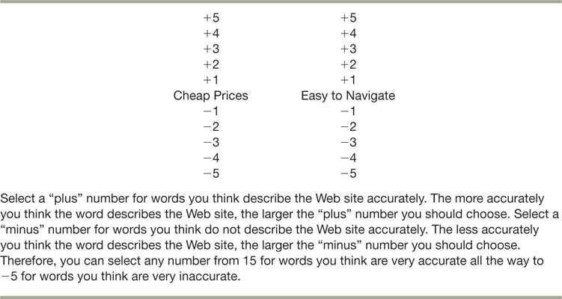

Pros
- Enable researcher to avoid the arduous task of creating bipolar adjective pairs.
- The scale may also permit finer discrimination in measuring attitudes.

Cons
- A drawback is that descriptor adjectives can be phrased in a positive, neutral, or negative vain, and the choice of phrasing has been shown to affect the scale results and the person’s ability to respond.

Likert Scale
Measurement scales in which the respondent specifies a level of agreement or disagreement with statements expressing either a favourable or unfavourable attitude toward the concept under study. (Strongly disagree to strongly agree)

Pros
- Quick, easy to construct, can be administered by telephone or the internet.
Purchase Intent Scales
Scales used to measure a respondent’s intention to buy or not buy a product

Pros
- Good predictor of consumer choice and frequently purchased and durable consumer products.
- Very easy to construct, and consumers are simply asked to make a subjective judgement of their likelihood of buying a new product

Cons
- Sometimes people forget to take a look at market share (lump definitely will buy with probably will buy)

How to Select a Scale
1. The Nature of the Construct Being Measured
2. Type of Scale and Number of Scale Categories
  - Speed/cost issue: rank order easier, semantic differential harder – several types used in one survey
  - Survey mode: develop for phone or web (fewer scale categories)
  - Respondents prefer ordinal or nominal
  - Availability of validated scales
3. Balanced vs. Non-balanced (Depends on existing attitude)
Balanced:
- Scales with equal numbers of positive & negative categories.
Non-balanced:
- Scales weighted towards one end or the other of the scale.
4. Forced vs. Non-forced
Having an odd vs. even number of response choices. (or DK option)

Attitude Measures and Management Decision Making
Determinant Attitudes
Those customer attitudes most closely related to preferences or to actual purchase decisions.

Types of Questioning
Direct
Indirect
Observation

CHAPTER 12: QUESTIONNAIRE DESIGN

The Role of the Questionnaire
Set of questions designed to generate the data necessary to accomplish the objectives of the research project; also called an interview schedule or survey instrument.
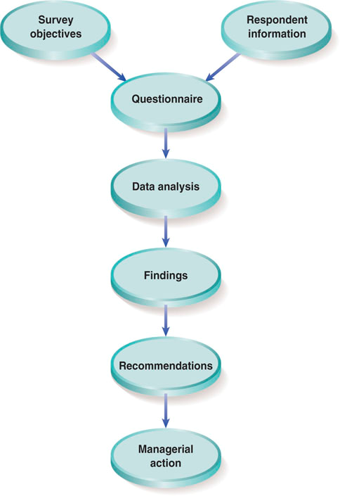

Criteria for a Good Questionnaire
- Does it provide decision-making information?
- Does it consider the respondent?
- Does it meet editing and coding requirements?

Editing
Going through each question to ensure that skip patterns were followed and the required questions were filled out.

Skip Patterns
Sequence in which questions are asked, based on a respondent’s answer.

Coding
The process of grouping and assigning numeric codes to the various responses to a question

The Questionnaire Design Process
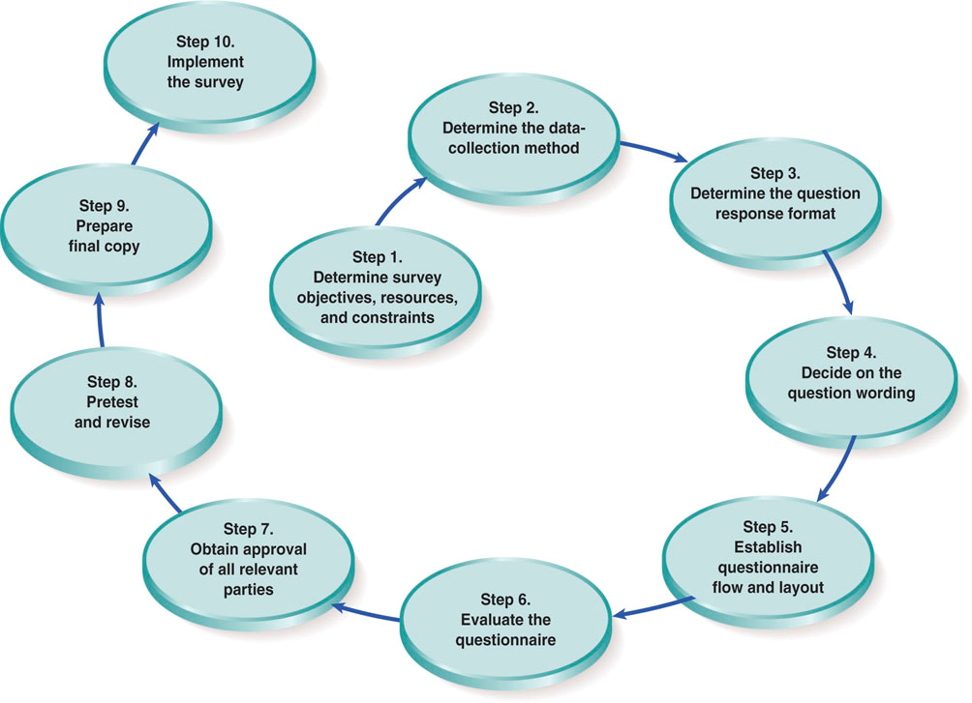

Key Questionnaire Issues
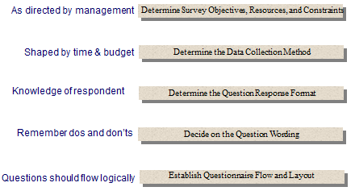

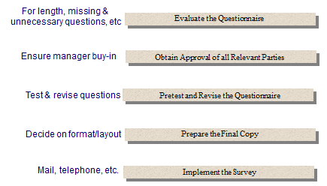

1. Survey Objectives, Resources, and Constraints
Objectives
Outline of the decision-making information required

Resources
Budget in terms of money, time, and personnel

Constraints
The budget, also and other requirements

2. Data Collection Method
The data collection method will have a major impact on the questionnaire design and the project’s time and money budget.

Examples: In-person - such as mall intercept, telephone, mail or other self-administered, Internet
An in-person interview in a mall with have constraints (such as time limitation) not encountered with an internet questionnaire.
A self-administered questionnaire must be explicit and is usually rather short; because no interviewer will be present, respondents will not have the opportunity to clarify a question.
A telephone interview may require a rich verbal description of a concept to make certain the respondent understands the idea being discussed.
In contrast, an internet survey can show the respondent a picture or video or demonstrate a concept.

3. The Response Format
Open-Ended
Questions to which the respondent replies in his or her own words

Pros
- Enable respondents to give their general reactions to questions.
- Provides the researcher with a rich array of information.
- The respondent’s answers are based on his or her personal frame of reference and described in real-world terminology rather than laboratory or marketing jargon. This is helpful in designing promotion themes and campaigns; it enables copywriters to use the consumer’s language.
- This rich array of information can also be captured in computer-assisted interviews and internet surveys. They may also suggest additional alternative not listen in a close-ended question format and show weighted average of preferences

Cons
- Editing and coding can consume great amounts of time and money if done manually.
- If too many categories are used, data patterns ad response frequencies may be difficult to interpret.
- Even if a proper number of categories are used, editors may still have to interpret what the interviewer has recorded and force the data into a category.
- If the categories are too broad, the data may be too general and important meaning may be lost.
- Biased towards articulate respondents.
- Not good for self-administered questionnaires, because there is no one to probe

Probing: the interviewer encourages the respondent to elaborate or continue the discussion. Three kinds:
- Proactive: pre-emptively known that it will be asked. (e.g. when reviewing your past ans, etc.)
- Reactive: requests for elaboration, word association, clarification, classification or hand movements
- Spontaneous: natural probe, question follows well what the respondent said

Closed-Ended
Questions requiring respondents to choose from a list of answers
- Dichotomous: Choice is between two answers.
- Multiple Choice: Choice is among three or more options.
- Scaled Responses: Designed to capture the intensity of respondent’s feelings.

Pros
- Avoidance of many of the problems associated with open-ended questions.
- Reading response alternatives may jog a person’s memory and generate a more realistic response.
- Interviewer bias is eliminated
- No bias towards the articulate
- Coding and data entry can be done automatically with questionnaire software programs.

Dichotomous
Pros: easy to administer and tabulate and usually evoke a rapid response
Cons: Prone to large amounts of measurement error. Because alternatives are polarized, the wide range of possible choices between the poles is omitted. Thus, the appropriate wording is critical to obtaining accurate responses. Also, responses fail to communicate any intensity of feeling on the part of the respondent

Multiple Choice
Pros: replies don’t have to be coded
Cons: amount of information provided is limited, takes time to generate list of possible responses, the researcher must settle on a range of possible answers (can’t be too long). Position bias is present.

Scaled
Pros: permits measurement of the intensity of respondent’s answers and can be used directly as codes. Marketing researcher can use much more pwoerful statistical tools with some scaled-response questions
Cons: Some things, like timeliness from 1-10. What does a 6 mean? Use yes or no for general satisfaction of timeliness instead

4. Question Wording
- Make Sure the Wording is Clear
- Avoid Biasing the Respondent (Leading questions that give away the research goal or sponsor identity)
  - Leading question
    - Implies answer, used by organizations with an agenda
    - Provides reasons for only one alternative – “Should we raise taxes to get more social housing, or not?”
  - Loaded question
    - Suggests socially desirable answer, emotionally charged
    - Uses “fair profits”, “radical”, “luxury items”, “crisis”
- Consider the Respondent’s Ability to Answer the Questions (Factors affecting this ability include lack of required information, forgetfulness, or incomplete recall ability)
- Consider the Respondent’s Willingness to Answer the Question (Embarrassing, sensitive, or threatening questions or questions divergent from respondent’s self-image may cause them to refuse to answer)
- Use everyday vocabulary suited to the respondent
  - Avoid university-level vocabulary: ‘marginal tax rate’
- Avoid double-barrelled questions
  - ‘Have you often, sometimes, or never felt bad because you were unfaithful to your wife?’ [Harris - 85% said never]
- Provide Frame of Reference in Time and Space, Define Terms
  - ‘Store brand’, ‘semi-permanent’
  - “Usually”, “often”, “occasionally”
  - “Dinner”, “government”
  - Use of examples can affect responses – spinach vs. lettuce both leafy vegetables
  - “What is your income? How long have you lived here?”
  - Split-ballot technique
    - Using two alternative phrasings of the same questions for respective halves of a sample

Question Do’s
- Be as brief as is appropriate for your audience.
- Use clarity in wording.
- Be grammatically simple.
- Be focused on a single issue or topic.
- Use the respondent’s core vocabulary.
- Use plenty of white space between the questions.
- Number the questions.
- Questions should be interpreted equally by respondents.

Question Don’ts
- Biasing the respondent
- Using loaded or leading phrasing
- Using words overstating the condition
- Assuming criteria that are not obvious
- Using a specific example for a general case
- Being beyond the respondent's ability to answer
- Requiring the respondent to guess at a generalization
- Asking for specifics when only generalities will be remembered

5. Questionnaire Flow and Layout
Screeners - Qualifying Questions
- Ask general questions first - establish respondent “buy-in”
- Identify appropriate respondents
- Basic questions that lay the groundwork for upcoming questions
- Example: “Have you shopped at the Gap in the past month?”

Warm-ups - First Few Questions
- Gets the respondent thinking about the topic at hand
- Establishes parameters about the respondents’ attitudes, behavior, etc.
- Example: “How often do you go shopping?”

Transitions - First Third of the Questions
- Questions that set the tone for the more difficult questions to come
- Example: “Now I’m going to ask you some more difficult questions”

Complicated-Second Third of the Questions
- Use of rating scales for attributes, attitudes, beliefs, opinion, etc.
- Tackling controversial issues
- Example: “How would you rate your boss’ performance?” (scale 1 to 10)

Classification – Last Third of the Questions
- Personal & demographic type questions – more invasive
- Example: “What is your religion?”

Tips
- Begin with a question that gets the respondent’s interest
- Ask general questions first
- Ask questions that require “Work” in the middle
- Insert “prompters” (short encouraging statements to rebuild respondent interest) at strategic points
- Position sensitive, threatening, and demographic questions at the end
- Put instructions in capital letters
- Use a proper introduction and closing
- Avoid abbreviations, slang, or uncommon words that your audience might not understand.
- Be specific. Vague questions generate vague answers.
- On the other hand, don’t overdo it.
- Make sure your questions are easy to answer.
- Don’t assume too much
- Watch out for double questions and double negatives.
- Check for bias.

6. Evaluate the Questionnaire
- Is the question necessary?
- Is the questionnaire too long?(Tradeoff with response rate and cost – 70% of cost is finding a qualified respondent)
- Will the questions provide the information needed to accomplish the research objectives?
Also:
- Separate the IV and the DV into 2 questions (remember for project)

Last Four Steps
7. Obtain Approval of All Relevant Parties
8. Pretest and Revise
- Pilot run of the questionnaire (n=15 to 25) with reasonably typical respondents. Pre-tests answer questions about questionnaire:
  - Does the questionnaire flow naturally?
  - Are the questions clear and easy to understand?
  - Can respondents answer the questions easily? Is the skip pattern OK?
  - Check for respondent interest: if too long/dull, they will quit halfway and you won’t get key answers
  - For international research: do a back-translation
9. Prepare Final Questionnaire Copy
10. Implement the Survey
- Field Management Companies: Firms that provide such support services as questionnaire formatting, screener writing, and coordination of data collection.

The Internet Impact
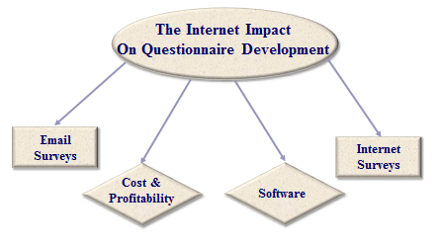

Pros
- The questionnaire’s appearance consistency is easier to achieve.
- The questionnaire can be checked for typos easily.
- The survey can be created quickly.
- Skip patterns can be efficiently established.
- The survey can be distributed quickly for expert review & input.

Cons
- Over reliance on electronic survey construction can lead to the researcher’s getting sloppy as he/she might think the software will do the work and correct any errors.
- The researcher might feel less connected to the process.
- Multiple versions of the survey might get circulated / distributed.

Global Research Issues
- Cultural differences - gender, body language, behavioral
- Traditions, religion, ways of conducting business, beliefs
- Word usage differences - phrases, expressions, idioms
- Acceptable & unacceptable types of questions
- Receptiveness level of audience for given question types
- The best way to approach the population
- Which issues are sensitive & how to approach them
- Whether various dialects are present
- What issues are most important to your audience

Roadblocks that Adds to Research Costs
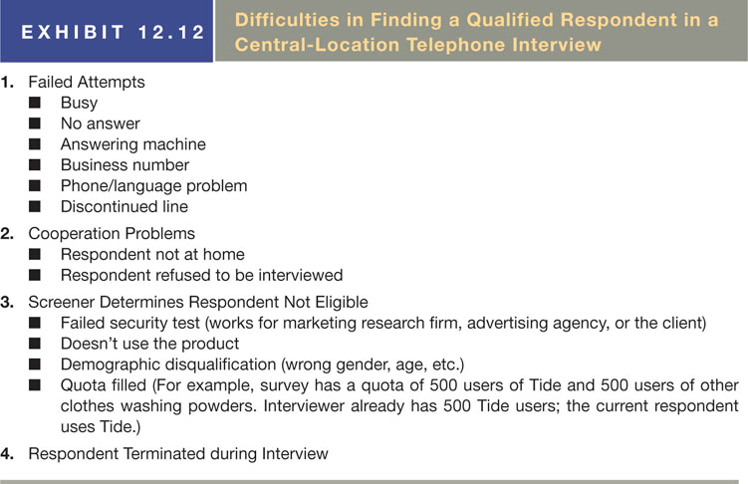

Questionnaire costs and profitability
Factors affecting costs and profits include over-estimating, overbidding, incidence rate, roadblocks to completed interviews, and premature interview terminations.

