1.0 Problem Identification and Statement:

Create a program that offers two games; playing dice or guessing a number between 1 and 100.

2.0 Gathering of Information and Input and Output Description:

User enters a number between 2 and 12.
Computer generates a random number between 2 and 12 and tells you if you guessed correctly

Figure 2: The input/output process for “Playing Dice".

Computer generates a random number between 1 and 100 and tells you if you guessed too high, too low or correctly.

User enters a number between 2 and 12.

Figure 2: The input/output process for “Guess a Number”.

3.0 Test Cases and Algorithm Design

3.1 Algorithm:
- Assign “Playing Dice” and “Guess a Number” as functions
- Ask user to select a game; either 1 for “Playing Dice” or 2 for “Guess a Number”. Any other number entered will cause the program to exit
- If user selects “Playing Dice”, prompt the user to guess a number between 1 and 12
- If the user enters a number outside the range 2 – 12, inform the user that their choice is invalid and ask them to guess again
- Once a valid number is guessed, inform the user if their guess is correct or not.
- Return to the main prompt
- If the user chooses “Guess a Number” prompt the user to guess a number between 1 and 100
- If the user enters a number outside the range 1 – 100, inform the user that their choice is invalid and ask them to guess again
- Once a valid number is guessed, inform the user if their guess is correct, too high or too low
- Once the user has guessed the correct number, inform them how many tries is took to get the correct answer and return to the main prompt

4.0 Implementation
#include <stdio.h>
#include <stdlib.h>
#define TRUE 1

void game_one();
void game_two();

int main()
{
int f = 0;

//prompt user for game selection until user enters a number other than 1 or 2
do
{
printf("Please enter 1 to select 'Playing Dice' or 2 to select 'Guess a Number'\n");
scanf("%d",&f);
if (f == 1)
{
game_one();
}
else if (f == 2)
{
game_two();
}
else
{
break;
}
}
while (TRUE);

printf("Thanks for playing, have a good day.\n");
return 0;
}

void game_one()
{
int answer, dice1, dice2, result;
printf("Playing Dice:\n");
printf("Please choose and enter a number between 2 and 12.\n");
scanf("%d",&answer);
// validate user input
while (( answer < 2) || (answer > 12))
{
printf("Invalid entry, please choose and enter a number between 2 and 12.\n");
scanf("%d",&answer);
}
// initialize random seed
srand (time(NULL));
//get random number for dice1, dice2, and the summation of dice1 and dice2
dice1 = 1 + rand() % 6;
dice2 = 1 + rand() % 6;
result = dice1 + dice2;
//check is user has won
if (answer == result)
{
printf("Congratulations, you have won!\n");
}
else
{
printf("Sorry you guessed %d, result was %d.\n", answer, result);
}
}

void game_two()
{
int answer, guess;
printf("Playing Guess a Number:\n");
printf("Please guess a number between 1 and 100.\n");
scanf("%d", &guess);
//validate user input
while (( guess < 1) || (guess > 100))
{
printf("Invalid entry, please choose and enter a number between 0 and 100.\n");
scanf("%d",&guess);
}
//initialize random seed
srand (time(NULL));
//get random number between 0 and 100
answer = rand() % 100;
//initialize counter variable
int i = 1;
//loop until user guesses correctly
while (answer != guess)
{
if (guess < answer)
{
printf("Your guess is too low, please guess again.\n");
scanf("%d", &guess);
}
else
{
printf("Your guess is too high, please guess again.\n");
scanf("%d", &guess);
}
i++;
}
printf("Congratulations, you've won! It took you %d tries.\n", i);
}

5.0 Tests and Verification
5.1 Main Prompt

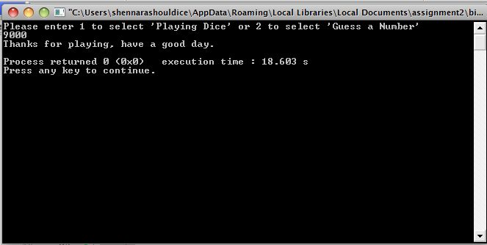

5.2 Playing Dice

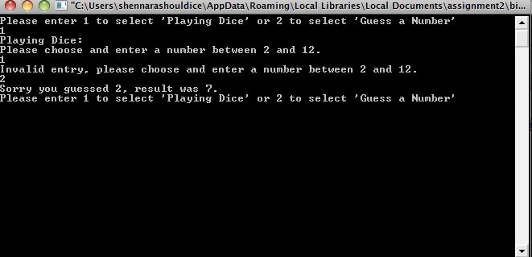
5.3 Guess a Number


