ADM2336 Midterm 2 review
Chapter 5: Stress
In Canada, 62% of main source of stress is work.
Stress: The psychological response to demands when there is something at stake for the individual, and when coping with these demands would tax or exceed the individual’s capacity or resources.
Feeling positive, upbeat, ability to think clearly, ability to work effectively, ability to regulate behaviour= resource (intangible)
Stressors: Demands that cause the stress response. STRESSORSTRESSSTRAIN
Strains: Negative consequences of the stress response- visible effects of stress
Why some employees more are “stressed” than others
Transactional theory of stress: A theory that explains how stressful demands are perceived and appraised, as well as how people respond to the perceptions of appraisals.
Primary appraisal: Evaluation of whether a demand is stressful and, if it is, the implications of the stressor in terms of personal goals and well-being. Does this demand cause me to feel stressed?
Secondary appraisal: How do I cope with this stressor?
Benign job demands: Job demands that are not appraised as being stressful.
Types of stressors
 | Hindrance | Challenge
Work | - Role conflict  - Role ambiguity  - Role overload  - Daily hassles  - Sexual harrasment | - Time pressure  - Work complexity  - Work responsibility
Non-work | - Work-family conflict  - Negative life events  - Financial uncertainty | - Family time demands  - Personal development  - Positive life events

Whether approach focuses more Whether approach manages the situation or one’s emotions
on behaviour or cognition

Hindrance stressors: Stressors that tend to be appraised as thwarting progress toward growth, achievement, and achievement. Stressful demands that are perceived as hindering progress toward personal accomplishments or goal attainment. These tend to trigger negative emotions such as anger and anxiety. Example dealing with equipment breakdown or unhappy customers. Has little to no benefit to the employee.
Challenge stressors: Stressors that tend to be appraised as opportunities for growth, achievement, and goals. Managing additional responsibilities or higher workloads has a long-term benefit, in that it helps build the employee’s skills. Stressful demands that are perceived as opportunities for learning, growth, and achievement. Often trigger positive emotions such as pride and enthusiasm.

Work Hindrance Stressors
Role conflict: others’ having differing expectations of what an individual needs to do in a role.
Role ambiguity: A lack of direction and information about what needs to be done in a role.
Role overload: An excess amount of demands on an employee preventing him or her from working effectively.
Daily hassles: Minor day-to-day demands that interfere with work accomplishment.

Work Challenge Stressors
Time pressure: The sense that the amount of time allotted to do a job is not quite enough
Work complexity: The degree to which job requirements tax or just exceed employee capabilities
Work responsibility: The number and importance of the obligations that an employee has to others.

Non-Work Hindrance Stressors
Work-family conflict: A form of role conflict in which the demands of a work role hinder the fulfillment of the demands in a family role (or vice versa)
Negative life events: Events such as a divorce or death of a family member that tend to be appraised as a hindrance
Financial uncertainty: Uncertainties with regard to the potential for loss of livelihood, savings, or the ability to pay expenses

Non-Work Challenge Stressors
Family time demands: The amount of time committed to fulfilling family responsibilities
Personal development: Participation in activities outside of work that foster growth and learning
Positive life events: Events such as marriage, or the birth of a child that tend to be appraised as a challenge

How people cope with stressors
Secondary appraisal: When people determine how to cope with the various stressors they face
Coping: Behaviours and thoughts used to manage stressful demands and the emotions associated with the stressful demands
 | Problem-Focused | Emotion-Focused
Behavioural methods | - Working harder  - Seeking assistance  - Acquiring additional resources | - Engaging in alternative activities  - Seeking support  - Venting anger
Cognitive methods | - Strategizing  - Self-motivation  - Changing priorities | - Avoiding, distancing, and ignoring  - Looking for the positive in the negative  - Reappraising

Behavioural coping: Physical activities used to deal with a stressful situation. Example, working faster, coming in late, returning home from international assignment early.
Cognitive coping: Thoughts used to deal with a stressful situation. Example, thinking about ways to accomplish a task more efficiently, and convincing one’s self that his daily hassles are not that bad.
Problem-focused coping: Behaviours and cognitions of an individual intended to manage the stressful situation itself. In previous two examples, they reacted to time and pressure similarly, in that each focused on meeting the demand rather than avoiding it.
Emotion-focused coping: Behaviours and cognitions of an individual intended to help manage emotional reactions to the stressful demands

Example: One morning, your boss calls you into his office and tells you that he has been somewhat disappointed in your work recently. After speaking with your boss, your colleague innocently asks you if you are coming to the new task force meeting that afternoon. You tell her that you weren’t informed of the meeting and she mentions that you were probably accidentally left off the email thread since everyone was invited to attend. You aren’t so sure that your boss didn’t purposefully leave you out of the loop to send a message to you about working harder.
 | PROBLEM-FOCUSED | EMOTION-FOCUSED
Behavioural Methods | Go speak with your boss about the situation | Discuss the situation with your partner
Cognitive Methods | Vow to yourself that you will work harder and not make any mistakes | Re-evaluate the situation and assume it  was accident to be left off the email

The experience of strain
Physiological strains: Reactions from stressors that harm the human body (illness, ^BP, CAD, headaches, back pain, stomach aches)
Psychological strains: Negative psychological reactions from stressors such as depression, anxiety, and anger (depression, anxiety, irritability, forgetfulness, inability to think clearly, reduced confidence, burnout)
Burnout: The emotional, mental, and physical exhaustion from coping with stressful demands on a continuing basis
Behavioural strains: Patterns of negative behaviours that are associated with other strains (Alcohol and drug use, teeth grinding, compulsive behaviours, overeating)

Accounting for individuals in the stress process
Type A behaviour pattern: People who tend to experience more stressors, to appraise more demands as stressful, and to be prone to experiencing more strains.
Type A personality: Strong sense of time, urgency, impatient, controlling, focus on perfection
Social support: The help people receive from others when they are confronted with stressful demand. Those who have a strong social support network tend to manage stress better
Instrumental support: The help people receive from others that can be used to address a stressful demand directly
Emotional support: The empathy and understanding people receive from others that can be used to alleviate emotional distress from stressful situations

Stress management
Assessment
Stress audit: An assessment of the sources of stress in the workplace
Reducing stressors
Job sharing: When two people share the responsibilities of a single job
Providing resources
Training interventions: Practices that increase employees’ competencies and skills
Supportive practices: Ways in which organizations help employees manage and balance their demands

Examples of supportive practices used by organizations:
- Offer flexible hours
- Allow workers to work from home where possible and appropriate
- Encourage staff to stay home with sick children or elderly relatives when needed
- Permit those returning from a leave to gradually build up to a full-time schedule
- Train managers on how to support work-life balance
- Eliminate unnecessary meetings
- Communicate expectations clearly to staff
- Allow staff to control their own priorities as much as possible

Reducing strains
Relaxation techniques: Calming activities to reduce stress
Cognitive-behavioural techniques: Various practices that help workers cope with life’s stressors in a rational manner
Health and wellness programs: Employee assistance programs that help workers with personal problems such as alcoholism and other addictions

Chapter 6: Motivation
Motivation: A set of energetic forces that determine the direction, intensity, and persistence of an employee’s work effort
Engagement: A widely used term in contemporary workplaces that has different meanings depending on context; most often refers to motivation, but it can refer to affective commitment
Motivation determines the…
DIRECTION of effort: What are you going to do right now?
INTENSITY of effort: How hard are you going to work on it?
PERSISTENCE of effort: How long are you going to work on it?

Why some employees are more motivated than others
Expectancy theory: People are motivated to act if they believe their actions will result in their desired goals. A theory that describes the cognitive process employees go through to make choices among different voluntary responses. Expectancy theory argues that employee behaviour is directed toward pleasure and away from pain or, more generally, toward certain outcomes and away from others. The theory suggests that our choices depend on three specific beliefs that are based in our past learning and experience expectancy, instrumentality, and valence.
Expectancy: The belief that exerting a high level of effort will result in successful performance on some task. If I exert a lot of effort, will I perform well?
Self-efficacy: The belief that a person has the capabilities needed to perform the behaviours required on some task
Instrumentality: The belief that successful performance will result in come outcome or outcomes. If I perform well, will I receive certain outcomes?
Valence: The anticipated value of the outcome(s) associate with successful performance. Will the outcomes be satisfying? Valence is linked to needs. In general, the more an outcome satisfies a need, the more positively valenced that outcome is.
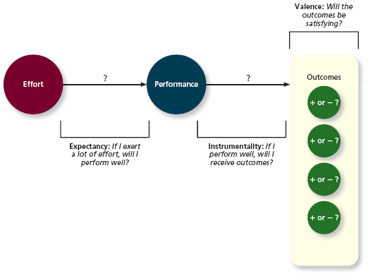
Needs: Groupings or clusters of outcomes viewed as having critical psychological or psychological consequences.
Commonly studied needs in OB:
Need Label | Alternative Labels | Description
Existence | Physiological, safety | The need for the food, shelter, safety, and protection required for human existence
Relatedness | Love, belongingness | The need to create and maintain lasting, positive, interpersonal relationships
Control | Autonomy, responsibility | The need to be able to predict and control one’s future
Esteem | Self-regard, growth | The need to hold a high evaluation of oneself and to feel effective and respected by others
Meaning | Self-actualization | The need to perform tasks that one cares about and that appeal to one’s ideals and sense of purpose

Extrinsic motivation: Desire to put forth work effort due to some contingency that depends on task performance
Intrinsic motivation: Desire to put forth work effort due to the sense that task performance serves as its own reward
Extrinsic outcomes | Intrinsic outcomes
Pay | Enjoyment
Bonuses | Interestingness
Promotions | Accomplishment
Benefits and perks | Knowledge gain
Spot awards | Skill development
Praise | Personal expression
Job security | (Lack of) Boredom
Support | (Lack of) Anxiety
Free time | (Lack of) Frustration
(Lack of) Disciplinary actions
(Lack of) Demotions
(Lack of) Terminations

Meaning of money: The idea that money can have symbolic value (eg achievement, respect, freedom) in addiction to economic value.
Motivational Force
Motivational force= [EP] [∑((PO)V)]
EP : Expectancy
PO : Instrumentality
V: Valence

Goal setting theory
Goal setting theory: A theory that views goals as the primary drivers of the intensity and persistence of effort. Goals are defined as the objective or aim of an action and typically refer to attaining a specific standard of proficiency, often within a specified time limit. More specifically, the theory argues that assigning employees specific and difficult goals will result in higher levels of performance than assigning no goals, easy goals, or “do-you-best” goals.
Pitfalls of goal setting: Goals can narrow our focus, and “aggressive [production] goal setting within an organization increases the likelihood of creating an organizational climate ripe for unethical behaviour. Multiple safeguards may be necessary to ensure ethical behaviour while attaining goals
Specific and difficult goals: Goals that stretch an employee to perform at his or her maximum level while still staying within the boundaries of his or her ability.
Self-set goals: The internalized goals that people use to monitor their own progress.
Three “Moderators” (“depend on” factors): feedback, task complexity, and goal commitment
Feedback: In goal setting theory, it refers to progress updates on work goals.
Task complexity: The degree to which the information and actions needed to complete a task are complicated.
Goal commitment: The degree to which a person is determined to reach the goal
SMART goals: Acronym that stands for specific, measurable, achievable, results-based, time-sensitive goals.
Strategies for fostering goal commitment

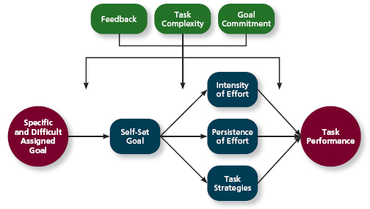
Equity theory
Equity theory: A theory that suggests that employees create a mental ledger of the outcomes they receive for their job inputs, relative to come comparison other. This theory acknowledges that motivation doesn’t just depend on your own beliefs and circumstances, but also what happens to other people. The theory further suggests that employees create a mental ledger of the inputs they put into their job duties. We are ‘disturbed’ by perceived unfairness.
Comparison other: Another person who provides a frame of reference for judging equity
Equity distress: An internal tension that results from being overrewarded or underrewarded relative to some comparison other.

Three possible outcomes of equity theory comparisons:
- Equity- no actions needed
- Underreward inequity- Grow your outcomes by talking to your boss or by stealing from the company. Shrink your inputs by lowering the intensity or persistence of effort
- Overreward inequity: Shrink your outcomes, or grow your inputs through more high-quality work or though some “cognitive distortion.”
Cognitive distortion: A reevaluation of the inputs an employee brings to a job, often occurring in response to equity distress.
Internal comparisons: Comparing oneself to someone in your same company
External comparisons: Comparing oneself to someone in a different company

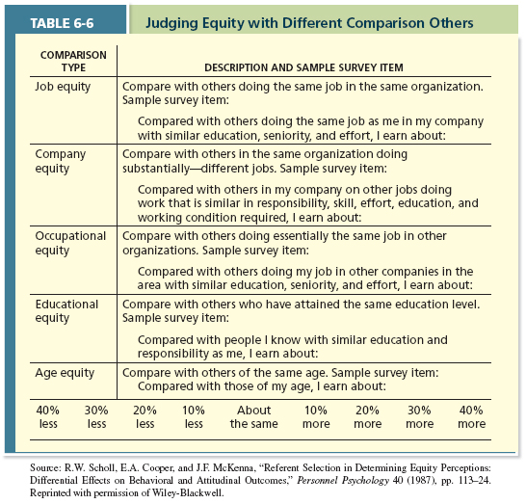

Psychological Empowerment
Psychological empowerment: An energy rooted in the belief that tasks are contributing to some larger purpose, or matter
Meaningfulness: A psychological state reflecting one’s feelings about work tasks, goals, and purposes, and the degree to which they contribute to society and fulfill one’s ideals and passions. More concerned with someone’s sense of self e.g. does an employee’s work provide them with a sense of purpose or satisfaction in terms of their own goals, ideals, or passions?
Self-determination: A sense of choice in the initiation and continuation of work tasks
Competence: The capability to perform work tasks successfully
Impact: The sense that a person’s actions “make a difference”- that progress is being made toward fulfilling some important purpose.
Experiment example: The robot building. Condition 1: give the person the parts to build a robot, set it aside, give them more parts. Result- 11 made. Condition 2: give a person the parts, let the build it, take it from them, disassemble it, and hand it back. Result- 7 made.
This is an example of a moderator, the relationship between love of Lego and # of bionicles is contingent upon the experimental condition.

Summary
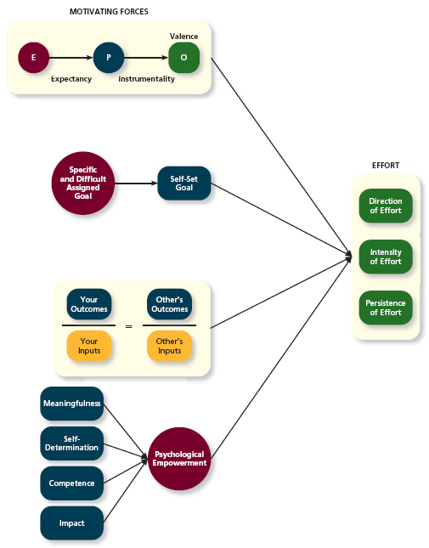

Chapter 7: Trust, Justice, and Ethics
Trust: The willingness to be vulnerable to an authority based on positive expectations about the authority’s actions and intentions.
Justice: The perceived fairness of an authority’s decision making
Ethics: The degree to which the behaviours of an authority are in accordance with generally accepted moral norms.
Why some authorities are more trusted than others
Types of Trust
Disposition-based trust: Trust that is rooted in one’s own personality, as opposed to a careful assessment of the trustee’s trustworthiness. Influenced by trust propensity.
Cognition-based trust: Trust that is rooted in a rational assessment of the authority’s trustworthiness. Influenced by trustworthiness- ability, benevolence, and integrity.
Affect-based trust: Trust that depends on feelings toward the authority that go beyond any rational assessment of trustworthiness. Influenced by feelings toward trustee. We trust them because we like them.

Trust propensity: A general expectation that the words, promises, and statements of individuals can be relied upon.
Trustworthiness: Characteristics or attributed of a person that inspire trust, including competence, character, and benevolence.
Ability: The skills, competence, and areas of expertise that enable an authority to be successful in some specific area.
Benevolence: The belief that an authority wants to do good for a trustor, apart from any selfish profit-centered motives.
Integrity: The perception that an authority adheres to a set of values and principles that the trustor finds acceptable.

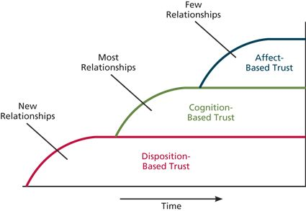
Justice
Distributive justice: The perceived fairness of decision-making outcomes. Employees gauge distributive by asking whether decision outcomes such as pay, rewards, evaluations, promotions, and work assignments, are allocated using proper norms. In most businesses, the proper norm is equity, with more outcomes allocated to those who contribute more inputs.
Procedural justice: The perceived fairness of decision-making process. Rules include voice, correctability, consistency, bias suppression, representativeness, accuracy. Research suggests that distributive justice and procedural justice influence employee reactions. When outcomes are good, people don’t worry about fairness; procedural justice has little impact on reactions when distributive justice is high. When outcomes are bad, procedural justice becomes enormously important. Research shows that procedural justice tends to be a stronger driver of reactions to authorities than distributive justice.
Interpersonal justice: The perceived fairness of the interpersonal treatment received by employees from authorities. Fostered when authorities adhere to two particular rules. The respect rule pertains to whether authorities treat employees in a dignified and sincere manner, and the propriety rule reflects whether authorities refrain from making improper or offensive remarks. Interpersonal INJUSTICE occurs when authorities are rude or disrespectful to employees, or when they refer to them with inappropriate labels.
Informational justice: The perceived fairness of the communications provided to employees from authorities. Fostered when authorities adhere to two particular rules. The justification rule mandates that authorities explain decision-making procedures and outcomes in a comprehensive and reasonable manner, and the truthfulness rule requires that those communications be honest and candid. Informational INJUSTICE occurs when an organization does not explain decisions in a comprehensive and adequate manner.

Ethics
Recall that motivation refers to three components: direction, intensity, and persistence. “Direction” can also imply the ethicality of behaviour or the nature of the task we do. Organizational pressure unethical behaviours
Whistle blowing: Employees’ exposing illegal or immoral actions by their employer
Moral awareness
Moral awareness: Recognition by an authority that a moral issue exists in a situation
Moral intensity (situational factor): The degree to which an issue has ethical urgency. A particular issue is high in moral intensity if the potential for harm is perceived to be high (killing a person vs hurting 100 people vs hurting 10 people). Second, a particular issue is high in moral intensity if there is social pressure surrounding it.
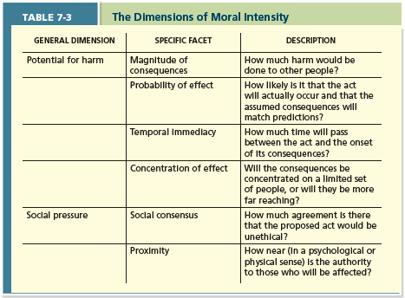
The four-Component model of ethical decision making: A model that argues that ethical behaviours result from the multistage sequence of moral awareness, moral judgement, and ethical behaviour. This model recognizes that moral awareness, judgment, intention and behaviour do not always coincide.
According to the 4-component model, we might engage in unethical behaviour because:
- We didn’t realize there was an ethical issues (no awareness)
- Because we had no intention/desire (‘no’(or wrong) moral judgement)
- Because we have the best intentions but something prevented us to act (intention but no behaviour)
- Or weak intentions (we want to do the right thing, but don’t really care about the situation)
We might do the right thing, but it isn’t necessarily considered ethical if we didn’t intentionally mean to act ethically.

Strength of the 4-component model: recognizes that moral awareness, judgment, intention, and behaviour do not always coincide
Criticisms of the 4-component model: Strict emphasis on rational processes, undervalues situational factors, and weak links between components.
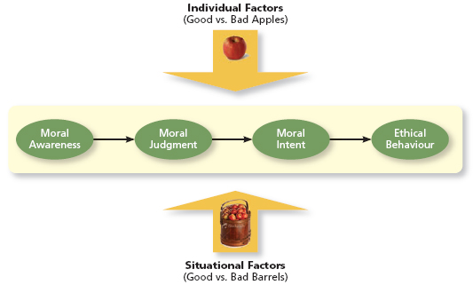
This figure presents an adaptation of the four-component model of ethical decision making. In addition to depicting the four components, the figure illustrates that unethical behaviour can be triggered by characteristics of a person or the situation. Put differently, and drawing on the adage “One bad apple spoils the barrel,” ethical behaviour can be driven by both good versus bad apples and good versus bad barrels.
Moral attentiveness (individual factor): The degree to which people chronically perceive and consider issues of morality during their experiences. Authorities that are morally attentive tend to view the world through the lens of morality, giving ethical issues a particular significance, vividness, and recognisability.
Moral Judgement
Moral judgement: When an authority can accurately identify the “right” course of action.
Cognitive moral development (individual factor): As people age and mature, they move through several states of moral development, each more mature and sophisticated than the prior one. The most sophisticated moral thinkers reach the principled stage. At this stage, right versus wrong is referenced to a set of defined, established more principles.
Moral principles: Prescriptive guides for making moral judgements, define what is ‘right’
Moral principles used in the principled stage:
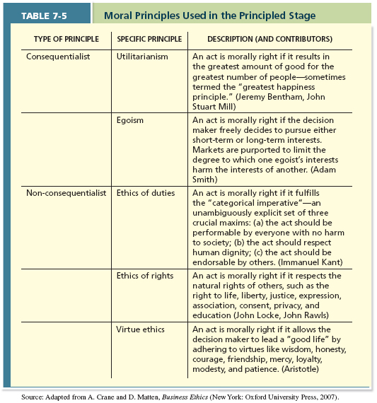
Moral intent
Moral intent: An authority’s degree of commitment to the moral course of action
What influences whether someone intends to ‘do the right thing’?
Moral identity (individual factor): The degree to which a person views himself or herself as a moral person
Organizational culture/norms

Summary:
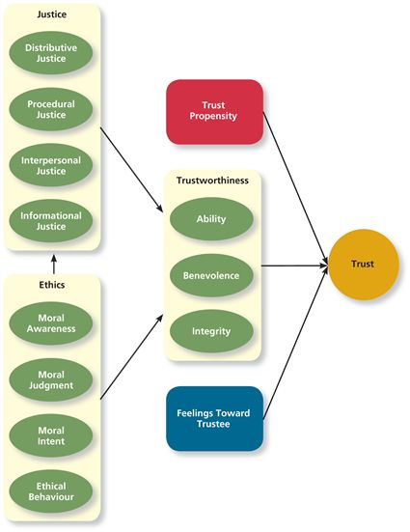
How important is trust?
Economic exchange: Work relationships that resemble a contractual agreement by which employees fulfill job duties in exchange for financial compensation
Social exchange Work relationships that are characterized by mutual investment with employees willing to engage in “extra mile” sorts of behaviours because they trust that their efforts will eventually be rewarded.
Corporate social responsibility: A perspective that acknowledges that the responsibility of a business encompasses the economic, legal, ethical, and citizenship expectations of society.

Chapter 8: Learning and Decision Making
Leaning: A relatively permanent change in an employee’s knowledge or skill that results from experience.
Decision making: The process of generating and choosing from a set of alternatives to solve a problem.
Why some employees learn to make decisions better than others
Expertise: The knowledge and skills that distinguish experts from novices
Types of knowledge
Explicit knowledge: knowledge that is easily communicated and available to everyone. If you can put the information or knowledge in a manual or write it down for someone else, chances are good you’re talking about explicit knowledge.
Tacit knowledge: knowledge that employees can only learn through experience. Not easily communicated, but could very well be the most important aspect of what we learn in organizations.

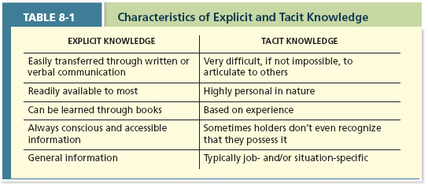
Methods of learning
Reinforcement
Contingencies of reinforcement: Four specific consequences used by organizations to modify employee behaviour
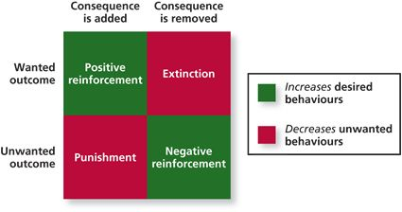
Positive reinforcement: A reinforcement contingency in which a positive outcome follows a desired behaviour
Negative reinforcement: A reinforcement contingency in which an unwanted outcome is removed following a desired behaviour.
Punishment: An unwanted outcome that follows an unwanted behaviour
Extinction: The removal of a positive outcome following an unwanted behaviour

Schedules of reinforcement: The timing of when contingencies are applied or removed
Continuous reinforcement: A schedule of reinforcement in which a specific consequence follows each and every occurrence of a certain behaviour
Fixed-interval schedule: A schedule whereby reinforcement occurs at fixed time periods.
Variable-interval schedule: A schedule whereby reinforcement occurs at random periods of time.
Fixed-ratio schedule: A schedule whereby reinforcement occurs following a fixed number of desired behaviours
Variable-ratio schedule: A schedule whereby behaviours are reinforced after a varying number of them have been exhibited
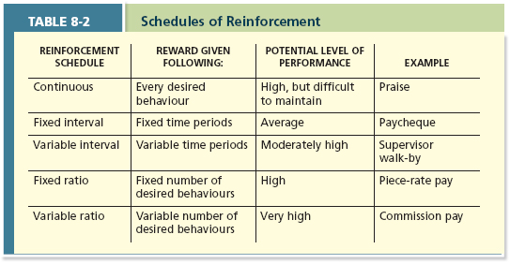

Observation
Social leaning theory: Theory that argues that people in organizations learn by observing others
Behavioural modelling: When employees observe the actions of others, learn from what they observe, and then repeat the observed behaviour.
The modelling process
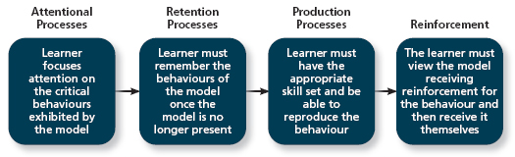
Goal orientation
Learning orientation: A predisposition or attitude according to which building competence is deemed more important by an employee than demonstrating competence.
Performance-prove orientation: A predisposition or attitude by which employees focus on demonstrating their competence so that others think favourably of them
Performance-avoid orientation: A predisposition or attitude by which employees focus on demonstrating their competence so that others will not think poorly of them.

Methods of decision making
Programmed decisions: Decisions that are somewhat automatic because the decision maker’s knowledge allows him or her to recognize the situation and the course of action to be taken
Intuition: An emotional judgement based on quick, unconscious gut feelings
Crisis situation: A change-sudden or evolving- that results in an urgent problem that must be addressed immediately
Non-programmed decisions: Decisions made by employees when a problem is new, complex, or not recognized.
Rational decision-making model: A step-by-step approach to making decisions that is designed to maximize outcomes by examining all available outcomes.
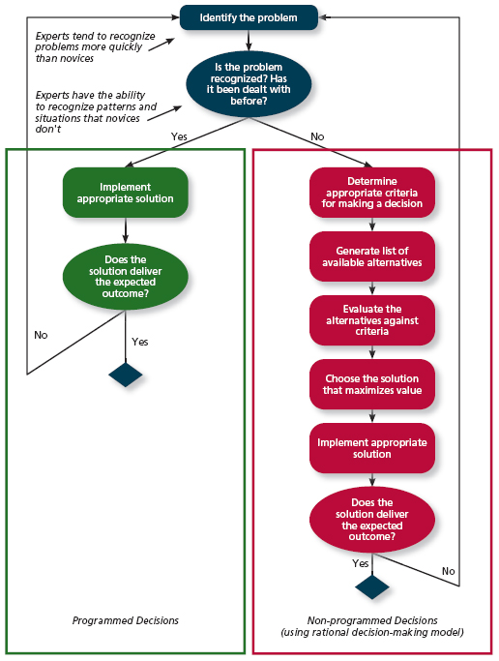
Decision-Making Problems
Why do people make bad decisions? Your freedom to make decisions in influenced by a number of factors:
- Organizational factors (values, your position, structure, other individuals and groups)
- Personal traits (personality, background, experience)
- Characteristics of the decision (time pressure, available information, who it impacts, risk)
- The context of decisions is subject to influence
- Decisions are not always made with the same amount of available information
- We often face situation of information overload
- We also face time pressure
- The BEST decision often depends on what happens afterwards
- Managers have differing predispositions
  - Optimism
  - Pessimism
  - Risk aversion

Limited information
Bounded rationality: The notion that people do not have the ability or resourced to process all available information and alternatives when making a decision. This limit results in two major problems for decision making. First, people have to filter and simplify information to make sense of their complex environment and the myriad potential choices they face. This simplification leads them to miss information when perceiving problems, generating and evaluating alternatives, or judging the results.
Second, because people cannot possibly consider every single alternative when making a decision, they satisfice.
Satisficting: What a decision maker is doing who chooses the first acceptable alternative considered.

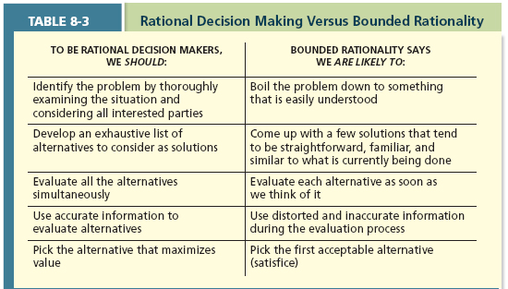

Faulty perceptions
Selective perception: The tendency for people to see their environment only as it affects them and as it is consistent with their expectations
Projection bias: They faulty perception by decision makers that others think, feel, and act as they do
Social identity theory: A theory that people identify themselves according to the various groups to which they belong and judge others according to the groups they associate with
Stereotype: Assumptions made about others based on their social group membership
Heuristics: Simple and efficient rules of thumb that allow one to make decisions more easily
Availability bias: The tendency for people to base their judgements on information that is easier to recall

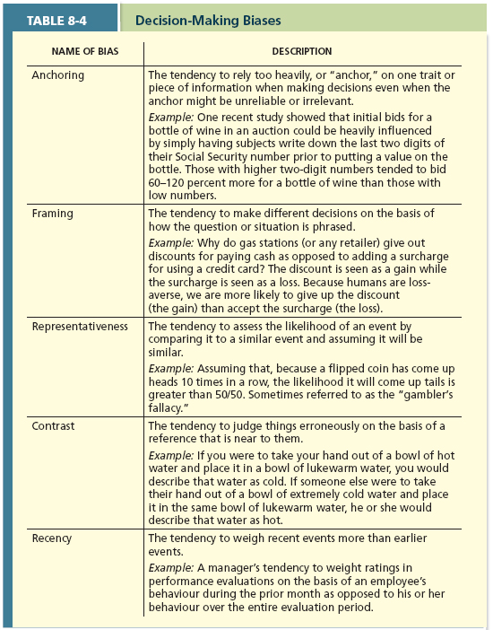

Faulty attributions
Fundamental attribution error: The tendency for people to judge others’ behaviours as being due to internal factors such as ability, motivation, or attitudes.
Self-serving bias: When one attributes one’s own failures to external factors and success to internal factors.
Consensus: Used by decision makers to attribute cause; whether other individuals behave the same way under similar circumstances
Distinctiveness: Used by decision makers to attribute cause; whether the person being judges acts in a similar fashion under different circumstances
Consistency: Used by decision makers to attribute cause; whether this individual has behaved this way before under similar circumstances
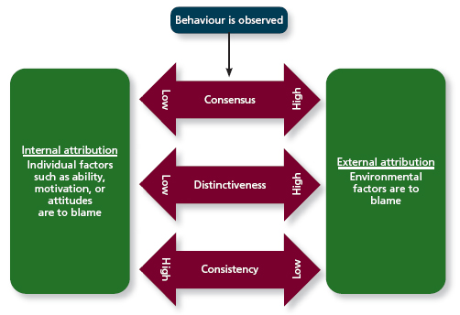
Escalation of commitment
Escalation of commitment: A common decision-making error, in which the decision maker continues to follow a failing course of action.

Summary
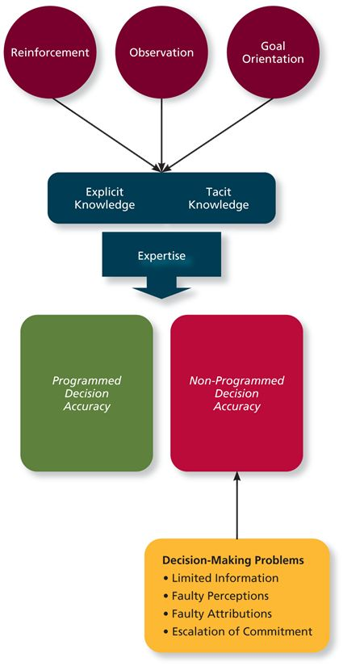
Application: Training
Training: A systematic effort by organizations to facilitate the learning of job-related knowledge and behaviour
Knowledge transfer: The exchange of knowledge between employees
Behaviour modelling training: When employees observe the actions of others, learn from what they observe, and then repeat the observed behaviour.
Communities of practice: Groups of employees who learn from one another through collaboration over an extended period of time.
Transfer of training: Occurs when employees retain and demonstrate the knowledge, skills, and behaviours required for their job after training ends.
Climate for transfer: An organizational environment that supports the use of new skills

