CHAPTER 6

Cost-Volume-Profit Analysis and Income Statement

Cost-volume-profit (CVP) analysis is the study of the effects that changes in costs and volume have on a company's profits.

1. | The behaviour of both costs and revenues is linear throughout the relevant range of the activity index.
2. | All costs can be classified with reasonable accuracy as either variable or fixed.
3. | Changes in activity are the only factors that affect costs.
4. | Inventory levels remain constant—all units that are produced are sold.
5. | When more than one type of product is sold, the sales mix will remain constant. That is, the percentage of total sales that each product represents will stay the same. The sales mix complicates CVP analysis because different products will have different cost relationships. In this chapter, we assume first a single product is being sold. Study objective 7 addresses sales mix issues.

The cost-volume-proflt (CVP) income statement classifies costs as variable or fixed and calculates a contribution margin. Contribution margin (CM) is the amount of revenue that remains after variable costs have been deducted. It is often stated both as a total amount and on a per-unit basis,

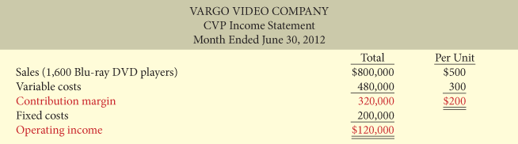

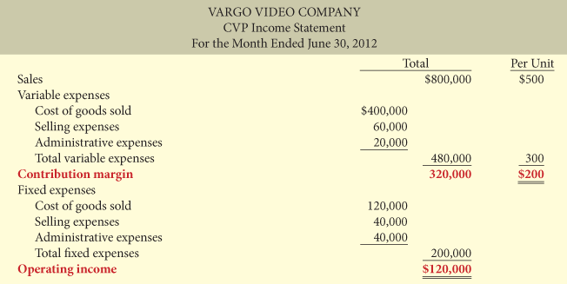

Contribution Margin
CONTRIBUTION MARGIN PER UNIT

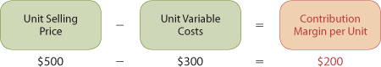

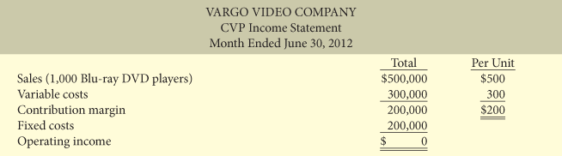

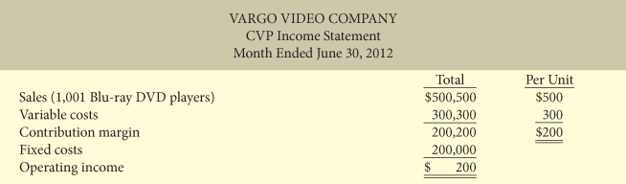

CONTRIBUTION MARGIN RATIO

The contribution margin ratio is the contribution margin per unit divided by the unit selling price. It is generally expressed as a percentage.

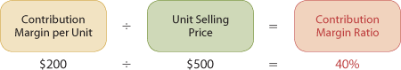

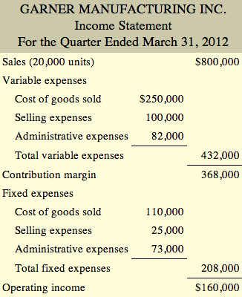
Applying Basic Cost-Volume-Profit Concepts
BREAK-EVEN ANALYSIS

his level of activity is called thebreak-even point. At this volume of sales, the company will realize no income and will suffer no loss. The process of finding the break-even point is calledbreak-even analysis.

The break-even point can be
1. | calculated with a mathematical equation,
2. | calculated by using contribution margin, or
3. | derived from a cost-volume-profit (CVP) graph.

break-even occurs when total sales equal variable costs plus fixed costs.

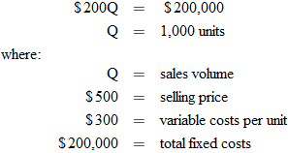



To find the sales dollars required to break even, we multiply the units sold at the break-even point by the selling price per unit, as shown below:

Contribution Margin Technique

at the break-even point, the contribution margin must equal total fixed costs

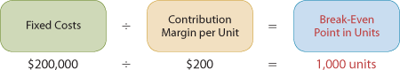

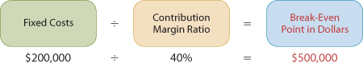
Graphic Presentation

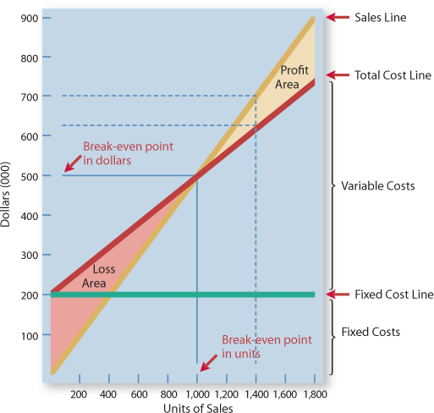

Using the data for Vargo Video, the steps to construct the graph are as follows:
1. | Plot the total sales line, starting at the zero activity level. For every DVD player sold, total revenue increases by $500. For example, at 200 units, sales are $100,000. At the upper level of activity (1,800 units), sales are $900,000. Note that the revenue line is assumed to be linear throughout the relevant range of activity.
2. | Plot the total fixed cost using a horizontal line. For the Blu-ray DVD players, this line is plotted at $200,000.The fixed cost is the same at every level of activity.
3. | Plot the total cost line. This starts at the fixed-cost line at zero activity. It increases by the variable cost at each level of activity. For each DVD player, variable costs are $300. Thus, at 200 units, the total variable cost is $60,000, and the total cost is $260,000. At 1,800 units the total variable cost is $540,000, and the total cost is $740,000. On the graph, the amount of the variable cost can be derived from the difference between the total cost and fixed cost lines at each level of activity.
4. | Determine the break-even point from the intersection of the total cost line and the total revenue line. The break-even point in dollars is found by drawing a horizontal line from the break-even point to the vertical axis. The break-even point in units is found by drawing a vertical line from the break-even point to the horizontal axis.

TARGET OPERATING INCOME BEFORE AND AFTER TAX
Target Operating Income

This objective is called the target operating income. It indicates the sales the company needs in order to achieve a specified level of income.



The sales dollars required to achieve the target operating income is found by multiplying the units sold by the unit selling price .
Contribution Margin Technique

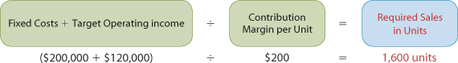
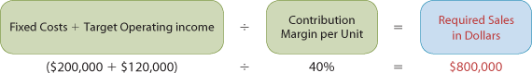
The company can find the required sales amount by analyzing the differences between the two lines until it finds its desired operating income.

Target Operating Income After Tax

operating income after taxes is equal to operating income before taxes multiplied by the difference between 1 and the tax rate :

o figure out what the operating income before taxes needs to be in order to reach a specific target operating income after taxes, we divide the desired operating income after taxes by the difference between 1 and the tax rate (1– tax rate):

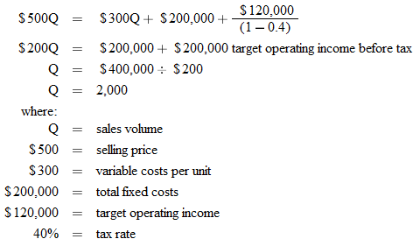
The sales dollars amount that is needed to reach the target operating income after taxes is found by multiplying the required sales in units by the unit selling price .

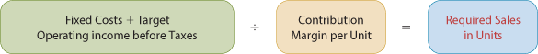

Contribution Margin Technique



MARGIN OF SAFETY

Margin of safety is the difference between actual or expected sales and sales at the break-even point. This relationship measures the “cushion” that management has, allowing it to still break-even if expected sales fail to be reached. The margin of safety may be expressed in dollars, units or as a ratio.

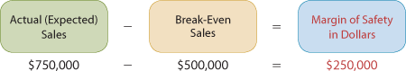

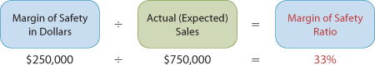

The higher the dollars or the percentage, the greater the margin of safety will be.

CVP AND CHANGES IN THE BUSINESS ENVIRONMENT

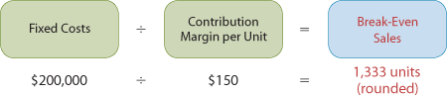

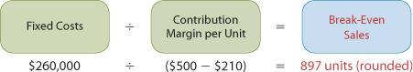

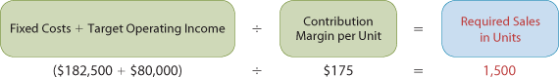Sales Mix

The sales mix is the relative proportion in which each product is sold when a company sells more than one product.

BREAK-EVEN SALES IN UNITS

Companies can calculate break-even sales for a mix of two or more products by determining the weighted-average unit contribution margin of all the products.

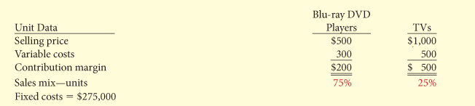

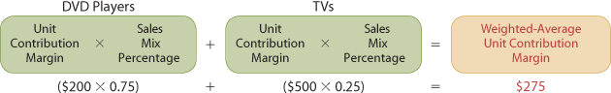

We then use the weighted-average unit contribution margin of $275 to calculate the break-even point in unit sales.

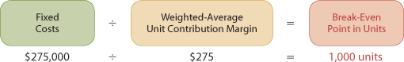

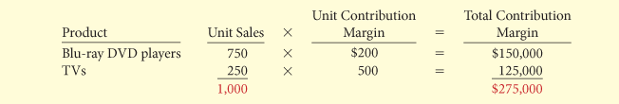

operating income will be greater if higher contribution margin units are sold, rather than lower contribution margin units.

BREAK-EVEN SALES IN DOLLARS

Therefore, for a company like Loblaw, we calculate the break-even point in terms of sales dollars (rather than units sold), using sales information for divisions or product lines (rather than individual products). This approach requires that we calculate sales mix as a percentage of total sales dollars (rather than units sold) and that we calculate the contribution margin ratio (rather than contribution margin per unit).

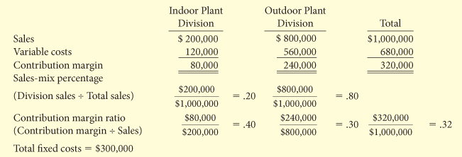

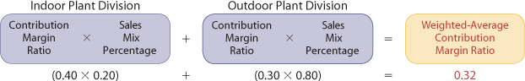
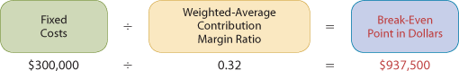

What would be the impact on the break-even point if a higher percentage of Kale Garden Supply's sales were to come from the indoor plant division? Because the indoor plant division enjoys a higher contribution margin ratio, this change in the sales mix would result in a higher weighted-average contribution margin ratio, and consequently a lower break-even point in dollars.

APPENDIX 6A — COST STRUCTURE AND OPERATING LEVERAGE

Cost struricte and operating leverage

Cost structure refers to the relative proportion of fixed versus variable costs that a company incurs.

Alternatively, some companies have reduced their fixed costs and increased their variable costs by outsourcing their production.

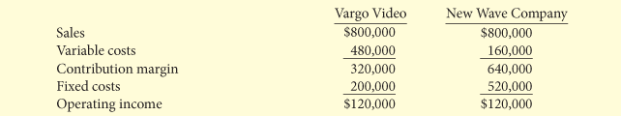

EFFECT ON CONTRIBUTION MARGIN RATIO

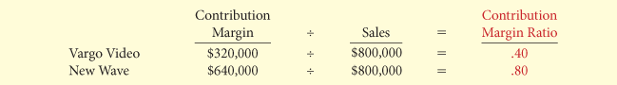
That means that with every dollar of sales, New Wave generates 80 cents of contribution margin (and thus an 80-cent increase in operating income), versus only 40 cents for Vargo. However, it also means that for every dollar that sales decline, New Wave loses 80 cents in operating income, whereas Vargo will lose only 40 cents. New Wave's cost structure, which relies more heavily on fixed costs, makes it more sensitive to changes in sales revenue.

EFFECT ON BREAK-EVEN POINT



New Wave needs to generate $150,000 more in sales than Vargo before it breaks even. This makes New Wave riskier than Vargo because a company cannot survive for very long unless it at least breaks even.

EFFECT ON MARGIN OF SAFETY RATIO

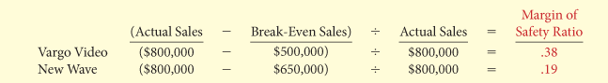

Vargo could sustain a 38% decline in sales before it would be operating at a loss. New Wave could sustain only a 19% decline in sales before it would be “in the red.”

OPERATING LEVERAGE

Operating leverage refers to the extent to which a company's operating income reacts to a given change in sales. Companies that have higher fixed costs relative to variable costs have higher operating leverage. When a company's sales revenue is increasing, high operating leverage is a good thing because it means that profits will increase rapidly. But when sales are declining, too much operating leverage can have devastating consequences.

Degree of Operating Leverage

The degree of operating leverage provides a measure of a company's earnings volatility and can be used to compare companies. The degree of operating leverage is calculated by dividing contribution margin by operating income



New Wave's earnings would go up (or down) by about two times as much as Vargo's with an equal increase (or decrease) in sales. For example, suppose both companies experience a 10% decrease in sales. Vargo's operating income will decrease by 26.7% , while New Wave's will decrease by 53.3% . Thus, New Wave's higher operating leverage exposes it to greater earnings volatility risk.

