Sept. 24, 2013
Lecture 3 – Mycaneans
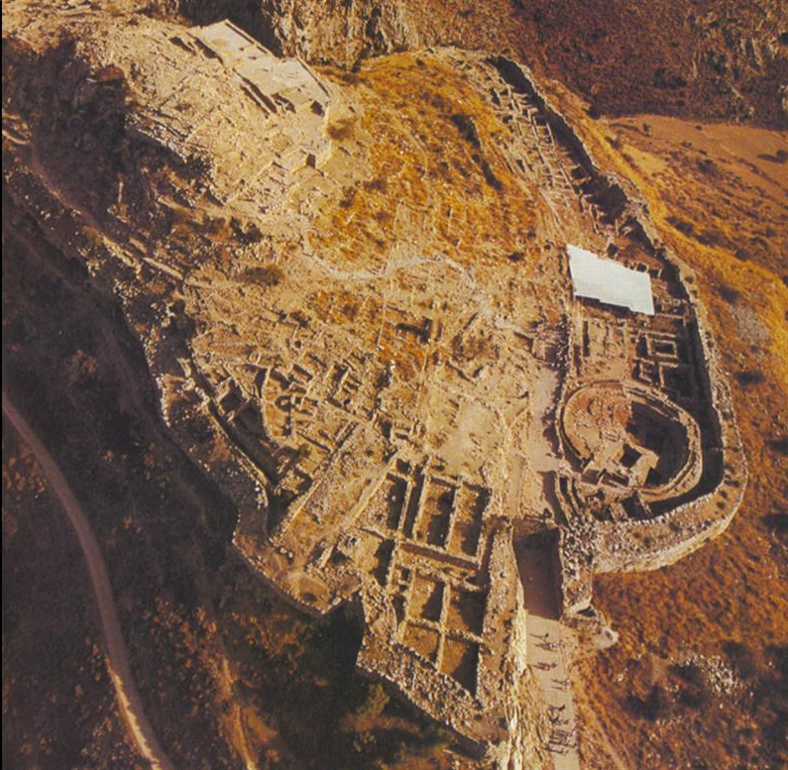
Mycenae

- On a hill-top
- Most famous site
- Fortification wall
- A citadel
- Greeks thought it was impossible that it was built by humans
  - Hypothesized that it was made by Cyclopes (giants); “Cyclopean Masonry”
- Discussed in Greek literature
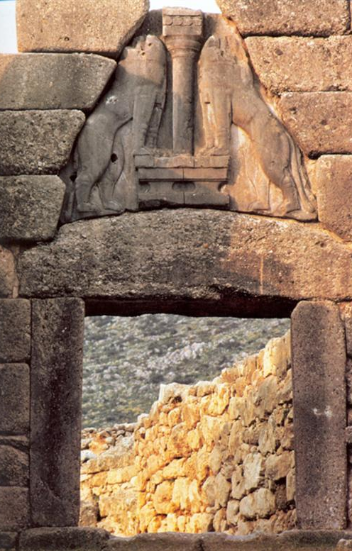
  - Mythical home to Agamemnon, son of Atreus, married to Clytemnestra

Mycenae Lion Gate
- Lion Gate and fortification wall built c. 1250 BC
  - Life began centuries before
- Post and Lintel construction
  - 5m wide
  - 20 tons
- Monumental scale: designed to impress/awe; welcoming/foreboding
  - Larger than it logically needs to be
- Lions in Heraldic Pose (heads in wood) = engage viewer
  - Heads are lost
    - Must have been made w/ a different material
  - Inviting or foreboding
  - 2 lions on a column
    - Architectural symbolism: lions guarding the column
  - Lions increase monumental element
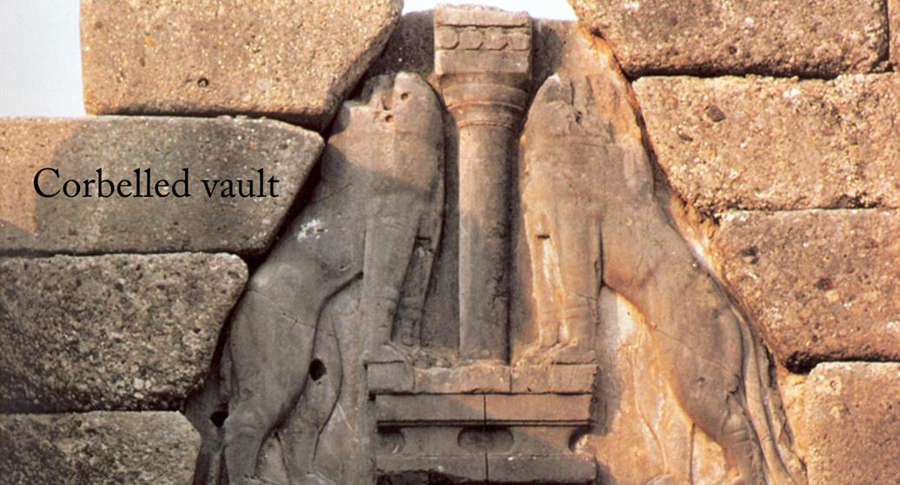
- Architecture and sculpture first brought together
- Ashler, limestone blocks

Corbelled Vault
- They feared that heavy blocks at the front/on top of the lintel would cause it to crack
- Relieving triangle; gap avoids the weight of the blocks

Palace of Nestor at Pylos
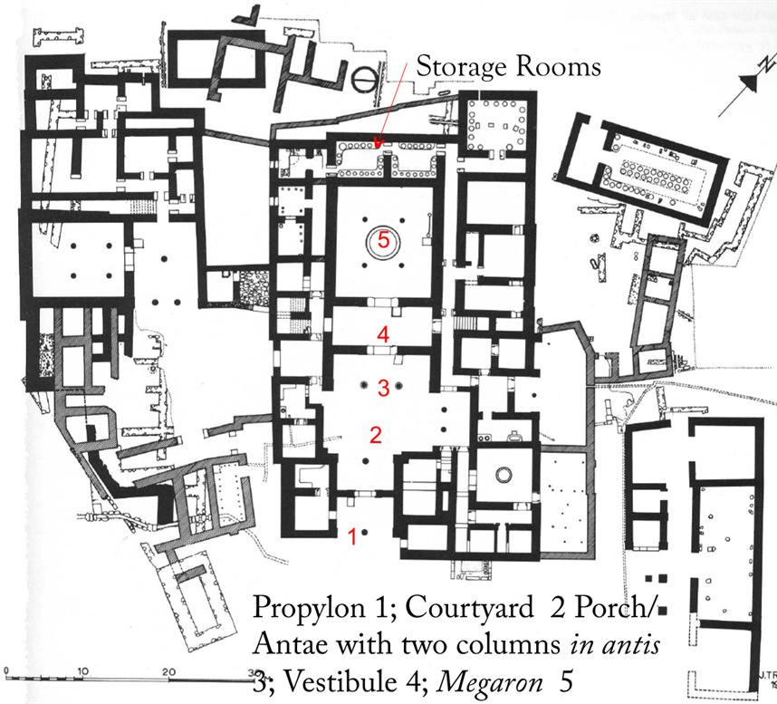
- Occupied c.1300-1200 BC
- Name given by Homer
- Megaron – “the big room”
  - Heart of the palace
  - Office for ruler
  - Business/administrative stuff
  - Close to the ruler
- Difficult to get in the palace
  - More exclusive; VIP
  - Allowed the ruler to control access
  - Reflects culture difference from Minoans
    - Denies access; rejects gathering
- Antis – projecting walls
- “In antis” – held up by two columns

Megaron
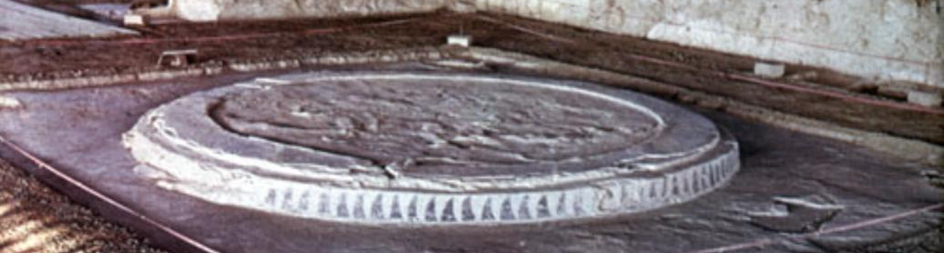
- Hearth in Megaron (terracotta)
  - Circular terracotta disc
  - Center for sacrifice/religious activities
  - Shows that the ruler controlled religion
    - Chose who could/could not worship
    - Those denied could not prey to the Gods to ask for clemency, acceptance, ect.
- Demonstrates that the ruler determined who was in the community & who was not
  - Could marginalize/enfranchise people as they saw fit
  - Ancient equivalent of the 99% and 1 %

Mycenaean Architecture
- Megaron – Large reception hall, focus of the palaces
- Anta (pl. antae) – Projecting spur walls in the front of a porch or room
- Distyle in antis – Two columns placed between antae

Tiryns: Mycenaean Citadel
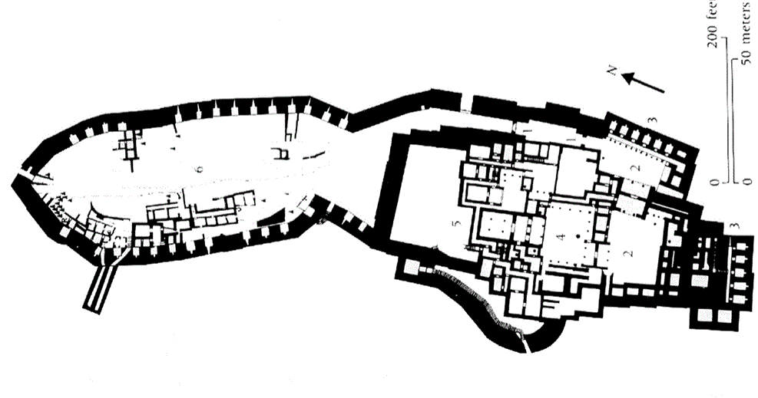
- Cyclopean masonry
- Active 1300 – 1200 BC
- Vaulted walkways
- Corbelled vault
- Fortification wall (at almost all Mycanean sites)

Athens
- Mycanean wall runs the same course as modern retaining wall

Acropolis

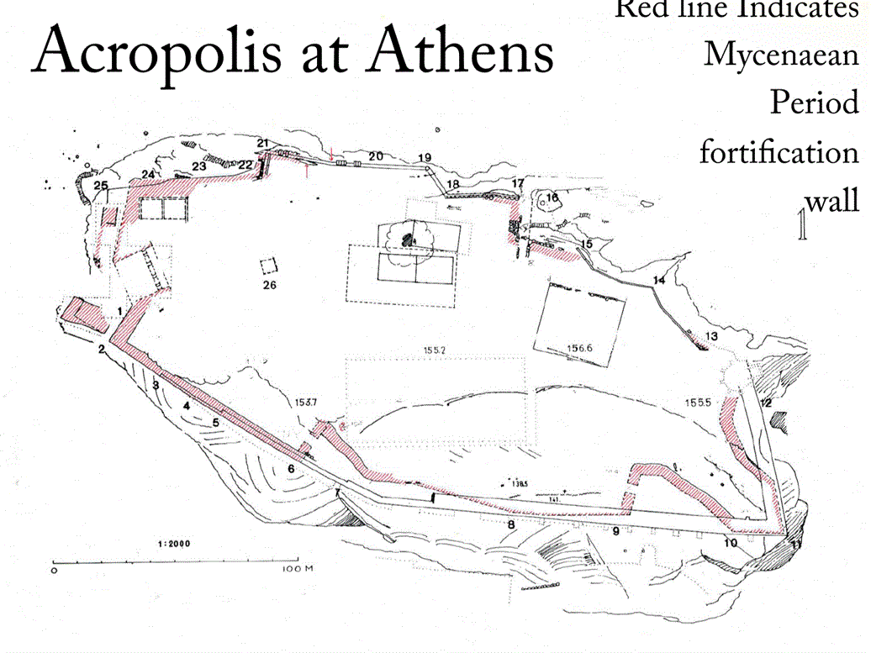

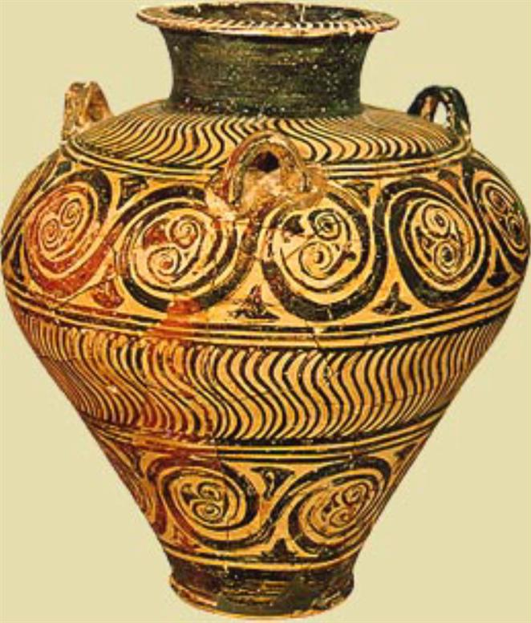
Mycenaean Vase
- Three-handled piriform jar
  - Large on top, narrow at the base
- Pattern Style
  - Repeated patterns (tendrils), quickly painted
    - Regularized, flattened, ordered
    - Now wildness
- Close Style
  - Compact design
  - Off-shoot of Pattern Style
  - Entire vessel covered w/embellishment
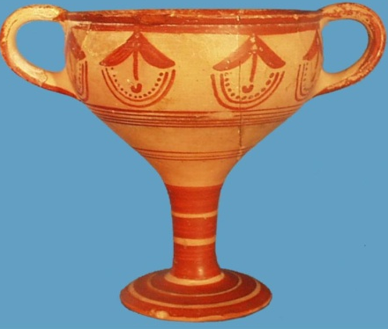
- Vines – incorporation of the natural world
- Artist makes a deliberate choice to use realism but also artistic formality
  - More formal than realistic
  - Mute, geometric forms

Mycenaean Kylix
- Drinking cup for wine
- Pattern Style
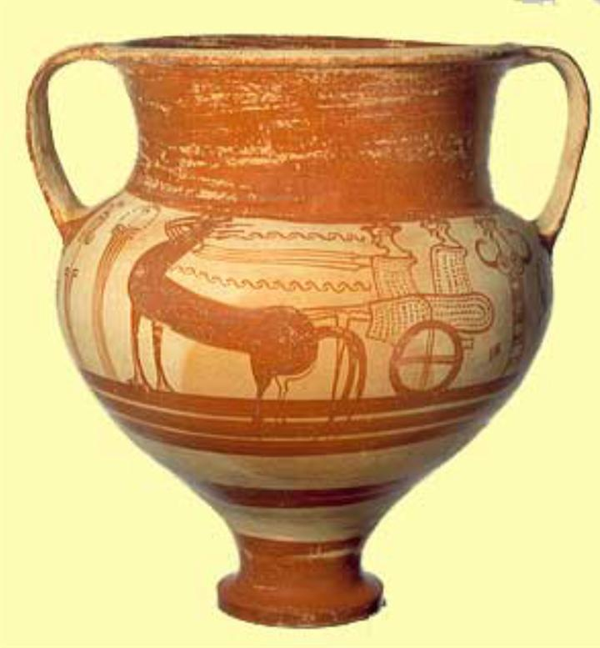
- Wide-mouthed so wine can breathe
- Hook(s) for thumb(s)

Pictorial Style
- LH IIB 1300-1200
- Story telling narrative
- Human forms; no more geometric forms
- Scene of departure depicted
  - House & chariot indicate warrior status (but also aristocratic)
  - Wealth & physical strength
- 2 women are watching the departure
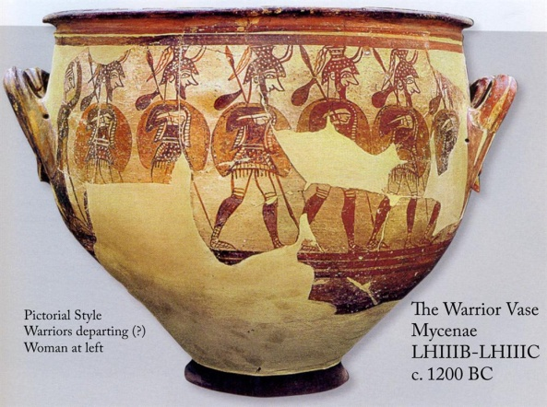
  - Mourning & grieving – ululation
  - Confirms hero status

The Warriors Vase Mycenae
- LHIIB-LHIIC c. 1200 BC
- Pictorial Style
- Warriors departing, women to the left
  - Women tearing out hair in grief
  - Represent community that is left behind
- Figures are stylized
  - No personality; uniform; one pose; same face

Mycenaean Larnax
- Type of coffin
- Could be wood, terracotta, or stone

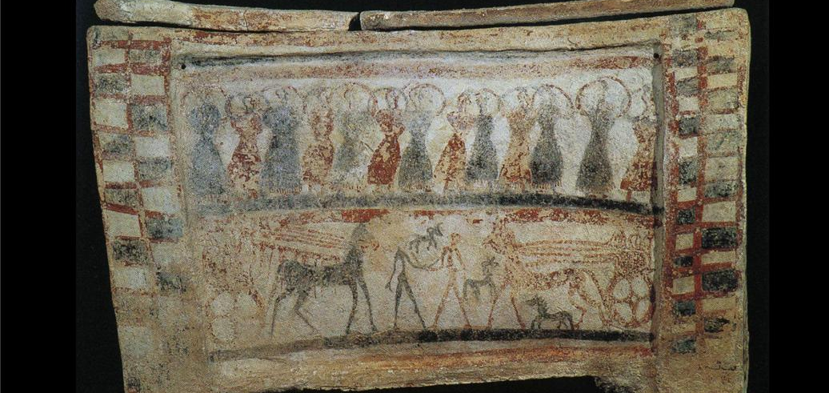
From Tanagra (near Thebes)
- 1400-1300 BC
- Above is a scene of ululation; bottom is a scene of warriors
- Deceased is being remembered as a hero
- Helps bond the decedents
  - Family is united and status is strengthened

Knossos (Minoan) vs. Pylos (Mycenaean)
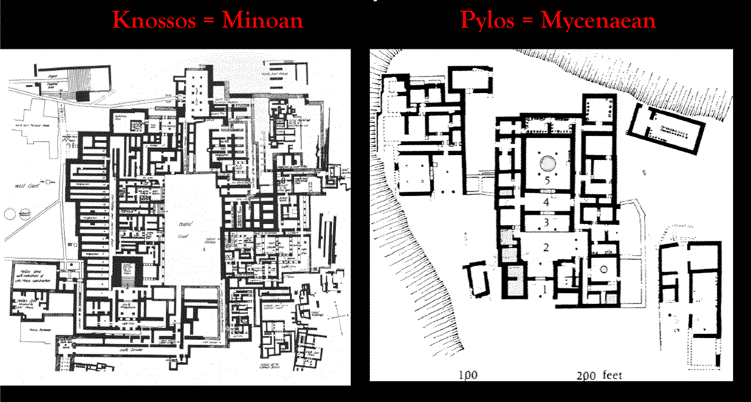
- Served similar functions:
  - Storage
  - Production of goods
  - Economic centers
- No central gathering place in Mycenaean palaces

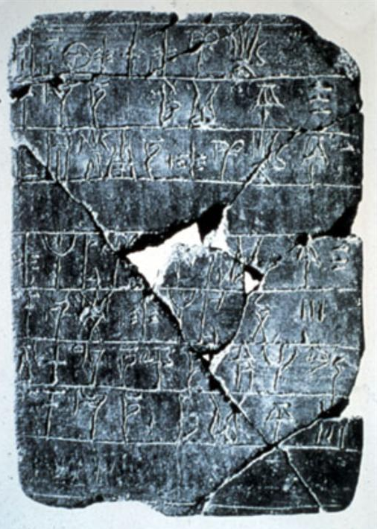
Linear B Tablets: Mycenaean Scripts
- Clay tablets with writing engraved
  - Shows they had a system of writing
  - Similar to hieroglyphics
- Baked in the fiery destruction of the palaces
- Used as inventories; economic ledgers
- Only a small portion of Mycenaeans were literate
  - Shows sophistication
- Limited in scope and audience
- An early form of Greek
  - Allows us to say that Mycenaeans were first Greeks

Trade in B.A. Mediterranean
- Wealth of Mycenaeans was aided by wide trade routes
- Mycenaean pottery was shipped out and later ended up in Italian cities
- An exchange of prestigious, luxury goods
  - Tokens that elevated status

Uluburun Shipwreck
- Excavated 1984-1994 by Institute for Nautical Archaeology and Texas A&M University (USA)
- 44-52 m beneath surface
- Sank c. 1300 BC
  - Dating based on dendrochronology (1306 BC), confirmed by ceramic and other finds
- Merchant ship, with varied cargos
- Through intact cargos, widespread trade networks were revealed

Cargo
- Oxhide Ingots: 354 in Cypriot Copper
- Bun (piano-convex) Ingots: 120 Cypriot
- Tin Ingots: both bun and oxhide (earliest known)
- Ingot = material fused for transport, later to be worked into final form, (bullion)

Oxhide Ingot
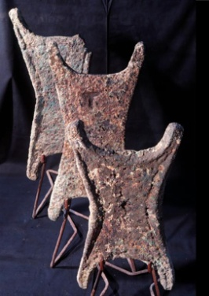

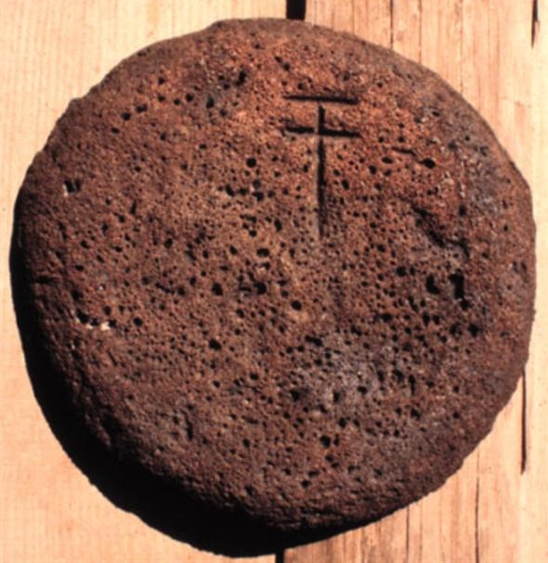
Copper Bun Ingots
- Marks chiselled onto surface (not stamped) – added later (upon receipt)
- Pictogram script (not Linear B)
- 28 of 121 buns
- 13 appear twice/ +

Glass Ingots
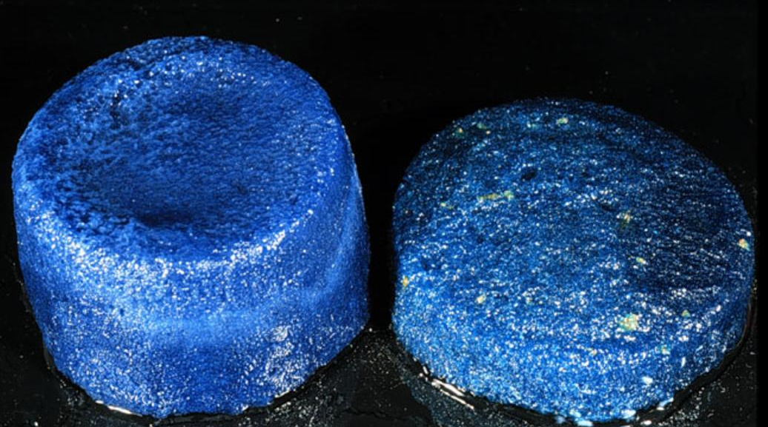

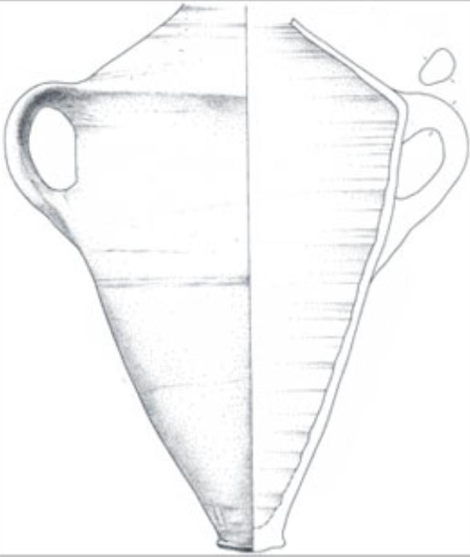
Canaanite Amphoras
- 9 canaanite amphoras found in the wreck
- Contained:
  - Other pottery (fineware)
  - Pomegranates
  - Olive oil
  - 150 contained terebinth resin (tree resin) for incense
- Medium sized mouth that tapers down and narrows at the foot
- Two handles
- From Canaan
- Won’t stand up by themselves

Mycenaean-type Sword (Bronze)
- Found in small numbers
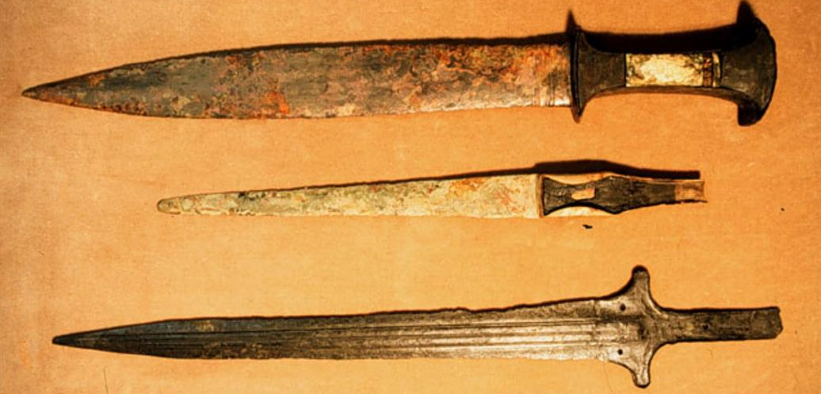
- Intended for security for those on board
Wooden Writing Board: Literacy
- Covered in wax and scratched in
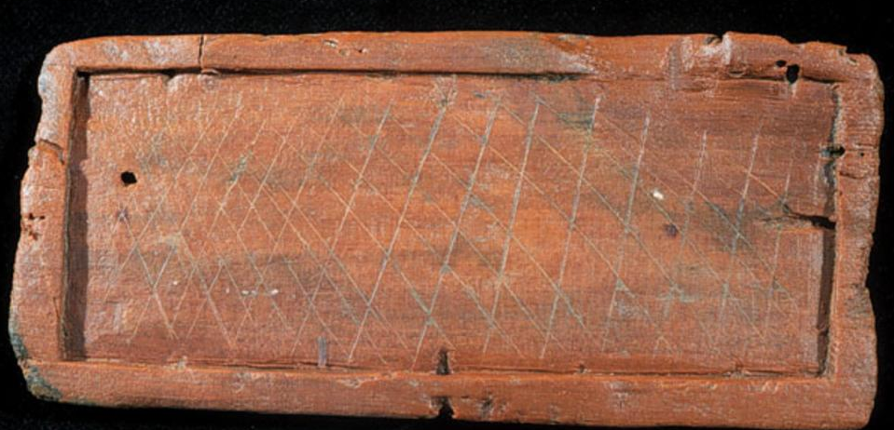

Uluburun Continued
- Cargo: metals (copper, tin = Bronze), glass, ceramic jars (pomegranates, oil)
- Exotic/luxury goods: ebony, ivory, murex seashells, ivory objects, figurines, beads, scarabs
- Tools: writing board, lead sinkers for fishing nets, Canaanite and Mycenaean pottery

Conclusions
- Trade of metals, glass, resin (in ceramic vessels)
- Intricate trade network involving luxury goods (both finished and unfinished)
  - Meets needs of several classes
- Literacy (captain?)
- Crew: Cypriot, Near eastern (personal possessions), Mycenaean (?)
- Trade was not on a point-to-point basis
  - A series of ports/stops
  - Worked like a city bus rather than a GO bus
  - Goods could be loaded/unloaded & picked up/dropped off

Mycenaean Burial: Grave Circle A, Grave Circle B: 1650 – 1450 BC
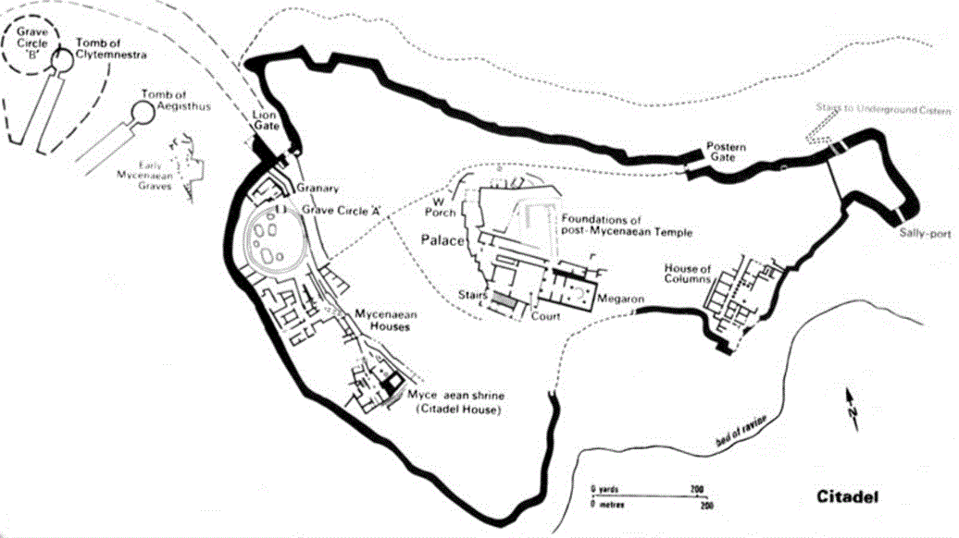
Grave Circle A
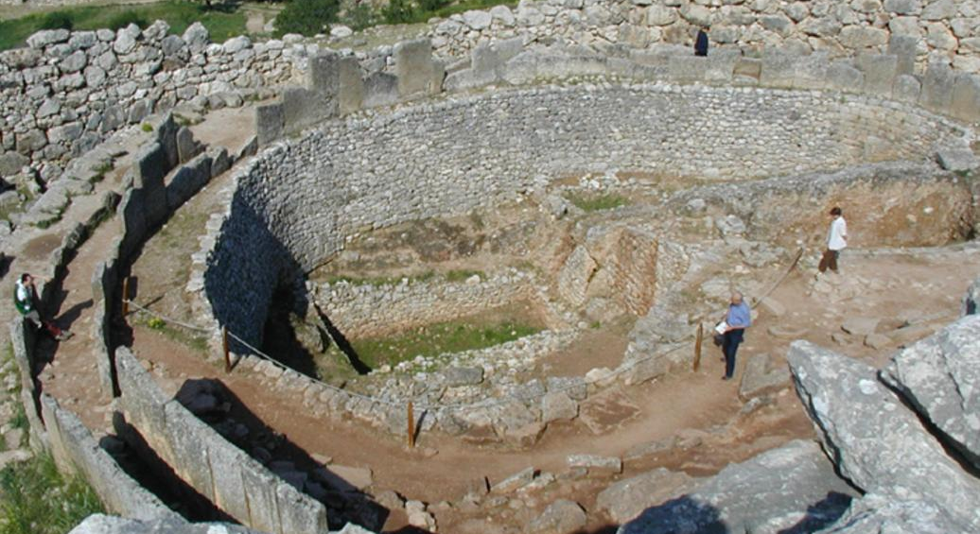
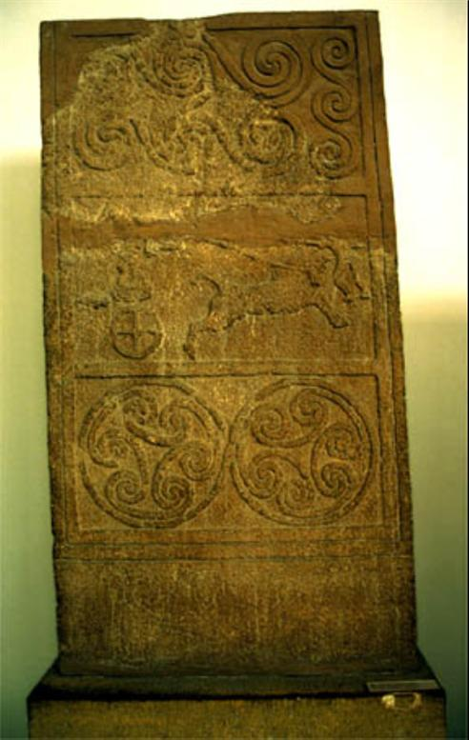
- 1650 – 1450 BC
- Circular, fenced
- Male burials given more attention than female
- Idea of blood-lines employed; lineage can be traced back
- Grave good – item left with the deceased
  - Gift/ sacrifice, possibly to be used in death

Stele
- Vertical slab marking grave
- Spirals = pattern style

Funerary Masks
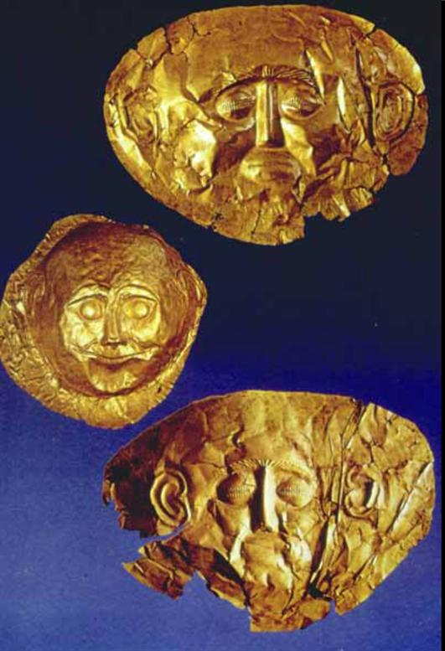
- Individual style
  - Attempt at portraiture
- Used for male burial only
- Bronze
- Essential facial features are complete

The Mask of Agamemnon
- Detailed eyes
- Individual eyebrow hairs
- Use of facial hair
- Excavated by Henreich Slemon
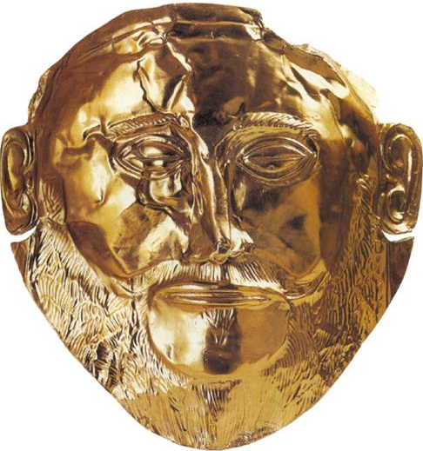
- 19 c. product
- 3 axis: time, place, status

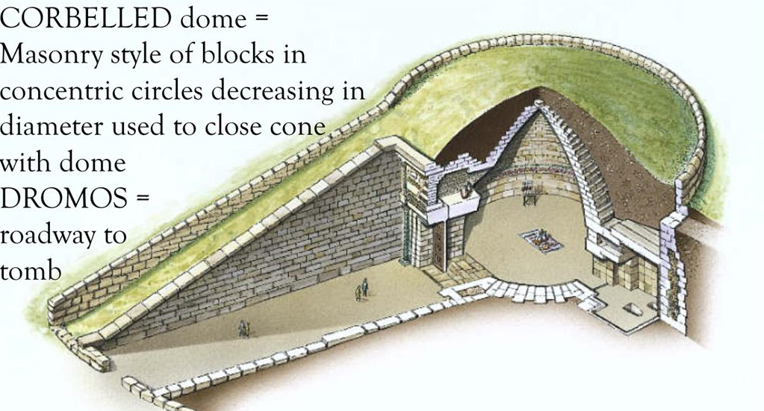
Mycenaean Tholos Tomb
- Most monumental, expensive, luxury tomb
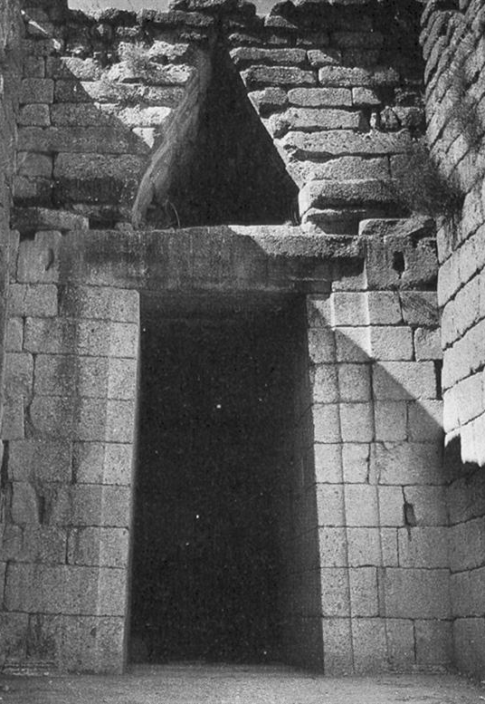
- Corbelled dome – masonry style of blocks in concentric circles decreasing in diameter used to close cone with dome
- Dromos – roadway to tomb

Treasury of Atreus: 1300 BC
- Mycenaean Tholos Tomb
- Family “royal” tomb with multiple depositions
- Opened and resealed
- Family kept together in afterlife – lineage recorded

Reconstruction
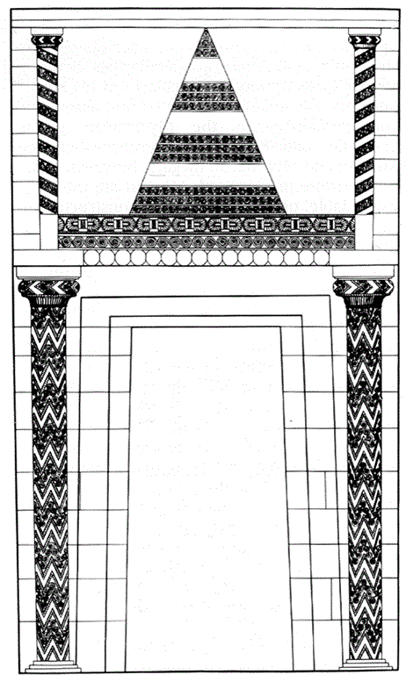
- Ornamental half-columns flanking door & flanking relieving triangle
- Half-columns decorated with multi-coloured precious stones

Terminology
- Tholos – round building
- Dromos – road/entranceway leading into tholos
- Relieving Triangle – void left above lintel block to alleviate weight
- Corbelled vault – vault constructed by set of concentric courses of stones that progressively decrease in diameter
The End of the Bronze Age
- 1200 BC – Collapse of Mycenaean Hegemony, beginning of period known as “Dark Ages” c. 1100 – 900 BC
  - Subsistence rather than sophistication
  - No community, politics, ect.
  - “Sea People” invaded from Anatolia (?)
  - “Return of Heraclids” – Dorian Invasion (from Balkan Peninsula)
  - Accounts for differing dialects in Greek language – Dorian and Ionian
- All but one of the palaces were burnt to the ground
- Writing disappeared

The Catastrophe
- Mycenaean Kingdoms collapse c. 1200 – 1180
- New population brought new technology
  - Iron tools
  - Practice of cremation developed (inhumation used in Greece up to this point)

