Chapter 11: Decision Making
- 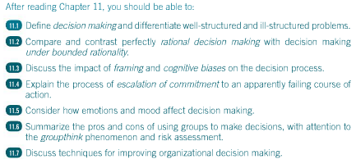
- Decision making: the process of developing a commitment to some course of action
  - Three noteworthy things
    - Decision making involves making a choice among several action alternatives
    - Decision making is a process that involves more than simply the final choice among alternatives
    - The “commitment” usually involves some commitment of resources, such as time, money, or personnel
  - Process of problem solving
  - A problem exists when a gap is perceived between some existing state and some desired state
- Well Structured Problems: a problem for which the existing state is clear, and how to get from one state to the other is fairly obvious
  - These problems are simple
  - Their solutions arouse little controversy because such problems are repetitive and familiar
  - Because decision takes time and is prone to error, organizations and individuals attempt to program the decision making for well-structured problems
  - Program is simply a standardized way of solving a problem
    - Programs short-circuit the decision-making process by enabling the decision maker to go directly from problem identification to solution
    - Programs usually go under labels such as rules, routines, standard operating procedures, or rules of thumb
    - However, some problems come from experience and exist internally
  - Many of the problems that organizations encounter are well structured, and programmed decision making provides a useful means of solving these problems
  - Programs are only as good as the decision-making process that led to the adoption of the program in the first place
- Ill-Structured Problems: a problem for which the existing and desired states are unclear and the method of getting to the desired state (even if clarified) is unknown
  - Generally unique; they are unusual and have not been encountered before
  - Tend to be complex and involve a high degree of uncertainty
  - They frequently arouse controversy and conflict among the people who are interested in the decision
  - Decision makers must resort to non-programmed decision making
    - They are likely to gather more information and be more self-consciously analytical in their approach
  - Entail high risk and stimulate strong political considerations
- 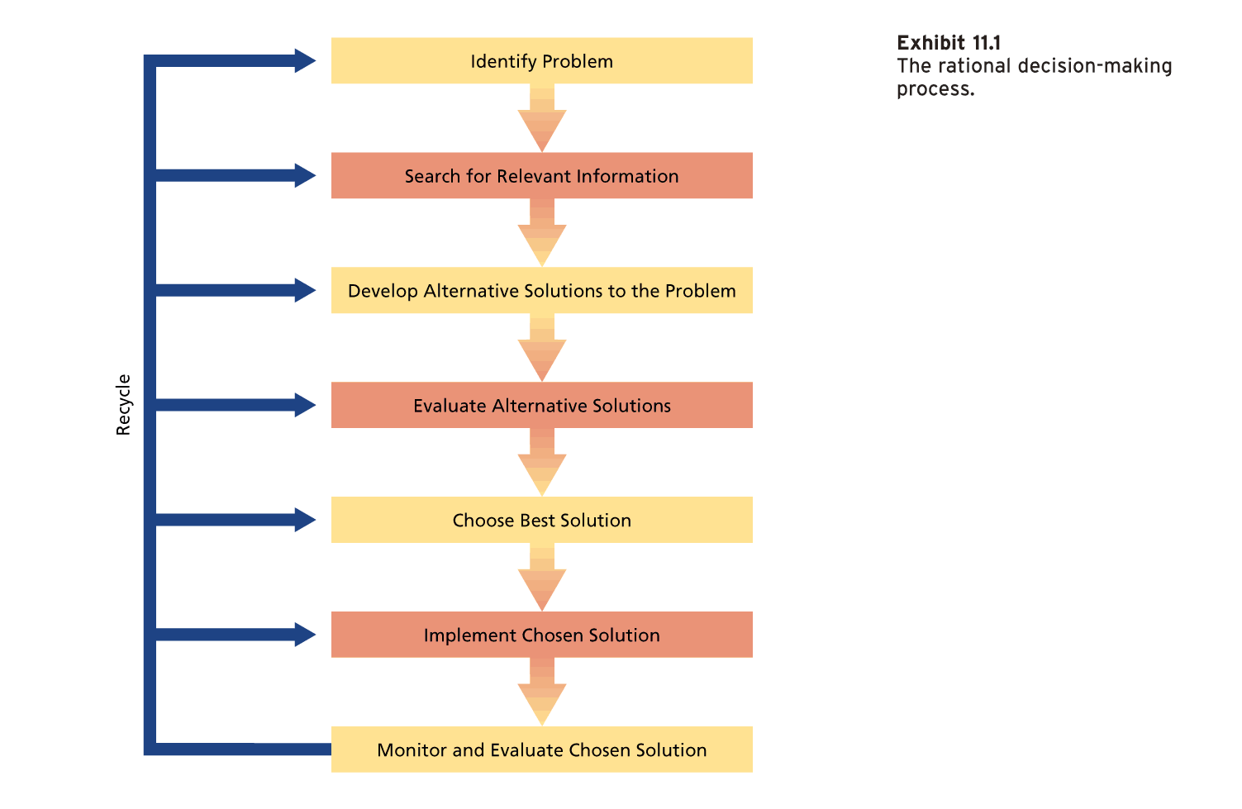

- Perfect Vs. Bounded Rationality
  - Perfect rationality (‘economic person’): a decision strategy that is completely informed, perfectly logical, and oriented toward economic gain
    - Perfect, cool, calculating decision maker
    - He or she:
      - Can gather information about problems and solutions without cost and is thus completely informed
      - Is perfectly logical
      - Has only one criterion for decision making—economic gain
    - Useful for theoretical purposes, however, the perfectly rational characteristics embodied in economic person do not exist in real decision makers
  - Bounded rationality: a decision strategy that relies on limited information and that reflects time constraints and political considerations
    - Framing and cognitive biases the operation of bounded rationality , as does the impact of emotions and mood on decisions
    - Framing: (sometimes subtle) aspects of the presentation of information about a problem that are assumed by decision makers
      - Could include assumptions about the boundaries of a problem, the possible outcomes of a decision, or the reference points used to decide if a decision is successful
      - How problems and decisions are framed can have a powerful impact on resulting decisions
    - Cognitive biases: tendencies to acquire and process information in an error-prone way
      - Constitute assumptions and shortcuts that can improve decision-making efficiency, but they frequently lead to serious errors in judgment

- Problem Identification and Framing
  - Bounded rationality can lead to the following difficulties in problem identification
    - Perceptual defence: the perceptual system may act to defend the perceiver against unpleasant perceptions
    - Problem defined in terms of functional specialty: selective perception can cause decision makers to view a problem as being in the domain of their own specialty even when some other perspective might be warranted
    - Problem defined in terms of solution: this form of jumping to conclusions effectively short-circuits the rational decision-making process
    - Problem diagnosed in terms of symptoms: “what we have here is a morale problem”. While this might be true, a concentration on surface symptoms will provide the decision maker with few clues about an adequate solution. The real problem here involves the cause of the morale problem.

- Information Search
  - Once a problem is identified, a search for information is instigated
  - This info may clarify the nature or extent of the problem and begin to suggest alternative solutions
  - Perfectly rational Economic Person is in good shape at this second stage; they have free and instantaneous access to all info necessary to clarify the problem and develop alternative solutions
  - Bounded rationality, however, presents a different picture; the information search might be slow and costly
  - Too Little Information
    - Sometimes decision makers do not acquire enough information to make a good decision; several cognitive biases contribute to this
      - People tend to be mentally lazy and use whatever information is most readily available to them
        - Also tend to remember vivid events
      - Curtail information and rely on familiar experience
      - Over-confidence
      - Confirmation bias: the tendency to seek out information that conforms to one’s own definition of or solution to a problem
        - According to one expert: this leads to “decision-based evidence making” rather than “evidence-based decision making”
  - Too Much Information
    - This can also damage the quality of decisions
    - Information overload: the reception of more information than is necessary to make effective decisions
      - Can lead to errors, omissions, delays, and cutting corners
      - Attempt to use all the info at hand, then get confused and permit low-quality information or irrelevant information to influence their decisions
    - Decision makers seem to think more is better
      - Even if decisions do not improve with additional information, confidence in the decisions will increase
      - Decision makers may fear being “kept in the dark” and associate the possession of all information with power
    - One research review concludes that managers
      - Gather much information that has little decision relevance
      - Use info that they collected and gathered after a decision to justify that decision
      - Request info that they do not use
      - Request more info, regardless of what is already available
      - Complain that there is not enough information to make a decision even though they ignore available information
    - Information search often involves seeking advice from various parties, including trade associations, government agencies, and consultants
    - Research reveals that people have a cognitive bias to value advice for which they have paid over free advice of equal quality

- Alternative Development, Evaluation, and Choice
  - Perfectly informed or not, now the decision maker can now list alternative solutions to the problem, examine the solutions, and choose the best one
  - In this case, the decision maker can exhibit maximization—he or she can choose the alternative with the greatest expected value
  - People frequently violate standard statistical principles, for example:
    - Avoid incorporating known existing data about the likelihood of events into their decisions
    - Large samples warrant more confidence than small samples but people only use small focus groups
    - Decision makers overestimate the odds of complex chains of events occurring
    - People are poor at revising estimates of probabilities and values as they acquire additional information.
      - Anchoring effect: the inadequate adjustment of subsequent estimates from an initial estimate that serves as an anchor
  - By making people more accountable for their decision it may reduce cognitive biases
  - The accountability must be placed on them prior to when the decision is made
  - Bounded decision makers evaluate solutions against economic gain, and other criteria such as political acceptability, that increases decision making complexity
  - Firms normally don’t invest much money in exploring alternatives
  - Bottom line here is that the decision maker working under bounded rationality frequently “satisfices” rather than maximizes
  - Satisficing: establishing an adequate level of acceptability for a solution to a problem and then screening solutions until one that exceeds this level is found
    - This is key to decision making to reduce complexity and costs
  - The provision of information concerning alternatives is crucial to good decision making

- Risky Business
  - Choosing between decision alternatives often involves an element of risk, and the research evidence on how people handle such risks is fascinating
  - Research shows that when people view a problem as a choice between losses, they tend to make risky decisions, rolling the dice in the face of a sure loss
  - When people frame the alternatives as a choice between gains they tend to make conservative decisions, protecting the sure win
  - It is very important to be aware of what reference point you are using when you frame decision alternatives
  - It is not necessarily wrong to frame the problem as a choice between losses, but this can contribute to a foolish level of risk taking
  - Learning history can modify these general preferences for or against risk

Solution Implementation
  - When a decision is made to choose a particular solution to a problem, the solution must be implemented
  - The perfectly rational decision maker will have factored any possible implementation problems in to his or her choice of solutions
  - The bounded decision maker will attempt to do the same when estimating probabilities of success
  - Decision makers are often dependent on others to implement their decisions, and it might be difficult to anticipate their ability or motivation to do so

- Solution Evaluation
  - When the time comes to evaluate the implemented solution, the decision maker is effectively examining the possibility that a new problem has occurred: Does the (new) existing state match the desired state? Has the decision been effective?
    - The perfectly rational decision maker should be able to evaluate the effectiveness of the decision with calm, objective detachment
    - The bounded decision maker might encounter problems at this stage
  - Justification
    - People tend to be overconfident about the adequacy of their decisions, thus, substantial dissonance can be aroused when a decision turns out to be faulty
      - One way to prevent this dissonance is to avoid careful tests of the adequacy of the decision
    - The justification of faulty decisions is best seen in the irrational treatment of sunk costs
    - Sunk costs: permanent losses of resources incurred as the result of a decision
    - Escalation of commitment: the tendency to invest additional resources in an apparently falling course of action
      - Sometimes happens even if the current decision maker is not responsible for previous sunk costs
      - Dissonance reduction and the appearance of consistency are irrelevant, suggesting some other causes of escalation
      - Decision makers might be motivated not to appear wasteful
      - Also might be due to the way in which decision makers frame the problem once some resources have been sunk
      - Personality, moods, and emotions can also affect this
      - Can occur in both competitive and non-competitive situations
    - Ways to prevent the tendency to escalate commitment to a failing course of action? Research suggests:
      - Encourage continuous experimentation with reframing the problem to avoid the decision trap of feeling that more resources have to be invested. Shift the frame to saving rather than spending
      - Set specific goals for the project in advance that must be met if more resources are to be invested. This prevents escalation when early results are “unclear”
      - Place more emphasis when evaluating managers on how they made decisions and less on decision outcomes
      - Separate initial and subsequent decision making so that individuals who make the initial decision to embark on a course of action are assisted or replaced by others who decide if a course of action should be continued
    - Groups are more prone than individuals to escalate commitment
  - Hindsight
    - Hindsight refers to the tendency to review the decision-making process that was used to find out what was done right (in the case of success) or wrong (in the case of failure)
    - Often reflects a cognitive bias
    - Classic example of hindsight involves the armchair quarterback who “knew” that a chancy intercepted pass in the first quarter was unnecessary because the team won the game
      - This is faulty hindsight; the tendency to assume, after the fact, that we knew all along what the outcome of a decision would be
      - In effect, faulty memory adjust the probabilities that we estimated before making the decision to correspond to what actually happened
    - Another form of faulty hindsight is the tendency to take personal responsibility for successful decision outcomes while denying responsibility for unsuccessful outcomes

- How Emotion and Mood Affect Decision Making
  - People do not like to be wrong, and they often become emotionally attached to the failing course of action that signals escalation of commitment
  - Decision makers in a good mood can overestimate the likelihood of good events and use shortcut decision strategies
  - It should be emphasized that emotionless decision making would be poor decision making, and the rationale model is not meant to suggest otherwise
  - Strong emotions frequently figure in the decision-making process that corrects ethical errors, and so-called whistle-blowers often report that they were motivated by emotion to protest decision errors
  - Strong (positive) emotion has also been implicated in creative decision making and the proper use of intuition to solve problems
    - Such intuition can lead to the successful short-circuiting of the steps in the rational model when speed is of the essence
  - Many cases where strong emotions are a hindrance, as people experiencing strong emotions are often self-focused and distracted from the actual demands of the problem at hand
  - Mood is a pretty low-key state, and you might think it would not have much impact on decisions, however, there is plenty of evidence that mood affects what and how people think when making decisions
  - Mood has its greatest impact on uncertain, ambiguous decisions of the type that are especially crucial for organizations. Research reveals:
    - People in a positive mood tend to remember positive information and those in a negative mood remember negative information
    - People in a positive mood tend to evaluate objects, people, and events more positively
    - People in a good mood tend to overestimate the likelihood that good events will occur and underestimate the occurrence of bad events. People in a bad mood do the opposite
    - People in a good mood adopt simplified, shortcut decision-making strategies, more likely violating a rational model. People in a negative mood are prone to approach decisions in a more deliberate, systematic, detailed way
    - Positive mood promotes more creative, intuitive decision making

- Rational Decision Making—A Summary
  - For complex, unfamiliar decisions, such as choosing an occupation, the rational model provides a pretty good picture of how people actually make decisions
  - Organizational decision makers often follow the rational model when they agree about the goals they are pursuing
- 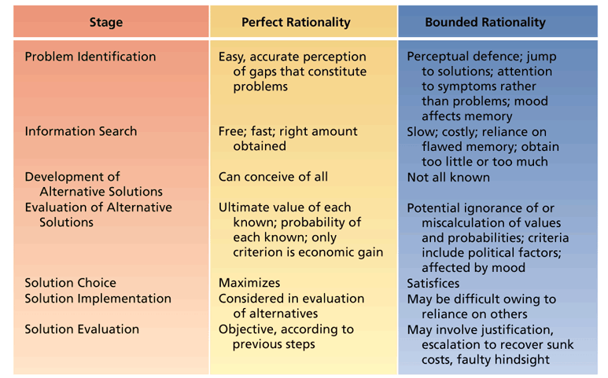
  - True experts in a field will short-circuit the rational model, using their intuitive knowledge base stored in memory to skip steps logically

Group Decision Making
  - Advantages and Disadvantages of group decision making
- 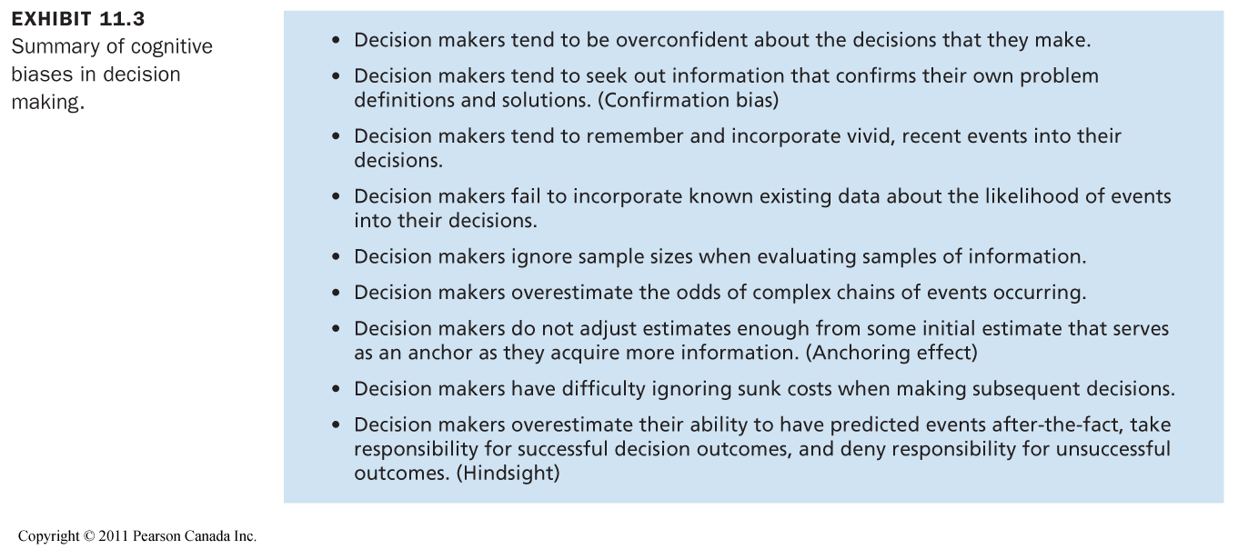
- Why Use Groups?
  - Decision Quality
    - Experts often argue that groups can make higher-quality decisions than individuals, based on these three assumptions:
      - Groups are MORE VIGILANT than individuals are—more people are scanning the environment
      - Groups can GENERATE MORE IDEAS than individuals can
      - Groups can EVAULATE IDEAS better than individuals
    - Vigilance is especially advantageous
    - When it comes to developing alternative solutions, more people should literally have more ideas, if only because someone remembers something that others have forgotten
    - Members with different backgrounds and experiences may bring different perspectives to the problem
    - When it comes to evaluating solutions and choosing the best one, groups have the advantage of checks and balances—an extreme position or incorrect notion held by one member should be offset by the pooled judgments of the rest of the group
  - Decision Acceptance and Commitment
    - Groups are often used to make decisions on the premise that a decision made in this way will be more acceptable to those involved. Several assumptions underlying this premise:
      - People wish to be involved in decisions that will affect them
      - People will better understand a decision in which they participated
      - People will be more committed to a decision in which they invested personal time and energy
    - The acceptability of group decisions is especially useful in dealing with a problem described earlier—getting the decision implemented
  - Diffusion of Responsibility
    - High quality and acceptance are sensible reasons for using groups to make decisions
    - A less admirable reason to employ groups is to allow for diffusion of responsibility
    - Diffusion of responsibility: the ability of group members to share the burden of the negative consequences of a poor decision
      - No one person singled out for punishment
      - When this happens, often group members “abandon ship” and exhibit biased hindsight

Do Groups Actually Make Higher-Quality Decisions than Individuals?
  - The answer is YES—“groups usually produce more and better solutions to problems than do individuals working alone”
  - More specifically, groups should perform better than individuals when:
    - The group members differ in relevant skills and abilities, as long as they do not differ so much that conflict occurs
    - Some divisions of labour can occur
    - Memory of facts is an important issue
    - Individual judgments can be combined by weighting them to reflect the expertise of the various members

- Disadvantages of Group Decision Making
  - There are a number of potential disadvantages to group decision making:
    - Time
      - Groups seldom work quickly or efficiently compared with individuals
    - Conflict
      - Participants in group decisions may have their own personal axes to grind or their own resources to protect
    - Domination
      - The advantages of group decision making will seldom be realized if meetings are dominated by a single individual or small coalition, especially if the dominant person is particularly misinformed
    - Groupthink
      - The capacity for group pressure to damage the mental efficiency, reality testing, and moral judgment of decision-making groups
      - In effect, unanimous acceptance of decisions is stressed over quality of decisions
      - Groupthink symptoms:
        - Illusion of invulnerability: members are overconfident and willing to assume great risks. They ignore obvious danger signals
        - Rationalization: problems and counter-arguments that members cannot ignore are “rationalized away”. Seemingly logical but improbable excuses are given
        - Stereotypes of outsiders: the group constructs unfavourable stereotypes of those outside the group who are targets of their decisions
        - Pressure for conformity: members pressure each other to fall in line and conform with the group’s views
        - Self-censorship: members convince themselves to avoid voicing opinions contrary to the group
        - Illusion of unanimity: members perceive that unanimous support exists for their chosen course of action
        - Mindguards: some group members may adopt the role of “protecting” the group from information that goes against it’s decisions
      - Victims of groupthink are operating in an atmosphere of unreality that should lead to low-quality decisions
      - What can prevent groupthink?
        - Leaders must not exert undue pressure for a particular decision outcome and concentrate on good decision processes
        - Leaders should establish norms that encourage and even reward responsible dissent
        - Experts should be brought in to challenge the group’s views

- How Do Groups Handle Risk?
  - Argued that group will make riskier decisions than individuals because there is security in numbers
  - Also argued that groups are cautious, with members checking and balancing each other so much that a conservative outcome is sure to occur
  - Research discovered clear evidence of a risky shift in decision making
  - Risky shift: the tendency for groups to make riskier decisions than the average risk initially advocated by their individual members
  - Other groups showed conservative shifts
  - Conservative shifts: the tendency for groups to make less risky decisions than the average risk initially advocated by their individual members
  - It is now clear that both risky and conservative shifts are possible, and that they occur in a wide variety of real settings, including investment and purchasing decisions
  - A key factor of this appears to be the initial positions of the group members before they discuss the problem
  - Group discussion seems to polarize or exaggerate the initial position of the group
- 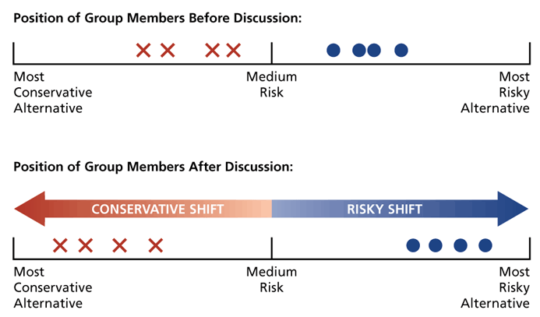
  - Why do risky and conservative shifts occur when groups make decisions? Evidence indicates 2 factors:
    - Group discussion generates ideas and arguments that individual members have not considered before; this information naturally favours the members’ initial tendency toward risk or toward conservatism
    - Group members try to present themselves as basically similar to other members but “even better” ; they try to one-up others in discussion by adopting a slightly more extreme version of the group’s initial stance
  - Managers should be aware of the tendency for group interaction to polarize initial risk levels
  - If this polarization results from the sensible exchange of information, it might actually improve he group’s decision
  - However, if it results from one-upmanship, it might lead to low-quality decisions

- Improving Decision Making in Organizations
  - Managers can improve the success of heir decision by using various tactics:
    - Training Discussion Leaders
      - An appointed leader often convenes the group and guides the discussion in groups
      - The actions of this leader can make or break the decision
      - If the leader behaves autocratically, trying to “sell” a preconceived decision, the advantages of using a group are obliterated, and decision acceptance can suffer
      - If the leader fails to exert any influence, however, the group might develop a low-quality solution that does not meet the needs of the organization
      - the use of role-playing training to develop these leadership skills has increased the quality and acceptance of group decisions
    - Stimulating and Managing Controversy
      - Research shows a variety of ways to stimulate the controversy in decision-making groups
        - Incorporating members with the diverse ideas and backgrounds, forming subgroups to “tear the problem apart”
        - Establishing norms that favour the open sharing of information
      - An interesting method of controversy stimulation is the appointment of a devil’s advocate
      - Devil’s advocate: a person appointed to identify and challenge the weaknesses of a proposed plan or strategy
        - The the decision is made in full recognition of the pros and cons of the plan
        - Improves decision quality
        - To be effective, the advocate must present his or her views in an objective, unemotional manner
    - Traditional and Electronic Brainstorming
      - Major purpose is to increase the number of creative solution alternatives to problems
      - Focuses on the generation of ideas rather than the evaluation of ideas
      - If a group generates a large number of ideas, the chance of obtaining a truly creative solution is increased
      - No ideas should be considered too extreme or unusual to be voiced
      - Research has shown conclusively that individuals working alone tend to generate more ideas than those in groups
      - Brainstorming can provide advantages that extend beyond the mere number of ideas generated
        - Helps organizational memory and supports a culture of wisdom; ideas from one session can be used on subsequent, unrelated projects, and participants learn to appreciate the good ideas of others
        - Sessions motivate and stimulate the engineers and allow them to show off their good ideas to their colleagues
        - Shapes the organizational culture, helps retain good talent, and contributes to client confidence
      - Electronic brainstorming: the use of computer-mediated technology to improve traditional brainstorming practices
        - As electronic groups get larger, they tend to produce more ideas, but the ideas-per-person measure remains stable
        - Reduced inhibition about participating and the ability for people to enter ideas simultaneously without waiting for others seem to be the main reason these are successful
    - Nominal Group Technique
      - Nominal group structure: a structured group decision-making technique in which ideas are generated without group interaction and then systematically evaluated by the group
      - NGT is concerned with both the generation of ideas and the evaluation of these ideas
      - NGT carefully separates the generation of ideas from their evaluation
      - ideas are generated nominally (without interaction) to prevent inhibition and conformity
      - NGT’s chief disadvantage would seem to be the time and resources required to assemble the group for face-to-face interaction
    - The Delphi Technique
      - Delphi technique: a method of pooling a large number of expert judgments by using a series of increasingly refined questionnaires
      - Minimally, there are two waves of questionnaires, but more is not unusual
        - First questionnaire is usually general in nature and permits free responses to the problem
      - Chief disadvantage of Delphi is the rather lengthly time frame involved in the questionnaire phases, although email and other web-based solutions can speed up sending and receiving
      - Its effectiveness depends on the writing skills of the respondents and their interest in the problem, since they must work on their own rather than as a part of an actual group
      - Delphi is an efficient method of pooling a large number of expert judgments while avoiding the problems of conformity and domination that can occur in interacting groups

Chapter 12: Power, Politics, and Ethics

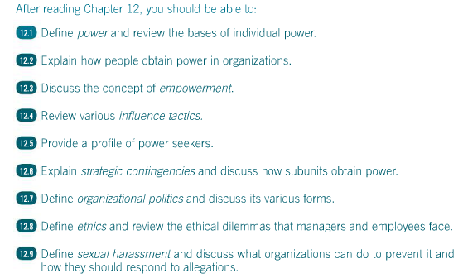

What is Power?
  - Power: the capacity to influence others who are in a state of dependence
    - Not always perceived or exercised
    - The fact that the target of power is dependent on the power holder does not imply that a poor relationship exists between the two
    - You can exert reciprocal influence for similar reasons
    - Power can flow in any direction in an organization
    - Often members at higher organizational levels have more power than those at lower levels, however, in specific cases, reversals can occur
    - Power is a broad concept that applies to both individuals and groups

- The Bases of Individual Power
  - Psychologists John French and Bertram Raven explained that power can be found in the position that you occupy in the organization or the resources that you are able to command
  - The first base of power—legitimate power—is dependent on one’s position of job
  - The other bases (reward, coercive, referent, and expert power) involve the control of important resources
  - Legitimate Power: power derived from a person’s position or job in an organization
    - It constitutes the organization’s judgment about who is formally permitted to influence whom, and it is often called authority
    - As you move up the organization’s hierarchy, we find that members possess more and more legitimate power
    - Organizational equals have equal legitimate power
    - Organizations differ greatly in the extent to which they emphasize and reinforce legitimate power
    - When legitimate power works, it often does so because people have been socialized to accept its influence
    - Employees consistently cite legitimate power as a major reason for following their boss’s directives, even across various cultures
  - Reward Power: power derived from the ability to provide positive outcomes and prevent negative outcomes
    - In general, it corresponds to the concept of positive reinforcement
    - Reward power often backs up legitimate power
    - Any organizational member can attempt to exert influence over others with praise, compliments, and flattery, which also constitute rewards
  - Coercive Power: power derived from the use of punishment and threat
    - It is often a support for legitimate power
    - When managers use coercive power, it is generally ineffective and can provoke considerable employee resistance
  - Referent Power: power derived from being well liked by others
    - People we like readily influence us; we are prone to consider their points of view, ignore their failures, seek their approval, and use them as role models
    - Often highly dissonant to hold a point of view that is discrepant from that held by someone we like
    - Referent power is especially potent for two reasons
      - It stems from identification with the power holder
      - Anyone in the organization may be well liked, irrespective of their other bases of power
    - It is available to anyone in the organization
    - Friendly interpersonal relations often permit influence to extend across the organization, outside the usual channels of legitimate authority, reward, and coercion
  - Expert Power: power derived from having special information or expertise that is valued by an organization
    - The more critical and unusual this expertise, the greater is the expert power available
    - Expert power corresponds to difficulty of replacement
    - One of the most fascinating aspects of expert power occurs when lower-level organizational members accrue it (ex. Many secretaries)
    - Of all the bases of managerial power, expertise is the most consistently associated with employee effectiveness
    - Research shows that employees perceive women managers as more likely than male managers to be high in expert power
  - Likely responses to various bases of managerial power:
    - Coercion is likely to produce resistance and lack of cooperation
    - Legitimate power and reward power are likely to produce compliance with the boss’s wishes
    - Referent and expert power are most likely to generate true commitment and enthusiasm for the manager’s agenda
- 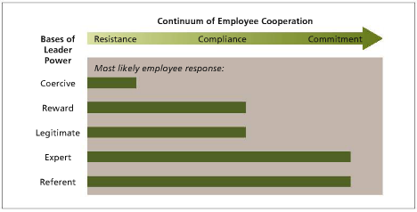
- How Do People Obtain Power?
  - Doing the right things
    - Rosabeth Moss Kanter has provided a succinct recipe: Do the right things, and cultivate the right people
    - According to Kanter, some activities are “righter” than others for obtaining power
    - Activities lead to power when they are extraordinary, highly visible, and especially relevant to the solution of organizational problems
    - Extraordinary Activities
      - Excellent performance in unusual or non-routine activities
    - Visible Activities
      - People who have an interest in power are especially good at identifying visible activities and publicizing them
    - Relevant Activities
      - Extraordinary, visible work may fail to generate power if no one cares
      - If nobody sees the work as relevant to the solution of important organizational problems, it will not add to one’s influence
  - Cultivating the Right People
    - “It’s not what you know, it’s who you know”
    - developing informal relationships with the right people can prove a useful means of acquiring power
    - Outsiders
      - Establishing relationships with key people outside one’s organization can lead to increased power within the organization
      - Cultivating outsiders may also contribute to more tangible sources of power (i.e. information)
    - Subordinates
      - An individual can gain influence if she is closely identified with certain up-and-coming subordinates
      - Can also provide power when a manager can demonstrate that he or she is backed by a cohesive team
    - Peers
      - A means of ensuring that nothing gets in the way of one’s future acquisition of power
    - Superiors
      - Liasions with key supervisors probably represent the best way of obtaining power through cultivating others
      - Mentors and sponsors; provide power in several ways—can provide special information and useful introductions to other “right people”
    - Although cultivating others can add to one’s power base, associates of people who have power sometimes develop an exaggerated and illusory sense of their own power, status, and influence

- Empowerment—Putting Power Where it is Needed
  - Early organizational scholars treated power as something of a fixed quantity: an organization had so much, the people on the top had a lot, and lower-level employees had a little
  - Contemporary views of power treat it less as a fixed-sum phenomenon
  - This is best seen as the concept of empowerment
  - Empowerment: giving people the authority, opportunity, and motivation to take initiative and solve organizational problems
  - Having opportunity usually means freedom from bureaucratic barriers and other system problems that block initative
  - Opportunity also includes any relevant training and information about the impact of one’s actions on other parts of the organization
  - The motivation part of the empowerment equation suggest hiring people who will be intrinsically motivated by power and opportunity and aligning extrinsic rewards with successful performance
  - People who are empowered have a strong sense of self-efficacy, the feeling that thet are capable of doing their jobs well and “making things happen”
  - There is growing evidence that empowerment fosters job satisfaction, organizational commitment, organizational citizenship behaviours, and high performance
  - Used properly, empowerment puts power where it’s needed

Relationships Between Power and Performance

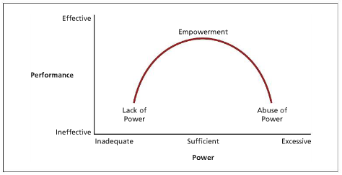

Influence Tactics—Putting Power to Work
  - Research has shown that various influence tactics convert power into actual influence
  - These are specific behaviours that people use to affect others and manage other’s impressions of themselves
  - These tactics include:
    - Assertiveness—ordering, nagging, setting deadlines, and verbally confronting others
    - Ingratiation—using flattery and acting friendly, polite, or humble
    - Rationality—using logic, reason, planning, and compromise
    - Exchange—doing favours or offering to trade favours
    - Upward appeal—making formal or informal appeals to organizational superiors for intervention
    - Coalition formation—seeking united support from other organizational members
  - Your bases of power can determine which influence tactics you might use
  - Surveys show that people report trying to use rationality very frequently
  - The use of tactics is also dependent on who you use them on
  - Some research concerns upward influence attempts directed toward superiors
  - It shows that, at least for men, using rationality as an influence tactic was associated with receiving better performance evaluations, earning more money, and experiencing less work stress
  - Ineffective to use a “shotgun” style—high on all tactics with particular emphasis on assertiveness and exchange
  - Women who used ingratiation as an influence tactic received the highest performance evaluations (from male managers)
  - Another study showed that top managers who used ingratiation with their CEOs were inclined to receive appointments to corporate boards with whom the CEO was connected

- Who Wants Power?
  - Some power seekers feel weak and resort primarily to coercive power to cover up, compensate for, or substitute for this weakness
  - Power is sought for its own sake and is used irresponsibly to hurt others (ex. Hitler)
  - However, power can be used responsibly to influence others
  - David McClelland did research on need for power (n Pow)
    - n Pow is the need to have strong influence over others; this need is a reliable personality characteristic—some people have more than others
    - people who are high in n Pow in its “pure” form conform to the negative stereotype—they are rude, sexually exploitative, abuse alcohol, and show a great concern for status symbols
    - When n Pow is responsible and controlled, these negative properties are not observed
    - McClelland argues that the most effective managers
      - Have high n Pow
      - Use their power to achieve organizational goals
      - Adopt a participative or “coaching” leadership style
      - Are relatively unconcerned with how much others like them
    - He calls this managers institutional managers because they use their power for the good of the institution rather than for self-aggrandizement
    - His research reveals that institutional managers are more effective than personal power managers (who use power for personal gain) and affiliative managers (who are more concerned with being liked than exercising power)
  - The need for power can be a useful asset, as long as it is not a neurotic expression of perceived weakness

Controlling Strategic Contingencies—How Subunit Obtain Power
  - Subunit power: the degree of power held by various organizational subunits, such as departments
  - How do organizational subunits acquire power?
  - In short, they control strategic contingencies, which are critical factors affecting organizational effectiveness that are controlled by a key subunit
    - The work other subunits perform is contingent on the activities and performance of a key subunit
    - Again, we see the critical role of dependence in power relationships
  - Conditions under which subunits can control strategic contingencies
    - Scarcity
      - Differences in subunit power are likely to be magnified when resources become scarce
      - If cutbacks occur, differences in power will become apparent
      - Subunits tend to acquire power when they are able to secure scarce resources that are important to the organization as a whole
    - Uncertainty
      - Organizations detest the unknown
      - Unanticipated events wreak havoc with financial commitments, long-range plans, and tomorrow’s operations
      - The basic sources of uncertainty exist mainly in the organization’s environment—government policies might change, sources of supply and demand might dry up, or the economy might take an unanticipated turn
      - The subunits that that are most capable of coping with uncertainty with tend to acquire power
      - Changes in the sources of uncertainty frequently lead to shifts in subunit power
    - Centrality
      - Subunits whose activities are most central to the mission or work flow of the organization should acquire more power than those whose activities are more peripheral
      - A subunit’s activities can be central in at least htree senses
        - It may influence the work of most other subunits
        - When a subunit has an especially crucial impact on the quantity or quality of the organization’s key product or service
        - A subunit’s activities are more central when their impact is more immediate
    - Substitutability
      - A subunit will have relatively little power if others inside or outside the organization can perform it’s activities
      - If the subunit’s staff is non-substitutable, however, it can acquire substantial power
      - One crucial factor here is the labour market for the specialty performed by the subunit
      - A change in the labour market can result in a change in the subunit’s influence

- Organizational Politics—Using and Abusing Power
  - Not all uses of power constitute politics
- The Basis of Organizational Politics
  - Organizational politics: the pursuit of self-interest in an organization, whether or not this self-interest corresponds to organizational goals
  - Frequently, politics involves using means of influence that the organization does not sanction or pursuing end goals that is does not sanction
  - Political activity is self-conscious and intentional
  - We can conceive politics as either individual activity or subunit activity
    - Either a person or a whole department could act politically
  - It is possible for political activity to have beneficial outcomes for the organization, even though these outcomes are achieved by questionable tactics
  - Means/Ends Matrix: the association between influence means and influences ends that determines whether activities are political and whether these activities benefit the organization
    - I. Sanctioned means/sanctioned ends: here, power is used to routinely pursue agreed-on goals. Familiar, accepted means of influence are employed to achieve sanctioned outcomes
    - II. Sanctioned means/not-sanctioned ends: in this case, acceptable means of influence are abused to pursue goals that the organization does not approve of
    - III. Not-sanctioned means/sanctioned ends: here, ends that are useful for the organization are pursued through questionable means
    - IV. Not Sanctioned means/not-sanctioned ends: this quadrant may exemplify the most flagrant use of power, since disapproved tactics are used to pursuer disapproved outcomes
- 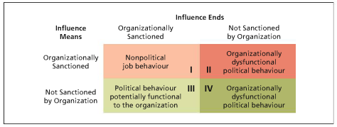
  - Sometimes politicians conceal their activities with a “cover story” or “smoke screen” to make them appear legitimate
  - Such a tactic will increase the odds of success and avoid punishment from superiors
  - A common strategy is to cover non-sanctioned means and ends with a cloak of rationality
  - Do political activities occur under particular conditions or in particular locations in organizations? Research suggests:
    - Managers report that the most political maneuvering occurs at middle and upper management levels rather than at lower levels
    - Some submits are more prone to politicking than others. Clear goals and routine tasks might provoke less political activity than vague goals and complex tasks
    - Some issues are more likely than others to stimulate political activity
    - In general, scarce resources, uncertainty, and important issues provoke political behaviour
  - Highly political climates result in lower job satisfaction, commitment, and organizational citizenship, and increased stress and turnover intentions
  - When it comes to work, politics take a toll on older works but not on younger workers, perhaps due to stress factors

- The Facets of Political Skill
  - It is one thing to engage in organizational politics, but it is another thing to do it skillfully, because pursuing self-interest can encounter resistance
  - Gerald Ferris defines political skill as “the ability to understand others at work and to use that knowledge to influence others to act in ways that enhance one’s personal or organizational objectives”
    - 2 main aspects:
      - Comprehending others
      - Translating this comprehension into influence
  - There are 4 facets to political skill:
    - Social astuteness: good politicians are careful observers who are turned in to others’ needs and motives. They can “read” people and thus possess emotional intelligence and are self-monitors who know how to present themselves to others
    - Interpersonal Influence: the politically skilled have a convincing and persuasive interpersonal style but employ it flexibly to meet the needs of the situation. They put others at ease
    - Apparent Sincerity: influence attempts will be seen as manipulative unless they are accompanied by sincerity. A good politician comes across as genuine and exhibits high integrity
    - Networking Ability: networks provide a channel for favours to be asked for and given. An effective network enhances one’s organizational reputation, thus aiding influence attempts
  - Political skill, as measured by these four facets, is positively related to job performance, and more skilled politicians are less inclined to feel stressed in response to role conflict (better at coping)
  - Monica Forret and Thomas Dougherty determined that there are various aspects to networking:
    - Maintaining contacts
    - Socializing
    - Engaging in professional activities
    - Participating in community activities
    - Increasing internal visibility
- 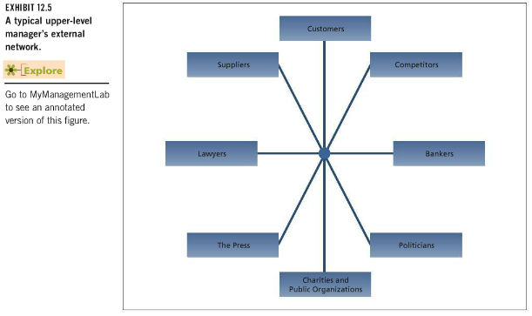
  - They found that those high in self-esteem and extraversion were more likely to engage in networking behaviours
  - Also found that engaging in professional activities and increasing internal visibility were more associated with career success—but this applied only to men
  - Networking has increased in importance as people become more self-reliant and less reliant on organizations to plot their career futures
  - Being central in a large network provides power because you have access to considerable resources, such as knowledge
    - Especially true if the network is diverse and consists of those who themselves hold power

- Machiavellianism—The Harder Side of Politics
  - Machiavellianism: a set of cynical beliefs about human nature, morality, and the permissibility of using various tactics to achieve one’s ends
  - Compared with “low Machs”, “high Machs” are more likely to advocate the use of lying and deceit to achieve desired goals and argue that morality can be compromised to fit the situation in question
  - High Machs assume that many people are excessively gullible and do not know what is best for themselves
  - In interpersonal situations, the high Mach acts in an exceedingly practical manner, assuming that the ends justify the means
  - They are quite willing to form coalitions with others to outmaneuver or defeat people who get in their way
  - High Machs are likely to be enthusiastic organizational politicians
  - Appears that high Machs do not feel guilty about the social tactics they use
    - Seem to be able to insulate themselves from the negative social consequences of their tactics
    - High Mach’s are able to accurately identify situations in which their favoured tactics will work; such situations have the following characteristics:
      - The high Mach can deal face to face with those he or she is trying to influence
      - The interaction occurs under fairly emotional circumstances
      - The situation is fairly unstructured, with few guidelines for appropriate forms of interaction
  - In combination, these characteristics reveal a situation in which the high Mach can use his or her tactics because emotion distracts others
  - High Machs, by remaining calm and rational, can create a social structure that facilitates their personal goals at the expense of others
  - Research shows that high Machs are unlikely to be high performers; in fact, they are inclined toward counterproductive behaviours such as sabotage and theft

Defensiveness—Reactive Politics
  - The goal here is to reduce threats to one’s own power by avoiding actions that do not suit one’s own political agenda or avoiding blame for events that might threaten one’s political capital
  - Astute organizational politicians are aware that sometimes the best action to take is no action at all
  - A number of defense behaviours can accomplish this mission:
    - Stalling: moving slowly when someone asks for your cooperation is the most obvious way of avoiding taking action without actually saying no
    - Overconforming: sticking to the strict letter of your job description or to organizational regulations is a common way to avoid action
    - Buck passing: having someone else take action is an effective way to avoid doing it yourself
  - Another set of defensive behaviours is oriented around the motto “if you can’t avoid action, avoid blame for its consequences”; these include:
    - Buffing: the tactic of carefully documenting information showing that an appropriate course of action was followed. Can be sensible behaviour, but it takes on political overtones when doing the documenting becomes more important that making a good decision
    - Scapegoating: blaming others when things go wrong is classic political behaviour. It works best when you have some power behind you

- Ethics in Organizations
  - Ethics: systematic thinking about the moral consequences of decisions
  - Moral consequences can be framed in terms of the potential for harm to any stakeholders in the decision
  - Stakeholders: people inside or outside the organization who have the potential to be affected by organizational decisions
  - After a number of surveys were conducted, a large majority agree that unethical practices occur in business and a substantial proportion report that they have been pressured to compromise their own ethical standards when making decisions
  - In line with the concept of self-serving attributions, managers invariably tend to see themselves as having higher ethical standards than their peers and sometimes their superiors
  - Undergrad business students have been found to be more ethical than MBA students
  - Women are marginally more ethical than men and older people are marginally more ethical than young

- The Nature of Ethical Dilemmas
  - The figures below indicate the extent for which various issues are covered for the firms’ own employees, its suppliers and its joint venture partners
    - Contractual and legally mandated issues find the most consensus
    - The important but more subjective matters at the bottom of the list are less likely to be addressed
- 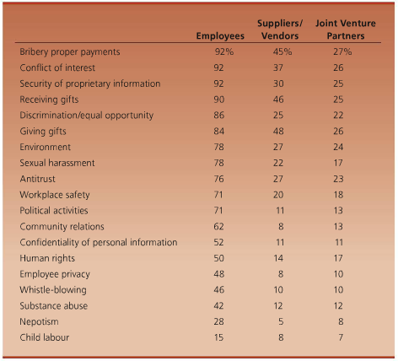
  - Ethical issues are often occupationally specific
  - Moral standards for decision making; some typical examples of associated ethical behaviour:
    - Honest communication
    - Fair treatment
    - Special consideration
    - Fair competition
    - Responsibility to organization
    - Corporate social responsibility
    - Respect for law

- Causes of Unethical Behaviour
  - Knowing the causes can aid in its prevention
  - The major evidence comes from surveys of executive opinion, case studies of prominent ethical failures, business game simulations, and responses to written scenarios involving ethical dilemmas
  - Gain
    - Critical to recognize the role of temptation in unethical activity
    - The anticipation of healthy reinforcement for following an unethical course of action, especially if no punishment is expected should promote unethical behaviour
  - Role Conflict
    - Many ethical dilemmas are actually forms of role conflict that get resolved in an unethical way
    - A very common form of role conflict that provokes unethical behaviour occurs when our “bureaucratic” role as an organizational employee is at odds with our role as the member of a profession
    - Reward systems heighten the conflict, which then becomes a conflict of interest between self and client
  - Strong Organizational Identification
    - Some employees identify very strongly with their organizations, seeing their membership as an integral part of their identity
    - This can sometimes lead them to engage in unethical behaviour to “help” the organization
  - Competition
    - Stiff competition for scarce resources can stimulate unethical behaviour
    - In cases which essentially no competition exists, there is also a strong temptation to make unethical decisions
  - Personality
    - The cynical and those with external locus of control are less tuned into ethical matters
    - People with a high need for personal power may be prone to make unethical decisions, using this power to further self-interest rather than for the good of the organization as a whole
    - People with strong economic values are more likely to behave unethically
    - Less disengagement and more attentiveness is associated with more ethical behaviour
  - Organizational and Industry Culture
    - Aspects of an organization’s culture can influence ethics
    - Firms convicted of illegal acts often tend to be repeat offenders
    - No one thing creates a “culture of corruption”; it is often a combination of factors, such as evaluating managers solely “by the numbers”, denying responsibility, denying injury to others, and teaching (low power) newcomers corrupt practices that lead to unethical corporate cultures
    - Research shows that upper-level managers generally tend to be naïve about the extent of ethical lapses in those below them

- Whistle-Blowing
  - Individuals occasionally step forward and “blow the whistle” on unethical actions
  - Whistle blowing: disclosure of illegitimate practices by a current or former organizational member to some person or organization that may be able to take action to correct these practices
  - People with power rarely blow the whistle

- Sexual Harassment—When Power and Ethics Collide
  - In recent years, a number of high-profile sexual harassment cases have made news headlines and brought increased attention to this problem
  - Failure of organizations to effectively respond to charges of sexual harassment can cost millions of dollars in settlements as well as lower productivity, increased absenteeism, and turnover
  - Also, decreased job satisfaction and organizational commitment as well as reduced psychological and physical well-being
  - Sexual harassment is a form of unethical behaviour that stems, in part, from the abuse of power and the perpetuation of a gender power imbalance
  - Most frequent perpetrators are co-workers
  - Incidents of harassment and organizational inaction to complaints of harassment are more likely in male-dominated industries and organizations in which men attempt to maintain their dominance relative to women
  - Many organizations are slow to react to complaints of sexual harassment
    - This is labeled “deaf ear syndrome” which refers to the inaction or complacency or organizations in the face of charges of sexual harassment
    - Three main reasons why organizations fail to respond:
      - Inadequate organizational policies and procedures for managing harassment complaints
      - Defensive managerial reactions
      - Organizational features that contribute to inertial defensive tendencies
  - Organizations can effectively deal with allegations of sexual harassment and increase their responsiveness by taking a number of important measures:
    - Examine the characteristics of deaf ear syndrome
    - Foster management support and education
    - Stay vigilant (observe closely)
    - Take immediate action
    - Create a state-of-the-art policy
    - Establish clear reporting procedures

- Employing Ethical Guidelines
  - A few simple guidelines, regularly used, should help in the ethical screening of decisions
  - You want to think seriously about the moral implications of your decision before you make them
    - Identify the stakeholders that will be affected
    - Identify the costs and benefits of various decision alternatives to these stakeholders
    - Consider the relevant moral expectations that surround a particular decision
    - Be familiar with the common ethical dilemmas that decision makers face in your specific organizational role or profession
    - Discuss ethical matters with decision stakeholders and others
    - Convert your ethical judgments into appropriate action
  - Evidence indicates that formal education in ethics does have a positive impact on ethical attitudes

- Chapter 13: Conflict and Stress

What is Conflict?
- Interpersonal conflict: the process that occurs when one person, group, or organizational subunit frustrates the goal attainment of another
- Conflict involves antagonistic attitudes and behaviours
- As for attitudes, the parting might develop a dislike for each other, see each other as unreasonable, and develop negative stereotypes of their opposites
- Antagonistic behaviours might include name calling, sabotage, or physical aggression
- Organizations manage collaborative ways that keep antagonism at a minimum or they keep conflict hidden or suppressed

Causes of Organizational Conflict
-It is possible to isolate a number of factors that contribute to organizational conflict
Group Identification and Intergroup Bias
- Identification with a particular group or class of people can set the stage for organizational conflict
- People develop more positive view of their in-group versus the out-group. Easy to develop intergroup bias
- Self-esteem is a critical factor to why intergroup bias occurs. Identifying with the successes of one’s own group and disassociating oneself from out-group failures boosts self-esteem and provides comforting feelings of social solidarity
- Differences between groups in organizations might be accentuated by real differences in power, opportunity, clients serviced, and etc.
- The increased emphasis on teams in organizations generally places a high premium on getting employees to identify strongly with their team therefore relationship between teams must be managed carefully
Interdependence
- When individuals or subunits are mutually dependent on each other to accomplish their own goals the potential for conflict exists
- Interdependence can set the stage for conflict for two reasons:
  - It necessitates interaction between the parties so that they can coordinate their interests. Conflict will not arise when people go at it alone.
  - Interdependence implies that each party has some power over the other. One side can easily abuse its power
- Interdependence does not always lead to conflict because it can provides a good basis for collaboration through mutual assistance
Differences in Power, Status, and Cultures
- The degree to which interdependence prompts conflict depends on power, status, and cultures
Power
- If dependence is not mutual the potential for conflict increases
- Antagonism may develop
Status
- Status differences provide little impetus for conflict when people of lower status are dependent on those of higher status because people are socialized to accept status differences
- Because of some jobs some lower level workers might have to give demands to upper level workers which can lead to resentment of the lower level worker
- Executives are defensive when it comes to the reversal of influence roles
Culture
- When two or more organizational cultures develop in an organization the clash in beliefs and values can result in overt conflict
Ambiguity
- Ambiguous goals or performance criteria can lead to conflict
- It is hard to assign proper rewards and punishments during times of ambiguity because it is hard to tell who is responsible for what
- Ambiguous performance criteria are a frequent cause of conflict between managers and employees.
Scarce Resources
- Conflict arises when people try to acquire scarce resources
- Scarcity can turn disguised conflict into overt conflict

Types of Conflict
- Relationship conflict: interpersonal tensions among individuals that have to do with their relationship per se, not the task at hand (ex. personality clashes)
- Task conflict: disagreements about the nature of the work to be done
- Process conflict: disagreements about how work should be organized and accomplished (ex. responsibility, authority, resource allocation, etc.)
- Conflict presents the development of cohesiveness, member satisfaction, and team performance
- Some conflict can be beneficial to team performance when the task is non routine and requires a variety of perspectives, and when it does not generate relationship conflict
Conflict Dynamics
- A number of events occur when one or more of the causes of conflict take effects.
- Conflict can occur between groups or individuals in groups
- When conflict begins the following events transpire:
  - “Winning” the conflict becomes more important than a good solution.
  - The parties conceal information from each other or distort it.
  - Each side becomes more cohesive.
  - Contact with the opposite party is discouraged.
  - Opposite party is negatively stereotyped and image of one’s own position is boosted.
  - More aggressive people who are skilled at engaging in conflict may emerge as leaders.
- The conflict process itself becomes a conflict. The elements of this process then work against the achievement of a peaceful solution. The conflict continues to cycle on its own.

Modes of Managing Conflict
- The approaches to managing conflict are a function of both how assertive you are in trying to satisfy your own or your group’s concerns and how cooperative you are in trying to satisfy those of the other party or group
- None of the five styles for dealing with conflict are inherently superior. Depends on the situation
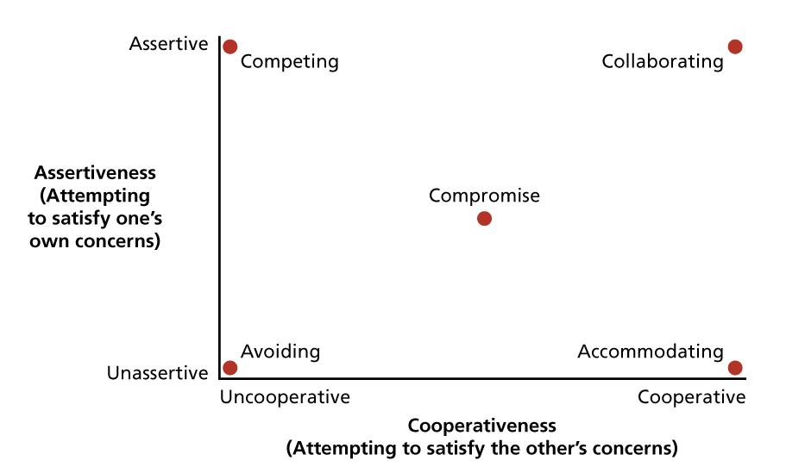
Avoiding
- A conflict management style characterized by low assertiveness of one’s own interests and low cooperation with the other party
- Hiding your head in the sand
- Short term stress reduction from the conflict, it does not change the situation therefore effectiveness lacks
- Avoidance does apply to certain situations
Accommodating
- A conflict management style in which one cooperates with the other party while not asserting one’s own interests
- If people see accommodation as a sign of weakness it does not bode well for future interactions
- It can be effective when you are wrong, the issue is more important to the other party, or you want to build good will
Competing
- A conflict management style that maximizes assertiveness and minimizes cooperation
- Framing conflicts in strict win lose terms
- Full priority is given to your own goals, facts, and procedures
- Holds promise when one has a lot of power, one is sure of their facts, the situation is truly win-lose, or one will not have to interact with the other party in the future
Compromise
- A conflict management style that combines intermediate levels of assertiveness and cooperation
- Combination of pure competition and pure accommodation
- Attempts to satisfice rather than maximize your outcomes and hope that the same occurs for the other party
- Plea bargain is an example
- Compromise places a premium on determining rules of exchange between the two parties
- Compromise does not always result in the most creative response to conflict. It is not useful for resolving conflicts that stem from power asymmetry, because the weaker party may have little to offer the stronger party
- It is a sensible reaction to conflict stemming from scarce resources and is a good feedback position when strategies fail
Collaborating
- A conflict management style that maximizes both assertiveness and cooperation in hope that an integrative agreement occurs that fully satisfies the interests of both parties
- Emphasis put on win-win resolution in which there is no assumption that someone must lose something
- Solution can leave both parties in a better condition
- Works best when conflict is not intense and when each party has information that is useful to the other
- Can take time and practice but enhances productivity and achievement
- Helps to mange conflict inside organizations
- Collaboration between departments is particularly important or providing good customer service

Managing Conflict with Negotiation
- Negotiation: a decision making process among interdependent parties who do not share identical preferences
- Negotiation constitutes conflict management, in that it prevents or resolves existing conflict
- It is an attempt to reach a satisfactory exchange among or between the parties
- Negotiation can proceed in a very implicit or tactic way
- Distributive negotiation: win-lose negotiation in which a fixed amount of assets is divided between parties
- Integrative negotiation: win-win negotiation that assumes that mutual problem solving can enlarge the assets to be divided between parties (between avoiding and collaborating)

Distributive Negotiation Tactics
- Single-issue negotiation
- How to reach a settlement:
Threats and promises
- Threats: consists of implying that you will punish the other part if they do not concede to your position
- Promises: pledges that concessions will lead to rewards in the future
- Threat has some merit as a bargaining tactic if on party has power over the other than corresponds to the nature of the threat
- If power is more balanced and the threat is crude, a counter threat could scuttle the negotiations
- Promises have merit when your side lacks power and anticipates future negotiations
- Threat and promises work best when they send interpretable signals to the others about your true position
- Careful timing is critical
Firmness Versus Concessions
- A series of small concessions early in the negotiation will often be matched
- Concessions are most likely reciprocated leading to a deadlock therefore sometimes better to be firm
Persuasion
- Verbal persuasion and debates are common forms
- Two pronged attack: first prong asserts the technical merits of the party’s position (ex. The consultating firm might justify its target price by saying “we have the most qualified staff and do the most reliable surveys) then the other prong asserts the fairness of the target position (ex. The negotiator might make a speech about the expenses the company would incur in doing the survey)
- Verbal persuasion is an attempt to change the attitudes of the other party toward your target position
- Bias can be a problem because both parties are aware of what the other party wants
- Persuaders are most effective when they are perceived as expert, likeable, and unbiased
- Men have significantly better negotiation outcomes due to the glass ceiling effect
- Salary negotiation is a traditional example of distributive bargaining

Integrative Negotiation Tactics
- Strives for collaborative problem solving and rejects a fixed-pie assumption
- Why the bias for fixed-pie thinking?
  - Integrative negotiation requires a degree of creativity.
Copious Information Exchange
- A freer flow of information is critical to finding an integrative settlement
- Trust must be built slowly to trust the information being used against us in bargaining situations
- To start one must reveal non-critical pieces of information to start the conversation and bargaining then the negotiation tends to be reciprocated
- Ask questions and listen to responses
- If all goes well both parties will start to reveal their true interests and not just their current positions
Framing differences as opportunities
- By framing the differences in the party’s preferences, it sets as a barrier for the other party to agree or compromise
- Frame things differently
Cutting Costs
- Integrative solutions are more attractive when they cut costs for all parties in a dispute or for one of them
- Can reduce costly competition
Increasing Resources
- Increasing available resources is a very literal way of getting around the fixed-pie syndrome
- By combining resources and working together one, the parties can come to an agreement faster
Introducing Subordinate Goals
- Subordinate goals- attractive outcomes that can be achieved only by collaboration

Third Party Involvement
- Third parties can come to intervene between negotiating parties. This happen when the parties reach an impasse
- Some third party negotiations can start from the beginning
Mediation
- The process of mediation occurs when a neutral third party helps to facilitate a negotiated agreement
- Almost any manager can play a mediation role
- What mediators do:
  - Anything that aids to the process or atmosphere of negotiation
  - Tries to help the parties clarify their underlying interests both to them and the others
  - Imposes deadlines
  - Pushes parties towards more integrative bargaining
  - Intervene in content of the negotiation, highlighting points of agreement, pointing out new options, or encouraging concessions
- Works best only when conflict is not too intense and if the mediator is seen as neutral
Arbitration
- The process occurs when a third party is given the authority to dictate the terms of settlement of a conflict
- Can be mandated formally by law
- Arbitrator makes a final distributive allocation decision
- Conventional arbitration- the arbitrator can choose any outcome
- Final offer arbitration- each party makes a final offer and the arbitrator chooses one of them. Motivates more reasonable negotiation agreements
- Arbitrators side with company when they complain that employees have been excessively absent
- One of the most commonly arbitrated disputes between employers and employees is dismissal for excessive absenteeism

Is all Conflict Bad?
- Conflict change adaption survival
- For organizations to survive they must adapt to their environments. This requires changes in strategy that may be stimulated through conflict
- How does conflict promote change?
  - Might bring into consideration new ideas that would not be offered without conflict in trying to one-up the other
  - Because each party begins to monitor the other’s performance more carefully. This search for weakness and address errors and problems in the organization
  - Signals that redistribution of power is necessary
- Conflict stimulation: a strategy of increasing conflict to motivate change
- Conflict is a good thing when:
  - There is a “friendly rut” in which peaceful relationships take precedence over organizational goals
  - When parties should be interacting closely but have withdrawn from each other to avoid overt conflict
  - When conflict is suppressed by denying differences, ignoring controversy, and exaggerating points of agreement
- Causes of conflict can promote change

A Model of Stress in Organizations
- 40% of workers found their jobs to be stressful
Stressors
- Stressors: environmental events or conditions that have the potential to induce stress
- Conditions that prove stressful for everyone:
  - Extreme heat
  - Extreme cold
  - Isolation
  - Hostile people
- Personality determines whether an event is a stressor and how much it effects the person
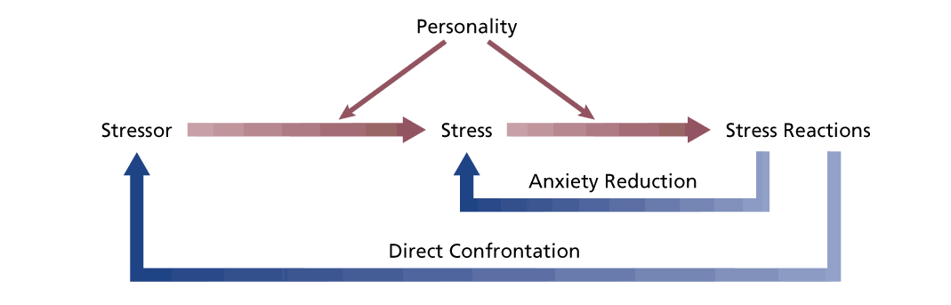Model of a stress episode
Stress
- Stress: a psychological reaction to the demands inherent in a stressor that has the potential to make a persona feel tense or anxious
- Not intrinsically bad because everyone requires a certain level of stimulation from their environment
- Stress becomes a problem when it provokes high levels of anxiety and tension
Stress Reactions
- Stress reactions: the behavioural, psychological, and physiological consequences of stress
- Can be passive responses where the individual has little control such as elevated blood pressure or reduced immune function
- Other reactions involve coping which is directed at the stressor or reducing anxiety generated by stress
- Directing efforts at the stressor will increase the likelihood of terminating it
- Stress reactions may be costly to organizations
- Stress reactions are global

Personality and Stress

Locus of Control
- Internals believe that they control their own behaviour therefore external are more likely to feel anxious in the face of potential stressors
- Internals are more likely to confront stressors directly because they assume that this response of trying to control their environment will make a difference
- Externals feel stressed but won’t address the stressor directly thus are more prone to anxiety reduction strategies that are only short term
Type A Behaviour
- A personality pattern that includes aggressiveness, ambitiousness, competitiveness, hostility, impatience, and a sense of time urgency
- Type A personalities tend to have heavier work loads, work longer hours, and more conflicting work demands
- Type A people encounter more stressful situations and are likely to exhibit adverse physiological reactions in response such as elevated blood pressure, elevated heart rate, and modified blood chemistry
- What prompts stress for them is frustrating, difficult, or competitive events
- When hostility, anger, cynicism, and distrust of others already exist in their personality, stress effects type A personalities more
Negative Affectivity
- Propensity to view the world, including oneself and other people, in a negative light
- Neuroticism
- Feel more subjective to stress
- Feel stress in heavy work loads
- Factors that are responsible to the susceptibility to stress of those high in negative affectivity:
  - A predisposition to perceive stressors in the workplace
  - Hypersensitivity to existing stressors
  - Tendency to gravitate to stressful jobs
  - Tendency to provoke stress through their negativity
  - The use of passive, indirect coping styles that avoid the real sources of stress

Stressors in Organizational Life
Executive and Managerial Stressors

Role Overload
- The requirement for too many tasks to be performed in too short a time period
- A heavy workload often provokes conflict between the manager’s role as an organizational member and their role as a spouse or parent
- Only some signposts where managers have successfully completed a task and can relax for a short period of time
Heavy Responsibility
- Heavy workload can have many consequences on them and the organization
- Making an incorrect decision can have bad consequences
- Making a large decision will have major consequences
- Managers influence other people and they can induce stress
Operative-Level Stressors
- Operative positions in organizations are sometimes exposed to a special set of stressors
Poor physical Working Conditions
- Operative-level employees are more likely than managers and professionals to be exposed to physically unpleasant and even dangerous working conditions
Poor Job Design
- Jobs can be too simple
- Job scope can be a stressor at levels that are either too high or too low

Boundary Role Stressors, Burnout, and Emotional Labour
- Boundary roles: positions in which organizational members are required to interact with members of other organizations or with the public
- Trying to startle the imaginary boundary between the organization and its environment can be stressful
- Job is not compatible with the public
- Sales reps are a classic case of role boundary
Burnout
- A syndrome of emotional exhaustion, cynicism, and a reduced self-efficacy
- Burnout can occur in non-boundary spanners
- The process of burnout begins with emotional exhaustion which might lead to depersonalizing themselves, treating others like objects, and lacking concern for what happens to their clients
- Then the burnout person develops feelings of low self-efficacy and low personal accomplishment
- Occurs most often in people who entered their jobs with high ideals
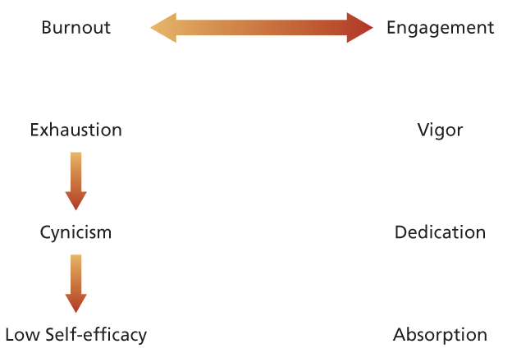
- Consequences of burnout:
  - Some individuals pursue a new occupation
  - Others stay in the occupation but seek a new job
  - Some people attempt to climb above the source of their difficulties
  - Some people stay in their jobs and become “deadwood”. Many good bureaucrats take this route
Emotional Labour
- Stress stems from jobs that require emotional labour
- Oppression of feelings and acting takes a toll on cognitive and emotional resources over time

The Job Demands-Resources Model and Work Engagement
- Organizations strive to foster engagement and enthusiasm for the job which is the opposite of burnout
- 17% are highly engaged and 17% of workers are disengaged
- Work engagement: a positive work related state of mind that is characterized by vigor, dedication, and absorption
- Vigor: involves high levels of energy and mental resilience at work
- Dedication: being strongly involved in work and experiencing a sense of significance and challenge
- Absorption: being fully concentrated on and engrossed in your work
- Vigor and dedication put engagement as opposite of burnout
- Job-demands resource model: a model that specifies how job demands cause burnout and job resources cause engagement
- Sustained physical or psychological effort in a job can cause physical and psychological costs
- Common demands:
  - Work overload
  - Time pressure
  - Role ambiguity
  - Role conflict
- Job resources refers to features of a job that are functional in that they help achieve work goals, reduce job demands, and stimulate personal growth, learning, and development
- Job resources can come from:
  - The organization
  - Interpersonal and social relations
  - The organization of work
  - The task itself
- High job resources foster work engagement while high job demands exhaust employees
- Job demands are related to:
  - Burnout
  - Disengagement
  - Health problems
- Job resources lead to:
  - Work engagement
  - Organizational citizenship behaviour
  - Organizational commitment
- Resources can buffer the negative impact demands have

Some General Stressors
Interpersonal Conflict
- When our self-esteem and integrity are attacked and personality clashes occur it can provoke stress
- Removing yourself form a negative relationship at work cannot happen most of the time
- Bullying: repeated negative behaviour directed toward one or more individuals of lower power or status that creates a hostile work environment
- Bullying provokes stress and negative well-being
- Bullying can take the form of physical aggression, teasing, demeaning, criticism, social isolation, or sabotaging others’ resources
- Must be repeated acts to be bullying
- Bullying must involve some degree of power imbalance but it may be subtle
- Power in numbers which can lead to mobbing which occurs when a number of individuals, usually direct coworkers, gang up on a particular employee
- Mobbing restricts the availability for social support that might be present when there is only a single bully
- Bullying and mobbing make the victim feel powerless and causes stress
Work-family conflict
- Occurs when duties interfere with family life or family life interferes with work responsibilities
- The increase in the number of households in which both parents work and the increase of single-parent families has led to a number of stressors centered around childcare
- Increased life spans have meant people find themselves supporting the elderly and going to work can make them feel guilty. Taking care of the elderly causes stress
- Women are particularly victimized.
- Occupations that require a high degree of teamwork or responsibility for others tend to provoke most work family conflict
Job Insecurity and Change
- Downsizing, restructuring, acquisitions, and re-engineering causes increased stress because it threatens job security
- Organizations have been trying to reduce top management positions. Can cause more roles and jobs for one person when cutting jobs
Role Ambiguity
- Uncertainty can provoke stress when the goals of one’s job and the methods of performing the job are unclear
- More stressful for people who cannot tolerate ambiguity well
Sexual Harassment
- Victims are subjective to ongoing harassment incidences
- Negative effects:
  - Decreased morale
  - Job satisfaction decrease
  - Decrease in organizational commitment
  - Decreased job performance
  - Increased absenteeism
- Victims suffer from nervousness, nausea, frustration, depression, and symptoms of posttraumatic stress disorder
- Women are victims in male predominant organizations and environments
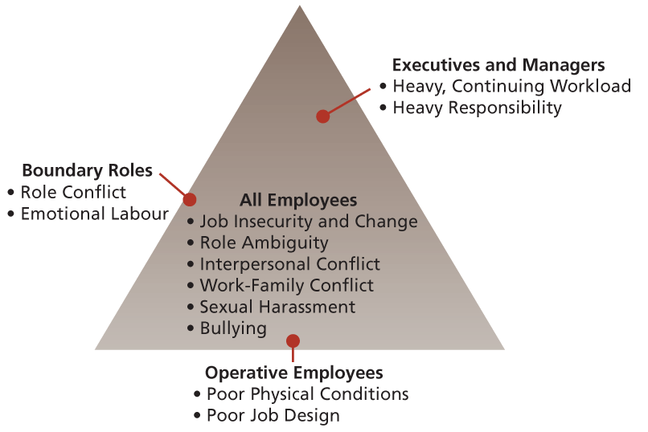

Reactions to Organizational Stress
Behavioural reactions to Stress
Problem Solving
- Directed toward terminating the stressor or reducing its potency
- Might not always be successful but reflects reality and shows flexibility and feedback
- Problem solving is mostly used when the situation is not dramatic because problem solving is routine and sensible
- Examples:
  - Delegation (handing over some tasks to others)
  - Time management (making daily schedule)
  - Talking it out
  - Asking for help
  - Searching for alternatives
Seeking Social Support
- Social ties can boost self-esteem, give useful information, offering comfort and humour, or providing material resources
- People with stronger social networks exhibit better psychological and physical well-being
- When people encounter stressful events those with good social networks are likely to cope more positively
- Social ties are most effective when they are directly connected to the source of stress (ex. close ties with coworkers in a stressful situation at work)
Performance Change
- Stress reduces job performance
- Some stressors can directly damage goal attainment (role ambiguity) and some can damage performance (heavy workload) and others can serve as motivation
Withdrawal
- Most basic reaction to stress
- Takes form as absence or turnover
- Fails to attack the stressor directly
- Short-term tactic
- When escaping the stressful situation to go into a less stressful situation can serve as problem solving and be effective rather than just escaping the job and going into another equally stressful job
- Turnover intentions provoke stress
Use of Addictive Substances
- Smoking, drinking, drug use
- Terminate stress episodes and leave employees less physically and mentally prepared to perform their jobs

Psychological Reactions to Stress
- Most common reaction is defense mechanisms
- Defense mechanisms: physiological attempts to reduce the anxiety associated with stress
- Concentrates on anxiety reduction rather than confronting or dealing with the stressor
- Common defense mechanisms:
  - Rationalization- attributing socially acceptable reasons or motives to one’s actions so they appear reasonable to one self
  - Projection- attributing one’s own undesirable idea and motives to others so that they seem less negative
  - Displacement- directing feelings of anger at a safe target
  - Reaction formation- expressing oneself in a manner that is directly opposite to the ay one truly feels
  - Compensation- applying one’s skills in a particular area to make up for the failure in another area
- Defense mechanisms when used occasionally can appear to be useful for anxiety reduction
- People who do not use defense mechanisms usually resort to dysfunctional withdrawal or addiction
- Stress might increase because after the mechanism wears off the problem still exists and you realize the defense tactic was unsuccessful

Physiological Reactions to Stress
- Work stress is associated with electrocardiogram irregularities and elevated levels of blood pressure, cholesterol, and pulse.
- Stress has also been associated with the onset of various diseases due to its ill effects on the immune system.
- The accumulation of stress into burnout has been particularly implicated in cardiovascular problems.
Organizational Strategies for Managing Stress
- Reduces demands on employees or enhances resources
Job Redesign
- Organizations can redesign jobs to reduce their stressful characteristics.
- Most formal job redesign efforts involve enriching operative-level jobs to make them more stimulating and challenging.
- There is growing evidence that providing more autonomy in how service is delivered can alleviate stress and burnout.
Family-Friendly Human Resource Policies
- “Family friendly” human resource policies include some combination of formalized social support, material support, and increased flexibility to adapt to employee needs.
- Some firms distribute newsletters that deal with work-family issues and some have developed company support groups.
- A common form of material support is corporate daycare centres.
- Flexibility is also important, and includes flex-time, telecommuting, job sharing, and family leave policies.
- Research shows that perceptions of flexibility, a reasonable workload, supportive supervision, and a supportive culture are associated with less work-family conflict and higher job satisfaction and organizational commitment.
Stress Management Programs
- Programs designed to help employees “manage” work-related stress.
- Stress management programs involve techniques such as meditation, training in muscle-relaxation exercises, biofeedback training, training in time management, and training to think more positively and realistically about sources of job stress.
- They can be useful in reducing physiological arousal, sleep disturbances, and self-reported tension and anxiety.
Work-Life Balance, Fitness, and Wellness Programs
- Work-life balance programs encourage employees to have a balanced lifestyle that includes a healthy diet and physical exercise.
- Employees are increasingly demanding work-life balance benefits, and employers are realizing that by providing them they can increase commitment and reduce turnover.
- Work-life programs are believed to lower health-care costs due in part to stress reduction.

Chapter 14: The Total Organization
What is Organizational Structure?
- Organizational Structure: the manner in which an organization divides its labour into specific tasks and achieves coordination among these tasks
- Organization’s individuals and groups are put together or organized to accomplish work
- An organization must divide labour and coordinate what has been divided in order to succeed

The Division and Coordination of Labour
- Labour must be divided because people have different physical and intellectual limits
- Not everyone can do everything
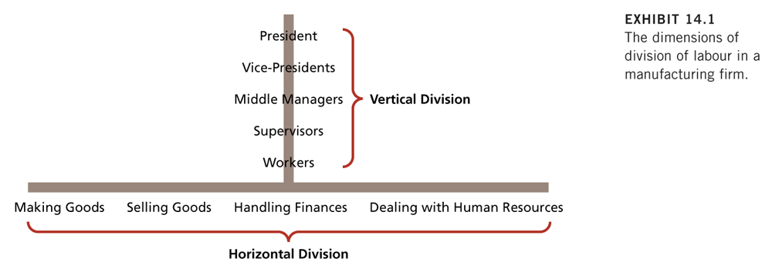
Vertical Division of Labour
- Concerned with apportioning authority for planning and decision making
- Organizations differ greatly in the extent to which labour is divided vertically
- Separate departments, units, or functions within an organization will also often vary in the extent to which they vertically divide labour
Autonomy and Control
- The domain of decision-making and authority is reduced as the number of levels in the hierarchy increases. Managers have less authority over fewer matters
- A flatter hierarchy pushes authority lower
Communication
- As labour is progressively divided vertically, timely communication and coordination can become harder to achieve. Filtering most likely will occur
- The labour must be divided vertically enough to ensure proper control but not so much as to make vertical communication and coordination impossible
- The proper degree of division varies across organizations

Horizontal Division of Labour
- Groups the basic tasks that must be performed into jobs and then into departments so that the organization can achieve its goals
- As the organization grows horizontal division of labour is likely to grow, with different groups of employees assigned to perform each of these tasks
- Specialization increases efficiency of division of labour
Job Design
- How a job is designed has implications for the jobs involved and how these jobs are coordinated
- When everyone works together there is less management needed
- High specialization needs much coordination
- Splitting works into departments has the greatest horizontal division of labour and provides for great control and accountability for separate tasks but also needs coordination
- Horizontal division of labour implications:
  - Strongly effects job design
  - Implications on the degree of coordination needed
  - Has implications for the vertical division of labour and where control over work processes should logically reside
- There are at least three basic ways in which it might structure base tasks:
  - Form an ABC department in which all workers do ABC work
  - Form an ABC department in which workers specialize in either A, B or C work
  - Form a separate A department, B department and C department
Differentiation
- Differentiation: The tendency for managers in separate units, functions, or departments to differ in terms of goals, time spans, and interpersonal styles
- Under high differentiation, organizations tend to operate more autonomously
- Most common differentiation occurs between research and development and marketing departments
Departmentation
- Assignment of jobs to departments
- Core aspect of horizontal division of labour
Functional Departmentation
- Functional departmentation: Employees with closely related skills and responsibilities are assigned to the same department
- Employees are grouped according to the kind of resources they contribute to achieving the overall goals of the organization
- Advantages of functional departmentation:
  - Efficiency- sure that no one is over or under loaded with work and resources are allocated properly
  - Communication within departments should be enhanced
  - Career ladders and training opportunities within the function are enhanced because all parties will share the same view of career progression
  - The performance of functional specialists should be easier to measure and evaluate when they are all located in the same department
- Disadvantages:
  - A high degree of differentiation.
  - Poor coordination and slow response to organizational problems.
  - Conflicts between departments.
  - Department empires built at expense of organizational goals.
- There is consensus that functional departmentation works best in small to medium-sized firms that offer relatively few product lines or services.
- When the scale gets bigger and the output of the organization gets more complex, most firms gravitate toward product departmentation or its variations.
Product Departmentation
- Product departmentation: Departments are formed on the basis of a particular product, product line, or service
- Can function autonomously because it has its own set of functional specialists dedicated to the output of that department
- Advantages:
  - Better coordination and communication among functional specialists who work on a particular product line.
  - Flexibility since product lines can be added or subtracted without severely affecting the organization
  - Departments can be evaluated as profit centres since they have individual control over their costs and revenues
  - Serves the customer or client better. More timely response to customers.
- Disadvantages:
  - Professional development might suffer.
  - Economies of scale might suffer.
  - Inefficiency if there is a lack of coordination
  - Departments might work on similar problems and cross-purposes because they are not aware of other departments efforts
Matrix Departmentation
- Matrix departmentation: Employees remain members of a functional department while also reporting to a product or project manager
- Employees remain tied to a functional departments (i.e. marketing/production) but they also report to a product manager who draws on their services
- Most matrix designs boil down to what exactly gets crossed with functional areas to form the matrix and the degree of stability of the matrix relationships (ex. a matrix could be based on geographical area instead of a product)
- A matrix can be based on short term projects
- It provides a degree of balance between the abstract demands of the product or project and the people who actually do the work resulting in a better outcome
- It is very flexible because people can be moved around as project flow dictates and projects or new regions can be added without total restructuring
- Can lead to better communication
- Two interrelated problems threaten the matrix structure:
  - Conflict between product or project managers and functional managers.
  - Role conflict and stress because employees must report to a functional manager as well as a product or project manager.
Other Forms of Departmentation
- Other forms of product departmentation:
Geographic departmentation
- Geographic departmentation: Relatively self-contained units deliver an organization’s products or services in a specific geographic area.
- Shortens communication channels, allows the organization to cater to regional tastes, and gives some appearance of local control to clients and customers
- Disadvantages are the same as product departmentation
Customer departmentation
- Customer departmentation: Relatively self-contained units deliver an organization’s products or services to specific customer groups
- Provides better service to each customer group through specialization
- Disadvantages are the same as product departmentation
Hybrid Departmentation
- Hybrid departmentation: A structure based on some mixture of functional, product, geographic, or customer departmentation
- The hybrids attempt to capitalize on the strengths of various structures while avoiding weaknesses of others

Basic Methods of Coordinating Divided Labour
- Coordination: a process of facilitating timing, communication, and feedback among work tasks
- There are five basic methods of coordination
Direct Supervision
- Working through a chain of command, designated supervisors or managers coordinate the work of their subordinates
Standardization of Work Processes
- Jobs that are routine provide their own means of coordination and little direct supervision is necessary
- Work processes can be standardized by rules and regulations
Standardization of Outputs
- Coordination can be achieved through standardization of work outputs
- Ensuring that work that is done meets certain physical or economic standards
- Frequently top management assigns each division a profit target to ensure the division pulls their weight in contributing to the overall profit goals
Standardization of Skills
- When everyone knows what to expect from others and what jobs need what specific people to have what specific skills
Mutual Adjustment
- Relies on informal communication to coordinate tasks
- Useful for the most simple and complicated divisions of labour
- Helps when standardization is impossible
- Can mutually adjust to each other’s needs
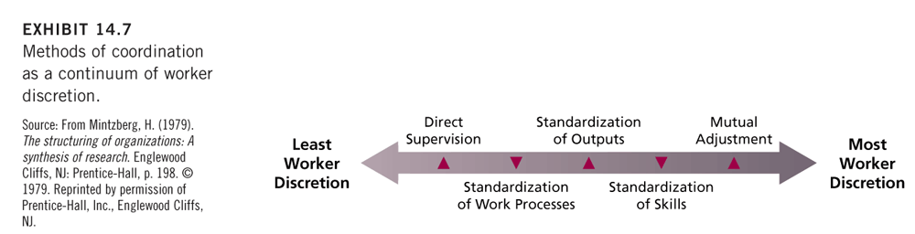
Coordination Continued
- The methods can be ordered in terms of the degree of discretion they permit in terms of task performance.
- Direct supervision permits little discretion Vs. standardization of processes and outputs permits successively more discretion
- Standardization of skills and mutual adjustment put even more control into the hands of those who are actually doing the work
- Method of coordination employed affects job design
- An improper coordination strategy can destroy the intrinsic motivation of a job
- As we move to the right side of the continuum there is greater potential for jobs to be designed in an enriched manner
- The differences in coordination across parts of the organizations stems from the way labour has been divided
- Methods of coordination may change as task demands change
- Managers and top management use mutual adjustment

Other Methods of Coordination
- Other more customized, elaborate mechanisms are necessary to achieve coordination because of different cultures, different situations, different people, different skills, and different departments
- Integration: the process of attaining coordination across differentiated departments
- Good integration achieves coordination without reducing the differences that enable each department to do its own job well
- Integration specifies who is accountable for what, enables one department to predict the activities of another, and creates a shared understanding of overarching goals
- Three methods of achieving integration include liaison roles, task forces, and full-time integrators (in order of importance)
1) Liaison Roles
- Liaison role: A person who is assigned to help achieve coordination between their department and another department
- Sometimes the other department has its own liaison as well
- Some liaisons will be located in corresponding departments
2) Task Forces and Teams
- Task forces: temporary groups set up to solve coordination problems across several departments
- When adequate coordination is achieved the task force is disbanded
- Self-managed and cross-functional teams are also an effective means of achieving coordination
- Such teams are used when employees otherwise might be working individually
- Cross functional teams are used for product development
3) Integrators
- Integrators: Organizational members permanently assigned to facilitate coordination between departments
- Useful for dealing with conflict between departments that:
  - Highly interdependent departments
  - Have very diverse goals and orientations
  - Operate in a very ambiguous environment.
- Integrators report to the executive whom the heads of the two departments report
- Rewarded according to the success of the unit
- The integrator is:
  - Unbiased
  - Speaks the departments language
  - Relies heavily on expert power
  - Identifies strongly with overall goals of the organization
- Typical job name is project coordinator

Traditional Structural Characteristics
- There are a number of characteristics that summarize how organizations structure the division of labour, and coordination of labour
Span of Control
- Span of control: the number of subordinates supervised by a manager
- The larger the span the less potential there is for coordination by direct supervision
- As the span increases the attention that a supervisor can devote to each subordinate decreases
- Standardization often substitutes for direct supervision in large spans
- At low levels, workers with one or few specialties report to one supervisor but workers with radically different specialties in higher levels might report to the boss
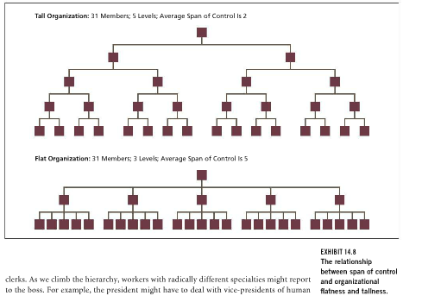
Flat versus Tall
- Flat organization: an organization with relatively few levels in its hierarchy of authority
- Tall organization: an organization with relatively many level in its hierarchy of authority
- Flatter structures tend to push decision making powers downward in the organization because a given number of decisions are apportioned among fewer levels
- Flatter structures general enhance vertical communication and coordination
- Differences in organizational height can exist within industries
Formalization
- Formalization: the extent to which work roles are highly defined by an organization
- A very formalized organization tolerates little variability in the way members perform their tasks
- Formalization can stem from the nature of the job or rules, regulations, and procedures
- Complex tasks dictate high formalization
- Formalization seems excessive sometimes
Centralization
- Centralization: The extent to which decision making power is localized in a particular part of an organization
- In the most centralized organization, the power for all key decisions would rest in a single individual
- Limitations to individual brain power often prompt decentralization
- Aside from executives determining whether the decision making is centralized or not, the organization can set the climate for more decentralized decision making
- The proper degree of centralization should put decision-making power where the best knowledge is located. Often this means decentralizing functions with direct customer contact while centralizing functions that have a more internal orientation
- British Petroleum is a good example of decentralized decision making
Complexity
- Complexity: the extent to which an organization divides labour vertically, horizontally, and geographically
- An organization can be simple or complex
- A complex organization will be tall, will have a large number of job titles and departments, and might be spread around the world
- Essential characteristic of complexity is variety

Summarizing Structure- Organic Versus Mechanistic
- Classical theorists tended to favour mechanistic structures
- Mechanistic structures: organizational structures characterized by tallness, specialization, centralization, and formalization. Each part in the organization serves a separate function, closely coordinated with each other
- Functional structures tend to be more mechanic
- Organic structures: organizational structures characterized by flatness. Low specialization, low formalization, and decentralization. Flexibility and informal communication are favoured. More inline with the human relations movement
- Matrix form is more organic
- Mechanistic and organic represent theoretical extreme and structures can fall between them
- There is no best way to organize. More mechanistic structures are called for when an organization’s external environment is more stable and its technology is more routine.
- Organic structures work better when the environment is uncertain, the technology is less routine, and innovation is important
- Organizations do not have only a single structure and the structure can change over time
- Innovation is one factor that often dictates multiple structures

Contemporary Organic Structures
- Global competition, deregulation, and advances in technology and communications have motivated the creation of these organic structures
- Removing bureaucracy and making decision making decentralized is more adaptable
The Ambidextrous Organization
- Ambidextrous organization: an organization that can simultaneously exploit current competencies and explore emerging opportunities
- More mechanistic structures
- The need for it comes from the distinction between exploiting versus exploring
- The tension between these two strategies stems from the fact that both require organizational resources, most of which are generated by exploitation. It also stems from the fact that exploiting is a more certain activity but with diminishing returns, while exploring is a highly uncertain activity but has the potential to unlock opportunities for renewal
- Proper structuring is part of the solution to dealing with this tension
- Exploration and searching for innovation requires a more organic approach
- Ambidexterity has been associated with superior innovation, better financial performance, and longer survival because it provides a dynamic capability for change.
- Ambidexterity provides pressure for differentiation and special attention to integration causing synergy
- The most successful structure for achieving ambidexterity was one in which an innovative unit maintained its own culture, structure, and processes but was integrated with the core of the firm by existing senior management.
- As innovative units mature, they often tend to become less differentiated, more mechanistic, and more integrated into the larger organization.
Network and Virtual Organizations
- Network organization: liaisons between specialist organizations that rely strongly on market mechanisms for coordination
- Emphasis is placed in who can do what most effectively and economically
- The network members should cooperate, share information, and customize their services to meet the needs of the network
- In stable networks core firms that are departmentalized contract out some functions so they can concentrate on things they do best
- Virtual organizations: a network on continually evolving independent organization that share skills, costs, and access to one another’s markets
  - Consists of continuously evolving independent companies
  - Dynamic network
- Each partner in a virtual organization contributes only in its area of core competencies
- A key advantage of the network form is its flexibility and adaptability.
- Virtual organizations are more flexible than a matrix
- Networks allow specialization
- Virtual organizations give up part of their control and are interdependent
- Disadvantages:
  - Lose their technological edge because they are isolated from market demands and too concentrated on the central firm
  - Lose organic advantage when they become legalistic, secretive, and too binding of the other partners
  - Virtual partners can exploit their loose structure to profit at the expense of the core firm
  - Networks sometimes suffer from structural inertia- network ties are maintained even when they are not economical (occurs in older organizations)

The Modular Organization
- Modular organization: an organization that performs a few core functions and outsources other activities to specialists and suppliers
- More economically friendly instead of being a large vertically stretched organization
- Modular organizations are like hubs that are surrounded by networks of suppliers that can be added or removed as needed. The modular organization maintains complete strategic control
- By outsourcing unit costs are low and can develop new products more rapidly. Allows their capital to go to areas where it is maximized and provides a competitive advantage
- The trend is spreading to Europe and Japan
- Spreading in technology, manufacturing, and automotive industries
- Disadvantages:
  - Having many non reliable outsourced companies
  - Cannot outsource future technologies because it can diminish competitive advantage
  - Decreases operational control due to its dependence on outsiders
- Can work well in rapidly changing environments and fast paced. Promote flexibility, competitive advantage, and profitability

The Boundaryless Organization
- The boundaryless organization: an organization that removes vertical, horizontal, and external barriers so that employees, managers, customers, and suppliers can work together, share ideas, and identify the best ideas for the organization
- No divides between hierarchy and departments
- Barriers in organization can promote conflict due to the interdependence which promotes innovation and productivity (because of the competitiveness)
- The boundaryless organization is made up of self-managing and cross-functional teams that are organized around core business processes that are critical for satisfying customers. The teams comprise individuals from different functional areas within the organization as well as customers and suppliers
- Each business process has an owner who is in charge of the process performance and the process
- Vertical division of labour is flattened with layers of teams
- Information and knowledge can be quickly distributed throughout the organization and directly to where it is needed without first being filtered through the tall hierarchy
- Able to achieve greater integration and coordination in the organization and with external stakeholders
- Advantages:
  - Ability to adapt to environmental changes
- Disadvantages:
  - Difficult to overcome political boundaries
  - Time consuming to manage the democratic processes required to coordinate the efforts of many stakeholders

The Impact of Size
Size and Structure
- Large organizations are more complex, less centralized, taller, and more formal than small organizations to maintain control of decentralization.
- More horizontal organizations require increased management
- Acquisitions require restructuring to optimize firm performance because growth leads to decentralization
- Product departmentation is often preferred as the organization increases in size.
- Organizations with product departmentation should exhibit more complexity and more decentralization than those with functional departmentation.
- Size is only one determinant of organizational structure.
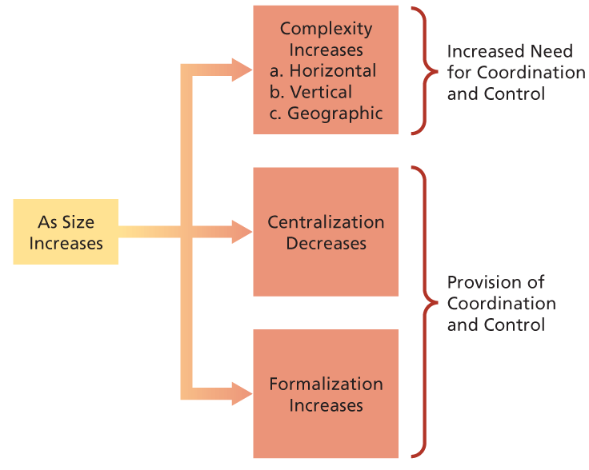
Downsizing
- Reduction in workforce size
- Has many implications for organizational structure
Downsizing and Structure
- Downsizing: the intentional reduction in workforce size with the goal of improving organizational efficiency and effectiveness
- A shrinking market could motivate downsizing but doesn’t always have to be the motivator
- When size decreases the firm gets less complex more centralized and becomes less formalized
- Limitations:
  - A downsized structure is not necessarily a mini version of the old structure.
  - Equal downsizing may not occur across the organization
- Downsizing is often accompanied by reducing horizontal or vertical complexity.
- Self-managed teams can act as substitutes for a level of management.
- Horizontally, functions can be combined or removed by contracting them out.
Problems with Downsizing
- Can reduce flexibility because when downsizing strict rules and regulations must be enforced and high levels of management take place in day-to-day activities
  - Tip: do not allow internal tightening up (centralization and formalization that occurs during downsizing) to damage external relationships
- By contracting out instead of keeping the old department in the company can serve as a more costly form
  - Tip: think about what work needs to be done and who must do it. Human-capital cannot take a backseat
- Removing management levels and flattening organizations can cause other managers to have more responsibility and other lower members of the organization to assume positions they are not trained for.
  - Must take into consideration job design and workload
- The increased spans that occurs when flattening an organization can increase unethical behaviour due to less supervision
- Should involve employees in downsizing plans for success and in order for a stable morale, trust in management, and equal productivity
- Downsizing often leads to reduced satisfaction and commitment, increased absenteeism, and damaged health. It also results in cost reduction and improved productivity in the long run
- Negative affects of downsizing stem from it not being implemented properly
Symptoms of Structural Problems
- Bad job design
- The right hand does not know what the left is doing
- Persistent conflict between departments
- Slow response times
- Decisions made with incomplete information
- A proliferation (rapid increase in numbers) of committees

Chapter 16: Organizational Change, Development and Innovation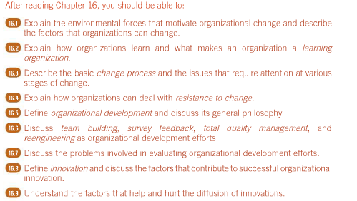

The Concept of Organizational Change
  - Common experience indicates that organizations are far from static
  - It is the way in which changes are implemented and managed that is crucial to both customers and members
- Why Organizations Must Change
  - All organizations face two basic sources of pressure to change
    - External sources
    - Internal sources
  - Environmental changes must be matched by organizational changes if the organization is to remain effective
    - Ex. Increased competitiveness
  - Internal changes, such as low productivity, conflict, strikes, sabotage, turnover and high absenteeism can provoke change
  - Very often, internal forces for change occur in response to organizational changes that are designed to deal with the external environment
  - Change almost always entails some investment of resources, be it money or management time
  - Also, it almost always requires some modification of routines and processes
  - Internal and external environments of various organizations will be more or less dynamic; organizations should differ in the amount of change they display
  - Most CEOs see their organizations as being poor at executing change
    - Majority reported budget, quality, or time problems

- What Organizations Can Change
  - Since change is a broad concept, it is useful to identify several specific domains in which modifications can occur; of course, the choice of what to change depends on a well-informed analysis of the internal and external forces signaling that change is necessary
  - Factors that can be changed include:
    - Goals and strategies
    - Technology
    - Job design
    - Structure
    - Processes
    - Culture
    - People
  - Two important factors should be made about the various areas in which organizations introduce change
    - A change in one area very often calls for changes in others
    - Changes in goals, strategies, technology, structure, process, job design, and culture almost always require that organizations give serious attention to people changes
      - As much as possible, necessary skills and favourable attitudes should be fostered before these changes are introduced
      - Adequate technical training and clear, open communication about the change can do much to alleviate this anxiety

The Change Process
  - The distinguished psychologist Kurt Lewin suggested that this sequence or process involves three basic stages—unfreezing, changing and refreezing
    - Unfreezing: occurs when it is recognized that some current state of affairs is unsatisfactory. Crises are especially likely to stimulate unfreezing. Unfreezing can also occur without crisis; employee attitude surveys, customer surveys, and accounting data are often used to anticipate problems and to initiate change before crises are reached
    - Change: the implementation of a program or plan to move the organization or its members to a more satisfactory state. Change efforts can range from minor to major. Employees who identified more strongly with the organization showed particular interest in the details of the change process; those who identified less strongly were more concerned with the outcomes
    - Refreezing: the condition that exists when newly developed behaviours, attitudes, or structures become an enduring part of the organization. The effectiveness of the change can be examined, and the desirability of extending the change further can be considered.

- The Learning Organization
  - Organizational learning: the process through which an organization acquires, develops, and transfers knowledge throughout the organization
  - There are two primary methods of organizational learning
    - Organizations learn through knowledge acquisition
      - Involves the acquisition, distribution and interpretation of knowledge that already exists but is external to the organization
    - Organizations also learn through knowledge development
      - This involves the development of new knowledge that occurs in an organization primarily through dialogue and experience
  - Some organizations are better at learning than others because they have processes and systems in place to facilitate learning and the transfer of knowledge throughout the organization
  - Learning organizations: an organization that has systems and processes for creating, acquiring, and transferring knowledge to modify and change its behaviour ro reflect new knowledge and insights
  - There are four key dimensions that are critical for a learning organization
    - Vision/support: leaders must communicate a clear vision of the organization’s strategy and goals, in which learning is a critical part and key to the organization
    - Culture: a culture that supports learning
    - Learning systems/dynamics: employees are challenged to think, solve problems, make decisions, and act according to a systems approach by considering patterns of interdependencies and by “learning by doing”
    - Knowledge management/infrastructure: established systems and structures to acquire, code, store, and distribute important information and knowledge so that it is available to those who need it, when they need it
  - Learning organizations are almost 50% more likely to have higher overall levels of profitability than those not rated as LO and are also better able to retain employees
  - Learning organizations are better able to change and transform themselves because of their greater capacity for acquiring and transferring knowledge

- Issues in the Change Process
  - Diagnosis: the systematic collection of information relevant to impeding organizational change
    - Initial diagnosis can provide information that contributes to unfreezing by showing that a problem exists
    - Once unfreezing occurs, further diagnosis can clarify the problem and suggest just what changes should be implemented
    - Relatively routine diagnosis might be handled through existing channels
    - For more complex, non-routine problems, there is considerable merit in seeking out the diagnostic skills of a change agent
    - Change agents: experts in the application of behavioural science knowledge to organizational diagnosis and change
    - It is possible to obtain diagnostic information through a combination of observations, interviews, questionnaires, and the scrutiny of records
    - Attention to the views of customers and clients is critical
    - The importance of careful diagnosis cannot be overemphasized
    - Proper diagnosis clarifies the problem and suggests what should be changed and the appropriate strategy for implementing change without resistance
- 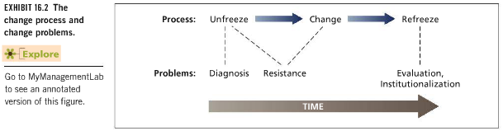
  - Resistance: overt or covert failure by organizational members to support a change effort
    - Chance is frequently resisted by those at whom it is targeted
    - Causes of resistance:
      - Politics and self-interest
        - People may feel that they personally will lose status, power, or even their jobs with the advent of change
      - Low individual tolerance for change
        - Predispositions in personality make some people uncomfortable with changes in established routines
      - Lack of trust
        - People might clearly understand the arguments being made for change but not trust the motives
      - Different assessments of the situation
        - The targets of change might sincerely feel that the situation does not warrant the proposed change and that the advocates of change have misread the situation
      - Strong emotions
        - Change has the capacity to induce strong emotions in people trying to make sense of the change; helpless and resistant
      - A resistant organizational culture
        - Some organizational cultures have especially stressed and rewarded stability and tradition and advocates of change in such cultures are viewed as misguided deviants or aberrant outsiders
    - Underlying these various reasons for change are two major themes
      - 1) change is unnecessary because there is only a small gap between the organization’s current identity and its ideal identity
      - 2) change is unobtainable (and threatening) because the gap between the current and ideal identities is too large
- 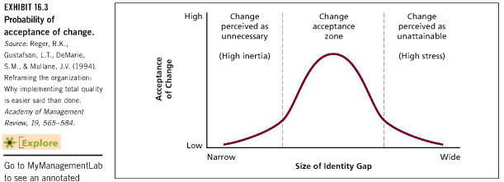
  - Dealing with resistance
    - Low tolerance for change is mainly an individual matter, and it can often be overcome with supportive, patient supervision
    - Politics and self-interest are at the root of resistance, it might be possible to co-opt the reluctant by giving them a special, desirable role in the change process or by negotiating special incentives for change
    - Contemporary organizations are learning that obsessive secrecy about strategy and competition can have more internal costs than external benefits
    - Springing secret changes on employees is sure to provoke resistance
    - Managers who are generally perceived as fair have a real advantage because this can lead to the anticipation that change efforts will unfold fairly

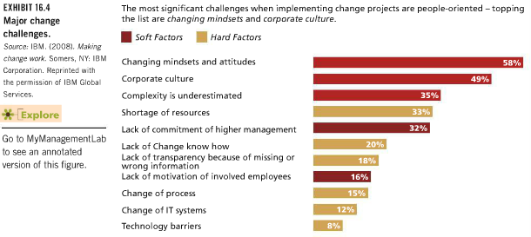
  - Transformational leaders are particularly adept at overcoming resistance to change
  - One way they accomplish this is by “striking the iron while it’s hot”—that is, by being especially sensitive to when followers are ready for change
  - The other way is to unfreeze current thinking by installing practices that constantly examine and question the status quo
  - One research study of CEOs who were transformational leaders noted the following unfreezing practices:
    - An atmosphere is established in which dissent is not only tolerated but encouraged; disagreement is not treated as disloyalty
    - The environment is scanned for objective information about the organization’s true performance
    - Organizational members are sent to other organizations and even other countries to see how things are done elsewhere
    - The organization compares itself along a wide range of criteria against the competition, rather than simply comparing its performance against last years; this avoids complacency
  - Evaluation and Institutionalization
    - Organizations are notorious for doing a weak job of evaluating “soft” change programs that involve skill, attitudes, and values
    - It is possible to do a thorough evaluation by considering a range of variables:
      - Reactions
      - Learning
      - Behaviour
      - Outcomes
    - To some extent, reactions measure resistance, learning reflects change, and behaviour reflects successful refreezing
    - Outcomes indicate whether refreezing is useful for the organization
    - If the outcome of a change is evaluated favourably, the organization will wish to institutionalize that change
    - Many change efforts go unevaluated or are only weakly evaluated, and without hard proof of success it is very easy for institutionalization to be rejected by disaffected parties

- Organizational Development: Planned Organizational Change
  - Organizational development (OD): a planned, ongoing effort to change organizations to be more effective and more human
  - It uses the knowledge of behavioural science to foster a culture of organizational self-examination and readiness for change
  - A strong emphasis is placed on the interpersonal and group processes
  - The fact that OD is planned distinguishes it from the haphazard, accidental, or routine changes that may occur in all organizations
  - OD efforts tends to be ongoing in at least two senses
    - Many OD programs extend over a long period of time, involving several distinct phases of activities
    - If OD becomes institutionalized, continual re-examination and readiness for further change become permanent parts of the culture
  - OD seeks to modify cultural norms and roles so that the organization remains self-conscious and prepared for adaptation
  - The values and assumptions of OD change agents were decidedly humanistic and democratic
  - Self-actualization, trust, cooperation, and the open expression of feelings among all organizational members have been viewed as desirable

Some Specific Organizational Development Strategies
  - The organization that seeks to “develop itself” has recourse to a wide variety of specific techniques
  - Team building and survey feedback are limited in scope and are often a part of other change efforts
  - Total quality management and reengineering are broader in scope and lead to more sweeping organizational change
  - Team Building: an effort to increase the effectiveness of work teams by improving interpersonal processes, goal clarification, and role clarification
    - Can facilitate communication and coordination
    - Preliminary diagnostic session
    - Ideally, team building is a continuing process that involves regular diagnostic sessions and further developed exercise as needed
    - This permits the team to anticipate new problems and to avoid regression to less effective, predevelopment habits
  - Survey Feedback: the collection of data from organizational members and the provision of feedback about the results
    - Changes formulated that emerge from the data
    - Who should participate in the survey?
    - What questions should the survey ask?
    - Feedback seems to be most effective when it is presented to natural working units in face-to-face meetings
    - Surveys have the most beneficial effects when the results are indeed reviewed with employees and when action is taken in response to the survey
    - Some firms have a yearly companywide employee attitude survey (pulse)
  - Total Quality Management: a systematic attempt to achieve continuous improvement in the quality of an organization’s products or services
    - Typical characteristics of TQM programs include an obsession with customer satisfaction; a concern for good relations with suppliers; continuous improvement of work processes; the prevention of quality errors; frequent measurement and assessment; extensive training; and high employee involvement and teamwork
    - View improvement as a continuum ranging from responding to product or service problems (a reactive strategy) to creating new products or services that please customers (a proactive strategy)
    - Error prevention is a hallmark of TQM
    - Continuous improvement can come from small gains over time or from more radical innovation; the goal is long-term improvement, not a short-term fix
    - Improvement requires knowing where we are in the first place
    - TQM is very concerned with measurement and data collection
    - TQM stresses teamwork among employees and with suppliers and customers
    - TQM relies heavily on training to achieve continuous improvement
    - Some specialized training tools that empower employees to diagnose and solve quality problems on an ongoing basis:
      - Flowcharts of work process (illustrate the operations and steps in accomplishing some tasks, noting who does what, and when)
      - Pareto analysis (collects frequency data on the causes of errors and problems, showing where attention should be directed)
      - Fishbone diagrams (cause-and-effect; illustrate the factors that could contribute to a particular quality problem; very specific causes are ‘small bones’ and are divided into logical classes called ‘large bones’)
      - Statistical process control (gives employees hard data about the quality of their own output that enables them to correct any deviations from standard)
    - An essential problem is that quality has many different and potentially incompatible definitions; this is why it is important firms stay close to their customers
  - Reengineering: the radical redesign of organizational processes to achieve major improvements in such factors as time, cost, quality or service
    - It does not fine-tune existing jobs, structures, technology, or human resources policies
    - Rather, it uses a “clean slate” approach that asks basic questions, such as “what business are we really in?” and “if we were creating this organization today, what would it look like?”
    - A key word in our definition of reengineering is “processes”
    - Organizational processes: activities of work that have to be accomplished to create outputs that internal or external customers value
    - The gains from reengineering will be greatest when the process is complex and cuts across a number of jobs and departments
    - A TQM effort can be part of a reengineering project
    - What factors prompt interest in reengineering?
      - “Creeping bureaucracy” (common in large, established firms; with growth, rather than rethinking basic work processes, many firms have simply tacked on more bureaucratic controls to maintain order)
      - New information technology (many firms disappointed that initial investments in information technology did not result in anticipated reductions in costs or improved productivity)
    - How does reengineering actually proceed? In essence, much reengineering is oriented toward one or both of these goals:
      - The number of mediating steps in a process is reduced, making the process more efficient
        - Reduces labour requirements, removes redundancies, decreases chances for errors, and speeds up the production of the final output
      - Collaboration among the people involved in the process is enhanced
        - Often permits simultaneous, rather than sequential, work on a process and reduces the chances for misunderstanding and conflict
    - Some of the nitty-gritty aspects of reengineering include:
      - Jobs are redesigned and usually enriched
      - A strong emphasis is placed on teamwork
      - Work is performed by the most logical people
      - Unnecessary checks and balances are removed
      - Advanced technology is exploited
    - Reengineering is most extensive in industries where:
      - 1) much creeping bureaucracy has set in
      - 2) large gains were available with advanced technology
      - 3) deregulation increased the heat of competition
      - Examples: insurance, banking, brokerage, and telecommunications industries
    - Reengineering requires strong CEO support and transformational leadership qualities
    - Before it begins, it is essential that the organization clarify its overall strategy
    - Reengineering must be both broad and deep to have long-lasting, bottom-line results
    - It should span a large number of activities that cut costs or add customer value, and it should affect a number of elements, including skills, values, roles, incentives, structure, and technology

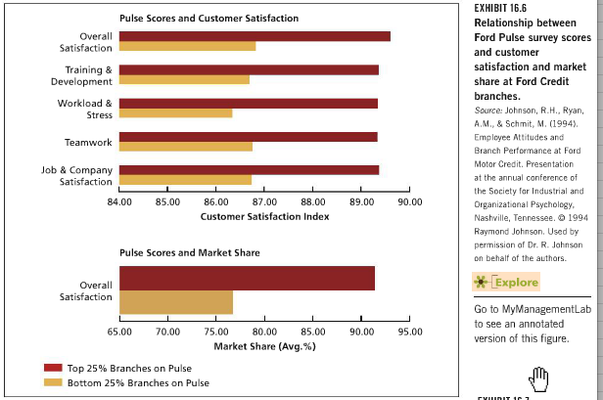

Principles, Practices and Techniques of Total Quality Judgment (below)

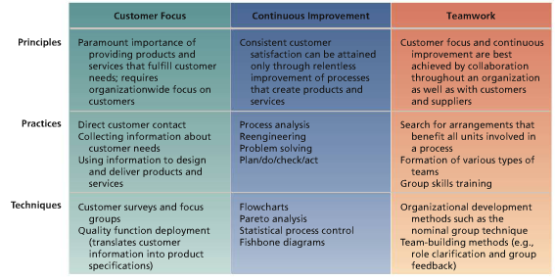

Does Organizational Development Work?
  - Should reemphasize that most OD efforts are NOT carefully evaluated
  - Political factors and budget limitations might be prime culprits, but the situation is not helped by some OD practitioners who argue that certain OD goals are incompatible with impersonal, scientifically rigorous evaluation
  - Conclusions:
    - Most OD techniques have a positive impact on productivity, job satisfaction, or other work attitudes
    - OD seems to work better for supervisors or managers than for blue-collar workers
    - Changes that use more than one technique seem to have more impact
    - There are great differences across sites in the success of OD interventions
- 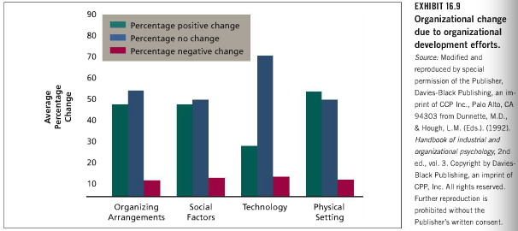
  - A healthy percentage of studies reported positive changes following an OD effort, but many reported no change
  - Weak methodology has sometimes plagued research evaluations of the success of OD interventions, although the quality of research seems to be improving over time. Some specific problems include the following:
    - OD efforts involve a complex series of changes. There is little evidence of exactly which of these changes produce changes in processes or outcomes
    - Novelty effects or the fact that participants receive special treatment might produce short-term gains that really don’t persist over time
    - Self-reports of changes after OD might involve unconscious attempts to please the change event
    - Organizations may be reluctant to publicize failures

- The Innovation Process
  - Innovation: the process of developing and implementing new ideas in an organization
  - The term developing is intentionally broad
    - Covers everything from the genuine invention of a new idea to recognizing an idea in the environment, importing it to the organization, and giving it unique application
  - The essential point is a degree of creativity
  - We can roughly classify innovations as
    - Product/service innovations
      - Have a direct impact on the cost, quality, style, or availability of a p/s
      - Very obvious
      - Tangible consumer products or intangible services
    - Process innovations
      - New ways of designing products, making products, or delivering services
      - Often invisible to customers, but help the organization to perform more effectively
    - Managerial innovations
      - New forms of strategy, structure, human resource systems, and managerial practices that facilitate organizational change and adaptation
  - IDEA GENERATION IDEA IMPLEMENTATION IDEA DIFFUSION
  - Interesting themes that underlie the process of innovation:
    - Much idea generation is due to serendipity
    - The beginning of innovation can be pretty haphazard and chaotic, and the conditions necessary to create new ideas might be very different from the conditions necessary to get these ideas implemented
    - The generation of good ideas is no guarantee that they will be implemented and diffused

- Generating and Implementing Innovative Ideas
  - Innovation requires creative ideas, someone to fight for these ideas, good communication, and proper application of resources and rewards
  - Individual Creativity: the production of novel but potentially useful ideas
    - Creative chemists will emerge from those who are well trained and up to date in their field
    - Creative money managers among those who have a truly excellent grasp of finance and economics
    - No correlation between level of intelligence and creativity
    - Creative people have creative-relevant skills; ability to tolerate ambiguity, withhold early judgment, see things in new ways, and be open to new and diverse experiences
    - Creative people have intrinsic motivation and also a genuine interest for the task at hand
  - Idea Champions: people who recognize an innovative idea and guide it through to implementation
    - Often an informal emergent role
    - Guiding the idea may mean talking it up to peers, selling it to management, garnering resources for its development, etc.
    - They often have a real sense of mission about the innovation
    - Sponsorship and support
    - Common to see more than one idea champion emerge during the innovation process
    - Exhibit clear signs of transformational leadership, using charisma, inspiration, and intellectual stimulation
    - Use a wide variety of influence tactics to gain support for the idea
    - Some idea champions feel compelled to engage in creative deviance which means they defy orders by management to stop work on a creative idea
  - External Communication
    - Effective communication with the external environment and effective communication within the organization are vital for successful innovation
    - The most innovative firms seem to be those that are best at recognizing the relevance of new, external information, importing and assimilating this information, and then applying it
    - Use of gatekeepers: people who span organizational boundaries to import new information, translate it for local use, and disseminate it
    - Technical gatekeepers are not the only means of extracting information from the environment
    - Many successful innovative firms excel at going directly to users, clients, or customers to obtain ideas for product or service innovation
    - Information can also be extracted from the environment by hiring employees with multicultural experience or providing opportunities for such experience, which has been shown to enhance creativity
    - Research shows that firms that put their R&D activities in several geographic locations exhibit higher levels of imitative innovation, because they can access a broader set of knowledge
  - Internal Communication
    - Generally true that organic structures facilitate innovation more easily than mechanistic structures
    - Decentralization, informality, and a lack of bureaucracy all foster the exchange of information that innovation requires
    - In general, internal communication can be stimulated with in-house training, cross-functional transfer, and varied job assignments
    - Research found that groups with members who had worked together a short time or a long time engaged in less communication than groups that had medium longevity
    - High-communicating, medium-longevity groups are the best performers
    - Mechanistic structures are better for actually implementing innovations
  - Resources and Rewards
    - Abundant resources greatly enhance the chances of successful innovation
    - They provide funds in the obvious sense, but they also serve as a strong cultural symbol that the organization truly supports innovation
    - Money is not the only thing that spurs innovation
    - Time can be an even more crucial factor for some innovations
    - Reward systems must match the culture that is seeded by the resource system
    - Avoid punishing failure
    - Freedom and autonomy were the most cited organizational factors leading to creativity
    - Many firms now offer dual career ladders that enable people to be extrinsically rewarded while still doing actual science or engineering

- Diffusing Innovative Ideas
  - Many innovations, especially process innovations, begin as limited experiments in one section or division of an organization
  - If such efforts are judged successful, it seems logical to extend them to other parts of the organization
  - Diffusion: the process by which innovations move through an organization
  - Poor diffusion can be caused by:
    - Lack of support and commitment from top management
    - Significant differences between the technology or setting of the pilot project and those of other units in the organization, raising arguments that “it won’t work here”
    - Attempts to diffuse particular techniques rather than goals that could be tailored to other situations
    - Management reward systems that concentrate on traditional performance measures while ignoring success at implementing innovation
    - Union resistance to extending the negotiated “exceptions” in the pilot project
    - Fears that pilot projects begun in non-unionized locations could not be implemented in unionized portions of the firm
    - Conflict between the pilot project and the bureaucratic structures in the rest of the firm (e.g. pay policies and staffing requirements)
  - Because of the problems above, the depressing spectre of a “diffuse or die” principle is raised
    - If diffusion does not occur, the pilot project and its leaders become more and more isolated from the mainstream of the organization and less and less able to proceed alone
  - Some research suggests that innovations are especially difficult to diffuse in organizations dominated by professionals, who tend to focus on their own “silos”
  - One classic review suggests that the following factors are critical determinants of the rate of diffusion of a wide variety of innovations:
    - Relative advantage (diffusion is more likely to occur when the new idea is perceived as truly better than the one it replaces)
    - Compatibility (diffusion is easier when the innovation is compatible with the values, beliefs, needs, and current practices of potential new adopters
    - Complexity (complex innovations that are fairly difficult to comprehend and use are less likely to diffuse)
    - Trialability (if an innovation can be given a limited trial run, its chances of diffusion will be improved)
    - Observability (when the consequences of an innovation are more visible, diffusion will be more likely to occur)
  - Innovations often have to be custom-tailored to diffuse effectively
  - There is also considerable advantage to thinking about how innovations are “packaged” and “sold” so as to increase their chances of a more widespread adoption

- A Footnote: The Knowing-Doing Gap
  - Despite the need for organizations to change, develop, and innovate, they often exhibit considerable inertia
  - Many managers know what to do, but have considerable trouble implementing this knowledge in the form of action = the knowing-doing gap
  - Why does the gap happen?
    - The tendency for some organizational cultures to reward short-term talk rather than longer-term action
    - Meetings, presentations, documentation and mission statements thus take precedence over action and experimentation
    - Many changes require cooperation between organizational units, but many organizations foster internal competition that is not conductive to such cooperation
    - When managers do manage to make changes, these changes sometimes fail because techniques are adopted without an understanding of their underlying philosophy

