STATS MIDTERM
Levels of measurement:
- Binary: consists of 2 categories
- Ex. Dead or Alive.
- Nominal: more than two categories
- Ex. Taste in music: pop, jazz, hip hop, rap ect…
- Ordinal: categories have logical order
- Ex. Letter grade: A, B, C, D….
- Interval: Equal intervals on variables represent equal differences in the property of being measured.
- Ex. Likert scale variable, temperature.
- Ratio: Similar to interval however, ratio must make sense, measure has meaning.
- Ex. Age, height, reaction time.
Validity: whether an instrument measures what it set out to measure.
Reliability: whether a measure produces the same results in the same condition.

ANALYZING DATA

Descriptive Statistics: Statistical procedures used to DESRIBE the population/ sample that is being examined.
Inferential statistics: Statistical procedures used to make INFERENCES or predictions about a population from observations and analyses of a sample.

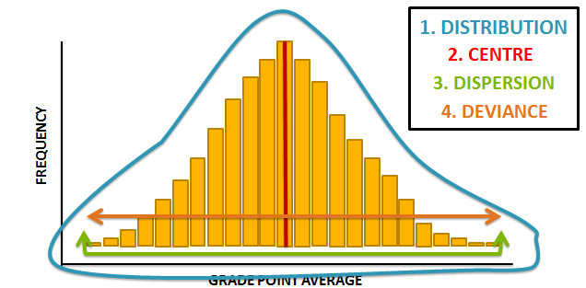

Distribution of score
Look at distribution of scores in two ways:
- Frequency charts (categorical and continuous data)
- Graphs (Bar or Histogram)
Characteristics: bell shape with majority of scores in the centre.
- When distribution deviates it is generally from lack of symmetry (skew) and lack of pointiness (kurtosis)

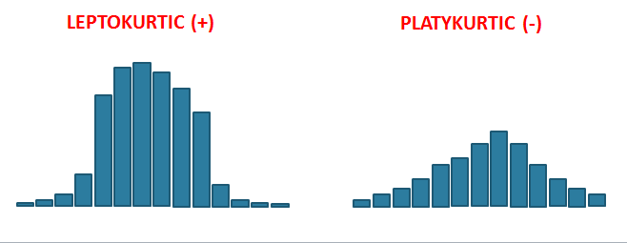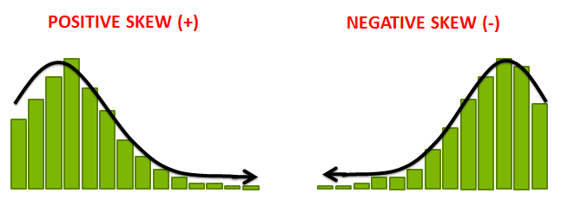

Measures of central tendency
- Mode: score that occurs most frequently. Appropriate for categorical (binary, nominal and ordinal) data.
- Limitation. Variable can be bimodal or multimodal.
- Median: Score in the middle of the distribution appropriate for ordinal, interval, and ratio data.
- Unaffected by extreme scores/skews. Most score are generally not represented though.
- Mean: sum of all scores, divided by number of scores. Interval and ratio.
- Uses all scores and is most stable. Affected by extreme scores/ skewed (ONLY for interval ratio).
Preparing Data for Analysis

- Check for impossible and out-of-range values
- Check for response sets
- Deal with missing values
- Manage outliers
- Check for assumptions
- Check for reliability

CORRELATION
Must require both variables to be interval/ratio and not imply causation.
Procedure:
  - STEP 1: Hypothesis
  - STEP 2: Assumptions
  - STEP 3: Covariance
  - STEP 4: Correlation
  - STEP 5: Interpretation
  - STEP 6: Effect Size
  - STEP 7: Write-Up

Is there A RELATIONSHIP between students’ scores on their practice exam and their scores on the midterm exam?

STEP 1: Hypothesis
H0: There is no relationship between students’ scores on their practice exam and their scores on the midterm exam
H1: There is a relationship between students’ scores on their practice exam and their scores on the midterm exam.

STEP2: Assumption
*Create scatter plot to check for linearity.

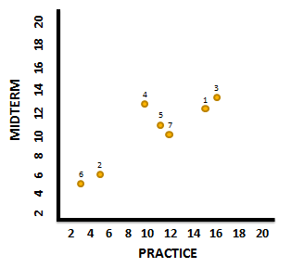
STEP3:Covariance

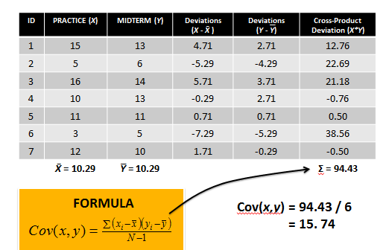
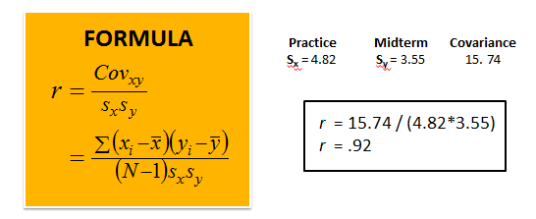
STEP5: interpretation*if observed correlation coefficient (o_{bserved}) exceeds the critical value of r (c_{ritical}) you can reject the null hypothesis.
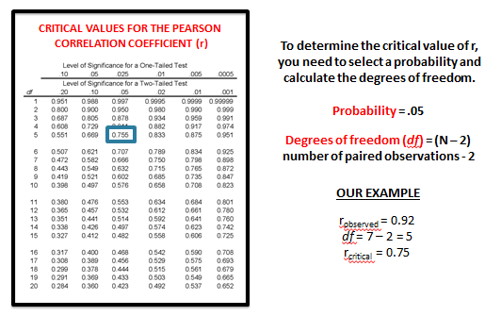
STEP6: effect size.
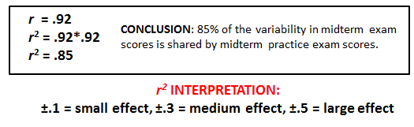

Step 7: Write up
- Decision about null hypothesis
- Test statistic (confidence intervals where possible)
- Report of effect size
- Interpretation in plain English.
A correlational study was done to determine whether there is a link between happiness and energy levels. Results suggest that we can reject the null hypothesis and conclude that there is a strong positive relationship between reported happiness and energy levels (r = .708, 95%, BCa CI [.405, .882], p < .001). 50% of the variance in happiness was shared with energy. This analysis suggests that happiness is linked to energy levels.
We ran a Kendall's tau correlational coefficient analysis to determine whether there is a relationship between happiness and placement in a race. Results suggest that we can reject the null hypothesis and that there is a weak negative relationship between happiness and placement (t = -.364, 95%, BCa CI [-.620, -.101], p =.020). 13% of the variance in happiness is shared by placement in a race. This analysis suggests that higher happiness is associated with a lower placement in a race.
Spearman’s: Ranked data, useful to minimize effects of extreme scores or violation of assumptions.
- Notation: r_{s}
Kendall’s: Small data set or large number of tied rankings.
- Notation: τ

REGRESSION

Must have interval/ ratio variables and imply causation.
- Regression Formula: Y’ = a +bX or Regression Formula: Y’ = a +bX
  - STEP 1: Hypothesis
  - STEP 2: Assumptions
  - STEP 3: Correlation
  - STEP 4: Regression
  - STEP 5: Model Fit
  - STEP 6: Interpretation
  - STEP 7: Effect Size
  - STEP 8: Write-Up

Does study time PREDICT students grades on a test?
STEP1: Hypothesis

H0: Study time does not predict student’s grades on a test.
H1: Study time does predict student’s grades on a test.

STEP2: Assumptions

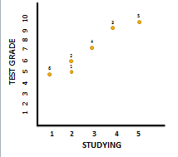

STEP3: Correlation
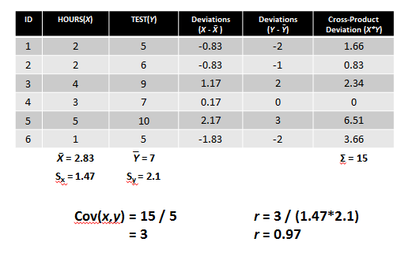
STEP4: Regression
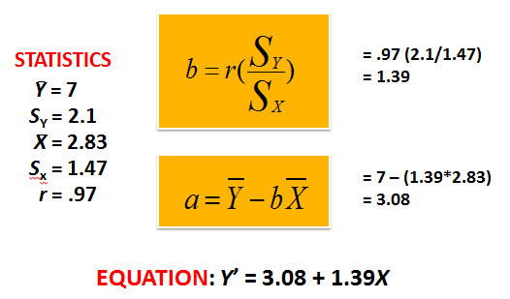

STEP5: Model Fit
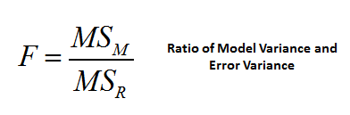
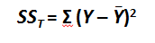
Sum of Squares total (SS_{t)} : Difference between observed data and the mean value of Y .
Total Variation:

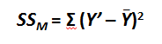
Sum of Squares Model (SS_{M}): Difference between regression line and the mean value of Y
Explained variation:

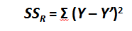
Sum of Squares Residual (SS_{R}): Difference between the observed data and the regression line.
Unexplained Variance:

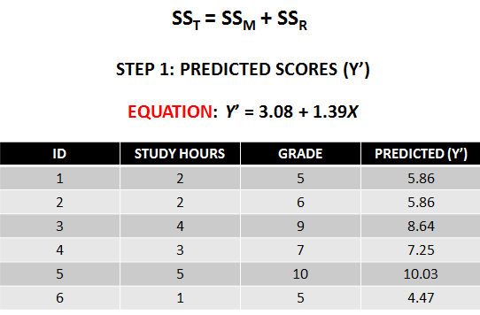

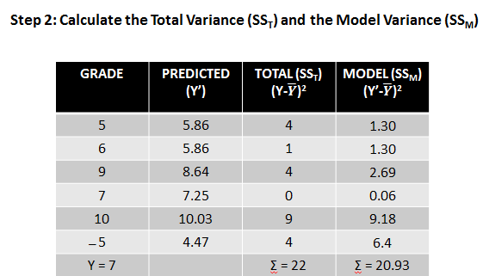

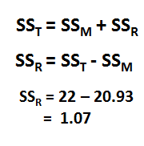
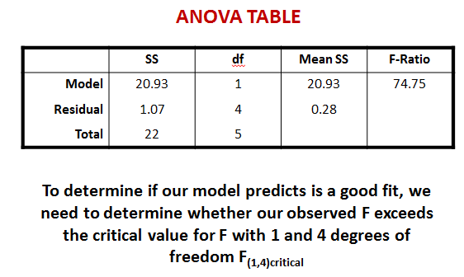
Df_{M}: equals to the number of predictor variables (always 1)
Df_{R}: equal to number of parameters being estimated (n-2)
Df_{T}: equal to DfM + DfR
MS_{M}: equal to SS_{M} / df_{M}
MS_{R}: SS_{R}/ df_{R}
F-Ratio: MS_{M}/MS_{R} (20.93/0.28)
** use df to determine the critical F at 0.05 results show it is equal to 7.71
If F_{observed} surpasses F_{critical}, we can reject the null hypothesis

STEP7: Effect size
R² = SS_{M} / SS_{T}
R² = .97 * .97
= .95
Amount of Variance.
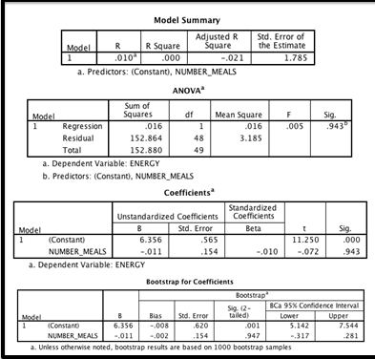
STEP8: Write up

A simple regression analysis was started to determine whether the number of meals per day influenced reported energy levels. Preliminary results suggest that we cannot reject the null hypothesis and that there is no linear relationship between the number of meals per day and energy levels. (F(1,48) = 0.005, p >.05).Number of meals has no influence on energy.

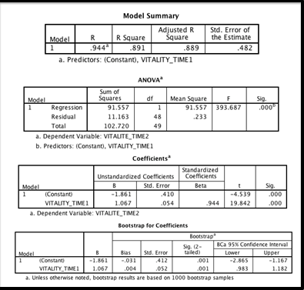
A simple regression analysis was conducted to determine whether reported vitality at the beginning of the semester predicted vitality at the end of the semester. Results suggest that we can reject the null hypothesis and conclude that there is a positive linear relationship between vitality at the beginning of the semester and vitality at the end of the semester (y’ = -1.86 + 1.06X, BCa CI 95% [.98, 1.18]. 89% of the variance in the reported vitality at the beginning of the semester explained the vitality at the end of the semester (F(1,48) = 393.68, p < .001). This analysis suggests that the reported vitality at the beginning of the semester will explain the vitality at the end of the semester.

MULTIPLE REGRESSIONS
Interval/ration variables, more than 1 predictor, imply causation
  - STEP 1: Hypothesis
  - STEP 2: Assumptions
  - STEP 3: Regression
  - STEP 4: Model Fit
  - STEP 5: Interpretation
  - STEP 6: Effect Size
  - STEP 7: Write-Up

STEP1: Hypothesis
H₀: Quizzes 1, 2, and 3 do not predict students’ final grades in the course
H₁: Quizzes 1, 2, and 3 do predict students’ final grades in the course

STEP2: Assumption
- Check Durbin – Watson test: Anything between 1-3 is good (2 is best) if it is close to 0 then it is a positive correlation and vice versa if it is 4.
- Linear relationship.
- Multicollinearity: 2 or more predictor variables are highly linear related.
- Tolerance must be above .2 and VIF is smaller than 10.
- Homoscedasticity: residuals are approx.. equal for all for all predicted DV scores.
- Scatter plot, line of best fit.
STEP3: Multiple regression methods
- Hiearchical
- Forced Entry
- Stepwise
Hierarchical: Predictors that are already known are entered first into the model. New predictors are entered in a separate step/block
Block 1: quiz 1 and 2
Block2: Quiz 3

Forced Entry: all variables are entered into the model simultaneously.
Quiz 1 + Quiz 2 + Quiz 3.

STEP4: Model Fit
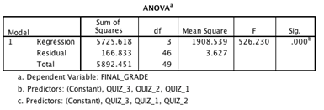
Since p < 0.05 we can reject the null hypothesis.

STEP5: Interpretation
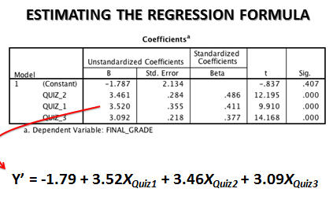
Predictor with the largest influence we can look using the Standardized coefficients. In this case it would be Quiz 2 that accounts for the most variance.

STEP6: Effect Size
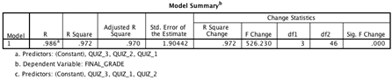
Therefore, 97% variance (R Square).
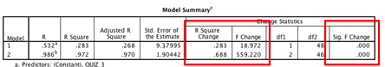
Hiearchical Regression: To determine which model is better to analyse when both are significant read the model summary.
R and F change value show that our model improved by adding additional predictor variables in Block 2.
STEP7: Write up.
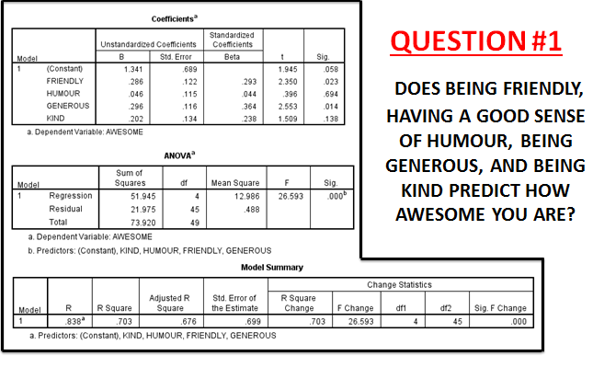
Forced Entry
A Multiple regression analysis was conducted to determine whether being friendly, having a good sense of humor, being generous and being kind predicted how awesome you are. Results suggest that we can reject the null hypothesis and conclude that there is a relationship between being friendly, humorous, generous and kind and how awesome you are (F (4,45) = 26.59, p < .05). All predictor variables had a significant linear relationship except for being humorous and kind (y’= 1.31 + 0.28Xfriendly + 0.29Xgenerous ). 70 % of the variance in awesomeness is explained by being friendly; humor being generous and being kind. This analysis suggests that being friendly and generous tend to predict how awesome you are.
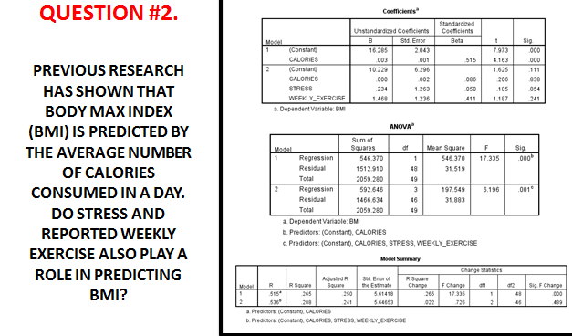
Hierarchical
A Hiearchical regression analysis was conducted to determine whether stress and reported weekly exercise predicted BMI above and beyond the number of calories consumed. Results suggested that calories alone accounted for more variance than the combination of all variables. The results of our analyses lookingat the relationship between just calories and BMI suggest that we can reject the null hypothesis and conclude that there is a relationship between the two variables (F(1,48)=17.3, p < 0.001). Calories consumed had a significant linear relationship with BMI (y’ = 16.29 + 0.003Xcalories p<0.001), 27% of the variance in BMI explained by the calories consumed. This analysis suggests that people who consume less calories have a lower BMI.

