ADM 2372 B - Chapter 1 Notes
  - Information Systems and Business Strategy

Section 1-1: Information Systems in Business

Information Systems’ Role in Business
- Information Systems can be found everywhere and are a key aspect to business now-a-days

Information System's Impact on Business Operations
- Information technology plays a critical role in deploying enterprise-wide initiatives by facilitating communication and increasing business intelligence
  - Can create efficiencies and effectiveness across the organization
  - For IS to work every department of an organization has to work together and be interdependent
- Benefits (1) Customer Service (2) Finance (3) Sales and Marketing (4) IT Operations (5) Operations Management (6) HR (7) Security
- Goals (1) Reduce Costs (2) Improve Customer Satisfaction (3) Create Competitive Advantage (4) Generate Growth (5) Streamline Supply Chain (6) Global Expansion

Information Systems Basics
- Information Systems: Computer-based tools that people use to work with information and that support the information and information-processing needs of an organization; it can be an important enabler of business success and innovation
  - Is alone is not useful unless right people know how to use and manage them effectively
- Management Information Systems (MIS): Function that plans for, develops, implements, and maintains IT hardware, software, and applications that people use to support the goals of an organization
  - Every large company has a IS, IT or MIS department
- Data, Information and Knowledge
  - Data: Raw facts that describe characteristics
  - Information: Data converted into meaningful/useful context
  - Knowledge: Information that can be acted upon, actionable information
- IS Resources: Plans and goals of MIS have to along with the plans and goals of organization. Most managers do not know how to use IS resources effectively
  - In essence, People use processes to work with information systems to produce information
  - Order of priority people, processes, information
  - Key resources are inextricably linked and are essential for the creation of information.
  - ne Fails - All Fail - Business May Fail
- Information Cultures - Organization's culture plays a large role in determining how successfully it will share information
  - 4 common information-sharing cultures exist:
    - Information-Functional: Employees use info to exercise influence or power
    - Information-Sharing: Employees across departments trust each other to use info to improve performance
    - Information-Inquiring: Employees across departments search for info to better understand the future and align themselves with current trends and new directions
    - Information-Discovery: Employees across departments are open to new insights about crisis and radical changes and seek ways to create competitive advantages

Roles and Responsibilities in Information Systems
- Chief Information Officer: Executive-level position that involves high-level strategic planning and management of IS pertaining to the creation, storage and use of information by a business. The CIO is responsible for overseeing all uses of IS and ensuring the strategic alignment of IS with business goals and business.
  - Roles (1) Manager- Ensure the delivery of all IS projects, on time and within budget (2) Leader- Ensure the strategic vision of IS is in line with the strategic vision of the organization (3) Communicator - Advocate and communicate the IS strategy by building and maintaining strong executive relationships
- Chief Technology Officer: Responsible for ensuring the throughput, speed, accuracy, availability and reliability of an organization's information technology
- Chief Security Officer: Responsible for ensuring the security and IS, and developing strategies and technical safeguards against attacks from hackers and viruses
- Chief Privacy Officer: Responsible for ensuring the ethical and legal use of information within an organization
- Chief Knowledge Officer: Responsible for collecting, maintaining and distributing an organization's knowledge
  - All of those position and their responsibilities are critical to an organizations success

Skills Gap
- The Skill Gap - Greatest Challenge is effective communication between business personnel and IT personnel
  - Communications: The ability to communicate and influence at all levels
  - Business Knowledge: A need to understand and focus on how they can help their businesses grow and not just look at cutting costs and being more efficient.
  - Innovation/Creativity: The vision that differentiates a CIO from a more traditional IT director - innovation, creativity, flair and an entrepreneurial spirit
  - Leadership: Good leaders inspire and motivate their teams and drive them to achieve remarkable things
  - Domain Knowledge: A practical understanding of technology fundamentals in order to make the right strategic calls about the deployment and exploitation of IT
- Improving Communication - Business personnel must seek to increase their understanding of IS
  - Organization must develop strategies for integrating its IS personnel into various business functions. It's the CIO's responsibility to ensure effective communications between business and IS personnel

Section 1-2: Business Strategy

Identifying Competitive Advantages
- Competitive Advantage: A product or service that an organization's customers place a greater value on than similar offerings from a competitor
  - Usually competitive advantage is only kept for short time as competition will find ways to challenge your competitive advantage
- First Mover Advantage: occurs when an organization can significantly impact its market share by being first to market with a competitive advantage
  - Pay close attention to competition through environmental scanning, which is the acquisition and analysis of events and trends in the environment external to an organization

The Five Forces Model (by Michael Porter) - Evaluating Business Segments
- Buyer Power - Buying Power is high when buyers have many choices of where to buy their desired product and low when the choices are limited. Organizations want buyer power to be low when it comes to selling their product to customers. Organizations trying to create a competitive advantage on an IS level such as loyalty programs to help increase their sales and making customers return. These loyalty programs have lots of IS needs as far as the storing of the data, information and knowledge of those clients goes. With respect to suppliers, the organization wants high buyer power as that gives the company many suppliers to choose from.
- Supplier Power - Supplier Power is high when buyers have few choices to buy from and low when they have many choices. It is the converse of Buyer power. Companies want their supplier power to be high with the customers, but low with their own suppliers. As a buyer the company can create a comp. adv. by locating alternative supply sources in places such as the IS-enabled Business to business marketplace, which is a internet based service that connects buyers and sellers. Another marketplace is the private marketplace, where one buyer asks for products and/or services and then the supplier bid through reserve auction (where companies lower their price each time they bid). Internet based reversed auctions are an example of how IS can reduce Supplier power.
- Threat of Substitute Products or Services is high when there are many alternatives to a product or service and low when there are few alternatives from which to choose. Switching Costs are a way of keeping customers by making the reluctant to change their product. (such as amazon.com where they store the info of the customer and tailor searches of that customer to fit his/her needs, when switching this tailored and simplified search is gone). When business reduce or eliminate switching costs, the consumer gains more power.
- Threat of New Entrants - high when it is easy for new competition to enter the market, and low if it is difficult for new competition to enter the market. High Barriers for entry are for example: A new bank must offer its customers an array of IS-enabled services, including ATM use, online bill paying, online banking and account monitoring.
- Rivalry Among Existing Competitors - high when competition is fierce and low when there is barely any competition. Talking with suppliers of grocery stores over telecommunications network rather than using paper-based systems makes the procurement process faster, cheaper and more accurate which helps lower the prices for the products given customers an incentive to shop at that grocery store.

The Three Generic Strategies - Creating a Business Focus
- Formulate Strategy for entering a market ( 1) Broad cost leadership (2) Broad differentiation (3) Focus strategy
  - Broad strategies reach a large market segment while focused strategies, which focus on cost leadership or differentiation a niche market
 | Cost Strategy
Competitive Scope | Low Cost | High Cost
Broad Market | Cost Leadership  (low-cost, appeal to many) | Differentiation  (several price points, for large stratified audience)
Narrow Market | Focused Strategy  (lower levels of stratification, low cost), (differentiated, expensive)

Value Chain Analysis -Targeting Business Process
- Value Creation - A business process(is a standardized set of activities that accomplish a specific task, such as processing a customer's order.) can be evaluated by Porter's value chain approach, which views an organization as a series of processes, each of which adds value to the product or service for each customer. Organization should attempt to use IS to add value to both primary and support value activities. Value chain analysis is a highly useful tool in that it provides hard and fast numbers for evaluating the activities that add value to products and services. Use Value Chain and Porter's Five Forces to find more value. EG. If an organization wants to decrease its customer's buyer power, it can conduct its value chain activity of "service after sale" by offering high levels of quality customer service.
- To remain successful, an organization should use Porter's Five Forces, the three generic strategies and the value chain analysis to adopt a new business strategy

Generic Strategies
Industry Force | Cost Leadership | Differentiation | Focused
Entry Barriers | Ability to cut price in retaliation deters potential entrants | Customer loyalty can discourage potential entrants | Focusing develops core competencies that can act as an entry barrier
Buyer Power | Ability to offer lower price to powerful buyers | Large buyers have less power to negotiate because of few close alternatives | Large buyers have less power to negotiate because of few alternatives
Supplier Power | Better insulated from powerful suppliers | Better able to pass on supplier price increases to customers | Suppliers have power because of low volumes, but a differentiation-focused firm is better able to pass on supplier price increases
Threat of Substitutes | Can use low price to defend against substitutes | Customers become attached to differentiating attributes. Reducing threat of substitutes | Specialized products and core competency protect against substitutes
Rivalry | Better able to compete on price | Brand loyalty to keep customers from rivals | Rivals cannot meet differentiation-focused customers need

Business Driven Information Systems and Business Strategy
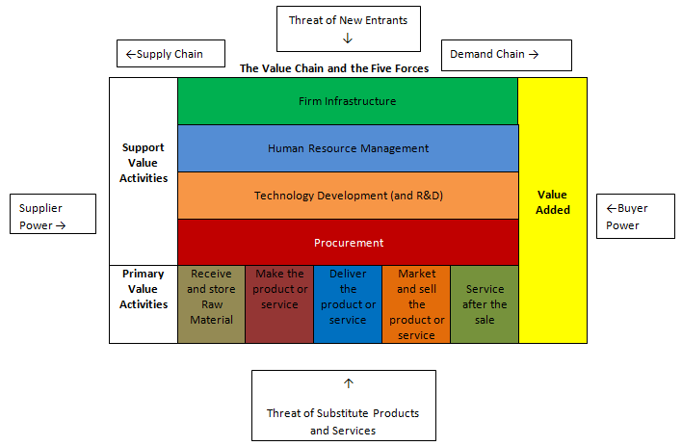
- 5 Forces Model: Framework that helps companies evaluate the relative attractiveness of entering or operating within an industry
- 3 Generic Strategies: Broad competitive approaches that organizations fall under, knowing which one an organization is following can help the firm make informed decisions about how the company should compete with other firms
- Value Chain Analysis: Systematic approach organizations can use to assess and improve the value of their business activities.
- Armed with the knowledge these three approaches give the company, organizations can then think about how IS can be used to facilitate and support this behaviour. (Business Driven Information System)
- Information systems are implemented to support a company's competitive business strategy

