Lab 1: Logic Circuits

ITI1100B
Christiane Mayo, 7272881
William Pearson, 7204884
Group #:___
January 29, 2014
Objectives
- Construct simple combinational logic circuits from a schematic.
- Experimentally determine the functional operation of simple combinational logic circuits.
- Identify common logic functions produced by various circuit configurations by the resulting truth table.
- Connect various gates together to create simple logic functions.
- Analyze combinational logic circuits and predict their operation.
- Construct and test more complex combinational logic circuits.

Equipment and components
- QUARTUS II Student Edition Software
- Altera UP-1 circuit board
- AC adapter, minimum output: 9VDC, 250mA
- Anti-static wrist straps
- #22 solid-core wires
- Wire strippers

Circuit Diagrams

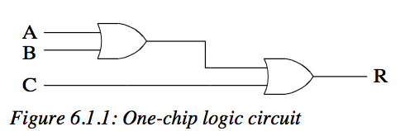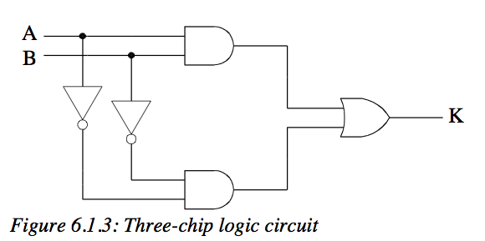
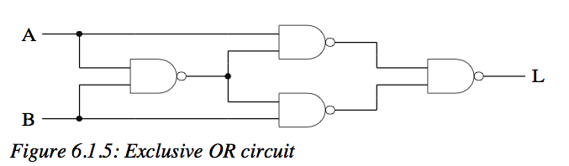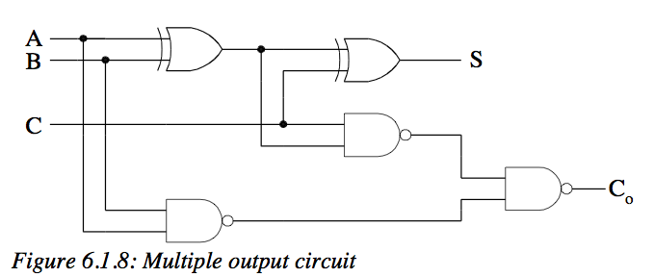

Experimental data and data processing

Part I

6.1.1
- 4. Create a simulation and note the results.

A | 0 | 1 | 0 | 1 | 0 | 1 | 0 | 1
B | 0 | 0 | 1 | 1 | 0 | 0 | 1 | 1
C | 0 | 0 | 0 | 0 | 1 | 1 | 1 | 1
R | 0 | 1 | 1 | 1 | 1 | 1 | 1 | 1

6.1.3
- 4. Create a simulation and note the results.
A | 0 | 1 | 0 | 1
B | 0 | 0 | 1 | 1
K | 1 | 0 | 0 | 1

Part II

6.1.5
7. Find out the truth table of the logic function that is implemented by your circuit, using each combination of the input logic variables from the truth table as the inputs to your circuit. Verify that the output of the circuit matches the corresponding output from the truth table you have derived above.
A | 0 | 1 | 0 | 1
B | 0 | 0 | 1 | 1
L | 0 | 1 | 1 | 0

6.1.8
7. Find out the truth table of the logic function that is implemented by your circuit, using each combination of the input logic variables from the truth table as the inputs to your circuit. Verify that the output of the circuit matches the corresponding output from the truth table you have derived above.

A | 0 | 1 | 0 | 1 | 0 | 1 | 0 | 1
B | 0 | 0 | 1 | 1 | 0 | 0 | 1 | 1
C | 0 | 0 | 0 | 0 | 1 | 1 | 1 | 1
S | 0 | 1 | 1 | 0 | 1 | 0 | 0 | 1
$$C_{O}$$ | 0 | 0 | 0 | 1 | 0 | 1 | 1 | 1

Comparison of expected data and experimental data

When comparing the output data of the simulation and the expected output data, we had to account for a propagation delay of 7.5 ns. Otherwise, experimental data matched up exactly with our expected data.

Discussion and conclusion

We use two or-gates in order to make one or gate that takes three inputs. We used two inverters, two and gates and an or gate in order to make an xnor gate. We used four nand gates in order to make an xor gate. We used two xor gates and three nand gates in order to make a full adder.

We had problem wiring up our CPLD so that it would run the programmed circuits. It turned out that we had to recompile before uploading. Once we recompiled, everything worked as expected. We expected to be able to use one project for all of the circuits. This did not work at all. When we created a separate project for each circuit, however, everything worked as expected.

Laboratory data sheets (Pre-lab)

Part 1

1) 6.11: R = (A + B) + C
6.12: U = [(AB)(CD)]’
6.13: K = (AB) + (A’B’)

2) 6.11:
A | B | C | (A + B) +C
1 | 1 | 1 | 1
1 | 1 | 0 | 1
1 | 0 | 1 | 1
0 | 1 | 1 | 1
1 | 0 | 0 | 1
0 | 1 | 0 | 1
0 | 0 | 1 | 1
0 | 0 | 0 | 0

6.12:
A | B | C | D | [(AB)(CD)]’
1 | 1 | 1 | 1 | 0
1 | 1 | 1 | 0 | 1
1 | 1 | 0 | 1 | 1
1 | 0 | 1 | 1 | 1
0 | 1 | 1 | 1 | 1
1 | 0 | 0 | 0 | 1
0 | 1 | 0 | 0 | 1
0 | 0 | 1 | 0 | 1
0 | 0 | 0 | 1 | 1
1 | 1 | 0 | 0 | 1
1 | 0 | 1 | 0 | 1
1 | 0 | 0 | 1 | 1
0 | 1 | 0 | 1 | 1
1 | 1 | 1 | 1 | 1

6.13:
A | B | (AB) + (A’B’)
1 | 1 | 1
1 | 0 | 0
0 | 1 | 0
0 | 0 | 1

Part 2

6.15:
L = {[(BA)’A]’[(BA)’B]’}’
6.16:
V = {(A’C) + (AC)}{[(B’D)’(BD)’]’}
6.17:
P = [(A+C)(B’)] + [(AB) + (A’C)]
6.18:
$$S=(A⊕B)⊕C$$
$$C_{O}=\{{\left(AC\right)}^{'}{\left[\left(A⊕B\right)C\right]}^{'}\}'$$

- 6.15:
A | B | L
0 | 0 | 0
0 | 1 | 1
0 | 1 | 0
0 | 0 | 1

6.16:
A | B | C | D | V
0 | 0 | 0 | 0 | 0
0 | 0 | 0 | 1 | 0
0 | 0 | 1 | 0 | 0
0 | 1 | 0 | 0 | 0
1 | 0 | 0 | 0 | 0
1 | 1 | 0 | 0 | 0
1 | 0 | 1 | 0 | 0
0 | 1 | 1 | 0 | 0
0 | 0 | 1 | 1 | 1
1 | 1 | 1 | 0 | 0
1 | 1 | 0 | 1 | 0
0 | 1 | 1 | 1 | 1
0 | 1 | 1 | 1 | 1
1 | 0 | 0 | 1 | 0
0 | 1 | 0 | 1 | 0
1 | 1 | 1 | 1 | 1

6.17:
A | B | C | P
0 | 0 | 0 | 0
1 | 0 | 0 | 1
0 | 1 | 0 | 0
0 | 0 | 1 | 1
1 | 1 | 0 | 1
1 | 0 | 1 | 1
0 | 1 | 1 | 1
1 | 1 | 1 | 1

6.18:
A | B | C | S | $$C_{O}$$
0 | 0 | 0 | 0 | 0
1 | 0 | 0 | 1 | 0
0 | 1 | 0 | 1 | 0
0 | 0 | 1 | 1 | 0
1 | 1 | 0 | 0 | 1
1 | 0 | 1 | 0 | 1
0 | 1 | 1 | 0 | 1
1 | 1 | 1 | 1 | 1

