Psychology 1000 – Frontiers and Applications – Chapters 5 + 6 Notes

Vocab words | Definition
Absolute Threshold | The lowest intensity at which stimulus can be detected correctly 50% of the time.
Amplitude | The vertical size of the sound wave, which gives rise to the perception of loudness and is measured in terms of decibels.
Basilar membrane | A membrane that runs the length of the cochlea and contains the organ of Corti and its (16000) sound receptor hair cells
Binocular cues | Depth cues that require the use of both eyes.
Binocular disparity | The binocular depth cues produced by the projection of slightly different images of the object on the retinas of the two eyes.
Bipolar cells | Have synaptic connections with rods and cones. Synapse with a layer of about 1 million ganglion cells whose axons are collected into a bundle to form the optic nerve.
Bottom-up processing | Perceptual processing that begins with the analysis of individual elements of the stimulus and works up to the brain’s integration of them into a unified perception.
Cochlea | A small coil-like structure of the inner ear that contains the receptors for sound. Contains Basilar membrane and organ of Corti
Conduction deafness | Hearing loss caused by damage to the mechanical system that conducts sound waves to the cochlea.
Cones | Colour receptors that focus best is bright lighting.
Convergence | Produced by feedback from the muscles that turn your eyes inward to view near objects, creates a depth cue.
Critical periods | A time period in which exposure to particular kinds of stimulation is required for normal development to occur.
Dark adaptation | Progressive improvement in brightness sensitivity that occurs over time under conditions of low illumination.
Decibels | A logarithmic measure of sound intensity (to measure amplitude).
Decision criterion | A standard of how certain they must be that a stimulus is present before they will say they can detect it.
Deprivation experiment | A method of determining the critical periods during which certain experiences must occur for the related brain mechanisms to develop normally.
Difference threshold | Sometimes called the just noticeable difference (jnd), it is the smallest difference between two stimuli that people can perceive 50% of the time.
Dual-process theory | Combines the Trichromatic and opponent-process theory to explain the colour transduction process.
Endorphins | Natural opiate like substances that are involved in pain reduction. Function to inhibit release of neurotransmitters that transmit pain impulses from the spinal cord to the brain.
Feature detectors | Groups of neurons that fire selectively in response to stimuli that have specific characteristics.
Figure-(back)ground relations | Perceptual organization to which a focal stimulus is perceived as a figure against a background of other stimuli.
Fovea | A small area in the centre of the retina that contains only cones. These cones decrease as in concentration as one moves away from the centre of the retina.
Frequency | In audition, the number of cycles per second in a sound wave, responsible for the pitch of the sound; the measure of frequency is the hertz (Hz), which equals one cycle per second.
Frequency theory | The theory of pitch perception that holds that the number of nerve impulses sent to the brain by the hair cells of the cochlea corresponds to the frequency of the sound wave, this theory is accurate at low frequencies.
Ganglion cells | The third layer of retinal cells with which the bipolar cells synapse and whose axons form the optic nerve.
Gate control theory | Proposes that the experience of pain results from the opening and closing of ‘gating mechanisms’ in the nervous system. Developed by Canadian psychologist Ronald Melzack and physiologist Patrick Wall (1982). Acupuncture works because the needles stimulate tactile receptors that close the pain gate. It also likely releases endorphins to the blunt pain sensations.
Gestalt laws | The laws of perceptual organization advanced from the Gestalt psychologists – namely: similarity, proximity, closure, and continuity.  Similarity: parts that appear similar will be perceived as belonging together.  Proximity: objects near one another will be perceived as belonging  Closure: people tend to close open ends of figure to make it whole.  Continuity: people link objects together to create a pattern that makes sense.
Gustation | Sense of Taste.
Hertz | The measure of sound-wave frequencies as cycles per second.
Hyperopia | Far-sightedness.
Illusions | Incorrect perceptions based on false perceptual hypotheses that often result from constancies that do not apply to the stimuli in question.
Inattentional blindness | The failure of unattended stimuli to register in consciousness.
Kinesthesis | The body sense that provides feedback on the position and movements of our body parts. The receptors are nerve endings in the muscles, tendons, and joints. The info this sense gives us is basis for making coordinated movements.
Lens | Located behind the pupil, the lens is an elastic structure that functions to focus on distant objects by becoming thinner, or thicker to focus on near objects.
Menstrual synchrony | The tendency for some women who live together over time to become more similar to one another in the timing of their menstrual cycles.
Monocular cues | Depth cues that require only one eye; include linear perspective, decreasing size, height in the horizontal plane, texture, clarity, light and shadow, motion parallax, and interposition.
Myopia | Near-sightedness.
Nerve deafness | Hearing loss caused by damage to the cochlea receptor cells or the auditory nerve.
Olfaction | Sense of Smell.
Olfactory bulb | A forebrain structure immediately above the nasal cavity.
Opponent-process theory | Proposed that each of the three cone types responds to two different wavelengths
Optic nerve | Composed of a bundle of ganglion cells, which synapse with bipolar cells.
Organ of Corti | A structure embedded in the basilar membrane that contains the hair cell receptors for sound.
Parallel processing | Our ability to use our senses to take in a variety of information about an object and construct a unified image of its properties.
Perception | Making sense of what our senses tell us – is the active process of organizing this stimulus input and giving it meaning.
Perceptual constancies | The ability to recognize stimulus characteristics – size, colour, etc. – under varying conditions.
Perceptual schema | Internal representations that contain the essential features of an object of perception.
Perceptual set | A readiness to perceive stimuli in a particular way.
Pheromones | Chemical signals found in natural body scents.
Photopigments | Protein molecules that rods and cones use to translate light waves into nerve impulses.
Place theory | Theory of pitch perception that holds that sound frequencies are coded in terms of the portion of the basilar membrane where the fluid wave in the cochlea peaks; this theory accounts for perception of frequencies above 4,000 Hz.
Primary visual cortex | The area of the occipital lobe which receives impulses generated from the retina via the thalamus and analyses visual input by using its feature detectors.
Psychophysics | The study of relations between the physical characteristics of stimuli and sensory capacities.
Retina | A multilayered tissue at the rear of the fluid-filled eyeball. Light sensitive.
Rods | Primarily black-white brightness receptors, which functions best in dim light. They are about 500 times more sensitive to light than cones, but they do not give rise to colour sensations. NOT found is fovea, this can account for lights disappearing in the dark, found mostly in periphery of retina.
Sensation | The stimulus detection process by which our sense organs respond to and translate environmental stimuli into nerve impulses that are sent to the brain.
Sensory adaptation | Sensory neurons are engineered to respond to a constant stimulus by decreasing their activity and the diminishing sensitivity to an unchanging stimulus.
Sensory prosthetic devices | Devices that provide sensory input that can, to some extent, substitute for what deaf and blind people are not supplied by their sensory receptors.
Shadowing | An experimental procedure used in attention research in which a person simultaneously receives two or more messages, is asked to focus on one of them, and then is asked to report on the other messages as well.
Signal detection theory | Concerned with the factors that influence sensory judgements.
Stroboscopic movement | Illusory movement produced when a light in briefly flashed in darkness and then, a few milliseconds later another light is flashed nearby.
Subliminal stimulus | A stimulus that is so weak or brief that, though it is received by the senses, cannot be perceived consciously because it is way below the absolute threshold.
Synesthesia | Literally means mixing of the senses. A person with this disease may experience sounds as colours, tastes as words, etc. Women are more likely to have this disease.
Taste buds | The receptors for taste in the tongue and in the roof and back of the mouth that are sensitive to the qualities of sweet, sour, salty, and bitter.
Top-down processing | Perceptual processing in which existing knowledge, concepts, ideas, or expectations are applied to make sense of incoming stimulation.
Transduction | The process whereby the characteristics of a stimulus are converted into nerve impulses through the action of photopigments.
Trichromatic theory | Adanced by English physicist Thomas Young and German physiologist Hermann von Helmholtz. States that there are three types of colour receptors in the retina: red, green, and blue.
Vestibular sense | The sense of body orientation or equilibrium.
Visual acuity | The ability to see fine detail, greatest when the visual image projects directly into fovea.
Visual association cortex | Cortical areas in the occipital, parietal, and temporal lobes that analyze visual stimuli sent to the primary visual cortex in relation to stored knowledge and that establish the ‘meaning’ of the stimuli.
Weber’s Law | States that the difference threshold or jnd is directionally proportional to the magnitude of the stimulus with which the comparison is being made, and can be expressed as a Weber fraction.

Chapter 5: Sensation and Perception:

Abstract

- 3 Reporters in Moncton – Lutes Mountain: car rolled up hill.
- 6 magnetic or gravity hills in Canada, hundreds around the world, all have normal magnetic fields.

Introduction

- Synesthesia: Mixing of the senses; one may taste in colours, hear in sight, etc.
    - Different parts of the brain are specialized for different sensory functions, people w/synesthesia have a cross-wiring so that activity in one part of the brain evokes responses in another part of the brain dedicated to another sensory modality.
    - Women more susceptible than men 1:1150 vs. 1:7150
    - Maurer suggests that we are all born synesthetic, as the neural pathways in the brain are all relatively undifferentiated at birth.
    - Russian psychologist A.R. Luria was a famous synaesthete.
    - Theories
      - Pruning of connections in infancy does not occur, resulting in synesthesia.
      - Deficit in neural inhibitory processes in the brain that ordinarily keep input from overflowing into other sensory areas and stimulating them.

  - Binding problem: how do we bind all our perceptions together into one unified picture while keeping sensory elements separate.

- No matter the stimulus, sensory receptors must translate it into nerve impulses, this is known as transduction.
- Because sensory input is an active and creative process, the same sensory input could be interpreted differently at different times i.e. in different contexts.
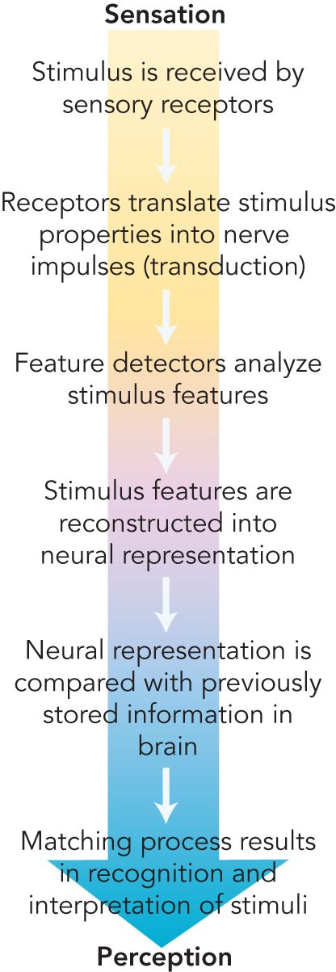
Sensory Processes

- Sensory equipment varies greatly among animals because it adapts to the environment in which the creature lives and is designed to extract from the environment the information that we need to function and survive.
- Receptors in the brain monitor chemical composition of our blood.

Stimulus detection:
  - Absolute threshold: The lowest intensity at which a stimulus can be detected 50% of the time.
      - The lower the threshold, the greater the sensitivity

Signal detection theory
- Counter-argument to absolute threshold
- Believes in a decision criterion: a standard of how certain they must be that a stimulus is present before they will say they detect it.
  - Changes from time to time based on factors: fatigue, expectations, etc.
- Signal detection theory is concerned with the factors that influence sensory judgements.
  - At low intensity stimuli, both the participant’s and the situation’s characteristics influence the decision criteria.
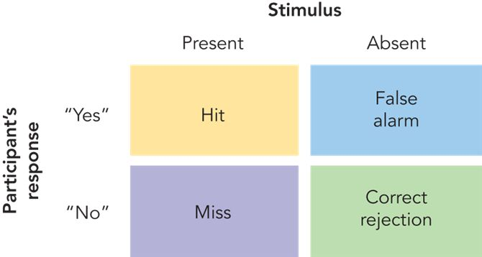

- Subliminal stimulus
- Is one that is so weak or brief that, although it is perceived by the senses, does not register in consciousness because it is way below the absolute threshold.
- Such a stimulus can, to a limited extent, influence attitudes and behaviours.

James Vicary had subliminal messages flash across a movie screen and concluded that that was the reason for 50% higher sales of popcorn and food.
- As a result, subliminal messaging on TV was outlawed by the National Association of Broadcasters
  - Attempts to duplicate this study all failed and Vicary later confessed that it was all a hoax.

Focus on Neuroscience

- Individuals with prosopagnosia are unable to recognize faces
- Lateral occipital area (LOA) is associated with object permanence.
- Fusiform gyrus: Associated with facial processing.
- Together they form the Fusiform facial area (FFA)
- Higher order facial recognize is a complex process that requires several brain regions including the FFA, LOA, and primary visual cortex.
  - Philip Merikle and colleagues argued that subliminal cues can bias what we perceive at a conscious level and may alter our conscious experience of those stimuli.

Weber Fraction

German physiologist Ernest Weber discovered that there is some degree of lawfulness the range of sensitivities within our sensory system. He created the Weber fraction (def. above). An example of the Weber fraction in use is to consider that the jnd for value for weights in a weber fraction is about 1/50, meaning that if you can lift a weight of 50 grams, a comparison weight must be at least 51 in order for you to judge if it is heavier or if the weight were 500, it must 510 for you to discriminate between them.
- Weber’s law breaks down at extremely low and high intensity stimulation
- The SMALLER the fraction the GREATER the sensitivity. 1/3 more sensitive to than 1/3000.
- Weber fractions also show that humans are highly sensitive to differences in pitch of sounds but far less to loudness differences.
- Human’s are highly visual creatures, very poor sense of smell (olfaction)

Sensory Adaptation

- Sensory systems are finely attuned to changes in stimulation.
- Sensory neurons are engineered to respond to constant stimulus by decreasing their activity and the diminishing sensitivity to an unchanging stimulus is called sensory adaptation (or habituation).
- Occurs in all sensory modalities, even vision.
- To demonstrate sensory adaption, R.M. Pritchard attached a tiny camera to a contact lens worn by a participant, when the stabilized image was projected through the lens onto the retina, participants reported that the image would appear completely for a time then begin to vanish and reappear as parts of the original stimulus.
- Sensory adaptation is beneficial to us because although it reduces our overall sensitivity, it frees our senses from the constant and the mundane to pick up informative changes in the environment.

The Sensory Systems

- Vision
  - Normal stimulus: electromagnetic energy in the form of light waves (measured in nanometers = 1 billionth of a metre)
  - Bees can see ultraviolet rays, rattlesnakes can detect infrared energy.
  - Humans can only see wavelengths from 700 nanometers (red) to 400 nanometers (blue-violet)
  - ROY G. BIV Red, orange, yellow, green, blue, indigo, violet (like a rainbow). Higher the wavelength top of rainbow, lower to the bottom of the rainbow.

- The human eye

  - Light enters through cornea (transparent protective at the front of eye)
  - Pupil, directly behind cornea, is an adjustable opening that can dilate or constrict to control the amount of light that can enter the eye, the change is size is controlled by the iris (colour part of eye).
  - Low light – dilation for optic clarity/ High light - constriction
  - Lens, located behind pupil, is an elastic structure that becomes thinner to focus of distant objects and thicker to focus on closer ones. Directs the visual image onto the…
  - Retina, a light sensitive multi-layered tissue located at the back of the eyeball.
  - The image is flipped from right to left and upside-down through the lens but the brain reconstructs it into the image we perceive.
  - Ability to see clearly = Lens / Ability to focus = retina.
  - Myopia occurs when the lens focuses the visual image in front of the retina, which is too close to the lens, resulting in a blurred image for far away objects.
  - Hyperopia occurs when the lens does not thicken enough and the image is therefore focused on a point behind the retina (too far from the lens).
  - Aging process contributes to hyperopia in middle-aged and older people as the eyeball becomes shorter over time. Conversely this process can improve vision in people with myopia as the retina moves closer to the lens.

- Photoreceptors: Rods and Cones

  - Retina is an extension of the brain located in the back of the surface of the eyeball and contains specialized sensory neurons in addition to two types of light-sensitive receptor cells: Rods and Cones (due to their shape).
  - There are approx. 6 million cones and 120 million rods in the human eye.
  - Rods: Function best in dim light and are about 500 times more sensitive to light than are cones, but do not give rise to colour. Owls have exceptional night vision but terrible day vision because their retinas contain purely rods.
  - Cones: colour receptors that focus optimally in bright illumination. Animals that are active only during the day have only cones in their retinas such as: chipmunks and pigeons.
  - Animals such as humans who are active during the day and night have a mixture of both rods and cones.
  - In humans, rods are found everywhere but the fovea, a small area on the retina where there are just cones.
  - Bipolar cells have synaptic connections with rods and cones and synapse with
  - Ganglion cells (one million approx..) whose axons are collected into a bundle and form the optic nerve. Creating an input of more than 126 million rods and ones is eventually funnel into only 1 million traffic lanes leading out of the retina toward higher visual centres.
  - Rods and cones make up the rear end of the retina and face the opposite way meaning that they only receive a fraction of the light energy that enters the eye.
  - Many rods are often connected to the same bipolar cell, meaning that they can combine and funnel their individual electrical message to that bipolar cell . this is why we can often detect a faint stimulus such as a star. If we look slightly to one side since that where most of the rods are (periphery) NONE in fovea (centre).
  - Each rod in the fovea has its own ‘private line’ to a single bipolar cell, resulting in our increased ability to see fine details when we look at something dead-on.
  - There is a blind spot resulting from the optic nerve exiting form the back of the eye, close to the fovea.

- Visual transduction – Light to nerve impulses

  - *See transduction and Photopigments def.*
  - Greater the change in transmitter release, the stronger the signal passed onto the bipolar cell and in turn the ganglion cell optic nerve.
  - If nerve responses are triggered at each of the three levels, rods, cones, bipolar cells, and ganglion cell, the message is instantaneously on its way to the relay station in the visual relay station in the thalamus, and then onto the visual cortex of the brain.

- Brightness Vision and Dark Adaptation

  - Brightness sensitivity of both cones and rods depends on the wavelengths of the light.
  - Rods have much greater brightness sensitivity than cones throughout the colour spectrum except at the red ends, where reds are relatively insensitive.
  - Cones are more sensitive to low-illumination in the greenish-yellow range of the spectrum.
  - Airport runways are typically blue because the wavelength is picked up very well by rods during night vision where cones are essentially inoperative.
  - Dark adaptation *see definition* - After absorbing light, a photoreceptor is depleted of its pigment molecules for a period of time. If they eye has been exposed to a condition of high illumination, a substantial amount of photo-pigment will be diminished, during the process of dark adaptation, the photopigments are regenerated and receptor sensitivity is as well.
  - Vision researchers have developed a two part curve of the process of dark adaption: Cones gradually become more sensitive to light as time passes but after about 5 -10 minutes in the dark their sensitivity has reached its maximum, rods on the other hand do not reach their sensitivity until about half an hour because their Photopigments regenerate more slowly.
  - After complete adaptation, it is estimated that rods are able to detect intensities only 1/10,000 as great as they could before dark adaptation.

- Colour vision

  - Humans can distinguish approx.. 7.5 million hue variations, and historically, there are two different theories that have tried to explain this:

    - Trichromatic theory *see def.*

      - Additive colour mixture: Any colour in the visible spectrum can be produced from the wavelengths blue, green, red (primary colours).
      - Trichromatic theory was based off of this discovery – Advanced by Thomas Young and Hermann von Helmholtz, the theory states that there are only 3 types of colour receptors in the retina (primary colours). Although cones can be stimulated by any colour, individual cones are most sensitive to wavelengths that correspond to either blue, green, and red.
      - Each receptor class sends a message to the brain based on the extent to which they are activated by the light energy’s wavelength. The visual system then combines the signals to recreate the original hue. If all three cones are equally activated, a pure white colour is perceived.
      - Problems: Yellow is supposed to be produced by the combination of red + green activity receptors, yet people with red/green colour blindness can perceive yellow. Also the colour afterimage in which a different colour appears after a colour stimulus has been viewed steadily and then withdrawn.

    - Opponent-Processing theory *see def.*

      - Developed by Ewald Herring in 1870
      - States that there are 3 types of cone, but that each of the cones responds to two different wavelengths. Ie. red to green and blue or yellow.
      - For example a red-green cone responds with one chemical reaction to a green stimulus with its other chemical reaction (opponent process) to red stimulus.
      - According to this theory, as you stare at the afterimage photo, the neural processing that register these colours became fatigued.
      - Then when you cast your gaze on a white surface (which reflects all wavelengths), a ‘rebound’ opponent reaction occurred as each receptor responded with its opposing white or red reactions.

    - Dual-processing theory

      - Combines trichromatic and opponent-processing theory to account for the colour transduction process.
      - Trichromatic theorists such as Helmholtz and Young were right in that cones do indeed contain 3 different protein Photopigments that are most sensitive to wavelengths close to red, blue and green.
      - Different ratios of activity in the red, blue, and green sensitive cones produce a pattern of neural activity that corresponds to any hue within the spectrum, similar to what occurs on a TV screen (which contains red, blue, green dots to create the picture on the screen).
      - Hering’s opponent-processing theory was right in that opponent processing does not occur in the cones, but rather some neurons in visual relay station and within ganglion cells by altering their rate of firing. Example: if a red light is shone into the retina, a ganglion cell may respond with a high rate of firing, but if the same thing is done with a green cell, it may lower the firing rate.
      - The red-green opponent processes are triggered by direct input from red or green sensitive cones in the retina.
      - The blue-yellow opponent processes are more complex and are triggered by blue-sensitive cones stimulating the blue process farther along is the visual system and the yellow opponent processes are triggered by simultaneous input from both green and red sensitive cones.
      - Trichromat- people with normal colour vision. Dichromat – colourblind in only one system. Monochromat – can only see black and white.
      - 7% male population and 1 % of female have some deficiency in either the red-green, blue-yellow or both.
      - Deficiency is caused by the absence of a hue-sensitive photopigment in cones.

    - Analysis and reconstruction of visual scenes

      - Retina - optic nerve sends nerve impulses thalamus cortex (esp. primary visual cortex in occipital lobe)
      - In fovea, one-to-one synapses of cones with bipolar cells produces high visual acuity.
      - *See feature detectors* - discovery of these won david hubel and torsten wiesel of Harvard the ’81 nobel prize.
      - Different feature detectors fire at different line orientations.
      - Cells respond most strongly to bars, slits, and edges in certain positions.
      - Different classes of feature detectors also fire to colour, depth, and movement
      - Different modules of these detectors subdivide a visual scene into its component dimensions and then process them simultaneously by using parallel processing (analyzing images into separate parts then combining them to form a whole).
      - After the primary visual cortex is finished processing the info, it is routed to the visual association (the final step) where the new info is combined and interpreted in relation to our memories and knowledge.
      - Neurons In the brain respond selectively to complex stimuli that has acquired special meaning through experience, not just basic stimuli such as corners, and lines.

      - Light energy that strikes the retina is converted into nerve impulses by chemical reactions in the photopigments of rods and cones.

Audition

  - Sound waves are the stimuli for audition. They have two characteristics: frequency (measured in hertz and cycles per second), and amplitude (measured in decibels) refers to the vertical size of the sound waves, frequency is related to pitch (higher frequency, higher pitch), amplitude to loudness (. The receptors for hearing are hair cells on the organ of Corti in the inner ear. Humans can detect hertz from 20 to about 20000 (12000 in older folks). Absolute threshold for hearing = arbitrarily 0 decibels.

  - Loudness is coded in terms of the number and types of auditory nerve fibres that fire. Pitch is coded in two ways. Low-frequency tones are coded in terms of corresponding numbers of nerve impulses in individual receptors or by volleys of impulses from a number of receptors. Frequencies above 4000 hertz are coded according to the region of the basilar membrane that is displaced most by the fluid wave in the cochlear canal.

  - 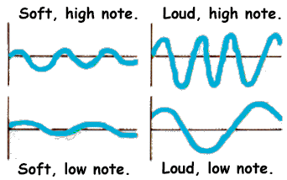

Auditory Transduction: from pressure waves to nerve impulses

  - Transduction system for audition is composed of tiny bones, membranes, and liquid filled tubes designed to translate pressure waves into nerve impulses. Sound travels into the air at about 1200 km/h first into the ear canal to the eardrum (a moveable membrane that vibrates in response to sound waves, then into the middle ear, a cavity housing 3 tiny bones (smallest in the body at about a grain of rice): the vibrating of the bones: hammer, anvil, and the stirrup, amplifies sound waves more than 30 times.

    - First bone – Hammer – is attached to the ear drum, the 2nd bone, the stirrup, is attached to the oval window, which forms the boundary between the middle ear and the inner ear (which contains the cochlea! *See def.) Cochlea contains the basilar membrane *See def. which is also the resting place for the organ of Corti and its 16000 hair cell sound receptors. Tips of the hair cells are tectorial membrane, which overhangs the basilar membrane along the entire length of the cochlea. The hair cells function to synapse with neurons of the auditory nerve which sends impulses via auditory relay station in thalamus to the auditory cortex, located in temporal lobe.

    - Sound waves eardrum vibration of the hammer, stirrup, and anvil creates pressure at the oval window and sets the fluid inside the cochlea in motion fluid causes vibration of the basilar membrane membrane above it, which contains the hair cells, vibrates as well and bends the cells in the organ of Corti bending of hair cells releases a neurotransmitter into the synaptic space between the hair cells and the neurons of the auditory nerve, resulting in nerve impulses that are sent to the brain.

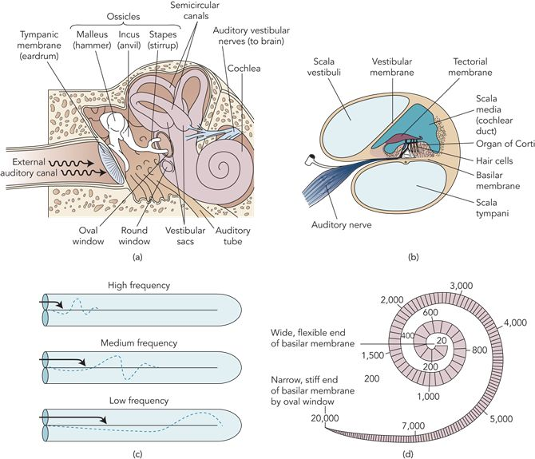

Coding of Pitch and Loudness

      - Higher amplitude sound waves cause more relapse of a neurotransmitter by bending the hairs more, resulting in a higher rate of firing in the auditory system. In addition to this, certain receptor neurons have higher thresholds and will only fire when the hairs have been bended considerably.
      - Loudness is coded in terms of the rate of firing AND which specific hairs are sending the message.

    - Similar to feature detector neurons that respond to different visual cues/orientations, feature detectors in the auditory cortex in the temporal lobe respond to specific kinds of auditory input.
  - Coding of pitch: 2 processes
    - Frequencies below 1000 hertz
    - High Frequencies
      - Frequency theory: nerve impulses sent to brain match the frequency of sound waves. I.e. 30 hertz sound wave from a piano should send 30 volleys of nerve impulses per second to the brain
        - Problem: Neurons are limited in their firing – recall absolute refractory period from chapter 2 – and are unable to produce such higher volleys of nerve impulses over 1000 hertz.
        - Bekesy – observed the cochlea of guinea pig to uncover that high frequency sounds produced an abrupt wave of fluid that peaked close to oval window, whereas low frequencies sounds produced a slower fluid wave that peaked farther down the cochlear canal. This discovery came to Place Theory *see def.
Sound Localization
- The nervous system uses information concerning the time and intensity differences of sounds arriving at the two ears to locate the source of sounds in space.
- Depending on which side the sound is coming from; it will reach the ear closest to it first, if the sound is coming from directly in front, it will reach both ears simultaneously.
Spinal and Brain Mechanisms
- See Gate control theory def.
  - Nerve impulses from the brain can also stimulate the gates in the spinal cord, thereby increasing or decreasing the flow of pain stimulation to the brain. Central control mechanism allows thoughts, emotions, and beliefs to influence experience of pain. Immune system plays a role in pain; glial cells (which structurally support and service neurons in the spinal cord, are involved in the creation and maintenance of pathological pain. Glial cells can become activated by changes in immune system
(viral or bacterial infection), and function to amplify the pain by releasing cytokines (messenger molecules) that promote inflammation, think ‘ache all over’.
- Endorphins
  - Opiates (morphine, opium, heroin) relieve pain and strongly affect the brain’s pain and pleasure systems by locking into specific receptor sites in brain regions associated wit pain and perception.
  - The nervous system has its own built-in analgesics (painkillers) with opiate like properties called endorphins!

Review:

  - Hearing loss can result from conduction deafness (hearing aids can often help), produced by problems involving the structures of the inner ear that transmit vibrations to the cochlea, or from nerve deafness, in which the receptors of the inner ear or the auditory nerve are damaged. 3 million Canadians are approximated to suffer from some sort of hearing loss. Brief expose to sounds exceeding 140 decibels can be detrimental to hearing

  - The receptors for taste and smell respond to chemical molecules. Taste buds are responsive to four basic qualities; sweet, sour, salty, bitter. The receptors for smell (olfaction) are long cells in the upper nasal cavity in the mucous membrane. Humans have about 40 million olfactory receptors. The receptors resemble neurotransmitter binding sites on neurons, the receptors that fire get sent to the olfactory bulb *see def.

    - These two senses are so intertwined that many scientists refer to a ‘common chemical sense’. The tongue contains its own touch and temperature senses in addition to the abundance (about 9000) of taste buds. Taste buds are most commonly concentrated along the edges and back surface of the tongue. Each taste bud is responsive to only one or two basic taste qualities. Hair like structures project from the top of each cell into the taste pore, an opening to the outside surface of the tongue.

    - The Centre of the tongue is least sensitive to taste, the tip is the most. Tip of tongue- sweet, just behind tip – salty, centre- insensitive to taste, middle-back – sour, back – bitter.

    - Each odorous chemical excites only a limited portion of the olfactory bulb and odours are coded in terms of which specific areas is excited.

    - ‘Taste’ is the result of neural activity produced by the four types of taste receptors.

    - Umani- an additional taste sense – increases the sensitivity to of other taste qualities.

  - Tactile Senses
    - Lack of tactile contact with a caretaker retards a child’s social, emotional, physical, physically massaging infants helps them to develop.

  - Menstrual synchrony can be attributed in most cases to pheromones.

  - At the biological level, the major pain receptors (and temperature) appear to be free nerve endings, Gate control theory attributes pain to the opening and closing of gates in the spinal cord and to influences from the brain. Pain receptors are found all over the body EXCEPT for the brain, bones, hair, nails, and non-living parts of teeth. Endorphins play a major role in pain reduction. Cerebral processing of pain stimuli occurs faster than other types of stimuli. Some pain tracts to the limbic system which seems to control the emotional component of pain. Pain has both a sensory and emotional component. Suffering occurs when both painful sensations and negative emotional responses are present.

  - Humans are sensitive to four tactile sense: pressure (touch), pain, warmth, and cold. These are all conveyed by receptors in our skin and internal organs, and it is a mixture of these four sensations that makes up all other skin sensations ie. itch. Skin, a multi-layered elastic structure that covers 90cm2 and weighs 2.7 and 4.5 kg, is the largest organ in the body. Nerve fibres situated at the base of hair follicles are receptors for touch and light pressure.

    - Phantom limb syndrome occurs in amputees, and it is a sensation that a missing limb is being touch, and results from an irritation of nerves that used to originate in the limb fools the brain into interpreting the resulting nerve impulses as real sensations. Prosthetic limbs seems to help with the phenomenon.

  - Skin and body senses include: touch, kinesthesis, and equilibrium. Receptors in the skin are sensitive to touch, pain, warmth, and cold. Kinesthesis functions by nerve endings in the muscles, tendons, joints. Sense organ for equilibrium is the vestibular apparatus in the inner ear. Kinesthesis and equilibrium are called ‘body senses’ because the help us orient the body’s position and movement, ie. if we’re laying down or standing up.* See kinesthesis and equilibrium def.*

    - One part of the equilibrium are the 3 semicircular canals, which contain the receptors for head movement. Each canal lies in a different place – left/right, backwards/forwards, up/down. The canals are filled with fluid and lines with hair like cells that function as receptors. When the head moves, the fluid shift, stimulating hair cells, which send messages to the brain. The canals respond only to acceleration and deceleration. The vestibular sacs are located at the base of the semicircular canals and contain hair cells that, given our position, tell us weather we a upright or tilted at an angle.

  - Studying the sensory process has facilitated the production of sensory prosthetics.

Sensory Prosthetic Devices *See Definition above.

Sonicguide- provides new eyes through the ears; it uses the same technology as echolocation

Tactile tongue-based electrical input sensor as a substitute for visual input, it functions to receive digital data from a camera and provides patterns of stimulation to the tongue through a 144-electrode array. The array transmits shapes that correspond to the visual stimulus.

When cells in the visual cortex are stimulated by electricity random dots of light called phosphenes are experienced by both sighted and blind people.

Cochlear implants are for people suffering from nerve deafness, who cannot be helped by more sound amplification. A set of 22 electrode is implanted into coil-like fashion around the cochlea to directly stimulate the auditory nerve, a microphone sends sound waves to processor implanted in the bone behind the ear, and then breaks it down and sends the messages to the brain. 22 electrodes compared to 16000 hairs normally, the sound quality cannot compare, but it is a start.

Bionic hand- Smart hand – contains 40 sensors that are connected to the sensory nerves in arms of amputees. 4 motors also linked to brain through their attachment to motor nerves, allow patients in very precise ways. This is the first prosthetic hand to allow for the control of movement that only comes through tactile feedback.

Perception: the creation of experience

- Sense organs merely transmit information through the nervous system.
- Perception is an active creating process which means that different people can experience the same sensory information is differing ways.
- See bottom-up processing* as well as top-down.
- Top-down processing accounts for psychological influences on our perceptions such as motives, expectations, previous experiences, and cultural learning.
- Attentional involves two basic processes- focusing on certain stimuli, and filtering out other info.
- *see shadowing
- stimuli characteristics that attract our attention are intensity, novelty, movement, contrast, and repetition. Internal factors such as motives and interests also filter which stimuli we will take notice to in our environment.
- Evidence suggests that humans have developed a special visual response system that unconsciously triggers protective responses to stimuli that is threatening.

Gestalt

- Gestalt in the German word for shape, pattern, or from. The gestalt psychologists were masters of top-down processing and argued that the wholes we perceive are more important than the sum of their parts. They placed much emphasis on figure-ground relations *see Def.
- We tend to organize stimuli into a central (in front or on top of background) or foreground figure.
- What’s figure and what’s ground can sometimes get confused.
- Suggested that people group and interpret stimuli according to the Gestalt Laws *see Def
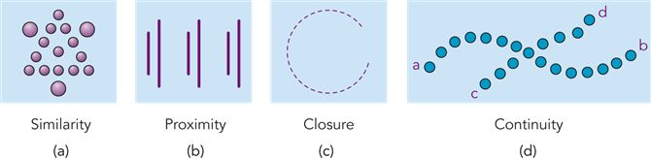

Perception involves hypothesis testing:

- ‘Recognizing’ a stimulus implies a perceptual schema – mental representation to compare it to.
  - Schemas contain: Critical features of objects, events, and other perceptual phenomena.
  - Allow us to classify & identify sensory input in a top-down fashion.
- Perception is an attempt to ‘make sense’ of the stimulus input, to search for the best interpretation of sensory information we can arrive at based on our knowledge and experience.
- Richard L. Gregory – each of our perceptions is a hypothesis about the nature of an object or the meaning of the sensory input.
- In some instances, sensory information matches two different internal representations and there is not enough info to rule out one or the other.

Perceptual sets –readiness to perceive stimuli in a particular way
- Perceptual sets can also influence our social perceptions i.e. if we’re told that someone is mean, we’re more likely to perceive sometimes neutral actions exhibited by them as fitting to the ‘mean persona’.
Perceptual Constancies
- Allow us to recognize familiar stimuli under changing conditions.
- Without this we would have to rediscover something each time we saw it again.
  - Shape Constancy – allow us to recognize people, shapes, and objects, from many different angles i.e. a swinging door.
  - Brightness constancy – the relative brightness of an object remains constant even under varying degrees of illumination.
  - Size Constancy – size of an object remains relatively constant even though images on our retina change in size with variation in distance.

REVIEW

- Perception involves both bottom-up, processing in which involves taking individual elements of an image and combining them to create a unified one and top-down processing, in which existing knowledge and perceptual schemas are applied to interpret stimuli.
- Attention is an active process in which we focus on certain stimuli and block out other. We cannot attend completely to more than one thing at once, but we are capable of rapid attentional shifts. Attentional processes are affected both by the nature of the stimuli and personal factors such as motives and interests. Stimuli that denotes danger or threat will attract our attention quickly.
- The Gestalt psychologist’s main principles are: Figure-ground relations and the laws similarity, proximity, closure, and continuation. R.L. Gregory: perception is a hypothesis about the stimuli is based on previous experience and the nature of the stimulus.
- Perceptual sets involve a readiness to perceive stimuli in certain ways based on our expectations, assumptions, motivation, and current emotional state.
- Perceptual constancies allow for us to recognize familiar stimuli under changing conditions. The three visual constancies are: Shape, brightness, and size.
- Info sent to brain by retina is nothing but light energy of different intensities and frequencies.

Perception of Depth, Distance, and Movement

- To adapt to a spatial world, we must make distinctions involving distances, and the movement of objects in the environment.
- The retina receives information in only two dimensions: length and width.
- Brain translates these into three-dimensional perceptions by using:

  - Monocular Depth cues (only require one eye)
    - Light and shadow
    - Linear perspective – perceptions that linear lines converge towards each other in the distance (think of train tracks)
    - Interposition – closer objects may cut off part of another object in the distance.
    - Height in the horizontal plane (ship on the horizon)
    - Texture – texture or grain of an object becomes finer as distance increases.
    - Clarity – objects that are nearer appear more clear than far-away objects.
    - Relative size – object that looks smaller is often judged to be farther away
    - Motion Parallax – if we are moving, nearby objects appear to move faster in the opposite direction than do father away ones.

  - Binocular Depth cues (require two eyes)
    - Binocular disparity –Each eye sees a slightly different image
      - Some of the feature detectors in the brain respond only to stimuli that are either in front of or behind the point we are fixing our gaze on. The responses of these depth-sensitive neurons produce our perception of depth.
    - Convergence - Produced by feedback from the muscles that turn your eyes inward to view near objects, creates a depth cue.
- Perception of Movement
  - Primary cue for perceiving is the movement of the stimulus across the retina.
    - Stimulus can move as little as 1/5 the diameter of a single cone for us to perceive movement.
    - Movement of object against a background is also a movement cue.

  - Gestalt Psychologist Mac Wertheimer demonstrated that the illusion of smooth motion can be produced if we arrange for the sequential appearance of two or more stimuli.
    - Stroboscopic Movement (or Phi Phenomenon as coined by Wertheimer) – Illusory movement produced when a light in briefly flashed in darkness and then, a few milliseconds later another light is flashed nearby.
      - The principle behind motion picture
        - Usual frame speed in films is 24 frames per second.
        - TV at 30 frames per second.
- Illusions: False perceptual hypothesis
  - Illusions – compelling but false perceptions, can be explained as erroneous perceptual hypothesis about the nature of the stimulus.
    - Most can be attributed to perceptual constancies.
      - Study of perceptual constancies shows that our perceptual hypotheses are strongly influenced by the context or surroundings in which the stimulus takes place.
        - Devil’s tuning fork

- Experience, Critical periods, and perceptual development
  - Development of sensory and perceptual systems results from interplay of biological and experimental factors. Genes program biological development, but this development is also influenced by environmental experiences.
    - Bambuti Pygmies – Turnbull (1961): lack of size constancy from living in an environment without open spaces. Buffalo in the distance confused as insect.

- Cross-Cultural research on Perception
  - Helps to identify which aspects of perception occur in all people regardless of their culture.
  - Müller-Lyer illusion – Line appears longer when V-shaped lines radiate outward rather than inward.
  - Westerner’s susceptible to Müller-Lyer illusion because they are used to a ‘carpentered’ environment with many corners and square shapes, inward facing lines occur when corners are closer, outward facing lines when they are farther away.
  - People who live in a different environment with more rounded shapes, perceive the illusion correctly.
  - Perceptions of taste, odour, and textures are also strongly influenced by our culture. 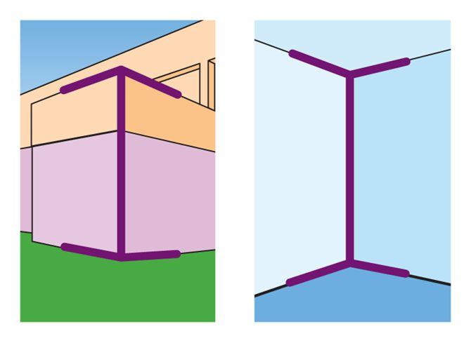

- Research Foundation

  - Critical periods - A time period in which exposure to particular kinds of stimulation is required for normal development to occur. If this period passes, the deficit is irreversible.
  - Deprivation experiment - A method of determining the critical periods during which certain experiences must occur for the related brain mechanisms to develop normally.
    - Blackmore and Cooper (1970) – Kittens’ ability to adapt to a different environment – Horizontal stripes vs. Vertical stripes.
      - Found that Kittens could adapt quickly to their environment but the opposite line orientation would not register to them, i.e. if raised in horizontal room, they would be blind to vertical ones.
      - The feature detectors in the kittens’ visual cortexes would not fire to the opposite line orientation.
      - Thus, the cortical neurons of both groups developed in accordance to their environment.
      - The cortical change discovered by Blackmore and Cooper appears to be permanent.
    - Maurer notes that the critical period for children to develop visual acuity is from birth-10 years.

Restored Sensory Capacity

- Visual deprivation studies, manipulation of visual input, and studies of restored vision have shown that the normal biological development of the perceptual system depends on certain sensory experience at early periods of development.
- Virgil – blind since birth – had cataracts removed and while he then had a functioning retina and optic nerve, could not make sense of the information.
- German physician Von Senden –tested adults who had been blind, but had visual restored in adulthood.
  - Found that patients could quickly identify figure-ground relations, scan objects with eyes, and following moving objects, indicating that these abilities are innate.
  - They could not, however, identify objects very well, and had poor visual constancies.
- Perception is very much a biopsychological process whose mysteries are best explored by examining them from biological, psychological, and environmental levels of analysis.

