OOP (Object-oriented programming): Java is an object-oriented programming language. In an object-oriented language, you use objects and classes to organize your data.
Language: Java object-oriented programming.
Error/Exception: Syntax errors are errors that violate the rules of Java (typo or illegal entry). Logic errors are errors that occur in statements that are syntactically correct, but produce undesired or unexpected results (bad order). Run-time errors are errors that are not detected by the compiler may generate a run-time error. This error, also called an exception, halts program execution at the statement that cannot be executed (crashing).
IDE: Integrated Development Environment include a window for typing the program, a window for running the program, and a window to keep track of the code you wrote.
Method: Inside a class are methods. Methods are segments of programming code that have a particular purpose. A method is a way to accomplish a task in a Java program.
Declaration: Declare classes, methods, and variables.
Class: Each application program is a class.
Statement: Statements are lines in Java that actually issue direct instructions to the computer. In Java, each statement ends with a semi-colon (;).
App Inventor: A programmer who makes applications.
Appshed: Easy application creator.
Constructor: A constructor is a special method in a class. It has the same name as the class name. Constructors are only called once and do not return a value.
Method Overloading: The method declaration is used by the complier to determine which method to execute. Method overloading is when more than one method of the same name is included in a class.
Control Structure: All programs can be written in terms of only three control structures- the sequence structure, the selection structure, and the repetition structure.
IFs/Loops: Jumps right in, takes action, and then checks a condition to see whether the result makes sense. If the result does make sense, execution of the loop is done. If not, the program goes back to the top of the loop for another go around.
Math Methods: “ + , - , / , * , = ”
Random Numbers: To generate a random number: (highNum –lowNum +1) * Math.random() + lowNum.
Import: An import statement is a way of making more of the functionality of Java available to your program.
Variables: Variables in computer languages are placeholders. This thing stored in the variable is called a value. The kind of value that is stored in a variable is a variable type. Integer, a positive or negative number that can have no decimals. Double, a positive or negative number that can have decimals. String, a word. Char, a single character. Boolean, true or false.
Data Types: Data types are divided into two categories in java – primitive and reference. This is the process of converting a number from one type to a different by compatible type.
Constant: Cannot change value.
GradeBook

- courseName: String

<<constructor>>GradeBook(name:String)
+setCoursename( name : String)
+getCourseName( ) :String
+ displayMessage ( )

Package: A package organizes a set of related classes.

Extends: Object inherits properties or characteristics.
Robocode: Coding robots.
UML (Unified Modeling Language): A graphical language that allows people build systems to represent their object-oriented designs in a common notation.
GUI Swing: Swing is a java package that provides a set of classes for creating graphical user interfaces (GUIs).
Main Class: Every program created in Java must have a method named main.
Scanner: This method grabs the word entered by the user and places it into a String variable.

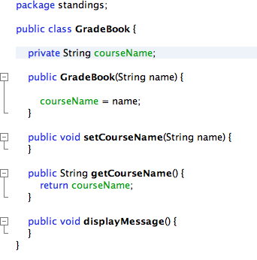
Type Casting: This is the process of converting a number from one type to a different but compatible type.
Parsing: Parameters are things in parenthesis.
ComboBox: A combo box offers a user a way to select from a limited set of choices.
Recursion: Recursion is when a method calls itself.
Increment: The increment operator (++) increases the value of a variable by one.
Multi-threading: A technique by which a single set of code can be used by several processors at different stages of execution.
Encapsulation: Protecting an object’s data.
Break statement: Causes immediate exit from a statement.
Void: Void means that this method does not return a value.
Static: Static loads the main method into memory.
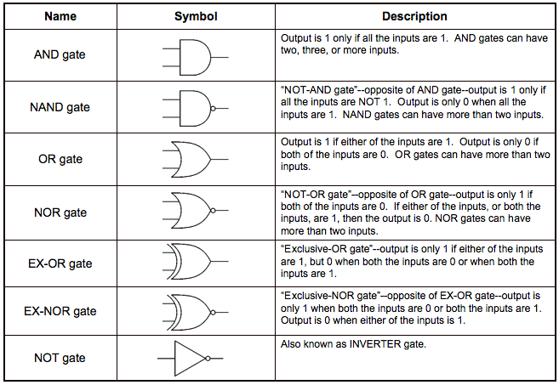
Unicode: An international encoding standard for use with different languages and scripts, by which each letter, digit, or symbol is assigned a unique numeric value that applies across different platforms and programs.
Case: A container.
Polymorphism: A feature that allows values of different data types to be handled using a uniform interface.
Public: Public means that other classes can call this main method.
Reference: Reference-type variables store the locations of objects in the computer’s memory.
//Input
File textFile = new File("frc.txt");
FileReader in;
BufferedReader readFile;
String lineOfText;
try {
in = new FileReader(textFile);
readFile = new BufferedReader(in);
while ((lineOfText = readFile.readLine()) != null) {
item.add(lineOfText);
lineOfText = readFile.readLine();
price.add(Integer.parseInt(lineOfText));
lineOfText = readFile.readLine();
quantity.add(Integer.parseInt(lineOfText));
}
readFile.close();
in.close();
} catch (FileNotFoundException e) {
System.out.println("file does not exist");
System.err.println("fileNotFoundException: " + e.getMessage());
} catch (IOException e) {
System.out.println("Problem reading file");
System.err.println("IOEception: " + e.getMessage());
}
for (int a = 0; a < item.size(); a++) {
jcItem.addItem(item.get(a));

//Output
File textOut = new File("frc.txt");
FileWriter out;
BufferedWriter writeFile;
try {
out = new FileWriter(textOut, false);
writeFile = new BufferedWriter(out);
for (int i = 0; i < item.size(); i++) {
writeFile.write(item.get(i));
writeFile.newLine();
writeFile.write(String.valueOf(price.get(i)));
writeFile.newLine();
writeFile.write(String.valueOf(quantity.get(i)));
writeFile.newLine();
}
writeFile.close();
out.close();
} catch (IOException e) {
System.out.println("problem writing to file");
System.err.println("IOException : " + e.getMessage());
}
this.dispose();//close program



