ADM 1340 – Midterm Notes

Financial Statement

Perpetual vs. Periodic

Journal Entry

Equations

Chapter 1

Financing Activities
Obtaining funds to finance the operations of the business
Debt: borrowing money from lenders and other creditors
Equity: issuing ownership interests in the corporation to shareholders
Investing Activities
Obtaining resources or assets needed to operate the business
Purchase of long-term investments
Purchase of long-lived assets such as equipment
Operating Activities
Main day-to-day activities of the business
Sale of merchandise, purchasing of goods for sale, payments made for repairs, short-term investments

Financial Statements

Income Statement
Reports success of failure – summarizes all revenues and expenses
Prepared first – needed for profit figure
*See single step and multistep* Chapter 5

Statement of Changes in Equity
Shows the amounts and causes of the changes in shareholder’ equity as well as changes in each component of SE

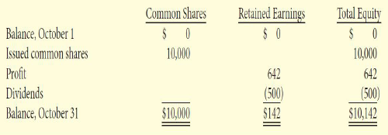

Statement of Financial Position
Show what the business owns and owes – net worth
Assets = Liabilities + Shareholders’ Equity
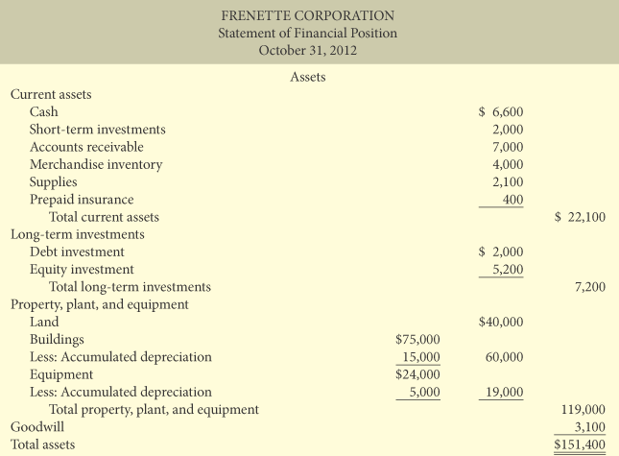
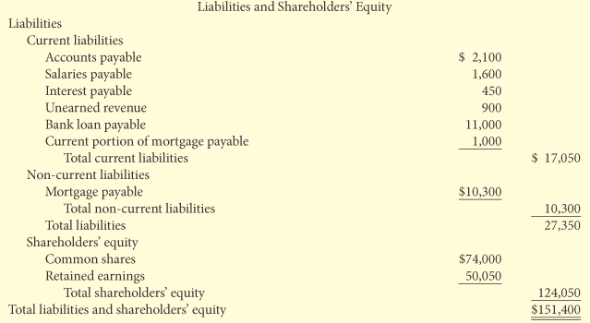

Statement of Cash Flows
Reports the cash effects of a company’s activities
Shows Cash increases and decreases from operating, investing and financing
Indicates net increase or decrease as well as ending balance

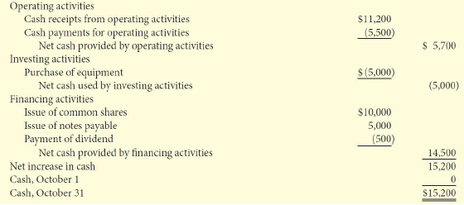

Relationship Between Statements
Profit from income statement is reported in statement of changes in equity
Ending balances of each component of shareholders equity from statement of change in equity is reported in statements of financial position
Cash balance reported in the balance sheet agrees to ending cash balance on statement of cash flows

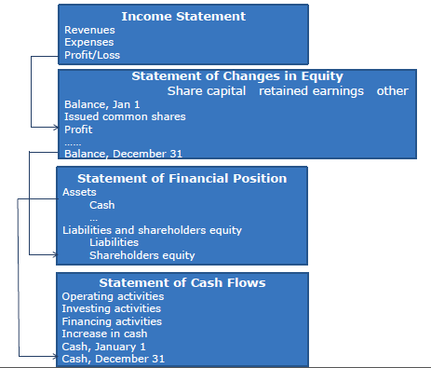

Chapter 2

Ratios
Liquidity measures the ability to pay obligations as they become due
Working Capital = CA – CL
Current Ratio = CA/CL
Solvency measures the ability to survive over a long period of time through paying interest as it comes due and repaying the face value of debt maturity
Debt to total Assets = TL/TA
Profitability measures a companies operating success for a given period of time
Earnings Per Share = Profit available to common shareholders
Weighted average number of common shares
Price-earnings ratio = Market price per share/earnings per share

Framework for the Preparation and presentation of Financial Statements
Qualitative Characteristics
Fundamental
Relevance and faithful representation
Enhancing
Comparability, verifiability, timeliness and understandability
Relevance
The information has the ability to make a difference in a decision scenario
May have predictive and confirmatory value
Faithful Representation
Should reflect the economic reality of what really exists or has just happened
Must be complete, neutral, and free from error
Comparability
Users can identify and understand similarities and differences in and among items
Verifiability
Different knowledgeable and independent users can reach consensus that the information is faithfully represented
Timeliness
Information must be available to decision makes before it loses its ability to influence decisions
Understandability
The information is classified, characterized, and presented clearly and concisely

The Cost Constraint
Information will be presented only when the benefit associated with it exceeds the cost of providing it
The Going Concern Assumption
The business will continue operating in the future

Chapter 3

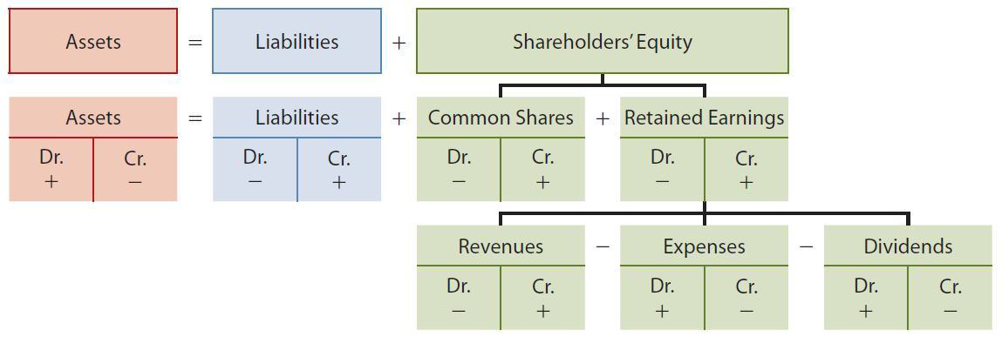

The Journal
Record the debit and credit effects on specific accounts for each transaction
The Ledger
Contains all of the asset, liability, and SE accounts as well as revenue and expenses
Provides balances in various accounts
Trial Balance
Provides a list of accounts and their balances at a specific time
Proves the mathematical equality of debits and credits
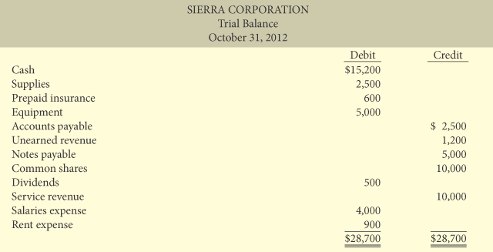

Chapter 4

Revenue and Expense Recognition
Revenue Recognition
When there is an increase in future economic benefits arising from an increase in an asset or a decrease in a liability, due to ordinary activities
Criteria for Recognition
The sales effort is substantially complete
The amount is determinable – measurable
Collection is reasonably assured
Expense Recognition
When there is a decrease in future economic benefits due to an ordinary activity – decrease in an asset/increase in a liability
Accrual Basis Accounting
Transactions are recorded in the period in which the events occur
Satisfy the requirements of ASPE and IFRS
Cash Basis Accounting
Events are recognized in the period that cash is paid or received
Does not satisfy ASPE and IFRS
Can lead to misleading financial statements
Types of Adjusting Entries
Prepayments
Prepaid expenses, unearned revenue
Accruals
Accrued Expenses – Incurred but not yet paid in cash or recorded
Accrued Revenues – Earned but not yet received in cash or recorded
Prepaid Expenses
Are paid for in cash before they are used
It is not practical to record expiration on a daily basis
Adjusting Entries
Record the expense that applies to the current period Dr. an Expense account
Reduce the asset account that was originally recorded Cr. An Asset
Dr. Prepaid Insurance 1800
Cr. Cash 1800
Dr. Insurance Expense 1050
Cr. Prepaid Insurance 1050
Depreciation
Dr. Depreciation Expense
Cr. Accumulated Depreciation
Straight Line Depreciation
(Cost – Residual Value)/Estimate Useful Life
Unearned Revenue
Dr. Cash 3600
Cr Unearned Revenue 3600

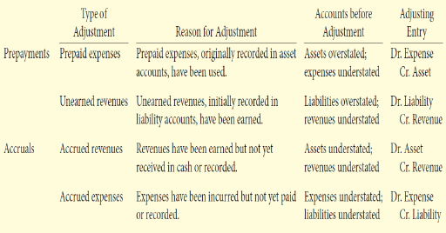

After journalizing adjusting entries, post adjusting entries, prepare the adjusted trial balance and prepare the financial statements from the trial balance

Temporary/Permanent Accounts
Revenue, Expense, and Dividend accounts are considered temporary
Statements of Financial position accounts are permanent
At the end of each period the temporary account balances are transferred to the permanent shareholders equity account retained earnings through the preparation of closing entries

The Closing Process
Close Revenue Accounts
Debit each individual revenue account
Credit each income summary for total revenues
Close Expense Accounts
Debit income summary for total expenses
Credit each individual expense account
Close Income Summary Account
Debit (Credit) Income Summary
Credit (Debit) Retained Earnings
Close the Dividend Account
Debit Retained Earnings
Credit Dividends
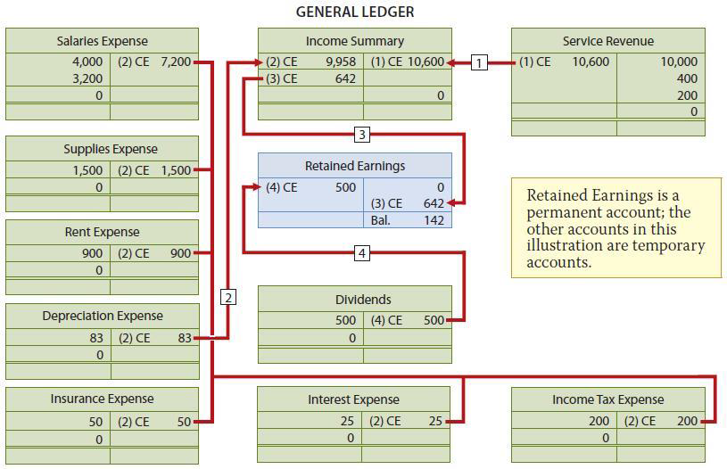

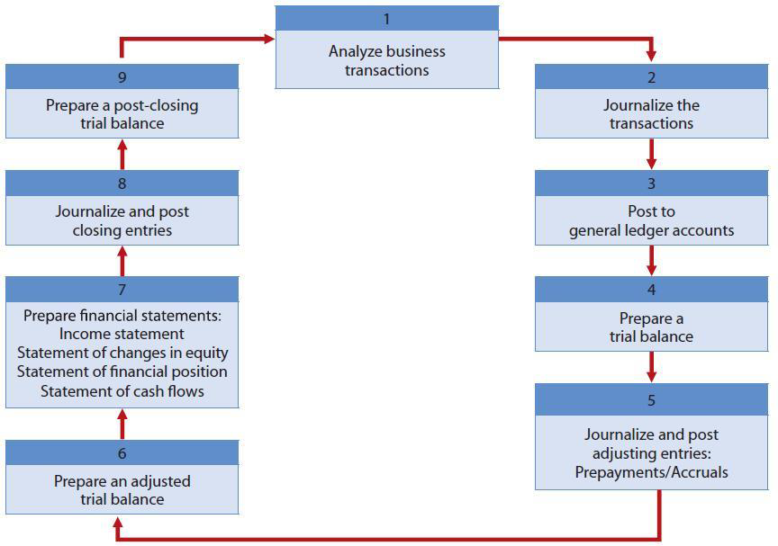

Chapter 5

Perpetual
COGS is determined each time a sale occurs
Periodic
COGS determined only at the end of the accounting period
Purchases
Perpetual
Dr. Merchandise Inventory
Cr. Cash/AP
Periodic
Dr. Purchases
Cr. Cash/AP
Sales taxes do not form part of the cost of the merchandise

FOB Shipping Point
The buyer pays the freight costs – the buyer is responsible for any damage that may occur
Part of the cost of purchasing the inventory
FOB Destination
The seller pays the freight costs – the seller is responsible for any damage that may occur
Operating Expense for seller
FOB Shipping Point journal entry for the buyer
Perpetual
Dr. Merchandise Inventory
Cr. Cash/AP
Periodic
Dr. Freight In
Cr. Cash/AP
FOB Destination journal entry for the seller
Dr. Freight Out
Cr. Cash/AP
Purchase Returns and Allowances
Purchase Return
The buyer returns the goods to the seller and receives a cash refund or credit
Purchase Allowance
The seller gives an allowance from the purchase price
Perpetual
Dr. Cash/AP
Cr. Merchandise Inventory
Periodic
Dr. Cash/AP
Cr. Purchase Returns and Allowances
Purchase Discount
Recorded separately when payment is made
Perpetual
Dr. A/P
Cr. Cash
Cr. Merchandise Inventory
Periodic
Dr. A/P
Cr. Cash
Cr. Purchase Discounts
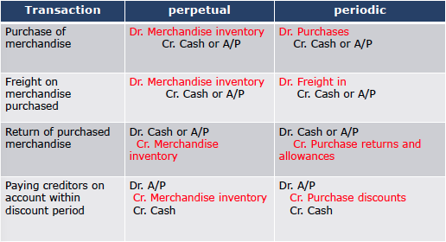

Sales
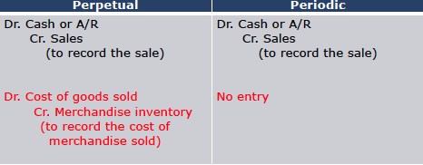

Sales Tax
Not recorded as revenue but recorded as a liability until they are paid
Return of Sold Merchandise
Use of a contra revenue account: Sales returns and allowances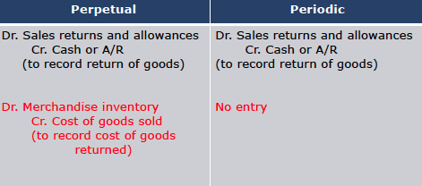

Sales Discount
Dr. Cash
Dr. Sales Discount
Cr. Accounts Receivable
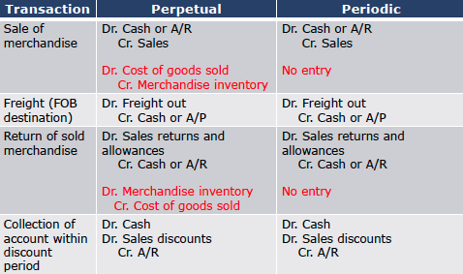

Income Statement Presentation
Single Step Income Statement
Data are classified into two categories – revenues and expenses
Multiple Step Income Statement
Shows several steps
Net Sales, Gross Profit, Profit from Operations, Non Operating Activities, Profits
Under IFRS, expenses should be classified by nature or by function
By nature: salaries, transportation, depreciation, and advertising
By function: expenses are reported according to the activity for which they were incurred – COGS, administrative, selling
Single Step
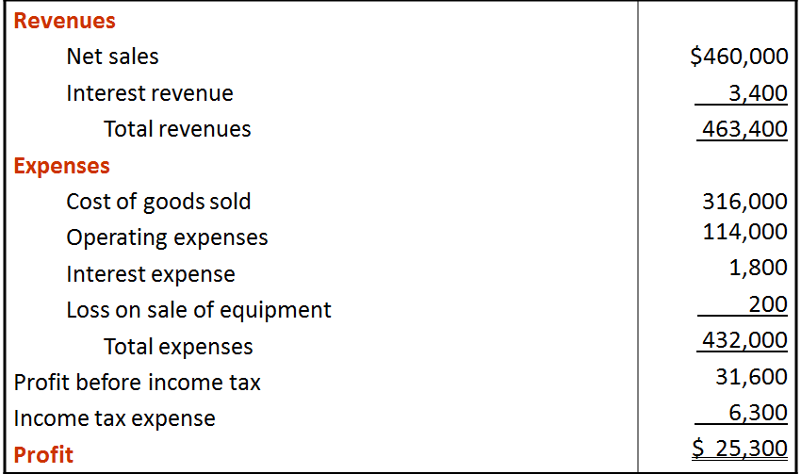

Net Sales = Gross sales – sales retunrs and allowances – sales discounts
COGS = (Beg Inventory + COG purchased =COG Available) – ending inventory

Multiple Step Income Step
Sales revenue – COGS = Gross Profit – Operating Expenses = Profit from Operations
+(-) Other Revenues (expenses) = Profit before income tax – Income tax = Profit

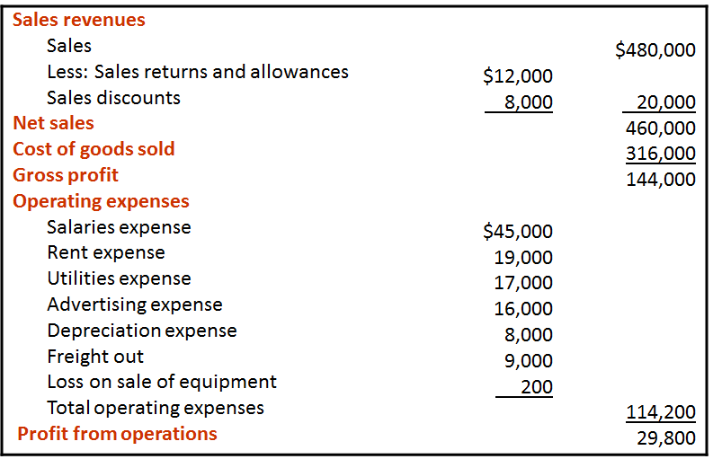
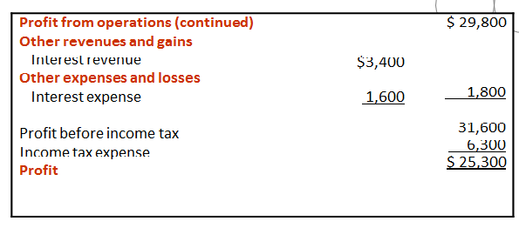
Evaluating Profitability
Gross Profit Margin = Gross Profit/Net Sales
Profit Margin = Profit/Net Sales

Chapter 6

Consigned Goods – Useless Shit
The consignee sells the goods on behalf of the consignor in exchange for a fee without ever transferring legal title or ownership
Consigned goods are counted in the inventory of the consignor rather than the consignee
Method Cost Determination
Specific Identification Method
Used when goods are not ordinarily interchangeable or have been produced an segregated for specific projects
Tracks the actual physical flow of goods
Normally only used in perpetual inventory systems
It reports ending inventory at its actual cost
Disadvantage – easy to manipulate the profits by choosing to sell units with higher or lower purchase cost
Cost Formula Method
Assume a flow of costs that may not be the same as the actual flow of goods
FIFO
Assumes that the earliest goods purchased are the first to be sold and recognized as cost of goods sold
Average Cost
Assumes it is not possible to measure a specific physical flow
The allocation of the cost of goods available for sale between COGS and ending inventory is made based on the weighted average unit cost
Weighted average cost = the cost of goods available for sale/number of units on hand
A new average is calculated after each purchase in the perpetual inventory system
Only one average is calculated under the periodic inventory system and the allocation is made at the end of the period
The average cost is applied to the units sold to determine the COGS and the remaining units on hand to determine the cost of the ending inventory

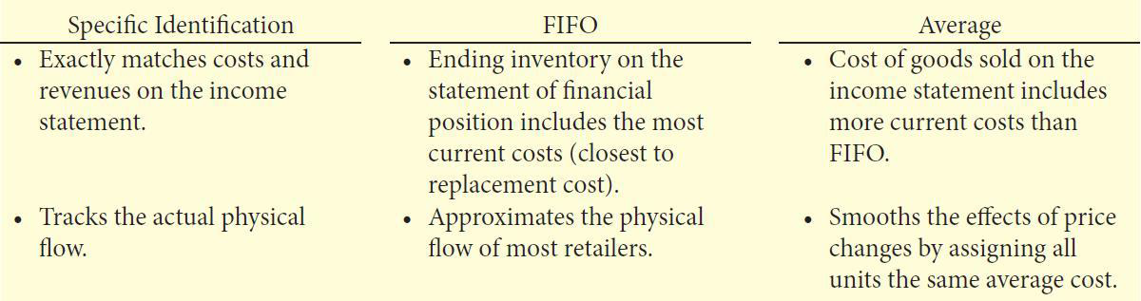

If prices are increasing
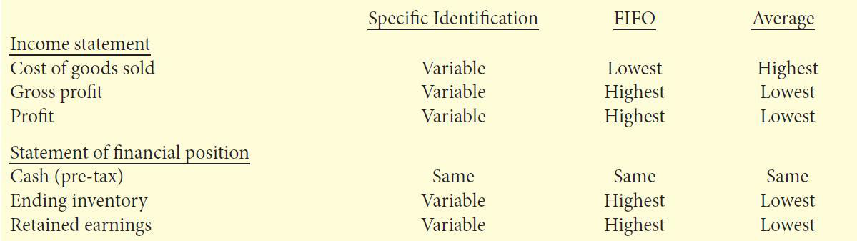

Value the inventory at the lower of cost and net realizable value
Net realizable value = selling price – any costs required to make the goods ready for sale
The lower of cost and net realizable value basis should be applied to individual inventory items
If the value of inventory<cost
Dr. Cost of Goods Sold
Cr. Merchandise Inventory
When conditions that caused the write down no longer exist reverse the write down

Inventory Ratios
Inventory Turnover = COGS/Average Inventory
Days in Inventory = 365/Inventory Turnover

Chapter 8

Receivables
The term refers to amounts that are due to a business from customers or entities
Classified as accounts receivable, notes receivable, and other receivables
Some receivables become uncollectable
Need to estimate the amount
At the end of each period
Estimate the uncollectable accounts
Show this estimate in the allowance for doubtful accounts
Dr. Bad Debts Expense
Cr. Allowance for doubtful accounts
Estimating the Allowance
Percentage of Total Receivables
Management estimates the percentage of outstanding receivables that will result in losses from uncollectable accounts
Aging The Accounts Receivable Method
Classifies the outstanding accounts by and applies percentages to these categories based on past experience

Recording the write-off of an uncollectable
Actual uncollectables are debited to ADA and credited to accounts receivable at the time the specific account is written off
Dr. ADA
Cr. A/R
Under the allowance method, every bad debt write-off is debited to the allowance account and not to bad debt expense
When a bad debt is recovered, two entries are needed
The entry made in writing off the account is reversed
Dr. A/R
Cr. ADA
The collection is recorded as:
Dr. Cash
Cr. A/R
Notes Receivable
Dr. Notes Receivable
Cr. A/R
Interest = (principal)(interest rate)(time in terms on one year)

Adjusting Journal Entry
Dr. Interest Receivable
Cr. Interest Revenue
Honoured Note
Dr. Cash 10,200
Cr. Notes Receivable 10,000
Cr. Interest Receivable 50
Cr. Interest Revenue 150
Dishonoured Note
Dr. Accounts Receivable 10,200
Cr. Notes Receivable 10,00
Cr. Interest Receivable 50
Cr. Interest Revenue 150
If no hope of collection
Dr. ADA 10,050
Cr. Notes Receivable 10,000
Cr. Interest Receivable 50

Net Realizable Value = Accounts Receivable – ADA
Bad Debt Expense is an operating expense
Interest revenue is a non-operating profit

Managing Receivables
- Determine to whom to extend credit
- Establish a payment period
- Monitor Collections
- Evaluate the liquidity of receivables
  - Receivables Turnover = Net Credit Sales/Average Gross Receivables
  - Average Collection Period = 365/Receivables Turnover
- Accelerate Cash receipts from receivables
Loans Secured by Receivables: Borrow money from a bank by using receivables as collateral
Sales of Receivables: Securitization: transfer receivables to investors in return for cash – Factoring: sell the receivables to a factor

