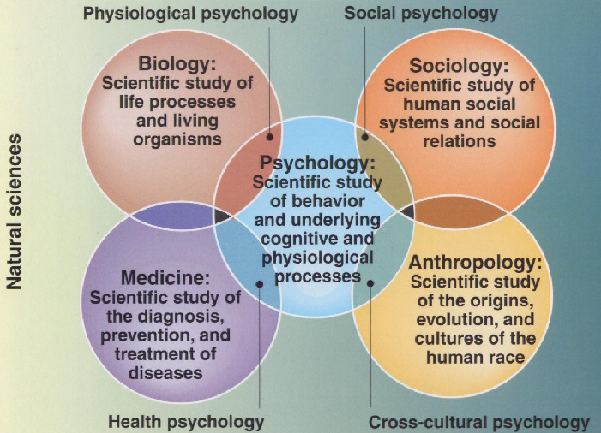
Components of Psychology
1. A Body of Knowledge
2. Set of Skills
3. A Way of Thinking
Definition of Psych
Scientific:
- Behavior
- Physiological & Cognitive processes
Profession:
-Scientific findings applied to practical problems

Behaviour
OVERT – behaviors that are manifestly obvious; we can observe or measure
ex. heart rate, blood pressure, respiratory rate
COVERT – internal, only known to person; assumptions based on overt behaviours can be incorrect
ex. inverted feet, frown, fidgeting, quiet voice (assume sad) actually happy
Profession Specialties
Clinical (largest): 4 Domains
1. Assessment (severe disorders)
2. Treatment (therapy)
3. Teaching (professor)
4. Research (academic university)
Counselling (2nd largest)
-typical common problems; ex. school related anxiety, financial stress, etc.
Psychiatrist over Psychologist
-education
-training in research methods
-prescription privileges
Goals of Psychological Research
- Describe – make observations and accurate descriptions of behaviour
- Understand and Explain - causes of behaviour
- Predict - future behaviour
- Influence and Control - implement predictions about behaviour

BEHAVIOURAL (John Watson)
- “black box”
- overt behaviours; not interested in conscious
- assume that environment controls actions
PSYCHOANALYTICAL (Sigmund Freud, Alfred Alder, Carl Jung)
- behaviour based on internal, subconscious forces
ex. unresolved conflicts
- what past experiences motivate people
HUMANISTIC (Carl Rogers, Abraham Malson)
- stresses conscious experience through freedom and personal growth
- deemphasizes scientific analysis of behaviour
- philosophical > scientific
- people’s choice as to how they act; their personal drive to succeed
COGNITIVE (Wilhelm Wundt)
- analyzing how conscious behaviour evaluates and processes in response to stimulation
STRUCTURALISM
- First School of Psych
- identifying components of conscious experience; sensations and feelings
ex. Introspection (Titchner): subjects analyze what they have experienced
- static points within a flow of thoughts
FUNCTIONALISM (William James)
- Studying proposal methods of consciousness rather than structure
- Darwin’s theory of selected heredity
- flow itself
GESTALT (Wertheimer, Koffka, Kholer)
- “whole is greater than the sum”
- thought process is an entire entity; behaviour and conscience is continuous
BIOLOGICAL
- behavioural genetics: Nature vs Nurture
-Experimented through;
Twin studies
ex. Fraternal twins have similar IQs. If true; Nature influences a child’s knowledge
Adoption studies
ex. Alcoholism; if biological or new parents are alcoholics

