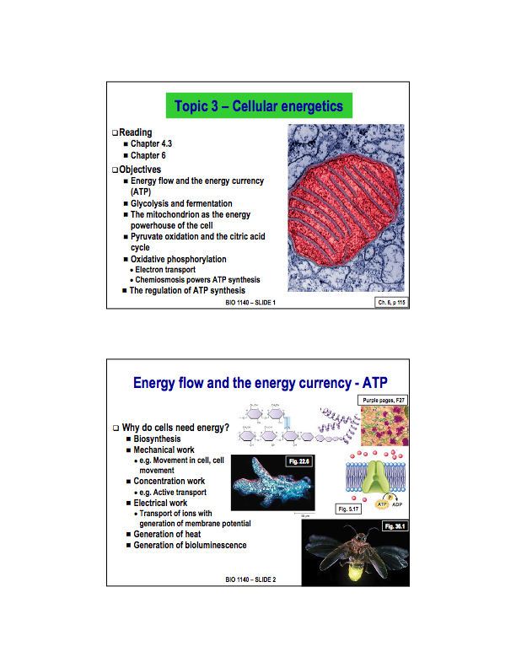
Lecture 6 starts here
What does the cell need energy for? What is energy?

Energy is the capacity to do work. The work that a cell does tends to relate to creating chemical bonds or mechanical work. Examples include:

- Biosynthesis: the synthesis of macromolecules requires energy
- Mechanical work: the moving of the cell itself, or internal movement requires energy.
- Concentration work: creating concentration or electrochemical gradients, achieved by active transport which requires the expenditure of energy.
- Electrical work: see slide
- Generation of Heat
- Generation of bioluminescence

All these things require the expenditure of energy.

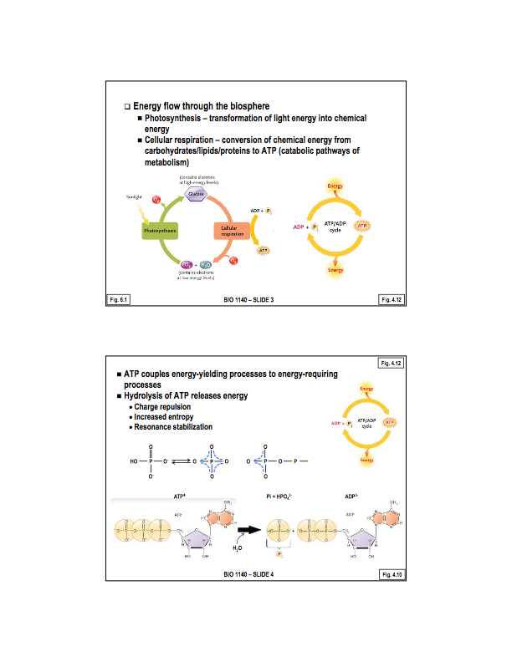
Where does this energy come from?

Ultimately, it comes from sunlight. Photosynthetic organisms capture sunlight and store its energy in the form of carbohydrates (chemical energy). Other organisms then take advantage of this by consuming plants and oxidizing the carbohydrates and other macromolecules in order to release energy and capture this energy in the form of chemicals that can transfer energy from one source to another (energy carriers) with ATP being the ultimate production goal (energy currency of the cell). ATP is synthesized through the harness of this energy, ADP and in inorganic phosphate.

Photosynthetic organisms also take advantage of these cellular pathways in the absences of light (by consuming the carbohydrates that formed during periods of sunlight). Ultimately, this process in both cases is known as cellular respiration.
Why ATP?

ATP is the energy currency of the cell. It basically couples reactions that produce energy to reactions that require energy.

The hydrolysis of ATP involves removing the last phosphate group to from Adenosine tripohosphate and 1 inorganic phosphate. This process realizes energy for the following reasons:

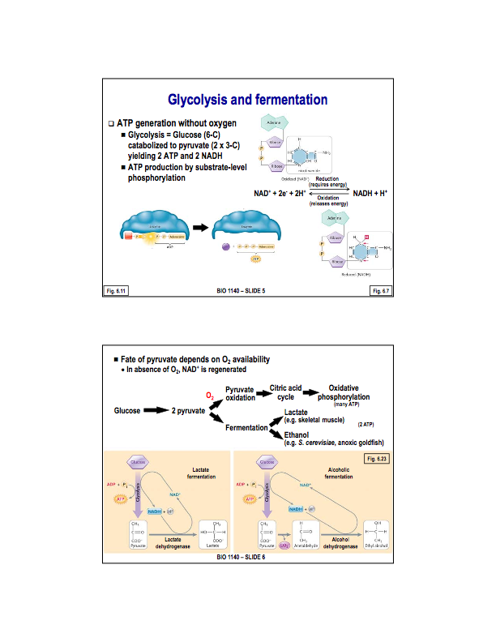
Where does the ATP come from?

ATP is generated through cellular respiration. This process begins with Glycolysis.

Glycolysis:

In glycolysis, a glucose molecule is broken down into 2, 3-carbon pyruvate molecules (partial oxidation). This process yields 2 ATP and 2 NADH per glucose molecule. NADH is the reduced form of nicotinamide adenine dinucleotide (NAD+). This is a derivative of vitamin D. NAD+ and NADH are energy carriers. Reduction of NAD+ yields NADH —> this process requires the expenditure of energy. Energy then, released from the partial oxidation of glucose is used to reduced NAD+ to NADH, effectively temporarily storing energy in NADH.
The ATP produced is produced by substrate-level phosphorylation. In which, and inorganic phosphate is directly transferred from an intermediate (carrying a phosphate group) to ADP

The fate of pyruvate depends on O2 availability.

If oxygen is present —> pyruvate will enter the mitochondria, go throughout the citric acid cycle, and go through oxidative phosphorylation.
If oxygen is not available—> pyruvate will begin fermentation. Fermentation is a different set of pathway that can continue in the absence of oxygen (this is actually their reason for existence). There are two different pathways of fermentation, the first yields the end product of lactate, and the second yields ethanol.
In both cases, pyruvate is reduced (either to lactate or ethanol) AND NADH is oxidized back to NAD+ (the regeneration of NAD+ is important!) Also note that the these two pathways are never found together in the same cell.
- The process decreases the order of the state. These increase in entropy is accompanied by the release of energy.
- Both inorganic phosphate and ADP carry a negative charge. Therefore, the synthesis of ATP from ADP and inorganic phosphate requires energy to overcome the repulsion by their charges. So conversely, it is intuitive that energy must be released (the energy required to overcome the repulsion in the first place).
- Phosphate has a resonance stabilization. When it is bound to ATP, it is less stable than when it exists as its own entity (because the electrons can spread out over the entire inorganic phosphate molecule) Thus, the removal of one phosphate brings it from a less stable to more stable state, and as such, releases energy.

ADP can also be hydrolzyed to AMP, yet this does not realizes as much energy as the former hydrolization.

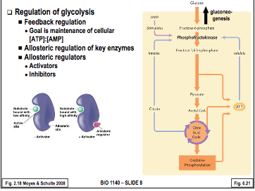
Glycolysis Cont’d

Glycolysis consists of a series of 10 reactions. 3 of the enzymes that catalyze these reactions are there to regulate ATP production. The goal of this regulation is to maintain the proper concentrations of ATP within the cell. This is achieved by a feed-back type type method, namely: If ATP levels in the cell are high, glycolysis will be carried out less regularly, whilst if they are allow, glycolysis will be ramped up. The ratio the cell is trying to maintain is one between [ATP]:[AMP]. (note that it is the rate of glycolysis that is being altered). Match ATP production to ATP demand.

One enzyme in particular, phospofructokinase is perhaps the most important. This enzyme regulates the rate of glycolsysis by the following mehcanicms:

First off, the activity of phosphofructokinase is stimulated by AMP. If AMP levels are high, its likely because ATP levels are low. Therefore, a high amount of AMP stimulates phophofructokinse to increase the rate of glycolysis. If ATP levels are high, the rate of glycolysis is slowed by this same enzyme, which is actually inhibited by ATP its self (negative feedback mechanism).

Phosphofructokinase is also regulated by citrate. A larger amount of citrate will allosterically inhibit phospofructokinase.

Allosteric Regulation

The regulator binds to a enzyme, affecting its interaction with its substrate, An allosteric activator will increase the activity of the enzyme, While an allosteric inhibiter will decrease the activity of the enzyme. The enzyme usually contains an activate site, where the substrate binds, along with an allosteric site, were the allosteric regulator will bind to affect enzyme activity.

Ex:) When AMP binds to its allosteric site on phophofructokinase, the conformation of the enzyme is changed so that the activity at the active site is increased (allosteric activation). On the flip side, when ATP binds to its allosteric site on the enzyme, its conformation changes to that the activity of the enzyme is decreased (allosteric inhibition). The advantage of regulate phosphofructokinase, is that when there is sufficient ATP, fructo-6-phosphate will build up, and will move back toward glucose, or glycogen for storage - as opposed to needlessly converting it to pyruvate.

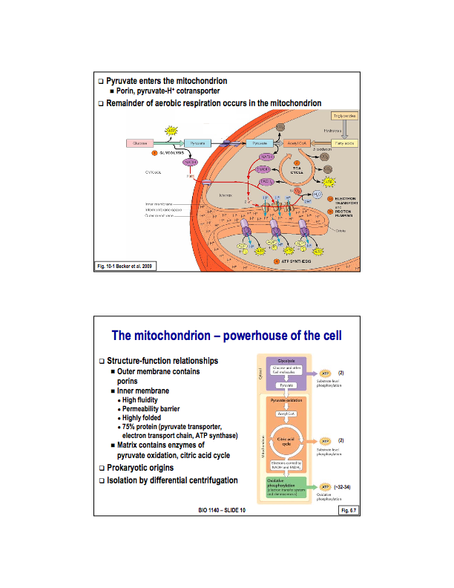
Once pyruvate is formed, it must enter the mitochondria to begin pyruvate oxidation and start the citric acid cycle.

The mitochondria is a double membrane organelle, so pyruvate must move through both the outer and inner mitochondrial membranes to enter the matrix of the mitochondria, where the next steps in cellular respiration (pyruvate oxidation and the citric acid cycle) occur.

The outer mitochondrial membrane contains a passage or channel, called porins, by which pyruvate can passively diffuse through.

The innermitochondrial membrane has a protein transporter to actively move pyruvate into the matrix (Important! notice that the expenditure of ATP is required here). This transporter is actually a pyruvate-proton co-transporter. It makes use of a hydrogen gradient (proton) between the inter membrane space and the matrix. There are high levels or protons in the inner membrane space and lower in the matrix, therefore, pyruvate is carried in with protons down this gradate (secondary active transport). The rest of cellular respiration occurs in the mitochondria matrix (chemiosmosis and the electron transport chain occur in the inner membrane). To better understand the next steps of cellular respiration, we must understand the structure and function of the mitochondria
The location in the cell where the most ATP production occurs. The mitochondria, during cellular respiration produces anywhere from 34-36 ATP molecules. The mitochondria is of prokaryotic origin (protobacteria). Through evolution, the mitochondria has been tailored to ATP production.

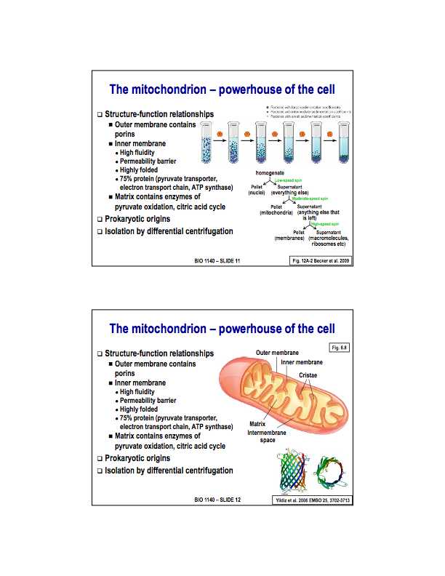
Differential Centrifugation:

An experimental approach, in which you create a homogenate (grind up the cells) and centrifuge them at different speeds in order to separate the components of the cell. The large heavier components of the cell tend to go to the bottom of the homogenate. At low speeds, these larger components separate towards the bottom. By adjusting the speed of centrifugation, you can selectively sediment different bits of the cell. The components of the cell have characteristic sedimentation coefficients. S stands for sedimentation coefficient (40S ribosome subunit).

At a relatively low speed, you will end up with a pellet at the bottom, and the supernatant above it. The pellet will largely consit of cell debris and nuclei, while the rest of the cell remains in the supernatant.

This supernatant is taken, and centrifuged at a relatively higher speed. This time, the pellet will contain mitochondria, as the next heaviest component of the cell.

Taking this same supernatant at very high speeds will separate the membrane into the pellet, leaving macromolecules ribosomes etc in the supernatant (very small cell components).

NOTE: that mitochondria can not survive on their own, and must be kept in a incubation solution to be studied in an isolated environment.

Inner mitochondrial membrane:

The inner mitochondria membrane is folded into cristea. These folds increase the surface area on the innermitochondrial relative to the outermembrane.

The inner mitochondrial membrane IS a permeability membrane. For this reason there exists many proteins transporters on the innermitochondrial membrane. The inner mitochondrial membrane is about 75% protein, because of the ATP synthase enzymes and electron transport chains. The cristea of the innermitochondrial membrane significantly increase its surface area, thus increasing the efficiency of ATP synthesis. The membrane is also very fluid (lacks cholesterol), this allows for the membrane to carry out mitochondrial function effectively

Outer mitochondrial membrane:

The outermitochondrial membrane contains porins, these channels are a bacterial characteristic (further proof for the symbiont theory, as they are located on the inner membrane and not the outer, who's origin is the host cell and not the bacteria).

Porins are relatively large, relatively non-selective channel. Everything smaller than about 5000 daltons, can move through a porin (basically everything but proteins). For this reason, the outer mitochondrial membrane is NOT a permeability barrier. Porins are made up of beta-pleated sheets. It is basically a water filled pore through the membrane.

To some extent proton leaking occurs through the porins. More often though, they accumulate within the critea folds without leaking.

Matrix:

Within the matrix, the enzymes needed for pyruvate oxidation, the citric acid cycle, the mitochondria's genetic material, and ribosomes all exists.
First Question During LEc on 31st: answer is C. Regeneration of NAD+ is necessary to continue ATP production. In the absence of oxygen, the only source of ATP is glycolysis. NOTE that fermentation and ethanol production DO not create ATP. NO problem with a builtd of pyruvate. Accumilation of protons isn't neccecarily d=angerous becuas off buffers in the cell.

SEcoond question:
4 compartments: outer, inner membrane, intermembrane, matrix.
Outer: contains porins
Inner membrane: transporters, atp synthase.
Matrix: enzymes for py ox. and cackle
intermembrane space: proton gradient.

heart cells: much larger surface area to produce the surface are for proteins involved in atp synthesis as the cells require more energy.

Heart-cells: much larger surface area to produce the surface area for proteins involved in ATP synthesis as the cells require more energy.

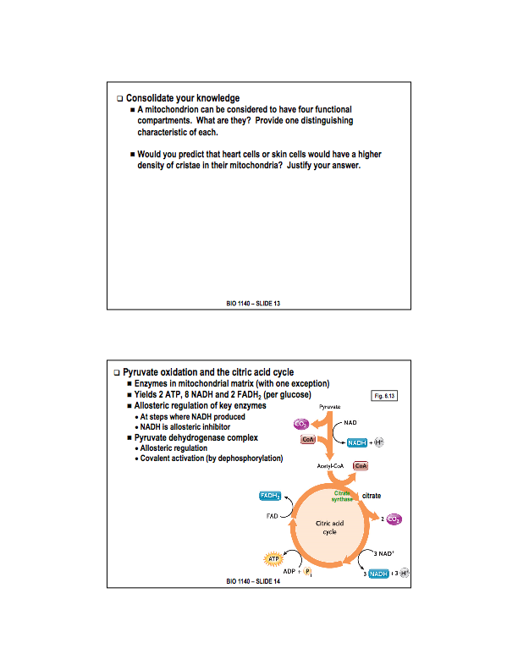
The enzymes required to carrier out Pyruvate Oxidation and the Citric Acid Cycle are for the most part, contained within the matrix of the mitochondria. In a bacterial cell, this occurs in the cytoplasm.

In terms of regulation, feedback regulation using allosteric regulators. The points that are regulated, are the reaction that create NADH. Thus, pyruvate oxidation, and the 3 steps of the citric acid cycle that produce NADH are also regulated. NADH functions as an allosteric inhibited allosterically inhibits the enzymes involved in its own production - slowing down the pyruvate oxidation and citric acid cycle.

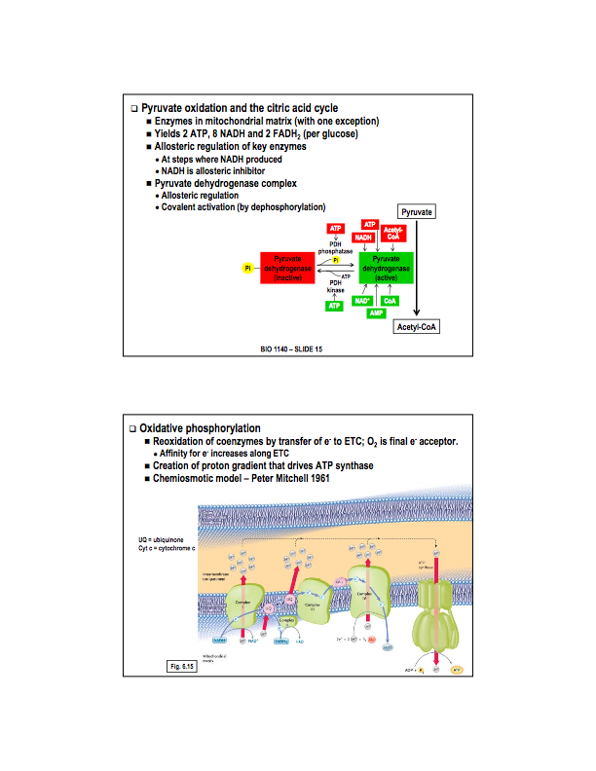
Pyruvate Oxidation:

Regulated by both allosteric regulation and covalent regulation.

Pyruvate dehydrogenase complex contains 3 enzymes, regulatory proteins, and co-factors. The active form of this complex is allosterically regulated by both the input and output of the reaction. It is inhibited by the products (ATP, NADH, Acetly - CoA) and is activated by the substrate for these reaction (NAD+, AMP, CoA).
Lots of ATP for example, will allosterically inhibit the activity of that enzyme. When ATP levels are low, the inhibition is lowered and allosteric activation occurs on this complex, facilitating more ATP production.

On top of this allosteric regulation of the active form of pyruvate dehydrogenase complex, it can also be phosphorylated to be turned into its inactive form. Pyruvate dehydrogenase kinase adds a phosphate to inactivate it, while phosphatase removes this phosphate group, activating it to the active form that catalyzes pyruvate oxidation. High levels of ATP not only allosterically inhibit pyruvate dehydrogenase, they also activate the kinase and inhibit the phosphates with the result that pyruvate dehydrogenase is changed to the inactive form. Conversely, when ATP levels are low, the allosteric inhibition of ATP is relieved, and also the phosphate is activate, the kinase is deactivated, meaning more of the active form of pyruvate dehydrogenase complex.

Citrate synthase is an enzyme involved in the first step of the citric acid cycle, producing citrate, which allosterically inhibits phosphofructokinase.

Oxidative Phosporylation:

By the end of glycolysis, and pyruvate oxidation, citric acid cycle, we have generated 4ATP. However, we have generated lots of NADH and FADH2. Oxidative phophorylation is when energy stored in the energy carriers is used to form more ATP.

- What happens in oxidative phosphorylation?

Electrons are transferred resulting in the generation of a proton gradient, and this proton gradient drives ATP synthesis. So one process is the generation of the proton gradient, and the second separate process is the use of this gradient to power ATP synthesis.

It used to be believed that these process were linked. In 1961, Peter Mitchell proposed the idea of this sperate process of the proton gradient - The Chemiosmotic model.

Incredibly controversial at first, but at the same time very attractive. Once experimental data came around, it was found to support this model.

So what is happening in the electron transport chain?

in the inner mitochondrial membrane, there exists a series of protein complexes that serve as an electron transport chain. This is possible because the various proteins and cofactors or prothstetic groups with an affinity for electrons, such that electrons can be transferred progressively along this electron transport chain - to an ultimate electron exceptor - oxygen.

Electrons enter the chain, associated with either NADH or FADH2 and are then transferred along this chain, through a series of steps, with each protein complex having a higher affinity for electrons than the last, with oxygen being the ultimate except or.

As these electrons are pulled from the energy carrying molecules, protons are pumped into the inner membrane space and this builds the proton gradient. There exists 4 of these protein complexes - namely: I, III, and IV are transmembrane proteins within the innermitochondrial membranes. The fluidity of this inner membrane is important in order to allow these complexes to move around easy.

Complex II is a single protein (as opposed to being a collection of proteins like the other compexes) along with being a peripheral membrane protein. Its associated with the matrix side of the innermitochondrial membrane, and also functions as a enzyme in the citric acid cycle.

- There are two protein carriers that shuttle electrons through the chain.

They are known as ubiquinone (or Coenzyme Q) found in the core of the innermitochondrial membrane. The second electron shuttle is phytochrome C, it is a peripheral membrane protein localized to the inner membrane space size of the membrane.

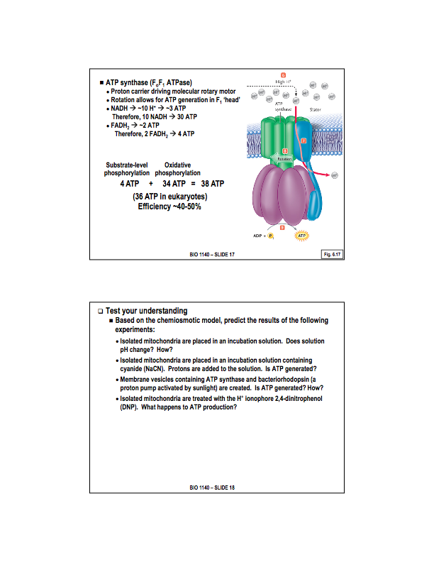
Electrons are transferred from NADH to complex I, where they are carried to complex III by ubiquinone, then carried to complex IV by phytochrome C. FADH2 donates its electrons to complex II. Complex II is the smallest of the complex proteins, electrons that go through complex II do not facilitate any proton pumping. for this reasons, less protons are generated in the inner membrane space by FADH2 than NADH
- ATP Synthase Enzyzyme

ATP synthase is a transmemberane protein complex. The Fo part is the part embedded in the membrane, while the F1 head is the segment which sticks out from the membrane facing the matrix. It functions as a molecular rotary motor. The Fo segment is able to move protons from the inter membrane space into the matrix, and as protons move through this molecule, which causes the Fo segment to spin - which in turn forces the synthesis of ATP in the F1 head (the rotation causes conformation changes in the F1 head which is responsible for synthesis by phosphorylation of ATP from ADP). The F1 and Fo heads are connected via the stater stalk,
- NOTE: 2 ATP are creating in glycolysis and 2 in citric acid

The proton pump steps take place at complex I with ubiquinone, complex III, and complex IV. because FADH2 comes in at complex II, it pumps slightly less protons then does NADH. Electrons leave complex IV via the terminal oxygen acceptor, oxygen, forming water as they do this.

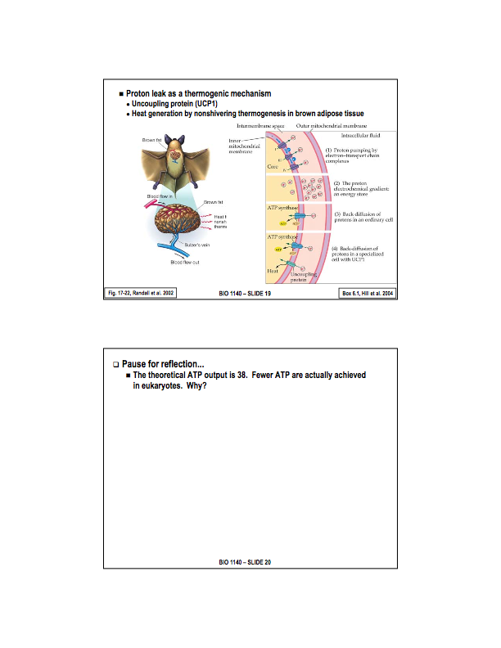
- pH is lowered. They escape through the porins.
- Yes. As long as proton gradient is provided, ATP synthesis will continue.
- Yes, the electron transport chain and ATP synthesis are two different things. The proton gradient here is generated by the proton pump powered by the sun.
- ATP synthesis stops, the proton gradient is eliminated and therefore ATP synthesis stops

THE PROTON GRADIENT DRIVES ATP SYNTHESIS, NOT NECESSARILY THE ELECTRON TRANSPORT CHAIN.
- Brown adipose tissue or brown fat
Brown tissue, functions as a thermogenic tissue. Its purpose is to generate heat, usually for small mammals who have a hard time maintaining body tissue. In the mitochondria of brown fat, there is a specific protein, called uncoupling protein - 1. Basically when inserted into the inner membrane, this is a proton channel that short circuits the proton gradient, shutting down ATP synthesis. This allows all of the energy that goes into the proton gradient to be lost as heat. This makes brown fat a thermogenic tissue. Brown fat is very high in mitochondria, hence the colour of the fat.

- 2 ATP is spent during glycolysis. Also, the proton gradient is used to get pyruvate into the innermitochondrial membrane, meaning less proteins available to synthesis ATP. Lastly, protons may be lost through proton leaking through the porins in the mitochondria.

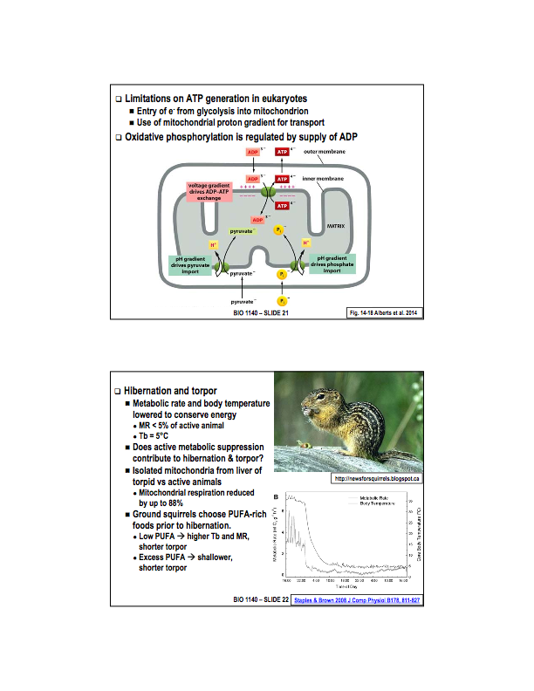
- Regulation of Oxidative Phsophorylation?

The main control for the regulation of oxidative phosphorylation is regulated by the supply of ADP. The more ADP availible, the less ATP available and the more ATP will be synthesis at the end of the chemiosmosis. The less ADP, the more ATP and the less ATP will be synthesized.

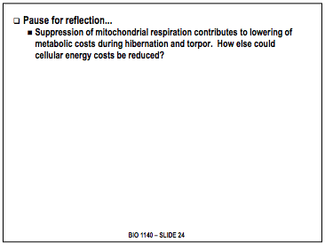
Hibernating animals lower metabolic rate (less than 5% of an active animal) during hibernation in order to lower body heat.

One of the way this is achieved is by shutting down the rate of ATP synthesis. When comparing the mitochondria of a hibernating organism to one that isn’t, we see about an 88% reduction is ATP production. These animals actively suppress ATP synthesis at the level of the mitochondria in the interest of saving energy.

Before entering hibernation, these animals will choose foods rich in PUFA. This is because they add PUFA to increase membrane fluidity when the temperature drops and the enter hibernation.
REDUCE ANY OF THESE PROPERTIES

