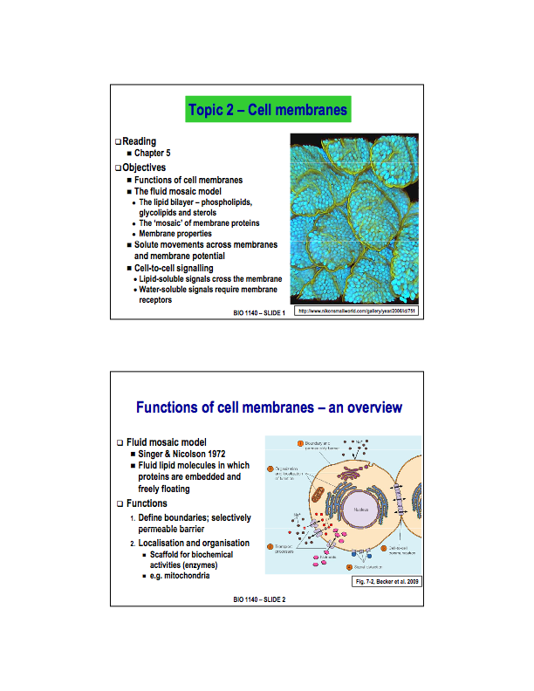
Topic 2 - Cell Membranes

Lecture 3 Starts here

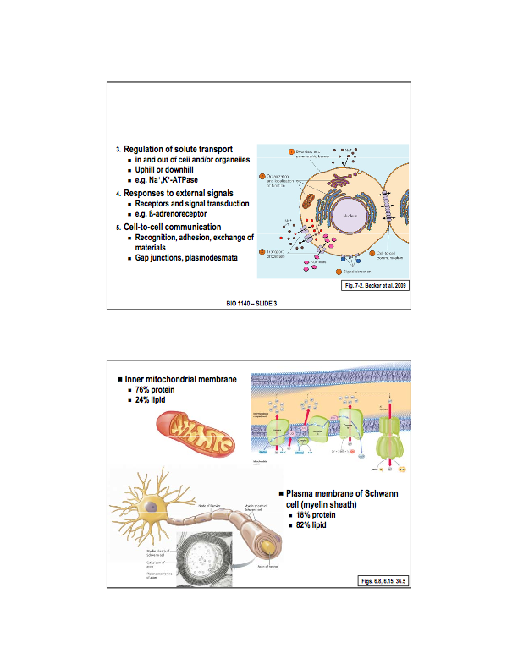
Fluid Mosaic Model
A model conceived by S.J. Singer and Garth Nicolson in 1972 to describe the structural features of biological membranes.
- The plasma membrane is described to be fluid because of its hydrophobic integral components such as lipids and membrane proteins that move laterally or sideways throughout the membrane. That means the membrane is not solid, but more like a ‘fluid'.
- The membrane is depicted as mosaic because like a mosaic that is made up of many different parts the plasma membrane is composed of different kinds of macromolecules, such as integral proteins, peripheral proteins, glycoproteins, phospholipids, glycolipids, and in some cases cholesterol, lipoproteins.
- According to the model, the plasma membrane is a lipid bilayer (interspersed with proteins). It is so because of its phospholipid component that can fold in itself creating a double layer - or bilayer - when placed in a polar surrounding, like water. This structural feature of the membrane is essential to its functions, such as cellular transport and cell recognition.
Functions
- The cell membrane defines the boundaries of the cell. Inside the cell, membranes around organelles define the boundaries of the organelle. For both, this membrane is selective. Because they are made of lipids, water-soluble compounds have a hard time moving through the bi-layer.
- Used in the organization of organelles and components of the cell (i.e. ribosome's bound to the rough ER, or proteins that are organized within the inner mitochondrial membrane).
- Selectively permeable, water soluble compounds have a hard time moving through the bi-layer. The proteins imbedded in the membrane aid in the transport of such molecules. Note that these proteins bridges are able to allow diffusion both with and against the gradient (against being known as ‘active transport’, i.e. the sodium-potassium pump).
- Response to external stimuli. This includes signals from the extra cellular environment and the intracellular environment.
- Cell-to-cell communication. Receptors in the cell membrane (proteins) allow the cell to respond to these stimuli - this includes both recognition signals, and proteins that allow cells to form junctions in order anchor together (multicellular organisms) and communicate with one another.

Composition of cell membranes depends highly on the function of the cell. There are two main deviations from the standard 50/50% lipid/protein split.

- Cells or Organelles that rely heavily on embedded proteins in their membranes for tasks such as active transport, An example is the mitochondrial membrane, which contains a 76/24% split as there are many proteins necessary for the production of ATP.

- Cells that may require a larger amount of insulation will contain a larger percentile of lipids in their membranes. An example is the myelin sheath, that surrounds the Schwann cell, with a split of about 18/82% protein/lipid.

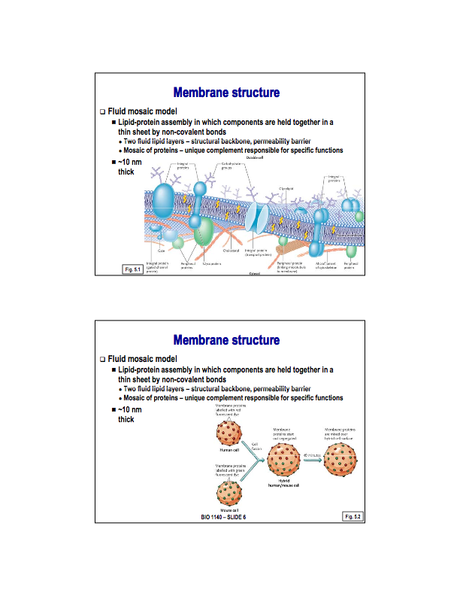
Recapping from above slides…

- The fluid mosaic model suggests that the membrane is made up of lipids and proteins. These lipids form a fluid double layer (lipid bi-layer) that is primarily responsible for defining boundaries and functions as a permeability barrier. Studded in this lipid bi-layer are various proteins - the type and concentration of each protein in the membrane is unique to each cell type and depends on the cells specific functions.

- A cell membrane is about 10nm thick, and is held together by non-covalent bonds.
In 1970, an experiment was preformed where a human cell line and a mouse cell line were taken and proteins in the membrane were labeled with fluorescent colours (different in each cell line). The cell was then fused using a virus. It was observed that at first, each colour of fluorescent marker appeared to be grouped together, but atet 30-40mins the colours had merged and were now undistinguishable. In other words, this proved that the proteins were obviously able to move throughout the membrane, the fluidity of the membrane was proven.

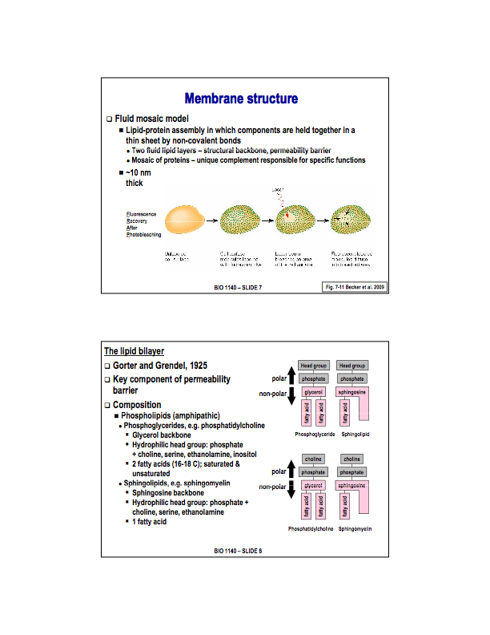
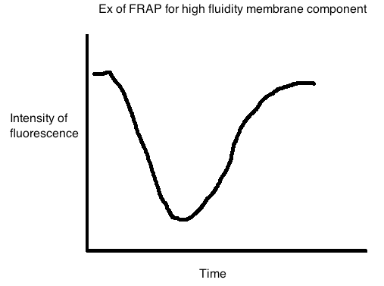
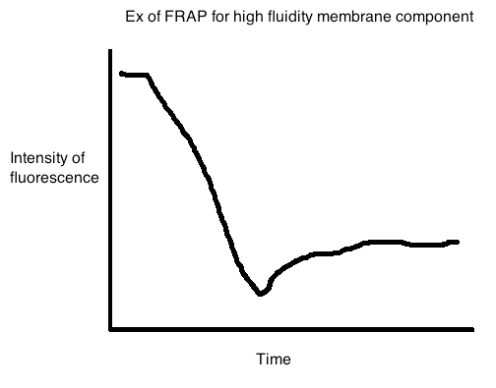
FRAP - Fluorescence Recovery After Bleaching

Steps:

- Label a membrane component (protein or lipid) with a fluorescence dye.
- Expose the a certain area of the membrane with a high-powered laser to ‘bleach’ the fluorescent dye.
- Observe the duration of time it takes for the components of the membrane to diffuse back into the bleached spot. The longer it takes, the lesser the fluidity of the labeled component in the membrane.

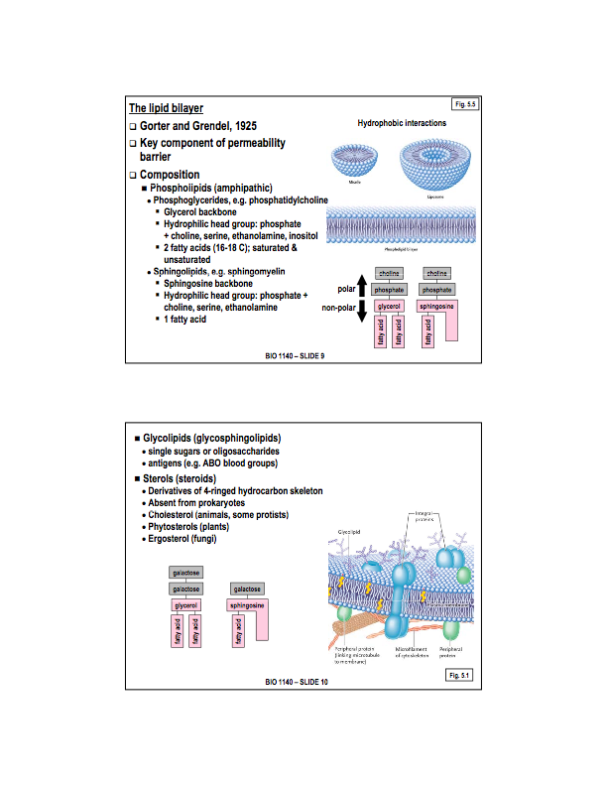
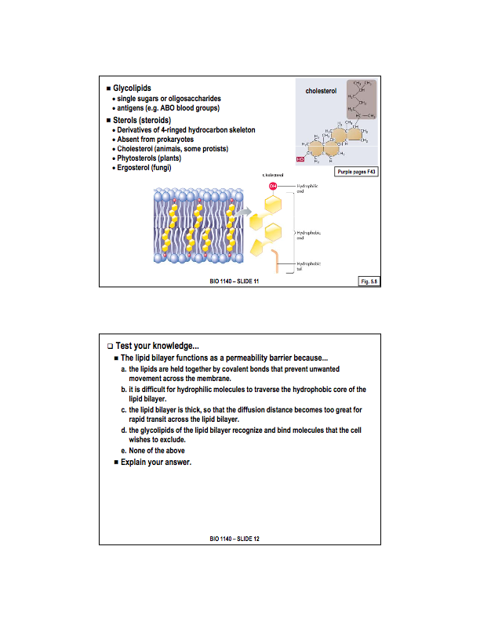
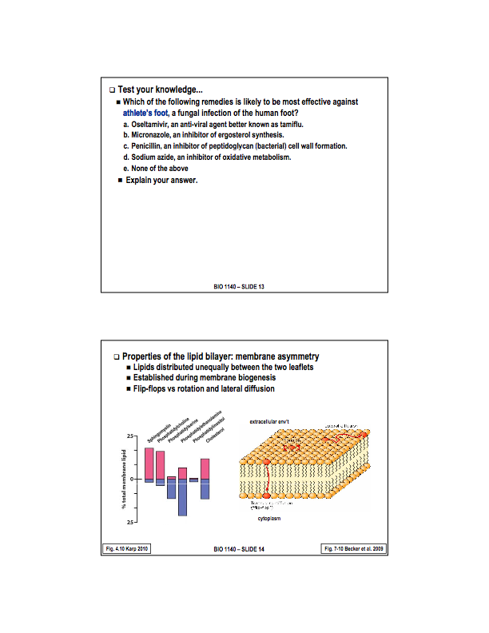
In 1925, It was observed the cell membrane contained double the amount of lipids required to cover the surface area of the cell. Thus, the proposition that the membrane was actually a lipid bi-layer.

There are 3 different types of lipids that make up the lipid bi-layer. These include Phospholipids, Glycolipids, and Sterols.

Phospolipids contain 2 types (note that both are amphipathic)

- Phosophoglycerides: are the MAIN component of the cellular membrane. Phosphoglycerides are amphipathic, which is a term to describe a chemical compound possessing both hydrophilic (water-loving, polar) and lipophilic (fat-loving) properties. The glycerol backbone and the two fatty acids that are attached to this backbone are made up of hydrocarbon and represent the non-polar region (hydrophobic or lipid-soluble) of the phosophoglyceride. The head group, attached to the phosphate, is the polar component (hydrophilic, water-loving, or water-soluble) of the phosophoglyceride.

- Sphingolipids: function much the same way as phosophoglycerides, but structurally are somewhat different. The main difference when compared to a phosophoglyceride is the backbone. Phosophoglycerides are built on a glycerol backbone, while sphingolipids are built on a sphingosine backbone. Part of the sphingosine molecule is a long hydrocarbon chain that looks very much like a fatty acid, and is also non-polar. Attached to the spingosine backbone is 1 fatty acid. Aslo attached to the spingosine backbone is a polar head group, which can be identical to that of a phosophoglyceride.

*Both are amphipathic molecules with a poler head group and 2 non-polar hydrocarbon chains. Functions is very similar even with these small differences. Look at diagram in lecture slide for an idea of the layout of these molecules.

The amphipathic nature of these molecules causes hydrophobic interactions (a type of non-covalent interaction), which causes the shape of the cell membrane. In a membrane, non-polar regions of a molecule gather together to get away from the extra and intra cellular polar environments, which are polar.

This organization is seen clear phospholipid bi-layer of the cell membrane.
Glycolipids

Very similar to phospholipids. Essentially the phosphate group and the head group of the phospholipid are removed and replaced with sugars. Normally these molecules are organized int he membrane so that the non-polar region anchor the molecule in the membrane and then the carbohydrate component is facing the external or internal environment.

Primarily, their function is believed to be recognition symbols to allow cells to be identified. An example of this is the ABO blood groups. Red blood cells would contain a certain sequence of sugars in the glycolipids embedded in the membrane which designates type A, B, AB, or O blood type (no recognition sugars means type O, both means type AB).

Sterols

Steroids derivatives, their structure is based off a four ringed hydrocarbon skeleton. They have hydrocarbon chain on one end, and on the other end a hydroxyl group - meaning they are ALSO amphipathic. They are organized in the membrane such that the hydrocarbon rings and tail insert themselves in to the hydrocarbon chains of the phospholipids, while the polar hydroxyl group mixes with the polar heads of the phospholipids.

Only exist in the membranes of eukaryotic cells, which means they can be used to distinguish between eukaryotic and prokaryotic cells. Furhtermore, each group of eukaryotic cells has its on particular type of sterol, making them even more useful for distinguishing the type of eukaryotic cell:

Animals, some protists —> cholesterol
Plants —> Phytosterols
Fungi —> Ergosterol

The answer is b. This is because it is athletes foot is a fungus, therefore:
a. is anti-viral and will not work.
c. is bacterial and also will not work.
d. would destroy health cells along with the final cells.

b. is the best choice.
The answer is b. This is because it is athletes foot is a fungus, therefore:
a. lipids are held together by non-polar bonds NOT polar bonds
c. The cell membrane is only about 10nm thick
d. Glycolipids serve as recognition factors so that the cell can be identified, d. doesn't make sense.

b. is the best choice.

The two leaflets of the bilayer are not the same, known as ‘membrane asymmetry’ The leaflet of ‘half’ of the cell membrane that faces the extra-cellular environment and the leaflet that faces the intra-cellular environment have a different composition.

Lipids can move freely within each individual leaflet they existence in, yet, there is very little movement between each leaflet. This is so because the polar head group cannot move through the non polar region which exists between the leaflets, as this would create a lot of heat.

The figure on the below shows the typical distribution of membrane components between the leaflets. Notably, shingomyelin and phosphatidylcholine is largely in the outer leaflet, while phosphatidylserin and phosphatidylethanolaimine are largely found in the inner leaflet. Interestingly, phosphatidylinositol and cholesterol (sterols) are two of the only membrane components found in equal proportions in both leaflets. Glycolipids are missing from this diagram, but are found mainly in the outer leaflet.

Lecture 4 Starts here

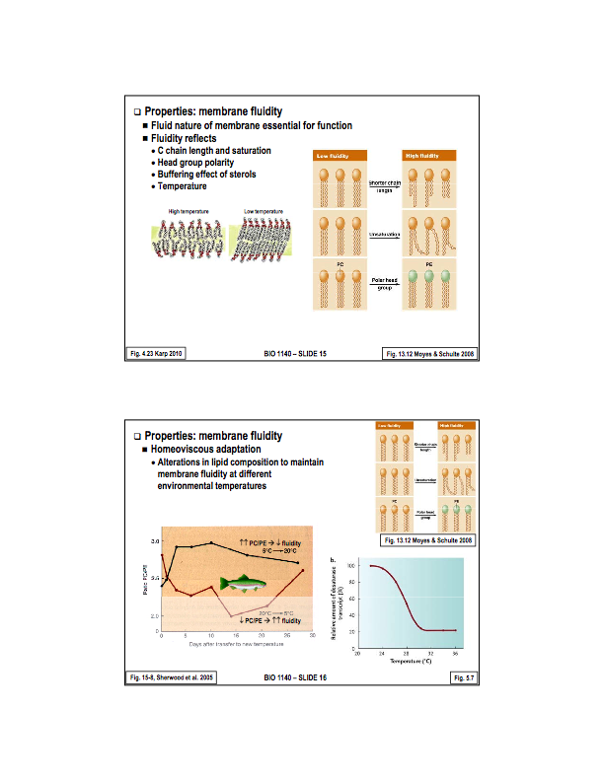
Membranes must be fluid to function. An example is when your fingers get so cold that they feel numb, this is because fluidity of components in the membrane of the nerves in your finger get too stiff to function.

Fluidity is affected by several factors.

Temperature:

- Colder temperature cause the fatty acid chain to pack title together(thing butter in the fridge). This reduces the fluidity of the membrane.
- Warmer temperatures allow the fatty acid chains to be more mobile, they don't back together as tightly, which increases the fluidity of the components in the membrane (think butter in the microwave.)

Membrane Composition and degree of saturation:

1.Fatty acid chains that are all long, strait, and the same length pack together nicely and this results in low fluidity.

2.Fatty acids that are shorter chains results in less packing and therefore a more fluid membrane

- When all the fatty acids are saturated, they tend to be quite strait, and situation 1 occurs.
- When there are unsaturated fatty acids, there are ‘kinks’ at the location of double bounds, and situation 2 occurs.

Head group polarity:

- When head groups are less polar (phosphatidylcholine) allows for them to pack together more tightly, decreasing the fluidity of the membrane.
- When head groups are more polar, (phosphatidylethanolaimine) they tend to repulse each other resulting in a less tightly packed membrane, increasing fluidity of the membrane.

Sterols:

Sterols act as a buffer with respect to temperature.

At high temperatures they arent affected much, and offer stability to the membrane, decreasing fluidity, or reducing the affects of warm temperature (increasing fluidity)

- At low temperatures, they also arent affected much, and the fatty acid chains have trouble packing around the membrane, tending to increases fluidity, or reduce the normal affects of cold temperature (low fluidity)

Homeoviscous adaptation is the ability of an organism to alter the lipid composition of its membrane, in order to maintain fluidity of its membranes in response to environmental temperature changes. Extreme changes in environmental changes would otherwise destroy cell function, more specifically functions involved with the cell membrane. Namely : cell-to-cell communication, transport of solutes through the membrane, response to external stimuli etc.

Lower temperature tend to decrease membrane fluidty, while higher temperatures increase membrane fluidity. Membrane fluidity needs to be at a certain value in order for cells to function correctly.

Organisms alter their lipid composition in a few ways, namely:

- When exposed to cold temperatures, an organism will increase the expression of desaturase enzymes. The enzymes add double bonds to the fatty acid chains in the membrane lipids in order to increase the saturation of membrane lipids and therefore increase the fluidity of the membrane - effectively countering the effects of the cold temperature at the cellular level.
- When exposed to warm temperature, an organism may (such as the rainbow trout) increase the ratio of phosphatidylcholine to phosphatidylethanolaimine. The increase in PC/PE ratio will decrease the fluidity of the membrane, effectively counteracting the environmental affect or warmer temperature. This occurs because PC is more polar than PE, so increasing PC concentration decreases fluidity (as they pack more tightly than PE). Note*: the reverse of this process occurs if the fish is moved from warm temperatures to cold temperatures.

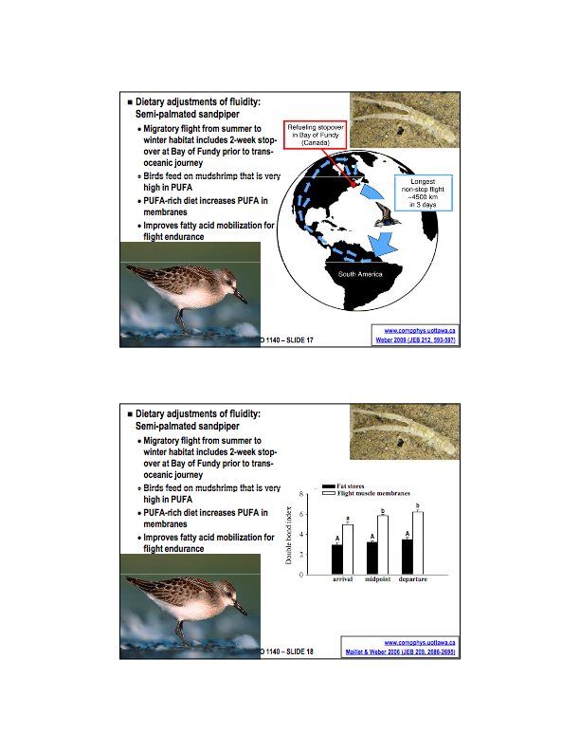
An experiment carried out by John-Michelle Webber from the University of Ottawa

The semi-palmated sandpiper, spends its summers in the high arctic, and its winters in south america. As it travels back to the high arctic for the summer, it follows the land masses and uses a series of short flights. Yet, when the migrate from the arctic to south america, the go from the arctic to the Bay of Fundy, and remains there for a few weeks before making a trans-atlantic 3 day flight (4500km) non-stop flying.

While at the Bay of Fundy, they spend most of their time feeding on a particular mud shrimp that is very high in PUFA, specifically of the omega-3 fatty acid type. Just for a relative scale, eggs have about a 1% fatty acid composition where as these mud shrimp have about 45%.

The birds eat Corophium valuator (mudshrimps) for two weeks, doubling their body weight and building fat stores for the trans-atlantic flight. The interesting part is that the polyunsaturated fats are selectively integrated into the flight muscles of the bird. That is to say, the only location where a significant increase in unsaturated fats occurs is in the membranes of the flight muscle cells. This is a benefit because it increases the efficiency of using fat as an energy source for the flight muscle cells.

The second interesting thing is that it was found that there is a correlation between fat content and a key enzyme in ATP production, known as citrate synthase (CS). So is this a causation or correlation?

It was postulated that the increase in fat consumption was causing the increase in enzyme activity (and therefore efficiency of ATP production).

Aside: Causation Vs Correlation?

Causation is when one variable increases as a direct result of another, while correlation is when two variable change in the same direction. A proof between correlation and causation usually starts by recognizing a correlation

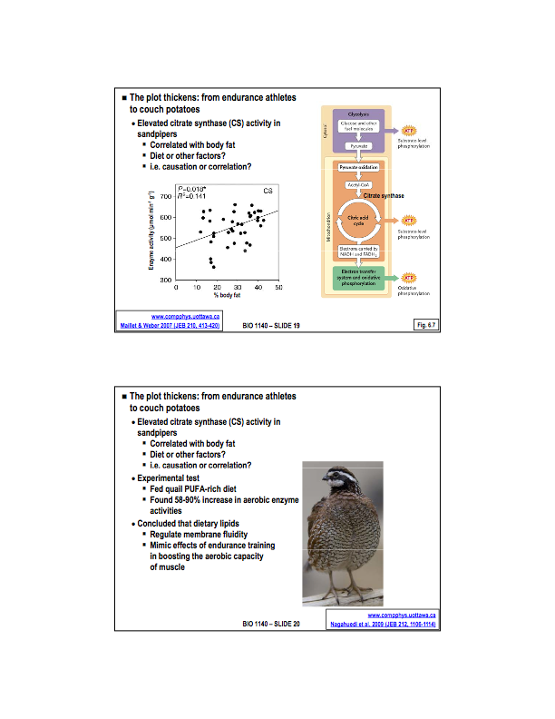
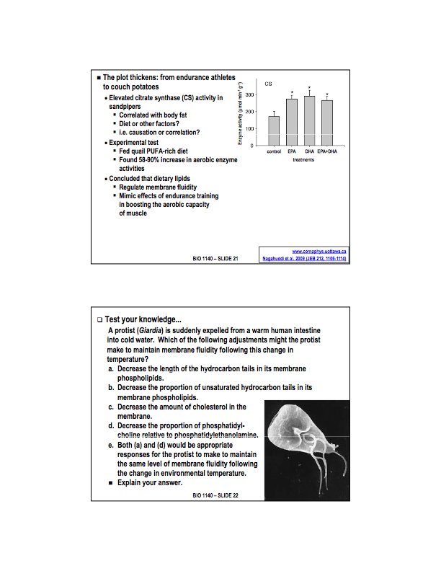
ANSWER: e.

Both a and e are correct.

a:) by decreasing the length of the hydrocarbon tails in its membrane phosoplipds, it would result in less packing of the phospholipids, increasing membrane fluidity thus counter the affects of the cold envionment.

d:) decreasing PC::PE ratios would lower the amount of less polar head and increase the amount of more polar heads - meaning less packing and a more fluid membrane counteracting the environmental influences.
In order to prove this causation, a bob-way quail (a usually sedimentary bird who prefers walking over flying) was fed a diet high in polyunsaturated fatty acids. As a result, a significant increase in aerobic enzymes was observed. This proves the causation, showing that the consumption of PUFA’s not only affects membrane fluidity, but can go as far as to increase the ATP producing efficiency of selected cells, namely in this case, the flight muscle cells, in order to increase the endurance capabilities of the bird.
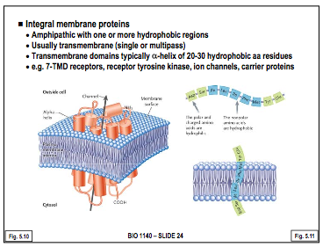
Proteins in the membrane are mobile as are lipids, yet it is possible for them to be anchored, and so their fluidity varies much more than that of lipids. Functions of the membrane proteins include:

- Transport:
- Enzymes:
- Signal Transduction:
- Attachment/recognition

There are 3 major types of membrane proteins, and they include integral, peripheral, and lipid-anchored.

Integral:
Integral proteins are studded within the membrane itself. Often, they extend through the thickness of the membrane, with bits of them sticking out on either side, in this case they are known as trans-membrane proteins. They are held in place by the membrane by hydrophobic interactions. This is made possible by transmembrane domains (alpha-helix, 20-30 aa’s long) that contain hydrophobic amino acid residues. Multipass or single-pass simply describe wether or not multiple transmembrane proteins are clustered together, or not, respectively. These components are linked together by hydrophilic domaines.
These proteins are therefore ampithatic, as they have polar regions near the exposed ints and extra cellular regions and non-polar regions near the centre of the membrane where they are anchored. They are usually hard to study, because they are so firmly anchored in place.

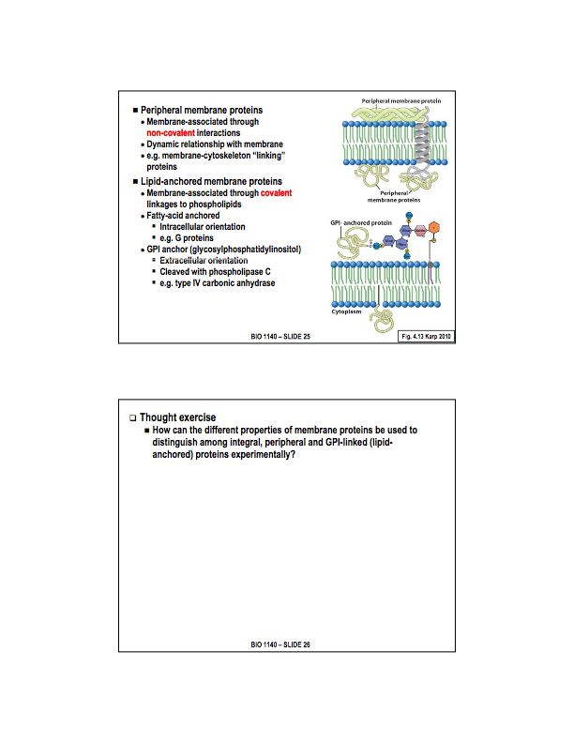
Peripheral membrane proteins:

These membrane proteins are found on the extra or intra-cellular surface. They are held to the surface of the membrane by non-covalent interactions; Hydrogen bonds, ionic bonds,Van-der-Walls forces etc. These non-covalent interactions can occur between the protein and membrane lipids, OR between the peripheral membrane protein and an integral membrane protein.
Because these non-covalent bonds are not very strong, peripheral membrane proteins tend to be very dynamic, and are easily attached are detached from the cell membrane, either experimentally or by the cell itself. Soap, changing pH, or salt concentration can be used to remove theses proteins from the membrane.
Lipid-anchored membrane proteins:

There are two types of proteins within this category:
*In both cases, the protein is covalently linked to a membrane lipid.

- Fatty-acid anchored:
Covalently linked to a fatty acid. The fatty acid can insert into the membrane, which holds the protein in place. These proteins are found in the cytosolic leaflet of the membrane, meaning they extend into the cytoplasm of the cell. An example of Fatty-acid anchored proteins are G proteins (will be looked at soon)

- GPI anchored (glycosylphosphatidylinositol):
Phosphatidylinositol is a membrane phosphoglyceride that has inositol as its head group. There is a carbohydrate group that is bonded to phosphatidylinositol, and a protein covalently bonded to the carbohydrate group. The whole molecule is held in the membrane by the phosphoglyceride (phosphatidylinositol).
These type of bonds are very strong, and can only be broken by the enzyme phospholipase C. This means we can remove them from the membrane simply by treating it with phospholipase C. These membranes are found in the extracellular leaflet, meaning the protein itself is exposed to the extracellular environment. An example is type IV carbonic anhydrase, which is present in the kidneys and other locations in order to regulate acid/base balance.

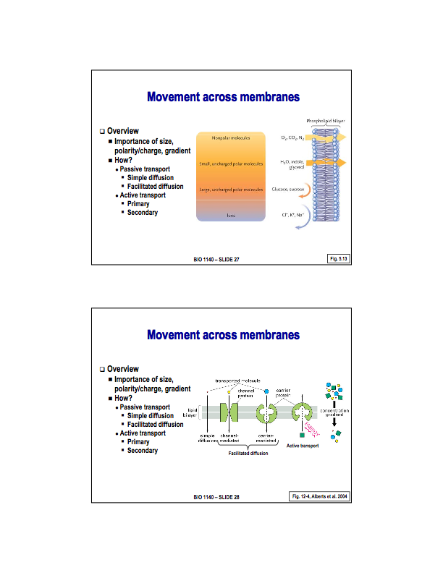
What kind of solutes can pass through the membrane without spending energy?

Anything that is non-polar will be able to move across the membrane quite easily. Even large non-polar molecules such as lipid steroids can pass through the cell membrane quite easily, and of course the same goes for small non-polar molecules such as oxygen and carbon dioxide. This is simply because of the fact that they are not attracted to the polar regions of the membrane and can pass easily throughout the non-polar areas.

It is far more difficult for polar molecules to cross the membrane. Very small polar molecules can still move through easily (such as water). Larger polar molecules or even charged molecules simply cannot pass through the membrane without spending energy.

Answer:

By changing the pH, or ionic strength, it will remove the peripheral proteins. To remove any lipid - anchored
proteins, use phospolipase C.
If protein still remains, its an intregal membrane protein. In order to isolate this, use a detergent to break
apart the membrane leaving the protein of interest.

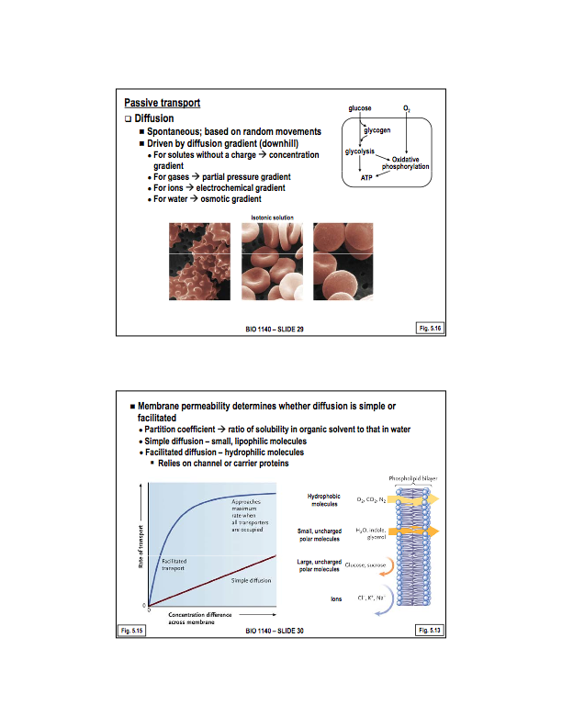
Hypertonic solution Hypotonic Solution

A hypotonic solution is a solution having a lesser solute concentration than the cytosol. It contains a lesser concentration of impermeable solutes on the external side of the membrane. When a cell’s cytoplasm is bathed in a hypotonic solution the water will be drawn out of the solution and into the cell by osmosis. If water molecules continue to diffuse into the cell, it will cause the cell to swell, up to the point that cytolysis (rupture) may occur.

A hypertonic solution is a solution having a greater solute concentration than the cytosol. It contains a greater concentration of impermeable solutes on the external side of the membrane. When a cell’s cytoplasm is bathed in a hypertonic solution the water will be drawn into the solution and out of the cell by osmosis. If water molecules continue to diffuse out of the cell, it will cause the cell to shrink, or crenate.
Lets start by examining membrane travel that doesn't require the expenditure of energy. Namely, Passive Transport.

Passive Transport

- Simple Diffusion: The movement of individuals molecules by random brownian motion. Molecules will move with the concentration gradient, sometimes called “downhill” movement. The rate of movement of the molecule and its diffusion gradient is a linear relationship. They will move from an area of high abundance to an area of low abundance. Different types of gradients exist for different solutes:

Ex:) of simple diffusion: red blood cells in different types of solutions

Lecture 5 Starts here

- Facilitated diffusion:
The process of spontaneous passive transport (as opposed to active transport) of molecules or ions across a biological membrane via specific transmembrane integral proteins. Being passive, facilitated transport does not involve the use of chemical energy; rather, molecules and ions move down their concentration gradient. It is a transport process in which molecules or ions which would otherwise cross the membrane with great difficulty exploit transmembrane protein channels to help them cross this membrane.
The relationship between the rate of movement of the molecule and its diffusion gradient is curved, and so it approaches an asymptote at which represents the point in time where all the transport proteins are occupied. This is known as saturation kinetics, when all the transmembrane integral proteins are being used the maximum rate of transport is being achieved. The maximum rate of transport is determined by the number of transport proteins present.
These transport proteins can be inhibited, typically because they compete with the molecule the transporter would normally move to use the transporter themselves. These compounds prevent transportation because the compete for the transporter. This is known as competitive competition. Competitive inhibition is possible with facilitated diffusion but does not occur with simple diffusion because there are no transport proteins.

How to tell the difference between facilitated diffusion and simple diffusion?

A judgement call must be made based on the features of the molecule in question. The partition coefficient, the ratio of solubility in a non polar solvent to its solubility in water, is often used to make this judgement call. The greater the partition coefficient, the more likely the molecule will be able to simply diffusion across the membrane. Molecules with higher partition coefficients may require transport proteins to move through the membrane.

There are two types of transport proteins involved in simple diffusion. They include channel proteins and carrier proteins.
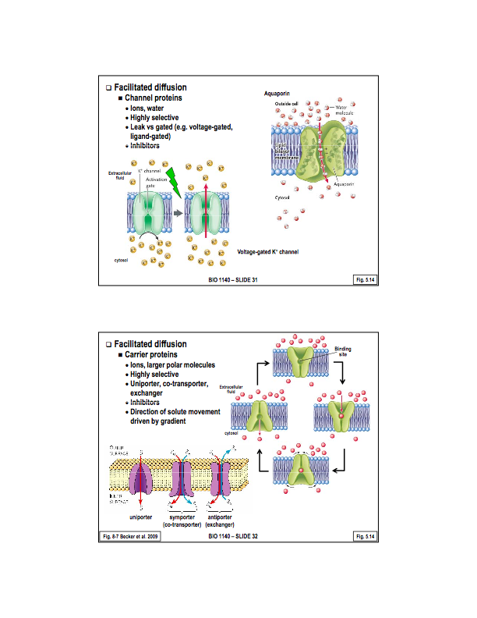
- Channel proteins:
Channel proteins are integral membrane (transmembrane)
proteins. On the outer part of the channel through the membrane, there exists hydrophobic amino acids which hold the transmembrane protein in place in the membrane. Basically, these proteins are a pore through the membrane. The inner portion of the pore is lined with hydrophilic amino acids, which allow a particular molecule to pass through. These transport proteins tend to be very selective. For example, a particular protein may allow for water molecules to pass through, but not more polar compounds such as ions.

Why is a transport protein being used to transport water when it is able to simply diffuse across the membrane? Its because the rate of transport is much quicker with the aid of a transport membrane. An example of this is in the kidney, as large amounts water must be reabsorbed from urine, so the use of facilitated diffusions occurs the minium rate of transport is met.

2. Carrier Proteins:
Carrier proteins are also integral membrane (transmembrane) proteins. They are typically in one of two conformations, it is the switching between these two conformations that moves the solute across the membrane. The top left of the slide on the right clear illustrates this. It is important to note that this movement is with the diffusion gradient. The direction of the transport of solutes is variable, and is controlled by the gradient. Think swimming doors, you can move through either direction, the direction they open is opened on the number of people on each side. Carrier proteins are also, notably, highly selective.

A carrier protein that transports only one single type of solute across the membrane is know as a uniporter. A protein that is able to transport at least two types of solutes in the same direction is known as a co-transporter. An exchanger is a carrier protein that transports at least two types of solutes in opposite directions. It is important to note that these terms: uniporter, exchanger, and co-transporter, simply refer to the number of solutes and their direction that the protein can move through the membrane, and are not reserved for facilitated diffusion. The same terms may be used to describe mechanisms in active transport.
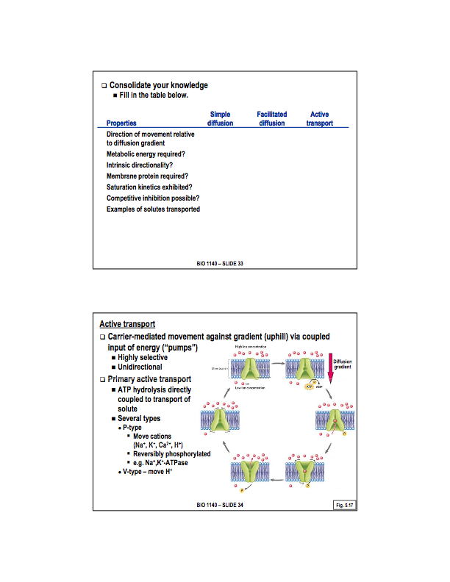

We will now examine solute transportation that does require the expenditure of energy. Namely, Active Transport.

- Active Transport:

Active transport again requires the use of membrane proteins to transfer solutes across the membrane. Because of this, they are also highly selective. It shoes two main differences from facilitated diffusion, namely:

The movements of the molecule is against its diffusion gradient (uphill movement or pumping) and therefore requires the expenditure of metabolic energy (ATP). Active transport demonstrates intrinsic directionality, meaning they only pump in one direction. The diffusion gradient has no influence on the direction of the pump.

There are two types of active transport. Primary Active Transport and Secondary Active Transport

with
no
no
no
no
no
non-polar, small polar
with
no
no
yes
yes
yes
ions, polar molecules, non-polar molecules
- Practice question:

yes
yes
yes
yes
yes
- Primary active transport:
In primary active transport, the expenditure of ATP is directly linked to the movement of the molecules or solvent. This includes the classic primary pumps, in which a membrane protein binds to the molecule to be transported while simultaneously hydrolyzing ATP - in which a phosphate group is removed in order to derive the energy required to move the solute uphill. The hydrolysis of the ATP and movement of the molecule are both at the level of the carrier. One example of primary active transport is P-type pumps (Phosphorylation - type pumps).

A p-type pump works by hydrolyzing ATP and removing a phosphate group. This phosphate group actually binds to the pump itself (the pump is phosphorolayted) providing the energy needed to change its conformation. Once the pump has moved the solute across the membrane, the phosphate is removed and the pump returns to its original shape, the cycle is then repeated. The Na+/K- pump is the best known example of a P-Type pump. Note: P-type pumps transport cations (positively charged ions).

A V-type pump (Vacuoler - type pump) is a hydrogen ion or proton
pump. First discorved on the membrane of vacuoles where they pump protons into the vacuole against the electrochemical gradient. These pumps are also found in the plasma membrane of the cell. These pumps only transport protons. They also work by hydrolyzing ATP, but the phosphate does not bind itself to the pump, there is also no change in conformation of the pump.
Membrane Potential

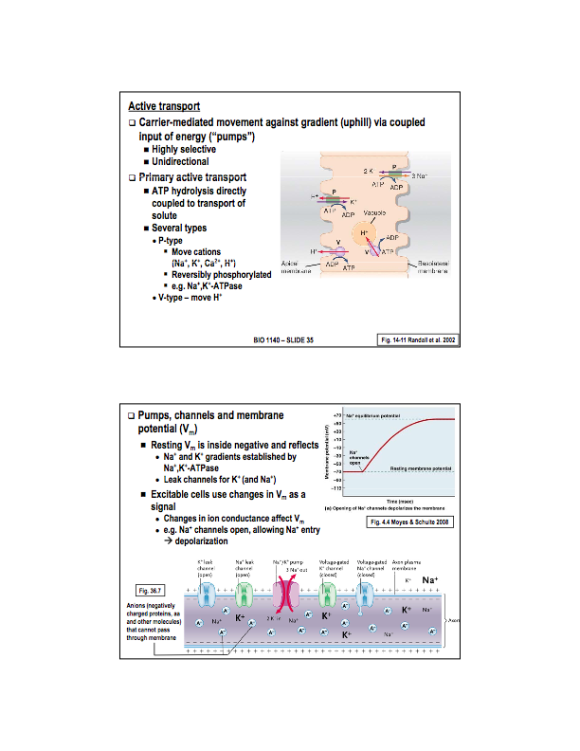
Membrane potential refers to a voltage gradient or voltage difference across the cell membrane. The inside of the cell is negatively charged relative to the the outside environment. This charge ranges anywhere from -5mV to -90mV (this chard refers to the inside of the cell)
The existence of membrane potential primarily depends on pumps and channels. In bacteria, plants, and fungus, the main source of membrane potential is proton pumps. In animals, the main source of membrane potential is the Na+/K+ ATPase pump, which pumps 3 Na+ ions out of the cell for every 2 K+ ions moving into the cell. (K+ concentration becomes high on the inside while Na+ concentration increases on the outside of the cell). Once formed formed, these concentration gradients together with passive movement of potassium and sodium though leak channels give rise to a different number of charged particles inside the membrane relative to the outside, and that create a membrane potential. Membrane potential is important in signalling messages between cells.

The answer is d.

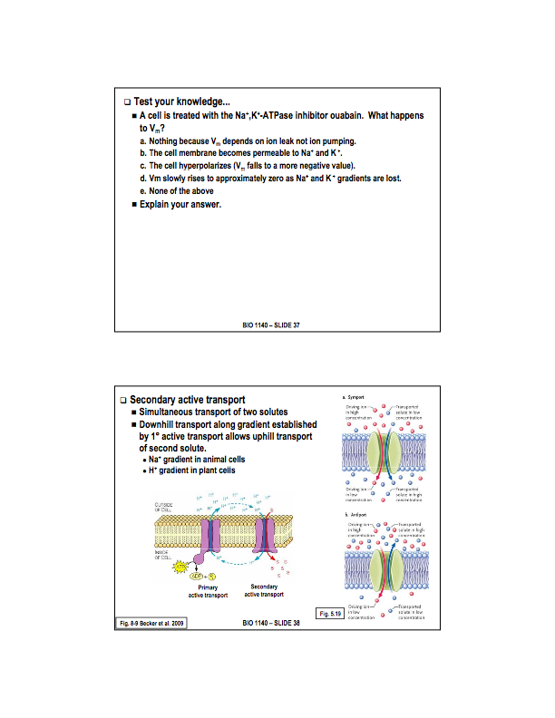
- Secondary Active Transport:
Secondary active transport involves two proteins. One is a primary pump (in animal cells that pump is the Na+/K+ ATPase. In plant cells and other types of cels it is a proton pump. In both cases, this pump creates a gradient (either a sodium gradient or hydrogen ion gradient respectively). The second transport protein then uses that gradient to bring another solute into the cell.

Example 1: Here is a proton pump moving hydrogen ions out of the cell creating a gradient for H+ ions to enter the cell (this requires the expenditure of energy). The transport protein (in this case a co-transporter) allow the H+ ions to enter the cell via a channel in which the move with the concentration gradient, whilst at the same time another solute is moved in against its diffusion gradient.

This is known as secondary active transport because two transport proteins are created. Also, energy is spent to create a gradient and then energy from this very gradient is used to bring in the second solute of interest.

Example 2:The kidney filters liquid waste that ultimately becomes urine. Certain things in the filtrate are desired, such as glucose, and we wish to pass them back to the blood. The mechanism invoked to do this is Secondary active transport. On the blood side of the membrane, there exists a Na+/K+ ATPase that pumps Na+ out of the cell and K+ ions into the cell. The sodium gradient that is developed outside the cell is then used by a sodium-glucose co-transporter. The sodium ions move downhill thought this membrane protein and it brings with it glucose, which is travelling against its concentration gradient. This movement throughout the co-transport is made possible by the Na+ gradient developed outside the cell by the Na+/K+ ATPase pump.
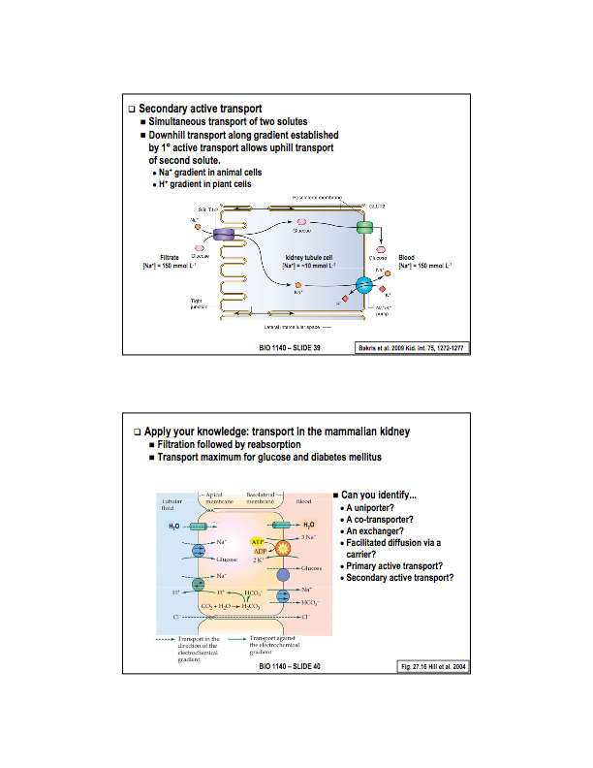
Facilitated diffusion via a channel
co-transporter
(involved with secondary active transport)
exchanger
(involved with secondary active transport)
Facilitated diffusion via a channel
Primary active transport (Na+K+ ATPase - exchanger)
facilitated diffusion via a carrier (uniporter)
co-transporter

Lecture 5 Starts here

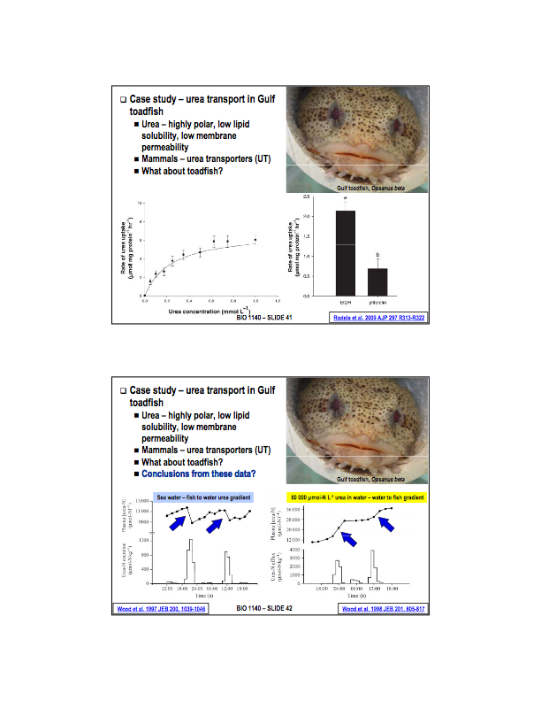
Case Study: Urea Transport in Gulf Toadfish.

This research was carried out about a UofO Ph.D student.

The toadfish excretes urea as their waste product, whilst most fish excrete ammonia. Urea is very polar, and by examining its partition coefficient, one wouldn't expect that it would be able to cross the membrane without the expenditure of energy. In mammalian systems, urea is able to cross the membrane by the means of urea transporters. The question proposed is by what mechanisms is urea exerted from aquatic organism shuch as the toadfish?

The first set of experiments involved measuring the rate of urea transport as a function of urea concentration. Here is the data collected.

By examine the graph, we can see that it paperers as if a transporter protein is involved, as the cure increases and approaches a maximum. Thus, it is said to show saturation kinetics, a tell-tale sign that transport proteins are involved.

A second set of experience in which the rate of urea movement under controlled conditions and when the tissue had been treated with flourotin (a well-known inhibit of mammalian urea transporters). It was found that their was a significant reduction in the rate of transport. Meaning flurotin was able to inhibit urea transport by toadfish cells. This leads to the postulate that transport proteins are intact involved. As not only are saturation kinetics observed but the rate of diffusion is able to be inhibited (meaning transport proteins are involved). The question now becomes whether this is facilitated diffusion, primary, or secondary active transport?

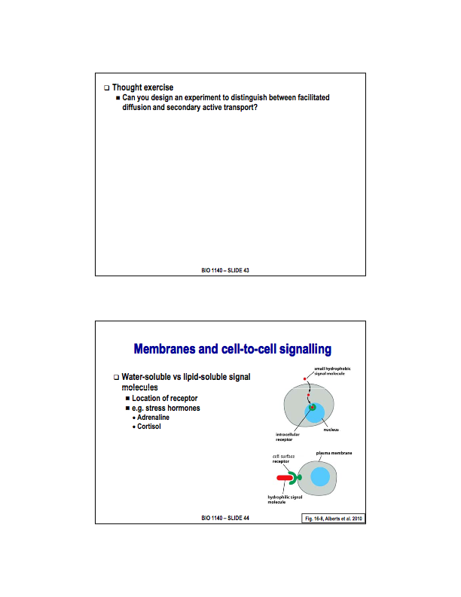
ANSWER THIS
To address this question, additional experiments were carried out to see whether the direction of movement could be reduced by reducing the direction of the diffusion gradient. Normally, the gradient exists in such a way that urea will flow to the environment (water). Urea was added to the water to attempt to change the diffusion gradient of urea. It was discover that it was possible, in fact, to change the direction of the urea gradient.

TAKEAWAY: saturation kinetics were observed, as well as the ability to inhibit movement across the membrane. This provides evidence that a transport protein is part of the mechanism by which the urea is transported across the membrane. Secondly, because the flow of urea was influenced by the diffusion gradient, urea must be moved across the membrane by Facilitated Diffusion (non-intrinsic directionality).
Recall: The cell membrane is a selectively permeable barrier, and the specific transport proteins allow for specific solutes to cross the membrane

We will now looks at a second function of membrane, cell-to-cell signalling.

Most cells contain receptors within the cell membrane that allow for cell-to-cell communication, OR cell-environment communication. This is true of both multi and unicellular organisms , yet it is especially important of multicellular organism in order to coordinate actions of tissues and organs.

There are two basic types of signalling systems. Namely Water-soluble and Lipid soluble signals. (note: we will be focusing on water-soluble signals).

- Water Soluble Signals:
Water-soluble signals are signals that cannot traverse the membrane (through simple diffusion at least) due to their polarity. As such, they specifically interact with receptors on the membrane that face the extracellular environment. Examples of water-soluble signals include Adrenaline and Noradrenaline both responsible for the flight-or-flight phenomena. Cortisol is another steroid stress hormone that is lipid-soluble, therefore it traverses the membrane and interacts with intracellular receptors.

Both water-soluble and lipid soluble signalling system work in a similar fashion. We however, will examine the general case but focus on water-soluble signalling.

The following slides pertain to water soluble signals.

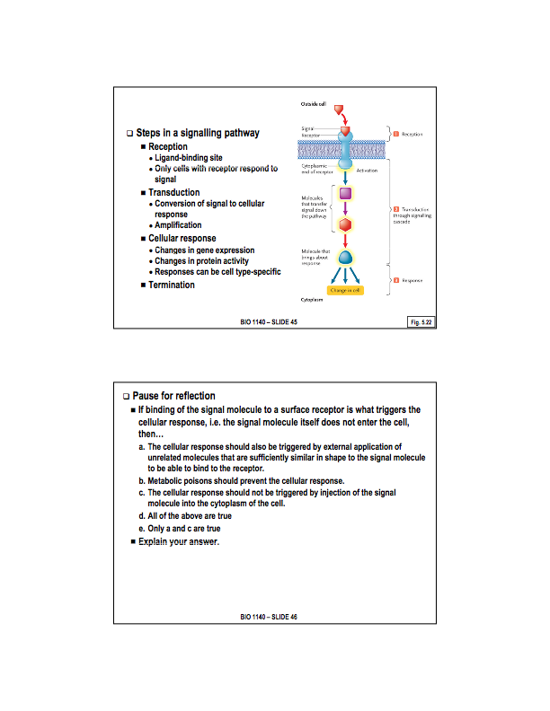
- ANSWER THIS

Steps in cell signalling:
1.Reception: Cells cannot respond to a signal unless it has a receptor for that specific signal. In the case of water-soluble signals, the receptors exists on the surface of the cell membrane facing the extracellular environment. All of these receptors share in common a Ligand-binding site. This part of the receptor is a protein domain which binds the signal to the receptor. It works much like a lock and key mechanism, meaning the receptor must have the right fit for the signalling molecule to cause a response from the cell. Most cells contain many receptors for a host of signalling molecules. The binding of a signal to a receptor then initiations Transduction.
2. Transduction: Transduction is the process of converting the external signal into a cellular response. The signal is said to be “transduced”. This requires a series of steps of varying length. Usually involved is an amplification of the signal in order to cause a change throughout the cell. Transduction is the link between the external signal and the Cellular Response.
3. Cellular Response: Cellular responses can be quite varied. They include changes in the activities of proteins, gene expressions, cell movement, secretion, changing transcription factors, promote cell growth or division, induce apoptosis, etc. Different types of cells may show different types of responses to the exact same signalling molecule. Think testosterone, in the testes it promotes sperm production while in muscle cells in promotes cell growth.
4. Termination: Most signalling molecules have multiple ways of turning off the signalling pathway. This in important in terminating the response of the cell. Example: image a signal that promotes cell growth and proliferation, without a termination component to the signal transduction pathway, the cell will continue to grow without stopping. This is the basis of many cancers.
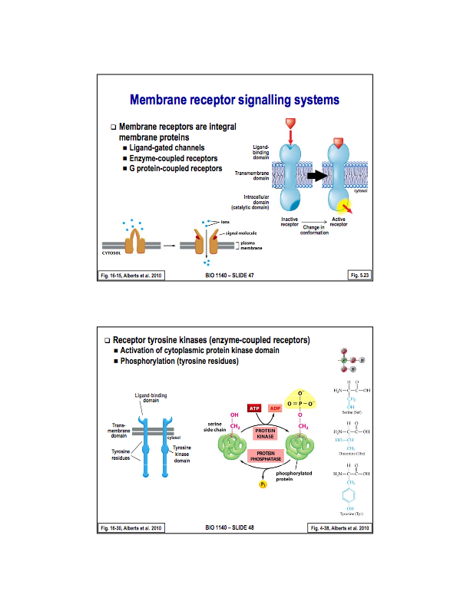
There are three membrane receptors that we will be taking a look at: Ligand-gated channels, Enzyme-coupled receptors, and G protein-coupled receptors. All of these receptors exist within the membrane and thus are integral membrane proteins. The receptors also except water-soluble signals, meaning the binding occurs at a receptor site that is extracellular.

These receptors all share certain things in common, namely:
- There exists at least one transmembrane domaine, this holds the receptor protein in the membrane.
- There is a ligand binding domain, which is responsible for binding water soluble signals on the extracellular surface of the receptor.
- There is usually some type of intracellular domain, which is responsible for activating the signal transduction pathway. The binding of a water soluble solute to the cell causes a conformational change in this intracellular domain which is then responsible for the activation of the cellular response (the signal transduction).

- Ligand-gated channels:
These ion channels open or close when a chemical messenger binds to them. This receptor/channel combo undergoes a conformational change when a chemical messaging (signal) binds to it . This allows ions to flow into the cell which causes a change in membrane potential, which is the cellular response. (we have seen these in previous examples above).
Ex:) Collernergic receptors in muscle tissue: when acetyl choline binds to them, the channels open, and sodium flows in creating the membrane potential needed to induced muscle contraction.
NOTE: these are receptor/ion channel combos

  - Enzyme-coupled receptors:
There exists several different versions of these, but we will focus on Receptor tyrosine kinases. Receptor tyrosine kinases are a type of membrane receptors in which there exists an enzyme which is part of the receptor. The receptor has a single transmembrane domain which holds it in the membrane. The ligand brining domain exists on the extracellular side. On the intracellular side there exists a tyrosine kinase domain. Also, there exists tyrosine residues (amino acid residues of tyrosine).

Aside: A protein kinase is an enzyme that catalzyes the transfer of a phosphate group from ATP to a protein. Specifically, to an amino acid residue that contains an hydroxyl group. The additional phosphate is attached to the hydroxyl group of the animo acid.

Tyrosine kinase, then, is a kinase that specifically phosphorylates tyrosine residues. In general, cells will contain many kinases, because the phospohrolatyion of proteins us usually used to change the conformation of the protein and therefore control its activity. Turing off a phosphorylated protein is called dephosphorylation. This is carried out by protein phosphatases. Anything that is phosphorylated is typically rapidly dephosphorylated.

First Question During LEc on 31st: answer is C. Regeneration of NAD+ is necessary to continue ATP production. In the absence of oxygen, the only source of ATP is glycolysis. NOTE that fermentation and ethanol production DO not create ATP. NO problem with a builtd of pyruvate. Accumilation of protons isn't neccecarily d=angerous becuas off buffers in the cell.

SEcoond question:
4 compartments: outer, inner membrane, intermembrane, matrix.
Outer: contains porins
Inner membrane: transporters, atp synthase.
Matrix: enzymes for py ox. and cackle
intermembrane space: proton gradient.

heart cells: much larger surface area to produce the surface are for proteins involved in atp synthesis as the cells require more energy.

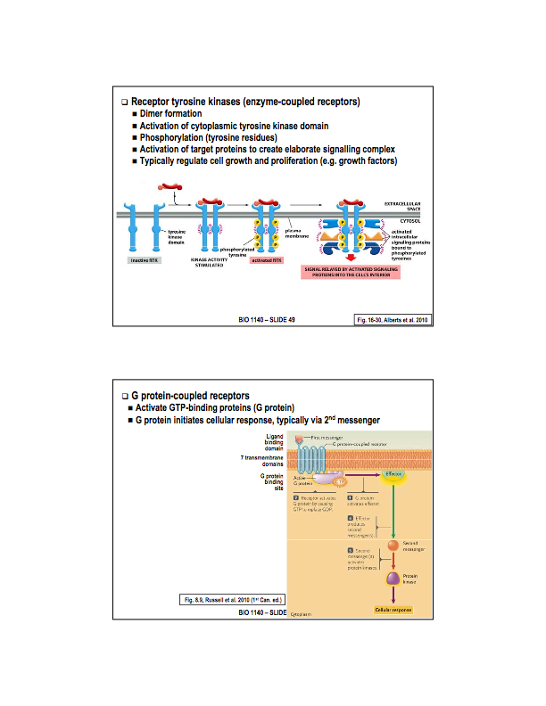
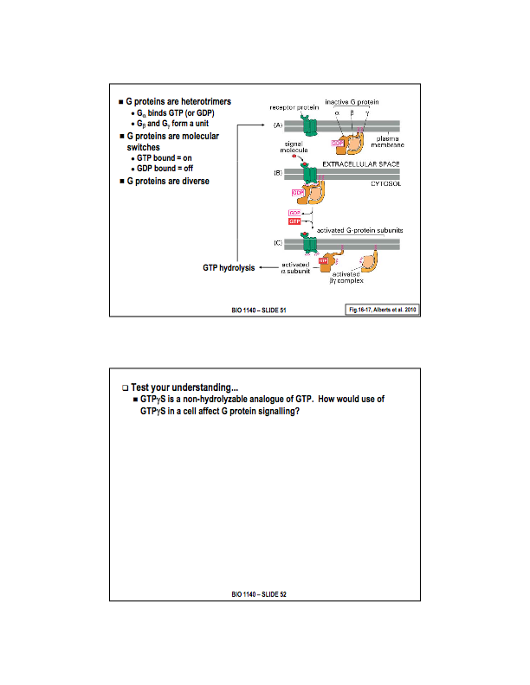
The cytosolic domain of the tyrosine kinase receptor contains a tyrosine kinase domain. This means it contains the enzyme to phosphorylate tyrosine molecules. The cytosolic domain also contains tyrosine molecules. When the receptor is activated (it is actually 2 that are activated at the same time), it causes two receptors to dimorize, and thus the receptor becomes active.
Once the signalling molecule is bound and the receptors have formed the dimer, the tyrosine kinase domain is activated. Thus, it is now capable of phosphorylating tyrosine resides. The first residues to get phosphorylated are the tyrosine residues which already exist on the receptor (known as autophosphorylation). The receptor complex is now active, and will start to phosphoralate other proteins within the cell, which then turns on cellular pathways. In many cases, these pathways regulate the growth, division, and differentiation of cells. Thus, Tyrosine kinase receptors are frequently activated by growth factors.

Ex:) Nerve growth factor, epidermal growth factor, human growth factor, insulin, EPO - a growth factor that is sometimes used by athletes, it increases the proliferation of red blood cells (illegally). It is estimated that about 30% of cancers are a result of mistakes in growth factor signalling pathways.

- G protein-coupled receptors
G protien-coupled receptors belong to a large family of receptors. Again they are integral membrane and transmembrane proteins. They are characterized by having 7 transmembrane domains. Often referred to as 7-TMD receptor. They are particularly common in animal cells, within animal cells, the receptors form the targets super-family of proteins.

Structure: Contain seven transmembrane domains, and an extra cellular ligand binding domain (as these respond to water soluble signals). On the cytosolic side of the membrane, these receptors have a binding site for G-Proteins (hence the name). G-Protein stand for GTP binding protein. These proteins act as molecular switches within the cell.

When the signalling molecule binds to the receptor, it changes the conformation of the receptor to activate it, and what the receptor does is activate the G-Protein which then goes on to activate signal transduction pathways within the cell.

Typically, this involves what is known as a second messenger, which is a chemical messenger that operates within the cell. By contrast, the signalling molecule that operates outside the cell (the ones that binds to the lignin bonding domain) is often referred to as the first messenger. In order to further understand g protein-coupled receptors, we must understand the structure and function of a g-protein.
- ANSWER THIS
GTP or G-Binding Proteins:
GTP Binding Proteins are proteins that bind to the nucleotide GTP. This nucleotide contains guanine as its base, a sugar, and three phosphate groups. GTP can be hydrolyzed to GDP (contains two phosphate groups). GTP binding proteins (or g-proteins) are fatty acid anchored proteins, and are found on the intracellular side of the membrane. They are heterotrimers - meaning the protein is made up from 3 different subunits. There is an alpha, beta, and gamma subunit.

The alpha subunit is the subunit that binds GTP. It also, as a subunit, has the ability to hydrolyze GTP into GDP.

G-proteins act as molecular switches by being turned on when GTP is bind to them, and turned off when GTP is hydrolyzed to GDP. Activation of the receptor allows for the activation of g-proteins by forcing the protein to drop GDP and bond to GTP. Once GTP is bound to the alpha subunit, the protein is activated and will split into two components, namely: the alpha subunit, and the beta-gamma complex. Each of these are then able to activate cellular pathways by moving around in the membrane. To turn them off again, the alpha subunit will eventually hydrolyze GTP to GDP, once this happens the alpha subunit and the beta-gamma complex fuse and return to the membrane waiting the activation of the g proton-coupled receptor.

Lecture 5 Starts here
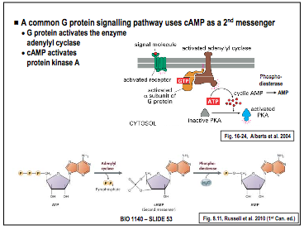
GTP or G-Binding Proteins CONT’D:
There are in fact a number of different g-proteins, each with its own set of proteins that it turns on in the cell.

ex:) Cyclic AMP is a derivative of ATP, a secondary messenger. It contains the 5 carbon sugar, the adenine base, and three phosphate groups. To go from ATP to Cyclic AMP, two phosphate groups are removed (hence monophosphate) and the remaining phosphate (which is linked to the 5’ carbon of the sugar) is now linked to both the 3’ and 5’ carbon of the sugar, giving it its cyclic shape (hence cyclic AMP). The enzyme that does this is called Adenylyl cyclase. Adenylyl cyclase catalyses the conversion of ATP to cAMP, and cAMP is a signalling molecule within the cell.
In order to remove this second messenger, phospodiesterase breaks the bond between the 3’ carbon and phosphate, yielding AMP which does not function as a signalling molecule, shutting down the transaction pathway.

ATP ————-—> cAMP ——————-—> AMP

The G protein is what turns on the enzyme Adenyly Cyclase. A G protein-coupled receptor sits in the membrane waiting to receive a signal. When the signal molecule binds to it, the receptor is turned on, this allows it to bind the G-protein (which is located on the inside of the cell bound to the membrane) by dropping GDP and picking up GTP, the activated G-protein then splits into the alpha subunit and the beta-gamma complex. In this case, the alpha subunit turns on adenyly cyclase (which in this case is a transmembrane protein). Notice the importance of the G-protein being linked to the membrane, as it allows for the communication between the receptor and the enzyme, in this case adenylyl cyclase.
As we known, adenyly cyclase catalyses ATP to cAMP. The cAMP serves as a secondary messenger, whereby it turns on a kinase, called protein kinase a. This kinase is now able to phosphorylate other proteins. Protein kinase a is one of a number of different kinases within a cell.
NOTE: for our purposes, we will be focusing on protein kinase a.
Adenyly cyclase
Phospodiesterase

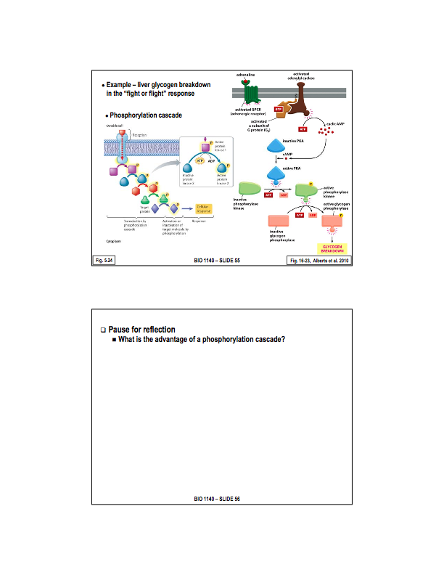
We will now look at a specific example in liver cells during a fight of flight response:

The fight of flight response occurs in a panicked situation, it is triggered by adrenaline and noradreneline and other stress hormones (cortisol). General affects are increased blood flow to muscles, increased heart rate, dilation of pupils to allow in more light in AND notably, the release of glucose from the liver.

The response of glucose being released from the liver is a cAMP regulated pathway. The membrane receptor is a G-protein coupled receptor (which is activated by adrenaline). When this receptor is activated it turns on a G-protein. This G-protein in turns on transmembrane adenyly cyclase, which created the second messenger, cAMP, which turns on protein kinase a.

(Note the thus far, the pathway is the same as the one we have examined) What happens next, is that protein kinase a turns on a second kinase, called phosphorylate kinase, which is done by phosphorylating it (adding a phosphate from ATP to the protein). This activated phosphoralyzed kinase then activates a second enzyme called glycogen phosphoralyze (by phosphoylation again) which is responsible for the breakdown or catylization of glucose in the liver.

This kind of sequential activation of kinases is known as a phosphoralation cascade. Note: the reason/function/advantages of this type of transduction pathway are discussed below.
Phosphoralation Cascade: A very small signal is amplified each time the phosphorolation of a kinease occurs. This allows a small signal transduction to induce large cellular response.

It also acts as a means of controlling signals final induced response.

Prevents the breakdown of cAMP to AMP, which effectively destroys the cascade and so the pathway runs continuously and amplifies the effect and durations of adrenaline. This cascade will function normally once the caffeine is no longer present.

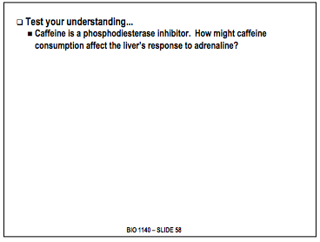
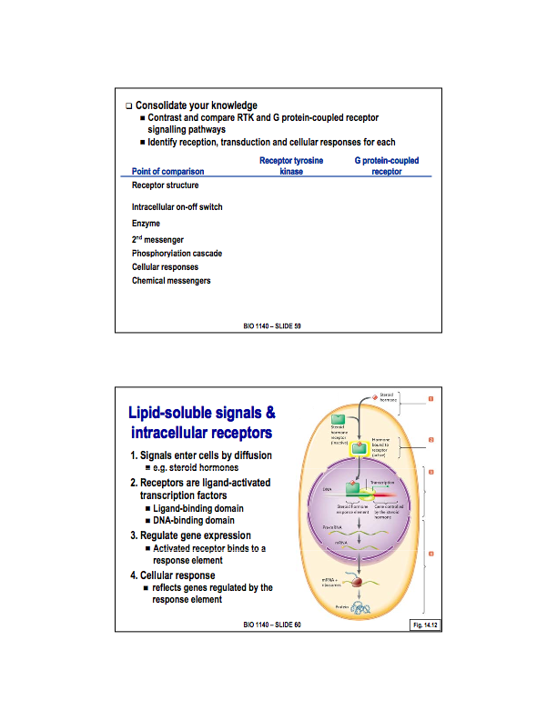
ANSWER THIS

The following slides pertain to Lipid-Soluble Signals
We will now turn our attention to Lipid Soluble Signals and intracellular receptors.

- Lipid soluble signals
Lipid soluble signals cross the membrane, and because of such, they interact with receptors within the cell.
The receipts still contain a ligand binding domain for the signalling molecule to bind to - this is consist across all trypes of receptors. The difference, occurs once the receptor has been activated.

With lipid soluble signals, once the receptor is activated, it will bind to DNA and affect transcription (either increase or decrease) the transcription of gene. As such, these receptors act as ligand activated transcription factors.

In order to be able to affect transition, they must be able to bind to DNA. So in addition to the ligand binding site, these receptors also contain a DNA binding domain. The region of the DNA that thesee receptors bind to is called a response element. The response elements are found in the promoter region of the genes that are affected by that particular signalling molecule.

