Topic 1 - Introduction to cell biology - Lecture 2

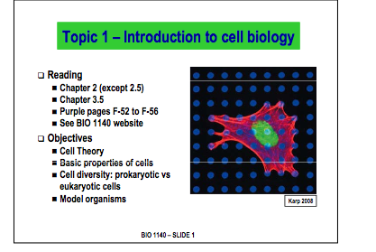

The three tenets to the cell theory are as described below:

1.All organisms are composed of one or more cells.

2.The cell is the most basic unit of structure, function, and organization in all organisms.

3.All cells arise from pre-existing, living cells.
- Some cells are large enough to be seen by the naked eye

Ex:) Ostrich Egg

- Cells demonstrate similar chemical processes across all cell types. This facts allow us to state broad facts about all cell types, it also leads itself to the theory that all cells are derived from a starting cell (LUCAS)
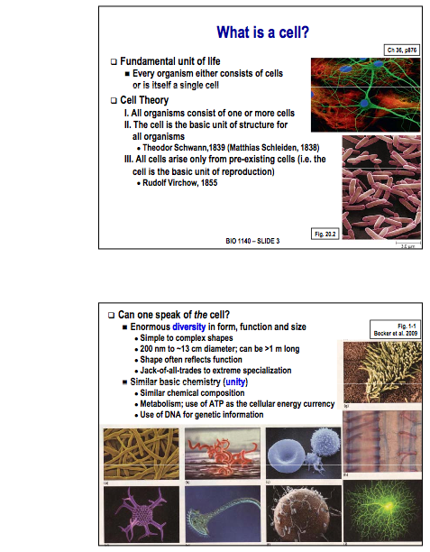

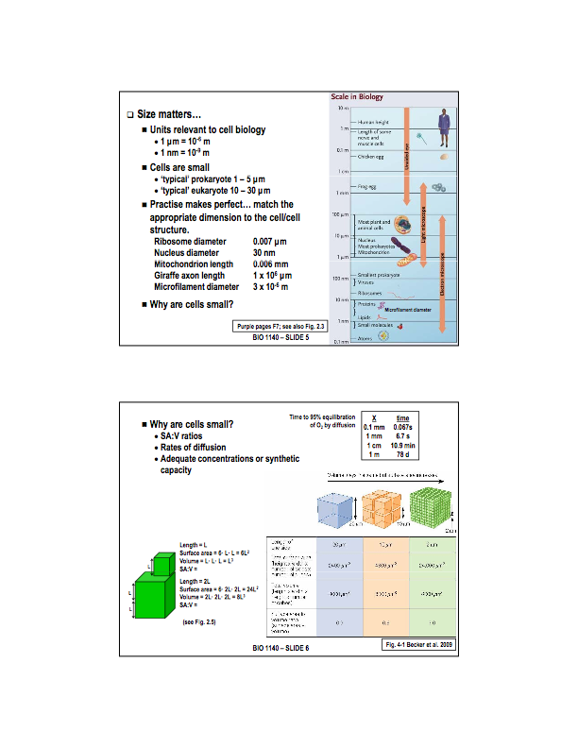
Why are cells small?

- SA:V ratios: Volume determines the amount of material a cell can hold (its size). Surface determines the rate at which material can move in/out of the cell.

- Rates of diffusion: Time required for diffusion is proportional the square of the surface area

- Adequate concentration or synthetic capacity: The appropriate concentration of biochemical molecules must be achieved to maintain life. The larger the cell, the more of each molecule it may need to maintain these concentrations.

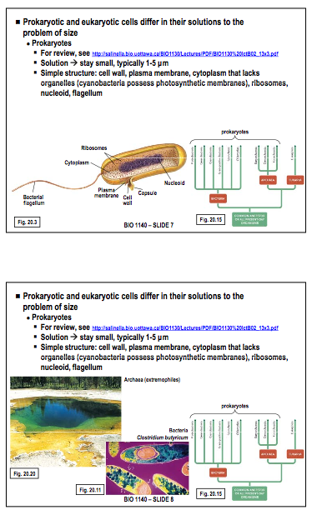
Extremophiles include:
Thermophiles
Halophiles
Methanogens

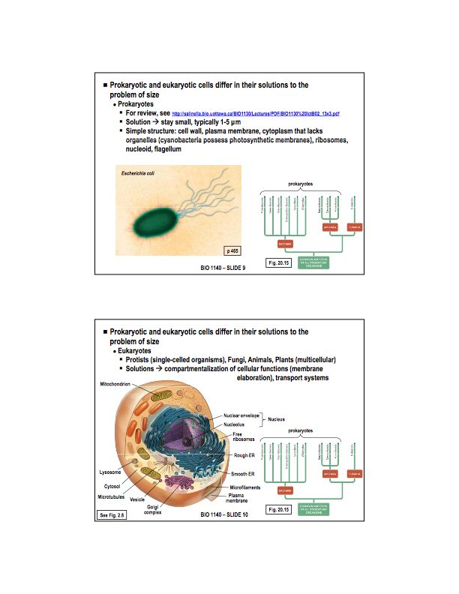
E.coli as a model organism
- E.coli serves as a model organism (of particular interest to biotechnicians)

- A model organism is a non-human species that is extensively studied to understand particular biological phenomena, with the expectation that discoveries made in the organism model will provide insight into the workings of other organisms.

- The bacterium can be grown easily and inexpensively in a laboratory setting, and has been intensively investigated for over 60 years. E. coli is the most widely studied prokaryotic model organism, and an important species in the fields of biotechnology and microbiology, where it has served as the host organism for the majority of work with recombinant DNA.

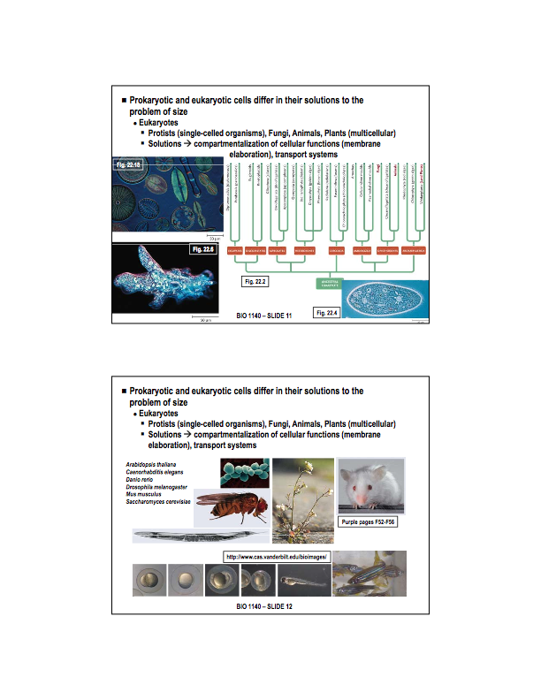
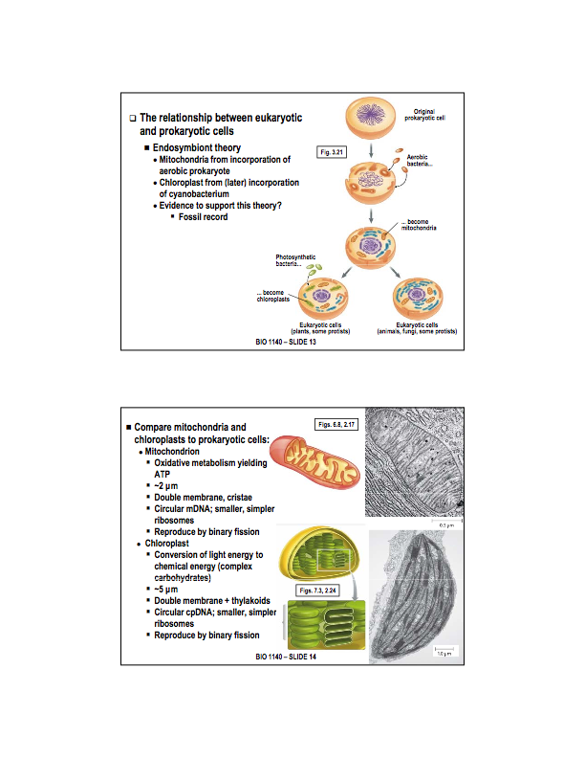
More important model organisms
Arabidopsis thaliana - mustard weed: Contains a relatively small genome making it an easy organism to genetically modify. It can also be cultured quickly and inexpensively.
Caenorhabditis elegans - nematode: again small genome, contains exactly 959 genes. It shares a number of characteristics with humans (aging, developmental patterns, behaviours). This was the first multicellular organism to have its entire genome mapped.
Danio rerio - Zebra fish: Capable of regenerating heart cells (a desirable property). External fertilization occurs in transparent eggs, so that the entire process can be observed easily. It only takes 48 hours from fertilization to hatching. Also small so large numbers can be kept in small spaces. Reproduce easily & rapidly
Drosophila melanogaster - fruit fly: easy to culture in the lab, large samples can be kept in a small area. Reproduce rapidly. Popular with geneticist because there are many observable phenotypes that can be used to categorize them into geneotipic groupings.
Mus musculus - mouse: Happy to live in high numbers and crowded small areas. Reproduces rapidly, shares many physiological characteristics with humans.
Saccharomyces cerevisiae - Bakers yeast: It is one of the most intensively studied eukaryotic model organisms in molecular and cell biology, much like Escherichia coli as the model bacterium. As a single celled organism S. cerevisiae is small with a short generation time and and can be easily cultured. Can be transformed allowing for either the addition of new genes or deletion through homologous recombination. shares the complex internal cell structure of plants and animals without the high percentage of non-coding DNA that can confound research in higher eukaryotes.

Endosymbiotic Theory - In one particular circumstance, a bacteria may have been phagocytosis by an organism and for some reason was not broken down. This bacterium had a unique chemistry; it scavenged 3 carbon pyruvates to produce ATP for its cellular processes. A symbiotic relationship was set up, such that the organism supplied the bacteria with pyruvate and the bacteria in turn supplied the cell with ATP. This same theory can be used to explain the chloroplast . BASICALLY one bacteria engulfed another and a symbiotic relationship was developed. This new cell becomes extremely successful and continues to divide. This is considered a monophyletic event.

What evidence exists?

Since Prokaryotes precede eukaryotes in the fossil record. It isn’t hard to deduce that prokaryotes must have led to eukaryotes.

There are also many remarkable similarities between mitochondria and chloroplast to prokaryotic cells. These similarities are listed on the slide.

- Mitochondria also undergo oxidative metabolism, yielding ATP. Aerobic bacteria do exactly this
- Chloroplasts are involved in photosynthesis, the exact same process as cyanobacteria.

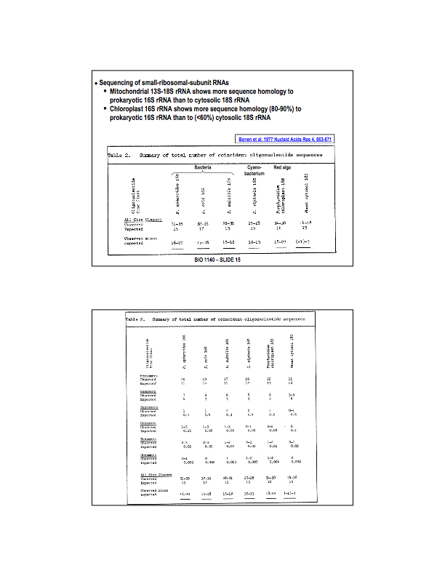
Observed sequence homologies are compered to expected similarities for bacteria, cyanobacterium, red alga and wheat RNA were used as evidence to support the endosymbiotic theory.

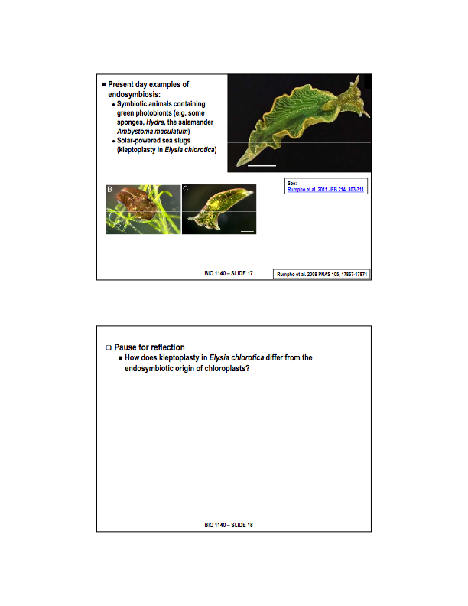
- NEED WORK

- Kleptoplasty: Kleptoplasty is a symbiotic phenomenon whereby plastids, (notably chloroplasts), from algae are sequestered by host organisms. The alga is eaten normally and partially digested, leaving the plastid intact. The plastids are maintained within the host, temporarily retaining functional photosynthesis for use by the predator.

- Endosymbiosis: The endosymbiotic theory states that several key organelles of eukaryotes originated as symbioses between separate single-celled organisms. According to this theory, mitochondria and plastids (e.g. chloroplasts), and possibly other organelles, represent formerly free-living bacteria that were taken inside another cell as an endosymbiont. Molecular and biochemical evidence suggest that the mitochondrion developed from proteobacteria and the chloroplast from cyanobacteria.

What are the major differences?

In kleptoplasty, the chloroplasts existence is limited to the intestinal cells of the sea slug, whereas in endosymbiosis chloroplasts exist in ALL cells. They are NOT passed down from one generation to the next; they must be acquired by each new organism. The uptake is also of strictly of the organelle (in this case chloroplasts), NOT a cell, as is done in endosymbiosis.

