Section 3:
1) David Sussman: “What’s wrong with torture?”
- look at powerpoint from the internet
2) Vittorio Bufacchi and Jean Maria Arrigo: “Torture, terrorism, and the state: a refutation of the ticking-bomb argument”
Section 4:
1) Richard Wasserstrom : “Racism, Sexism, and Preferential Treatment”

- Three Types of perspectives within racism, sexism, and affirmative action
  - “What are its institutions, attitudes and ideologies in respect to matters of race and sex?” – SOCIAL REALITIES
  - “What would the good society – in terms of its institutions, its attitudes, and its values – look like in respect to matters involving race and sex?” – SOCIAL IDEALS
  - What could make the ideal society into reality?
- SOCIAL REALITIES
  - Sex and race are socially important to our society
  - However trivial they may be, both sex and race do play a part in everyday life – “Race does not function as eye color”
  - Sex is import also – see transsexuals
    - Transsexuals identify themselves with the opposite gender because “he (or she) is more comfortable with the role allocated by the culture to people who are physiologically of the opposite sex”
  - Sex is more important than race
    - Only 2 sexes, many races
    - Sex determines the way we are raised, etc.
    - Sex determines the social norms for a person (to marry and have children, or to be successful in the business world, etc.)
    - Women are idealized and at the same time regarded as less competent
    - Sexism is harder to identify than racism at times – i.e. bathrooms
  - TYPES OF RACISM/SEXISM
    - Overt – obvious – i.e. law, segregation, etc.
    - Covert – not so obvious – i.e. school segregation on “location” etc.
    - Intuitional racism
      - Type 1 – dividing schools by racial locations
      - Type 2 – “conceptual” – i.e. separate but equal
        - Brown v. Board, didn’t immediately integrate, rather waited until poor black schools were made acceptable to whites

- SOCIAL IDEALS
  - A non-racist/sexist society would be one in which race and sex are viewed just as eye color is today
    - I.e. “no basic political rights and obligations are determined on the basis of eye color. No important institutional benefits are connected with eye color.”
    - I have blue eyes, but I feel more like a brown-eyed person…
    - Would force the abolition of laws such as those keeping gays from marriage, for sex would not be important
    - Ideals of masculinity and femininity would disappear
  - Diversity and tolerance (keep things interesting while still accepting all)

- 2) Boxill and Boxill: “Affirmative Action”

- Boxill: Might membership in a disadvantaged minority (e.g. racial) sometimes be a qualification?
  - Argument pro (Bernard Boxill)

P1. “Qualifications” = qualities advantageous for performance of the socially desirable functions of a position.

P2. Sometimes membership in some disadvantaged group is advantageous for performance of such functions.

-----------------

C. Therefore, sometimes membership in a particular disadvantaged group is a qualification for a position.

Section 5:
1) L.W. Sumner: “Hate Crimes, Literature, and Speech”
2) Lori Gruen: “Pornography and Censorship”

Section 6:
1) Susan Moller Okin: “Feminisim and multiculturalism: some tensions”
Feminism, multiculturalism and the limits of sovereignty
In a highly contentious and much-discussed book, Susan Moller Okin famously asks ‘Is multiculturalism bad for women?’ This question and the range of responses and refutations that it elicits demonstrate a key shift in understandings of feminism and the relation of feminism to other social movements. The framing of the question indicates the fraught space of this debate and its implications: that liberal tolerance of some cultural communities is a tolerance of the oppression and suppression of women; that the cultural and social ambitions of some groups are antithetical to the interests of women; that the appeal to women in the West to adapt to newcomers and their ways is a demand that they give up on their own hard-won social freedoms. In fact the analysis of such issues has become a busy subset of academic and political life (Okin, 1999; Reitman, 2005; Nussbaum, 2000; Young, 1990).
My interest here is not in the competing claims of those for and against the proposition – these are rehearsed thoroughly in Okin’s collection – but in the implications of such a debate. Okin responds to her opponents with this paragraph, clarifying her proposition and alluding to its implications:

I argue that many cultures oppress some of their members, in particular women, and that they are often able to socialize these oppressed members so that they accept, without question, their designated cultural status. I argue, therefore, that in the context of liberal states, when cultural or religious groups claim special rights – whether to be exercised by them together as a group or individually as members of that group – attention should be paid to the status of women within the culture or religion. This means that it is not enough for those representing the liberal state simply to listen to the requests of the self-styled group leaders. They must enquire into the point of view of the women, and take especially seriously the perspective of the younger women. (Moller Okin, 1999, 117)
Susan Moller Okin 's Feminism and Multiculturalism : Some Tensions ' is a well-argued that explores the tensions ' between feminism and multiculturalism (particularly the group-rights ' variety ) from a consistent liberal perspective
The author writes as a liberal and as a feminist in putting forth a critique of the ways in which multiculturalism - as it was , and still is , being advocated by various activists and academics - poses real dangers to the rights and interests of girls and women that belong to minority groups . The way she does this is admirable : In a manner that is clear and with not-so-well-known examples , she shows how most of the major cultures of the world puts a premium on maintaining control of women ' and how the advancement of the rights and interests of women conflict and clash with particular practices within the cultures of minority groups . She is admirable in standing firm with the feminist insight that more often than not , sex discrimination is far less overt . In many cultures , strict control of women is enforced in the private sphere by the authority of either actual or symbolic fathers often acting through , or with the complicity of , the older women of the culture ' This , I think , is her central argument in making the case that there are tensions ' if not contradictions , between feminism and multiculturalism

2) Will Kymlicka: “Justice and minority rights”
Will Kymlicka Justice and Minority Rights (an excerpt from his book Multicultural Citizenship
The increasingly multicultural fabric of modern societies has given rise to many new issues and conflicts, as ethnic and national minorities demand recognition and support for their cultural identity. This book presents a new conception of the rights and status of minority cultures. It argues that certain "collective rights" of minority cultures are consistent with liberal democratic principles, and that standard liberal objections to such rights can be answered. However, the author emphasizes that no single formula can be applied to all groups, and that the needs and aspirations of immigrants are very different from those of indigenous peoples and national minorities. He looks at issues such as language rights, group representation, religious education, federalism, and secession--issues central to an understanding of multicultural politics, but which have been neglected in contemporary liberal theory. Scholars of political theory and philosophy, as well as the general reader, will find this work to be the most comprehensive analysis to date of this crucial political issue.
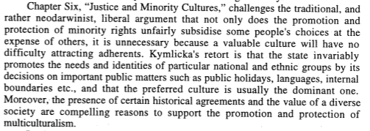

Chapter 6: Justice and Minority Rights [107]

1. The Equality Argument [108]
Two opposed positions, both supposedly concerned with preserving equality:
1. Accommodationists, who think that (in the words of the Canadian Supreme Court) �the accommodation of differences is the essence of true equality�
2. �Benign Neglect� proponents: true equality requires equal rights for each individual regardless of race or ethnicity

Two big problems for benign neglect, on Kymlicka�s view:
(i) The language of government [relevant for national minorities]
When the government decides the language of public schooling, it is providing what is probably the most important form of support needed by societal cultures, since it guarantees the passing on of the language and its associated traditions and conventions to the next generation�. The government therefore cannot avoid deciding which societal culture will be supported. [111]
This means that the proponents of benign neglect can�t make the argument that culture is like a church, and that, just as a government can (and should) remain neutral between churches, so it should between cultures. Unlike churches, the government can�t remain neutral between languages.
Can�t we just solve this problem by allowing political subunits to decide on their language of government?
Kymlicka: no, because who decides what the boundaries of those subunits are? The US has a history of ensuring Anglo domination (compare gerrymandering).
So the real question is, what is a fair way to recognize languages, draw boundaries, and distribute powers? And the answer, I think, is that we should aim at ensuring that all national groups have the opportunity to maintain themselves as a distinct culture if they so choose� Hence group-differentiated self-government rights compensate for unequal circumstances which put the members of minority cultures at a systematic disadvantage in the cultural market-place, regardless of their personal choices in life. This is one of many areas in which true equality requires not identical treatment, but rather differential treatment in order to accommodate differential needs. [113]
(ii) Other ethnically-based elements of government [relevant for ethnic groups, including immigrants, as well]
a. public holidays
b. government uniforms
c. flags, anthems, mottoes

2. The Role of Historical Agreements [116]
Can we just rely on historical pacts, such as treaties signed (and since ignored by the powerful majority) with minorities?
if we wish to defend group-differentiated rights, we should not rely solely on historical agreements. Since historical agreements must always be interpreted, and inevitably need to be updated and revised, we must be able to ground the historical agreements in a deeper theory of justice. The historical and equality arguments must work together. [120]
3. The Value of Cultural Diversity [121]
Liberals could value cultural diversity for two main reasons:
1. it creates a more interesting world
2. it offers new ideas that can help people adapt to new circumstances (for example, indigenous peoples can teach Westerners about sustainability.
BUT neither of these are a firm basis for valuing the cultural rights of national minorities, because they support intrastate diversity, but national minorities want interstate diversity (that is, they want each culture to have its own governing body, which might limit exposure to the culture by outsiders).

4. The Analogy with States [124]
Most liberals want to adopt a compromise position that it is inconsistent between these two consistent alternatives:
1. Open borders, with no separate states, and a global system of equal rights and movement for all (nowadays called cosmopolitanism)
2. Kymlicka�s position of culturally-based states.
The compromise position is a system of states that are not culturally based, with limits on immigration allowed. The only way to justify such states against the �open border� challenge is to recognize them as designed to protect cultures. Otherwise, why would individuals need distinctions between states (with the inequality that that entails)?
I believe that the orthodox liberal view about the right of states to determine who has citizenship rests on the same principles which justify group-differentiated citizenship within states, and that accepting the former leads logically to the latter.
5. Conclusion [126]

Should minority groups such as recent immigrants be given rights that other citizens don't have? Will Kymlicka believes that they should. The difficulty of reconciling apparently preferential treatment with a policy of equality is a central one for anyone committed to multiculturalism. He addresses this important issue in this episode of Philosophy Bites.

Explores the main arguments in favour of group‐differentiated rights for ethnic groups and national minorities. In particular, it distinguishes between equality‐based arguments, which aim to show that the minority is facing some sort of unfair disadvantage that can be rectified by a group‐differentiated right, and various history‐based arguments, which aim to show that the minority has some historical claim to the group‐differentiated right, based on prior sovereignty, treaties, or some other historical agreement or precedent. It also considers arguments that appeal to the intrinsic value of cultural diversity, and how these relate to both the equality‐based and history‐based arguments. http://www.oxfordscholarship.com/view/10.1093/0198290918.001.0001/acprof-9780198290919-chapter-6

Section 7:
1) Robert Goodin: “Permissible paternalism: in defense of the nanny state”
2) Jessica Flanigan: Three arguments against prescription requirements
In this essay, I argue that prescription drug laws violate patients' rights to self-medication. Patients have rights to self-medication for the same reasons they have rights to refuse medical treatment according to the doctrine of informed consent (DIC). Since we should accept the DIC, we ought to reject paternalistic prohibitions of prescription drugs and respect the right of self-medication. In section 1, I frame the puzzle of self-medication; why don't the same considerations that tell in favour of informed consent also justify a right of self-medication? In section 2, I show that the prescription drug system was historically motivated by paternalism. In section 3, I outline the justifications for the DIC in more detail. I show that consequentialist, epistemic, and deontic considerations justify the DIC. In sections 4-6, I argue that these considerations also justify rights of self-medication. I then propose that rights of self-medication require non-prohibitive prescription policies in section 7. I consider two objections in sections 8 and 9: that patients ought not to make medically risky or deadly decisions, and that unrestricted access to prescription-grade pharmaceuticals would result in widespread misuse and abuse. Section 10 concludes.
In 'Three Arguments Against Prescription Requirements', Jessica Flanigan argues that 'prescription drug laws violate patients' rights to self-medication' and that patients 'have rights to self-medication for the same reasons they have rights to refuse medical treatment according to the doctrine of informed consent (DIC), claiming that the strongest of these reasons is grounded on the value of autonomy. However, close examination of the moral value of autonomy shows that rather than being the strongest justification for the DIC, respect for the value of autonomy is actually the weakest, and it is dependent upon the first two well-being-based justifications for the DIC. Recognising this has important implications for Flanigan's argument against prescription requirements.

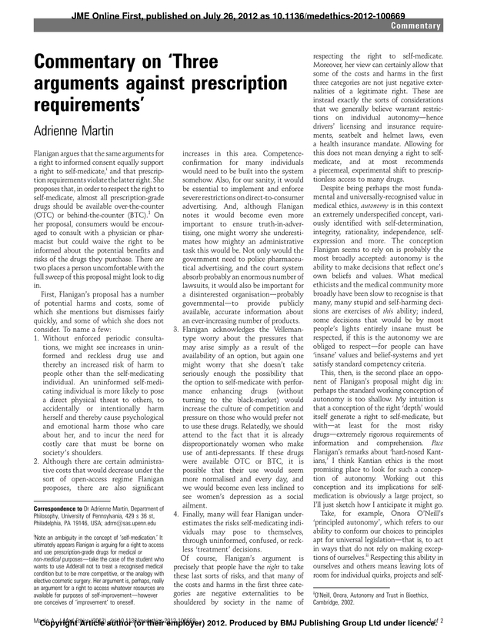

In 'Three Arguments Against Prescription Requirements', Jessica Flanigan argues that 'prescription drug laws violate patients' rights to self-medication' and that patients 'have rights to self-medication for the same reasons they have rights to refuse medical treatment according to the doctrine of informed consent (DIC), claiming that the strongest of these reasons is grounded on the value of autonomy. However, close examination of the moral value of autonomy shows that rather than being the strongest justification for the DIC, respect for the value of autonomy is actually the weakest, and it is dependent upon the first two well-being-based justifications for the DIC. Recognising this has important implications for Flanigan's argument against prescription requirements.

Section 8:
1) Elizabeth Fenton and Loren Lomasky: “Dispensing with Liberty: Conscientious Refusal and the Morning-After Pill”
Citing grounds of conscience, pharmacists are increasingly refusing to fill prescriptions for emergency contraception, or the "morning-after pill." Whether correctly or not, these pharmacists believe that emergency contraception either constitutes the destruction of post-conception human life, or poses a significant risk of such destruction. We argue that the liberty of conscientious refusal grounds a strong moral claim, one that cannot be defeated solely by consideration of the interests of those seeking medication. We examine, and find lacking, five arguments for requiring pharmacists to fill prescriptions. However, we argue that in their professional context, pharmacists benefit from liberty restrictions on those seeking medication. What would otherwise amount to very strong claims can be defeated if they rest on some prior restriction of the liberty of others. We conclude that the issue of what policy should require pharmacists to do must be settled by way of a theory of second best. Asking "What is second best?" rather than "What is best?" offers a way to navigate the liberty restrictions that may be fixed obstacles to optimality.
A common view—defended by Elizabeth Fenton and Loren Lomasky, among others—is that these refusals inconvenience rather than harm women so long as the women can easily get EC somewhere else close by.
In paper by Elizabeth Fenton & Loren Lomasky, they provide five statements that are against a pharmacist having the right to refuse to dispense emergency contraceptives and evaluate its validity.2 Starting with the first statement, it states, “Pharmacists acting in their professional capacity are not judges, legislators, or ethics review committee members. Their job is knowledgeably and effectively to fill prescriptions. Refusal to do so on non-medical grounds violates a standard of professional accountability.”2 The authors, justly, give more respect and value to the pharmacists and insist that they are professionals, and like other professionals are
allowed to select or decline clients based on how they feel necessary. It is very important that this is made known. Given a pharmacist’s professional nature they are allowed to exercise decisions regarding the selection of clientele. The second statement involves the nature of emergency contraception, that being an emergency:
“Although it is not incumbent on the population at large to render emergency assistance to those who will otherwise suffer significant harms, the same is not true for those possessing unique professional qualifications. So, for example, in case of medical emergency, physicians may be obliged to provide services. By parity of reasoning, pharmacists may justifiably be held to a requirement of performance when prompt receipt of medication is essential.”2

The above statement is certainly true but when dealing with the case of emergency contraception, it is hardly an emergency compared to the manner that is in the above statement. Pharmacists certainly do render their services in emergencies. The dispensing of medications in medical emergencies is one example. Another example is aid in disaster situations. Pharmacists have rendered their services in these types of situations as well, most recently in New Orleans. The authors also believe that the use of emergency contraceptives is not a type of emergency that requires immediate services, stating that the woman has up to 72 hours to retrieve the drug after unprotected intercourse.2 It could be seen that in rural areas this situation could escalate to something towards an emergency since access to a product could take time and possibly distant travel. Considering this, it still does not make the situation a full fledged emergency. With that, the dispensing of an emergency contraceptive is not necessarily imperative to warrant that a pharmacist dispense the medication without delay contrary to what is seen in the state of Illinois. The third statement is, “Emergency contraceptive relief is not abortion.” This is the one that has the most gray. Therefore, it is the most difficult to either refute or accept. It is dependent on definitions and an individual’s thoughts on these definitions. Lines have been drawn but people have held their beliefs. Both the FDA and NIH have reached a consensus on a definition of when pregnancy starts, that being when the implantation of a fertilized egg in the wall of the uterus has occurred.2 Even with this definition, certain people retain their beliefs and hold the belief that emergency contraception is a form of abortion. The fourth statement reads, “Refusal to provide contraceptive relief is tantamount to the infliction of harm.”2 This seems to be quite a bold statement. The authors refute the statement with the following, “By refusing to enter into a transaction that the other party desires, one thereby fails to provide a benefit but not to inflict a liability. If that were not so, then anyone who turns down an offer from a prospective buyer, seller, employer, or suitor is guilty of inflicting a harm on the disappointed party.”2 The instance of refusing to sell an emergency contraceptive does not produce nonmaleficence since the patient remains the same without receiving the drug. In some cases harm can be inflicted when a pharmacist refuses to fill a prescription, while doing so the pharmacist berates the individual in an unwelcome manner. This is certainly uncalled for and can be very detrimental to the patient. But if the pharmacist simply refuses no harm is done. The fifth and final statement of the paper is as follows: “Declining to fill medically and legally
legitimate prescriptions shows disrespect toward women. Because women become pregnant and men do not, refusing them service is impermissibly sexist.”2 John H. Fielder states that there is a saying that abortion would be a sacrament if men were the ones who get pregnant.3 This is quite a bold statement and I believe it to be a false one as well but the truth will never be known. Regarding the refusal, the fact behind the refusal is most likely, that the refusing pharmacist believes that an abortion will take place if the medication is ingested. The predicament that only women get pregnant is not the reason for refusing to fill the prescription

2) Paul Kelleher: “Emergency Contraception and Conscientious Objection”
Emergency contraception—also known as the morning after pill—is marketed and sold, under various brand names, in over one hundred countries around the world. In some countries, customers can purchase the drug without a prescription. In others, a prescription must be presented to a licensed pharmacist. In virtually all of these countries, pharmacists are the last link in the chain of delivery. This article examines and ultimately rejects several standard moves in the bioethics literature on the right of pharmacists conscientiously to refuse to dispense emergency contraception. Its central thesis is that the standard ‘moderate’ solution to this problem is mistaken. Thus, when all publicly relevant interests are given their due, it is not acceptable to allow refusals in the big city, where pharmacies are plentiful, but forbid them in rural settings, where pharmacies are scarce. Rather, there should be strong public policy requiring that all pharmacists dispense emergency contraception to customers who request it, regardless of pharmacists’ moral or religious objections.

This author also does not agree with idea of pharmacists denying patients care. He feels as though the patient should not be inconvenienced or troubled. The primary goal of health care providers should be protecting the patient. He says that no other businesses are limited by who they provide services to so pharmacists should not be either. He also brings up the fact that if these medications are limited to customers in the rural or countryside, this could be a huge problem. It should be unacceptable in the city but absolutely forbidden in the more rural area where resources are scarcer. He feels there should be laws requiring pharmacists to give out emergency contraception regardless of their personal views.
This journal was very current; it was published in 2010. This information definitely relates to my topic. The vocabulary was a little more advanced, however, I could decipher the information because I have enough knowledge on the topic. Upon doing a quick search of the author, J. Paul Kelleher, I found that he is a professor from the Department of Medical History and Bioethics at the University of Wisconsin – Madison. Knowing this information and knowing that this is from a peer reviewed journal, leads me to believe that he is qualified to write on this subject and his information is accurate. This information is also consistent with other information I have seen on my topic. The purpose of this source almost seems to persuade the audience. The author takes a very strong side on this controversial issue.
I can definitely use this source for my presentation. I agree with the author’s opinion so it helps me to strengthen my argument. He also provides a lot of examples such as references and information about the Morning after Pill, Plan B, etc. that will be useful to me in my presentation. I feel like my audience will like the real life statistics and examples referring to particular medications that fall under the category of emergency contraception.

Section 9:
1) Peter Singer: “All Animals Are Equal”
- The basic principle of equality from one group to another does not imply that we must treat groups in exactly the same rights to both groups. What we should do depends on the nature of the group. The basic principle of equality does not require equal or identical treatment; it requires equal consideration. Equal consideration for different beings may lead to different treatment and different rights. The principle of the equality of human beings is not a description of an alleged actual equality among humans; it is a prescription of how we should treat humans.
- Speciesism is a prejudice or attitude of bias toward the interests of members of one’s own species and against those members of other species. IF possessing a higher degree of intelligence does not entitle one human to use another for his own ends, how can it entitle humans to exploit nonhumans for the same purpose?
- The sanctity of life view is the view that it is always wrong to take an innocent human life. To avoid speciesism we must allow that beings which are similar in all relevant respects have a similar right to life. He rejects this view, since people should give the same respect to the lives of animals as we would give to the lives of those humans at a similar mental level. For instance, chimpanzee has a higher degree of self-awareness and a greater capacity for meaningful relations with others than a retarded infant.

Animal Ethics

Questions
Do (non-human) animals have rights?
Do we have obligations to animals?
Do animals have interests and are we morally required to consider them?
Is killing an animal a morally bad thing?
Is inflicting pain or suffering on animals morally bad?
Do animals have moral standing?

Peter Singer, All Animals are Equal
Singer addresses the last question by focusing on animal interests and animal pain and suffering via the concept of equality
Moral equality: we ought to give equal consideration to satisfying needs and interests.
Factual equality: equality with regard to various abilities: intelligence, rationality, moral sensitivity, capacity to experience pleasure or pain.
One argument against discriminatory treatment can be based on factual equality.
Arguments based on factual equality are sometimes appropriate because attempted justifications of such treatment are sometimes based on unfounded claims about factual inequality.
But Singer thinks that this is not ultimately the best way to justify moral equality because
(a) a society that discriminated on the basis of actual differences is still unjust, and (b) such differences might turn out to exist.
A better justification is moral rather than factual: where individuals have interests, it is morally wrong to ignore them or to give some interests more consideration than others.
This is a moral justification based on a consequentialist (utilitarian) principle.
The test of whether a being has any interests at all is whether it can feel pleasure or pain.
Many animals can feel pleasure and pain, so many have interests.
Speciesism is a form of immoral discrimination parallel with racism or sexism.

Argument for the equal consideration of animals
1. Discrimination on the basis of sex is wrong.
2. What makes this wrong is not primarily the fact that different sexes are factually equal with regard to various abilities and capacities.
3. Rather, what makes it wrong is that different sexes are morally equal: they ought to be given equal consideration in satisfying their needs and interests.
4. Therefore, the mark of unjust discrimination is giving unequal consideration to the needs and interests of one group of individuals over another group.
5. We commonly do give unequal consideration to the needs and interests of human over other animals.
6. This (speciesism) is a form of unjust discrimination comparable to sexism or racism.

Clarifications
Moral equality requires equal consideration of interests but not always equal treatment.
Because human beings have richer lives and can suffer in more complex ways, it is sometimes justifiable to sacrifice animal interests to human interests.
What is unjustifiable is preferring lesser human interests over greater animal interests.
However, once we give equal consideration, various human practices are unjustifiable:
Using animals for food (at least when they are raised and slaughtered in ways that cause them considerable suffering.)
Using animals in many experiments or trials when this causes them great suffering and the benefits to humans are minimal.

2) R.G. Frey: “Moral standing, the value of lives, and speciecism “

R. G. Frey: “Moral Standing, the Value of Lives, and Speciesism”
Frey is an act-utilitarian, like Singer, but comes to rather different conclusions about the morality of many of our contemporary practices
-  Frey accepts that the pain and suffering of non-human animals matters morally...
-  ... but Frey denies that the value of non-human animals lives is equal in value to the lives of most human beings
- Frey argues for the Unequal Value Thesis: The value of the lives of human and non-human animals is not equal but unequal, and the value of the lives of human animals is much, much greater than the value of the lives of non-human animals
-  Frey thinks our intuitions support the UVT
-  Frey cautions animal activists from supposing their work is finished even if they successfully show that non-human animals, e.g., belong to the moral community or have an interest in not being made to suffer Frey’s Argument for the UVT The UVT is based upon considerations having to do with autonomy and its contribution to the value of a life
-  Human animals can have and acquire different various plans and projects and conceptions of a good life
-  Non-human animals are confined to only living one sort of life

- Three theses:
* The value of a life is a function of its quality
* The quality of a life is a function of its richness
* The richness of a life is a function of its capacity for improvement and enrichment
1) A life has greater value than some other if that life has greater comparative quality
2) A life has greater comparative quality if that life is comparatively richer.
3) A life is comparatively richer if that life has greater potential for enrichment
4) The normal life of a human animal has greater potential for enrichment than the normal life of a non-human animal
5) Therefore, the normal life of a human animal has greater value than the normal life of a non- human animal

Since the normal life of a non-human animal is of less value than the life of a normal human animal, it is morally permissible to sacrifice some non-human animals for the benefit of some human animals
Therefore, Frey is not a speciesist: he does not claim that we can privilege the interests of our own species at the expense of non-human animals simply because we are human and they are not.
Note: Frey admits that not all lives of individual human beings are equally rich and therefore, the lives of human beings are not equally valuable
Note: Frey admits that the lives of some non-human animals are richer than the lives of some human animals and therefore, the lives of some non-human animals have more value than the lives of some human animals
Frey recognizes the implications of all of this: if we can justify sacrificing the lives of some non-human animals, we are committed to justifying sacrificing the lives of some human animals
Cutting up five bunny rabbits to save one human being is justifiable only if cutting up five human beings with comparatively disvaluable lives is
Again, no speciesist is Frey

Interestingly, there may be a utilitarian reason to only use non-human animals and not human animals in medical experiments
-  Many human beings are likely to be shocked and horrified if we use other human beings in medical experiments
-  Perhaps using human beings in medical experiments would cause more pain and suffering compared to the benefits of using human beings
-  Perhaps using only non-human animals generates more utility than also using human animals Implications for Marquis’ FLO argument? Indirect Speciesism General problem: we do not know what the life of a non-human animal is like and perhaps we do not know what the good life of a non-human animal is like

 Wittgenstein and the lion
Frey worries that while he is not a speciesist, he may be an indirect speciesist: perhaps Frey overestimates the value and richness of human lives compared to the lives of non-human animals
http://www.clas.ufl.edu/users/woodling/cmi/frey.pdf

R.G.Frey, meanwhile, considers that the human beings have a higher value as compared to animals on account of their potential and abilities and the quality of life that they lead. However he accepts that equal pain and suffering is also suffered by animals.
R.G. Frey argued that not all animals have the same value, even though they could experience pain and pleasure. He stated that humans certainly have an edge over animals on account of their greater potential and ability. All animals were not the same in value as well and their quality of life differed according to whether they could bring about a change in it. This view however also implies that it is justifiable to deprive irrational human beings of their life, who do not have the same value as other human beings.

Section 10:

1)
Jeff McMahan: Just Cause for War

The central contention of this essay is that a just cause for war is a wrong that is of a type that can make those responsible for it morally liable to military attack as a means of preventing or rectifying it. This claim has many implications that conflict with assumptions of the currently orthodox theory of the just war. Among the implications explored in the text are that the requirement of just cause is logically and morally prior to all the other requirements of a just war, that this requirement governs all phases of a war and not just the resort to war, that it is thus impermissible to continue to fight a war once the just cause or causes have been achieved, that it is impermissible to fight at all in a war that lacks a just cause, that just cause is a restriction on the type of aim that may be pursued by means of war and is not a matter of scale, that a war that lacks a just cause may be morally justified even if it is not just, and that a belligerent can pursue both just and unjust causes in the same war, which may then have elements or phases that are just and other elements or phases that are unjust.

In "Just Cause for War" for example, McMahan outlines a conception of just cause for war that he argues has radical implications for contemporary thinking about the morality of war. This revisionist theory is deeply rooted in classical just war tradition, but is antithetical to much of the prevailing doctrine of just war. To begin with, McMahan assigns much greater importance to the criterion of "just cause" than do most other contemporary just war theorists, (55-56) and at the same time greatly limits its scope to “the prevention or correction of wrongs that are serious enough to make the perpetrators liable to be killed or maimed.”(65) One consequence of this limited delineation of just
cause is to call into question the prevailing doctrine of U.S. foreign policy in the War on Terror – that “democratization” constitutes just cause for war. “For people cannot be liable to killing and maiming simply for failing to organize their internal affairs in a democratic manner."(71) Although McMahan maintains that there may be a just cause for war if a people's aspirations for democracy were forcibly prevented by a tyrannical regime, this would not be a war for democracy but an expansion of the category of humanitarian intervention that would include the defense of a people's right to collective self-determination. (71)

McMahan 's Thesis
McMahan begins the discussion by stating that engaging in war does not only begin and end with a just cause . He then proceeded by saying that the aim is a just war ' in its that in a just ware there are three things that must happen and these are enumerated as follows
resort to war
continuation of war and
termination of war
Simply put , McMahan argues that the justification for war must be present in the initial phase and will signal the start of going to war against an adversary . Then when engaged in battle , the one who initiated the war must look for evidence that will make them say that the conditions that they set for terminating war has not been achieved and therefore they are right in continuing the conflict . And when the conditions are met , when there is evidence that they already were able to achieve the desired results then the war should end
McMahan made it clear from the beginning that the ideas are not originally his and that he was merely putting emphasis on ideas that were already in existence even in the time of the ancients . Then he used his understanding of what classical theorists had said in the past and used it to criticize contemporary views on what makes a just war

This paper is a response to Jeff McMahan�s �Just Cause for War� ( Ethics & International Affairs 19, 2005). McMahan holds, as many have, that there is a just cause for war against group X only if X have made themselves liable to military force by being responsible for some serious wrong. But he interprets this liability requirement in a very strict way. He insists (1) that one may use force against X for purpose Y only if they are responsible for a wrong specifically connected to Y; and (2) that one may use force against an individual member of X only if he himself shares in the responsibility for the wrong. This paper defends a more permissive, and more traditional, view of just war liability against McMahan�s claims. Against McMahan�s first claim it argues that certain �conditional just causes,� such as disarming an aggressor, deterring future aggression, and preventing lesser humanitarian crimes, can be legitimate goals of war against X even if X have no specific liability connected to them. Against McMahan�s second claim it argues that soldiers who have no responsibility for X�s wrong may nonetheless be legitimately attacked because in becoming soldiers they freely surrendered their right not to be killed by enemy combatants in a war between their and another state, so killing them in such a war is not unjust. Though initially a criticism of McMahan, the paper makes positive proposals about conditional just causes and the moral justification for directing force at soldiers.

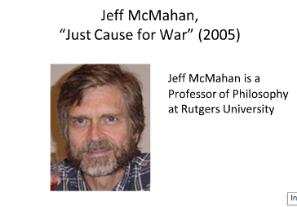

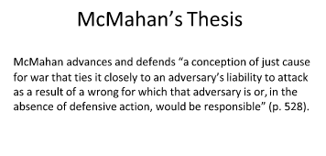

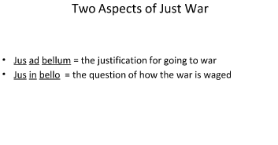

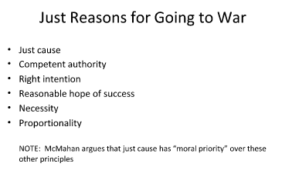

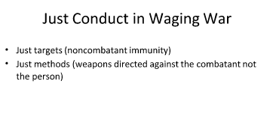

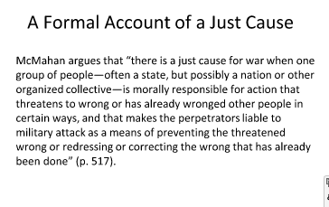

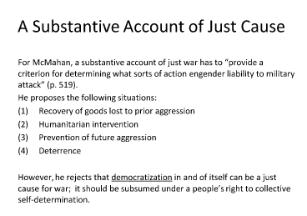

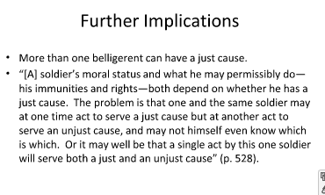

Section 12:

    - Singer: Famine, Affluence and Morality (1971)
    - In Bangladesh, people are starving, and this can be dramatically reduced through the action of rich nations and individuals.
    - Claim: the actions of relatively affluent countries cannot be justified

    - The Argument
    - “If it is in our power to prevent something bad from happening, without thereby sacrificing anything of comparable moral importance, we ought, morally, to do it”
    - Claim: if this principle were acted upon, our lives would be fundamentally changed.
    - Proximity to those in need make, no difference
    - There is no distinction between cases where I am the only one who can help, and where I am one among millions
    - With this principle, the distinction between duty and charity cannot be drawn in its traditional way
    - People who give should not be seen as generous, and those who do not receive a moral pain

    - (The Second) Objection

      - “Given the present conditions in many parts of the world… it does follow from my argument that we ought, morally, to be working full time to relieve great suffering of the sort that occurs as a result of famine or other disasters.”
      - [This makes one the tool of others, rather than an individuals with one’s own projects and goals. Singer’s approach reduces the human being to a welfare machine.]

      - Kant on Animals
      - Claim: we have no direct duties to animals
    - “Animals are not self-conscious and are there merely as a means to an end. That end is man.”
    - Example: we keep an old dog who has served us faithfully because such actions cultivate real duties towards human beings.

    - Singer: All Animals are equal
    - There are important differences between humans and other animals, and these give rise to some differences in the rights they have
    - The principle of equality does not demand identical treatment. It demands equal consideration
    - Why are Racism and Sexism Wrong
      - If the demand for equality of human beings were based on actual equality (of size, shape, intellectual capability…) we would have to stop demanding equality
      - [Is this correct? What about the capacity for moral reasoning?]
      - We cannot find racism/sexism wrong based on equality between races/genders. This makes their immorality depend on empirical evidence in the wrong way.
      - The principle of equality of human beings is not a description of an alleged actual equality- it is a prescription of how we should treat humans.
      - “Speciesism” is a prejudice towards the members of one’s own species and against members of others.
      - The capacity of suffering and enjoyment is a prerequisite for having interests
      - [Is this right? Can a plant or a nation have interests?]
      - Sentience is the only defensible boundary of concern for the interests of others
      - Humans have relevant differences given the capacity, say, for dread
      - Killing Animals
  - The morality of killing is complicated, but should not cut neatly among species lines
  - Self-awareness and intelligence may be relevant here

Famine, Affluence, and Morality

The thesis is about to what extent people are required to assists those in need. The argument is that people should help those unfortunate than them if the act of helping doesn’t have significant moral implications. The weakness is that Signer only views one side of the argument and even admits that he doesn’t care for other peoples views. He assumes that his statements are correct not matter how absurd they may seem to others.

Review Questions
- The moral implication is that the way people in affluent countries react to a situation like that in Bengal can’t be justified.
- His first moral principle is that we are required to prevent what is bad, and not what is good, and we are required to do this only when we can do it without sacrificing anything that is morally important.
- The second moral principle is that the fact that there are millions of other people in the same position, in respect to the Bengali refugees does not make the situation different from a situation different from a situation in which an individual is the only one who can prevent something bad from occurring. The two different versions are that neither the distance from a preventable evil nor the number of people who are in the same situation as others lessens their obligation to prevent an evil.
- Charity is something that is good to do, but not wrong not to do. Duty is defined as something people are bound to do if there are no significant moral implications. However, Signer later argues that helping others is neither charitable nor generous.
- Sigwick and Urmson line of argument is that there needs to be a basic moral code which is not too far beyond the capacities of the ordinary man, for otherwise there will b e a general breakdown of compliance with the moral code. Signer wonders where the line should be drawn between conduct that is required and conduct that is good although not required, so as to get the best possible results. His objection to the argument is that it takes insufficient account of the effect that oral standards can have on he decisions we make,
- The utilitarian theory s that we should be working full time to increase the balance of happiness over misery. Signer’s criticism is that we should try to prevent as much suffering as we can without sacrificing something else of comparable moral importance. The reason is that people are self-interested to some degree.
- His first conclusion is that most people are self-interested to some degree, so very few people are likely to do everything they are supposed to do. His second conclusion is that the best means of preventing famine, in the long run, is population control. His third point is about how much people should give away, and he discusses both the strong version and the moderate version. Lastly, he mentions that consumer society has a distorted effect on the goals and purposes of its members, but slowing down the economy would decrease the money given to poor countries.

Discussion Questions:
- I don’t agree, because consumer society is what allows countries to donate large amounts of money. Even if it is only on percent of the GDP the amount of money as a result of consumerism is greater than a larger amount of the GDP being donated if the economy was slowed down.
- He means that if doing something good is too costly that the actions shouldn’t be down, because to much harm results out of the deed.
- It is not a good reason, because population control takes a long time to implement. Eventually countries may start to have lower birth rates, and its not fair to let other people living now die.
- Yes, charity is something that a person does to benefit others even though it is not required. There are some people who contribute to society even though they are not required to do so, which indicates that they are picking up some of the weight of people who aren’t helping out. Duty on the other hand is an act a person is morally bound to do. Just because nobody else is helping out doesn’t mean one shouldn’t assists in a problem if the situation is drastic.
- He is not a utilitarian, because if he was he would argue that people should help others no matter how much pain and suffering it may cost them.

Sussman:
PPP Presentation
http://phil160.wordpress.com/2010/01/24/sussman-on-torture/

http://phil160.wordpress.com/2010/01/24/sussman-on-torture/

http://phil160.wordpress.com/2010/01/24/whats-wrong-with-torture/

http://www.las.illinois.edu/alumni/magazine/articles/2009/torture/

Sussman and McMahan: http://ethics.sandiego.edu/courses/Phil321/Notes%20on%20Sussman,%20Shue%20and%20MacMahan.asp

