- Quiz: multiple choice

- Look at syllabus for due dates, etc.

- Attendance in Course Labs is NOT Mandatory:
- Lab Sessions will take place in DMS 2130, 2140 and 2150
- Support Videos & Tutorials will be posted for MOST labs (from public media websites).
- When & Where possible, additional screencast videos may also be posted online.
- Check syllabus and course website for lab dates

- Technology is useful, support the processes
- Look at how processes change
- Marketing has evolved

- information technology tools to support operational, tactical and strategic level processes and decision making in an organization

- contemporary applications

- utilization and administration

- various ICTs that enable efficient data and information management, and consequently facilitate better problem solving and decision making capabilities in the organization.

- use information systems to enable the seamless flow of information between different parts of the organization as well as between the organization and its suppliers and customers

- Conducting business electronically enables new levels of efficiency, competitiveness, and profitability (i.e. strategy)

- As you read the course material think of examples of information and computing systems and how they can be used in business. Marketing, HR, Finance - how do they contribute to making the business more competitive?
- *****

- What is an Information System?

- Purpose: To provide accurate, timely and useful information

- Each element must be present and all of the elements must work together

- An Information System consists of FIVE PARTS, including:
- People,
- Procedures,
- Software,
- Hardware, and
- Data

- Info system and info technology: key definitions

- Information system (IS) = IT plus procedures, and people that produce & utilize information.

- IT = hardware + software + data
- Products
- Methods
- Inventions
- Standards

- Avoid a common mistake:
- Do not try to buy an IS; you cannot do it. That is because you cannot buy people or processes

- However you can buy IT:
- Buy or lease hardware, license programs and databases, even obtain predesigned procedures. Ultimately, people execute those procedures to employ that new IT.

- Any new system requires training tasks, overcoming employees’ resistance to change, and managing employees as they utilize new system.

- 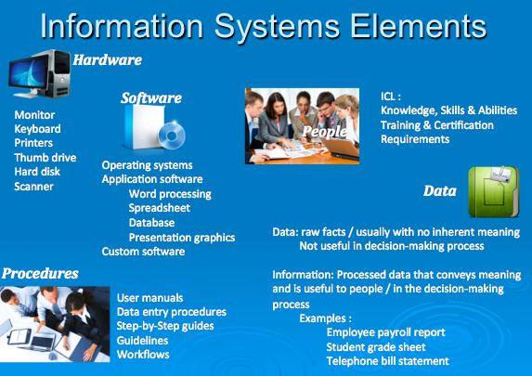

- Information system:

- Set of interrelated components

- Collect, process, store, and distribute information

- Support decision-making, coordination, and control

- Data versus Information:

- Data are streams of raw facts

- Information is data shaped into meaningful form

- Example: Raw data from a supermarket checkout counter can be processed and organized to produce meaningful information, such as the total unit sales of dish detergent or the total sales revenue from dish detergent for a specific store or sales territory.

- 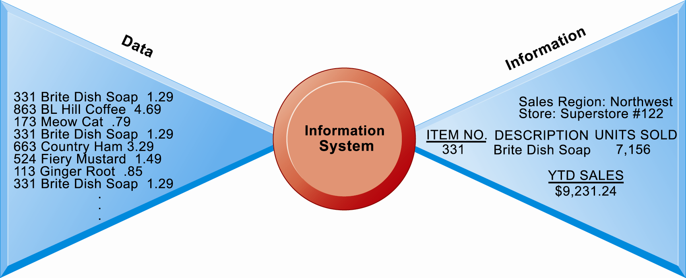

- 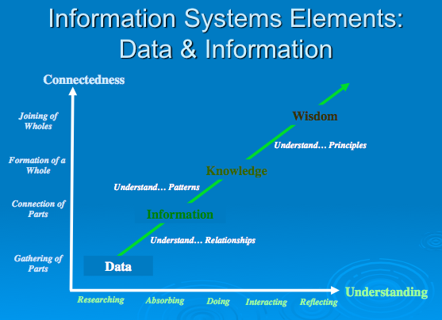
- Data: symbols

- Information: data that are processed to be useful; provides answers to "who", "what", "where", and "when" questions

- Knowledge: application of data and information; answers "how" questions

- Understanding: appreciation of "why"

- Wisdom: evaluated understanding. Apply knowledge

- Data is like puzzle pieces, they are bits

- Bundling the data by regions, prices, individual: convert from data to information that allow us to make better decisions and create strategies

- Ex: creating information systems for healthcare. Automate

- They change the processes and how the processes (what the tools do) are done. Before automating, consider the processes

- Remember: Facebook is a tool, processes are far more important
- Connecting people with strategies and processes

- Think about material from perspective of business: question how they do???

….respect to designing new applications

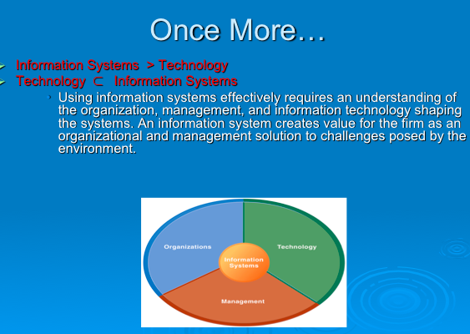

Benefits of an IS education for a management student:
- In today’s workplace, it is imperative that IS work effectively and reliably.
- IS managers DO NOT only work with the IT dept.:
- IS will be part of your job in other business functions such as Marketing, Operations, HR, Finance, Accounting etc.
- As an IS manager for your business function, you will play a vital role in the implementation and administration of technology within your divisions and for the benefit of your organization.
- You will plan, coordinate, and direct research on the computer-related activities of firms.
- You will consult with other managers, help determine the goals of an organization and then implement technology to meet those goals.
- You will coordinate with pertinent people about the technical aspects such as software development, network security, and Internet operations.

- “Information technology and business are becoming inextricably interwoven. I don't think anybody can talk meaningfully about one without the talking about the other.”
- Bill Gates
- More on the Strategic role of Information Systems in the Next Few Classes:
- Overview of Digitization & Globalization
- Introduction to Socialnomics
- Introduction to Friedman’s 10 Flatteners
- Social Computing in the Enterprise

- Three core activities of information systems:

- Input: Captures raw data from organization or external environment

- Processing: Converts raw data into meaningful form

- Output: Transfers processed information to people or activities that use it

- Advanced information systems also incorporate one additional functionality:

- Feedback:
- Output returned to appropriate members of organization to help evaluate or correct input stage

- It is important to remember that these functionalities are not limited to technologies:
- Can you think of these activities in a management context?

- Use an example similar to the one given in the previous slide to illustrate the three activities involved in the function of an information system. Continuing with that example, the process of asking students their age would represent input, calculating the average age and determining the oldest and youngest age would represent processing, and writing that information on the board would represent output.

