Chapter 19: The Cardiovascular System—Blood Vessels
- Blood vessels dynamic structures: pulsate, constrict, relax & proliferate
- Blood vessels of body form closed delivery system that begins & ends at heart
- 3 major types of blood vessels: arteries, capillaries & veins
- Heart contracts, forces blood into: arteriesarterioles (little arteries)capillariesvenules (smallest veins)veins=ultimately empty into heart
- Blood vessels in adult human, stretch about 100,000km (60,000miles)
- Arteries: carry blood away from heart (oxygenated blood)
- Veins: carry blood toward heart (oxygen-poor blood)
- Roles differ of arteries+veins in pulmonary circ. & umbilical vessels of fetus
- Only capillaries directly serve cells (intimate contact w tissue cells & directly serve cellular needs)

Structure of Blood Vessel Walls
- All blood vessels (except thinnest vessel) have 3 layers or tunics (covering); that surround central blood-containing space; the vessel lumen
- 3 vessel types vary in length, diameter, wall thickness & tissue makeup
Innermost tunic: tunica intima
- Intimate contact w blood in lumen
- Contains simple squamous epithelium that lines lumen of all vessels
- Continuous w endocrdial lining of heart & flat cells fit closely together=forms slick surface that min. friction as blood moves thru lumen
- Vessels larger than 1mm diameter, subendotherlial layer(consisting of a basement membrane & loose CT) supports endothelium
Middle tunic: tunica media
- Mostly circularly arranged smooth muscle cells & sheets of elastin
- Activity of smooth muscle regulated by sympathetic vasomotor nerve fibers (autonomic NS) & whole battery of cells
- Depends on body needs: either vasoconstriction or vasodilation occurs
- Vasoconstriction: reduction in lumen diameter as smooth muscle contracts
- Vasodilation: increase in lumen diameter as smooth muscle relax
- Role of tunica media: critical in regulating circulatory dynamics (small changes in vessels greatly impact blood flow & blood pressure
- Bulkiest layer in arteries
- Chief responsibility=maintaining blood pressure & continuous blood circulation
Outermost layer: tunica externa
- Composed largely of loosely woman collagen fibers (protect & reinforce vessel—anchor it to surrounding structures)
- Infiltrated w nerve cells, lymphatic vessels & network of elastin fibers
- Larger vessels: contain system of tiny blood vessels (vasa vasorum; vessels of vessels) that nourish external tissues of blood vessel wall
- Innermost portion of vessel get nutrients directly from blood in lumen

Arterial System
- Divided into 3 groups: elastic, muscular & arterioles
Elastic (conducting) Arteries
- Thick-walled arteries near heart (aorta & branches)
- Largest in diameter (2.5cm to 1cm) & most elastic
- Their large lumens make em low-resistance pathways conduct blood from heart to medium-sized arteries
- Present in all 3 tunics; most elastin than any other vessel
- Smooth muscleinactive in vasoconstriction; function: visualized as simple elastic tubes
- Pressure reservoirs, expanding & recoiling as blood is ejectedheart
- Arteriosclerosis: vessels become hard & unyielding
- Highest proportion of elastin smooth out pressure fluctuations
- w/o pressure-smoothing effect; walls of arteries experience higher pressures; becoming weak & may balloon out or burst
- recoil helps maintain pressure & blood flow
Muscular (disturbing) Arteries
- Deliver blood to specific organs
- Range from 0.3mm to 1cm
- Thickest tunica media; contains more smooth muscle, less elastic tissue than elastic arteries
- Consequence? More active in vasoconstriction & less distensible
- There is elastic lamina on each face of tunica media
Arterioles
  - Smallest arteries
  - 10um to 0.3mm
  - Large arterioles have all 3 layers; but tunica media primarily smooth muscle w few elastic fibers
  - Arterioles determine which capillary beds flushed
  - Minute to minute blood flow into capillary beds determined by arteriole diameter (varies in response to nural, hormonal & chemical influences)
  - Arteriole constricttissues served are largely bypassed
  - Arterioles dilateblood flow into local capillaries increase dramatically

Capillaries
- Smallest blood vessels
- Walls only consist of thin tunica intima
- Spider-shaped pericytes (smooth-muscle type cells)—stabilize the capillary wall & help control capillary permeability
- Length: 1mm. Avg lumen diameter: 8-10 um (large enuf for RBC slip thru single file)
- Provide direct access to nearly every cell in body
- Function: exchange of materials (gases, nutrients, hormones, etc.) b/w blood & interstitial fluid
- Three types: continuous, fenestrated & sinusoidal
Continuous capillaries
- Abundant in skin & muscles
- Continuous in sense that endothelial cells prove uninterrupted lining
- Adjacent cells being joined laterally by tight junctions
- Junctions are incomplete & leave gaps of un-joined membranes = intercellular clefts; allow limited passage of fluids & small solutes
- Brain capillaries are diff.; tight junctions; complete & extend
Fenestrated capillaries
- Similar to continuous variety; but some endothelial cells are ridded w pores or fenestrations (=window)
- These fenestrations usually covered by delicate membrane & diaphragm
- More permeable to fluids & small solutes than continuous
- Found wherever active capillary absorption or filtrate formation occurs
- Small intestine (receive nutrients from digested food); endocrine organs (allow hormones rapid entry into blood); kidney (w perpetually open pores; rapid filtration of blood plasma is MUST)
Sinusoids or sinusoidal capillaries
- Highly modified; leaky capillaries found only in liver, bone marrow, spleen; lymphoid tissues, adrenal medulla; endocrine organs)
- Large, irregularly shaped lumens & usually fenestrated
- Endothelial lining has fewer tight junctions & larger intercellular clefts than normal; for passage of proteins & RBCS
- Structural adaptations let large molecules & blood cells to pass b.w blood & surrounding tissues
- Liver: endothelium is discontinuous & lining includes large hepatic macrophages; remove & destroy any contained bacteria
- Other organs (spleen); phagocytes located outside the sinusoids stick cytoplasmic extensions thru the intercellular clefts into sinusoidal lumen to get at their “prey”
- Blood flows sluggishly thru sinusoid channels—allowing time for it to be modified in various ways
Capillary Beds
- Capillaries do not function independently—form interweaving networks=capillary beds
- Microcirculation: flow of blood from arteriole to venule thru a capillary bed
- Consist of two types of vessels: vascular shunt & true capillaries
- Vascular shunt = metarteriole + thoroughfare channel; short vessel directly connects to arteriole & venule at opp. Ends of bed.
- True capillaries: actual exchange vessels (10-100 per bed; depending on organ), branch off the metarteriole (proximal end of shunt) & return to thoroughfare channel (distant ends); sometimes spring from terminal arteriole & empty directly into venule
- Terminal arteriole feeding the bed leads into metarteriole (vessel structurally intermediate b/w arteriole & capillary), continuous w thoroughfare channel (intermediate b/w capillary & venule); this joins post capillary venule that drains bed
- Precapillary sphincter: cuff of smooth muscle fibers; surrounds root of each true capillary at metarteriole & acts as valve to regulate blood flow
- Blood flow thru terminal arteriole may go either thru true capillaries or shunt
- When sphincter is relaxed(open); blood flows thru true & exchanges w tissue cells
- When contracted(closed); blood flow thru the shunts & bypasses tissue cells
- Relative amount of blood entering cap. Bed is regulated by local chemical conditions, arteriolar vasomotor nerve fibers
- Bed may be flooded w blood or almost bypassed depending on conditions in body or specific organs
- When relaxed; blood flows freely thru true cap of gastrointestinal organs—b/w meals; most of these pathways are closed
- Exercising vigorously blood rerouted from digestive organs (food or no food) to cap. Beds of your skeletal muscles where it is more immediately needed—helps explain why vigorous exercise right after a meal can cause indigestion & abdominal cramps

Venous System
- Blood carried from cap. Beds toward heart by veins
- Along the route; diameter of successive venous vessel increases & wall gradually thicken as they progress from venules to larger & larger veins
Venules
- 8-100 um diameter
- Formed when capillaries unite
- Smallest venules; post-capillary venules = consist entirely of endothelium around which pericytes congregate
- Extremely porous (more like cap. Than veins in this way)
- Larger venules have one or two layers of smooth muscle cells (scanty tunica media) & thin tunica adventitia (externa)
- Fluid & WBCs move easily from bloodstream thru their walls
- Well recognized sign of an inflamed area is adhesion of WBCs to post-cap venule endothelium—followed by migration thru wall into inflamed tissue
Veins
- Venules join to veins
- Have three distinct tunics; but walls thinner & larger lumens than corresponding arteries
- Little smooth muscle or elastin in tunica media; poorly developed & tends to be thin in largest veins as well
- Tunica externa; heaviest wall layer—Consists of thick longitudinal bundles of collagen fibers & elastic networks (often several times thicker than tunica media)
- Larger veins-the venae cavae (return blood directly to the heart)-tunica externa if further thickened by longitudinal bands of smooth M
- W large lumens & thin walls; can accommodate fairly large blood vol.
- Veins called capacitance vessels & blood reservoirs b/c up to 65% of body blood supply is found in veins at any time; even tho they are partially filled
- No danger of bursting walls even tho thinner since pressure is low
- Low pressure conditions demands adaptations to ensure blood is returned to heart at same rate it was pumped into circulation
- Two structural adaptations of veins: large diameter lumens (offer relatively little resistance to blood flow) AND valves that prevent blood from flowing backwards
- Venous valves are formed from folds of tunica intima & resemble the semilunar valves of heart in function & structure; most abundant in veins of limbs where upward flow of blood is opposed by gravity; absent in veins of thoracic & abdominal body cavities
- Varicose veins are veins that become tortuous & dilated b/c of incompetent (leaky) valves; more than 15% of adults suffer from this, usually in lower limbs; factors contributing = heredity, conditions that hinder venous return (prolonged standing in one position, obesity or pregnancy)
- Pop belly & enlarged uterus of a pregnant women exert downward pressure on vessels of groin, restricting return of blood to heart = blood pools in lower limb; valves weaken & venous walls stretch & become floppy
- Another cause—elevated venous pressure (delivery of baby, bowel movement raises intra-abdominal pressure; preventing blood from draining from veins of anal canal = resulting in hemorrhoids
- Venous sinuses are highly specialized; flattened veins w extremely thin walls composed only of endothelium; supported by tissues
- Dural venous sinuses—receive cerebrospinal fluid & blood draining from brain; reinforced by tough dura mater that covers brain surface
RECAP
- Heart = pump; arteries = pressure reservoirs & conduits; arterioles = resistance vessels that control distribution; capillaries = exchange sites; veins = conduits & blood reservoirs

Physiology of Circulation: Intro to Blood Flow, Pressure & Resistance
- Blood flow: vol. of blood flowing through vessel, organ or entire circulation in a given period (ml/min). Blood flow same as cardiac output & under resting conditions = constant. @ any given moment; blood flow thru individual body organs may vary widely and is intimately related to their immediate needs. Blood flow = difference in blood pressure
peripheral resistance
- Blood pressure: force per unit area excreted on vessel wall by contained blood; is expressed in millimeters of mercury (mm Hg). 120mm Hg = 120 mm high. Term blood pressure means systemic arterial blood pressure in largest arteries near the heat. Pressure gradient—differences in blood pressure w/in vascular system that provides driving force that keeps blood moving; always from an area of higher pressure to lower (throughout body)
- Resistance: opposition to flow & is a measure of amount of friction blood encounters as passing thru vessels. B/c most friction is encountered in peripheral circulation (away from heart) = peripheral resistance. major determinant of blood flow because a change in blood vessel radius increases resistance to the 4th power
  - 3 imp. sources of resistance
  - Blood viscosity: internal resistance to flow that exists in all fluids; related to thickness or stickiness of fluid. ↑ viscosity, less easily molecules slide past eachother & more difficult to get & keep fluid moving—increase more RBCs. Less RBCs; peripheral resistance declines
  - Total blood vessel length: longer the vessel, greater the resistance. Older you grow; peripheral resistance & blood pressure increases
  - Blood vessel diameter: frequent changes. Laminar flow: tube of a given size, relative speed & position of fluid in diff. regions of the tube’s cross section remain constant. Can be regulated; fluid not touching walls moves faster
Velocity of Blood Flow
velocity ~ 1/total cross-sectional area
• aorta: (2.5 cm²): 40-50 cm/sec
• capillaries: (4500 cm²): ~0.03 cm/sec
• vena cava: (8 cm²): 10-30 cm/sec
When blood pressure increases, blood flow speeds up. When peripheral resistance increases, blood flow decreases. R is more imp than P in influencing local blod flow because altering blood vessel diameter can easily change R. F = P/R

Systemic Blood Pressure
- Blood flows thru blood vessels along pressure gradient, always moving from higher to lower pressure areas
- Fundamentally; pumping action of the heart generates blood flow; pressure results when flow is opposed by resistance
- Systemic blood pressure highest in aorta & declines throughout pathway finally reaching 0 mm Hg in arterioles, which offers greatest resistance to blood flow
- Long as pressure gradient exists; no matter how small, blond continues to flow until it completes the circuit back to the heart
Arterial Blood Pressure
- Reflects two factors—how much elastic arteries close to heart can be stretched & vol. of blood forced into them at any time
- If amount blood entering & leaving elastic arteries r equal = constant
- BUT instead blood pressure rises & falls in elastic arteries = pulsatile
- Left ventricle contracts & expels blood into aortaimparts kinetic energy to bloodstretches elastic aorta as aortic pressure hits peak
- Pressure peak = systolic pressure; averages 120mm Hg healthy
- Blood moves forward into arterial bed b/c pressure in aorta higher than pressure in the more distal vessels
- During diastole; aortic valve closes; preventing blood from flowing back into heart & walls of aorta (&other elastic arteries) recoil
- Maintaining pressure to keep blood moving forward = aortic pressure drops lowest (70mm to 80mm healthy) = diastolic pressure
- Vol. & energy of blood in elastic arteries; systole; given back; diastole
- Difference b/w systolic & diastolic pressures = pulse pressure; indicates vigor of contraction of ventricle & provides info elasticity of aorta & major arteries; ↑ by arteriosclerosis b/c elastic less stretchy
- Mean arterial pressure (MAP); pressure pushes the blood to tissues
- Diastole lasts longer than systole, that’s why MAP is not highway
- MAP = diastolic pressure & 1/3 of pulse pressure
- Person w systolic blood pressure; 120 & diastolic; 80—MAP = 80 mm Hg + 40mm Hg/3 = 93 mm Hg
- MAP & pulse pressure decrease with distance from heart; by end of arterial tree, blood flow is steady & pulse pressure has disappeared
Capillary Blood Pressure
- By the time blood reaches cap. Blood pressure has dropped to 35mm Hg and by end of cap beds will only be around 15 mm Hg
- Low cap. Pressures are desirable b/c cap. Are fragile & high pressures would rupture them & most cap are extremely permeable; thus even low cap. Pressure forces solute-containing fluids (filtrate) out of bloodstream into interstitial space; imp for refreshing interstitial fluid
Venous Blood Pressure
- Steady & changes very little during the cardiac cycle
- Pressure gradient: 15mm Hg –on slide says 20mm Hg
- Venous pressure is normally too low to promote adequate venous return
- Respiratory “pump”: pressure changes in ventral body cavity during breathing create resp. pump that moves blood up toward the heart. Inhale, abdominal pressure increases, squeezing local veins & forcing blood toward the heart. Same time, pressure in the chest decreases—allowing thoracic veins to expand & speeding blood entry into right atrium
- Second & most imp. muscular “pump”: consist of skeletal muscle activity; surrounding deep veins contract & relax—they ‘milk’ blood toward hear & once blood passes each valve, cannot flow back.
- Swollen ankles; since blood pools in feet & legs during prolonged periods of skeletal muscle inactivity (standing jobs; hairdresser)
- 3rd: layer of smooth muscle around veins that constricts under sympathetic control, increase venous return-increases cardiac output

Maintaining Blood Pressure
- Steady blood pressure vital for heart to the toe organs to function properly
- Homeostatic mechanisms in place to maintain adequate flow to tissues under a variety of circumstances
- Main factors influencing blood pressure are: cardiac output, peripheral resistance, blood volume
- Blood pressure = cardiac output x peripheral resistance
- Threatened blood pressure by a change in one, homeostasis quickly compensates for by changing other variables
- What determines CO?? HR (neural & hormonal factors), SV (venous return, neural & hormonal factors)CO = stroke vol. x heart rate (norm CO=5-5.5L/min)
- Cardio-inhibitory center in medulla is “in charge” of heart rate most of the time; via parasympathetic vagus nerves; maintains resting heart rate
- Resting = stroke vol. controlled by venous return. Stress = cardio-acceleratory center takes over by activating sympathetic NS & increasing heart rate (acting on SA node) & stroke vol. (enhancing cardiac muscle contractility; decreases end systolic vol.)
- Enhanced CO = increase in MAP
Short-term Mechanisms: Neural Controls
- Mediated by NS & bloodborne chemicals, counteract moment to moment fluctuations in BP by altering peripheral resistance +CO
- Neural controls of peripheral directed at two main goals
- Maintaining adequate MAP by altering blood vessel diameter (small changes in blood vessel dia.); low blood vol. = all vessels except those supplying heart & brain are constricted to allow as much blood to flow to those two vital organs AND altering blood distribution to respond to specific demands of various organs (exercise = blood shunted temp. from digestive organs to skeletal muscles): slide alter blood distribution to respond to specific demands AND maintain adequate MAP by altering blood vessel diameter
- Most neural controls operate via reflex arcs involving baroreceptors & associated afferent fibers; vasomotor center of medulla, vasomotor fibers, vascular smooth muscle—sometimes input from chemoreceptors & higher brain centers also influence neural control mechanisms; usually reflex arcs involving baroreceptors, vasomotor centre of medulla, vascular smooth muscle
Role of Vasomotor Center is the neural center that oversees changes in the diameter or blood vessels, a cluster of neurons in the medulla. Part of cardiovascular center; that integrates BP control by altering cardiac output & blood vessel diameter. It transmits impulses at steady rate along sympathetic efferent (vasomotor fibers)—exit from T1 thru L2innervate smooth muscle of blood vesselsesp arterioles. Vasomotor tone: arterioles are almost always in a state of moderate constriction. Any increase in symp ns activity » generalized vasoconstriction & rise in BP; decrease has reverse effect. Vasomotor centre responds to input from:
(i) baroreceptors (pressure sensitive mechanoreceptors that respond to changes in arterial pressure & stretch)
(ii) chemoreceptors (respond to change in blood levels in CO₂, O₂, H⁺)
(iii) higher brain centres or hormones
Baroreceptor-Initiated Reflexes: when arterial BP rises, stretches baroreceptors. Located in carotid sinuses(dilationsprovide maj. blood supply to brain), aortic arch & other large arteries of neck n thorax. Barorecpetors = stretched, rapid steam impulses to vasomotorinhibits vasomotor center = vasodilation of not only arteries, but VEINS, decrease BP.
increasing MAP stretches receptors; response (via vasomotor centre) is:
dilation of arterioles, venodilation to shift blood to venous reservoirs, afferents also to cardiac centres to stimulate parasymp ns & inhibit symp ns; thereby decreasing heart rate & contractile force –decreasing MAP initiates reflex vasoconstriction.
GOAL: protect against short-term changes in bp (standing, bending); ineffective chronically (body adapts)
Chemoreceptor-Initiated Reflexes: rise in CO2 or drop in O2/pH; chemoreceptors in aortic arch & large arteries of neck to vasomotor centerreflex vasoconstriction. Result: rise in BP that speeds return of bloodheart & lungs.
Influence of Higher Brain Centres: regulate BP integrated->medulla oblongata of brain stem. Cerebral cortex & hypothalamus not involved in routine controls of BP; can modify arterial pressure via relays to medullary centers. “fight or flight”, stress, anxious, exercise = cerebral cortex & hypothalamus get involved.
Short-Term Mechanisms: Hormonal Controls
- Hormones help regulate BP; short-term(peripheral resistance)&long-term(blood vol.)
- Paracrine (local chemicals) serve to match amount of blood flow to metablic need of particular tissue; rare: massive release of paracrine=impact BP
- Adrenal medulla hormones
  - Norepinephrine & epinephrine; enhance fight/flight
  - NE; vasoconstrictive action
  - E; increases CO + vasoconstriction (except skeletal/cardiac muscle »» vasodilation)
  - Nicotine mimics effects of catecholamine; causes intense vasoconstriction (sympathetic neurons but also release NE and E)
- Angiotensin II
  - BP/blood vol. low = release hormone reninkidneys
  - Release of renin: intense vasoconstriction to increase systemic BP; release of aldosterone; ADH
- Atrial natriuretic peptide (ANP)
  - Produced by atria of heart = ANP hormone (atrial natriuretic peptide)
  - Causes blood vol. & BP to decrease
  - Produces kidney to excrete more sodium & waterblood vol. drop
  - Generalized vasodilation
- Antidiuretic Hormone (ADH)
  - Produced by hypothalamus (antidiuretic hormone or vasopressin)
  - Stimulates kidney to conserve water
  - Not imp for short-term BP but when BP falls too low (severe hemorrhage)more ADH released & helps restore arterial pressure; causing intense vasoconstriction
Long-Term Mechanisms: Renal Regulation
- Counteract fluctuations in BP not by altering peripheral resistance (short-term) but by altering blood vol. (kidney does this)
- Baroreceptors adapt to prolonged/chronic high & low BPkidney steps in
- Blood vol. usually maintains close to 5L (varies w age/body size/sex/renal)
- Anything that changes blood vol. changes BP
- Blood vol increased; tells kidney to eliminate waterdecrease blood vol &BP
- Falling blood vol. triggers renal mechanisms that increase blood vol & BP
- Direct (renal mech.) Action: increased blood volume/pressure = increased rate of filtrate formation → insufficient time to reclaim water → increased volume of urine
- Indirect (renal mech.) Action: renin-angiotensin system - MAP decreases → kidney cells release renin → reactions to produce angiotensin II (potent vasoconstrictor; ↑BP ↑peripheral resistance) → increased rate of renal absorption angiotensin II stimulates secretion of aldosterone (adrenal cortex) → increases renal absorption of Na⁺ & water also increased secretion of ADH (post pituitary) promotes water reabsorption
Monitoring Circulatory Efficiency
- Vital signs: taking measurements of resp. rate/body temp/BP/pulse
- Pulse: alternating expansion & recoil of arteries during each cardiac cycle allow us to feel a pressure wave; transmitted thru arterial tree
- How do you take a pulse? Push surface artery against firm tissue (usually use radial pulse)
- Also called pressure points b/c they are compressed to stop blood flow into distal tissues during hemorrhage
- Healthy man; 66 beats/min laying down; 70 sits up; 80 suddenly stands; vigorous exercise/emotional upset 140-180 (not unusual)
- Measuring Blood Pressure? Usually using auscultatory method: brachial artery using sphygmomanometer
- Cuff fully inflated (artery fully collapsed »» no flow
- Systolic pressure: pressure read when first soft tapping sounds are heard (first point at which a small amount of blood is spurting thru constricted artery); record cuff pressure as systolic (110-140mm Hg)
- Sounds of korotkoff? Cuff pressure is reduced further, these sounds, become louder & more distinct; when artery no longer constricted; blood free; no sounds
- Diastolic pressure: Pressure when the sounds disappear (70-80 mm Hg)
- BP cycles 24h, peaks morning (response to levels of various hormones)
- Influenced: age, gender, weight, race, stress, nutrition, mood, posture, fitness

Blood Flow thru Body Tissues: Tissue Perfusion
- Involved in; delivery of O2 & nutrients’ removal of wastes from tissue cells, gas exchange in lungs, absorption of nutrients frm digestive tract, urine formation in kidney
- Blood flow to each organ right amount for prper function (nomore/noless)
- Rest: brain 13% blood flow, heart 4%, kidney 20%; organs 24%; skeletal muscle 20%(which make up half of body mass)
- Exercise all cardiac output flushes into skeletal muscle & bloodreduced in digestive organs & kidney
Velocity of Blood Flow
- Speed of blood flow changes thru systemic circulation
- Fastest in aorta & other large arteries; slowest capillaries; speeds up in veins
Autoregulation: Local Regulation of Blood Flow
- Process regulated by local conditions & largely independent of systemic factors; MAP same everywhere in body & homeostasis adjust cardiac output to maintain constant pressure
- Changes in blood flow thru individual organs controlled by intrinsically; modifying diameter of local arterioles feeding cap.
- Organs regulate their own blood flow by varying resistance of arterioles
Metabolic Controls
- Declining tissue levels of oxygen
- ↑ levels of CO₂, adenosine, H⁺, K⁺, heat, inflammatory chemicals
- End result: immediate increased perfusion of “needy” tissues
- Inflammatory chemicals (histamine, kinins & prostaglandins) released in injury infection, allergic reactions = vasodilation
- Inflammatory vasodilation helps defense mech. Clear microorganisms & toxins; promotes healing
Myogenic Controls
- Fluctuations in systemic BP cause problems if not for myogenic responses
- Vascular smooth muscle responds to increased stretch with increased tone »» stretch is resisted »» vasoconstriction
- Decreased stretch results in vasodilation
- Vascular smooth muscle responds to increased stretch with increased tone »» stretch is resisted »» vasoconstriction
- result: tissue perfusion homeostasis so cells not deprived/capillaries not damaged
active vs reactive hyperemia – what is the difference between these two? Reactive: refers to dramatically increased blood flow into tissue that occurs after the blood supply to the area has been temp. blocked; results both from the myogenic response & from an accumulation of metabolic wastes in area during occlusion. Active: when muscles become active, blood flow increases (hyperemia) in direct proportion to their greater metabolic activity.
Long-Term Autoregulation
- Nutrient requirements of tissue greater than short-term autoregulatory mech. Can easily supply (long-term develops over weeks or months to enrich local blood flow still more)
- # of blood vessels in region increases & existing vessels inlarge
- Angiogenesis: uncommon in heart when coronary vessel is partially occluded; occurs thru/out body in ppl who live in high altitudes; air contains less O2
Blood Flow thru Capillaries & Capillary Dynamics
- Blood flow thru cap networks is slow & intermittent
- Vasomotion: reflects on/off opening & closing of precapillary sphincters in response to local autoregulatory controls (contraction and relaxation of precapillary sphincter → sporadic flow through each capillary
- precapillary sphincter: cuff of smooth muscle at beginning of capillary; capillary walls themselves have no smooth muscle
Capillary Exchange of Resp Gases & Nutrients
- O2, CO2, nutrients, wastes pass b/w blood & interstitial fluid by diffusion
- Diffusion—occurs along concentration gradient; high to lower concentration
- O2 & nurtients; pass blood from high concentration to interstitial fluid to tissue cells; CO2 & wastes; leave cells where content is higher & diffuse into capillary blood
General
- Most cap cells in body w/in 0.02mm of a cap diffusion works
- Cap walls only 1 cell thick: mix of diffusional, osmotic & hydrostatic force
Bulk Flow
- While nutrient & gas exchanges occurring across cap walls by diffusion = bulk flow also going on
- Fluid forced out of cap thru clefts at arterial end of bed; most of it returns to bloodstreams at venous end
- Unimportant to cap exchange; bulk flow is extremely imp. in determining relative fluid volumes in bloodstream & interstitial space (app. 20L fluid filtered out of cap each day b/4 returned to blood; almost 7x plasma vol.)
HP=Hydrostatic Pressures(pushes): force excreted by fluid pressing against wall; cap hydrostatic pressure tends to force fluids thru cap walls (filtration), leaving behind cells & most proteins. BP drops as blood flows thru cap bed; HPc is higher at arterial end of bed than venous end. HPif = interstitial fluid hydrostatic pressure; acting outside cap; pushing fluid in.
OP=Colloid Osmotic Pressure(sucks): force opposing hydrostatic pressure, is created by presence in a fluid of large non-diffusible molecules (plasma proteins; unable to cross cap wall). Not does vary on one side than other of capillary bed.
NFP=Hydrostatic-Osmotic Pressure Interactions: determine whether there is net gain or net loss of fluid from blood; calculate net filtration pressure; NFP). Fluids leave cap if net HP is greater than OP, fluids enter if OP exceeds HP. SEE DIAGRAM 4 CAL.
Negative pressure value = NFP(due to net excess of OP) is forcing fluid into cap bed (reabsorption). Result = net fluid flow is out circulation at arterial ends of cap beds & into circulation at venous ends. More fluid enters than returned to blood (net loss of 1.5ml/min)
(i) increased arteriole pressure means increased filtration pressure = more fluid loss to tissues (edema); liver disease also edema (why??)
(ii) hemmorhage favours reabsorption
overall deficit of 1-2 mm Hg some fluid (3-4 ml/min) lost to tissues - returned by lymphatic system

Circulatory Pathways: Blood Vessels of the Body
Two Main Circulations of Body
- Pulmonary circulation: short loops; runs from heart to lungs; back to heart
- Systemic circulation: routes blood thru long loop to all parts of body b4 returning to heart
Systemic Arteries & Veins: Differences in pathways & courses
- Blood delivered to heart 2 terminal systemic veins; superior & inferior venae cavae; exception = blood draining from myocardium of heart
- Arteries run deep while veins are both deep & superficial
- Venous pathways are more interconnected = difficult to follow
- Brain & digestive systems have unique venous drainage systems; venous blood draining from brain enters large dural venous sinuses rather than local veins; blood draining from digestive organs enters a special subcirculation, hepatic portal system & perfuses thru liver before it reenters the general systemic circulation
Principal Vessels of Systemic Circulation
Pulmonary Circulation
- Functions: only bring blood into close contact w alveoli (air sacs) of lungs so gases can exchange does not directly serve metabolic needs of body tissues

Chapter 20: The Lymphatic System & Lymphoid Organs and Tissues
- If lymphoid organs and tissues failedcardiovascular system would stop working & immune system would be hopelessly impaired
- Consists of three parts: lymphatic vessels, lymph, lymph nodes

Lymphatic Vessels
- Hydrostatic & colloid osmotic pressures operating at capillary beds force fluid out of the blood at the arterial ends of the bedupstream & cause most of it to be reabsorbed at venous endsdownstream
- Up to 3L of “leaked” fluid plus plasma proteins returned to circulatory sysm
- Lymphatic vessels must make sure that cardiovascular system has sufficient blood vol. to operate properly
- Elaborate system of drainage vessels that collect the excess protein-containing interstitial fluid & return it to blood stream; once fluid enters the lymphatic called lymph
- Lymphatic tissues/organs: essential in body defense/resistance to disease
Distribution and Structure of Lymphatic Vessels
- Vessels form a one way system in which lymph flowsheart
- Transport system begins in microscopic blind-ended lymphatic capillaries (lacteals)
- Lymphatic collecting vessels have same 3 tunics as veins, but are thinner-walled, more valves, more anastomoses
- Capillaries weave b/w tissue cells & blood cap in loose CT of body
- Permeable lymphatic cap; absent from bones, teeth, bone marrow, CNS
- Lacteals: highly specialized lymphatic cap; present in the fingerlike villi of the intestinal mucosa
- Fluid pressure interstitial space greater than pressure in lymphatic cap; minivalve flaps gape open, allowing fluid to enter = pressure greater inside lymphatic cap, endothelial minivave flaps forced closed, preventing lymph from leaking back out as pressure moves along side vessel
- Fatty lymph: chyle (draining from digestive viscera is milky white since lacteals play major role in absorbing digested fats from intestine); also delivered to blood via lymphatic stream
- Lymphatic truck: formed by union of largest collecting vessels & drain fairly large areas of the body (paired lumbar, bronchomediastinal, subclavian & jugular trunks; single intestinal trunk)
- Right lymphatic duct: drains lymph from right upper limb and the right side of head & thorax
- Much larger, thoracic duct: receives lymph from rest of body (lower limbs, intestinal thorax, upper limb/head
- Inflamed? Related vessels of vasa vasorum become congested w blood. Result = pathway associated w superficial lymphatic become visible thru skin as red lines & tender to touch
Lymph Transport
- Lacks organ that works as a pump; same return aids as for veins
- Normal conditions: low pressure conduits
- Same mechanism that promote venous return in blood vessels act heremilking action of active skeletal muscles, pressure changes in the thorax during breathing, valves prevent black flow
- Lymph is sporadic & slow; 3L lymph ends every 24h
- When physical activity increases; lymph flows more rapidly (balancing greater rate of fluid loss from blood in such situations)
- Good idea to immobilize a badly infected body part to hinder flow of inflammatory material from that region
- Anything that prevents return of lymph to bloodblockage (tumors, removal of lymphatic during cancer surgery) results in short term but several localized edema (lymphedema); eventually reestablished by regrowth
Summary
- Lymphatic vessels: functions:
  - Return excess tissue fluid to bloodstream
  - Return leaked proteins to blood
  - Carry absorbed fat from intestine to blood (thru lacteals)

Lymphoid Cells and Tissues
Lymphoid Cells
- Fight infectious microorganisms that have penetrated epithelial layer and are starting to proliferate in underlying loose CT
- Lymphocytes: main warriors of immune system, arise in red bone marrow
- T lymphocytes (T-cells) or B-cells; protect body against antigens
- T-cells: manage immune response; some of them directly attack or kill infected cells
- B-cells: protect body by producing plasma cells, daughter cells that secrete antibodies into blood (or other body fluids); antibodies mark antigens to kill
- Macrophages: crucial role in body protection; immune response by phagocytizing foreign substances and by helping activate T-cells
- Dendritic cells: capture antigens & bring back to lymph nodes
Lymphoid Tissue
- Houses & provides a proliferation site for lymphocytes, furnishes an ideal surveillance vantage point for lymphocytes & macrophages
- Composed largely of loose CT called reticular CT; dominates all lymphoid organs except thalamus
- Macrophages live on fibers of reticular network
- The cycling of lymphocytes b/w circulatory vessels, lymphoid tissues & loose CT ensure lymphocytes reach infected/damaged sites quickly
- Lymphocytes make temporary stopovers in between patrolling body

Lymph Nodes
- Clustered along lymphatic vessels; larger clusters where lymphatic vessels converge (inguinal, axillary, cervical regions)
- Filter lymph (macrophages help remove & destroy microorganisms)
- Activate immune system
- Lymph nodes/other lymphoid organs located sites where lymphocytes encounter antigens and are activated to mount an attack against them
Structure of a Lymph Node
- Vary in shape & size; most bean shaped & less than 2.5cm long(1inch)
- Each nose surrounded by dense fibrous capsule from which CT strands (trabeculae) extend inward to divide node into a number of compartments
- Node’s internal framework, or stroma of reticular fiber physically supports ever-changing population of lymphocytes
- Cortex: follicles w germinal centres; heavy diving B-cells—T-cells circulate continuously b/w blood, lymph nodes, lymph; performing surveillance role
- Medulla: medullary cords & large lymph sinuses
- Medullary cords(thin inward extensions from cortical lymphoid tissue & contains both types of lymphocytes + plasma cells) & throughout node = large lymph sinuses (large lymph cap spanned by crisscrossing reticular fibers)
- Some of the lymph-borne antigens in percolating lymph leak into surrounding lymphoid tissue, where they activate lymphocytes to mount attack against them
Circulation in the Lymph Nodes
- Lymph enters convex side of lymph node thru afferent lymphatic vesselssubcaosular sinus(bag-like)into # of smaller sinuses that cut thru cortex & enter medulla; exits node at hilum (intended region on concave side via efferent lymphatic vessels)
- What is the significance of fewer efferent compared to afferent lymphatic vessels? So the flow of lymph thru the node stagnates somewhat, allowing time for lymphocytes and macrophages to carry out their protective functions
- Lymph passes thru several nodes before cleansed & one way flow of traffic
- Lymph nodes overwhelmed by antigens; large#of bacteria trapped in nodes= inflamed/swollen/tender to touch; condition= erroneously/swollen “glands”; infected nodes = buboes (obv symptom of bubonic plague/black death)

Other Lymphoid Organs
- Like lymph nodes; all spleen, tonsils, peyer’s patches of intestine are composed of reticular CT; except thymus
- All protect; only lymph nodes filter lymph; other lymphoid organs & tissue have efferent lymphatic draining them; lack afferent lymphatic
Spleen
- Size of fist/largest lymphoid organ; left side of abdominal cavity; beneath diaphragm; curled up anterior aspect to stomach
- Site for lymphocyte proliferation; immune surveillance & response
- Blood cleansing; extracting aged/defective/platelets; macrophages remove debris & foreign matter from blood
- Stores RBCs products (iron) for recycling
- RBC production in fetus (ceases after birth)
- Stores blood platelets
- White pulp: areas composed mostly of lymphocytes suspended on reticular fibers (immunity)
- Red pulp: essentially all remaining splenic tissue, that is, venous sinuses & splenic cords—regions of reticular CT exceptionally rich in macrophages (most concerned w disposing of worn-out RBCs & bloodborne pathogens)
- Capsule is thin; consequences? Direct blow or severe infection may cause; rupture, spilling blood into peritoneal cavity. Removal of ruptured spleen (procedure=splenectomy) was standard treatment. Now, if left alone often repairs itself
- If spleen removed; liver & bone marrow take over most functions; kids younger than 12; spleen regenerate if small part left in body
Thymus
- Imp functions primarily during early years of life
- Found inferior neck & extends into superior thorax
- Site where T0cells precursors mature = immunocompetence lymphocytes
- Other words; thymus is where T-cells become able to defend us against specific pathogens in immune response
- Prominent in newborns; increase size during childhood; then starts to atrophy; old age its replaced w entirely fibrous & fatty tissue
- Most thymus cells are lymphocytes; lacks B-cells (no follicles)
- Thymic (hassall’s) corpuscle involved in T-cell development = imp for preventing autoimmune responses
- Two ways different from other lymphoid organs
  - T lymphocyte maturation; thus does not directly fight antigens (blood-thymus barrier keeps antigens leaking into cortical regions; prevent premature activation of immature lymphocytes)
  - Stroma consists of epithelial cells (secrete thymosin & thymopoietin ) instead reticular fibers; provide physical & chemical environment in which T-cells can become immunocompetent
Tonsils
- Simplest lymphoid organ; form ring of lymphatic tissue; entrance to pharynx
- Palatine tonsils: located on either side of posterior end of oral cavity; largest tonsils; ones most often infected
- Lingual Tonsils: lumpy collection of lymphoid follicles @ base of tongue
- Pharyngeal tonsils (adenoids; if enlarged): in posterior wall of nasopharynx
- Tiny Tubal tonsils: surround openings of auditory tubes into pharynx
- Tonsils gather & remove many pathogens entering pharynx in food/air
Aggregates of Lymphoid Follicles
- Peyer’s patches (aggregated lymphoid nodules); lymph nodule clusters
- Appendix: lymph nodules forming offshoot of cecum
- Destroy bacteria; generate memory lymphocytes
- MALT = peyer’s patches + appendix + tonsils + nodules in walls of bronchi, areas of GI tract & genitourinary system (collection of lymphoid tissues referred to as mucosa-associated lymphatic tissue
- MALT protects passages that are open to exterior from never-ending onslaughts of foreign matter entering them.
Summary
- Lymphatic vessels: help maintain blood vol.; macrophages of lymphoid organs: remove & destroy foreign matter in lymph & blood; lymphoid organs & tissues: provide site from which immune system can be mobilized

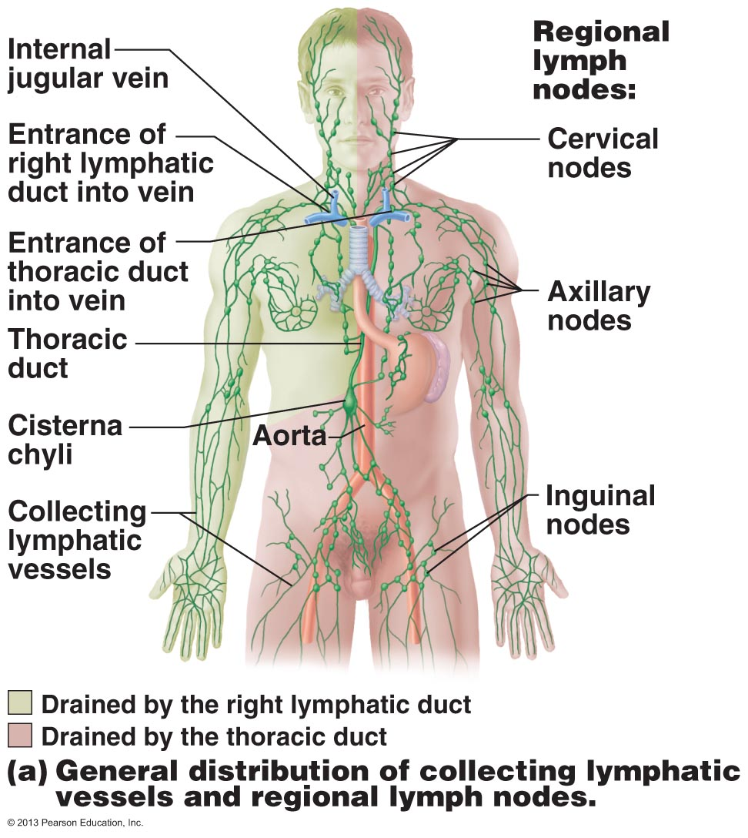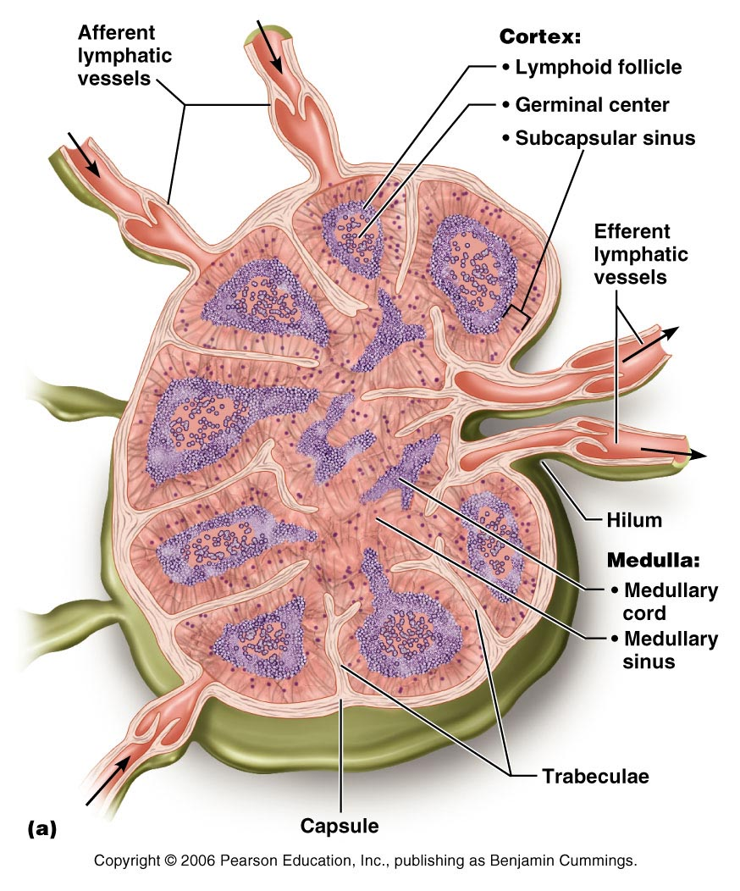

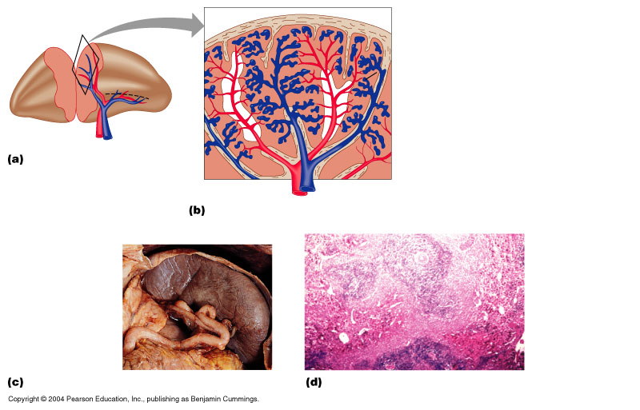
Spleen

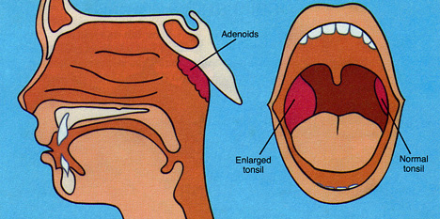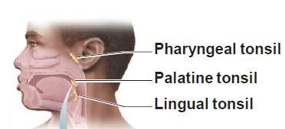

Chapter 22: The Respiratory System
- Major function: supply O2 & dispose of CO2
- 4 process:
- Pulmonary Ventilation: movement of air into and out of lungs; gases there are continuously changed & refreshed (called breathing)
- External Respiration: movement of oxygen from lungs to blood and of CO2 from blood to lungs (exchange of gases b/w blood & air of alveoli)
- Transport of Respiratory gases: transport of O2 from lungs to tissue cells & of CO2 from tissue cells to lungs; transport by cardiovascular system using blood as transporting fluid (role of blood in transport of gases between lungs & tissues of body)
- Internal Respiration: movement of O2 from blood to tissue cells & of CO2 from tissue cells to blood
- First two functions handled by resp system; other two by CV system
- Cannot accomplish primary goal of obtaining O2 & eliminating CO2 unless third and fourth process also occur
Functional Anatomy of the Respiratory System
- Includes nose, nasal cavity, paranasal sinuses, pharynx, larynx, trachea, bronchi & their smaller branches, lungs which contain air sacs or alveoli
- Respiratory zone: site of gas exchange; composed of resp bronchioles, alveolar ducts & alveoli (microscopic)
- Conducting zone: passageways; nose, nasal cavity, pharynx, larynx, trachea, bronchi, bronchioles, terminal bronchioles = also cleanse, humidify & warm incoming air; result = air has fewer irritants (dust, bacteria, etc)
The Nose and Parnasal Sinuses
- Only visible part of respiratory system
- Functions: airway for respiration, moistens & warms incoming air, filters & cleans inspired air, serves as resonating chamber for speech, houses the olfactory (smell) receptors
- Structure of nose divided into external nose & internal nasal cavity
- Differences in nose size & shapes due to difference in nasal cartilages
- Skin covering dorsal/lateral aspects of nose is thin; contains many sebaceous glands
- During breathing, air enters thru nasal cavity via nostrils/naresnasal cavity divided by midline nasal septum(cartilage/bone)air then goes via internal nares to nasopharynx
- Roof of nasal cavity formed by ethmoid & sphenoid bones of skull
- Flow of nasal cavity formed by palate (anterior is hard; posterior is soft)
- Vibrissae(hair): filter coarse particles (dust, pollen) from inspired air
- Nasal cavity lined; 2 types of mucosa: olfactory mucosa & respiratory mucosa
- Olfactory Mucosa: contains receptors for sense of smell; lining slit like superior region of nasal cavity
- Respiratory Mucosa: pseudo stratified ciliated columnar epithelium with goblet cells; lamina propria has mucous & serous glands (1 L/day sticky mucus containing lysozyme)
- Mucous cells secrete mucus & serous cells secrete watery fluid containing enzymes
- Respiratory Mucosa cilia move contaminated mucus posteriorly to pharynx
- Cold air slows cilia runny nose
- Nasal mucosa is richly supplied w sensory nerve endings & contact w irritating particles (dust, pollen, etc) sneeze
- Thin-walled veins under nasal epithelium; warm incoming air as flows across mucosal surface
- When cold air is inspired, vascular plexus becomes engorged w blood, intensifying the air-heating process b/c of abundance & superficial location of these blood vessels; nosebleed are common & often profuse
- Protruding medially from each lateral wall of nasal cavity; 3 scroll-like mucosa-covered projections: superior, middle & inferior nasal conchae (groove inferior; nasal meatus)
- Curved conchae greatly increase mucosal surface area exposed to air and enhance air turbulence in cavity
- Function: inhalation to filter, heat, moisten air; exhalation to reclaim this heat & moisture; precipitate moisture & extract heat from humid air over them
- Paranasal Sinuses: surround nasal cavity, located in frontal, sphenoid, ethmoid & maxillary bones
  - Lighten skull, produce mucus; warm & moisten air
  - Sinus mucosa continuous with nasal mucosa »» spread of infections
  - Rhinitis: inflammation of nasal mucosa accompanied by excessive mucus production, nasal congestion & postnasal drip
  - Continuous w rest of resp tract; explains cold to throat to chest colds
  - Sinus headache: passageways connecting sinuses to nasal cavity blocked » air in sinus absorbed which result in partial vacuum & sinus headache localized over inflamed areas
The Pharynx
- Common pathway for food and air
- Wall composed of skeletal muscle throughout ~13 cm length; mucosal lining varies
Nasopharynx
- Below sphenoid bone, above soft palate
- Only an air passageway
- During swallowing, soft palate & pendulous uvula move superiorly, an action that closes off nasopharynx & prevents food from entering nasal cavity
- When we giggle, this sealing action fails & fluids being swallowed can end up spraying out our nose
- Pseudostratified ciliated epithelium takes over job of propelling mucus where nasal mucosa leaves off
- High on posterior wall is pharyngeal tonsil; which traps & destroys pathogens entering nasopharynx in air
- Imbalance: pharyngotympanic (auditory) tubes; drain from middle ear cavities & allow middle ear pressure to equalize w atmospheric pressure
Oropharynx
- Lies posterior to oral cavity; continuous w it thru an archway = isthmus of the fauces (thoart)
- From soft palate to epiglottis (both air and food pass thru it)
- Epithelium becomes stratified squamous b/c nasopharynx blends into oropharynx & accommodates increased friction & greater chemical trauma for food passage
- Paired palatine tonsils + single lingual tonsil
Laryngopharynx
- Also both food and air
- Stratified squamous
- From epiglottis to larynx –then respiratory & GI pathways diverge
- During swallowing, food has “right-of-way”
The Larynx
- Extends 5 cm to about 4th-6th cervical vertebrae
- Attached to hyoid bone (above); continuous with trachea (below)
- 3 functions: open, 2 directional airway; switching: food vs air; voice production (houses vocal cords)
- 9 cartilages in total
- Thyroid cartilage: large, shield-shaped cartilage in front, external (adam-apple), larger in males than females; male sex hormones stimulate growth during puberty
- Arytenoid Cartilages (2): lateral, pyramid-shaped, anchor vocal cords
- 9th cartilage is epiglottis: elastic cartilage, anchored to anterior rim of thyroid cartilage & extends up to base of tongue
- True vocal cords: white (avascular); vibrate in response to air movement up from lungs; vocal folds & medial opening b/w them thru which air passes = called glottis
- False vocal cords: above true vocal cords; no direct part in sound production; help to close glottis when swallowing
  - Superior portion of larynx, area subject to food contact; lined by stratified squamous epithelium
  - Below the vocal folds the epithelium is pseduostrafified ciliated columnar type (acts as dust filter)
Voice Production
- Speech = intermittent release of expired air + opening & closing of glottis
- Length of vocal cords & size of glottis altered by action of laryngeal muscles that move arytenoid cartilages
- Male voice at puberty: vocal cords vibrate more slowly & deepens b/c boy’s larynx enlarges during puberty, vocal folds become longer & thicker
- Loudness of voice: force of air across vocal cords
- Laryngitis: inflammation of vocal cords ⇒ vibration impaired
- Sphincter functions of vocal cords: epiglottis closes respiratory tract during swallowing AND Valsalva’s maneuver help empty the rectum & can also stabilize body trunk when on lifts heavy load
The Trachea
- 10-12 cm long; ~2.5 cm diameter; flexible, mobile
- Pseudostratified ciliated columnar; cilia move mucus up to pharynx
- Smoking inhibits & then destroys cilia; only coughing to clear mucus
- Submucosa is CT with seromucous glands
- Outer adventitia reinforced internally by 16-20 C-shaped cartilaginous rings; keep airway open during pressure changes associated with breathing
- Heimlich maneuver; which is involved w trachea is a procedure in which air in the victim’s lungs is used to “pop out” or expel, an obstructing piece of food; saved many people from becoming victims of café coronaries
The Bronchial and Subdivisions
- Air passageways in lungs branch & branch again; 23 times overall
- Branching pattern of airways often called bronchial & respiratory tree
Conducting Zone Structures
- Divides into right and left main (primary) bronchi
- Right primary bronchus is wider, shorter, more vertical than left
- Air in bronchi is warm, cleansed of most impurities & humidified
- Bronchi smaller and smaller (fourth-order, fifth-order or 1 degree, 2 degree)
- Bronchioles (less <1mm diameter), terminal bronchioles (less than 0.55mm)
- Changes in wall composition as one moves through three:
  - Support structures change (cartilage: rings to plates to none)
  - Epithelium type changes (epithelium: pseudostratified columnar to columnar to cuboidal; no cilia or mucous cells in bronchioles)
  - Amount of smooth muscle increases: as passages become smaller
Respiratory Zone Structures
- Terminal bronchioles branch into respiratory bronchioles
- 300 million or so gas-filled alveoli in lungs account for most of lung volume & provide a tremendous surface for gas exchange
The Respiratory Membrane
- Respiratory membrane = alveolar wall + capillary wall + basal laminae
- Respiratory membrane is an air-blood barrier; gas exchange by simple diffusion
- Type II cells: scattered among type I cells; secrete surfactant
- Other characteristics of lung alveoli
  - Surrounded by fine elastic fibers
  - Alveolar pores: allow equalization of air pressure throughout lung; alternate air routes if bronchi collapsed
  - Alveolar macrophages = dust cells; inner alveolar surface; clear & swallow > 2 million dust cells/hour!
The Lungs and Pleurae
- Paired lungs occupy entire thoracic cavity except mediastinum
- Each lung suspended in own pleural cavity; connected to mediastinum by vascular & bronchial attachments (= root)
- Costal surface = anterior, lateral & posterior lung surfaces in close contact with ribs
- Apex, base; also hilus »» blood vessels enter & leave lungs
- 1⁰ bronchus enters lungs
- Fissures: oblique, horizontal » septa subdivide each lung into 10 bronchopulmonary segments (CT divisions; own artery & vein)
- Pulmonary disease often segmental & can be treated that way
- Lobule: smallest subdivision seen with naked eye; hexagon ~ size of pencil eraser; served by large bronchiole
- Lung : primarily air spaces; rest is elastic CT
Blood Supply and Innervation of the Lungs
- Pulmonary arteries bring blood to be oxygenated
- Pulmonary veins return oxygenated blood
- Bronchial arteries provide systemic blood to lungs ⇒ bronchial veins
- Innervation by primarily parasympathetic fibers; effect? Constrict the air tubes + some sympathetic fibers; effect? Dilate the air tubes
The Pleurae
- Thin, double-layered (parietal & visceral) serosa
- Pleural fluid: serous secretion that fills pleural cavity »» lungs slide easily during breathing; surface tension keeps pleurae from separating
- 3 chambers: central mediastinum + 2 lateral pleural compartments
- Pleurisy: inflammation of pleurae

