GENERAL PRINCIPLES OF MICROBIOLOGY
Microorganisms: organisms; vary in size, complexity, + growing ability in diff. growth conditions.
- Small (microscopic); 1-2 microns (1 mm = 1000 microns); majority harmless.
Classes of Microorganisms: (virus, bacteria, mycoplasma, parasites)
1) Viruses: made of nucleic acids (either RNA or DNA); surrounded by capsid (protein shell); attach, inject (nucleic acid) into cell & divert synthetic process for their own replication; (chlamydia=complex; only multiply in living cells)
2) Bacteria/Prokaryote (unicellular/no nucleus): rigid cell wall + cytoplasm; genetic material organized in circular chromosome; DNA & RNA; binary fission.
- Mycoplasma (grow on non-living media; bacteria with no rigid cell wall + more delicate)
3) Eukaryotes: unicellular & multicellular animals & plant organisms with cells containing membrane-bound nucleus (with genetic material).

Normal Bacterial Flora:
- Classified as resident or transient; ex; GI-tract: colon inhibited by anaerobes & coliforms; skin= coagulase negative staphylococci.
- Transient: found in specific location; result=resident flora displacement, injury, trauma.
- 1) Protect from invasive bacteria; 2) Metabolism (vit K); 3) Immune system stimulation.
- Antibiotic therapy may cause imbalance ecology & normal flora.
Protected by:
1) Mechanical barriers (skin, saliva, mucous, hair, tears)
2) Phagocytosis (T-cell; NK cell; macrophages; polymorphonuclear cells); phagocytic cells attach/form vacuole around bacteria; (Streptococcus Pneumoniae=surrounded with polysaccharide capsule/prevent phagocytosis)
Host response= Opsonization: antibodies produced/bind to capsule + allows phagocyte
3) Antibodies (humoural immunity); formed against bacteria; function as opsonin or kill directly.
4) Complement; complex system of plasma proteins; resist bacterial infection; 2 major roles.
5) Cell mediated immunity; vital defense; kill Mycobacterium tuberculosis & Legionella

Bacterial infection occurs through:
1) Adherence: ligands (small molecules) on surface of bac. bind to cell surface receptors.
2) Endo/exo toxin production; produce exotoxins damage defenses; host defense=antibody.
3) Compromised host; (when single species becomes predominate site with many species or invades body site that is normally sterile; result depend on bacterial pathogenicity factors & host response.

Examples of Antimicrobial Defense Deficiencies:
Host Defence Missing Patient at Risk for
Phagocytic cells (e.g., leukopenia) Staphylococcus aureus and Streptococcus pneumoniae
Antibody mediated immunity Streptococcus pneumonia and viral infections
Cell mediated immunity (including AIDS) Tuberculosis, Legionella and AIDS-related infections

- Bacteraemia: bacteria distributed through blood stream; primary focus of infection followed by dissemination of organism causing that infection; disseminated organism then cause clinical symptoms/first sign of infection at distant location; septicemia=rapid, life threatening; contain replicating bacteria to cause infection.
Infection: microorganism penetration; produce apparent (disease) or inapparent (no disease; no symptoms); not confused with contamination (microorganism deposition without multiplying) & colonisation (establishment/multiplying without producing any apparent/inapparent change; ex: skin with micrococci).
Microbial (infectious) Disease:
- Changes=functional damage to infected host; need to colonize in/on body.host & microorgan. Balance disturbed:
Large # of microbes VS Small no. of microbes
Increased virulence VS Attenuated virulence
Susceptible host VS Resistant host
- Microorganism causing clinical/sub clinical disease classified as: Pathogenicity: ability to produce disease; virulence: capacity to cause damage (degree of pathogenicity)
- Opportunism pathogens: don’t cause disease unless defense mechanism is compromised.

PATHOGENESIS OF INFECTIOUS DISEASE
- Pathogenic microorganism enters body=2 things happen;
1) Microorganism tries to multiply/invade/cause disease.
2) Host tries to prevent 1).
- Whether the invader wins depends on:
1) Transmission: effective transfer from source to host; routes of entry: inhalation, ingestion, break in protective barrier, direct deposit.
2) Pathogenicity: capacity to inflict damage by 3) invasiveness (ability to overcome host defenses/multiply=adhere, persistence, avoiding immune sys.) 4) Toxigenicity: toxin production.
Pathogen Adhere By:
- Surface Structures (pili, fimbriae): stick to specific receptors on body cell surface.
- Capsules: polysaccharides’ protect against leukocytes.
- Enzymes: encourage pathogen virulence; example:
- Coagulase: accelerate plasma clotting around infection=barrier against leukocytes & body fluids.
- Hyaluronidase: hydrolyse polymerized hyaluronic acid; liquefy viscous polymer & facilitate spread of bacteria carrying fluids.

Toxinogenicity:
- Toxins are substances/proteins/ secreted by bacteria to damage host tissues; 2 classes are exotoxins & endotoxins.
- Exotoxins: excreted by living bacterial cells; have specific affinities; potent in small concentrations; thermolabile (sensitive to heat); (botulinum=most toxic)
- Endotoxins: produced when cell disintegrates; less specific & less potent; cause pyrexia (fever), malaise, & vasomotor disturbance (shock); thermostable (heat resistant).

BODY DEFENCES (Immunity):
Immunity: protection against infectious disease by immune response generated by immunization or previous disease or by other nonimmunologic factors (body’s ability to resist infect.)
- 2 TYPES OF IMMUNITY: NON-SPECIFIC (INNATE) & SPECIFIC (ADAPTIVE, ACQUIRED)
1. Non-specific: Innate/Natural immunity: (protects against ANY invader)
a) Skin: effective=acid pH=sebaceous secretion + sweat contain bactericidal; low tempt suboptimal for bacteria.
b) Mucous membranes: (mechanical barrier); cilia in respiratory tract eliminate particle larger than 5 microns; lysozymes (antibacterial substance; in tears); pH (gastric juice, vagina acid, urine).
c) Iron-Binding proteins: some bacteria require iron for growth; transferrin & lactoferrin
d) Phagocytosis: polymorphonuclear (PMNs); macrophages, monocytes; WBCs.
e) Complement

2. Specific Immunity (Acquired/Adaptive) (directed to specific invader; dependant on past exposure)
- Divided into 2 major system: 1) Humoral Immunity (specific circulating antibodies in body fluids); 2) Cell Mediated Immunity (CMI) [cells trained to attack specific invading organisms]
- Both immunity are induced by attacking microorganisms they are directed to; “specific”
IMMUNE CELLS COME FROM:
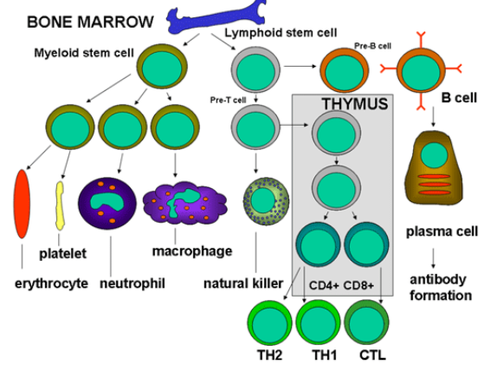
2.1. Humoral Immunity: antibodies are modified serum globulins.
Immunoglobulin/Antibody (Ab): (lg)
- Antibody: binds to specific antigen; immunoglobulin produced by B-lymphocytes (B-cells) stimulated by antigen presenting T-cells; recognize toxin production, capsules, & viral infection; distinguish macromolecules (non-self) from normal body constituents (self); constant & variable region responsible=antigen recognition.
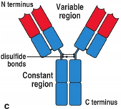
Antigen (Ag): (substance capable of inducing specific immune response)
- Must be recognized as foreign ("non-self") or cause auto-immune disease; protein, glycoprotein, lipoprotein, polysaccharide; particulate or soluble.
- Bacterial cells containing antigen: capsular substance, flagella, cell wall; viruses contain polypeptide antigens.
5 Classes of Immunoglobulins (lgs):
- 1) IgG, 2) IgM, 3) IgA, 4) IgD 5) IgE; basic unit=Y-shaped molecule.
1) IgG: contain 2 sites that combine with antigens; rest of molecule bind with phagocyte + macrophage; crosses placenta & protects newborn.
2) IgM: pentamer (made of polymer); mainly produced in early immune response; dont cross placenta.
3) IgA: dimer (2 joint molecule); found in secretion; tears, saliva, milk, respiratory, GI + genito-urinary tract.
4) lgD: role unknown
5) lgE: HYPERSENSITIVITY (allergies); defends against parasites.
- IgG, IgA, IgM=defense mechanism.
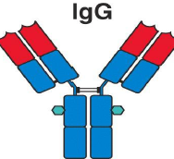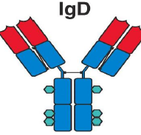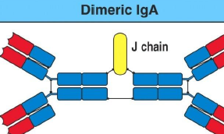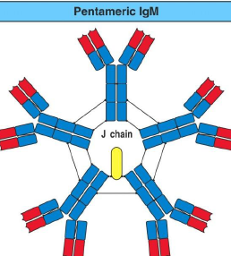

- Basis of immunization: Primary, secondary, & booster injection.
The Primary Immune Response: first antigen introduction triggers antibody; latent period of several days; circulating AB detectable after 5-10 d; AB serum peaks @ 3 w then drops to low undetectable level
The Secondary immune Response: response occurs when antigen introduced for 2nd x; short lag, then AB rise rapidly (2-3 d) slow decrease; booster injection maximize AB levels (3-5 IV).
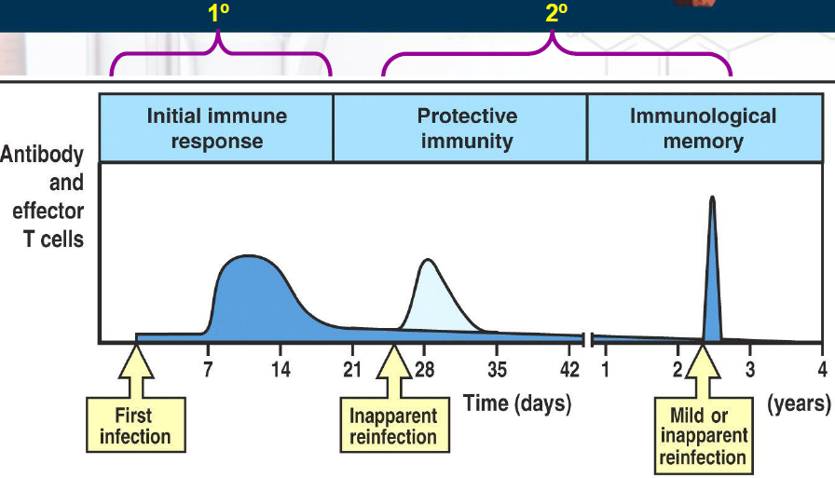
Antibody Detection:
1) The Serological Reaction:
- Detects antibody presence in serum sample; results in antigen-antibody reaction (agglutination); detect unknown microorganisms using diagnostic antisera; allows Antibody titration.
2) Cell-Mediated Immunity (CMI):
- T-cells=soluble antibodies not involved; suppressive, cytotoxic, generated from memory T-cells stimulated by antigen exposure; active in microbial infection; essential: defense against intracellular organisms, parasites, tumors, & other foreign cells (grafts, transplants).
Harmful Effects of the Immune Response = Immunity Disorders
1) Allergy and Hypersensitivity states: over-reaction to antigens in absence of infection; can be fatal (anaphylaxis: airway obstruction/circulatory collapse); observed in patient allergic to egg protein.
2) Auto-Immune Diseases: immune system reacts to its own “self” antigens + auto-antibody formation; Type 1 diabetes, MS rheumatoid arthritis, lupus.
3) Immunodeficiency States: inability to produce antibodies/dysfunctional CMI; cause congenital abnormalities, disease, AIDS.
4) Graft Rejection (kidney, bone-marrow, heart): normal immune reaction to “non-self”; control by immune-suppressive meds.

------------------------------------------------------------------------------------------------------------------------------------------

IMMUNIZATION (VACCINATION)
A) Passive immunization:
- Administration of pre-formed antibody against specific microbial agent (intramuscular route);
lgG animal origin: foreign by immune system; 10 d; short lived, risk of hypersensitivity reaction (igE cause serum sickness/anaphylaxis); IgG human origin: short lived, no risk of reaction.
- Immune serum/gamma globulin (IgG): pooled from large group of blood donors; contains antibodies 4 many diseases; Hyperimmune globulins (IgG): for specific microbe caused by exposure/hyperimmunication.
B) Active immunization:
- Stimulate immune system by antigen/vaccine administration; longer lasting; strategies include:
1) Live-attenuated Vaccine: sub-clinical or mild illness mimicking disease; provide local IgA & humoral immunity; rapid immunity development; cause to immunodeficiency syndrome=(AIDS).
2) Killed Vaccines, Subunit Vaccines & Toxoids: antigens without infectivity; require spaced out injections; may require boosters; adjuvant with toxoids.
3) Recombinant Vaccines: DNA recombinant technology; reduces microorganism, Hep. B vaccine.
4) Adsorbed Vaccines: vaccine mixed with inorganic salts (alum) =slower adsorption & longer lasting immunity; ex: tetanus & diphtheria toxoids.
5) Conjugate Vaccines: contain poorly antigenic polysaccharide capsule; conjugated antigen to immunogenic, non-toxic protein; ex: hemophilus influenza type B.
6) Combined Vaccines: many vaccines can be combined for ease of administration.
7. Schedule of immunizations: schedule of immunization routine from infancy-childhood.

C) Combined active-passive immunization:
- Immediate protection after exposure to microbe; hyperimmune globulins & vaccine injected=diff sites; ex: tetanus, rabies, Hep. B.
ANTIBIOTIC RESISTANCE:
1. History and significance of antibiotic resistance
- First Antibiotic: Penicillin discovered by Sir Alexander Fleming 1929; used in WW 2 FOR Staphylococci & Streptococci 1949.
- Penicillin resistance recognized: 80% of Staphylococcus aureus strains; still treats Streptococcus pyogenes (Group A strep); not effective against Gm-negative (Salmonella, Shigella, Bordetella pertussis, Yersinia pestis, Pseudomonas)
Antibiotic Therapy:
- Effective chemo depends on selective toxicity (good against pathogen, doesn’t affect host); exploit pathogen processes not seen in humans; adverse effects (GI tract, sin, haemopoietic system, renal, liver).
- Antibiotics reduce morbidity & mortality associated with pathogenic bacterial infections.
Antibiotic Resistance:
- Caused by a) antibiotic mis/use in agriculture/aquaculture; b) antibiotics mis/use in human pop. (develop. countries); 3) immunocompromised patients alive longer=transmit antibiotic resistant bacteria.
- Occurs to any antibiotic with sufficient time; when susceptible microorganism isn’t inhibited by antibiotic agent; classified into 2 types: intrinsic resistance & acquired resistance.
Intrinsic: predictable form based on characteristics of microorganisms & antibiotics mechanism of action (inherent or “natural”.
Acquired: previous susceptible organism becoming resistant to antibiotic; driven by 2 genetic processes (mutation & selection; vertical evolution) & genetic material exchange (horizontal evolution); 3 major mechanisms:
- 1) Alternation in drug target.
- 2) Production of inactivating enzymes.
- 3) Decreased antibiotic uptake.

Table 1 Major Resistance Mechanisms to Antibiotics
Resistance Type/Antibiotic Affected Mechanism of Resistance
Altered Target
Aminoblycosides (streptomycin) Altered ribosomal protein
$--‐lactams Altered or new penicillin binding proteins
Clindamycin and Erythromycin Ribosomal RNA methylation
Fluoroquinolones Altered DNA gyrase
Rifampin Altered RNA polymerase
Sulfonamides New drug--‐resistant dihydropteroate synthase
Tetracycline Ribosomal protection
Trimethoprim New drug-insensitive dihydrofolate reductase
Vancomycin Altered cell-wall stem peptide

Inactivating Enzymes
Aminoglycosides (gentamycin) Acetyl‐, nucleotidyl‐ or phosphotransferase
$--‐lactams $--‐lactamase
Chloramphenicol Acetyl transferase

Decreased Uptake
Decreased permeability
$-lactams, chloramphenicol, tetracycline, fluoroquinolones, trimethoprim Altered outer-membrane proteins

Efflux
Erythromycin, fluoroquinolones, tetracycline New membrane transport system

3. Genetics of Antibiotic Resistance:
- Encoded by bacterial chromosome or extra chromosomal entities (plasmids); resist by:
A) Genetic material exchange:
i) Conjugation (plasmid): requires cell-to-cell contact & conjugative pili (form of plasmids);
- Conjugative plasmid: plasmid with gene that allow to initiate their own transfer from organism 2 organism; powerful horizontal gene transfer; plasmid=limited host ranges.
ii) Transformation: uptake of free/naked DNA from environment & incorportation into bacterial genome & subsequent gene expression; occur in nature.
iii) Transduction: use bacteriophage as carrier; depend on accidental bacterial DNA incorporation in phage particle; limitation=high host specificity & host restriction/modification systems + not important in clinical bacteria; natural plasmid transfer in Staphylococcus spp.
iv) Transposition: powerful for mobilizing antibiotic resistance genes from one DNA molecule to another (chromosome to plasmid); conjugative transposons=jump from chromosome from 1 organism to another=circumventing plasmid-host range restriction; intregrons: mobile DNA elements with specific structure with 2 conserved segments flanking central region that encode functions.

(b) Chromosomal alteration or activation:
- Antibiotic resistance encoded by bacterial chromosomes; origin of resistant phenotype associated with chromosomal gene mutation; leads to:
- 1) Encoding antibiotic target site (making site functional/nonsusceptible); 2) regulatory genes (control alternative pathways & efflux mechanisms); 3) Control Cell permeability (& regulate antibiotic uptake/drug intracellular concentration).

- MAR (multiple antibiotic resistant): chromosomal locus; discovered 1980s; mar-related loci widely distributed on diff bacteria=mar locus activation result in bacteria with mar phenotype=clinically important form of multiple drug resistance.

General Principles of Diagnostic Microbiology
Micro. exist as mixed cultures; difficult to study; isolate diff species from clinical specimen.
Culture media: nutrient material used to grow & isolate microorganism; media type used based on:
i. Source of sample tested
ii. Species suspected to be in sample
iii. Nutritional requirement of the suspected organisms
Inoculation Methods: inoculum used used to inoculate diff media to isolate microorganisms
Inoculation Methods are:
i. Streak plate method
ii. Spread plate method
iii. Pour plate method
- Inoculated media=incubated at 37oC temp. allow microorganisms to grow/multiply; visible colonies are formed after enough cells have divided; each colony derived from single cell; all cells in colony=identical.
- Dff colonial morphologies=used to distinguish diff species in mix culture.

Preservation of pure cultures:
- Pure culture of bacteria are stored: Short‐term preservation: medium fridge temp (4-10Oc);
Long-term preservation:
i. Frozen in liquid nitrogen (-196oC)
ii. Frozen in special freezer (‐70oC - -120oC)
iii. Lyophilization (freeze drying): dehydration + vacuum sealing (most stable storage form)

Identification of microorganism after obtaining as pure culture:
- 2 approaches: 1) colony morphology; 2) cellular morphology (require microscope)
- Microscope’s magnification limited by resolving power (resolution); ability to distinguish 2 closely located objects as separate entities; fixed by light wavelength.

Staining Techniques: 3 steps
1. Make thin smear of specimen on clean microscope slide & air dried;
2. Fix dried smear by heat to make microorganism stick to slide;
3. Stain with desired dy+e.

Simple staining vs. Differential staining:
Simple staining: single dye used for all microorganisms=same color; vary in size, shape, number, cell arrangement; ex: methylene blue staining.
Differential staining: two or more special dyes used to observe difference between microbial cells or parts of cells; example:
- Acid fast stain: carbolfuchsin & methylene blue=differentiate acid‐fast bacteria; like Mycobacterium from other non‐acid-fast bacteria.
- Gram stain: most important; characterize bacteria into 2 groups: gram positive & gram negative.
The Gram Stain/ (Hans Christian Gram)
1. Flood slide with crystal (or gentian) violet. (Wash with running tap water).
2. Flood with Gram's iodine. (Wash with water).
3. Carefully decolorize with 95% ethanol. (Wash with water); most critical + affected by technical variation in timing + reagents.
4. Flood with safranin (pink). (Wash with water). Air dry, or blot with absorbent paper.
Cell Wall:
- Gram stain associated with bacterium cell wall; Rigid structure giving shape; essential for cell growth & division; bacteria shape related to peptidoglycan layer; gram negative thinner than gram positive.
(i) Gram‐positive cell wall:
- Thick structure; thick layer of peptidoglycan; Teichoic acids found attached to peptidoglycan= give negative charge to help transport positive ions & phosphorus storage.
(ii) Gram‐negative cell wall:
- More complex; outer membrane covering peptidoglycan thin layer; anchored to peptidoglycan by a lipoprotein; lipopolysaccharide (LPS) also found; selective barrier based on size & molecule charge.
- Alcohol increase permeability; shrink pores of g positive peptidoglycan.

- Diff staining determined by diff cell wall structures; other types:
Endospore staining: malachite green + heat to penetrate spores then counter-staining with safranin.
Capsule staining: treat with copper sulfate before staining to visualize capsule as clear zone surroundings cells.
Flagella staining: using mordant-thicken flagella b4 staining.

Light microscope: lens system manipulates path the light beam travels btw the specimen and the eye.
Fluorescence Microscopy: reveal objects in black background; uses fluoresces dye 4 specific wave length observed with light microscope; antibodies tagged with dyes (immunofluorescence) = common.
Electron microscope: beam of electrons controlled by system of magnetic fields instead of light; short wavelength allows greater resolving power (0.003 um); ex:
- Transmission electron microscopy (TEM): stain with heavy metals or microorganism sliced in thin sections; scanning electron microscopy (SEM): moving electron beam generate 3-D image coated with metal film.

Studying Morphology of microorganism is important because:
1) Helps classify; lack/presence & characteristics of cellular structure; (gram stain)
2) How cells will respond in environment; (capsules, endospores)

Bacteria:
- Small (0.75-1.25 um in diameter); higher surface area to volume ratio=higher metabolism; faster growth replication rate (20 m); common bacteria used Escherichia coli; 3 basic shapes:
- 1) Sherpical cells (coccus); 2) Cylindrical/rod shape (spirillum); 3) Spiral/helical shape (spirillum); Pleiomorphic organisms: bacteria that can change shape.
- Arranged in specific patterns:
1) Single cells (spiral/rod shaped);
2) Diplococci (pairs)= coccus divide in 1 plane (N. Gonorrheae);
3) Streptococcal arrangement; chain (coccus divide 1 plane & remain attached); Streptococcus SPP.
4) Tetrads (cocci divide at right angle to 1st plane of division); Pediococcus.
5) Sarcinae: division in 3rd plane cubical packet of 8 cells
6) Irregular division of 3 planes (grapelike clusters); Staphyloccus.

Definitions:
- 1. Chemically defined media: exact composition known; can alter individual component separately.
- Chemically Undefined: some components can’t be controlled (beef extract, blood) added to media.
- 2. If solid (vs liquid) = 1.5% agar used.
- 3. Enrichment media: increase specific bacteria by favouring growth of interested species.
- 4. Tissue culture media: to cultivate virus; derive from plant/animal cell.
General Media Requirements:
- Fastidious: microorganisms with demanding nutritional requirements; complex, undefined media.
- 5. Bacteria; requirements vary.
- 6. Yeasts: high sugar & lower pH; requires organic substrates to get carbon source for growth.
- 7. Anaerobes: must remove oxygen.
- 8. Selective Media: enhance growth of 1 bacterial species or suppress; ex: brilliant green isolate Salmonella species=inhibits Gram-positive bacteria; phenylethanol agar inhibits gram-negative bacteria.
- 9. Differential Media: differentiate bacteria based on nutritional requirements & phenotypic characteristics; ex: RBC lysis; hemolytic vs non-hemolytic bacteria.
- 10. Selective/Differential media: useful in public health microbiology/clinical labs (ex: MacConkey agar; bile salt & crystal violet inhibit gram-positive bacteria)
FIG: MacConkey : S/D media(Bile salts, crystal violet inhibit Gram +ves)
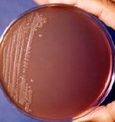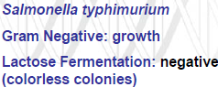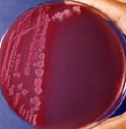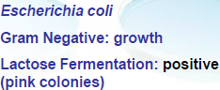

4 Essential Physical Conditions for Successful Cultivation of Microorganisms:
A. Temperature:
- Cardinal temp: min temp, opt. temp, max. temp; changes depends on nutritional growth content of medium; opt tempt close to max=enzyme activity increase with tempt until limit.
- Microorganisms are divided into 3 major groups based on optimum growth tempt:
1) Psychrophiles: grow at 15-20oC (die if exposed to room temp=cytoplasmic membrane damage); found in colder waters & soils (ocean; Polar Regions); problem: food spoilage; ex: bacteria=Pseudomonas & Flavobacterium.
2)Mesophiles: grow at 25-40oC; most bacteria belong here; saprophytic grow @ lower temp range; parasitic organism of human/animal grow @ 37oC.
(3) Thermophiles: grow at 40-85oC; mostly prokaryotes; found in volcanic areas, compost heaps, & hot springs; ex: Bacillus stearothermophilus.
Extreme Thermophiles: Pyrolobus fumarii; lobed shape; in deep sea hydrothermal vent walls; grows in 30-113C; 106C=optimal.

B. Gaseous Atmosphere: (oxygen, carbon dioxide, nitrogen, + methane)
1) Aerobic Microorganisms/Obligate aerobes: grow in 21% oxygen; include microbes; in broth, require higher carbon dioxide levels (ex: Neisseria gonorrhoeae; 5-10%);use candle jar, more complex gas jar.
2) Anaerobic Microorganisms/Obligate anaerobes: don’t use oxygen (poison) for energy-yielding chemical reactions; can’t grow in air atmosphere; use anaerobic jars, anaerobic chamber, or anaerobic glove box; oxygen toxicity from superoxide radical, hydrogen peroxide, + hydroxyl radicals=protected in aerobes=produce enzyme=superoxide dismutase, catalase, + peroxidase.
3) Facultative Microorganisms/Aerobes: grow in air atmosphere; also grown anaerobically; doesn’t require oxygen but can be used for chemical reactions; ex: E. coli & Saccharomyces cerevisiae.
4) Microaerophilis: can use oxygen for chemical reactions; 1-15% oxygen level; ex: Campylobacer jejuni.
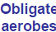 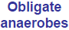 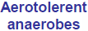 ↓↓decreasing oxygen concentration
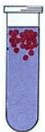 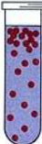 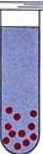 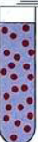 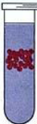 ↓↓↓

C. pH: optimal pH varies; intracellular pH = ~7.5; growth observed at pH 4-9 (optimum 6-8); molds & yeasts broader pH; optimum pH is ~ 5 to 6.

D. Other conditions:
- Water (light) important for certain microorganisms.
- Osmotic pressure (hypertonic=water loss, hypotonic=cell rupture, isotonic)

GRAM POSITIVE COCCI
A. STAPHYLOCOCCI
- 1 um diameter; grow in grape-like clusters; important specifies for human are:
- 1) Staphylococcus epidermidis: normal flora of skin & mucosae; sometimes pathogenic
- 2) Staphylococcus aureus: pathogenic; found as normal flora
- 3) Staphylococcus saprophyticus: in environment & skin; cause urinary infections

Staphylococcus Aureus: cause food poisoning, TSS, scalded skin.
- Grows on simple media (agar, blood-agar); produce 2‐3 mm colonies 24 h, 37oC.
Toxins:
Cytotoxins: (α, β, δ, γ, P-V leukocidin): toxic to leukocytes, erythrocytes, macrophages, platelets & fibroblasts
Haemolysins: dermonecrotic, lethal.
Enterotoxin (A‐E, G-I): super antigens; cause food poisoning.
Exfoliative toxins (ETA, ETB): scalded skin; TSS; formerly pyrogenic exotoxin C & enterotoxin F.

Enzymes:
Coagulase: made by pathogenic staphylococci; coagulates fibrin; vitro, coagulase test used as id for aureus; S. epidermidis, S. capitis & S. saprophyticus.
Beta-lactamase (penicillinase): destroys penicillin.

- Many S. aureus found in population (15%) on anterior nares, axilla, perineum, & hands
Problem:
- 85-90% of strains isolated in hospitals are penicillin resistant;
- Produce localized infections (pustules, boils, styles, conjunctivitis, otitis);
- Complications: Pneumonia, osteomyelitis, septicaemia, endocarditis in immunosuppressed hosts.

- Important cause of hospital acquired nosocomial infections from stitch abscess, infected wound, or generalized infections
- Prevent: aseptic tech in ER/OR, wound precaution; education; hand washing.

Staphylococcus Epidermidis:
- Non-pathogenic except in compromised patients (post-operative brain, open heart, endocarditis, shunt infections); opportunistic pathogen.

B. STREPTOCOCCI:
- Arranged in pairs or form chains; grown on blood agar/fastidious; divided based on:
1) Haemolytic properties: a) alpha-haemolysis (greenish brown zone of RBC destruction); b) beta-haemolysis (clear zone of RBC destruction); some are non-hemolytic.
2) Carbohydrate C antigen: extracted from cell wall, subdivide streptococci in groups A-T(Lancefield classification).

3) M-protein: divides beta-haemolytic S to 70 serotypes; mostly in group A; important virulence factor: antiphagocytic & degrades complement C3b.

Streptococcus Pyogenes:
- Group A, beta haemolytic, S. pyogenes; cause:
a) Acute tonsillitis: strep throat; lead to rheumatic heart disease; Scarlet fever.
b) Skin infections: cellulitis, erysipelas, wound/burn infections, impetigo.
c) Puerperal fever (sepsis): post-partum or post-abortion
d) Septicaemia
Complications following streptococcal infections:
1) Acute glomerulonephritis;
2) Rheumatic fever: joints & heart valves

Toxins:
Streptolysins (O & S): beta-haemolytic; for neutrophils + macrophages; anti-streptolysin‐O (ASO) antibody most powerful after recent infections (EXCEPT skin infections).
Streptococcal Pyrogenic Exotoxins (Spes): Superantigens SpeA, SpeB, SpeC; scarlet fever.

Enzyme:
Hyaluronidase: splits hyaluronic acid in CT & help spreading.
- Found in 5-10% healthy people; sensitive to penicillin G (vs S aureus)=antibiotic of choice; transmission by direct contact; nasal carriers are more likely to spread; contaminated food.
- Prevention: education; aseptic; early detection/treatment.
Flesh-eating disease aka Necrotizing fasciitis:
- Also causes flesh-eating disease/necrotizing fasciitis; toxin is responsible for damage.
- Research: hijacking human plasminogen from blood, attach to surface, & activate it into protease = good spreading; bacteriophage has gene encoding for enzyme allowing bacteria to escape & killing by neutrophils (WBC).

STREPTOCOCCUS GROUP B - (Streptococcus agalactiae):
- Group B; found in vagina; can cause neonatal infections.
1. Early septicaemia: respiratory distress/shock at birth; high fatality rate
2. Delayed meningitic form: 1‐23 weeks post-partum; neurologic/mental abnormalities may result.

STREPTOCOCCUS GROUP D (Streptococcus faecalis)
- Group D (Enterococcus); part of normal flora of GI tract; infection when in tissues (urinary urinary tract infections, septicaemia, endocarditis, meningitis); resistant to range of antibiotics.

VIRIDANS STREPTOCOCCI:
- Include alpha-hemolytic & non-hemolytic; found in oral cavity of healthy ple; can cause endocarditis in damaged heart valves.

Streptococcus pneumonia (Pneumococcus):
- Diplococcic; polysaccharide capsule + antiphagocytic properties; over 90 capsular serotypes.
- Found in naso-pharynx of healthy ple; can cause: lobar pneumonia (auto-infection; infancy, old age, alcoholics) & meningitis (infants, elderly; accompanied by bacteraemia).
- Prevention: avoiding crowdrd living areas; vaccination with polyvalent pneumococcal vaccine (23 capsular polysaccharide serotypes).

GRAM NEGATIVE COCCI
Neisseria meningitides (Meningococcus):
- Diplococci; found in naso-pharynx; lab isolation use/grow best on enriched media (heated blood/chocolate agar), 5-10% CO2; use selective media (Thayer-Martin) when isolating from naso-pharnyx.
- Antiphagocytic polysaccharide capsule=13 diff serogroups; A, B, C, X, Y & W135.
- Carriers can develop infection or pass to non-immune ple who get infection; only humans (children; crowded); occasional epidemics; cause:
1. Meningitis: purulent; high fatality rate.
2.Septicaemia (meningococcaemia): high fever, rash from petechiae to haemorrhagic rash + endotoxic shock.
3.Waterhouse‐Friderichsen syndrome: bilateral adrenal cortical haemorrhage with fulminating collapse; death less 24 hours’ complication of meningococcal septicaemia; most severe form of septicaemia.
- Penicillin; vaccination recommended for 11-12, teenagers, college kids in dorms.
- Conjugated vaccine protects against serogroups A, C, Y, W135; vaccine for 2-5 m infant, C.

Neisseria gonorrhoeae:
- Gram-negative diplococcic, 0.6-1um diameter; In clinical labs: grow on Plates, Thayer-Martin, or NYC agars kept in CO2 containment (candle jar).
- Sensitive to drying & temp. change; grows only on special media; second highest STD in US; decreasing.
- Common infections are:
Men (gonorrhoea): acute infection of urethra (purulent urethritis); cause epididymitis, prostatitis.
Women: 50% are asymptomatic cervicitis; infect urethra/rectum; cause pelvic inflammatory disease (PID) (salpingitis, pelvic peritonitis, adnexal abscesses) & sterility.
- Both sexes; rectal gonorrhea & pharyngeal infection occasionally present.
Disseminated gonococcal infection (DGI): gonococcal bacteraemia; in 1-3% of infected patients/women; with fever, skin infection & wrist, knees, ankle arthritis.
Neonatal infections: causes gonococcal ophthalmia neonatorum (acute purulent conjunctivitis); rare but acquired through mothers.
Microscopy/Diagnosis:
Men: urethral discharge smear showing intracellular; gram-neg=98% correlation with culture; homosexual: urethral, anal, pharyngeal swabs.
Women: culture necessary from endocervical, urethral, anal swabs; vaginal swabs isolation=lower.
Prevention & Treatment:
- Penicillin resistance (plasmid-mediated resistance) in South-East Asia, West Africa, Canada, US.
- Treat with ceftriaxone, cefixime, ciprofloxacin or ofloxacin in combination with doxycycline or azithromycin.
- Resistance to ciproflaoxacin emerging; simultaneous treatment of partners; no vaccines.

