Section 1: Structural Organization of the Human Body:
1.1 Levels of Organization:
- Chemical Level: atoms combine to form molecules.
- Cellular Level: cells are made up of molecules.
- Tissue Level: groups of similar types of cells.
- Organ Level: contains two or more types of tissues.
- Organ System Level: organs that work closely together.
- Organismal Level: All organ systems working together for survival.

Organ systems:
Digestive System: breaks down food into absorbable units that enter the blood for distribution to body cells; indigestible foodstuffs are eliminated as feces.
Respiratory System: keeps blood constantly supplied with oxygen and removes carbon dioxide; the gaseous exchanges occur through the walls of the air sacs of the lungs.
Urinary System: eliminates nitrogenous wastes from the body; regulates water, electrolyte and acid-base balance of blood.
Cardiovascular system: blood vessels transport blood, which carries oxygen, carbon dioxide, nutrients, wastes, etc. The heart pumps blood.
Integumentary System: forms the external body covering, and protects deeper tissues from injury. Synthesizes vitamin D, and houses cutaneous receptors and sweat and oil glands.
Skeletal System: protects and supports body organs, and provides a framework the muscles use to cause movement. Blood cells are formed within bones and bones store minerals.
Muscular System: Allows manipulation of the environment, locomotion, and facial expression. Maintains posture, and produces heat.
Nervous System: fast-acting control system of the body, it responds to internal and external changes by activating appropriate muscles and glands.
Endocrine System: glands secrete hormones that regulate processes such as growth, reproduction and nutrient use (metabolism) by body cells.
Lymphatic System: picks up fluid leaked from blood vessels and returns it to blood; disposes debris in the lymphatic stream. Houses white blood cells (lymphocytes) involved in immunity. The immune response mounts the attack against foreign substances within the body.
Reproductive System: overall function is production of offspring, testes produce sperm and male sex hormone and male ducts and glands aid in delivery of sperm to the female reproductive track; ovaries produce eggs and female sex hormones; the remaining female structures serve as sites for fertilization and development of the fetus. Mammary glands of female breasts produce milk to nourish the newborn.

1.2 Cells - Cell Theory:
Four concepts known as the cell theory:
1. The cell is the structural and functioning unit of life.
2. The activity of an organism depends on the activities of its cells.
3. The activities of cells depend on their form and relative numbers of subcellular structures.
4. Continuity of life has a cellular basis.

Generalized Cell:
- Cells are composed of carbon, hydrogen, nitrogen, oxygen, and trace amounts of other elements.
- Generalized cell: all cells have the same basic parts and some common functions.
A human cell has three main parts:
- Plasma membrane: the outer boundary of the cell.
- Cytoplasm: the intracellular fluid packed with organelles (small structures that perform specific cell tasks).
- Nucleus: located near the cell`s center, controls cellular activities.

Cytoplasmic Organelles:
- Specialized cellular compartments or structures, each performing its own job to maintain the life of the cell.
- Nonmembranous Organelles have no membranes; cytoskeleton, centrioles, and ribosomes.
- Membranous organelles have membranes which enable organelles to maintain an internal environment different from the surrounding cytosol; peroxisomes, lysosomes, endoplasmic reticulum, and Golgi apparatus.
- Endomembrane system is a system of organelles that work together mainly to a) produce, degrade, store, and export biological molecules, and b) degrade potentially harmful substances.

Plasma Membrane:
Structure:
- Made up of double layer of lipids (phospholipids, cholesterol, etc) with proteins embedded within.
- Proteins can either be extended entirely through the lipid bilayer or protrude on only one face.
- Most externally facing proteins and some lipids have sugar groups attached.
Function:
- Serves as an external cell barrier and transports substances into our out of the cell.
- Maintains a resting potential that is essential for excitable cells to function.
- Externally facing proteins act as receptors (for hormones, neurotransmitters, etc), transport proteins, and in cell-to-cell recognition.

Mitochondria:
Structure:
- Is enclosed by two membranes, each with the general structure of the plasma membrane.
- The outer membrane is smooth and featureless; the inside membrane folds inward, forming shelf like cristae that extend into the matrix (a gel-like substance within the mitochondrion).
Function:
- They squirm, elongate, and change shape almost continuously.
- They are the power plants of the cell and provide most of its ATP supply.
- Convert energy in the bonds of glucose and oxygen readily available energy in the form of ATP; process is referred to as aerobic respiration.
- Contain their own DNA, RNA, and ribosomes, and are able to reproduce themselves.

Ribosomes:
Structure:
- Small, dark-staining granules, consisting of two subunits that can switch back and forth; composed of proteins and ribosomal RNAs.
- Ribosomes that are attached to membranes; forming rough endoplasmic reticulum.
Function:
- Ribosomes are sites of protein synthesis.

Endoplasmic Reticulum (ER):
- Interconnected tubes and parallel membranes enclosing fluid-filled cavities or cisterns; coiling through the cytoplasm.
- Continuous with the outer nuclear membrane.
- Two types: rough endoplasmic reticulum and smooth endoplasmic reticulum.
Rough Endoplasmic Reticulum:
Structure:
- External surface is studded with ribosomes.
Function:
- Receives and directs proteins from ribosomes to fluid-filled interior of the ER cisterns
- When new proteins are complete, they are enclosed in vesicles directed to the Golgi apparatus.
- External ribosomes manufacture all proteins secreted from cells and synthesize phospholipids.
Smooth Endoplasmic Reticulum:
Structure:
- Consists of tubules arranged in a looping network.
Function:
- Synthesizes lipid and steroid molecules, and acts in fat metabolism and drug detoxification. In muscle cells, it’s a calcium ion deposit.

Golgi Apparatus:
Structure:
- Consists of stacked and flattened membranous sacs, associated with tiny membranous vesicles.
Function:
- Modifies, concentrates, and packages proteins and lipids made at the rough ER for secretion from the cell.
- Packages protein secretions for export, packages enzymes into lysosomes for cellular use, and modifies proteins destined to become part of cellular membranes.

Peroxisomes:
Structure:
- Spherical membranous sacs containing powerful enzymes; such as oxidases and catalases.
Function:
- The enzymes in peroxisomes detoxify harmful chemicals and neutralize free radicals.
- Play a role in energy metabolism by breaking down and synthesizing fatty acids.

Lysosomes:
Structure:
- Spherical membranous sacs of acid hydrolases, packaged by Golgi apparatus.
Function:
- Site of intracellular digestion, degrade worn-out organelles and tissues that aren’t useful, and release ionic calcium from bone.

Cytoskeleton:
- An elaborate network of rods running through the cytosol and accessory proteins that link these rods to other cell structures; “cell skeleton”.
- Three types of rods in the cytoskeleton: microfilaments, intermediate filaments, and microtubules.
Microfilaments:
- Thin, semiflexible strands of the protein actin.
- Dense cross-linked network of microfilaments called the terminal web, which helps strength the cell surface, resist compression, and transmit force during cellular movements and shape changes.
Intermediate Filaments:
- Tough, insoluble protein fibers made of twisted units of tetramer fibrils, most stable and have a high tensile strength.
- They resist pulling forces exerted on the cell.
Microtubules:
- Hollow tubes made up of spherical protein subunits called tubulins.
- Determines the overall shape of the cell.
- Tiny protein machines called motor protein continually move and reposition the organelles.

1.2 Cells - Cell Theory:
Four concepts known as the cell theory:
1. The cell is the structural and functioning unit of life.
2. The activity of an organism depends on the activities of its cells.
3. The activities of cells depend on their form and relative numbers of subcellular structures.
4. Continuity of life has a cellular basis.

Generalized Cell:
- Cells are composed of carbon, hydrogen, nitrogen, oxygen, and trace amounts of other elements.
- Generalized cell: all cells have the same basic parts and some common functions.
A human cell has three main parts:
- Plasma membrane: the outer boundary of the cell.
- Cytoplasm: the intracellular fluid packed with organelles (small structures that perform specific cell tasks).
- Nucleus: located near the cell`s center, controls cellular activities.

Cytoplasmic Organelles:
- Specialized cellular compartments or structures, each performing its own job to maintain the life of the cell.
- Nonmembranous Organelles have no membranes; cytoskeleton, centrioles, and ribosomes.
- Membranous organelles have membranes which enable organelles to maintain an internal environment different from the surrounding cytosol; peroxisomes, lysosomes, endoplasmic reticulum, and Golgi apparatus.
- Endomembrane system is a system of organelles that work together mainly to a) produce, degrade, store, and export biological molecules, and b) degrade potentially harmful substances.

Cytoplasm:
- Cellular region between the nuclear and plasma membranes consisting of cytosol, inclusions, and cytoplasmic organelles.

Plasma Membrane:
Structure:
- Made up of double layer of lipids (phospholipids, cholesterol, etc) with proteins embedded within.
- Proteins can either be extended entirely through the lipid bilayer or protrude on only one face.
- Most externally facing proteins and some lipids have sugar groups attached.
Function:
- Serves as an external cell barrier and transports substances into our out of the cell.
- Maintains a resting potential that is essential for excitable cells to function.
- Externally facing proteins act as receptors (for hormones, neurotransmitters, etc), transport proteins, and in cell-to-cell recognition.

Mitochondria:
Structure:
- Is enclosed by two membranes, each with the general structure of the plasma membrane.
- The outer membrane is smooth and featureless; the inside membrane folds inward, forming shelf like cristae that extend into the matrix (a gel-like substance within the mitochondrion).
Function:
- They squirm, elongate, and change shape almost continuously.
- They are the power plants of the cell and provide most of its ATP supply.
- Convert energy in the bonds of glucose and oxygen readily available energy in the form of ATP; process is referred to as aerobic respiration.
- Contain their own DNA, RNA, and ribosomes, and are able to reproduce themselves.

Ribosomes:
Structure:
- Small, dark-staining granules, consisting of two subunits that can switch back and forth; composed of proteins and ribosomal RNAs.
- Ribosomes that are attached to membranes; forming rough endoplasmic reticulum.
Function:
- Ribosomes are sites of protein synthesis.

Endoplasmic Reticulum (ER):
- Interconnected tubes and parallel membranes enclosing fluid-filled cavities or cisterns; coiling through the cytoplasm.
- Continuous with the outer nuclear membrane.
- Two types: rough endoplasmic reticulum and smooth endoplasmic reticulum.
Rough Endoplasmic Reticulum:
Structure:
- External surface is studded with ribosomes.
Function:
- Receives and directs proteins from ribosomes to fluid-filled interior of the ER cisterns
- When new proteins are complete, they are enclosed in vesicles directed to the Golgi apparatus.
- External ribosomes manufacture all proteins secreted from cells and synthesize phospholipids.
Smooth Endoplasmic Reticulum:
Structure:
- Consists of tubules arranged in a looping network.
Function:
- Enzymes catalyze reactions such as;
- Synthesizing cholesterol and lipid, steroid-based hormones, absorb, lipid metabolism, drug detoxification, and break down stored glycogen to form free glucose.

Golgi Apparatus:
Structure:
- Consists of stacked and flattened membranous sacs, associated with tiny membranous vesicles.
Function:
- Modifies, concentrates, and packages proteins and lipids made at the rough ER for secretion from the cell.
- Transport vesicles from the rough ER fuse with the membranes at the convex cis face, the receiving side of the Golgi apparatus.
- Ships vesicles from the concave trans face (shipping) of the Golgi
- Vesicles with proteins migrate to the plasma membrane and discharge their contents from the cell by exocytosis, vesicles with lipids and trans-membrane proteins get incorporated into the plasma membrane, and also packages digestive enzymes into membranous lysosomes that remain in the cell.

Peroxisomes:
Structure:
- Spherical membranous sacs containing powerful enzymes; such as oxidases and catalases.
Function:
- The enzymes in peroxisomes detoxify harmful chemicals and neutralize free radicals.- Play a role in energy metabolism by breaking down and synthesizing fatty acids.

Lysosomes:
Structure:
- Spherical membranous organelles containing activated digestive enzymes.
- Work best in acidic conditions; acid hydrolases.
Function:
- The lysosomal enzymes digest foreign substances engulfed by the cell, nonuseful or deteriorating organelles, or even the cell itself to prevent the buildup of cellular debris.

Cytoskeleton:
- An elaborate network of rods running through the cytosol and accessory proteins that link these rods to other cell structures; “cell skeleton”.
- Three types of rods in the cytoskeleton: microfilaments, intermediate filaments, and microtubules.
Microfilaments:
- Thin, semiflexible strands of the protein actin.
- Dense cross-linked network of microfilaments called the terminal web, which helps strength the cell surface, resist compression, and transmit force during cellular movements and shape changes.
Intermediate Filaments:
- Tough, insoluble protein fibers made of twisted units of tetramer fibrils, most stable and have a high tensile strength.
- They resist pulling forces exerted on the cell.
Microtubules:
- Hollow tubes made up of spherical protein subunits called tubulins.
- Determines the overall shape of the cell.
- Tiny protein machines called motor protein continually move and reposition the organelles.

Cellular Extensions:
Centrioles:
- Paired cylindrical bodies, each composed of nine triplets of microtubules.
- Organize the mitotic spindle and are the bases of cilia and flagella.
Cilia:
Structure:
- Short cell-surface projections; each cilium is composed of nine pairs of microtubules surrounding a central pair.
Function:
- Coordinated movement creates a unidirectional current that propels substances across cell surfaces.

Flagellum:
Structure:
- Like a cilium, but longer.
- Sperm tail.
Function:
- Propels the cell.

Microvilli:
- Extensions of the plasma membrane that increase its surface area for absorption.

Inclusions:
Structure:
- Varied; includes storied nutrients such as lipid droplets and glycogen granules, protein crystals, pigment granules.
Function:
- Storage for nutrients, wastes, and cell products.

Nucleus:
- Control center of the cell.
- Most cells have one, without one, cell cannot divide or synthesize more proteins.
- Responsible for transmitting genetic information and providing instructions for protein synthesis.

Nuclear Envelope:
- A double membrane penetrated by fairly large pores; surrounds the membrane.
- Regulates substances to and from the nucleus.

Nucleolus:
- Dense spherical bodies composed of ribosomal RNA and proteins.
- They are nuclear sites of ribosome subunit synthesis.

Chromatin:
- Complex network of slender threads containing histone proteins and DNA.
- Chromatin units are called nucleosomes.
- When a cell begins to divide, the chromatin coils and condenses, forming chromosomes.

1.3 Describe the Different Tissues of the Human Body:
- Each body cell type performs specific functions that maintain homeostasis (division of labour).
- Tissues; groups of cells similar in structure that perform common or related function.
- Histology; Study of tissues.
- Four basic tissue types: nervous (controls), muscle (produces movement), epithelial (covers), and connective (supports).

Epithelial tissue:
- A sheet of cells that covers a body surface or lines a body cavity.
- Covering and lining epithelium creates boundaries.
- Glandular epithelium creates secretion.

Six Epithelial Functions:
a) Protection
b) Absorption
c) Filtration
d) Excretion
e) Secretion
f) Sensory reception
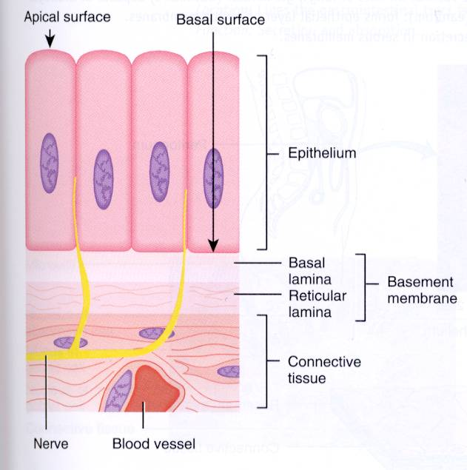

Seven Special Structural Characteristics of Epithelial Tissue:
1. Cellularity.
2. Specialized contacts: tight junctions and desmosomes; binds adjacent cells together; helps maintain polarity.
3. Polarity: apical and basal surface.
4. Basal lamina: noncellular, underlying supportive sheet of primarily glycoproteins; determines which molecules are going to be diffused and allowed to enter, also migrate to repair sounds.
5. Supported by connective tissue: basement membrane = basal lamina and reticular lamina; reinforces the epithelial sheet, helps it resist stretching and tearing, and defines the epithelial boundary.
6. Avascular (contains no blood vessels) but Innervated (supplied by nerve fibers); nourished by substances diffusing from blood vessels in the underlying connective tissue.
7. Regeneration: high regenerative capacity with receiving adequate nutrition.

- Cancerous epithelial cells have an important feature; failure to respect the boundary imposed by the basement membrane.

Indicate the Two Criteria Used to Classify Epithelial Cells:
- Can be classified by the cell shape and number of cell layers present.
1. Cell Shape:
Squamous Cells:
- Flattened and scale like with nucleus flattened.
Cuboidal Cells:
- Boxlike, tall as they are wide, nucleus round.
Columnar Cells:
- Tall; column shaped, nucleus elongated.
Columnar:
TALL AND COLUMN SHAPED
2. Cell Layers:
Simple Epithelia: single layer of cells and thin; typically found where absorption, secretion, and filtration occur.
Stratified Epithelia: two or more layers of cells; common in high abrasion areas where protection is important.
- In stratified epithelia, epithelia classified by cells shape in apical layer.
Simple Epithelia:
a) Simple Squamous Epithelium:
Description: single layer of flattened cells with disc-shaped central nuclei and sparse cytoplasm; simplest of the epithelia.
Function: allows materials to pass by diffusion and filtration in sites where protection is not important; secretes lubricating substances in serosae.
- Can be found in the kidneys and lungs.
- Two of them have special names according to their location;
Endothelium: provides a slick, friction-reducing lining in lymphatic vessels and in all hollow organs of the cardiovascular system.
Mesothelium: found in serous membranes, the membranes lining the ventral body cavity and covering its organs.

b) Simple Cuboidal Epithelium:
Description: Single layer of cube-like cells with large, spherical central nuclei.
Function: Secretion and absorption.
Location: Kidney tubules; small ducts and glands.

c) Simple columnar epithelium:
Description: Single layer of tall cells with round to oval nuclei.
Function: Absorption and secretion; also some have cilia which help move substances or cells through an internal pathway.
Location: 857-+ uterine tubes, and some regions of the uterus.

Stratified Epithelium Tissues:
e) Pseudostratified Columnar Epithelium:
Description: Single layer of cells of differing heights, some not reaching the free surface; nuclei seen at different levels; may contain mucus-secreting cells and bear cilia.
Function: Secrete or absorbs substances, a ciliated version contains mucus-secreting goblet cells.
Location: Male sperm-carrying ducts, and ducts of large glands, lines of trachea, upper respiratory tract.

Stratified Epithelia:
f) Stratified Squamous Epithelium:
- Consists of several thick layers, and well suited for protection (major role).
- Free surface cells are squamous, and the basal cells are cuboidal or columnar.
Keratinized type forms the external part of the skin and extends a short distance into every body opening that is directly continuous with the skin; others are nokeratinized: forms the moist lining of the esophagus, mouth, and vagina.
- PROTECTION.

f) Stratified Cuboidal Epithelium:
- Mostly found in ducts of larger glands (sweat glands, mammary glands, but are very rare.
- Consists of two layers of cuboidal cells.

g) Stratified columnar epithelium:
- Also very limited; found mainly in the pharynx, lining some glandular ducts, male urethra and transition areas/junctions between two other types of epithelia.
- Only its apical layer of cells is columnar

h) Transitional Epithelium:
- Basal layer are cuboidal or columnar; adapted for responding to stretch makes it helpful for when urine fills the bladder.
- Forms the lining of hollow urinary organs.

Glandular Epithelia:
Gland: one or more cells that make and secrete secretion; aqueous fluid that contains proteins.
- Secretion can refer to the gland’s product and process of making and releasing the product (obtains substances from the blood and transform them chemically into a product that is then discharged from the cell.)
Classified by:
- Site of product release: endocrine or exocrine.
- number of cells forming the gland; unicellular or multicellular.
Endocrine Glands: produce and release hormones into the blood; they are ductless.
Exocrine Glands: secrete products onto body surfaces (skin) or into body cavities.
- Unicellular secrete directly by exocytosis and multicellular glands do so via an epithelium-walled duct that transports the secretion to the epithelial surface.
- Mucous, sweat, oil/salivary glands, liver, pancreas, etc.

a) Unicellular exocrine glands:
- No ducts because only one cell.
- Just the goblet cells (digestive and respiratory tracts)
b) Multicellular exocrine glands:
- Consist of two basic parts; an epithelium-derived duct and a secretory unit (acinus) consisting of secretory cells; surrounded by supportive connective tissue which brings blood vessels and nerves.

Classification of Multicellular Glands:
- By structure and type of secretion.
- Simple glands (unbranched duct) or compound glands (branched duct).
- Further classified by secretory units:
- Turbular: if the secretory cells form tubes; alveolar if the secretory cells form small, flasklike sacs,
; if they have both types of secretory units.
Type of secretion:
Merocrine: Most common, secret products by exocytosis as produced; example, pancreas, salivary glands, most sweat glands.
Holocrine: Accumulate products within then rupture; example, only sebaceous glands; replaced by cell division.
Apocrine: Accumulates products within then apex pinches off, releasing secretory granules and cytoplasm.

Connective Tissue:
- Most abundant and widely distributed.
- Five major types: Mesenchyme, Connective Tissue proper, Cartilage, Bone, and Blood.
Functions:
1) Binding or support.
2) Protection.
3) Insulation.
4) Transportation.

Structural Organization of Connective Tissue:
1. Three Structural Elements of Connective Tissue:
a) Ground Substance: fills the space between cells and contains fibers.
- Composed of interstitial fluid and cell adhesion proteins [fibronectin, lamini; allows connective tissue cells to attach to matrix elements) and proteoglycans (consist of a protein core where glycosaminoglycans (GAGs) are attached).
- Functions; nutrients and other dissolved substances can diffuse between the blood capillaries and the cells.

b) Fibers: found in the matrix;
Collagen fibers: high tensile strength.
Elastic fibers: long thin fibers that form branching networks in the extracellular matrix; contain a rubberlike protein, elastin, allows them to stretch and recoil.
Reticular fibers: short collagenous fibers that supports blood vessels and soft tissues.

c) Cells: immature (“blast”) forms vs mature (“cyte”) forms.
- blasts: are actively dividing/synthesizing cells during growth and repair; secrete ground substance and fibers.
- cytes: primarily provide a level of maintenance.

Mesenchymal:
- Mature mature connective tissues from embryonic tissue, called mesenchyme.
- Ground substance contains sparse fibers.
- Eventually it differentiates into all other connective tissue cells and it provides a source of new cells in mature connective tissues.

Connective Tissue Proper: Loose Connective Tissues
a) Areolar:
Description: loose arrangement of fibers, gel-like matrix with all three fiber types: fibroblasts, macrophages, mast cells, and some white blood cells.
Function:
- Supports and binds other tissues (fibers).
- Holds body fluids (the ground substances).
- Defends against infection (white cells and macrophages).
- Stores nutrients as fat.
- Forms the subcutaneous tissue; cushions and attaches the sin to underlying structures.
Location: Widely distributed through the body, present in all mucus membranes.
Adipocytes, adipose/fat cells, make up 90% of this tissue’s mass.
b) Adipose:
Description: Sparse matrix, closely packed adipocytes, or fat cells, have nucleus pushed to the side by large fat droplet; richly vascularized meaning high metabolic activity.
Function: Provides reserve food fuel; insulates against heat loss; supports and protects organs, is an energy storage site.
- White fat stores nutrients for other cells and brown fat contains mitochondria, which use the lipid fuels to heat the bloodstream to warm the body.
Location: Under skin in subcutaneous tissue; around kidneys and eyeballs; within abdomen; in breasts.
c) Reticular:
Description: Network of reticular fibers in a typical soft ground substance; fibroblasts called reticular cells are scattered and widely distributed in the body but limited to certain areas.
Function: Fibers form a soft internal skeleton (stroma) that supports other cell types including white blood cells, mast cells, and macrophages;.
Location: Lymphoid organs (lymph nodes, bone marrow, and spleen).

Connective Tissue Proper: Loose Connective Tissues
d) Dense Regular:
Description: Dense parallel collagen fibers; a few elastic fibers; major cell type is the fibroblast; continuously manufactures fibers and scant ground substance, poorly vascularized.
Function: forms tendons: attaches muscles to bones or to muscles;: attaches bones to bones/joints; withstands great tensile stress when pulling force is applied in one direction.
- Also forms fascia, a fibrous membrane that wraps around and binds muscles, groups of muscles, blood vessels, and nerves.
Location: Tendon, most ligaments, aponeuroses.

e) Dense Irregular:
Description: thick collagen fibers are irregularly arranged; some elastic fibers, major cell type is fibroblast.
Function: Forms sheets in bodies which withstands tension exerted in many directions; provides structural strength.
Location: Fibrous capsules of organs and of joints; dermis of the skin, coverings that surround some organs (kidneys, bones, cartilages, muscles, and nerves).

f) Elastic Connective Tissue:
Description: Dense regular connective tissue containing a high proportion of elastic fiber.
Function: Allows tissue to recoil after stretching; maintains pulsatile flow of blood through arteries; aids passive recoil of lungs following inspiration.
Location: Walls of large arteries; within certain ligaments associated with the vertebral column; within the walls of the bronchial tubes.

Remaining Types Of Connective Tissue:
Cartilage: three types: hyaline cartilage (provide firm support with some pliability and absorbs compression at joints), elastic cartilage (has more elastic fibers, provides strength and exceptional stretchability), and fibrocartilage (rows of chondrocytes alternate with rows of thick collagen fibers, very compressible and resists tension well)
- Features between dense CT and bone; tough but flexible, also provides resilient rigidity.
- Avascular, devoid of nerve fibers
- Ground substance contains lots of the GAGs chondroitin sulfate & hyaluronic acid, chondronectin found in growing cartilage (adhesive protein), and firmly bound collagen fibers.
- Resists compression because of large amounts of water held in the matrix.
- Functions to cushion and support body structures.

Bone:
- Subclass: compact bone and spongy bone; matrix embedded with inorganic calcium salts which gives hardness & strength for support/protection of softer tissues; cavities for fat storage & synthesis of blood cells
Osteoblasts: produce the organic portion of the matrix; then bone salts are deposited on and between the fibers.
Osteocytes: reside in the lacunae within the matrix,
Osteoclasts: ………………………………………………….…………………

Blood:
Description: Red and white blood cells in a fluid matrix (plasma).
Function: Transport respiratory gases, nutrients, wastes, and other substances.
Location: Contained within blood vessels.

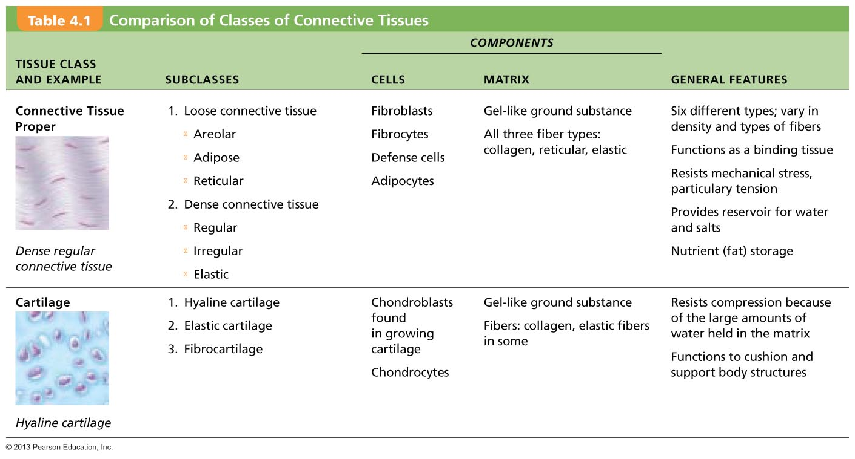
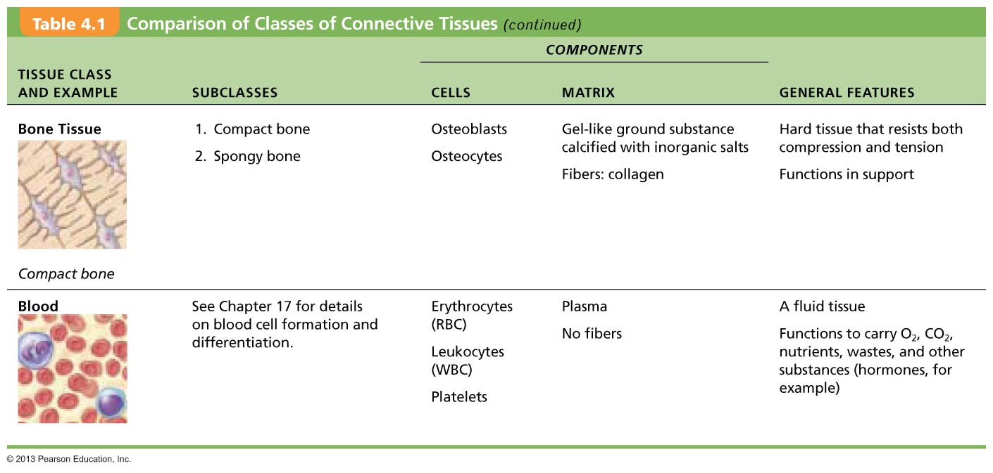
Muscle Tissue:
- Consists of elongated cells specialized to contract a cause movement.
- Based on structure and functions, the muscle tissues are:
- Skeletal muscle: attached to and moves the bony skeleton; cells are cylindrical and striated.
- Cardiac Muscle: forms the walls of the heart; pumps blood; cells are branched and striated.
- Smooth Muscle: in the walls of hollow organs; propels substances through the organs; cells are spindle shape and lack striations.

Nervous Tissue:
- Forms organs of the nervous system, composed of neurosn and supporting cells.
- Are branching cells that receive and transmit electrical impulses which are involved in body regulation and supporting cells support and protect neurons. Thick myofilaments

Cellular Physiology of Nerve and Muscle
2.1 Membrane Transport
Plasma Membrane:
- The plasma membrane encloses cell contents, mediates exchanges with the extracellular environment, and plays a role in cellular communication.
- It separates two of the body’s major fluid compartments; the intracellular fluid (within cells) and the extracellular fluid (outside cells).
- The fluid mosaic model is a fluid bilayer of lipids, consisting phospholipids, cholesterol, and glycolipids, with proteins inserted.

Membrane lipids:
- 75% phospholipids (lipid bilayer);
- Phosphate heads: charged polar & hydrophilic; attracted to water.
- Fatty acid tails: uncharged nonpolar & hydrophobic; avoid water.
- 5% glycolipids;
- Lipids with polar sugar groups on outer membrane surface.
- 20% cholesterol;
- Increases membrane stability.
- Includes a polar region (hydroxyl group) and nonpolar region (its fused ring system).

Membrane Proteins:
- Allow communication with environment.
- Responsible for most specialized membrane functions.
- Two types of membrane proteins;
Integral Proteins;
- Are firmly inserted into lipid bilayer; most are trans-membrane proteins that go through the entire membrane.
- Have hydrophobic and hydrophilic regions (can interact with lipid tails and water).
- Function is to transport proteins (channels and carriers), enzymes, or receptors.
Peripheral Proteins;
- Are loosely attached to integral proteins.
- Includes filaments that help support the membrane from its cytoplasmic side
- Functions as enzymes or motor proteins for shape change during cell division and muscle contraction; cell-to-cell connections.

- Many proteins in the extracellular fluid are glycoproteins with branching sugar groups. The sugar residues of the glycocalyx provide recognizable biological markers for cells to recognize each other.

Cell Junctions:
- Cell junctions join cells together and may aid or inhibit movement of molecules between or past cells.
Three Types Of Junctions:
Tight junctions: adjacent integral proteins fuse, forming impermeable junction, which prevent molecules from passing through the intercellular space.
Desmosomes: anchoring junctions mechanically couple cells; linker proteins (cadherins) extend between opposite plaque giving stability to cells.
Gap junctions: formed by trans-membrane proteins (connexions); allows adjacent cells to join and communicate.

Functions of Membrane Proteins: (LOOK AT PAGE 66 FIGURE FOR MORE DETAILS)
1. Transport.
2. Receptors for signal transduction.
3. Attachment to cytoskeleton and extracellular matrix.
4. Enzymatic activity.
4. Intercellular joining.
6. Cell-cell recognition.

Transport:
- A trans-membrane protein provides a hydrophilic channel across the membrane.
- Some transport proteins hydrolyze ATP as energy to actively pump substance across the membrane.
Receptors for Signal Transduction:
- A membrane protein exposed to the outside may have a binding site for a specific chemical messenger (transmitters, hormones).
- When bound, the chemical may cause a change in the protein that initiates a chain of reactions in the cell.
Attachment Proteins:
- Elements of cytoskeleton (cell`s internal supports) and extracellular matrix (fibers and substances outside the cell) may anchor to membrane proteins; helps maintain cell shape and location of certain membrane proteins.
- Others play a role in cell movement or bind adjacent cells together.
Enzyme Activity:
- A membrane protein may be an enzyme with its active site exposed to substances in the adjacent solution.
- A team of several enzymes in a membrane may catalyze sequential steps of a metabolic pathway (left to right).
Intercellular Joining:
- Membrane proteins of adjacent cells may be hooked together: intercellular junctions.
- Some membrane proteins (cell adhesion molecules [CAM]) provide temporary binding sites that guide cell migration and other cell-to-cell interactions.
Cell-Cell Recognition:
- Some glycoproteins (which are proteins bonded to short chain sugars) serve as identification tags that are specifically recognized by other cells.

Membrane Transport:
- Plasma membranes are selectively permeable; allows some substances to pass while excluding others.
- Substances cross membrane by; passive processes and active processes.
-Passive processes: require no energy (ATP); substances move down concentration gradient.
- Diffusion: simple diffusion; carrier- and channel-mediated facilitated diffusion; osmosis.
- Filtration: across capillary walls.
- Active Processes: energy (ATP) required moving substances across the membrane.

Passive Processes:
- Two main types of passive transport are diffusion and filtration.
Diffusion:
- Diffusion is when molecules or ions move from an area where they are in higher concentration to an area where they are in lower concentration down their concentration gradient.
- They are constantly colliding and changing direction because of their intrinsic kinetic energy.
- Because the force for diffusion is kinetic energy, speed of diffusion is influenced by: molecular size (smaller the faster), by temperature (warmer, the faster).
- Molecule will diffuse through if it is a) lipid soluble, b) small enough to pass through membrane channels, or c) assisted by a carrier molecule.
- Affected by concentration gradients and electrical charge on inner and outer faces of the membrane.
Simple diffusion: unassisted diffusion of lipid-soluble or very small particles.
Facilitated diffusion: assisted diffusion.
Osmosis: diffusion of a solvent (usually water) through a membrane.

Simple Diffusion:
- Nonpolar lipid-soluble (hydrophobic) substances diffuse directly through phospholipid bilayer; e.g. oxygen, carbon dioxide, fat-soluble vitamins, fats, urea, alcohol.
Facilitated Diffusion:
- Certain lipo-phobic molecules (glucose, amino acids, and ions) transported by Carrier-mediated facilitated diffusion by:
- Binding to protein (integral) carriers.
- Moving through water-filled channels.
Carrier-Mediated Facilitated Diffusion:
- Carriers are transmembrane integral proteins that are specific for transporting certain polar molecule, such as sugar and amino acids,that are too large to pass through membrane channels.
- Shape of the carrier allows it to pick up and release the transported substance, shielding it from the nonpolar regions of the membrane.
- Limited by number of carriers present.
- Carriers saturated when all engaged.
Channel-Mediated Facilitated Diffusion:
- Aqueous channels formed by trans-membrane proteins.
- Selectively transport ions or water.
- Two types of channels; leakage channels (always open) and gated channels (controlled by chemical or electrical signals).

Osmosis:
- Movement of solvent (water; polar) across selectively permeable membrane.
- Water diffuses directly through lipid bilayer via specific water channels; aquaporins (AQPs).
- Occurs when water is different on the two sides of the membrane.
- Osmolarity: refers to the total concentration of all solute particles in a solution.
- Extend on which solutes decrease water’s concentration depends on number of solute particles because one molecule/ion of solute displaces one water molecule.
- As water diffuses into the cell, the point is finally reached where hydrostatic pressure within the cell is equal to its osmotic pressure (tendency of water to move into the cell by osmosis).
- Osmotic imbalances cause cells to swell or shrink until either a) the solute concentration is the same on both sides of the membrane or b) the membrane stretches to its breaking point.

Filtration [Diffusion by Pressure]:
- Hydrostatic pressure: when water and solutes are forced through membrane or capillary wall by fluid.
- Since capillaries are thin (1 cell thick), diffusion easily occurs when blood flow pressure flows forces water and small solutes out.
Kidney: membrane pores of the Bowman’s capsule in the kidneys are very small and only filter albumins (the smallest of proteins).
Liver: have extremely large pores to allow a variety of solutes to pass through and be metabolized; detoxifies blood.

Membrane permeable to both solutes and water:
- Solute and water molecules move down their concentration gradients in opposite directions; fluid volume remains the same in both compartments; freely permeable membrane.
- Either direction of solution can have lower, greater, or the same osmolarity (measure of solute concentration).
Membrane permeable to water, impermeable to solutes:
- Solute molecules are prevented from moving but water moves by osmosis; volume increases in the compartment with the higher osmolarity; selectively permeable membrane.
- Even if both solutions have identical osmolarity, the volume of the solution may be greater on one side because only water is free to move.

Osmolarity & Tonicity:
Osmolarity: describes the concentration of solute particles in a quantity of osmoles OsM per liter.
Note: 1 mM NaCl = 2 mOsmol/L;
1 mM glucose – 1 mOsmol/L
1 mM CaCl₂- 3 mOsmol/L
Tonicity: Ability of a solution to alter cell’s volume due to non-penetrating solute concentration.
- Isotonic : Solution with same concentration as non-penetrating solute and cell.
- Hypotonic: Solution with higher non-penetrating solute concentration than cell.
- Hypotonic: Solution with lower non-pepetrating solute concentration than cell.

The Effects Of Solutions Of Varying Tonicities On Living Red Blood Cells:
a) Isotonic Solutions: Cells retain their normal size and shape in isotonic solutions (same solute/water concentration as inside cells; water moves in and out).
b) Hypertonic Solutions: Cells lose water by osmosis and shrink in a hypertonic solution (contains a higher concentration of solutes than inside the cells).
c) Hypotonic Solutions: Cells take on water by osmosis until they become bloated and burst, also known as lyse (contains a lower concentration of solutes than are present inside cells).
- Osmolarity is based on its total solute concentration.
- Tonicity is based on how the solution affects cell volume, depends on a) solute concentration and b) solute permeability of the plasma membrane.
- Osmosis is extremely important in determining distribution of water in the various-fluid containing compartments of the body.
- Osmosis continues until osmotic and hydrostatic pressure of blood against capillary wall forces water out of the capillary blood, but the solutes in blood are too large to cross the capillary membrane draw water back into the bloodstream, resuling in a very little net loss of plasma fluid occurs.

Applications In Medicine:
1. Hypertonic solutions for edema: pull water out of swollen tissues.
2. Hypotonic Solutions to carefully rehydrate dehydrated patients.

- 0.9% NaCl isotonic saline refers to it having normal concentration.

- The ability to control cell volume is a pivotal (vital) protective cell function.
- Volume regulatory electrolyte loss and accumulation is mediated by changes in the activity of membrane carriers and channels.
-After the volume perturbation (disturbance), activation of these transport pathways occurs rapidly, indicating that the channel and carrier proteins are either resident in the cell or are rapidly inserted from a pre-existing cytoplasmic pool.

Active Transport:
- Requires carrier proteins that combine specifically and reversibly with the transported substances.
- Moves solutes/ions, against a concentration gradient by expending energy from cells.
- Primary active transport uses energy that comes from directly from hydrolysis of ATP.
- Secondary active transport, transport is driven indirectly by energy stored in ionic gradients created by primary active transport pumps; are all coupled systems (they move more than one substance at a time).
- Symport system: two trasnpoted substances move in the same direction.
- Antiport system: transported substances cross the membrane in opposite directions.

Primary Active Transport:
- hydrolysis of ATP results in the phosphorylation of the transport protein, which causes the protein to change its shape so it pumps the bound solute across the membrane.
- Include calcium and hydrogen pumps, and sodium-potassium pump (which the carrier/pump is an enzyme called Na+ -K+ ATPase.
- ionic concentration differences are important for muscle and nerve cells to function normally and body cells to maintain normal fluid volume.
- Ions diffuse according to electrochemical gradients *crucial for cardiac, skeletal muscle, and neuron function).

Secondary Active Transport:
- A single ATP-powered pump can indirectly drive the secondary active transport of several other solutes.
- The energy of an ion gradient is used to transport a substance passively.
- Substances either move symport or antiport.

Vesicular Transport:
- Fluids containing large particles and macromolecules are transported across the cellular membrane inside memebranous sacs called viscles.
- Moves into the cell (endocytosis) and out of the cell (exocystosis).
- Uses transcytosis (moving substances into, across, and then out of the cell)
- Uses vescular trafficking (moving substances from one area in the cell to another).
- Are energized by ATP
Endocytosis: (via clathrin-coated vesicles)
Phagocytosis:
- A large external particle is surrounded by a `seizing: foot and becomes enclosed in a vesicle (phagosome)
- Occurs in some white cells and macrophages.
Pincotysosis (fluid-phase endocytosis):
- Occurs with dissolved molecules; plasma membrane sinks beneath external fluid droplets containing solutes and the edges fuse, forming a fluid-filled vesicle.
- Occurs in most cells, important for taking in dissolved solutes by absorptive cells of the kidney and intestines.
Receptor-mediated Endocytosis:
- Selective endocytosis and transcycotis.
- External substances bind to membrane receptors.
- Protein-coated vesicles provide the main route for endocytosis and transcytosis of bulk solids, macromolecules and fluids.
- Substances taken up include enzymes, insulin (some hormones), low density lipoporteins (cholesterol) and iron.
- Allows cells to concentrate material present only in very small amounts in extracellular fluid.

Caveolae: (caveolin-coated vesicles)
- Selective endocytosis and transcytosis; external substances bind to membrane receptors.
- Provide sites for cell signaling and cross talk between signaling pathways.

Vesicular Trafficking (coatomer-coated vesicles):
- Vesicles pinch off from organelles and travel to other organelles to deliver their cargo.
- Intracellular trafficking between certain organelles.

Exocytosis:
- Secretion or ejection of substances from a cell, substance is enclosed in a membranous vesicle, which fuses with the membrane and ruptures, releasing the substances to the exterior.
- Stimulated by cell-surface signal such as binding of a hormone to a membrane receptor or a change in membrane voltage.
- Accounts for hormone secretion, neurotransmitter release, mucus secretion, and ejection of wastes.
Vesicular transport also requires energy be provided.
- Involves a process where transmembrane proteins on the vesicles called v-SNAREs, recognize certain plasma membrane proteins called t-SNAREs and bind to them, which anchor vesicles to the plasma membrane and ejects the substances from the cell.

DON’T KNOW IF I NEED TO KNOW THIS:
- Voltage: is electrical potential energy resulting from the separation of oppositely charged particles.
- Diffusion causes ionic imbalances that polarize the membrane, and active transport process maintain that membrane potential.
- Resting potential is determined by the concentration gradient of K+ potassium and by the differential permeability of the plasma membrane to K_ and other ions.
- Extracellular fluid contains more Na+ which is balanced by Cl-.

- The resting membrane potential is determined by k+ because at rest, the membrane is much more permeable to K+ than Na+.
- Active transport pumps maintain these conditions.
- a) K+ diffuse down their steep concentration gradients (out of the cell_ by leakage channels which results in a negative charge on the inner plasma membrane face, b) K+ also move into the cell because they are attracted to the negative charge on the plasma membrane face, c) A negative membrane potential is established and potassium’s concentration gradient is balanced; one K+ leaves as one K+ comes in.
- Sodium Na+ is also attracted to the cell interior by its concentration gradient.
- Cl- does not contribute to resting membrane potential because its concentration and electrical gradients balance each other.

Active Transport Maintains Electrochemical Gradients:
- The rate of active transport is equal to/depends on the rate of Na+ diffusion into the cell.
- Na+K+ pump maintains both the membrane potential and the osmotic balance.
- Diffusion of K+ across the membrane is enabled because of the membrane’s permeability to it and its concentration gradient, but the negative charges on the cell interior prevent K+ diffusion.
- Electrochemical gradient attract Na+ into the cell but the membrane’s impermeability to it limits its diffusion.

The Plasma Membrane: Cell-Environmental Interactions:
- Cells interact directly and indirectly with other cells, indirect interactions involve extracellular chemicals carried in body fluids or forming part of the extracellular matrix.
- Molecules of the glycocalyux are involved in cell environment interactions.
- Glycocalyx has two types; cell adhesion molecules (CAMs) and plasma membrane receptors.
- Voltage-gated channel proteins allow cells to respond toe electrical signals.
Roles of Cell Adhesion Molecules:
- Play a key role in embryonic development and wound repair and in immunity.
- Sticky glyproteins (cadherins and integrins):
- Allows cells to anchor themselves to molecules in the extracellular space and to each other
- Help cells migrate past each other
- SOS signals signal white blood cells to nearby infected or injured area
- Mechanical sensors respond to changes in local tension or fluid movement at the cell surface by stimulating synthesis or degrading of adhesive membrane tight junctions
- Transmitters of intracellular signals that direct cell migration, proliferation, and specialization.
Roles of Plasma Membrane Receptors:
- Membrane receptors are integral proteins and glycoproteins that serve as binding sites.
Functions:
- Contact signaling; cells recognize each other.
- Chemical signaling; ligands (neurotransmitters (nervous system signals), hormones (endocrine system signals), and paracrines (chemicals that act locally and are rapidly destroyed) bind to plasma membrane receptors.
- Target cell`s response depends on the internal machinery that the receptor is linked to.
- When ligand binds to a membrane receptor, the receptor`s structure changes and cell proteins are altered;
- Catalytic receptor proteins are membrane proteins that respond to ligands by becoming activated enzymes.
- Chemically gated channel-linked receptors (common in muscle and nerve cells), respond by transiently opening or closing ion gates, which changes the excitability of the cell.
- G protein-linked receptors: use G protein (a regulatory molecule that relays to activate/inactive a membrane-bound enzyme or ion channel; which generates more intracellular chemical signals called second messengers.
- Messengers are cyclic ATP and ionic calcium which activate protein kinase enzymes, which transfer phosphate groups from ATP to other proteins.
Role of Voltage-Gated Membrane Channel Proteins: Electrical Signaling-
- Certain plasma membrane proteins are channel proteins that respond to changes in the membrane potential by opening or closing the channel..

Cellular Physiology of Nerve and Muscle
2.2. Neurons:
The Nervous System:
- The nervous system is the master control and contains 100 trillion synapses (electrical and chemical).
- The human brain has 1 trillion cells, 86-100 billion neurons, and 900 billion glial cells.
- Main components are the brain, spinal cord, and nerves, which regulates and controls body functions.
- Two major type cells are neurons and supporting cells.
Functions and Divisions of the Nervous System:
Three functions:
- Sensory input: the gathered information from sensory receptors used to monitor changes occurring .
- Integration: when the nervous system processes and interprets sensory input and decides what should be done at each moment.
- Motor output: the activation of effector organs, muscles and glands, to cause a response.
Central Nervous System:
- Consists of the brain and spinal cord.
- Integrating and control center of the nervous system.
- Interprets sensory input and dictates motor output based on reflexes, current conditions, and past experiences.
Peripheral Nervous system:
- Consists mainly of nerves (bundles of axons) that extend from the brain and spinal cord.
- Spinal nerves carry impulses to and from the spinal cord, and cranial nerves carry impulses to and from the brain.
- Serves as communication link between the body and CNS.
- PNS has two functional subdivisions: sensory division and motor vision.
Sensory division:
- Consists of nerve fibers that convey impulses to the CNS from sensory receptors.
- Somatic Sensory fibers: convey impulses from the skin, skeletal muscles and joints.
- Visceral sensory fibers transmit impulses from the visceral organs.
Motor division:
- Transmits impulses from the CNS to muscles and glands which activate muscles to contract and glands to secrete.
- Two main parts:
The somatic nervous system: composed of somatic motor nerve fibers that conduct impulses from the CNS to skeletal muscles; allows us to consciously control our skeletal muscles.
The autonomic nervous system: consists of visceral motor nerve fibers that regulate the activity of smooth muscles, cardiac muscles, and glands.

Nervous Tissue:
- Made up of two types of cells; neuroglia (small cells that surround and wrap the more delicate neurons) and neurons (transmit electrical signals).
Neuroglia:
- Neurons associate closely with much smaller cells are called neuroglia or glial cells.
- Six types; four in CNS (astrocytes, microglial cells, ependymal cells, and oligodendrocytes) and two in PNS (satellite cells and shwann cells)

Neurons:
- Highly specialized cells that conduct electrical impulses.
- Cytoplasmic extensions that enable them to respond to stimuli (dendrites) and transmit electrical impulses over great distances within the body (axons).
- Extreme longevity (>100 years).
- Amitotic. (Amitosis: direct cell division by splitting the nucleus and cytoplasm, without spindle formation or appearance of chromosomes.)
- High metabolic rate; requires continuous supply of oxygen o2 and glucose.
- All have cell body and one or more processes.

Neuron Cell Body (Perikaryon/Soma):
- Biosynthetic centre of neuron (free ribosome and endoplasmic reticulum) is the most active and best developed of any cell; synthesizes the essential chemistry.
- Spherical nucleus with nucleolus and some contain pigments.
- Clusters of cell bodies in the CNS are called nuclei.
- Cell bodies that lie along the nerve in the PNS are called ganglia.

Neuron Processes:
- Bundles of neuron processes are called tracts in the CCNS and nerves in the PNS.
- Two types of processes; dendrites and axons.

Structure of Motor Neuron:
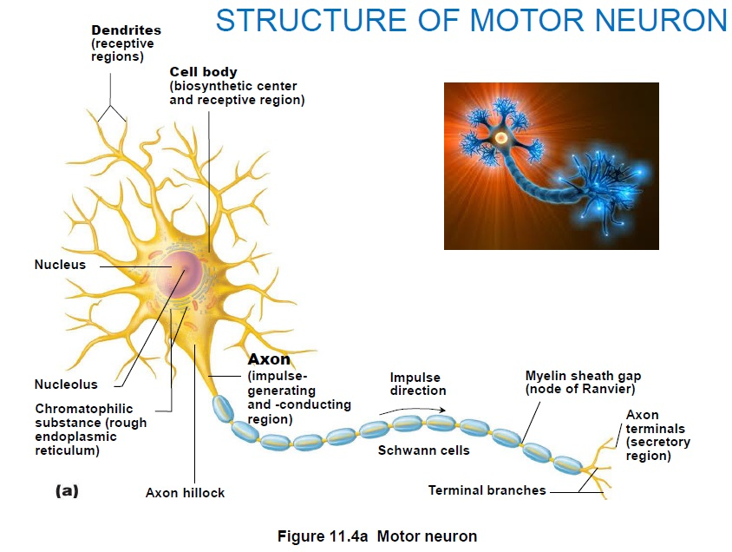

Dendrites:
- In motor neurons; hundreds short, tapering, diffuse processes; same organelles as in body.
- Receptive (input) region of the neuron.
- Convey incoming messages toward cell body as graded potentials (short distance signals).
- In many brain areas fine dendrites specialized in collecting information with dendritic spines (appendages with bulbous or spiky ends).

The Axon:
- Each neuron has one axon, arises from a cone-shaped area called axon hillock.
- In some, axons short or absent.
- Usually represent most of length of cell; some are 1 metre long.
- Long axons are called nerve fibers.
- Axon collaterals are the occasional branches.
- Many branches are located at the end (terminus); can have up to 10,000 terminal branches.
- Axon terminals located at the distal endings.

The Axon: Functional Characteristics:
- Generates and transmits nerve impulses along axolemma (cell membrane) to axon terminal.
- In motor neurons, nerve impulses are generated at the junction of the axon hillock and axon and conducted along the axon to the axon terminals called secretory region. When it reaches the axon termianls it releases neurotransmitters;
- Neurotransmitters released from nerve endings/vesicles either excite or inhibit neurons and carries on many conversations with different neurons at the same time.
- Lacks rough Endoplasmic Reticulum, ER, and Golgi apparatus;
- Relies on cell body to renew proteins and membranes and efficient transport mechanisms to distribute them.
- Quickly decay if cut or damaged (eg. spinal injury)

Axonal Transport:
- Molecules and organelles are moved along axons by motor proteins and cytoskeletal elements; movements are bi-directional (which uses ATP-dependant proteins, kinesin and dynein.
- Retrograde: moving backwards and Anterograde: moving forward.
- Substances moving retrograde direction are organelles looking to be degraded or recycled.
- Retrograde transport is important to intracellular communication to maintain the cell body conditions at the axon terminals and deliver the cell body vesicles containing signal molecules.
- Bi-directional

Myelin Sheath:
- Composed of myelin; a long whitish, protein-lipoid substance.
- Protects and electricallyl insulates fibers and increases transmission speed.
- Myelinated fibers: segmented sheath around long or large diameter axons, conduct nerve impulses rapidly.
- Non-myelinated fibers conduct impulses more slowly.
- Only associate with axons.
Myelination in the PNS:
- Formed by Schwann cells and wrapt hemselves around axons in a jelly roll fashion; initially loose but gradually tighter.
- Contains less protein and lacks channel and carrier proteins; making them good electrical insulators.
- Gaps between the myelin sheath are called nodes of Ranvier.
- Nonmyelinated fibers don’t have a wrapping process.
Myelination in the CNS:
- Formed by oligodendrocytes.
- Has multiple flat processes that coil around as many as 60 axons at the same time.
- Also contains gaps that separate adjacent sections of the axon’s myelin sheath.
- Regions of the brain and spinal cord containing dense collections of myelinated fibers are called white matter, mostly fiber tracts.
-Gray matter contains mostly nerve bodies and nonmyelinated fibers.

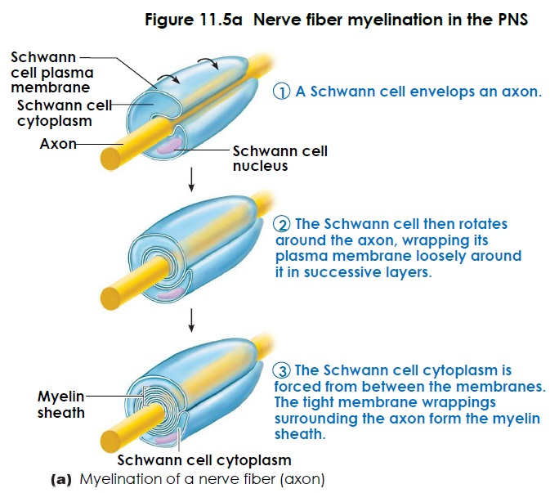

Structural Classification of Neurons:
- Classified by the number of processes extending from their cell body.
- Multipolar neurons: ≥ 3 processes; 1 axon, others dendrites; most common/major neuron in CNS.
- Bipolar neurons: 2 processes; 1 axon and 1 dendrite; are rare (eg., retina and olfactory)
- Unipolar neurons: 1 short process; divides into a T form, both branches are considered axons.
- Distal (peripheral) process: associated with sensory receptor.
- Proximal (central) process: enters CNS.
- Originate as bipolar neurons, the two processes converge and partially fuse to form the short single process.
Functions:
Multipolar neurons:
- Are interneurons (connect motor and sensory neurons) that conduct impulses within the CNS, integrating sensory input or motor output.
- Some are motor neurons (from the CNS to muscle or gland) that conduct impulses along the efferent pathways from the CNS to a muscle or gland.
Bipolar neurons:
- All are sensory neurons (from sensory receptors to CNS) located in a special organ.
Unipolar neuron:
- Most are sensory neurons that conduct impulses along afferent pathways to the CNS for interpretation.

Membrane Potentials:
Role of Membrane Ion Channels:
- Are large proteins that are selective to the type of ion it allows to pass.
- Leakage/non-gated channels are always open.
Chemically gated/ligand-gated channels: open when the appropriate chemical (neurotransmitter) binds.
Voltage-gated channels: open and close in response to changes in the membrane potential.
Mechanically gated channels: open in response to physical deformation of the receptor.
- They move along chemical concentration gradients when they diffuse passively from an area of higher concentration to an area of lower concentration.
- They move along electrical gradients when they move toward an area of opposite electrical charge.
- Electrochemical gradients: concentration gradient and electrical gradient.

Synapse:
- Neurons functionally connect by synapses.
- Axodendritic: between axon terminals of one neuron and dendrites of others.
- Axosomatic: between axon terminals of one neuron and soma of others.
- Or from one neuron to an effector cell.
- Less common types; Axoaxonic (axon to axon), Dendrodendritic (dendrite to dendrite), and Somatodendritic (dendrite to soma).

Chemical Synapses:
- Utilise neurotransmitters.
- Axon terminal of presynaptic neuron contains synaptic vesicles filled with neurotransmitters which bind to the neurotransmitter receptor region on postsynaptic neuron’s membrane, usually on dendrite or cell body.
- Two parts are separated by synaptic cleft; fluid-filled space through which transmitter diffuses.

Electrical Synapses:
- Less common;
- Neurons electrically coupled known as gap junctions, which connect cytoplasm of adjacent neurons.
- Rapid communication (10⁶ ions/sec or greater).
- Uni or bi-directional.
- Local inhibitory networks synchronize activity.
- Abundant in Embryo nervous tissue; also occurs in heart and gut.

Information Transfer: Chemical Synapses
- Action potential arrives at axon terminal which causes voltage-gated Ca²⁺ channels to open and Ca²⁺ floods into the cell.
- Synaptotagmin protein binds Ca²⁺ and promotes fusion of synaptic vesicles with axon membrane.
- Exocytosis (cell direct content of secretory vesicle out of the cell membrane) of neurotransmitter into synaptic cleft occurs; higher the impulse frequency, the more that is released.
- Neurotransmitter diffuses across synapse and binds to receptors on postsynaptic neuron; often chemically-gated ion channels.
- Ion channels are opened which causes an excitatory or inhibitory event known as graded potential.
- Neurotransmitter effects terminated by re-uptake (sending neuron reabsorbs remaining neurotransmitters), enzymatic degradation, and diffusion away.

The Resting Membrane Potential:
- The Resting Membrane Potential: the potential difference across membrane of resting cell: -70 mV in neurons (inside negative relative to positive outside); actual voltage difference varies from -40 mV to -90 mV.
- Membrane is polarized.
- Generated by; differences in ionic make up of ICF and ECF and differential permeability of the plasma membrane to those ions.
- Sodium/Potassium ATPases (pumps) maintain the concentration gradients of Na+ and K+ across the membrane.
Differences in Ionic Composition:
- ECF has higher concentration of Na+; balanced by [Cl-].
- ICF has higher [K+] than ECF; balanced by negative charged proteins.
- K+ plays most important role in resting potential.
Differences in Plasma Membrane Permeability:
- 25 x more permeable to K+ than Na+ (more leakage channels).
- Impermeable to large anionic (negatively charged ion) proteins.
- Slightly permeable to Na+ via leakage channels.
- Sodium diffuses into cell down concentration gradient and Potassium diffuses out of cell down concentration gradient.
- Membrane is quite permeable to Cl-.

Membrane Potentials that act as Signals:
- Use changes in their membrane potential as communication signals to receive, integrate, and send information.
- Can produce two types of signals; graded potentials (which are usually incoming signals operating short distances) and action potentials (which are long distance signals of axons).

Excitatory vs. Inhibitory Actions:
Depolarization:
- Decrease in resting membrane potential (toward 0 and above).
- Inside becomes less negative than resting membrane potential.
- Increases probability of producing a nerve impulse.
Hyperpolarization:
- An increase in membrane potential (away from 0).
- Inside of cell is more negative than resting membrane potential.
- Reduces probability of producing a nerve impulse.

Graded vs. Action Potentials:
- Graded potential: occurs in the cell body and dendrites, typically and travel short distances; within cell body to axon hillock.
- It has various sizes which decays with distance and requires chemical (neurotransmitter) or sensory stimulus to open ion channels.
- Does not have a positive feedback cycle.
- Can either be depolarized or hyperpolarized; repolarization occurs when stimulus is no longer present.
- Initial effect on stimulus is it opens chemically gated channels that allow simultaneous Na+ and K+ fluxes and also opens chemically gated K+ or Cl- channels.
- Peak membrane potential; depolarizes (moves toward 0 mV and hyperpolarizes (moves toward -90 mV)
- Name depends on where it occur and what function they perform;
- When the receptor of the sensory neuron is excited by stimuli it is a receptor potential/generator potential.
- If the stimulus is a neurotransmitter released by another neuron, it is called postsynaptic potential because the neurotransmitter is released into a fluid-filled gap called a synapse.

- Action potential occurs on the axon hillock and axon and travel long distances; from trigger zone at axon hillock through entire length of axon.
- It is always the same size which does not decay with distance and voltage (depolarization, triggered by graded potential reaching threshold) opens ion channels.
- Positive feedback cycle is present.
- Repolarization occur when the voltages are regulated; when Na+ channels inactivate and K+ channels open.
- Initial effect of stimulus opens voltage-gated channels; first Na+ channels, then K+ channels.
- Peak membrane potential is +30 to +50 mV.
1) Resting state: No ions move through voltage-gated ions.
2) Depolarization: caused by Na= flowing into the cell.
3) Repolarization caused by K+ flowing out of the cell.
4) Hyperpolarization: caused when K+ continuing to leave the cell
- Repolarization restores resting electrical conditions but not resting ionic conditions.

Action Potentials (AP):
- Occur in axons of neurons (and muscle cells).
- A brief reversal of membrane potential with a change in voltage of ~100 mV.
- Do not decay over distance as graded potentials do.
1) Resting state; no ions move through voltage-gated channels.
2) Depolarization; is caused by Na+ flowing into the cell.
3) Repolarization; is caused by K+ flowing out of the cell. (Repolarization resets electrical conditions, not ionic conditions. After repolarization, Na+/K- pumps restore ionic conditions.
4) Hyperpolarization; is caused by K+ continuing to leave the cell.
- AP is caused by permeability changes in the plasma membrane/is a brief change in membrane potential in a “patch” of membrane that is depolarized by local currents.

Action Potential: Depolarizing Phase
- Depolarizing local currents open voltage-gated Na+ channels; Na+ rushes into cell.
- Na+ influx causes more depolarization which opens more Na+ channels, making ICF less negative.
-At threshold (-55 to -50 mV) positive feedback causes opening of all Na+ channels which reverses the polarity of the membrane back to +30 mV; spike of ‘action potential’.
- Magnitude increases when stimuli become more intense.

Action Potential: Repolarizing Phase
During repolarizing phase:
- Na+ channels slow inactivation gates close.
- Membrane permeability to Na+ declines to resting state.
- Action potential spike stops rising.
- Slow voltage-gated K+ channels open.
- K+ exists the cell and internal negativity is restored.

Action potential propagation in nonmyelinated and myelinated axons:
a) In bare plasma membranes, voltage decays; without voltage-gated channels, as one a dendrite, voltage decays because current leaks across the membrane.
b) In nonmyelinated axons, conduction is slow (continuous conduction); voltage-gated Na+ and K+ channels regenerate the action point at each point along the axon, so voltage does not decay. Conduction is slow because it takes time for ions and for gates of channel proteins to move, and this must occur before voltage can be regenerated.
c) In myelinated axons, conduction is fast (saltatory [leaps] conduction); myelin keeps current in axons (voltage doesn’t decay much) and action potentials are generated only in the myelin sheath gaps and appear to jump rapidly from gap to gap.

Stimulus Intensity:
- Action potentials are independent of stimulus intensity.
- CNS detects the difference between a weak and strong stimulus because strong stimuli cause action potentials to occur more frequently and CNS determines stimulus intensity by the frequency; higher frequency = stronger stimulus.

Refractory periods:
- Absolute refractory period: when the Na+ channels open until they begin to reset to their original resting state.
- Relative refractory period is the interval following the absolute refractory period; most Na+ channels return to their resting state, some K+ channels are still open, and repolarization is occurring.
Conduction of Velocity:
- Conduction velocities of neurons vary widely.
- Nerve fibers that transmit impulses most rapidly are found in neural pathways.
- Axons that conduct impulses more slowly serve internal organs.
- Rate of impulse propagation depends on two factors:
- a) axon diameter: larger the diameter, faster it conducts impulses.
- b) Degree of myelination: in continuous conduction, action potential involving nonmyelinated axons are slower.

Postsynaptic Potentials:
- There are two types; excitatory postsynaptic potentials (EPSP) and inhibitory postsynaptic potentials (IPSP).
EPSP:
- EPSP is a local depolarization) of the postsynaptic membrane that brings the neuron closer to action potential threshold; neurotransmitter binding opens chemically gated ion channels, allowing Na+ and K+ to pass through simultaneously in opposite directions (Na+ influx greater than K+ efflux).
- EPSP helps trigger action potential if EPSP is of threshold strength; it can spread to axon hillock, trigger opening of voltage-gated channels, and cause action potential to be generated.
IPSP:
- A local hyperpolarization of postsynaptic membrane that drives the neuron away from action potential threshold.
- Neurotransmitter binding opens K+ or Cl- channels.

Synaptic Integration: Summation
- A single EPSP cannot induce an action potential; it can summate.
- IPSPs can also summate.
- Most neurons receive both excitatory and inhibitory inputs from thousands of other neurons but action potential only occurs if EPSP`s predominate and bring the threshold higher.

Types:
Temporal Summation: one or more presynaptic neurons transmit impulses in rapid-fire order. (2 excitatory stimuli close in time cause EPSPs that add together).
Spatial Summation: postsynaptic neuron stimulated simultaneously by large number of terminals at same time (2 simultaneous stimuli at different locations cause EPSPs that add together).
- Spatial summation of EPSPs and IPSPs changes the membrane potential and can cancel each other out.
- 2 stimuli separated in time cause EPSPs that do not add together; no summation.

Integration: Synaptic Potentiation
- Repeated use of synapse increases ability of presynaptic cell to excite post synaptic neuron;
- Ca²⁺ concentration increases in presynaptic terminal and postsynaptic neuron.
- System is PRIMED.
- Brief high-frequency stimulation partially depolarizes postsynaptic neuron.
- Chemically gated channels (NDMA [glutamate] receptors) allow Ca² entry which activates kinase enzymes that promote more effective responses to subsequent stimuli.

Integration: Presynaptic Inhibition
- Neurotransmitter release by one neuron (usually excitatory neuron) inhibited by another neuron via an axo-axonic synapse.
- Less neurotransmitter is released; smaller EPSPs formed; think of it as volume control.

Neurotransmitters:
- 60 neurotransmitters have been identified.
- Most neurons make two or more neurotransmitters; neurons can exert several influences.
- Usually released at different stimulation frequencies.
- Classified by;
a) Chemical structure.
b) Function (excitatory vs. inhibitory).
c) Type of receptor(s).
d) Actions direct (ion channels): indirect 2nd messengers).
- Promotes rapid responses by altering membrane potential; examples: ACh and GABA.

Neurotransmitters: Indirect Actions
- Through second messengers, usually G protein pathways.
- Oversee slow synaptic responses.
- Broader, longer-lasting effects similar to hormones.
- Biogenic amines, neuropeptides, and dissolved gases.

- G protein signaling mechanisms are like a molecular relay race; Ligand (1st messenger), Receptor, G protein, Enzymes, 2nd messenger.
1. Neurotransmitter (1st messenger) binds and activates receptor.
2. Receptor activates G protein.
3. G protein activates adenylate cyclase.
4. Adenylate cyclase converts ATP to cAMP [cyclic adenosine monophosphate {cyclic ATP}] (2nd messenger).
5a. cAMP changes membrane permeability by opening or closing ion channels.
5b. cAMP activates enzymes.
5c. cAMP activates specific genes.

Channel-Linked (Ionotropic) Receptors:
- Ligand-gated ion channels.
- Action is immediate and brief.
- Excitatory receptors are channels for small cations (positively charged ions); Na+ influx contributes most to depolarization (Glutamate).
- Inhibitory receptors allow Cl- influx that causes hyperpolarization (GABA)

G Protein-Linked (Metabotropic) Receptors
- Responses are indirect, complex, slow, and often prolonged.
- Trans-membrane protein complexes.
- Cause widespread metabolic changes.
- Examples: muscarinic ACh receptors, receptors that bind biogenic amines (derived from ammonia) and neuropeptides.

Neural Integration:
- Neurons function in groups that contribute to broader neural functions.
- Billions of neurons in the CNS; integration allows the individual parts to become a smoothly operating whole.
- CNS neurons are organized into several types of neuronal pools, each with distinguishing patterns of synaptic connections called circuits.
- Four types of circuits; diverging, converging, reverberating, and parallel after-discharge.
- In serial processing, one neuron stimulates the next in sequence, producing specific, predictable responses, as in spinal reflexes. A reflex is a rapid , involuntary motor response to a stimulus.
- Reflexes are mediated over neural pathways called reflex arcs. The minimum number of elements in a reflex arc is 5: receptor, sensory neuron, integration center, motor neuron, and effector.

- In parallel processing, which underlies complex mental functions, impulses travel along several pathways to different integration centers.

2.3 Muscles:
Muscle Tissue:
- Makes up 50% of body’s mass.
- Transforms chemical energy (ATP) to directed mechanical energy resulting in exerting force.
- Includes three types; skeletal, cardiac, and smooth.
- Myo, mys, and sarco = prefixes for muscle.
- Skeletal and smooth muscle cells are called muscle fibers.

Comparison of Skeletal, Cardiac, and Smooth Muscle:
Skeletal Muscle:
- Attached to bones or (some facial muscles) to skin.
- Appearance of cell; single, very long, cylindrical, multinucleate (two or more nuclei) cells with obvious striations.
- Elaborate sarcoplasmic reticulum but doesn’t contain gap junctions.
- Cells exhibit individual neuromuscular junctions.
- Regulation of contraction is voluntary via axon terminals of the somatic nervous system.
Cardiac Muscle:
- Located in the walls of the heart.
- Appearance of cells: branching chains of cells; uni- or binucleate; striations.
- Sarcoplasmic reticulum is less than skeletal muscle (1-8% of cell volume); scant terminal cisterns.
- Gap junctions located at intercalated discs; but cells do not exhibit individual neurotransmuscular transjunctions.
- Regulation of contraction is involuntary; intrinsic system regulation; also autonomic nervous system controls; hormones; stretch.
Smooth Muscle:
- Located in unitary muscle in walls of hollow visceral organs (other than the heart); multi-unit muscle in intrinsic eye muscles, airways, large arteries.
- Appearance of cells: single, fusiform, uninucleate; no striations.
- Sarcoplasmic reticulum is equivalent to cardiac muscle (1-8% of cell volume); some SR contacts the sarcolemma.
- Gap junctions located in unitary muscle.
- Cells exhibit individual neuromuscular junction in multi-unit muscle, not unitary muscle.
- Regulation of contraction is involuntary; autonomic nerves, hormones, local chemicals; stretch.

Skeletal Muscles:
- Attached to bones and skin.
- Elongated cells called muscle.
- Striated (striped).
- Voluntary; conscious control.
- Contract rapidly; tire easily; powerful.
- Require nerve stimulation.
- Responsible for overall body mobility.
*KEY WORDS: SKELETAL, STRAITED, AND VOLUNTARY.

Cardiac Muscle:
- Occurs only in the heart; bulk of the heart walls.
- Striated but not voluntary.
- Does contract without being stimulated by the nervous system.
*KEY WORDS: CARDIAC, STRIATED, AND INVOLUNTARY.
Smooth Muscle:
- Found in walls of hollow visceral organs, such as stomach , urinary bladder, and respiratory passages.
- Force fluids and other substances through internal body channels.
- Consists of elongated cells but no striations.
- Involuntary control, contractions are slow and sustained.
* KEY WORDS: VISCERAL, NONSTRAITED, AND INVOLUNTARY.

Skeletal Muscle:
- Each muscle is served by one artery, one nerve, and one or more veins.
- Enter and exit near central part and branch through connective tissue sheaths.
- Every skeletal muscle fiber is supplied by nerve ending that controls its activity.
- Huge nutrient and oxygen need; generates large amounts of waste.

Characteristics of Muscle Tissue:
- Four special characteristics:
- Excitability: the ability to receive and respond to a chemical stimulus.
- Contractility: ability to shorten forcibly when adequately stimulated.
- Extensibility: ability to extend or stretch.
- Elasticity: ability of a muscle cell to recoil and resume its resting length after stretching.

Muscle Functions:
- At least four important functions; produces movement, maintains posture, stabilizes joints, and generates heat.

Skeletal Muscle Structure:
Muscle Tissue Sheath:
- Connective tissue sheaths muscle;
- Support cells; reinforce whole muscle.
- External to internal;
a) Epimysium: dense irregular connective tissue surrounding entire muscle; may blend with fascia.
b) Perimysium: fibrous connective tissues surrounding fascicles; (groups of muscle fibers, next level of organization).
c) Endomysium: fine areolar connective tissue surrounding each muscle fiber.
- When muscle fibers contract, they pull on these sheaths, which transmit the pulling force to the bone to be moved.
- They provide natural elasticity and entry and exit routes for the blood vessels and nerve fibers.
- Supplied with nerve endings that controls its activity.
- Contracting muscles require huge amounts of energy and delivery of oxygen and nutrients via the arteries.

Skeletal Muscle: Attachments
- Attach in at least two places; insertion (moveable bone) and origin (immovable/less movable bone).
- Attachments are direct or indirect.
-Direct: epimysium (sheath of connective tissue around the muscle) fused to periosteum (thick layer of fibrous covering the bone) of bone or perichondrium (fibrous membrane of connective tissue covering the surface of cartilage) of cartilage.
- Indirect: connective tissue wrappings extend beyond muscle as rope like tendon or a sheet like aponeurosis (fibrous membrane that connects a muscle to a bone).

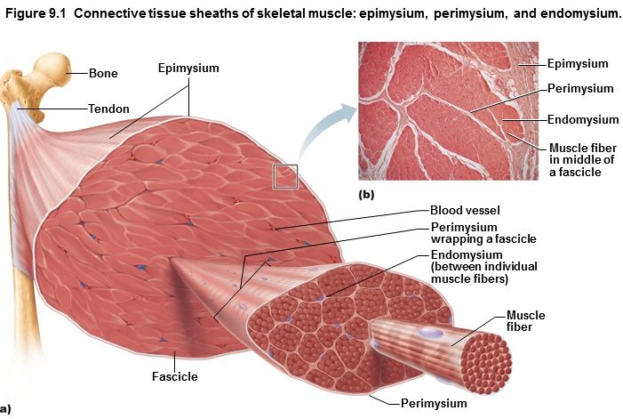
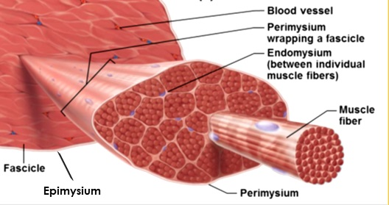
Anatomy Of A Skeletal Muscle Fiber:
- Long, cylindrical, huge.
- Multiple peripheral nuclei.
- Sarcolemma: plasma membrane.
- Sarcoplasm: cytoplasm, contain large amounts of glycosomes and myoglobin.
- Glycosomes: glycogen storage, myoglobin for oxygen storage.
- Modified structures: myofibrils, sarcoplasmic reticulum, and T tubules.
- Muscle capillaries are long and winding and have numerous cross links; accommodate changes in muscle length, they straighten when the muscle stretches and contort when the muscle contracts.
- Myofibrils are contractile elements that occupy most of the cell volume.
- Striations: Their banded appearance results from regular alternation of dark (A) and light (I) bands.
- H zone is the lighter region of the dark A band; M line is the dark line vertically bisecting H zone; Z disc is the darker midline of light I band.
- Sarcomere: the region of a myofibril between two successive Z dics; it is the functional unit of the skeletal muscle; contains A band and I band at each end.
Myofibrils are chains of sarcomeres; each sarcomere contains thick (myosin) and thin (actin) myofilaments arranged in a regular array. The heads of myosin molecules form cross bridges that interact with the thin filaments.
- Myofibrils contain myofilaments containing actin or myosin, which play ar ole in motility and shape change.
- Thick filaments (myosin) extend the entire length of the A band, connected in the middle of the sarcomere at the M line.
- Thin filaments (actin) extend across I band and partway into the A band.
- Z-disc, coin-shaped sheet composed of the protein alpha-actinin, anchors the thin filaments.
- Muscle contraction depends on myosin and actin containing myofilaments.
- Tropomyosin (thin filament) arrange end to end along the actin filament and in relaxed muscle fiber, they block myosin-binding sites on actin.
- Troponin (thin filament) inhibitory subunit that binds actin.
- Elastic filament composed of protein titin which extends from Z dic to the thick filament, then runs within it to attach to the M line, holding it in place.
-Dystrophin links the thin filaments to the entegral proteins of the sarcolemma.
- Muscle fibers consit of two intracellular tubules that help them regulate muscle contraction: sarcoplasmic reticulum and T tubules.
-The sarcoplasmic reticulum (SR) is a system of membranous tubules surrounding each myofibril. It stores calcium and releases it on demand when the muscle fiber is stimulated to contract.
- T tubules: the sarcolemma of the muscle cell protrudes deep into the cell interior called T tubules, that run between the terminal cisterns of the SR called triads. They allow an electrical stimulus to be delivered quickly deep into the cell.

- Muscle contraction is controlled by nerve initiated electrical impulses that travel along the sarcolemma, the T tubules conduct impulses to the deepest regions of the muscle cell and every sarcomere, which release calcium from terminal cisterns.
- T tubules and SR are linked closely to contraction because, the integral proteins of the T tubule act as voltage sensors and the SR integral proteins form gated channels through which terminal cisterns release calcium.

The cross bridge cycle is the series of events during which myosin heads pull thin filaments toward the center of the sarcomere:
1. Cross bridge formation; calcium binds troponin and removes the blocking action of tropomyosin. Energized myosin head can then attach to an actin myofilament, forming a cross bridge
2. The power (working) stroke; ADP and P_{i} (inorganic orthophosphate) are released and the myosin head pivots and bends changing to its bent low-energy state. As a result it pulls the actin filament toward the M line.
3. Cross bridge detachment; after ATP attaches to myosin, the link between myosin and actin weakens, and the myosin head detaches (the cross bridge “breaks”).
4. Cocking the myosin head; as ATP is hydrolyzed to ADP and Pi, the myosin head returns to its prestrike high-energy, or “cocked,” position.
This cycle will continue as long as ATP is available and is Ca²⁺ bound to troponin.

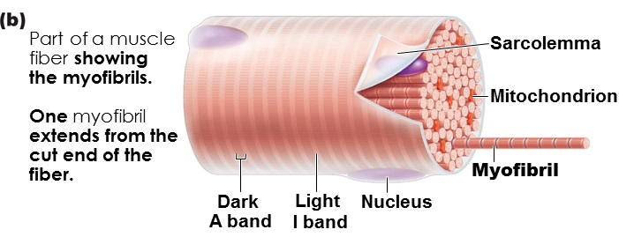
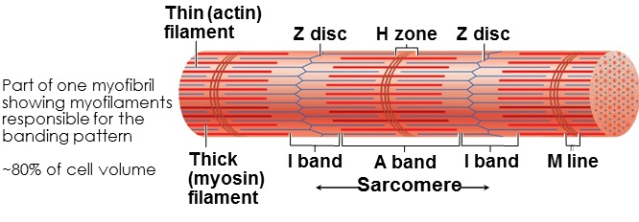
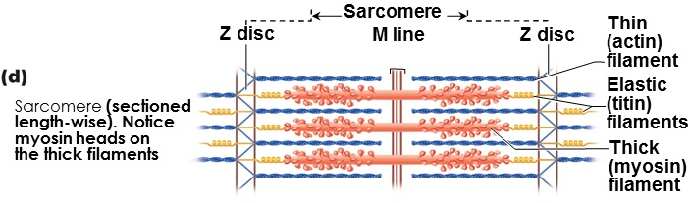
Z disc (line): coin-shaped sheet of proteins on midline of light I band that anchors thin filaments and connects myofibrils to one another.
Z-disc decreases during muscle contraction.

Sliding filament model of contraction:
- Shortening occurs if/when the cross bridges generate enough tension on the thin filaments to exceed the forces oppose shortening.
- Contraction ends when the cross bridges become inactive, the tension declines, and then the muscle fiber relaxes.
- In a relaxed muscle fiber, the thin and thick filaments overlap only at the end of the A band.
- The sliding filament model of contraction states that during contraction the thin filaments slide past the thick ones so that the actin and myosin filaments overlap to a greater degree.

-When the muscle fibers are stimluatled, the myosin heads on the thick filaments latch onto the nyosin-binding sites on actin in the thin filaments, and the sliding begins.
- These cross bridge attachments form and break several times during a contraction, to generate tension and propel the thin filaments toward the center of the sarcomere.
- Events occur simultaneously in sarcomeres, the muscle cell shortens.
- As the thin filaments slide centrally, the Z discs are pulled toward the M line.
- As the muscle cell shorten, the I band shorten, the distance between Z discs shortens, and the H zones disappear, and the A bands move closer together, but length does not change.

Physiology Of Skeletal Muscle:
- For a skeletal muscle to contract;
- a) It requires activation; stimulation of neuromuscular junction (junction between a nerve fiber and muscle it supplies) and must generate action potential in sarcolemma.
- b) Excitation-contraction coupling; action potential propagated along sarcolemma
- c) Intracellular Ca²⁺ must rise briefly. (events leading to the sliding of myofilaments).
- d) Skeletal muscles are stimulated by motor neurons.
- Each axon branches as it enters muscle.
- Each axon ending forms neuromuscular junction with single muscle fiber.
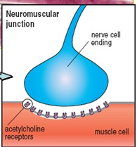

When a nerve impulse reaches a neuromuscular junction, acetylcholine (ACh) is released:
Phase 1:
1. Action potential arrives at axon terminal of motor neuron.
2. Voltage-gated Ca²⁺ channels open. Ca²⁺ enters the axon terminal moving down its electrochemical gradient.
3. Ca²⁺ entry causes ACh to be released by exocytosis.
4. ACh diffuses across the synaptic cleft and binds to its receptors on the sarcolemma.
5. ACh binding opens ion channels that allow simultaneous passage of Na+ into the muscle fiber and K+ ions exit, producing a local change in the membrane potential called the end plate potential-ignites action potential in sarcolemma.
6. ACh actions terminated by its breakdown in the synaptic cleft by Acetyl-cholinesterase (enzyme that hydrolyzes acetylcholine) and diffusion away from the junction.
Phase 2:
- Action potential travels across the entire sarcolemma.
- Action potential travels along T tubules.
- Sarcoplasmic reticulum releases Ca²⁺ which binds to troponin; myosin-binding sites (active sites) on actin exposed.
- Myosin heads bind to actin; contraction begins.

Nerve cells that activate skeletal muscle fibers are called somatic motor neurons/motor neurons of the somatic.
- Reside in the brain or spinal cord, but their axons travel to the muscle cells they serve.
- Axon divides, the ends give off several short, curling branches that form an ellipital neuromuscular junction / end plate with as single muscle fiber.
- The axon terminal and muscle fiber remain separate by synaptic cleft.
- The synaptic vesicles in the axon terminal contain the neurotransmitter acetylcholine ACH.
- The high surface area of sarcolemma helps form junction folds where millions of acetylcholine receptors are located.
- Neuromuscular junction: axon terminals, synaptic cleft, and the junctional folds of the sarcolemma.
Motor Neuron Stimulates a Skeletal Muscle Fiber:
a) when a nerve impulse reaches the end of an axon, the axon terminal releases ACH into the synaptic cleft.
b) ACh diffuses across the cleft and attaches to ach receptors on the sarcolemma of the muscle fiber.
c) ach binding triggers electrical events that generate an action potential.
- After ACH binds to ACH recepters, its effects are terminated by acetylcholinestarease.
- Removal of ACH prevents musclce fiber to contract.

Phase 1: Motor Neuron Stimulates Muscle Fiber:
a) Action potential arrives at axon terminal at neuromuscular junction.
b) ACh released; binds to receptors on sarcolemma.
c) Ion permeability of sarcolemma changes. Opens chemically gated ion channels.
d) Local change in membrane voltage depolarization occurs
e) local depolarization (end plate potential) ignites AP in sarcolemma
Phase 2: Excitation-contraction coupling occurs.
f) AP travels across the entire sarcolemma g( ap travels along t tubules h) SR releases calcium, calcium; binds to troponin; myosin-binding sites on actin exposed. I) myosin head bind to actin; contraction begins.

Excitation-Contraction Coupling:
- Sequence of events where transmission of an action potential along the sarcolemma causes myofilaments to slide.

Summary of Muscle Contraction:
1. The process begins when the nerve impulse reaches the axon terminal and opens voltage-gated calcium channels in the axonal membrane. Calcium entry triggers release of ACH into the synaptic cleft.
2. Released ACH binds to ACH receptors in the sarcolemma, opening chemically gated Na + K+ channels. Greater influx of Na causes a local voltage change (end plate potential).
3. Loccal depolarization opens voltage-gated sodium channels in the neighbouring region of the sarcolemma. This allows more sodium to enter, which further depolarizes the sarcolemma, generating and propagating an action potential.
4. Transmission of the AP along the T tubules changes the shape of voltage-sensitive proteins in the T tubules, which in turn stimulate sarcoplasmic reticulum calcium release channels to release calcium into the cytosol.

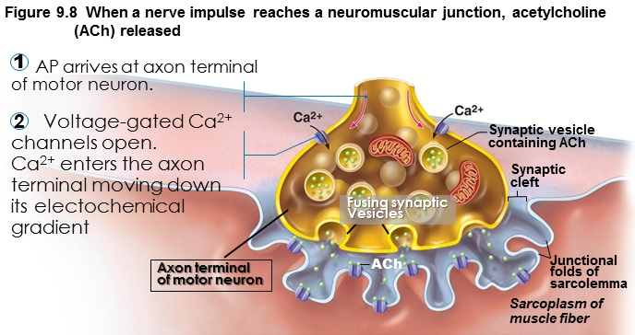
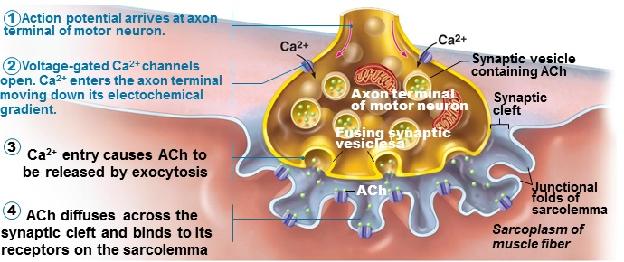
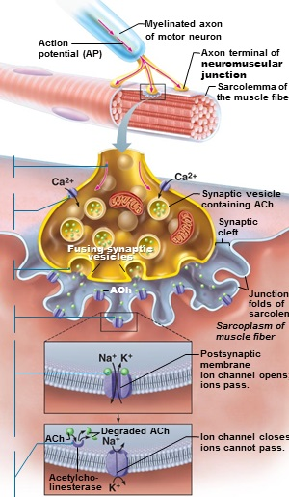
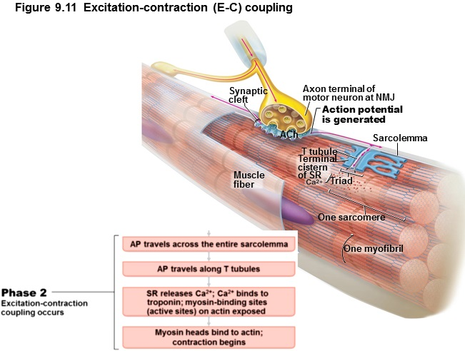
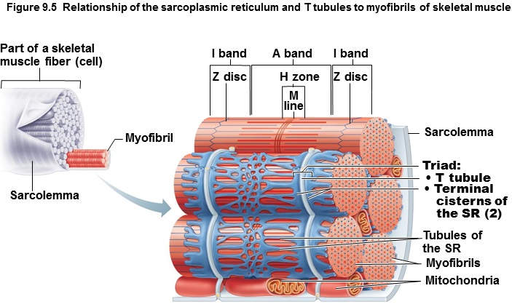
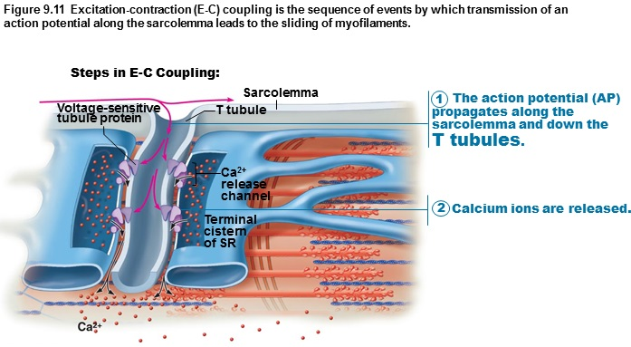
1. The action potential propagates along the sarcolemma and down the T tubules.
2. Calcium ions are released.

- T tubules conduct impulses deep into muscle fiber; ever sarcomere.
- Integral proteins protrude into inter-membrane space from T tubule and sarcoplasmic reticulum (SR) cistern membranes; act as voltage sensors.
- Sarcoplasmic reticulum (SR) foot proteins; gated channels that regulate Ca²⁺ release from sarcoplasmic reticulum (SR) cisterns
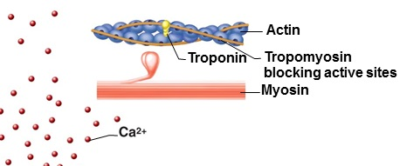
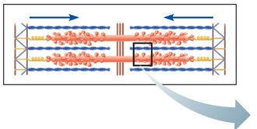
1. 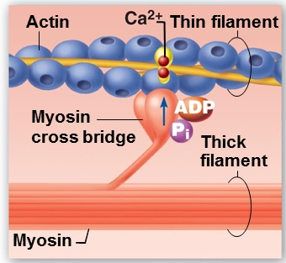2. 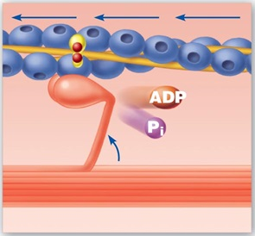3. 4. 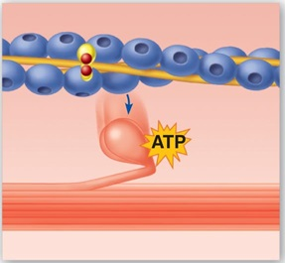

1. Speed of stimulation: wave summation & tetanus:
- rapid rate of stimuli; each contraction builds on the previous one but action potential refractory period is always honoured.
- tetanus: fused contractions – inter-stimulus interval too short to allow inter-twitch muscle relaxation, eventually followed by muscle fatigue. (a state of muscular contraction without relaxation).
- Allows smooth, continuous contractions.

a) A single stimulus is delivered; the muscle contracts and relaxes.
b) If another stimulus is applied before the muscle relaxes completely, then more tension results. This is wave (or temporal) summation and results in unfused (or incomplete) tetanus.
c) At higher stimulus frequencies, there is no relaxation at all between stimuli. This is fused (complete) tetanus.
a) 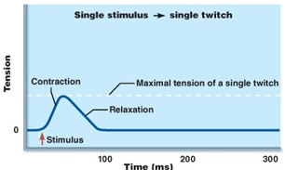b) 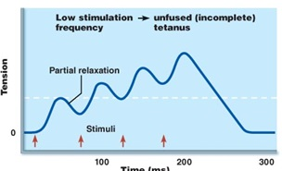
c) 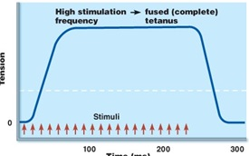

Multiple Motor Unit Summation:
- Allows increasing strength of contraction.
- Threshold stimulus: first observable response.
- Maximal stimulus: strongest stimulus that produces an increase in contractile force (more motor units recruited)
- Most excitable neurons control the smallest motor units.
- More intense stimulation recruits larger motor units.
- All units can be recruited simultaneously, but usally staggered.

Muscle Tone: even relaxed muscle a bit contracted (tone) due to spinal reflexes activated by stretch receptors; effects on muscles, joints, posture.

Isotonic vs. Isometric Contractions:
1. Isotonic: change in length & moves load.
- Concentric vs. eccentric isotonic contractions.
- Eccentric are 50% more forceful, use less ATP/O₂ and fewer muscle fibers but more prone to delayed-onset soreness than concentric contractions.
2. Isometric: tension increase but muscle same length.
- Most body movements are a mix of isotonic-isometric.
- In isotonic contractions, the thin filaments are sliding, in isometric contractions, cross bridges generating force but do not move thin filaments.
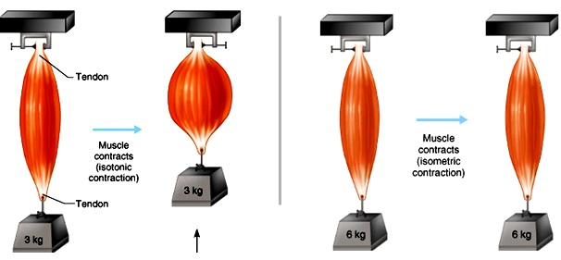

Define The Optimal Length-Tension Relationship for Muscle In Terms of Muscle Anatomy:
- Length-Tension relationship: is the optimal length of a muscle fiber that will generate maximum force.
- Ideal length-tension relationship when muscle slightly stretched; supported by attachment to bones.
- Why? Because if it is stretched or shortened beyond that point, the maximum active force generated decreases.

Factors that increase the force of skeletal muscle contraction (contractile force):
- Large number of muscle fibers recruited.
- Large muscle fibers.
- High frequency of stimulation (wave summation and tetanus).
- Muscle and sarcomere stretched to slightly over 100% of resting length.

Velocity & Duration of Contraction depends on:
1. Load: greater load = longer latent period = slower contraction = slower contraction duration.

Sources Of Energy For Muscle Contraction:
1. Stored ATP:
- ATP for cross bridge movement and detachment; Ca⁺⁺ pump.
- Only 4-6 sec stored ATP; regenerated immediately and continuously by (A2-A4).
2. Direct phosphorylation of ADP by creatine phosphate:
- Creatine phosphate = unique high-energy molecule stored in muscles.
CP + ADP => creatine + ATP
- Enzyme = creatine kinase; but creatine phosphate reserves quickly gone. (CP & ATP = 15-20 sec at maximum muscle power).
3. Aerobic respiration:
- High ATP yield but slower; requires continuous O2/nutrients.
4. Anaerobic glycolysis:
- Only 2 ATP/glucose (O2 not used) and it is fast.
- Usually pyruvic acid (end product of glycolysis) then enters aerobic pathway; but if ~70% activity for long period, blood vessels compressed by muscles and aerobic respiration too slow.
- Pyruvic acid converted to lactic acid; reconverted back to pyruvic acid post exercise; aerobic respiration replenishes ATP.
- Anaerobic pathway produces ~5% ATP of aerobic, but is 2.5x faster which is important during vigorous muscle activity.

Energy Sources During Exercise:
Short-Duration Exercise:
6 seconds; ATP stored in muscles is first used.
10 seconds; ATP is formed from creatine phosphate and ADP.
30-40 seconds – end of exercise; glycogen stored in muscles is broken down to glucose, which is oxidized to generate ATP.
Prolonged-Duration Exercise:
Hours; ATP is generated by breakdown of several nutrient energy fuels by aerobic pathway. This pathway uses oxygen released from myoglobin or delivered in the blood by hemoglobin. When it ends, the oxygen deficit is paid back.
Energy Systems Used During Sports Activities:
- Weight lifting, driving, sprinting: ATP and CP.
- Tennis, soccer, 100 m swim: almost entirely anaerobic.
- Marathon runs, jogging: mainly aerobic, but anaerobic may function until aerobic reaches full efficiency.
Aerobic endurance: time a muscle can be aerobic.
Anaerobic threshold: where muscle switches to anaerobic.

Muscle Fatigue:
- Physiological inability to contract; results from a relative deficit of ATP (total absence would cause contractures).
- Contributors: build-up lactic acid, ion imbalance (Na+/K+ pump requires ATP).

Oxygen Debt:
- Post exercise: replenish O2 reserves, convert lactic acid to pyruvic acid, replace glycogen stores, and restock ATP and creatine phosphate.
- Liver converts additional lactic acid to glucose/glycogen (Cori cycle).
- O2 debt: extra O2 needed to be taken in to accomplish the above (lactic acid indirectly stimulates respiratory center of the brain).
- New term is excess post-exercise oxygen consumption (EPOC).

Heat Production during Muscle Activity:
- ATP-driven muscle contraction 20-25% efficient; heat dissipated by body’s cooling mechanisms.
Muscle Fiber Type:
a) Slow oxidative fibers: thin cells with slow-acting myosin ATPases; contracts slowly; red because of lots of myoglobin; primary energy fuel is fat; for endurance type activities.
b) Fast glycolytic fibers: large, pale (white), little myoglobin and diameter 2x that of slow oxidative fibers; fast-acting myosin ATPases and contract quickly; few mitochondria; lots of glycogen reserves (glycolytic); will fatigue but powerful; for short-term, rapid, intense movements.
c) Fast oxidative fibers: red or pink, intermediate cell size; fast-acting myosin ATPases and contract quickly; high myoglobin content and O2 dependent; fairly fatigue-resistant; for intermediate activities.

- Most body muscles have a mixture of fiber types; genetics can alter distributions and subsequent athletic strengths.

Compare Properties Of Smooth Muscle With Skeletal Muscle:
- Walls of all hollow organs except heart

Arrangement of Fibers and Microscopic Structure:
- Small, spindle-shaped cells; one centrally-located nucleus.
- Diameter = 2-10µm; length 100-500µm.
- Cells separated by fine connective tissue; sheets of closely opposed fibers; usually at least two sheets with opposite orientations.
- Alternating contractions of opposing layers provide mixing, peristalsis, expelling.
- Varicosities; intrinsic instead of neuromuscular junctions (NMJs); bulbous swelling of autonomic nervous system; release NT into wide synaptic cleft near smooth muscle cells; diffuse junctions.

- SR less developed than in skeletal muscle; no T tubules but SR touches sarcolemma and smooth muscle cells have large surface area/volume ratio.
- No striations, but do have interdigitating thick and thin filaments:
1. Ratio of thick: thin = 1:13 (smooth) vs. 1:2 (skeletal); but smooth muscle myosin has actin-gripping heads along entire length, more strength.
2. Tropomyosin but no troponin (calmodulin instead).
3. No sarcomeres: thick and thin filaments spiral down smooth muscle cell.
4. Non-contractile intermediate filaments and dense bodies (attach to thin filaments).

Contraction of Smooth Muscle:
- Electrical coupling via gap junctions are slow, synchronized contractions.
- In the gut, interstitial cells are the pacemaker cells.
Mechanism:
1. Actin and myosin interact by sliding filament mechanism.
2. Final trigger is rise in intracellular Ca++.
3. Sliding process is energized by ATP.
- Contraction of smooth muscle is slow (30x), sustained, fatigue-resistant (24h maintenance of tone of blood vessels, visceral organs).
- Few mitos; most ATP generated aerobically. Why does that workÉ
Intermediate filaments and dense bodies of smooth muscle fibers harness the pull generated by myosin cross bridges. Intermediate filaments attach to dense bodies throughout the sarcoplasm.

Special Features of Smooth Muscle Contraction:
a) Response to stretch: more stretch (120% resting length), more vigorous contraction; stretching can induce brief contraction (gut) or can have stretch relaxation response (filling).
What does this accomplish?
b) Length & Tension changes: stretches more than skeletal; can generate more tension than skeletal (contracts in a corkscrew-like manner); 150% vs. 60%.
c) Hyperplasia: example: estrogen and uterine smooth muscle cells.
d) Secretory functions: collagen, elastin; make their own connective tissue.

- The response of a motor unit to a single action potential of its motor neuron is called a muscle twitch.
- The calcium calmodulin system of contraction regulation is found in smooth muscle only.
- Single-unit smooth muscle is found in the walls of most hollow organs.

