COMM 210 – Final Exam
- Herzburg’s Motivations Theory

Concepts

KITA = KICK IN THE ASS
- Getting people to do things through KITA management creates movement not motivation.
- What if we want people to do something again? We have to give another KITA
- Self-motivation comes from within!
Negative KITA = Threat (restricted pay, disciplinary action, criticism)
Positive KITA = Bribe (rewards, bonuses, praise)
Hygiene factors: factors insure reasonable level satisfaction (pay, job security, relationships with boss/peers, work conditions...)
Motivators: Source of great deal satisfaction (recognition, achievements, opportunity for
Advancements, challenging work...)
Dissatisfiers: primarily caused by hygiene factors
Satisfiers: primarily caused by motivators
- Horizontal job loading: reducing personal contribution of employees rather than giving them opportunities for growth in their accustomed jobs in order to enrich certain jobs – does not work! ex: increasing amount of production expected, adding another meaningless task, removing the most difficult parts of the assignment

- Vertical job loading: providing motivator factors

Principles of vertical job loading:
  - removing some controls while retaining responsibility
  - increasing responsibility of individuals for own work
  - giving a complete natural unit of work
  - granting additional authority to employees
  - making reports directly to workers rather than to supervisors
  - introducing new and more difficult tasks
  - assigning specialized tasks = making workers experts

Job enlargement:
- By widening the range of tasks that need to be performed, hopefully the employee will experience less repetition and monotony that are common on production lines which rely upon the division of labor.
- With job enlargement, the employee rarely needs to acquire new skills to carry out the additional task, and the motivational benefits of job enrichment are not usually experienced.
- One important negative aspect is that job enlargement is sometimes viewed by employees as a requirement to carry out more work for the same amount of pay.

Job enrichment: a systematic attempt to motivate employees by manipulating the motivator factors

Steps for job enrichment (instilling motivators):
  - select unmotivated jobs, approaching them with the conviction that they can be changed
  - brainstorm possible changes to enrich jobs
  - screen list to eliminate hygiene suggestions, horizontal loading suggestions, and generalities such as “give them more responsibility” that are rarely followed in practice
  - avoid direct participation by the employees whose jobs are to be enriched – a sense of participation will only result in short-term movement
  - set up a controlled experiment with one group having motivators and the other no changes
  - be prepared for an initial drop in performance, new job = temporary inefficiency
  - expect first-line supervisors to experience some anxiety over changes made which comes from fear that the changes will result in poorer performance

- Job enrichment is the key to motivating employees over the long term.

- Enrichment is not a onetime occurrence and should be continuous.

- Not all jobs can be enriched, nor do all jobs need to be enriched.
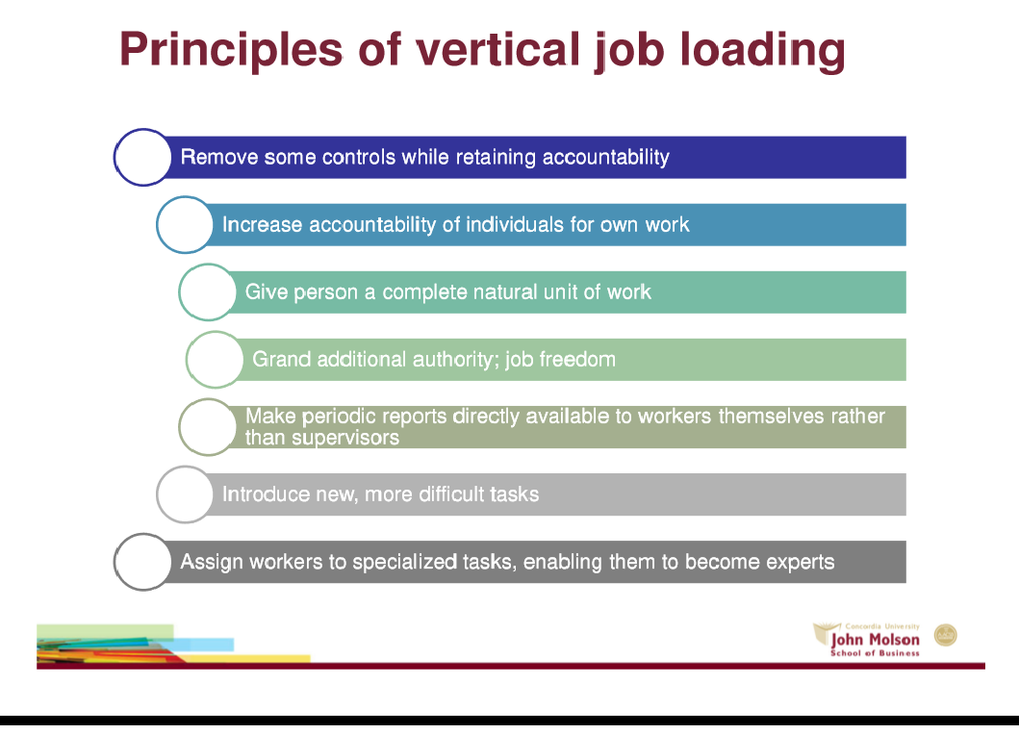
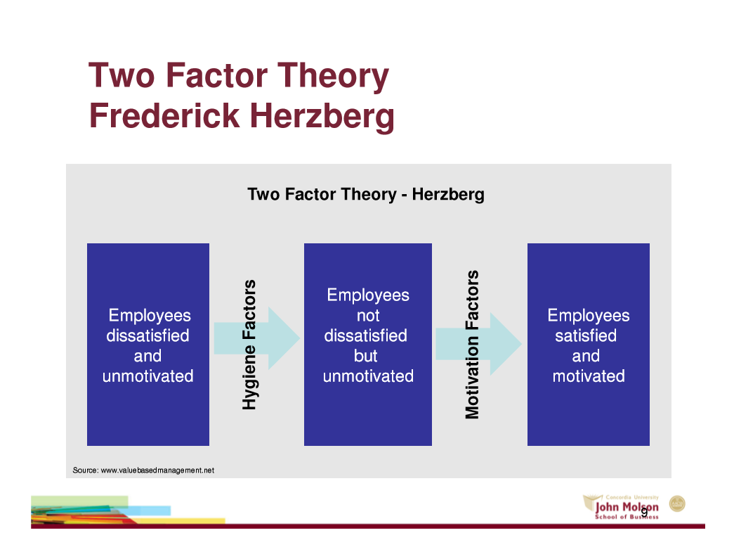

- Kaplan and Norton’s Balanced Score Card
- To measure all important assets & capabilities organization has
- Financial system cannot quantify the value of customers, innovation, culture… but can measure it!
- If can’t measure it, can manage it!

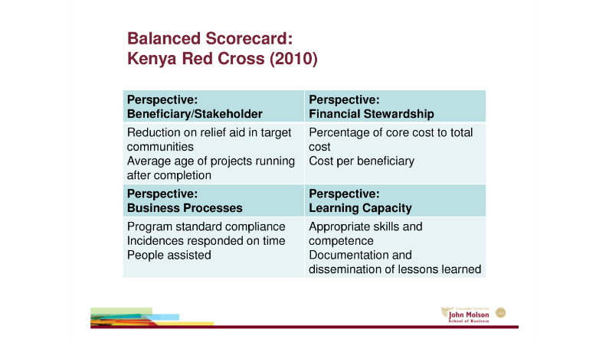
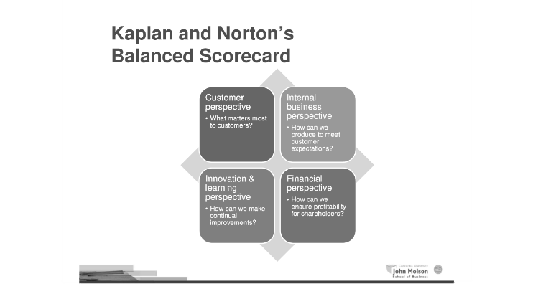
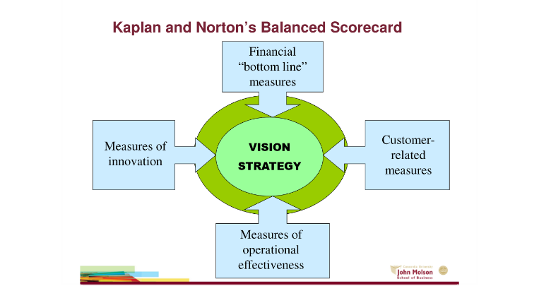

- Henry Mintzberg’s Managerial Roles
- Manager must understand all his roles and how to perform them effectively
- Classified the 10 most common roles in 3 categories: interpersonal, informational and decisional.
Interpersonal roles:
- behaviours associated with human interaction
- Interact with his employees for purpose of achieving organizational goals.
- Figurehead: inspiration & authority to employees ( has responsibilities that employees expect him to fulfil)
- Leader: direct & manage employee performance
- Liaison: communicates with internal and external members of organizations (network activity concerned with customers)
Informational roles:
- Generate & share knowledge to successfully achieve organizational goals
- Monitor: researching, locating and choosing useful info, Must stay abreast to current industry standards & changes occurring both internal & external business environment, Monitor employees, and level productivity.
- Disseminator: take info gathered and forward to appropriate individuals
- Spokesperson: communicates info about cie to outsiders

Decisional roles:
- Using info to make decisions
- Entrepreneur: improves productivity & efficiency with organization & directs change process from development to implementation
- disturbance handler: resolves conflicts
- resource allocator: plan dispense & monitor resources
- Negotiator: acts as representative, looks out for best interests of party whom he represents.

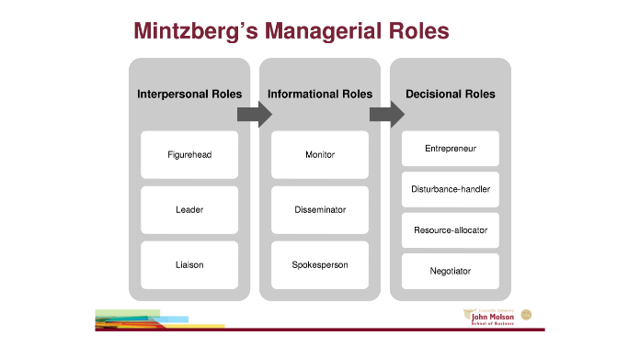
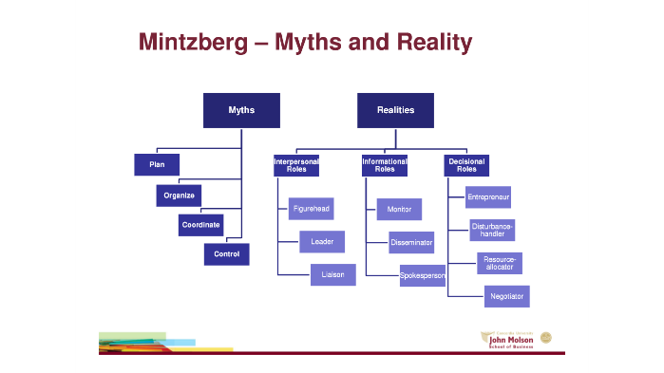
4.French and Raven’s Sources of power
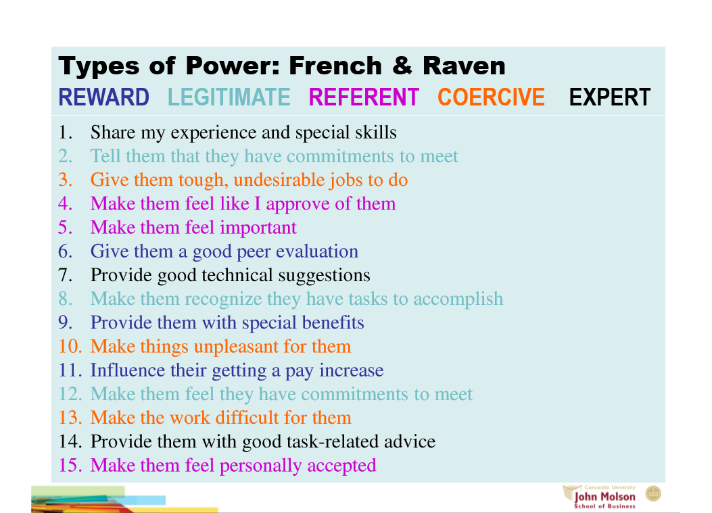
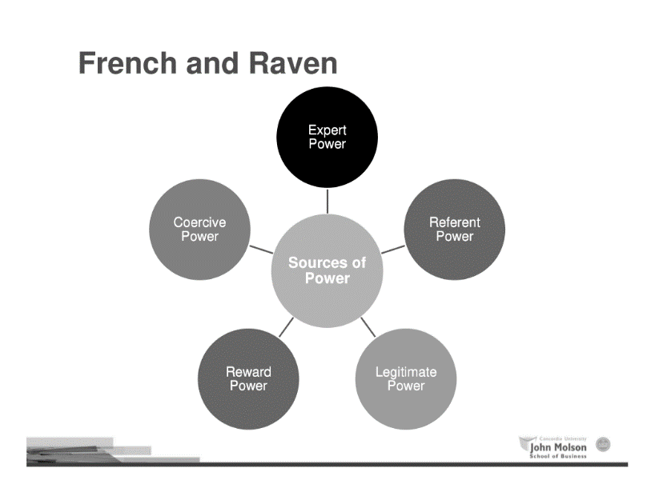

- Conceive Power:
-Someone is forced to do something that he/she does not desire to do

- Reward Power:
- Ability to grant another person things which that person desires or remove/decrease things the person does not desire
- Power is based on the idea that we as a society are more prone to do things and to do them well when we are getting something out of it
3. Legitimate power:
- Ability to administer to another certain feelings of obligation or the notion of responsibility
- Rewarding and Punishing subordinates is generally seen as a legitimate part of the formal or appointed leadership role and most managerial positions in work organizations carry with them, some degree of expected reward and punishment.
- People traditionally obey the person with this power solely based on their role, position or title rather than the person specifically as a leader. Therefore this type of power can easily be lost and the leader does not have his position or title anymore. This power is therefore not strong enough to be one's only form of influencing/persuading.
4. Referent Power:
- Ability to administer to another a sense of personal acceptance or personal approval.
- This type of power is strong enough that the power-holder is often looked up to as a role model.
- This power is often regarded as admiration, or charm. The responsibility involved is heavy and the power easily lost, but when combined with other forms of power it can be very useful.
- Referent power is commonly seen in political and military figures, although celebrities often have this as well.
5. Export Power:
- The ability to administer to another information, knowledge or expertise
- As a consequence of the expert power or knowledge, a leader is able to convince his subordinates to trust him.
- The expertise does not have to be genuine - it is the perception of expertise that provides the power base. When individuals perceive or assume that a person possesses superior skills or abilities, they award power to that person.

- Charles Handy: The Sigmoid Curve

- A way to sustain growth
- Best time to start a new 'curve' is before you reach the peak of your existing one! That way, you will be starting something new when you still have the resources, and the spirit, to take it to new heights.
- Most people think of doing something new only when they have reached the bottom of what they are presently involved in.
- Successful industries are constantly re-inventing themselves, even when things are going well
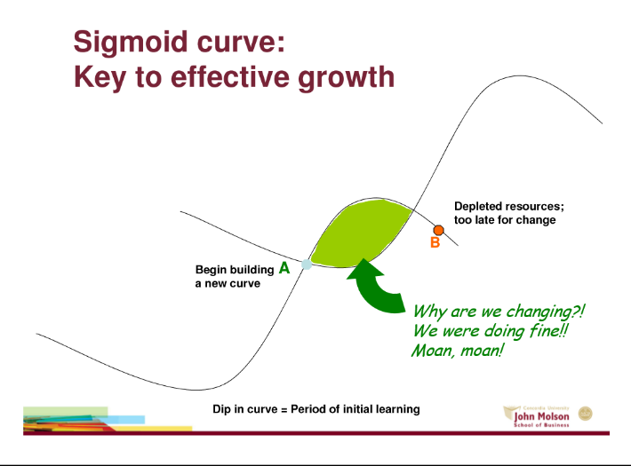

- Jeffrey Liker & Thomas Choi



