Kin 2032
- research universities keep up to date with current shit
- uses exercise to help people quit smoking
- lab info is included on midterms
  - for lab info you contact lab demonstrator
- all assignments have to be completed on 1 page
- all exams are multiple choice
- Midterm is Wed Feb 12 during class
Observation (not on powerpoint)
- Silverman and Keating 2002 - class material often are not matched to students knowledge in a research design class
Baseline Quiz (not on powerpoint)
- 1. what is the difference between validity and reliability?
  - validity is about accuracy
  - reliability is about reproducibility
- validity always precedes reliability
  - if a study is not accurate and you try and reproduce it, you're just reproducing inaccurate bullshit
- 2. What does the word equivocal mean?
  - has multiple interpretations (inconclusive)
- 3. effectiveness vs efficacy trials?
  - efficacy is how well something works in a controlled setting
  - effectiveness is how well something works in a "real life setting"
- 4. regression to the mean?
  - line of best fit, making predictions based on data collected
- 5. what do the letters SPSS stand for?
  - Statistical Package for the Social Science
  - apply statistics to data using this shit
- 6. what does 0.05p value?
- 7. define the term moderator?
- 8. what is meta-analysis?
  - replicating statistical studies across different populations
- 9. what is the Cochrane library?
  - systematic review of a topic
  - evidence that tells you something about the topic
  - free at western (probably still wont use this shit)
- 10. who is the current US surgeon general?
  - Regina Benjamin
The scientific process
Outline
- all studies that are based on quantitative data moves from the 4 interrelated phases
  - 1. Descriptive Phase - "What is"
  - 2. Explanation Phase - "Why"
  - 3. Prediction Phase - "What Will Be"
  - 4. Intervention (control) Phase "How Can Be"
- all science moves through these 4 steps
Stages of Science
Stage 1: Description ("what is")
- example study - "Exercise?"
  - 41% to 51% of individuals between 18 & 65 are sedentary
  - 20%-50% drop out within the first 6 months
- were describing how inactive a population is
- when individuals try to become active we know 20-50% drop out in 6 months (purely descriptive information)
- you need to describe what is out there and is it really a problem?
Stage 2: Explanation? ("why")
- Carron et al. (1988): proposed that strong group unity might reduce drop out behavior (class cohesion)
  - looked at what influence does a group play in sport and exercised
  - Compared
    - Perceptions of class cohesion for individuals who had dropped out versus those still in an exercise class
  - Found
    - Dropouts had lower perceptions of their exercise class’s cohesiveness
Stage 3: Prediction ("What Will Be")
- prediction is applying it to future events
  - important difference between explanation and prediction
  - prediction data is more powerful than explanation data because it moves forward
- Spink & Carron (1991) proposed that adherence behavior in exercise could be predicted from cohesion
  - Compared
    - Absenteeism and lateness of exercisers differing in perceptions of class cohesion
  - Found
    - High Absent & Lateness related to lower perceptions of class cohesiveness
Stage 4: Intervention (Control) ("How Can Be")
- for when you have information and want to do something about it
- Spink & Carron (1993) introduced team building in exercise classes to increase cohesion
  - fitness instructors were brought into a workshop
  - team building strategies were developed
  - strategies were implemented over a 13 week session
  - this study wanted to find out....
    - does cohesion change because of team building?
    - what affect does that have on adherence behaviour (dropping out)?
  - Found
    - team building classes improved group cohesion
    - team building classes had fewer dropouts
Three Generation Hierarchy of Research Questions Using Cohesion
- hierarchy means building off previous question (Q-3 builds off Q-2 which builds off Q-1)
- 3 generation types of questions
  - 1. Is there a relationship between X and Y?
    - description study - strength and direction
    - X is cohesion
    - Y is performance
  - 2. Under which conditions does X relate to Y (moderation)?
    - i.e. a task cohesion might relate to performance in interactive sports but not in co-active ones
    - identify a moderator as a third variable than can influence the strength and direction of the relationship between X and Y
      - i.e. in this case is cohesion and performance
  - 3. Why does X relate to Y under some conditions but not others (mediation)?
    - what are the causes of these relationships
      - i.e. task cohesion may influence team performance because team members perceive timing and coordination as a requirement for success in interactive sports but no co-active ones
    - difference between mediators (Q3) and moderators (Q2)
      - moderator is looking at "which" conditions X relates to Y whereas mediator is looking at "why" X relates to Y under certain conditions
- In order to understand the relationship between cohesion and performance with the intent of making progress towards a theory, these 3 questions MUST be considered and answered
Aspects of the Scientific Approach to Problem Solving
- three issues that a scientist is always faced with when conducting a study to see if something exists or not
  - 1. setting out the independent and dependent variables associated with the research question
    - i.e. cohesion (independent) and performance (dependent)
  - 2. providing an operational definition for these variables
    - how are you going to measure the variables?
    - operational definition drives measurement
  - 3. generating a hypothesis for a proposed relationship
    - experimenter makes a prediction
- Basketball Application
- does the presence of spectators increase or decrease performance?
  - whether the Cause (spectators) produces and Effect (change in performance)
  - cause is always the independent variable (x-value)
  - effect is always the dependent variable (y-value)
- highly skilled basketball player takes free throw shots alone in gym, and with an audience present
  - alone and audience - independent variable
  - ratio of free throws made: free throw attempts - dependent variable
    - this is also the operational definition for change in performance in this scenario
- a highly skilled basketball player would be familiar with playing in front of a crowd, and therefore the crowd would be motivating to him/her
  - Hypothesis: the presence of spectators leads to an improvement in free throw success
  - next step is to test hypothesis in a controlled situation
Inductive Reasoning
- A bottom up process that starts with observations, then moves to generating hypotheses, then moves to generating theories
  - starts with specific elements and then moves to general ones
- observation is the key element that drives inductive reasoning
  - i.e. you observe when you throw a ball up that it comes back down so you begin to generate hypothesis about gravity and so on....
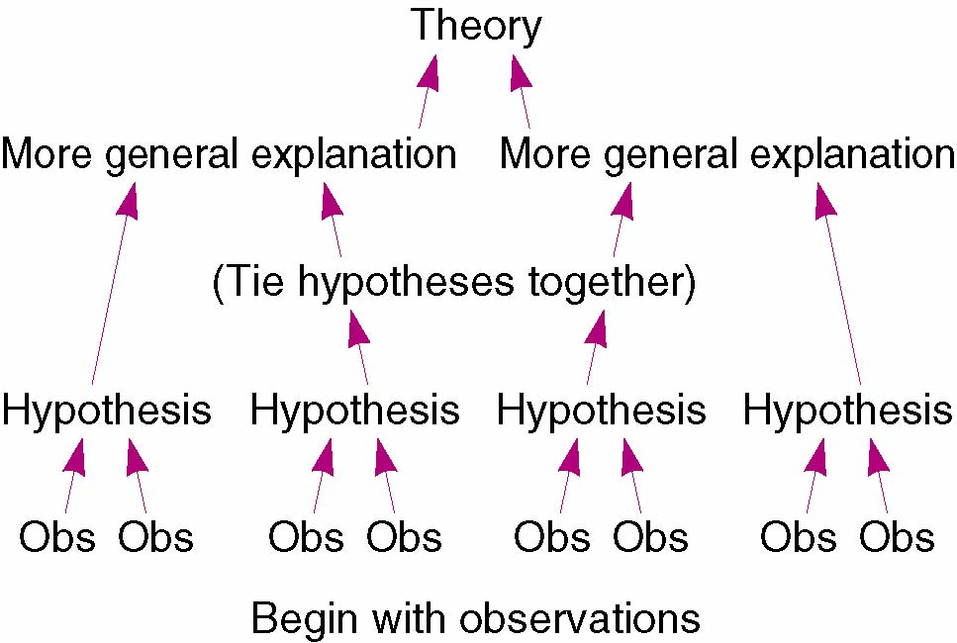
Deductive Reasoning
- A top down process that starts with a theory and moves towards generating a law
  - starts with general elements and then moves to specific ones
  - allows hypotheses to be tested
- any principle that is widely accepted (laws, rules, etc.) is best expressed deductively
  - i.e. Newton's Law expresses gravity so we know if an object is thrown up then it must come down. we can now test that by throwing shit up in the air and watching it drop like its hot
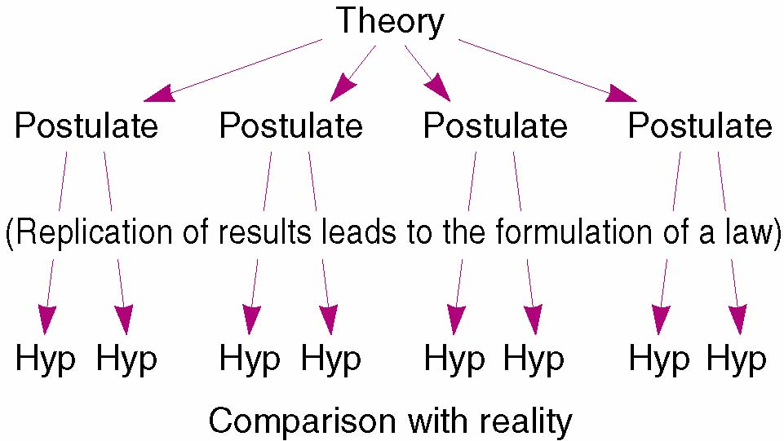
Inductive and Deductive Reasoning
- both are useful
- in the beginning of a study we use Deductive Reasoning to deduce hypothesis from previous findings or theories
- after the begging of a study we use Inductive Reasoning to induce hypotheses from relevant findings in other research
Model for Research
- a format that creates a level of consistency for scientific research
- ***important in 1st assignment
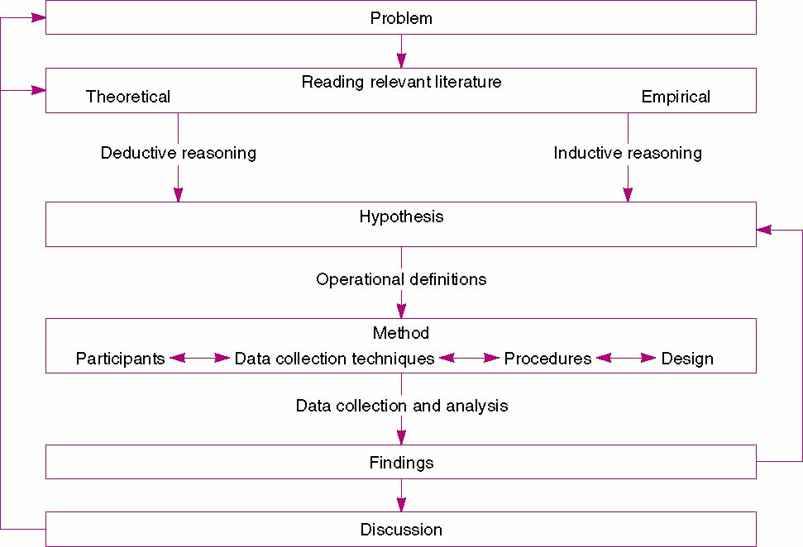
Quantitative Research
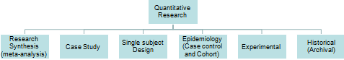
- structure drives function in a study
Statistical Concepts in Quantitative Research
- We need statistics so that we can make the strongest conclusion possible on a subject with a limited amount of data that we have
  - 2 problems in overcoming this
- Problem 1
  - biological variability and imprecise experiments can cause important changes in results
    - makes it hard to distinguish real differences from random variability
  - statistics help make this distinction between what is real and what is a result of random variability
- Problem 2
  - The human mind is inclined to conclude that differences and relationships are real and not due to just random variability
    - innate bias
    - this is especially a big problem when assessing our own research (naturally inclined to want to believe that you've found something significant)
  - statistics prevent you from making this mistake
Statistical Measurement Concepts in Research
- 1. Alpha (p) < .05, .01, .001
- 2. Effect Size
  - tells us the magnitude of the difference
    - differs from probability (alpha/p-value)
  - good science reports p-values with the effect size
- 3. Power
  - how correctly we can identify a difference between groups
- 4. Sample N
  - tells us how many people we need in a study to have an effect size that can determine that the study is statistically significant
- these concepts listed above are essential to understand how they work together
- by people focusing too heavily on null hypothesis testing, we have blinded ourselves to how statistics and conclusions are made
  - you can't just rely on null hypothesis scientific testing, you need to go further and critically analyze these 4 components and how they relate to each other
  - people just relying on alpha for years has been detrimental to science because they did not account for other factors (effect size, sample size, power)
Alpha
- Probability: the odds that an event will occur
- a p-value of 0.05 means that the probability that the findings in the study are simply a product of chance (sampling) are 5 in 100 (0.05 or 5%)
- the experimenter needs to set an acceptable level of findings happening by chance before the study is completed (called alpha α)
Type I and Type II errors
- Type I Error: to reject the null hypothesis when the null hypothesis is true
  - i.e. a researcher concludes there is a significant difference between two training methods when really there is not
- Type II Error: not rejecting the null hypothesis (accepting) when the null hypothesis is false
  - i.e. a researcher concludes there is no difference between two training methods (null) but really there was
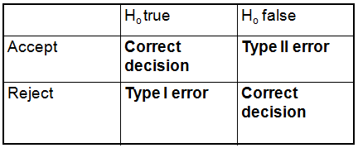
Alpha Cont'd
- the level of alpha will reflect the type of error you are more willing to make
- which error is more important to avoid, type I or type II?
  - debatable issue
- i.e. suppose a study was measuring the effect of a cancer treating drug
  - the experimenter would not want to accept the null if the null was actually false
  - therefore the experimenter would set a larger p-value (move from 0.05 to 0.1) to make it less likely of committing a type 1 error
  - “ Surely god loves .06 nearly as much as the .05” (Rosnow & Rosenthal, 1989)
    - just means that the value of 0.05 is subjective
- greater p-value = more likely to commit type 2 error
- smaller p-value = more likely to commit type 1 error
- the experimenter decides where to set alpha (p-value)
  - be sure to justify this decision
  - a better approach is to report the exact probability (i.e. p=.024) associated with the statistical test and then estimate the meaningfulness of the finding (effect size)
Effect Size
- strength and magnitude of the finding
  - meaningfulness
- if 2 groups are different, then how big is that difference?
- if 2 variables are related to each other, how strong is that association?
- one way to conceptualize this statistic is to use the amount of variation (overlap) in scores
  - i.e. how time of day affects learning
  - children (n=38) were randomly assigned into 2 different groups
  - one group listened to a story and were asked to answer questions the morning
  - the other group listened to the same story and were asked to answer questions in the afternoon
    - look at the amount of overlap (variation) between the scores
    - are there any differences between the 2 groups?
  - if there was no overlap in scores between the 2 groups, it would seem to be a very large difference
  - if there was a wide spread of scores, and a fair amount of overlap between scores, it would seem to be a less significant difference
- since we have an idea of the amount of variation (overlap) between 2 groups, we can compare the differences with a quantified calculation
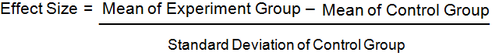
- The name of this equation is Cohen's D
- i.e. of calculating effect size
  - mean of afternoon score (experiment) = 17.9
  - mean of morning score (control) = 15.2
  - S.D. of control = 3.3
  - therefore it is (17.9 - 15.2) / 3.3 = 0.8
  - we get a Cohen's D of 0.8
- Cohen's D is expressed in units of S.D.
Percentiles and Effect Size
- effect size can be directly converted into a statement about the overlap between two samples by using a percentile
- the benefit to using a percentile instead of a Cohen's D value is that it is easier for the general population (with no stats background) to understand
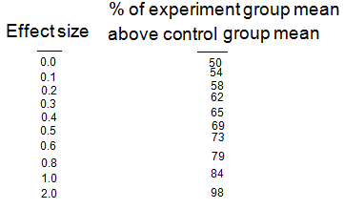
- ***need to memorize these values
- when an effect size is 0
  - distribution curve of the 2 groups overlap completely
  - midpoints are the same (50%)
- when the effect size becomes larger, typically the experiment group mean is greater than the values in the control group, and the result is that the midpoint of the distribution curve (percentage value) will go up accordingly
- i.e. in previous example when the effect size (Cohen's D) has a value of 0.8
  - this means the group average of the experiment group is 29% higher (net gain) over the control group
  - this allows us to conclude that the average score in the experiment group exceeds 79% of all participants in the sample for the control group
In terms of known effects (Cohen, 1981)
- Cohen's D
  - small = 0.2
  - medium = 0.5
  - large = 0.8
Power
- power of a test refers to how correctly we can identify a difference between groups
  - the probability of rejecting the null hypothesis when the null hypothesis is false (detecting a real difference)
  - increase in power = increase in probability of rejecting a false null hypothesis (correct decision)
  - increase in power = decrease in probability of a type II error occurring
- effect size and p-value will influence how many people you need in a sample size in the experiment in order for it to be adequately powered
- It is generally accepted that a power should be over 0.8
  - a power of 0.8 means that if another experimenter were to conduct the exact same study, there would be an 80% chance of getting the same result, and 20% chance of getting something different
  - it would be ideal to get 1.0 or 100% power (no chance of a different result) but the scientific community accepts anything above 80%
- i.e. suppose you have found that there is no differences between 2 groups (with a p-value less than 0.05) and the power is .73
  - you would need to interpret the reason for non-significant results
  - since the power is below .80, it is likely that these results are not a matter of no differences occurring between groups, but more about the test not being adequately powered
  - maybe you have a good enough effect size, but the sample size is not large enough to conclude there is enough power to reject the null hypothesis
Putting it All Together
- when you know alpha, effect size, and power, then the number needed in each treatment group can be estimated
- this is important from an ethical standpoint for something that is harmful
  - i.e. can minimize amount of people harmed in the study by figuring out exactly how many people you need in order to have achieve valid findings
Effect Size Curve to Estimate Sample Size When p = .05
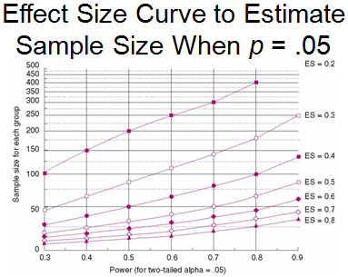
- x-axis is power
- y- axis is sample size
- as effect size gets smaller, you need a larger sample size to meet the adequate power level of 0.8
Effect Size Curve to Estimate Sample Size When p = .01
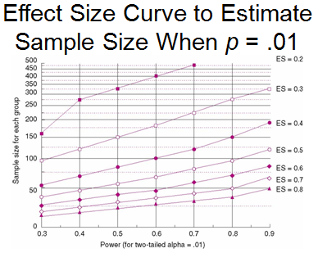
- now alpha is lower
- notice how along the 0.8 power line, the number of participants in the sample goes up as the effect size goes down
Using the Power Calculator When Reading a Research Study
- some formulas online allow us to estimate power levels of a research study when the following are given...
  - sample size
  - means
  - standard deviations
Key Learning Points
- p-values depend on the effect size and sample N
  - a statistically significant result with a large sample size may not be better than a non-significant result with a small sample if the statistically significant result with a large sample size has a low effect size (small magnitude of effect)
- testing the null hypothesis is the wrong idea
  - the correct idea is what is a meaningful difference (effect size) within the study and how many participants are required to reject a difference this large when alpha is less than 0.05 and the power of the study is greater than 80
    - ****important to memorize
- research is driven from the bottom up
Variance and Meaningfulness
Variance and Meaningfulness
- Variance: the degree of difference between the individual's score and the mean
  - describes variability
  - when you hear variance in a research article it means spread of scores
- Standard Deviation: an estimate of the variable of each score around the mean
  - square root of the variance
  - in research were more focused on standard deviation
Explaining Variance Using Relationships
- Correlation Coefficient (Pearson-r): tells us the strength and relation that X has to Y
  - i.e. -0.65 correlation
  - the problem with this is that it does not explain meaningfulness
- Coefficient of Determination (r²): interprets the meaningfulness of a correlation coefficient
  - indicates the portion of total variance in one measure that can be explained or accounted for by the variance in the other measure
  - most commonly used criterion for interpreting meaningfulness of a correlation
Coefficient of Determination (r²)
- tells us the common variance that exists between 2 variables
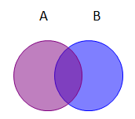
- Example above shows Variable A and Variable B
  - the Pearson-r value = 0.71
  - the Coefficient of Determination (r²) = 0.5
- what this means is that variable A and variable B share 50% common variance
  - can be expressed as a fraction or a percentage
t-tests and Power in Research
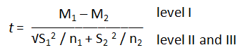
- a t-test has 3 levels that can be manipulated to increase or decrease power
  - Level 1: difference between means
  - Level 2: S.D. component
  - Level 3: N component (sample size)
- in research we try to manipulate these 3 levels to increase statistical power (ability to correctly reject the null hypothesis)
t- Test Level 1
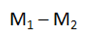
- level 1 is looking at the difference in means between two groups
- in order to increase power, we want to make this difference as big as possible
- if you were to keep level 2 and level 3 of a t-test constant, and increase the difference between means of two groups, you would see an increased t-value
  - increase in t = more power = greater chance of correctly rejecting the null hypothesis
- the best way to increase the difference between means is to apply more concentrated treatment
  - i.e. suppose you were looking at the effects of strength training on muscle growth and did a 6 week treatment and compared it to a control group
  - a more concentrated treatment would be doing a 12 week program instead of a 6 week program
    - this more concentrated difference would increase the difference of muscle growth between the treatment group (bigger difference between M₁ and M₂)
t-Test Level 2
- looking at the variance and S.D. between 2 groups
  - S₁² and S₂ ² of the variances (s²)
- in order to increase t-test power, we want to decrease the amount of variance/deviation between the 2 groups
  - because level 2 is a denominator as part of the t-test equation, if you kept level 1 and level 3 constant, while decreasing the difference between variance (level 2), it would result in an increase in power
- the best way to decrease variance/standard deviation between two groups is to apply more consistent treatment to each participant
  - if the treatment is consistent, it is more likely that you won't have as many outliers that fuck up your variation/S.D. (less distribution around the mean)
t-Test Level 3
- looking at the sample size N between 2 groups
  - n₁ + n₂ is the number of participants in each group
- in order to increase t-test power, we want to increase the sample size (N) in both groups
  - note that level 2 is the denominator and in the equation is divided by level 3
    - therefore if level 3 is larger, it will decrease the value that level 2 has when you go to calculate t-test
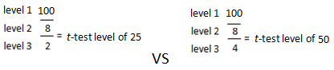
    - increase in level 3 = decreased denominator in t-test = increase t-score
  - if you were to keep level 1 and level 2 constant, while increasing level 3 (sample size N), you will see an increase in t-test score
  - when trying to obtain a large sample size there are issues with:
    - cost
      - cost more to have more participants
    - accessibility
      - it may be hard to get a hold of people or to find people willing to participate in the study
  - it would be ideal to get as many sample participants as possible but sometimes that is impossible. However to have an adequately powered test, you do need an adequate sample size
t-Test and Power in Research
- strong power can be obtained by using strong and consistent treatment while using as many samples as feasible
- power can be obtained by varying alpha
  - the more stringent alpha is (i.e. .05 vs .01) will reduce power and make it more difficult to detect a significant difference
- you need to account for all 3 levels of a t-test and not just rely on alpha values
True Variance, Error Variance, and t-Ratio
- note that the t-ratio has a numerator (level 1) and denominator (level 2 and 3)
  - numerator is called True Variance
    - difference between means
  - denominator is called Error Variance
    - variation about the mean
- t = true variance/error variance
  - true variance = M₁ – M₂
  - error variance = √S₁² / n₁ + S₂ ² / n₂
- note that if there is no real difference between the groups measured, the true variance to error variance ratio (t-ratio) will equal 1
  - t-ratio of 1 = no difference
- a significant t-ratio will have a true variance that is exceeds the error variance
  - significant t-ratio = true variance > error variance
- how much the true variance needs to exceed the error variance to prove a significant t-ratio depends on:
  - number of participants
  - alpha level established
Effect Size - Meaningfulness
- Effect Size (Meaningfulness) = True Variance/Total Variance (true variance + error variance)
  - this data is required in most good journals
- note that there are many ways to calculate effect size (Cohen's D, r², etc.)
- 2 more ways to calculate effect size
  - 1. Omega Squared
  - 2. Eta Squared
  - these 2 formulas essentially give you the same results
  - effect size for these formulas are:
    - small = .01
    - medium = .06
    - large = .14
  - these values were made by (Cohen, 1988)
  - ******note that these values are for Eta and Omega NOT for Cohen's D
    - don't confuse these values with Cohen's D you retarded fuck
Example of Testing for Differences (Meaningfulness) Between Groups
- testing 2 groups for the effect training intensity has on cardiorespiratory endurance (12 min run)
- both groups have 15 participants
- both train 30 minutes a day
- group 1 trains at 70% of vo² max and group 2 trains at 40% of vo² max
  - keep other variables constant and manipulate intensity to determine an effect
- use omega² formula to calculate meaningfulness
- Known values:
  - t = 13.81, p < .01
  - Number of participants in group 1; n₁ = 15
  - Number of participants in group 2; n₂ = 15
    - ω² = (t² - 1)/(t² + n₁ + n₂ – 1)
    - ω² = (13.81² -1)/(13.81² + 15 + 15 -1
    - ω² = 189.72/219.72
    - ω² = .86
  - we know an effect size of 0.14 is considered large in Omega² formula, so 0.86 is fucking huge
  - the good thing about Omega and Eta is that the end results are already in percentages (0.86 =86%)
    - unlike Cohen's D which has a conversion chart
  - what this end result of .86 actually means is that 86% of total variance in scores can be attributed to the difference between groups
    - the remaining variance, 100% - 86% = 14% is accounted for by other factors
Quantitative Research - Meta-Analysis
Reviews in Sport, Exercise, and Health
- the best source is a review
  - quite popular because not only are they great for the scientific community, but are understood by the general population
- new scientific information is being presented all the time and health care professionals need to update their knowledge base continually
  - need a reliable system for this
Collaboration of Rehabilitation Research Evidence (CORRE)
- Center of evidence-based practice in rehab at Western
  - Director: Robert Teasell
- Knowledge Transition is the best method of providing evidence to the bedside, with the emphasis on integration of research-education-clinical practice
- specialize in comprehensive evidence based reviews
Importance of Evidence Based Practice
- in medicine, optimal outcomes are achieved by keeping up with the latest research findings
  - studies show 55%-67% of patients receive health care that is based on the latest research findings (Grol 2001; McGlynn et al., 2003)
  - note that plenty of patients don't receive health care based on the latest findings
    - this is because people in medical care are busy and don't have time to continually stay up to date with the latest research
Types of Reviews
- 1. Narrative
- 2. Systematic
- 3. Meta-analytical
- look at is as one type of review building off of another
Narrative Reviews
- personal review from a scholar or group of scholars
- do not include a methods section in the review
- do not have an inclusion/exclusion criteria section
- the scholar(s) doing the review decide what they want to review
  - this leads to rich subjective and biased interpretation of a study
    - it is not necessarily a negative thing though. If a leader of a group has made the most contribution to this particular field they are doing a review on, then perhaps you want to listen and take account of their opinions
    - however if a person is not a leader in the field they are reviewing, it makes more sense to be more sceptical of their work
      - i.e. a sociology dude writing reviews about physiological studies is mad wack and this dude is likely to be illin harder than Run DMC
Systematic Reviews
- a multistage process that wants to provide all reliable evidence to a specific problem
  - systematic reviews build off of narrative reviews
- there are specific parameters that must be followed in order to call a paper a systematic review
  - these parameters include:
    - 1. a defined question
    - 2. what data is being included or excluded and why that is
      - key difference between systematic and narrative review is this. In a narrative review you don't have to explain what information you are going to include/exclude
    - 3. a pre-determined strategy of how they are going to find reliable evidence
    - 4. critical evaluation of the evidence
Narrative vs Systematic Reviews
- systematic reviews are often continuous whereas narrative reviews are not
- systematic reviews must have inclusion/exclusion criteria and the reason for it whereas narrative reviews do not
Meta-Analysis Reviews
- quantitative summary of a large number of research studies, that generally come to a basic conclusion
  - uses a mathematical method to come to conclusions
- goes further than systematic review by providing reviews of all articles (published and non-published)
  - this allows for a more complete analysis of data
  - published studies tend to be more significant than non-published studies though
Narrative Reviews vs Systematic and Meta-Analysis Reviews
- Meta-Analysis and Systematic studies provide a more complete analysis of a topic compared to narrative reviews
- Systematic Reviews and Meta-Analysis are generally based off of Cochrane Libraries (database full of previous existing studies)
Unit of Analysis - Effect Size
- findings for a study are converted into data points called effect sizes
- all Meta-Analysis studies use effect size as the unit of analysis

- Cohen's D
  - denominator of equation is S.D., therefore Cohen's D is expressed as a unit of Standard Deviation
- downside of using effect size is that there is so many ways of calculating it
- control group mean is subtracted from the experiment group mean to show a positive treatment effect, however if the control group mean is a greater value than the experiment group mean, you subtract the experiment group mean from the control group mean to show a negative treatment effect
- the formula converts the findings from a given study to S.D. units
- grouping the factor variable "explains" the total variability
Effect Size and Bell Shaped Curve
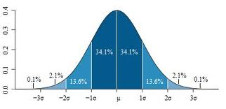
- when dealing with S.D., if 2 curves are different (apart from each other), Cohen's D will tell us how much of a difference exists between the 2 curves
- Greater Cohen's D = Greater Difference in Curves = Greater Effect Size
- going back to this chart you can see that effect size is expressed as a percentile of a S.D. unit
  - i.e. S.D. (Cohen's D) of 1 = 84 percentile
  - i.e. S.D. (Cohen's D) of 2 = 98 percentile
Example of Effect Size
- For example, an effect size of .60 could be interpreted as the average subject receiving the treatment scored better than 73% of control subjects’ scores on the dependent measure (i.e., 23% net gain favouring the intervention group)
Effect Size
- means and S.D. are usually required in articles, but not always
  - you can calculate effect size without mean or S.D. using t, ANOVA, and Pearson r (Glass, 1977)
  - if mean and S.D. is given with no effect size, you can calculate effect size
- to get an effect size in a Meta-Analysis study what they do is calculate effect size from all the articles its using to create the Meta-Analysis study, and then divide it by the total number of studies within the Meta-Analysis to get an average effect size
Step-by-Step in Meta-Analysis
- 1. identify the problem
- 2. search literature
- 3. code literature
- 4. quantify the effect size of the findings
- 5. statistically analyze the effect size
- 6. interpret results
- 7. report all of the above in a review paper
Criticism of Meta-Analysis studies
- it is hard to come to a general conclusion about a particular topic when each study has unique features
  - difficult to make comparison
  - when there is a lot of variation it is useful to estimate if there is more heterogeneity than can be reasonably explained by chance
  - heterogeneity: means alike
  - homogeneity: means different
Initial Severity and Antidepressant Benefits": A Meta-Analysis Submitted to the FDA
- Kirsch et al., Feb 2008, vol 5 issue 2 PLoS
  - he did a meta-analysis on antidepressants
    - this meta-analysis was published and open to the public
      - published by Public Library of Science
  - was an expert on placebo, not depression
- Background
  - meta-analyses of anti-depressants show only small benefits over placebos and when this information is combined with unpublished trials, the results are even less
  - Kirsh conducted the meta-analysis and said that the effect an anti-depressant has is heavily dependent on the severity of the patient's depression
- Purpose
  - To establish the relation of baseline severity of depression and antidepressant efficacy using a relevant dataset of published and unpublished clinical trials
- Methods
  - used a clinical trial submitted to the United States FDA for the licensing of 4 new antidepressants for which full data sets were available
  - statistics between improvement in experiment group compared to control group in Meta-Analysis study can either be:
    - 1. linear
    - 2. quadratic (curvlinear)
  - most often we use a linear statistic (X vs Y)
- Results
  - this study used a Hamilton Rating Scale of Depression (HRSD) to quantify the improvements in depression
    - experiment group score: 9.6
    - control group (placebo) score: 7.8
  - mean HRSD difference was only 1.8
    - in order for something to be considered clinically significant, the HRSD mean has to be at least 3 (used by the National Institute for Health & Clinical Excellence)
    - therefore even though the anti-depressant group showed a greater mean, the difference in means between the two groups are too small to be clinically significant
  - Standard mean difference (d) (same thing as Cohen's D) shows mean improvement from the experiment group compared to the control group
    - standard mean difference for drug group was +1.24
    - standard mean difference for placebo group was +.92
    - there was only a net difference in standard mean .32
      - in order for something to be considered clinically significant you need to have a S.D. difference of at least 0.5 (suggested by NICE)
  - Differences between drug and placebo effectiveness was a function of severity of depression
    - only very severe depression saw a clinically significant difference in depression levels when compared to the placebo group
    - low to moderate depression did not see a clinically significant difference in depression levels
      - basically in practical terms what this meant was that unless you have severe depression, you could take a sugar pill and expect basically the same results as an SSRI
Graphing the Results of the Meta-Analysis
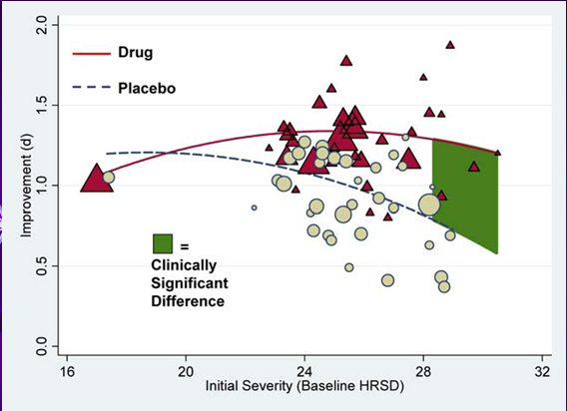
- Y-axis: improvement in Cohen's D - effect size
- X-axis: Hamilton Scale of Severity of Depression
- the triangle size on the graph represents the size of the study
  - the bigger the triangle, the bigger sample size there was in that study
  - the bigger the study was, the more weight it was given in the meta-analysis
- note that the green region shows clinically significant differences between groups and is not evident until severe levels of depression
  - another important note is that at extreme levels of depression it's not that drugs work better, it's that the placebo effect decreases
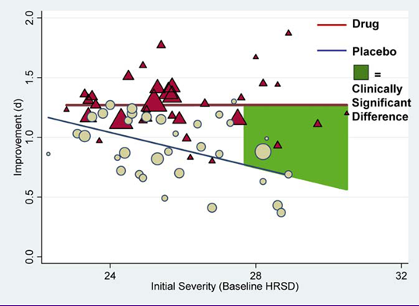
- now looking at the same graph but scaling is to show severe depression now
  - this graph's scaling demonstrates more clearly that the drug's effectiveness in treating depression remains constant across severe depression, and the placebo effect decreases
    - this results in the clinical significance (S.D. of 0.5 or more)
Conclusions of the Meta-Analysis study
- differences in effectiveness between drugs and placebos increases as a function of severity level of depression
  - this difference is because of the decreasing effectiveness of the placebo group as the severity of depression increases and not due to increasing effectiveness of the drug
- this opened up the door for a lot of future studies on the issue
- when treating depression, the number 1 action is to treat it with drugs
  - Kirsh proved that this would be ineffective unless the patient had a severe level of depression
    - pharmaceutical companies would be pissed the fuck off reading Kirsh's study
60 Minutes: Video on Kirsh's Meta-Analysis
- pharmaceutical industry in a 11.3 billion dollar annual business
- Kirsh proved that it's not the drug that makes depressed people feel better, but it is because of the placebo effect
- Kirsh said the placebo effect is not just present in depression, it can be related to knee surgery, IBS, and tons of other shit
- Kirsh believes when doctors prescribe anti-depressants they become a part of the placebo effect
- Pharmaceutical Industry dude says there is a 14% improvement in moderate depression and its more for severe depression
- FDA of psychiatry says that drugs are effective and improvement in depression from drugs and a placebo group is a "modest" difference
- The UK accepted these results and now only prescribes drugs as the 1st option for severe depression only
- another study showed exercise is just as effective as drug treatment in light to moderate depression
- The results of Kirsh's work
  - showed how a meta-analysis study can show you what is really going on
  - stresses the importance of unpublished studies
    - it's not that the methods are flawed in unpublished studies, it becomes unpublished because somebody doesn't like the results and just buries the study
      - i.e. if pharmaceutical companies were funding Kirsh's study, they probably wouldn't publish the results because it would fuck up their business, even though this nigga spits the truth harder than Talib Kweli
Prapavessis' Study: The acute effects of exercise on cigarette cravings, withdrawal symptoms, affect, and smoking behaviour: systematic review and meta-analysis
- Prof is on his own dick like Heath****study his article in depth
- wanted to see how exercise effects cravings in people who are trying to quit smoking
- "acute" in this study means short (short term effects of exercise of cigarette cravings)
- first part of his study was asking the person to not smoke for 15 hours prior to the start of the study
  - then from here you can begin and assign the participants to the experiment group (exercise) or control group (no-exercise)
    - non-exercise group is a passive control group in this study
  - this was a meta-analysis
- This is called a Forest Plot
  - tells us a lot about the main findings of a study in a topic where you really don't know shit
  - on the left shows mean differences between groups in their desire to smoke from 0-5 minutes following treatment
  - there's a standard error listed (S.D./ square root of sample size)
  - they listed the weight that each study carried (based on the size of the study)
  - they listed a confidence interval to show whether the value is representative of the general population
    - the tighter the range is around the mean (S.D.), the more accurate that mean value will be
  - in this study they measured desire to smoke on a scale from 1 to 7
    - the mean difference in groups was .27
  - with meta-analysis studies, generally you get a lot of heterogeneity (similarities between groups) but there are always some key differences in the studies used
    - i.e. one may use aerobic vs anaerobic, one may use actual weight lifting vs shit like crossfit, etc.
  - if you saw a Forest Plot on the exam you should be able to determine how similar or different certain studies are
Vitamin D status and ill health: a systematic review
- all you needed for the assignment was this one article
- Findings
  - observational studies showed an inverse relationship between vitamin D and many health outcomes
  - no association was found between vitamin D and cancer
    - except for colon cancer (only exception)
  - People with vitamin D levels lower than 50 nmol/L were given 50mcg of vitamin D a day and did not show any improvement in health
  - there is a discrepancy between intervention and observational studies
    - intervention studies are not supported
  - Ultimately the study found was that low vitamin D levels are a consequence of inflammation
    - therefore low vitamin D levels are related to negative health consequences (because of inflammation) but it does not prove that raising vitamin D levels would prevent illness from occurring
    - there is insufficient evidence to prove that vitamin D can prevent health conditions like cancer, diabetes, and cardiovascular disease
      - a vitamin D supplement would only improve bone health
- Trial Sequential Meta-Analysis: takes existing data and projects how many future trials are needed to change what the current meta-analysis is proving

INTERMISSION TIME - Go smoke a fatty - yedig?

Types of Research - Case Study
Case Study
- Case Study: a systematic inquiry of an event or a set of events that describe and explain a phenomenon (Bromely, 1992)
  - observes what goes on, and then tries to reconstruct and analyze the case (Zonabend, 1992)
American Crowbar Case

- case study in 1848
  - Phineas Gage had a railway spike go through his fucking head and survived like a true G
  - a lot of psychology research was based on him because it was an extremely rare case
Jacqueline Patterson Case Study - Medical Marijuana
- woman was born with cerebral palsy
- she can't speak properly
- after she hits 3 bowls of the Afghan Kush she:
  - can speak more fluently (unlike Deveret)
  - has better motor control (unlike Deveret)

- what we want to study here is why does marijuana work in this case?
  - if it is effective, what is it about THC that is producing this result?
  - maybe we can make a pill form of it for people with cerebral palsy?
- rare shit like this is why case studies are important
Steroid Side Effects
- some reasons we do case studies on steroids:
  - what are the reasons why people want to take steroids?
    - most important question
  - what are the side effects?
  - what's the training and diet like with the use of steroids?
Adrian Owen - Neuroscientist at Western
- this dude came from Cambridge to Western and got paid 20 million dollars to study shit here (dat coin tho)
- he did a case study on a person named "Patient 23" (2010)
  - patient 23 was 24 years old and was in a car accident that put him in a vegetative state for 5 years
  - Adrian Owen did an fMRI on Patient 23 and started asking him questions
  - the fMRI showed blow flow to certain parts of the brain when asked specific questions which lead Owen to believe that Patient 23 was conscious and able to communicate
    - critics question whether this was just brain noise instead of conscious signals
- did a case study on a 23 year old female who was in a vegetative state for 5 months (2006)
  - a healthy person imagining playing tennis shows activation in the supplementary motor cortex
  - did an fMRI on vegetable girl while asking her to imagine playing tennis
    - found that the brain activation was similar to healthy people when completing the same task
- Owens believed that 20% of people in a vegetative state are capable of communicating, but they just don't have a way to do it
- this brings up an ethical dilemma
  - if you can communicate with people in a vegetative state, then perhaps you could ask them if they want to die?
- Owen believes one day we will find a better way of communicating with people in a vegetative state

Escape Fire: The Fight to Rescue America's Health Care System
- case study on America's fucked up health care system
- The USA makes 2.7 trillion dollars a year on health care costs
- The average person's health care cost each year worldwide is $3000 but in America it is $8000
- The whole point of this study was showing that doctors are not valued based on how well the treat people, but on the amount of people that they treat
- the USA is 50th in the world for life expectancy (pretty shitty)
- The "Escape Fire" is symbolic for a burning US health system that has a way of getting out of
Case Study Pros and Cons
- Advantages
  - emphasizes helping individual or organization
  - provides an in depth analysis on how each variable affects a different variable
  - potentially more informative
  - potentially less expensive
    - ***key word potentially
      - so key you could cook it up with baking soda and slang it out east of Adelaide
- Disadvantages
  - external validity issues
    - often not applicable to others
  - potential research bias
Self-Regulation Training, State anxiety, and sport performance: a psycho-physiological case study
- Study Done by Prapavessis in 1992*****important shit
- there has been a lot of research studies that are built of modifying emotions in order to improve performance in sport
- Findings
  - Equivocal
  - controlling anxiety will lead to optimal performance but we are unsure why?
    - possible reasons are:
      - our operational definition for anxiety differs based on opinion
      - individual differences
        - anxiety affects everybody differently and sometimes a bit of anxiety is beneficial
Mace (1990)
- 1) athletes must show that symptoms of anxiety are detrimental to performance
- 2) intervention is more effective if you spend more time helping the athlete with anxiety
- 3) training/testing conditions should simulate competition conditions
Selection of Athlete
- training 20 year old male to be small bore Olympic rifle shooter
- athlete was recommended by coaching director
- the athlete rated state anxiety (cognitive and somatic) to be his worst mental skill
  - somatic anxiety increased HR and BP and that fucked up performance
Dependent Measures
- Measured state anxiety (didn't want just a self report - wanted a shitload of methods)
  - Self-Report (CSAI-2)
  - Electromyography Response (EMG)
  - Electrocardiography Response (ECG)
  - Biochemical response (took catecholamine and adrenaline concentrations)
  - Behaviour Response (accelerometry)
- you can take many different measures for a case study that involves one person because it is feasible and doesn't have to be applied to a large group
- Measured Performance
  - measured the exact distance from the bullet hole to the center of the target and then calculated errors based on how far off his shots would go
Treatment
- first was stress sensitivity
  - individual was wired to portable computers and became familiarized with a urine protocol
- Baseline
  - they thought the person may get stressed out by this so they hooked him up to many non-competition performance situations before a real one to get him comfortable
  - once this dude got comfortable, they began the intervention
  - he was okay, but all his equipment hooked up to him had this nigga lookin like optimus prime which made his competitors nervous (some even shat themselves)
- Intervention
  - did a 6 week program with 12 sessions focused on breathing, stretching, relaxing, stopping thoughts
- Post Intervention
  - looked for changes in anxiety variables related to performance during another competition
Self Report of Cognitive anxiety (do I feel nervous?)
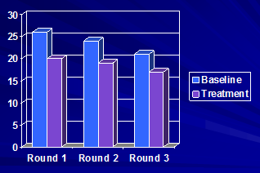
- regardless of which round it was, cognitive anxiety was lower in treatment than baseline
Self Report of Somatic Anxiety (do I recognize my physiology? - HR, BP, tension)
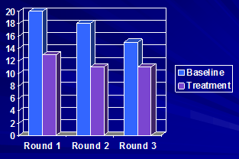
- decline from round 1, to 2, to 3
- treatment better than baseline
Self Reported State Confidence
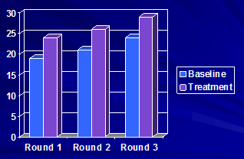
- improved in treatment
Urinary Noradrenalin
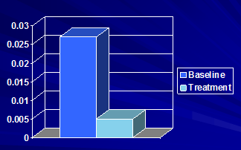
- improved in treatment
  - lower levels in treatment which means less nervous/stressed
Urinary Adrenaline
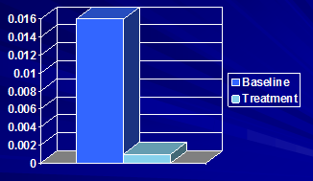
- improved in treatment
  - lower levels in treatment which means less nervous/stressed
Accelerometry (Gun Vibration)
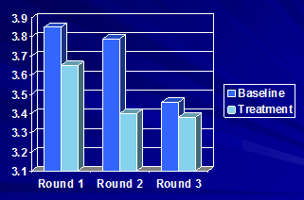
- improved in treatment
  - less in treatment means less shakiness
Heart Rate (ECG)
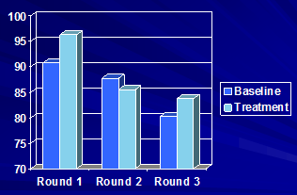
- measured in bpm
- notice how in rounds 1 and 3 the treatment had a higher HR than the baseline
  - this was the first pattern that was inconsistent with improvement in anxiety on performance
    - **showed opposite of what we expected
Forearm EMG
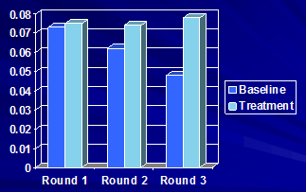
- not much different in round 1 but as you can see in round 2 and 3 there is more activation in the forearms
  - this is the opposite of what we expected to occur
- HR and Forearm activity did not improve like we thought it would

Performance Error
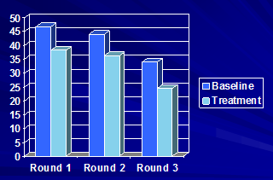
- Just as expected, the treatment group had lower performance error in all 3 groups
  - the lower the bar on the graph means the distance from the target was not as far off
Threats to Internal Validity in this study
- Differences in the environment
  - Baseline
    - Temperature: 18 degrees Celsius
    - Wind: 2 to 10mph
    - Importance: 3/4
  - Treatment
    - Temperature: 21 degrees Celsius
    - Wind 0 - 8mph
    - Importance: 3/4
- Differences in Personal Life (no differences)
  - Baseline
    - Diet: no restriction
    - Sleep: 9hrs per night
    - Training: 10-15 hours per week
  - Training
    - Diet: no restriction
    - Sleep: 9hrs per night
    - Training: 10-15 hours per week
- manipulations are very controllable
- from this information we can conclude that personal and environmental factors were not a threat to internal validity but note that in some studies they can be
Limitations in the Study
- Generalization of findings
  - very difficult to do, especially in a case study
  - results apply to this one particular shooter
  - the results may not apply to all shooters who experience anxiety
- Expectancy Effect
  - we can never say for certain that the self-regulation treatment was really responsible for the results
  - even if we did know 100% that it was, we still don't know which components of the treatment were more salient (important) in producing the results
Conclusions
- a multi-method intervention process reduced state anxiety (in most cases) and led to a better performance
- it's important to note that the combination of case studies and meta analyses are the avenue that most researchers take to becoming a good scientist (unlike deveret)
Single Subject Design - Intervention Research
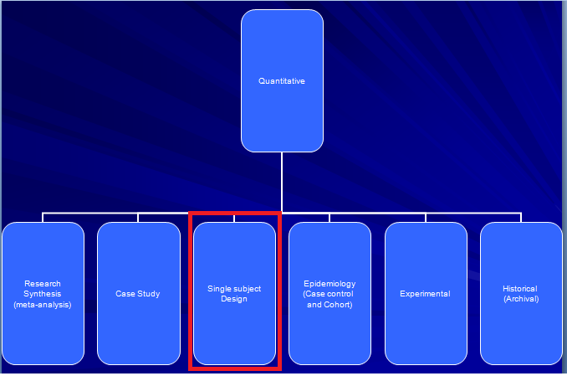
- A single subject design takes a step further than a case study
  - a case study does an in depth analysis of one person or a group and examines their particular case
  - a single subject design does a study on one individual at a time (never a group at once), and then repeats the same study on a different individual whereas a case study just focuses on that one person/group
- very few published articles use a single subject design format
- the methodology is not embraced by the scientific community
Rationale
- The reason we use a single subject design is because every individual is unique and the average change observed may not be representative of what went on
Advantages of a Single Subject Design
- 1. takes repeated measurements of an athlete's performance in different conditions (practice vs game)
  - this provides information on the variation in performance (potentially valuable)
- 2. very few subjects are needed to evaluate an intervention
  - generally completed on 3-5 people
- 3. can identify within and between subject designs that are easy to identify
- 4. everyone receives the intervention
  - no dividing people into control or intervention groups
  - everybody is their own control
    - participants go through the control (baseline) and intervention process to measure the difference in their own performance (improvement or not)
- 5. not hampered by assumptions required in a group deign
- 6. emphasizes social validation
  - asks people what they thought of the treatment after they do the study
Characteristics of a Single Subject Design
- everybody is measured at first to establish a baseline (control), then is provided an intervention
  - everybody is their own control group when comparing treatment results
- there is an ongoing assessment of the dependent variable
  - i.e. how many laps you swam, or how accurate your serve was, etc.
- does not rely on assumptions or inferential statistics that come with performance
The Ceiling Effect and Baseline Performance
- in a single subject design, there is always a trade-off between baseline stability and room for improvement
- Inexperienced/Novice athlete
  - Advantage: lots of room for improvement
  - Disadvantage: unstable baseline measure
  - when taking a novice athlete they will likely be shit at what they do and the baseline level will be unstable because their performance will be all over the place
    - i.e. if you ask somebody who doesn't play volley to serve multiple times to see how skilled they are without any training (baseline), they might snipe one in the corner and then the next serve blast one into the stands a fucking mile away from the target
      - since a novice athlete's baseline measure is so inconsistent, it is very difficult to establish a stable baseline of where their initial skill level is at
  - Since a novice athlete is so shit, there is a lot of room for improvement and it is easier to establish how effective the treatment was because they don't run into the ceiling effect (lots of room for improvement)
- Experienced Athlete
  - Advantage: stable baseline measure
  - Disadvantage: little room for improvement (ceiling effect)
  - since an athlete is already experienced, it is likely that they will have a more consistent level when measuring baseline skill
    - i.e. if you are asking an experienced volleyball to hit a target on the court, he may not hit it or get close to it every time, but his serves will be a lot more consistent than an inexperienced athlete like Adam Deveret
      - easier to establish a stable baseline level
  - the problem with an experienced athlete is since they are already skilled, there is a very limited amount they can improve before they hit a plateau/ceiling
    - called the ceiling effect
    - i.e. if an experienced athlete has a baseline that is 95% of his max potential skill, the most he can improve is 5% and then it becomes difficult to assess how effective treatment was because margins for improvement are so small
- just note that there is always that trade-off between baseline stability and room for improvement when picking experienced or inexperienced athletes
Procedural Reliability Assessment of Treatment
- steps taken in order to ensure that treatment applied was how it was intended to be applied
- how do you know if the treatment you offered was received in the right way?
  - to solve this problem we introduce a 3rd party person to observe the scores recorded and evaluate the dependent variable to ensure we get a reliable measure
  - the person conducting the study is the initial observer
  - the 3rd party person is the interobserver
  - we can then calculate an Interobserver Reliability Score
- Calculating the Interobserver Reliability Score
  - look at the dependent variables recorded
  - divide the smaller value of the DV taken by one observer, by the larger value of the DV recorded by the other observer
  - once you have this number, multiply it by 100 and that is your IOR (interobserver reliability score)
  - an IOR of 80% or greater is considered acceptable (Kazdin, 1994)
Assessment of Treatment Effects
- how convincing is it that the treatment is what was responsible for the change in the dependent variable?
- are the participants in the study satisfied with the result they got from the treatment? (social validation)
Three Types of Single Subject Designs
- 1. Replication-Reversal (ABAB )
- 2. Multiple-Baseline
- 3. Alternating Treatment
Replication-Reversal (ABAB) Single Subject Design
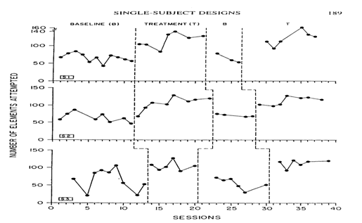
- in a replication-reversal study you apply Baseline then Treatment then Baseline then Treatment (like an on-off switch) ABAB
- in this study there were 3 individuals who self monitored their feedback in improving figure skating methods
- Internal Validity
  - the most convincing form of internal validity is a treatment's ability to turn on and off when it is introduced or withdrawn
  - this way if one improves and the other does not, then maybe you can identify a factor that lead to improvement?
Multiple-Baseline Single Subject Design
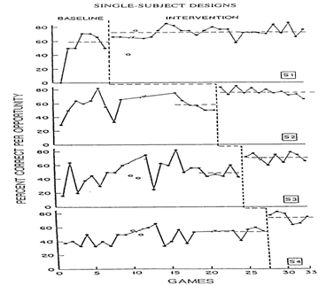
- in a multiple baseline study you apply different amounts of time spent in the baseline of treatment to rule out time as a factor
- the big difference between a reciprocal reversal ABAB design and a multiple baseline design is that in the multiple baseline design there is no "on-off-on-off" it's strictly control and then treatment
- in this study they were teaching 4 basketball players how to set a pick
- notice how for each participant they add a bit more time in the baseline zone to factor out time as a confounding variable
  - they found out that the time factor in the baseline zone didn't make a difference
- External Validity
  - means what happened to subject 1, was consistent with subject 2, was which was consistent with subject 3....and so on
  - in this experiment it was very clear that it had strong external validity because the results were generalized across all 4 subjects (not the general population but within the experiment)
Alternating Treatment Single Subject Design
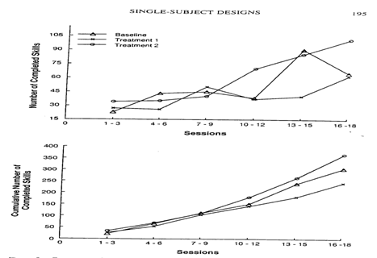
- in this type of subject design you are simply comparing different types of treatment (alternate) with to the baseline control over time
- we use a different order of treatment for the individual each time (remember in a single subject design each person is their own baseline)
  - constantly alternating treatments
- in this study they were looking at gymnasts and how different training methods improves performance
  - Baseline Group: standard coaching
  - Treatment 1 : standard coaching + self-regulation
  - Treatment 2 : standard coaching + private-regulation
  - after about 10-12 sessions we start to see some differences
- Advantages of Alternating Treatment Design
  - allows comparison of treatment within the individual over time
  - can detect delayed treatment effects
  - all conditions are introduced at the same time (congruently) so it avoids the need for lengthy conditions
- Disadvantages of Alternating Treatment Design
  - interaction may occur because of similarities between conditions
    - hard to separate
    - to try and avoid this, do a few additional sessions with the most effective treatment group after the experiment is done. If you find that performance continues at the same level even when you're alternating this treatment with a different treatment, then it is unlikely that an interaction between treatments occurred
Confidence in the Data (for all types of single subject design)
- baseline data should be stable
- the more times a study is replicated (within and across subjects), the more confident we can be that the data is legit
- the sooner the effect occurs following the introduction of treatment
- the larger the size of the effect in comparison to the baseline
- results are consistent with existing theories
- ***regardless of the types of design these points give us confidence in the data
Making a Decision Based on Visual Inspection
- sometimes we need to see things visually to properly analyze it
- statistics takes away visual assessment from us because we're naturally inclined to look for patterns that may not be there
- in a visual inspection if the difference between groups is large enough, we will likely see it
Making Decisions
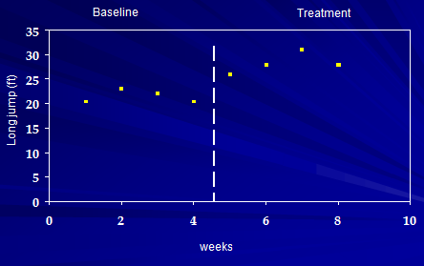
- what is the criteria for determining change?
- here we have long jump performance measured in feet
- for the treatment, they did some lower body strength training to try and improve explosiveness
How much change is needed to detect it visually?
- Bobrovitz and Ottenbacher (1998) did a study on 42 ABAB graphs that examined 32 students
  - they found that when comparing statistical analysis to visual analysis, there was an 86% agreement between techniques (eyes are pretty good)
Statistical Tests used in a single subject design
- uses a split middle method
  - what this does is it computes a trend line at the baseline level so you can visually compare the trend line to the treatment group and analyze the difference
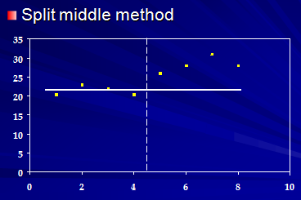
  - looking at baseline on the left
  - you construct the trend line by taking the 4 points and splitting them in half (hence "split-middle")
    - on the graph (2 above the line and 2 below the line)
  - now looking at the right side of the graph (treatment) we can visually see that all the points were above the baseline's trend line
    - from this visual we can conclude that treatment was effective
- 2 S.D. method
  - its argued that an effective treatment for performance will be 2 S.D. above the baseline
    - the likelihood of finding a data point outside of this treatment line is 5%
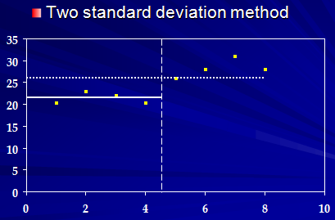
  - the dotted line represents 2 S.D. above baseline
  - notice how only 3 out of the 4 individuals in the study are above this line
    - shows us that our confidence might not be as robust (strong)
    - shows us that this may not be applicable to all individuals
Misunderstandings about Single Subject Design
- single-subject designs are essentially the same as Case studies and therefore lack internal validity
- single-subject design lack external validity
- visual inspection of data is subjective and not scholarly
  - there's actually an 86% agreement between statistics and visualization
- single-subject designs can’t be used to compare alternative treatments
  - avoiding interaction of what might be happening between treatments
- single-subject designs can’t be used to detect small effects
Final thoughts on Single Subject Design
- Research often develops in stages and the single-subject design can be useful in early stages for hypothesis generation (Reboussin & Morgan, 1996)
- when you start a clinical trial, it's good to use a pilot test on people to show its properly being received by subjects
- are we showing the type of results we would expect in the group?
- is the outcome variable behaving in the way we would expect it to?
- if you know this shit, you can gain more confidence that you can correctly apply it to more people
Experimental Research
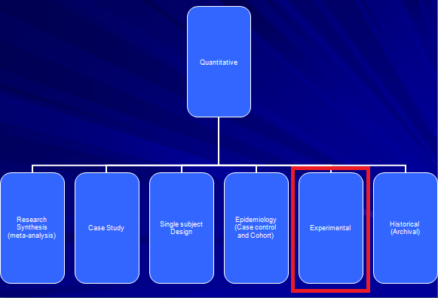
- experimental research studies cause and effect
  - in 1st assignment we saw that vitamin D did not improve bone health
  - this is because they researched cause and effect
  - in non experimental studies they found an association between vitamin D and non-bone health because of confounding variables
- experimental research has 3 important criteria that must be present
  - 1. the cause must precede the effect
  - 2. the cause and effect must show a correlation
  - 3. the correlation between cause and effect cannot be explained by another variable (confounder)
  - note that in the vitamin D studies, the association found between vitamin D and non bone health violated the 1st criteria
    - simply because there was an association between low vitamin D and poor health, did not prove that vitamin D was the cause and poor health was the effect (it was exactly the opposite)
    - experimental design studies found that low vitamin D levels were a result of inflammation due to poor health, therefore vitamin D was the effect and not the cause
Clinical Trials (Randomized Control Trials)
- used to test whether one health care intervention is superior to another
- doesn't just have to be drugs, it can be any intervention
  - i.e. benefits of exercise and physical activity
- has 4 sequential phases of clinical trials (randomized control trials)
  - Phase 1
    - done on a very small sample (sometimes as few as 12)
    - evaluate how the drug should be administered (i.e. injection vs pill)
    - evaluate the dosage and frequency that it should be taken
  - Phase 2
    - still a small sample size
    - often called a "proof of principal" or "proof of concept" trial
      - means once you figure out how to administer the drug, you now want to test that the drug is working the way it was intended to do
    - the goal here is to test the drug's safety
  - Phase 3
    - this is the phase where real shit gets done
      - no expenses spared
      - huge sample size
      - vigorous study
      - try to establish cause and effect
    - test the treatment (drug, surgery, etc.) to the current standard treatment
    - the key issue in this phase is the randomization design
      - randomization produces group equivalency of known and unknown factors
        - the term group equivalency means they had more consistent measures to help rule out the possibility of biases and confounding variables
      - randomized design is important because:
        - 1. increases group equivalency (which decreases 2 and 3)
        - 2. decreases biases
        - 3. decreases possibility of confounding variables
  - Phase 4
    - studies long term effects of the drug use in patients
    - done on thousands of people
    - Essentially the drug company wants to provide enough evidence to get FDA approval (particularly in phase 3 and 4) so they can put it out on the market and get people to buy it
      - Usually if there's no serious long term effects, FDA will feel more confident approving it
      - If side long term side effects are severe, FDA may not approve it, or they may approve it but give a warning about the side effects
    - From a clinical point of view you HAVE to go through theses 4 phases
END OF MIDTERM (study did you know section at bottom though)
Did You Know???
Corkscrew-Wine Bottle Experiment
- you can get cork out of wine by blowing up a fuckin bag and yanking the cork out
  - Jorgen Oden proposed "what if you could use the same principle to help women give birth"?
    - this dude was a car mechanic (unlikely source)
  - invented a double layer plastic inserted in the birth canal, where air is pumped into the bag and grips the baby's chin and yanks that nigga the fuck out
  - baby does not breathe in nose until birth so it doesn't hurt him/her/he-she
  - health implications
    - inexpensive
    - easy to use
    - prevents scalp damage
    - reduces risk of transmittable disease (HIV)
    - helps bring down of cesarean births (C-section)
Reinventing The Toilet Fair
- funded by Bill and Melinda Gates Foundation
- invented a toilet that kills bacteria, pathogens
- solar powered
- waterless toilet
- pour some orange chemical in the toilet?
- mixture heats with the shti and urine and takes 10 mins and becomes starlized
- *****look for this video online
Detox - Dr. OZ
- detoxing has become a billion dollar industry and Canadians are going to extremes to cleanse their bodies
  - on marketplace the TV show
  - 8 sorority sisters took part in a 48 hour detox at western on this show
  - based on doctor oz who claims we can detox ourselves in a very short period of time by eating nothing but specific foods
  - did test w/ toxicologist
- Results
  - toxicology test showed detox doesn't do shit
    - Dr. Oz claims is does and people follow him because he's well known, but in reality his claim was proven false at Western
  - message is to be an educated consumer

