Herzberg (Motivators & Hygiene Factors)
Negative Physical KITA: A literal application of the term that is used to motivate employees with physical attacks.
- It is vulgar and rude
- It’s a physical attack, therefore negative repercussions can happen

Negative psychological KITA: Motivate employees with threats and harassments. It had advantages over physical KITA.
- Cruelty isn’t visible
- Reduces the possibility of an employee to fight back
- No evidence if employees complain or accuse

Positive KITA: Motivate employees by telling them they will receive an award in return for something they are asked to do.
Attempts to motivate employees that don’t work:
1) Reduce Time Spent at Work
really motivated individuals seek more hours at work, not less
2) Spiraling Wages
this motivates individuals to seek the next wage increase
3) Fringe Benefits
benefits are no longer rewards, they are rights
4) Human Relations Training
no matter how many “pleases” you add, it won’t motivate
Sensitivity Training
short term, temporary gains as a result of increased comfort
5) Communication (One-Way)
not hearing what employees are saying, just frustrates them more
6) Two-Way Communication
employees want more than to just talk and listen; they want to actualize themselves
7) Employee Counseling
let employees talk about their problems
still does not discover how to motivate
8) Job Participation
it gives employees the big picture
but a feeling of real achievement requires a task that makes it possible

Hygiene factors: Salary, supervision, work conditions, how you are treated, security, etc. (extrinsic)
  - When hygiene is absent the employee is dissatisfied.
  - When hygiene is present the employee is not dissatisfied; neutral.
  - It is not enough to completely satisfy an employee.

Motivators: Achievement, recognition, responsibility, growth or advancement. A motivator is like a battery that can recharge itself. (intrinsic)
- Good motivators are the factors that have the potential to promote work satisfaction rather than prevent dissatisfaction.

Horizontal job loading: Adding or modifying the responsibility of a task. (learning something new)

Vertical job loading: Giving the employee a task outside of the usual, something new to them will motivate them.

Job enlargement: getting more tasks

Job enrichment: After you learn more, you become more efficient, opportunity to grow by adding more complex tasks.

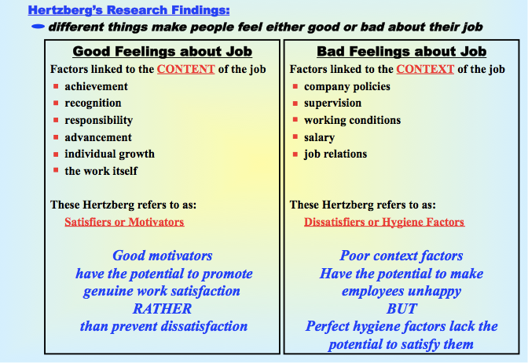
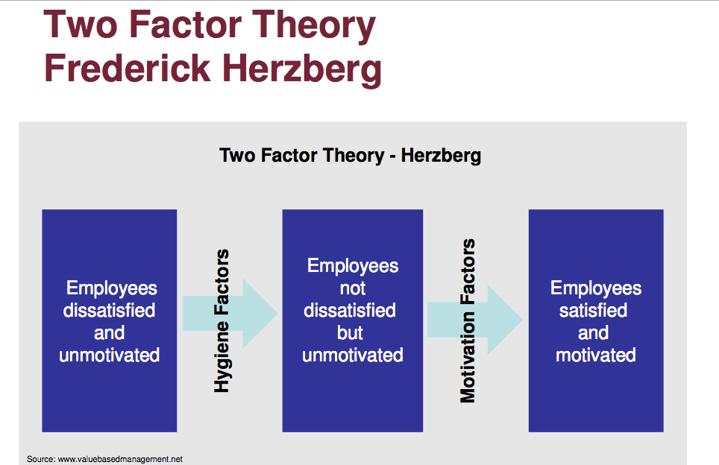

Handy (Sigmoid Curve)

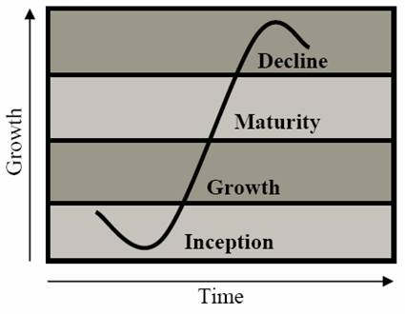
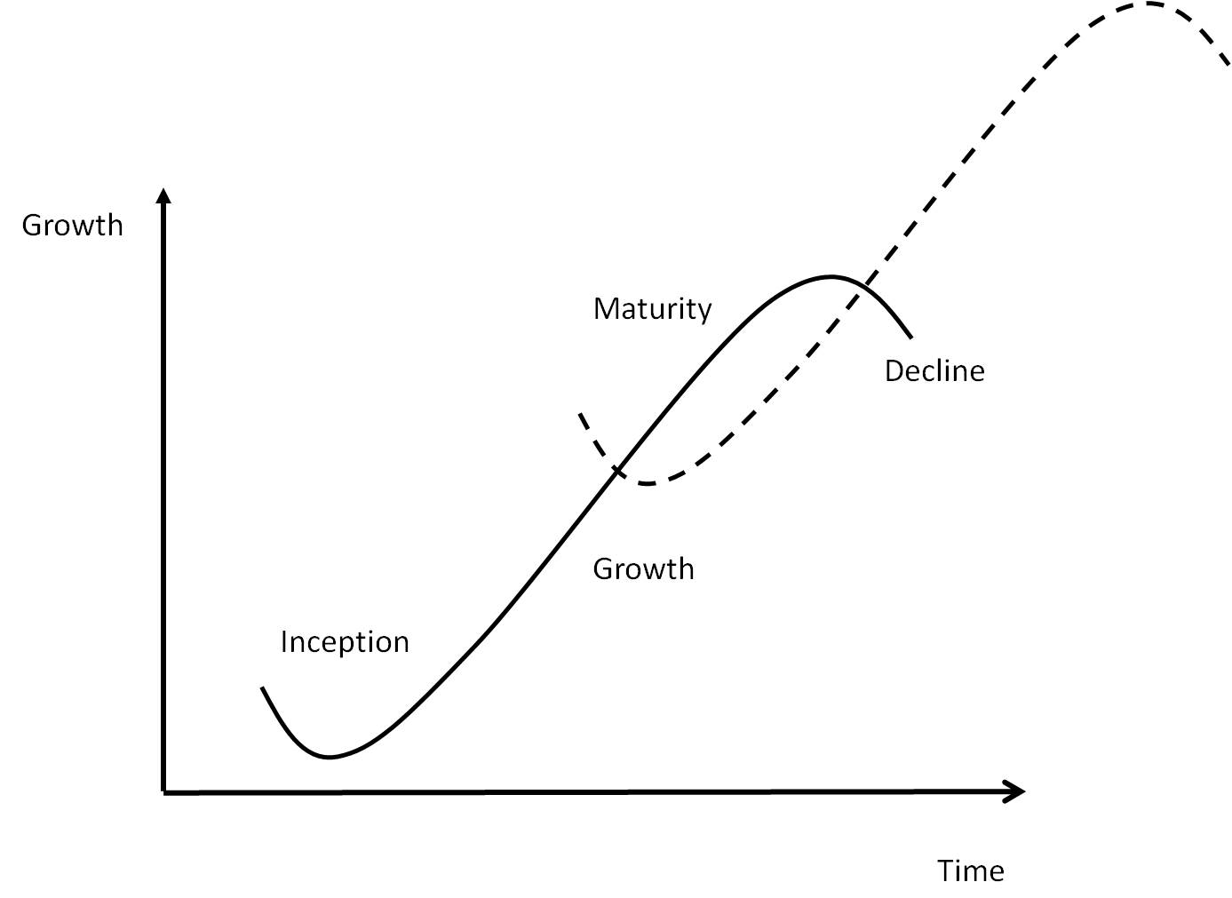

CLAIM:
The secret to constant growth is to start a new curve before the other one starts.

MAJOR CONCEPTS:

Paradox of success
- Things that got you where you are, are not often things that keep you there.
- When you know where you actually have to go in order to grow, it is often too late
- When everything is fine why change? (point A)
- Two or more groups of people and two sets of ideas competing for the future. (shaded area)
- Resources are depleted and energies are low. Ex. Layoffs (point B)
- To have a second curve: you need new products, operations, strategy and culture, new people
- Original leader must be able to keep the first curve going long enough, however it is difficult to abandon first curve
- New leader is needed for second curve, the first one must be able to leave the organization

The discipline of the second curve
- You do not re-invent the same life
- You must invest time for imagination
- Traditional 4 stage cycle
- Questions give new ideas & possibilities
- The best of these must be tested
- Results of the experiment are reviewed
- Must re-think and re-invent a new life

Curvilinear logic
- Starting life over again
- It can see more clearly where the first curve is heading what the next one might look like

Kaplan & Norton (Measuring)

What you measure is what you get!

The bottom line is not enough!

1) Managers want a balanced presentation of both financial and operational measures
2) The balanced scorecard forces managers to focus on the handful of measures that are most critical.
3) Complexity of managing an organization today requires that managers be able to view performance in several areas simultaneously.
4) A balanced scorecard gives top managers a fast but comprehensive view of the business
5) With an excellent set of balanced scorecard measures, no guarantee of a winning strategy.
6) The balanced scorecard can only translate a company’s strategy into specific measurable objectives
7) The balanced scorecard puts strategy and vision, not control, at the center.
8) The balanced scorecard keeps companies looking and moving forward instead of backward.

5) The scorecard includes:
financial measures that tell the results of actions already taken
It complements these with operational measures on
      - customer satisfaction
      - internal processes
      - the organization’s innovation and improvement activities that drive future performance
6) The Scorecard provides answers to 4 basic questions
How do customers see us ? (CUSTOMER PERSPECTIVE)
What must we excel at ? (INTERNAL BUSINESS PERSPECTIVE)
Can we continue to improve & create value? (INNOVATION & LEARNING)
How do we appear to shareholders ? (FINANCIAL PERSPECTIVE)

  - Customer perspective: how do customers see us? How a company is performing from the customer’s perspective. Balanced scorecard demands that managers translate their general mission statement on custom service into specific measures that reflect the factors that really matter to customers.

  - Internal perspective: what must we excel at? Measures to take internally to meet its customers’ expectations. Managers need to focus on those critical internal operations that enable them to satisfy customers’ needs.

  - Innovation & learning: Can we continue to improve and create value? Improve existing products, launch new ones, create more value for customers, improve operating efficiencies to penetrate new markets & increase revenues.

  - Financial perspective: how do we look to shareholders? Indicates whether the company’s strategy, implementation, and execution are contributing to bottom-line improvement.

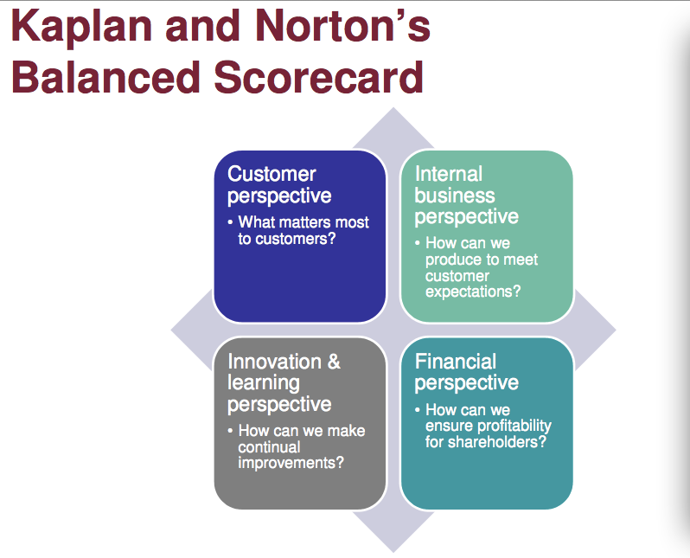

Mintzberg (Roles)
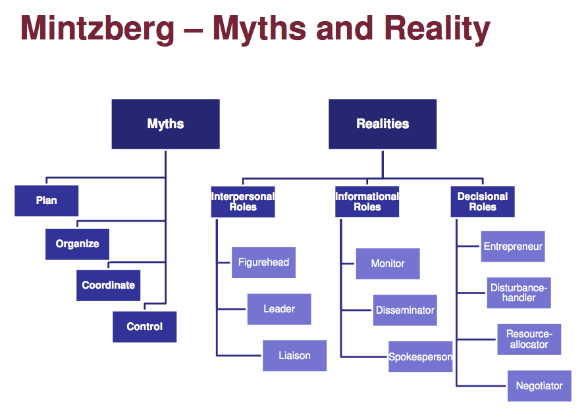
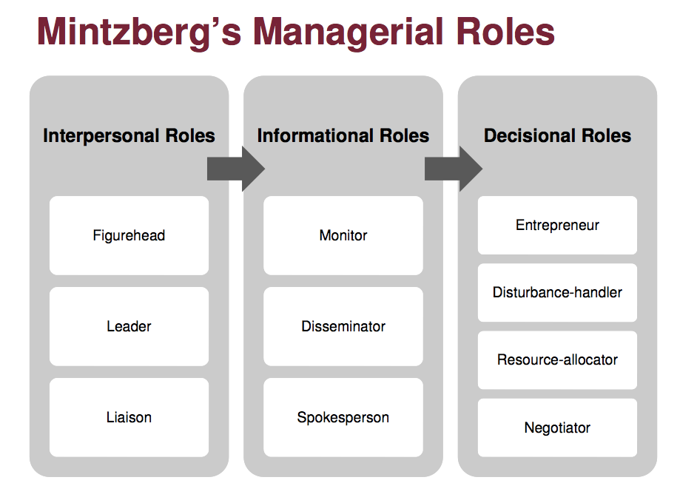

Interpersonal Roles
come about as a result of formal authority (legitimate power)
    - FIGUREHEAD
      - perform ceremonial duties
      - they greet representatives from other organizations
      - take customers to lunch etc.
    - LEADER
      - responsible for the work of subordinates
      - responsible for hiring and training of staff
      - they must motivate and encourage employees
    - LIAISON OFFICER
      - usually the one who makes contact with individuals horizontally within the organization

Informational Roles
communication is their work
    - MENTOR
      - forever scanning the environment for information
      - ask questions of their contacts
      - gather information from subordinates
      - filter unsolicited information
    - DISSEMINATOR
      - passes privileged information directly to subordinates
    - SPOKESPERSON
      - sends some information to people outside the unit
          - to directors
          - to shareholders
          - to government officials
          - etc.
Decisional Roles
the manager is the only one who has formal authority to commit the unit to important new courses of action
often, only the manager has the complete information to decide the unit’s strategic direction
      - ENTREPRENEUR
- seeks to improve the unit by adapting it to changes in the environment
      - DISTURBANCE HANDLER
- must often, involuntarily, respond to pressures that cannot be ignored
            - e.g.. dealing with a strike
            - deciding what to do about a customer that can’t pay its bills
      - RESOURCE ALLOCATOR
        - deciding who will get what
        - giving his/her time to someone
        - dividing up the unit’s work
        - coordinating functions
      - NEGOTIATOR
- conflict resolution
- getting the best deal for the unit/organization

Liker & Choi (Supplier)
Companies need to build long-lasting, mutually beneficial relationships with suppliers
    - This can be accomplished:
        - through collaboration
        - by having respect for each other
        - and by insisting on co-prosperity
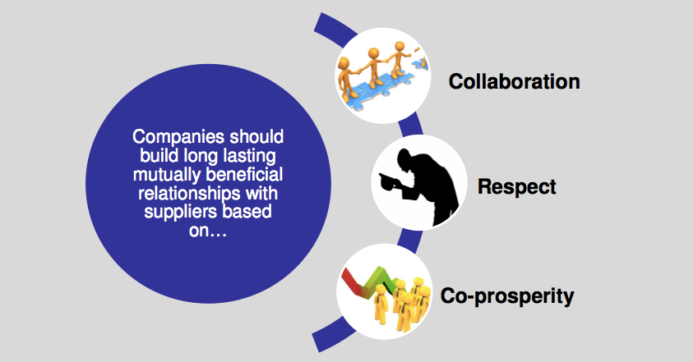

    - The underlying values necessary for this to happen are:
        - trust
        - improvement
        - empathy
        - and discipline

French & Raven ( Power)
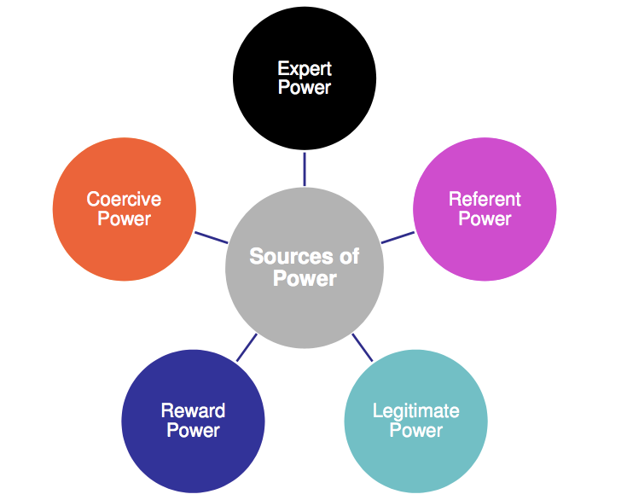
- Reward Power
The perception that one person can decide how a second person will be compensated
- Coercive Power
One person has the ability to punish another
3) Legitimate Power
  - Authority
  - The organization has given one individual the right to direct the actions of another
  - Subordinate must accept that the person has the right to direct her/him (Barnard’s research)
  - Varies widely with cultural background

4) Referent Power
- Sometimes we just are in awe of another person
- They inspire us
- This source of power has the broadest range
5) Expert Power
If one individual has some special knowledge or expertise they can exert power on others



