Evolution
Evolutionary theory before Darwin
Species] are the result of complex historical and evolutionary processes: They come into existence, change and then cease to exist. In short, species are the empirical traces left by the workings of evolution, and we cannot understand one without understanding the other
Lamarcks contributions to evolutionary thought
- Species change over time
- Changes pass on from one generation to the next
- Organisms respond to environmental conditions
- Hypothesized mechanism (principle of use and disuse and pincple of inheritance of acquired characteristics)
  - Today, Lamark’s reputation has been redeedmed by those working in field of epigenetics (the study of inherited changes in phenotype or gene expression caused by mechanisms other than changes in the underlying DNA sequence), who have found that environment experienced by parent can influence offspring.
Charles Darwin (1809-1882)
Observations and inferences
- Observation: Populations have a great capacity to grow but are ultimately limited by resource availability
- Inference: Competition between individuals in a population for resources
- Observation: Individuals vary within populations in heritable traits related to competitive success (ultimately survival)
- Inference: Some individuals more likely to survive and reproduce than others
- Observation: Individuals may also vary within populations in heritable traits related to REPRODUCTIVE competitive success
- Inference: Some individuals more likely to reproduce than others
Decent with modification
- A population’s characteristics will change over the generations, as advantageous characteristics become more common
- Populations become adapted to their local environment, eventually diverge and form new species
Changes in Allele frequency over time
- Evolution encompasses all types of changes brought about by selection processes and chance events
- Charles Darwin used domesticated species to first illustrate concept of artificial selection: change associated with exaggeration of desirable (from human perspective) rather than improved survival or reproductive abilities.
Domesticated species & adaptation
- Depending on environment, different phenotypes are adaptive or deleterious
- Traits (with genetic basis) that might otherwise put individuals at a competitive disadvantage may be desirable to humans and thus become favoured by selective breeding
- e.g. Change from dehiscence (shed ripened grains) to indehiscence (hold on to ripened grains)
Darwin’s Pigeons (in England)
- Artificial Selection is an analogous process to Natural Selection
- Adaptive Radiation caused by divergent selection to utilize alternate food resources
A change in the weather
Year 2: Drought
- Total rainfall for the entire year: 24mm.
- In a normal year, 130mm of rain would fall (137mm in Year 1 of study).
Seed production (availability) changed
- Year 1 June: 10+ grams of seeds per m².
- Year 2 June: 6 grams of seeds per m^{2.}
- Year 2 December: 3 grams of seeds per m^{2.}
Finches produced no eggs in year 2, most born in year 1 died.

What was there to eat?
- A variety of seeds are produced on the island, but Finches prefer the softest seeds, (the easiest to open).
- Hardest seed on island is produced by the Caltrop, (genus Tribulus).
  - It takes a medium ground finch with a beak at least 11mm long to open one.
  - Ground finches with beaks that are 10.5mm long or less haven’t even been seen trying to eat them.

For the selection acting on the ground finches to produce an evolutionary change what conditions must be met?
Competition for seeds among finches
- If resources were not limiting, there would be no consequences for phenotypic variation
Phenotypic variation in beak length among finches
- If there was no phenotypic variation there can be no differential performance between individuals
Beak length influences an individual’s ability to consume seeds
- The functional relationship between phenotype and performance
Beak Length variation has an genetic component
- Evolution is changes in allele frequencies over time, so variation in trait MUST be heritable to have an effect
Beak Length variation has an environmental component
- Not necessary for evolution to occur…
Year 3
- Beak depth is a heritable trait, and population make-up changed as a result of directional selection (Natural Selection against those with small beaks)
- Natural selection can occur without heritability, but evolution by natural selection cannot
Rate and type of speciation
- Anagenesis: Accumulation of changes in lineages, with no change in number of species
- Cladogenesis: Accumulation of changes in 2 or more descendant species
Genetics mechanisms of speciation
- Gradual and/or accumulation of genetic differences over time
- Involve few or many traits
Changes in chromosome number
- Euploids
  - Normal number of chromosomes
- Aneuploids
  - Extra or missing chromosomes
- Polyploids
  - Extra sets of chromosomes (triploids, tetraploids)
  - Spindle fails during mitosis
How to make your own Autopolyploid
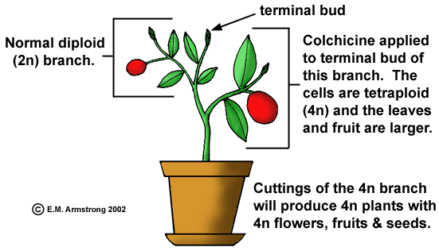

Evolutionary developmental biology
- Study of the effect of variation in genetic sequence, timing and location of gene expression during growth & development.
- Homeotic genes
  - Control transcription of development genes
- Small changes in homeotic genes can produce large changes in morphology
Hox Genes: Control animal body plan
Homeobox
- 180-nucleotide sequence
- Codes for homeodomain (part of a transcription factor)
Developmental Switches
- Regulatory sites of transcription factors switch on or off downstream genes
  - Small changes in regulation produce large changes in morphology
- Natural selection still determines success of regulatory genes

Evo-Devo beaks!
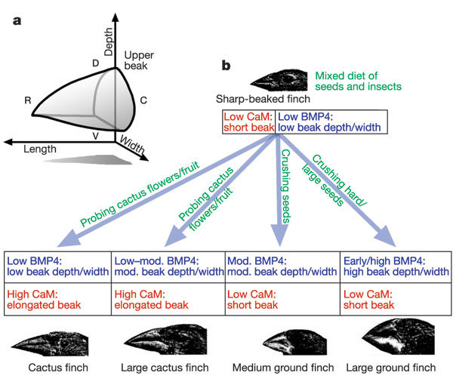
Systematics
- Twin goals of systematics: Reconstruction of evolutionary history and classification of species
- Phylogenetic trees come about through successive events of speciation (branching), in which one species gives rise to two (or more!).
- Reconstructing these trees requires comparison of traits (with shared genetic ancestry) in multiple species
- (homologies are good, analogies are not)
Use charaters to categorize
- Binary nomenclature: Genus & species (reflect the nested hierarchy of life)
- Taxon designation has 3 components:
  - Name: What group does it belong to?
  - Rank (Where does it fit into phylogeny?)
  - Content (Relevant to species concept)
Homologies V Homoplasties

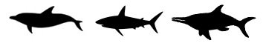

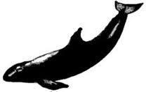

Descent, with modification
- Homologous structures reflect underlying genetic similarities
  - e.g. bones that support wings of bats, birds & pterosaur all look like modifications of pentadactyl limb
  - Develop from comparable embryonic structures
- When no homologies exist, traits are said to be analogous
  - Wings of insects are distinct
Why do analogous structures evolve?
- Adaptation to similar selection pressures
- Insect pit-fall trap “pitcher’ structures developed in response to low soil Nitrogen
Ancestral and derived structures
- Individuals show evidence of Mosaic evolution
- Combination of ancestral and derived characters in evolutionary lineage
- Derived characters determined from fossils and embryos
- Derived characters appear later in development
- Outgroup comparison for derived characters
Cladistic phylogenies based on...
- Principle of Monophly
  - All groups in a clade includes a common ancestor and all of its decendants
- Principle of Parsinomy
  - Simplest explanation most likely to be correct
- All phylogenetic trees are hypotheses that attempt to accurately reflect historical events
- All phylogenetic trees are hypotheses that attempt to accurately reflect historical events
Principle of parsimony
- Principle of parsimony (Occam’s razor)
  - Simplest explanation most likely to be correct
  - Unless other data suggest more complicated explanation
- Evolutionary change is an unlikely event
  - Evolution of character twice is extremely unlikely
  - Evolutionary trees with derived characters appearing once are most parsimonious
- A phylogenetic tree is a hypothesis.
Molecular Characters
- Allows the independent testing of evolutionary hypotheses based on fossils
- Molecular character advantages
  - Abundant data
  - Easier comparison of distant or very close relations
- Molecular character disadvantages
  - Only four states in nucleotides, 20 in amino acids
  - Base changes may have evolved independently
Importance of Land Plants
- Important evolutionary event
  - Dramatically influenced both terrestrial, aquatic and atmospheric conditions
  - Created new environmental niches
  - 300,000 living species, 10 phyla
- Important to today’s ecological processes
  - Carbon, water, Nitrogen etc…
  - Primary producers in terrestrial food web
- Domestication and cultivation of plants
Land Plants first evolved in the Ordovician period
- Early to Middle Ordovician: mild climate with moist atmosphere.
- Marine & Freshwater organism had dramatically changed atmosphere (Cyanobacteria use water as a reducing agent, producing atmospheric O₂ as a byproduct), but CO₂ levels were still 10X greater than today
The origin of land plants: Who?
- Ancestor was likely a Charophyte (a type of green algae, AKA “Stonewort”)
  - Multicellluar (with cellulose cell walls)
  - 2 forms of chlorophyll (a & b)
  - Most cells are photoautotrophic
  - Storage of products of photosynthesis as amylose starch
  - No specialized transport or support structures: body supported by water, where nutrients obtained
Challenge 1
Dryness
- Early plants has no control over water content, were restricted to moist areas
- Poikiohydric (Poikio=variable; hydric=relating to water)
- Like algae, water essential for reproduction (motile gametes
Selection for regulation of water
- Adaptation # 1: Cuticle
  - Present in all Bryophytes (mosses, liverworts and hornworts)
  - Problem: Prevents CO₂ uptake
  - Solution(?): Pores!
    - How to control H₂O loss?
- Adaptation # 2:
  - Present in mosses and hornworts (not in liverworts)
Other Bryophyte Characteristics
- No vascular tissues for movement of water and nutrients – in wet habitats
  - Typically small, low-lying – lack of lignin
- No roots, only filamentous rhizoids (anchors)
  - Some weak symbiotic associations with fungi
- Gametophyte (haploid) phase dominant
Challenge 2
Competition for light and gravity
- Why grow upwards?
  - Photosynthesis requires light
  - Competition between individuals for access to light, leads to selection for growth AND for structures that increase photosynthetic ability
Solution: Lignin
- Some plant cells have secondary cell wall
  - Cellulose fibres anchored with lignin: stronger and more rigid
  - Creates waterproof barrier (hydrophobic)
  - Resistant to decay and attack by microbes
- Lignin not found in Bryophytes or green algae
  - Recently discovered in red algae
Microphylls
- Single unbranched strand of vascular tissue
- Lycophytes
  - Club mosses and scale trees
Megaphyls
- Multiple, branched strand of vascular tissue
- Pterophytes
  - Ferns, horsetails and whisk ferns
Challenge 3
Spatial segregation and transportation of resources
- Minerals and most water in the soil
- Light & C0₂ for photosynthesis above ground
- As plants get bigger, how do they ensure that water and nutrients get to right places?
Primary Growth( Up and Down)
- Apical meristems at root and shoot tips
  - Self-perpetuating clusters of cells
  - Increases height of shoot, length of roots
Transportation and support
- Root & Shoot system are an integrated system with many adaptations for transport of water, minerals and organic substances, as well as structural support
- Material transport
  - Short distances between cells
  - Long distances between roots and shoot parts (xylem and phloem)
Rhynia, and early seddless vascular plant
- Phloem: Vascular tissue which conducts sugars through the plant body
- Xylem: Vascular tissue conducts water and dissolve minerals from soil to roots to shoots
Below ground...
- The rhizoids of early plants functioned as anchors, not for support, nutrition, storage or water absorption
- Extensive mutualisms with Mycorrhizial fungi (carbon for nutrients!)
  - Why are Mycorrhizia so good at extracting nutrients?
  - Root hairs
Other seedless vascular plant characteristics
- Sporophyte phase dominant
- Most seedless vascular plants are homosporous Some heterosporous
  - a few ferns
  - two extant genera of Lycophyta (Selaginella and Isoetes)
Some Vascular Plants Evolved Separate Male and Female Gametophytes
- Homosporous plants produce 1 type of spore
  - Gametophytes bisexual (sperm and eggs)
  - Motile sperm require liquid water
- Heterosporous plants produce 2 types of spores
  - Endosporous development: In many heterosporous plants, gametophytes produced by spores develop inside spore wall
  - Provides increased protection for gametes, and later, for developing embryo
Problem
Aridity and Reproduction
- The gametophytes of bryophytes, ferns and some gymnosperms produce motile (haploid) sperm cells (like their algal ancestors)
- Impossible for sperm to reach eggs in absence of water
Gymnosperms
- “Naked” seed plants
  - Sporophyte haploid spores retained in reproductive structures
- Pollen grains produce nonmotile sperm
  - male gametophyte contained within protective covering, eliminating the liquid-water requirement for fertilization
  - Pollination: Transfer of pollen to female reproductive parts
- Ovule
  - Sporophyte structure produces female gametophyte with egg
  - Connected to sporophyte by protective tissue
Seeds
- Structure forms when ovule matures after sperm fertilization through pollination
  - Embryo sporophyte (diploid)
  - Surrounded by nutritive tissues
  - Protective seed coat
- Seeds are major adaptations for uncertain environments
  - Long distance transport
  - Potential dormancy
Angiosperms
- Flowering plants with covered seeds
  - Flowers contain carpels at their center that protects ovules and seeds
  - Fruit structure nourishes and disperses seeds
  - Double fertilization
    - Produces embryo and endosperm
- Monocots (single cotyledon)
  - Grasses, palms, lilies, orchids, and others
  - Parallel-veined leaves common
  - Bundles of vascular tissue scattered in stem
- Eudicots (2 cotyledons)
  - Most fruit trees, roses, beans, potatoes, and others
  - Net-veined leaves common
  - Central core of vascular tissue in stem
Other angiosperm adaptations
- Efficient transport
  - Vessel elements (more efficient than tracheids)
  - More efficient phloem
- Many angiosperms have specific pollinators instead of just air currents
  - Co-evolutuion with insects, bats, birds
What is a plant?
- Multicellular eukaryotes
- Almost all* are photoautotrophs
  - Photosynthetic (chlorophylls a and b and carotenoids in thylokoid membranes.)
- Cell walls
- Food storage molecule: amylose starch
- Structural polysaccharide: cellulose
- Sessile or stationary
- Alternation of generations life cycle
- Embryo retained inside gametophyte tissues

