STUDENT NAME: ………….……………..…………..
STUDENT NUMBER: ………………………….........

University of Ottawa
ANP 1105A
Midterm #1
Date: October 13, 2011
Duration: 1 hr 20 min
Instructor: Joanna Komorowski
INSTRUCTIONS:
- 45 multiple choice questions (1 mark/1 correct answer per question) plus 2 labeling questions (1.5 and 2.5 marks; 4 marks total) plus one descriptive question (5 marks total). Total number of questions = 48; total possible mark = 54

- Please answer the multiple choice questions on the computer sheet that is provided

- Please put your name and student number at the top of this page and at the top of the final page. Please do not forget to put your course code (ANP 1105A), your surname (last name) and the initials, on the first page of the scantron sheet!!!

- Make sure this exam is complete. This exam contains 10 pages.

- The excuse of missing a page will not be accepted after the examination.

Good luck!!!!
- Which cell organelle is the site of protein synthesis?
- Golgi complex
- lysosome
- mitochondria
- rough endoplasmic reticulum
- smooth endoplasmic reticulum
- Collections of nerve cell bodies in the peripheral nervous system are called:
- nuclei
- nerves
- ganglia
- tracts
- none of the above
- Microfilaments:
- are thin strands made of contractile protein actin
- are tough, rope-like fibres made of keratin
- are intermediate protein fibres particularly numerous in metabolically active cells
- are hollow, tubular cylinders that assist with directional movement of vesicles
- Which of the following is a function of plasma membrane proteins?
- They serve as channels for lipid transport
- They serve as channels for ion transport
- They serve as cellular receptors
- Both A) and B)
- Both B) and C)
- Termination of muscle contraction is triggered by:
- removal of calcium ions from the cytosol back to the sarcoplasmic reticulum
- depolarization of the T tubules and opening of the ligand-gated calcium channels
- the power stroke
- attachment of ATP to myosin heads
- hydrolysis of ATP
- Which of the following statements is true?
- All human cells contain nucleus
- Lysosomes inactivate free radicals
- Mitochondria contain their own DNA and RNA
- Vaults provide the cells with support and enable some degree of motility within cells

- Solution A contains 3% glucose dissolved in water and Solution B contains 6% glucose dissolved in water. Assume that the cells put in these solutions are impermeable to glucose. Which of the followingis true?
- Solution A is hypertonic to Solution B.
- Solution B is hypertonic to Solution A.
- Solutions A and B are isotonic to each other.
- Solution A is hypotonic to Solution B
- The urinary bladder can stretch because it is lined with:
- simple squamous epithelium
- simple columnar epithelium
- loose connective tissue
- stratified cuboidal epithelium
- transitional epithelium
- How are phospholipid molecules arranged within the lipid bilayer of the plasma membrane? (ECF=extracellular fluid; ICF=intracellular fluid)
- Phospholipids molecules are arranged randomly
- The polar lipid tails are oriented toward the ECF and the ICF because they are hydrophobic
- The nonpolar lipid tails are oriented toward the ECF and the ICF because they are hydrophobic
- The nonpolar phosphate heads are oriented toward the ECF and ICF; they are hydrophobic
- The polar phosphate heads are oriented toward the ECF and ICF because they are hydrophilic
- Tight junctions:
- are numerous in skeletal muscle; they organize muscle fibres in bundles
- are numerous in the connective tissue
- are made of glycocalyx
- bind epithelial cells together and prevent separation of these cells
- none of the above is correct
- Which of the following links the ends of actin to the Z-discs?
- Nebulin
- Alpha-actinin
- C- protein
- Titin
- Which of the following applies to a muscarinic cholinergic receptor?
- It involves activation of G protein
- It is associated with production of a second messenger
- Its activation leads to immediate opening of the sodium/potassium channel
- Both A) and B)
- All of the above
- Dendrites of the postsynaptic neurons:
- conduct impulses away from the cell body
- contain chemically-gated channels
- contain centrioles that are necessary for the nerve cell division
- have voltage-gated channels
- Glycocalyx:
- plays a role in membrane stabilisation
- plays a role in cell to cell recognition
- is floating freely in the cytoplasm
- is made of lipoproteins
- When acetylcholine binds to the receptors in the skeletal muscle end plate, the next event is:
- opening of the end plate’s sodium/potassium channels and change in the end-plate’s local potential (depolarization)
- opening of the end-plate’s sodium/potassium channels and production of an action potential at the neuromuscular junction
- opening of the end plate’s voltage-gated sodium channels and production of an action potential at the neuromuscular junction
- opening of the sodium/potassium channels in the T-tubules
- Which of the following types of the epithelial tissue is found in body sites exposed to abrasion (e.g., skin)?
- simple cuboidal epithelium
- loose fibrous epithelium
- simple squamous epithelium
- transitional epithelium
- stratified squamous epithelium
- Connective tissue:
- usually is well nourished and well innervated
- sits on a basement membrane
- usually is not vascularized and is poorly innervated
- none of the above
- Which of the following is true about the glial cells?
- Astrocytes can modulate production and postsynaptic availability of neurotransmitters
- Schwann cells form myelin sheaths on axons in the central nervous system
- Oligodendrocytes can modulate production and postsynaptic availability of neurotransmitters
- Microglia nourish nerve cells
- The ratio between glial and nerve cells is 1:1

- Osmosis is a special case of diffusion in which:
- a solute moves against its concentration gradient.
- water moves against its concentration gradient.
- water moves down its concentration gradient.
- water moves from an area of high solute concentration to an area of low solute concentration
- Potassium ions are moved into the cells by:
- simple diffusion
- active transport
- facilitated diffusion
- osmosis
- exocytosis
- Which phrase best describes epithelial tissue?
- usually contains a large amount of matrix
- is avascular but innervated
- is always arranged in a single layer of cells
- contains “blast” cells
- usually contains lots of blood vessels
- Which of the following is true about the cellular transport?
- Endocytosis always requires clathrin coating on the extracellular side of the membrane
- Water can enter the cell only via aquaporins
- All of the clathrin coated vesicles entering the cell fuse with lysosomes
- In facilitated diffusion transport of molecules is limited by the saturation maximum
- Solute molecules always move from areas of low concentration to areas of high concentration
- Which of the following is true about the adipose tissue?
- Increased adipose tissue mass (obesity) has been associated with chronic inflammation and elevated levels of C-reactive protein (CRP)
- Both white fat and brown fat are necessary for ATP production
- On average, females need at least 25% body fat to maintain healthy status of their reproductive system
- All of the above
- In muscle contraction, binding of calcium to troponin:
- increases the action potential transmitted along the sarcomere
- leads to release of the inhibition on Z dics
- leads to removal of tropomyosin from the active sites on actin
- causes binding of ATP to actin
- none of the above
- The plasma membrane of a resting neuron is more permeable to potassium ions than to sodium ions because the membrane has:
- fewer voltage-gated sodium ion channels
- more potassium leakage channels
- more voltage-gated sodium ion channels
- more ligand-gated potassium ion channels
- more carrier molecules for potassium ions
- The threshold of the neuron is the:
- time between binding of the neurotransmitter and firing of an action potential
- total number of sodium ions that enters the cell before the sodium inactivation gates close
- total amount of neurotransmitter it takes to cause an action potential
- voltage at which the inflow of sodium ions causes enough depolarization to produce an action potential
- Which of the following is characteristic of a graded potential?
- Produced at axon hillock
- All-or-none
- Induces membrane hyperpolarization
- Causes release of neurotransmitter
- Current decreases with distance travelled
- Which statement about a RELAXED muscle cell is FALSE?
- Calcium ions are stored in the sarcoplasmic reticulum.
- Myosin cross bridges are bound to actin.
- Myosin cross bridges are bound to ATP.
- Tropomyosin-troponin complexes are bound to actin.
- The point at which an impulse from one nerve cell is communicated to another nerve cell is the:
- synapse
- cell body
- receptor
- effector
- axon hillock
- In which of the following neurons would an action potential be conducted most rapidly?
- In a large diameter, unmyelinated neuron
- In a small diameter, unmyelinated neuron
- In a small diameter, myelinated neuron
- In a large diameter, myelinated neuron
- Which of the following (A, B, C or D) represents the repolarization?

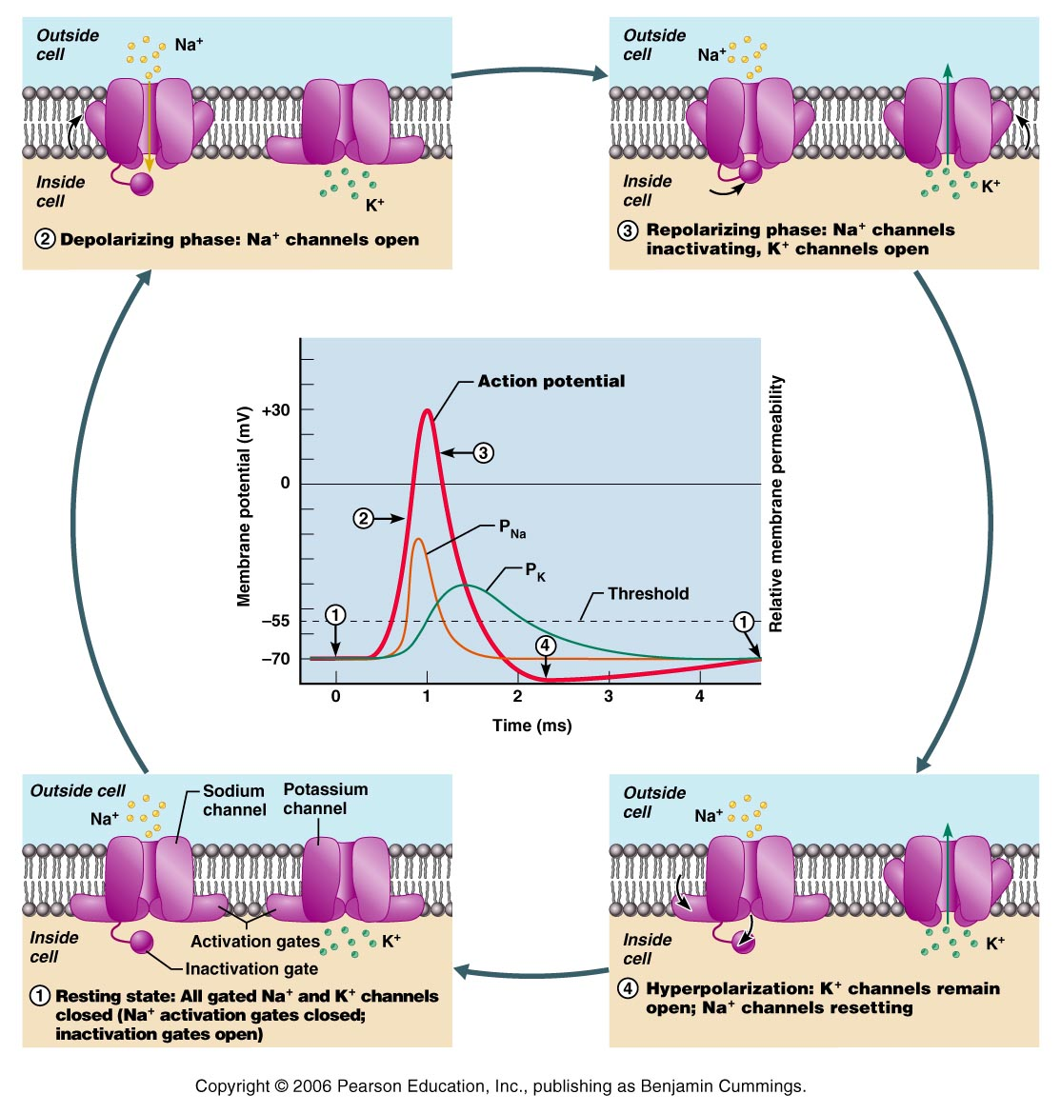
A
B
C
D
A

- One functional unit of a skeletal muscle is:
- a myofilament
- a myofibril
- the sarcoplasmic reticulum
- a sarcomere
- During the depolarizing phase of an action potential, which of the following is the primary activity?
- Sodium ions are flowing into the cell.
- Potassium ions are flowing into the cell.
- Potassium ions are flowing out of the cell.
- Sodium ions are flowing out of the cell.
- Neurotransmitter is diffusing into the cell.
- Which of the following statements is TRUE?
- The intensity of a stimulus is indicated by the size of action potential
- Chemically gated channels open in response to electrical stimulation and changes in the membrane potential.
- The relative refractory period is the period during which the outward current carried by K+ is exactly equal to the inward current carried by Na+.
- The intensity of a stimulus is indicated by the frequency of nerve impulses (action potentials).
- None of the above statements is true.
- The EPSP is stimulatory because:

- It hyperpolarizes the postsynaptic membrane
- It increases the amount of neurotransmitter released by the presynaptic terminal
- It prevents calcium ions entry into the presynaptic terminal
- It changes the threshold of the neuron

- The role of acetylcholinesterase is to:
- act as transmitting agent
- amplify or enhance the effect of acetylcholine
- stimulate the production of serotonin
- destroy acetylcholine a brief period after its release by the axonal endings
- Which of the following types of physical activity (A, B or C) uses ATP and creatine phosphate (CP) stored in the muscle cell as a main energy source for ATP production?

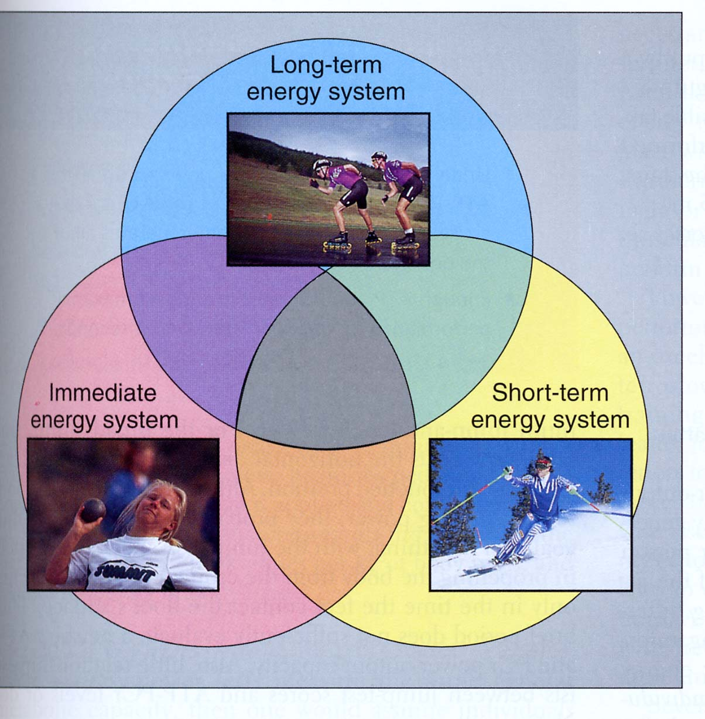
A.
Power
B.
Speed
C.
Endurance

- After nervous stimulation of the muscle has ceased, the calcium:
- is destroyed by cholinesterase
- is chemically bound to the filaments
- level in the cytoplasm drops
- is pumped is back into the sarcoplasmic reticulum for storage
- Both C) and D)
- In the sliding filament model of skeletal muscle contraction, muscle shortening is accompanied by:
- shortening of the A band and the H zone
- shortening of the I bands and the H zone
- shortening of both the A and I bands
- shortening of both the A and I bands and shortening of the H zone
- Characteristics of isometric contraction include all EXCEPT:

- increased muscle tension
- no change in muscle length
- calcium and energy requirement
- shortening

- Which of the following best describes the skeletal muscle fibre?
- It contains many nuclei, sarcolemma, sarcoplasm and myofilaments composed of nebulin and titin
- It contains one terminal cisterna and two T-tubules per one sarcomere
- It contains one nucleus, sarcolemma, sarcoplasm and myofibrils composed of actin and myosin myofilaments
- It contains many nuclei, sarcolemma, sarcoplasm and myofibrils composed of actin and myosin myofilaments
- It contains many nuclei, ATP-filled sarcoplasmic reticulum and myofibrils made of actin and myosin
- Which of the following is true?

- Skeletal muscle bundles are covered by perimysium
- Temporal (wave) summation usually results in fused (complete) tetanus
- Muscle fatigue is always due to accumulation of lactic acid during exercise
- Fast twitch muscle fibres require longer time to reach a peak tension and to relax
- Troponin is a structural protein

- The function of the T-tubules in skeletal muscle contraction is to:

- Transmit the action potential deep into the muscle cells
- Store glycogen
- Release and store calcium
- Form a cytoskeleton

- Which of the following (A, B or C) represents recruitment of the F(IIa) (fast twitch oxidative) muscle fibres?
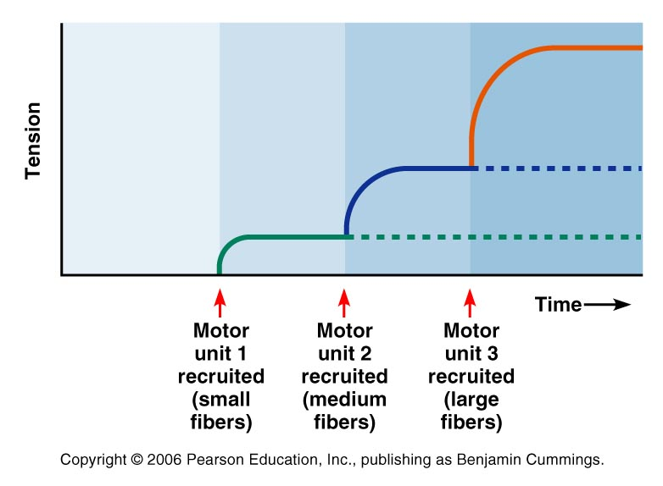
A
B
C
- In skeletal muscle fibre ATP is needed for:

- dissociation of myosin from actin
- uncovering of the active sites on actin
- removal of calcium from the cytosol after the stimulation has ceased
- both A) and B)
- both A) and C)

- Please label the following neurons (A, B and C); (0.5 mark/label, 1.5 total mark)
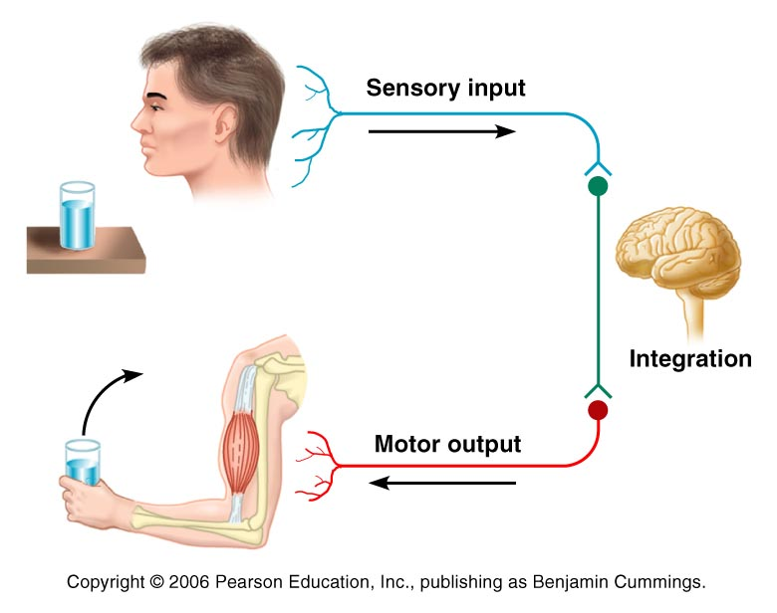
A.
B.

C.

- Please label the following structures (0.5 mark per label; 2.5 marks total)
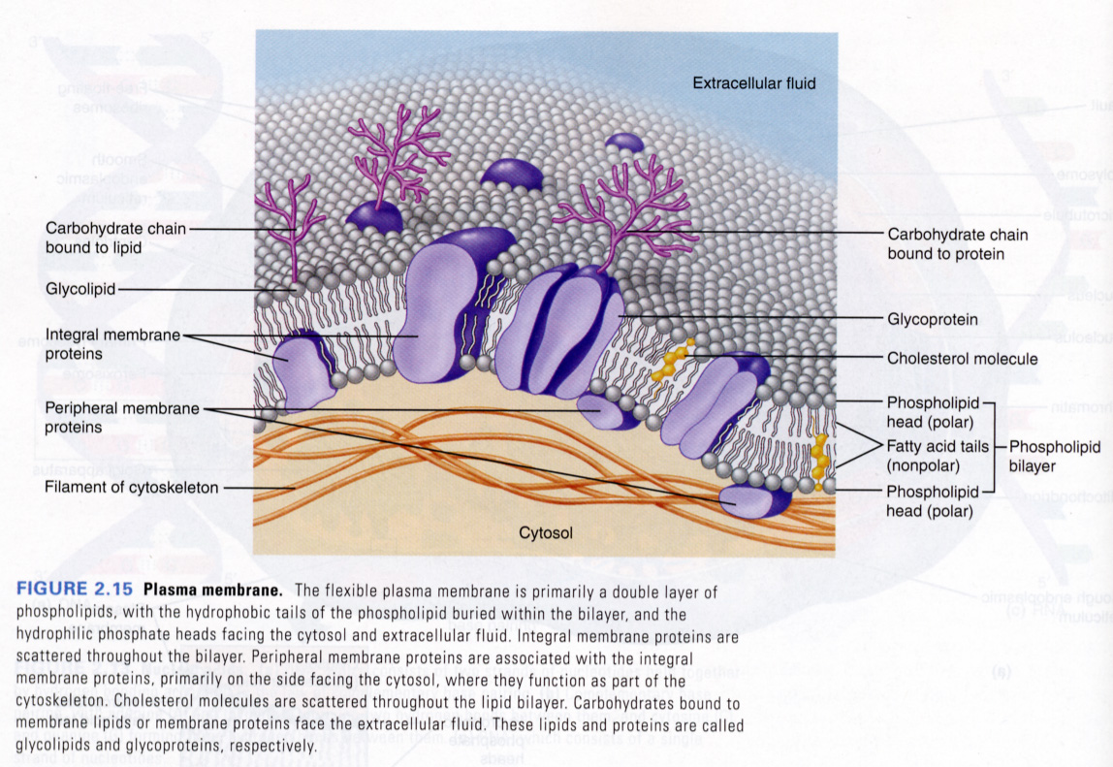

A.
B.
C.
D.
E.

- Describe briefly, in a point form ONE of the following: (5.0 marks total)

      - Main events following the arrival of an action potential at the terminal knob of axon (the events at the presynaptic and postsynaptic membranes and at the synaptic cleft of the chemical synapse)
Or
      - Main events occurring during the cross bridge cycle (muscle contraction and relaxation)

