Mesozoic: Triassic, Jurassic and Cretaceous
After the great Permian Extinction some Reptiles use the Amniote Egg and have survived
Early Triassic 237 Ma
- If we look at the planet at this time Pangaea is massive running from North to South
- Whatever animals come up on land like the reptiles have a huge area to diversify on
- The Reptiles that are coming up on land are going to be bitten by the insects that have been up on land watching they have not disappeared
Mass Extinctions
- The Triassic has a further extinction that is going to help the Reptilian come up on land and dominate the planet
Late Jurassic 152 Ma
- If we look at the continental plate they have started to shift away from each other
- North American is starting to split away and by the time we to the end of the Mesozoic in the Late Cretaceous
Late Cretaceous 94 Ma
- The continents have completely shifted apart and are separated probably the result of the great big Flood Basalts
- One of the problems of killing off all of the life in the oceans with the Permian Extinction is that we are going not going to see vertebrate fish in the oceans and the oceans will get populated again by the fish in the fresh water
- Fish are in fresh water fish and they return to the oceans all the cartilaginous and bony fish have come from fresh water
- Mollusc – Cephalopods
  - The fish from fresh water were the agile predators from back in time that forced the cephalopods to discard their shells
  - Because the Analopods and Cephalopods could not keep up with the predators that were coming from the fresh water so the response was to dissolve the shell

Vertebrate Phylogeny – Reptilla (Diapsida)
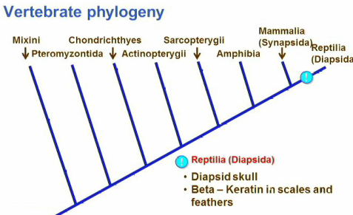

- Diapsid Skull
Have very special set of bones to accommodate
For the way they are going to feed
- Beta – Keratin in scales and feathers
Going to use beta- keratin to waterproof their skin and come up on land and is going to be the same fore mammals
- Keratinized Skin
- Scale
- Cornified Layer
- Epidermis
- Dermis
- Chromatophores
- Cell age move to the surface they are filled up with keratin and the keratin is going turn them into dead cells that are going to come to the surface for water proofing,
- In Reptiles you can take those cells and are going to form scales which will be a protective armor but it of course is going to have to be molted because it is going to have to be able to grow with this hardened outer surface
- Oviparous Reproduction
Amniote egg

Major Reptile Groups
- In both Amniote groups are going to have a jaw and in this group it is going to have enough force of the jaw to tear it off its food or at least can hold on to it much the same way that sharks can
- So we get musculature that is associated with the jaw
- Early on the muscle for opening and closing the jaw was inserted inside the skull for the jaw but as the strength of the jaw gets bigger so will the muscle and you will actually decrease the space of the cranial cavity
- So this involves the use of a tendon with a whole to make the contraction and will not affect the cranial capacity
- Anapsids-Turtles
Meaning NO hole and what we now know is that they fuse many of their bones together and sealed off the bones of the skull
They also no longer have teeth they have beaks and are more like birds because they use less of a musculature in their jaw
They are diapids that lost their hole
- Skeleton
- Vertebrae
- Ribs
- Carapace
- Plasteron
- Fuse for the turtle is important is how they created the box they live in which is a perfect reptilian solution for predation they live in a box of bones

- Diapsids (Anapsids)-Dinosaurs, pterosaurs, birds, snakes and lizards
Two insertion points for muscles and two hole in the head so that the tendons and the muscles are now running on the surface
This is something that distinguishes this group
They are Beta Keratins and have an Amniote egg they were the first terrestrial animals to waterproof its egg
Just like the first insects exploded with number so did the reptiles
Major Diapsid Groups:
- Extinct Diapsids- Dinosaurs and pterosaurs Locomotion
- Lizard like reptile that was on land and now breathing air with its lungs and expanding its rib cage but it walked like an amphibian
- As we know this would compress rib cage and a lung would collapse meaning it would not be able to receive air or work
- Would need to uncouple locomotion with breathing so they could continue to breath even if they were moving
Locomotion can divided up into three groups:
- Saurischian Dinosaurs
- ONE WAY
- Putting legs straight underneath so that you will not get any compression of the lungs
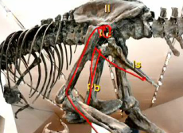
- They do not use the limbs that are causing the problem (Antior limbs) meaning go from four limbs to two limbs two ways
- Become bipedal
- Bones at right angles
- Pubis
- Ischium
- Illium
- Acetabulum
- mostly the carnivores, but also big herbivores

- Ornithischian
- SECOND WAY
- Putting legs straight underneath so that you will not get any compression of the lungs
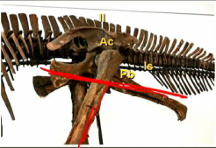
- They do not use the limbs that are causing the problem (Antioer limbs) meaning go from four limbs to two limbs two ways
- Become bipedal
- Bones are running parallel
- Pubis
- Ischium
- Illium
- Acetabulum
- Most duckbilled and Herbivores

- Pterosaurs
- They are the fliers
- They are quadrupedal because have to put their wing is a limb and they put their finger on the ground
- Muscles on ribs to expant their lungs
- They are so big that they jump off cliffs they get locomotion from flight
- Extant-Snakes, crocodiles and birds and lizards
- ONLY ones that SURVIVE of the huge diversity that use to dominate the planet
- Snakes
- Are the legless
- Same reparation and same beta-keratin skin
- The reason on why they survived is because they were burrowers they are in a more contained environment and were not subjected to conditions on the planet
- They have a pivoting locomotion
- But for FEEDING because they are legless they had to come up with a different feeding strategy they have modified salivary glands and uses Venom to catch its prey or uses Exficsiation to crush their lungs
- Then combines this with its Jaws that can detach with those huge widths it can swallow its prey whole and ingest huge meals
- Crocodiles +Birds
- Common with reptiles the teeth have not become specialized they are anchor in the jaw they are basically there for holding and grasping prey
- These predators do they have to thrash their prey and use Crushing Jaws but only good for crushing
- Lizards
- Synapsids-Modern mammals
- One insertion point for muscles and one hole in the head so that the tendons and the muscles are now running on the surface
- This is something that distinguishes this group
- We have reptilian like synapsids that will become mammals
- Therapsids
- Warm-blooded
- Noturnal hunting at night
- Glandular skin
- Specilized teeth and chewed their food

Angiosperm Life Cycle: Flowering Plants
Flowering plants we left the life cycle of the Gymnosperm behind with the conifers with a problem that we were still using wind and they were still making Megaspore on the off chance that it will be fertilized which is a huge waste of energy and the FLOWERING PLANTS are going to solve that
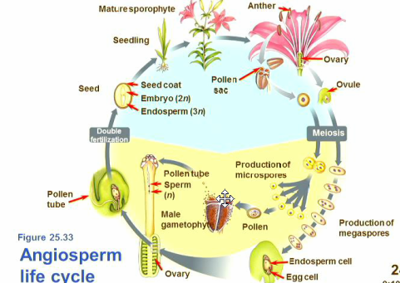

- We have the same structures to make Pollen(Sperm) the Anthers are the location of the Microsporangium
- On that Microsporangium on the Anther we are going to produce thousands of cells that are going to undergo Meiosis to create four produces
- Going to undergo Mitosis and one of the microspores will become pollen same as before
- Big change is going to come in the Oval we are going to go through Meiosis and then Mitotic division and we are going to go from four to eight eggs
- Going to position these eggs uniquely originally they start at four at each end in the Oval or Megasporangium we are going to send two to the middle one from each end we are going to leave one at the top to be fertilized and the rest are going to disappear
- Going to have two in the middle and one at the end
- When the pollen land on the oval going to put at Pollen Tube to the egg and the pollen is going to go through a mitotic division to make two and they are going to go down the tube
- One pollen is going to line up with the two in the middle and the other is going to fertilize the egg
- We get two fertilizations 2n that becomes the Zygote and 3n
- The 3n in the triple nuclei are going to undergo massive cell division which is going to provide all the nutrient or Endosperm for the embryo that is going to develop into the new sporophyte and is going to get all the food it is going to need from this
- we are going to put energy into nutrients for the sporophyte unless we get fertilization and we trigger the whole system

- Pollination Strategies
- We are going to use modified leaves that get modified into pedals to attract pollinators to get fertilization
- Nectar is Metabolic energy that is no benefit to the plant except to reward for passing pollen
- Ex Red colour naturally are going to be pollenated by birds or flying mammals bats because insects cannot see the colour red
- Ex But insects can see Ultraviolet lights and plants actually put a whole bunch of patterns that can be seen under ultraviolet light to bring insects in
- Insect Plant Coevolution
- Vast majority of insects that are around today are the pollinators of plants
- The insects move from plant to plant collecting pollen and then the plants start changing their form so that they have one to one relationships with insects
- This Coevolution you get the and insect diversify on the food source and you get the plants diversify on this new reproductive guaranty to pollen,
- Flowering plants during the Mesozoic takes over and still like that today
- Bees
- Butterflies
- Seed Dispersal
- Wind
- Water
- Animals
Making fruit as temptations from animal dispersal and are resistance to the animal digestive tract and they not relying on wind and water
Ex burs

K/T Boundary 66 Ma
- Dinosaurs are moving back and forth across the planet until what is call the K/T boundary which is where supposedly we have the meteorite impact in South American that spuses up enough dust and dirty that sends the world into a climatic tail spin
- the Dinosaurs disappear
- Called K/T Boundary because there is all types of evidence of impact of a global winter that persisted for hundreds of years
- Mass Extinction
- Cretaceous Extinction
- Iridium
- Minerals
- Location

Mass Extinction
- It does not look like a huge extinction the Dinosaurs were whipped out but all the Mammals, Insects, Birds, and Plants were still around
- If you look at the diversity of dinosaurs and look at the carnivores that represent the tops of the food chains they are disappearing
- They are probably disappearing because there are so many herbivores roaming the earth they tapping out on the food supply that is available so then the top of the food chain is being destroyed
- They are striping environment and it was probably stressed to the limit and the K/T probably helped it along because they were already on the decline

