Phanerozoic – Paleozoic
- Hadean (4.600-3,800Ma, 0-12th)
- Archanean (3,800 – 2,500 Ma 12th -33rd)
- Proterozic (2,500-543Ma, 33rd – 63rd)
- Phanterozic (543 Ma to present time, top 9 floors)
-Paleozoic Era (550-245 Ma, 63th to 65th)
-Mesozoic Era (245–65Ma, 65th to 71st)
- Cenozoic Era (65 Ma to Present time)
Paleozoic Periods
- Paleozoic era
- Cambrian 550-488 Ma
- Ordovician 488-443 Ma
Invertebrate Live in the Water: Going to see mulit cellularity in the oceans explode in the body plans
- Silurian 443-416 Ma
- Devonian 416-359 Ma
- Carboniferous 359-299 Ma
- Permian 299-245 Ma

Late Cambrian 514 Ma
- Continental Land masses are moving out of the water
- As they move No growth on land, just erosions and sediments
- Land masses have an effect on flow of the oceans
- Equator has arounded ideal place where it is the warmest and had the most sun it is also the global air patterns when the air rises and moister that rises comes back down and rains
- Consequences of this cycle as the air comes back down it is dried out there is no moister and dry air low productivity zone where we find deserts
- Fairly productive Temperate zone stable living
- Dry air moister has been locked up in poles
- Continental Shelves are the equitant of the rainforest of the ocean they are shallow, good light penetration and great productivity
- When a Continental shell sits on the Equator and became an ideal place going to be invertebrate

Unusual Invertebrates
- The diversity of life exploded with these invertebrate
- Animals would fall off with the sediment falling but won’t decompose and then more and more would fall over a huge period of time and fossilize so we have an idea of the biodiversity at the time
- First found at the Burgess Shales
- Find very unusual Invertebrates
- We know now that during this period the conditions were right for a huge array of biodiversity
- It was the beginning of multi cellular life for everything all the ones that made it and the ones that did not

History of Invertebrates: Burgess Shales Yoho National Park
Early nineteen hundreds a Family found the fossils after there had been a land slide and they were in the way of the horse trail. He got off his horse to move them so the horses would not trip. It turned out he was the expert at the time so he knew what he was looking at. When he found them and he said it is complete collection of the invertebrate in time and was not looked at again until 1980’s

Ancestor to All Multicellular Life: Colonial Choanocyte
- Very special type of cell
- It is a Unikont cell
- Creating a water current that it is going to feed on
- With a collar which are Small Microvillia and a flagella in the middle that helps water pass through the collar and this is the site where they collect food
- A colonial form meaning a group of organisms could pump more water than just one this meant that you were better nourished
- They come in stalk and mat form and they can still be seen today

Animalia (Autapomorphies)
This that define all the Animals
- Multicellular Eukaryotes
- Ingestive Heterotrophs
- Cells with different functions division of labor
- Choanocytes
- Collagen
LOOK AT PHYLA
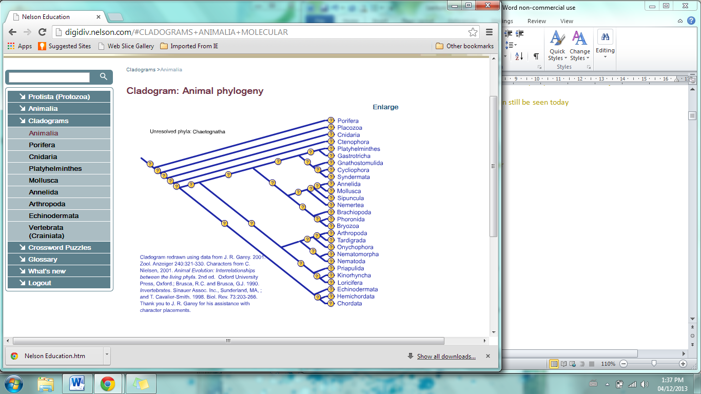
All Arise During the Cambrian
Porifera (Autapomorphies)
  - Asymmetrical Body Plan
  - Cells but no tissue
  - Use of choanocytes in an aquiferous system Pumping water
  - Totipotent cells
Animal Architecture
Ways to divide up the living world
- Tissues
-None, diploblastic or triploblastic
- Symmetry and cephalization
-Asymmetry, radial, and bilateral symmetry
- Embryology
-Protostome and deuterosome
- Body Cavity
-Coelomate, pseudocoelomate, acoelomate

- Colonial Choanoflagellates (Sponges)
Set up to be perfect water filtered are very old and are first attempt to make complex animals saw them in the Burgess Shales , very first form of life in the animals
- Tissues
- Stick cells together to make layers but are not tissues
- No allowed to call them tissues because they are not communicating with each other
- In the matrix because we do not have cell to cell communication we need to have a helper cells
- Symmetry and cephalization
- Asymmetrical body plan no endoderm meaning no mouth
- Cannot divided it from the oral to Aboral opening therefore there is not symmetry
- Embryology/ Reproduction: Sponge Sex
- They do not have permanent gonads Totipotent cells can change their morphology and can change their function
- Choanocytes when it is time to be sexually active become sperm lose their collar and keep their flagellum to swim away, not all the choanocytes will become sperm
- They are released into the Spongocoel and then the water filtration they are passes out of the sponge and into other sponges
- Sperm gets trapped by the Choanocytes thinking it is food but can recognise that it is sperm from its own species doesn’t digest it gives it to a vacuole and passes it to an
- Amebocyte that is the egg and then a zygote can be produced
- Can take two sponge into a blender break them up and they will actually try and find their species and form the two original sponge again
- Because they are Totipotent they go always back to being their original state stem cell or Archeocytes they are not committed to any cell
- Tremendous filter feeds first to be doing it but they are also tremendous at changing their cell function
- Body Cavity: choanocytes in an aquiferous
- Pumps and filters
- Found a way to find out how to tap into the small organisms in the water
- If we look at the body plan the choanocytes are line the body cavity of the sponge or the Spongocoel
- Choanocytes are all beating forcing water out of the opening at the top
- As a consequence when water flows out water is also flowing in through holes in the side
- Choanocytes are going to be the mechanism for the feeding
- If we are going to be multicellular we are going to have to have a division of labour between our cells
- On the outside of the Spongocoel are specialized cells on the Epithelium but cannot call it that because it is not a tissue so we call the Pinacoderm
- Helper cells that pass food from the Choanocytes to the Pinacoderm
- This whole thing would collapse if it was just cells so there are cells that are going to use mineral/ or proteins to hold the structure up called the Spicules
- Ingestive Heterotrophs with a division of labour and are so successful so they are huge diversity
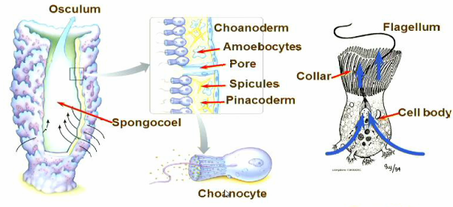

Animal Innovations (Symplesiomorphies)
- Gap (Septate) junctions
Loss of the Choanocyte
- True Tissue with all components
Differentiate:
- Internal Digestive Epithelium
- Oral-aboral axis and symmetry

Animal Architecture
- Tissues
-None, diploblastic or triploblastic
- Symmetry and cephalization
-Asymmetry, radial, and bilateral symmetry
- Embryology
-Protostome and deuterosome
- Body Cavity
-Coelomate, pseudocoelomate, acoelomate

- Tissues
Going to get Tissues meaning Communication between cells with many different types

- Gap (Septate) Junctions (Connexon)
- Cell to cell junctions are important
- But are going to have a cytoplasm opening between cells and a way to regulate everything chemicals, hormones and electrical signals can move between cells
- First key event in animal evolution are no longer going to function independently

- Types of Tissues
- No tissues
- Diploblastic germ layers
- Ectoderm and endoderm
- Triploblastic germ layers
- Ectoderm, mesoderm, and endoderm
- Organisms that have or don’t have muscles
Diploblastic Germ Layer Event: Gastrulation –Digestive Epithelium
- Going to come First
- Embryology zygote divided we get hollow ball of cells called Blastula
- Solid cell with one cell layer of Epithelium on the outside and hallow in the middle Blastula
- Some of these Epithelium cells are going invaginate inwards to the hallow center they are going to become an internal epithelium and we will get an Ectoderm and an Endoderm
- Inner Endoderm has an opening to the outside and we are going to dump food into the space and we are going to get Digestion

- Symmetry and Cephalization
Oral to Aboral axis are get symmetry and get identical halves
- Asymmetric
- Radial symmetry
- Passive organisms that are not interacting much with their environments
- Bilateral symmetry and Cephalization
- Organisms that moves in a directed manor
- All of the head structure on the front
- And puts all its sensory structures in the front of the organism where it is moving to

Cnidaria (Autapomorphies)
- Cnidocytes for catching prey
- Polyp body plan
- Epitheliomusculature no mesoderm but are going to move, are Diploblasts
Animal Architecture
- Tissues
-None, diploblastic or triploblastic
- Symmetry and cephalization
-Asymmetry, radial, and bilateral symmetry
- Embryology
-Protostome and deuterosome
- Body Cavity
-Coelomate, pseudocoelomate, acoelomate

- Characteristics
Polyp to Jellyfish to Coral
- Cnidocytes (Cnidaria)
- Are the stinging cells and where they get their name from
- Lies in the body wall if this cell is tweaked this organelle shoots out at huge G force
- Ready to fire coiled organelle with toxins at the end of the barbs
- They are Predators using this for hunting
- Body Wall (Cnidaria)
- Original Body Plan
- Epithelial cells Ectoderm and Endoderm
- Incomplete gut
- Going to capture food then is going to shut its mouth to release enzymes are going to stir it up with cilia
- Going to use Phagocytosis to absorb digested food
- And when the food is all digested the mouth is going open and the digestive waste is then released through the mouth
- Hydrostatic Skeleton (Cnidaria)
- When we want to move things into the mouth we will need muscles
- Endodermal cell also has muscles fibers that actin fibers that myosin motors are going to move along
- Endodermal cells are arranged circularly Epidermal cells arranged longitudinally going to give use the FIRST SKELETON in the ANIMAL WORLD
- Skeletons play an important role when you lengthen a muscle back to its original position
- When he closes the mouth and it becomes a water filled balloon and has muscles that go along the side and around so it can allow movement by alternate contraction against water
- Meeting the requirements for the skeleton but doing it with a water filled bag that uses Antagonist muscles called Hydrostatic Skeleton
- Unique Architecture and strength
- Epidermis have nerve cells and Cnidocytes
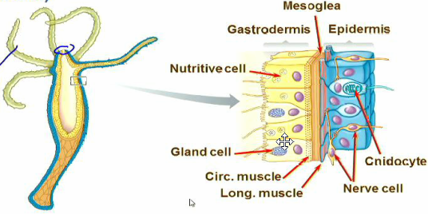

- Medusa: Jellyfish
- Slightly different set up
- Matrix in between jelly-like called Mesoglea, not cellular layer In larges because they are all circular
- Flip it upside down it becomes an umbrella tentacles hanging down
- When the muscles relax they can spring the bell that will spring them back into their place
- Uses rings to move up in the water and then when they stop they will fall
- One of the first predators

- Life Cycle
- Polyp
- Division of labour between cells some are for feeding and some make jellyfish that go off and feed
- As they feed and grow they undergo meiosis and we will produce egg and sperm
- To a zygote that will undergo cell division and will develop a whole set of cilia over its surface and will become bilaterally symmetrical
- And will crawl along the substrate feeding for a period of time it will then ball up and for a cup shape that will become the polyp and complete the life cycle
- Think that larva stage is how bilaterally came first because of this particular stage
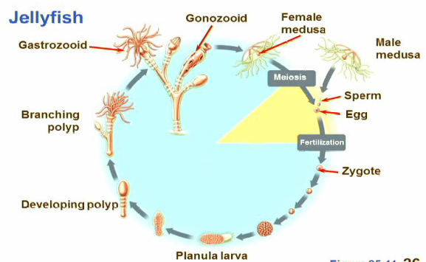

- Corals
- Are colonial Animals
- Are found in the fossil records
- Coral reefs are built by jellyfish polyps and for massive colonies
- As they grow they secrete calcium salts out of their bases and spend their time extending from that base and hiding in that base as they get larger the salt content also gets larger
- Are basically reside from jellyfish skeletons with polyp still living on the outer most surface
- They are the greatest productive environments in the world
- Biodiversity is going to sculpt the whole of the oceans and are created by these predatory polyps
- We are in a period where the bio productivity is going to be lost over time they are going to come and go
Animal Innovations (Symplesiomorphies)

- Embryology
- Cleavage
- At the eight cell stage you can take an animal’s embryo when it shifts from four to eight cells what you have is you get four cells that are aligned with each other you get a cleavage plain through the equator
- You get four cells on top and four cells underneath and one of two things happen:
- The top four cells shift change rotate, spiral put the little bottoms in the grooves of the lower four cells when you watch this occur you see a little spiral and this is referred to as Spiral Cleavage
- If the top four cell perfectly line up and sit directly on top of the bottom cells instead of sitting in the grooves this is called Radial Cleavage
- Gastrulation
- After Cleavage if the cell continue to proliferate we will have a Blastula
- Like previously we have a Blastula hallow ball of cells and have cell invaginate so we end up with endoderm
- So we get an organism with Endoderm and Ectoderm and we also get an oral opening that food is placed inside
- Endoderm is always involved with digestive epithelial
- Take a Gastrula and turn upside down and will get a Cnidarian
- At the end of Gastrulation we are going to get two opening when the Endoderm and Ectoderm are going to come together at the other end and form an opening
- Blastopore is going to form the mouth or when the other opening is formed it can become the mouth and the Blastopore can become to anus
- Protostomes
-Protostome (first mouth)
-Blastopore becomes mouth
- Spiral Cleavage
-Schizocoely
- Deuterostomes
- Deuterostomes (mouth is second opening)
-Blastopore anus
-Radial Cleavage
-Enterocoley
- Two major animal lineages
- Coelom formation
- Generating Mesoderm these are the Triploblasts
- Body cavity forming in two different ways
- Schizocel (cavity by splitting the mesoderm)
- At this junction between endoderm and ectoderm there is a programing change in the cells and cells puliferate start to fill the space in between as a single mass of cells keeps growing for each side and meets up at the top and the whole space is now Mesoderm
- It then splits open and are going to have a cavity lined with Mesoderm on both sides so two body cavities form
- And where these two cavities meet is where the Mesentery is going to hold the gut in place
- Enterocoel (cavity forms from gut cells)
- Arc of the gut that are going to bled out and are going to get bigger and bigger
- Think of it as a balloon filling out with a cavity already inside
- You get the same thing coming together at both sides and the Mesentery holding the gut in place
- The whole thing lined with Mesoderm and forms two body cavities same as before
- But arose in a different way it arose from cells from the primitive gut called the Archenteron

- Body Cavity
- Animal body cavity Important
- Acoelomate
- Organism entry mesoderm they do not have cavities ,
- A is not having without a Coelomate (cavity)
- No spaces in mesoderm
- Thought that they came first
- Derived
- Pseudoelmate
- Intermediate
- They only have part of coelomate body cavity
- They have mesoderm on the inside of the Ectoderm but there is none associated with the gut
- The gut has no muscles
- Not a true coelom
- Thought this came second
- Due to mineralization has appeared several times
- Coelomate
- Gut has a layer of mesoderm around it and a layer on the inside of the Ectoderm
- And between the two there are Mesenteries
- You have a body cavity that is lined with mesoderm
- Thought that this came third with fully formed
- It came FIRST Ancestral
- Coelomate is the synapomorphy shared by the animal groups whether made in a protostome or a deuterosome it was very advantageous differs in the way it is created but it is ancestral
- We now know that this fluid filled space made a number of changes in the biology of the animals
- For ONE thing they were able to with a mouth and anus with mesoderm lining the endoderm were now able to have a complete digestive tract and when they wanted to move food around they did not have to move their body wall. This meant that as an organism you could swallow a meal you digestive tract to move and churn the food around without changing the shape of your body and the body wall was capable of moving independently of the gut. Ex so it you wanted to hid you could without your body moving
- SECOND thing was that the fluid in the coelom has the potential to be circulatory fluid we use it to move nutrients around we can use it to move metabolic waste around,
- THIRDLY fluid filled cavity could be used as a hydrostatic skeleton and you would not have to compromise your digestive fluids like the Cnidarians
- FOURTHLY you change and in large organ systems without changing the shape of the body. So when you were going through you reproductive cycle you could has space for the growing ovaries or gonads

- Protostomia (Autapomorphies)
- Major event that divides animals
- Spiral cleavage
- Schizocoelus
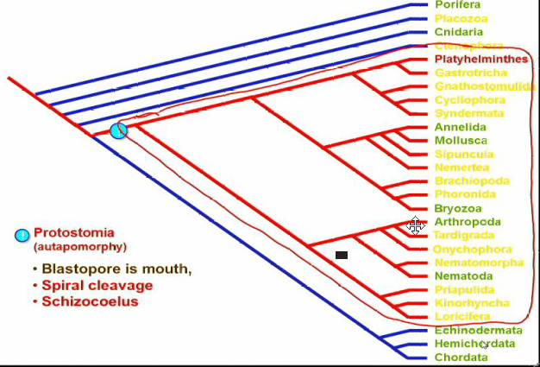
Three main protostome groups

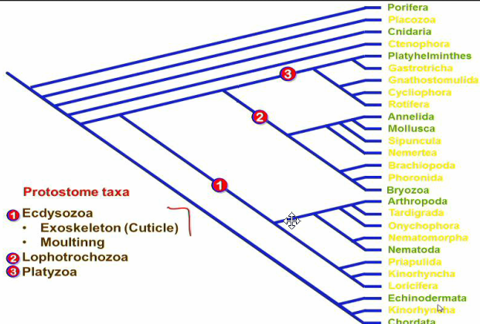

-- NOTE: Will be Looking at three things
Movement/Reproduction and Life Cycle/Feeding Mechanisms --

- Ecdysozoa(Animals that Moult)
  - Exoskeleton (Cuticle)
- This taxon’s definition characteristics had an outer exoskeleton layer of secretions and proteins
- Because it is none living we call it a cuticle so cuticle is equivalent to an exoskeleton is anything secreted to the outside of the body that is none living going to provided rigidity and support to this group of animals
- but is going to cause a problem once you secrete this outer exoskeleton going to fixed in size will not be able to grow any bigger than your exoskeleton.
  - Moulting/ Ecdysis
- So they fix this at various periods in their life they will create a bigger and new one and then continue growth in the new one this process is called Moulting or Ecdysis and this is where they get their name
- Includes Arthropods which is the largest group and they are going to be the first to concorours of land
- Ex Arthropods dragonfly emerging, Nematode

Symplesiomorphies Nematodes (round worms)
Medically Important can be infections ring worm and issues with nematodes in crops
Are very abundant in evolutionary tree might outnumber the Arthropods because we are just starting to understand because they all look the same as each other so genetics is being done
Animal Architecture
- Tissue
-None, diploblastic, or triploblastic
- Symmetry and Cephalization
-Asymmetry, radial, bilateral symmetry
- Embryology
-Protostome and deuterostome
- Body Cavities
-Coelomate, pseudocoelomate, acoelomate

- Collagenous Cuticle without microvilli Longitudinal but no circular muscles
- Cuticle is a nonliving, noncellular outer layer of an organism secreted by the underlying epidermis.
- Collagenous Cuticle is huge amount of proteins strung together
- Or you can have Chitin which is a reformat made out of sugars
- Pharynx Feeding
- Something is going to come back from the Cnidarians
- For the Cnidarians it was their solution to the fact that they did not have any muscles
- Going to use these muscles cell to help hold up its skeleton and going to be related to miniaturization
  - Epitheliomuscluar Phyarnx
- No muscle associated with gut, and how the nematode works by constantly whipping back and forth and there is constant pressure on the hydrostatic skeleton meaning that the gut is constantly being slammed shut
- So if it tries and opens its mouth going to vomit or defecate
- Taken epithelium and gone back to primitive state where the cnidarians has muscle fibers running through it and has created two values so rather than taking epithelial and adding muscle to it just going to use one cell layer with myoepithelial that will do both to conserve on complexity
- How the Pharynx it works his is the second valve closes then the first valve opens lets food in and close then the second valve opens and squirts the food down called Epitheliomuscular Pharynx
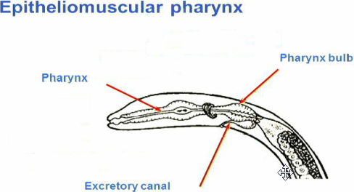

  - Triadiate pharynx
- Opening to the gut
- Biomechanically a triradial structure is the most effective to open up a duct or a tube because once you pull on one side you get more opening then you were trying to open, minimal amount of energy needed to open it as wide
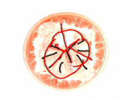
- Again for miniaturization

- Body Cavity – Pseudocoelomate
- Modify many systems
- Its survival strategy is to become minimal going to have a decrease in muscles will only have longitudinal muscle cells
- Going to have as many cells as it needs and not anymore
- Ring of muscles on the outside of the body and are running Longitudinally down the length of the body ONLY MUSCLE
- Cannot contract all of your longitudinal muscles at once to move because of the cuticle
- So it is going to contract muscles on one side and then on the other side and are going to use fluid in the pseudocoelomate as a hydrostatic skeleton to get motion
- This means that we have very unusual motion because we do not have complete muscle
- This is not a very effective swimming mechanism and they do not normally swim
- They are normally in the soil grains used to piviate around solid particles and grains to move, in deprey and materials
- Example Vinegar eel is a swimming Nematode
- Body Wall
- We also restrict complexity by the way they are innervated they do not have nerves coming to the muscles they have a rod of nerves cells that the muscles go to and send contractions to NOT SEEN ANYWHERE ELSE IN ANIMAL WORLD
- Reproduction
- This group is the only one that does not have flagellum on the end of the sperm it uses amoeboid sperm move up the reproductive tract

Pseudocoelomate we always see this when miniaturization is occurring, is a solution for a whole different life style the

Panarthropoda (Autapomorphies)
- Cuticle with chitin
- Food manipulation by limbs
- Long strands of chitin to reinforce cuticle layer going to have body layer lined up in segments end to end Ex Earthworm
- But each segment has an appendage including the head might be a mouth part
- Are going to be known for manipulating their food with these appendages going to be an important innovation because previously going to swallow whole but now we will preprocessing food before ingesting
- The only other is going to be the vertebrates that will do this preprocessing but will use the jaw

Onychophora (Autapomorphies) Velvet Worm
- Oral papillae with slime glands
- Body wall musculature continuous sheet
- Velvet worm is a transition animal because it has segmentation with limbs and an outer cuticle but it is still flexible enough that it has inner longitudinal muscles to move around by using the hydrostatic skeleton to do so
- Unarticulated limbs
- Limbs that they have are going to use hydrostatic skeleton or Hydrostatic Limbs are not going to articulated
- Will be able squeeze blood into move them and use muscles to contract them
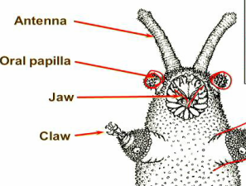
- Manipulate Food by Limbs
- Very worm like, identical body segments with appendages in each one that have adapted for different things
- It has Antenna a sensory structure
- Manipulate its food with Jaws
- Oral Papilla that are going to be associated with how it feeds squirt glue to immobilize its prey
- Claws on the end of each appendage that runs down its body
- Predator
- It is frozen in time using the same technique to capture food

Transitional on its way to being a Centipede or Millipede but is what we call a living fossil because they were found in the Burgess Shales that were in the oceans

They are also the Main proof of Continental Drift because when Pangaea was formed on the very south of it arose the very first Onychophorins and as South America pulls away from Africa the Onychophorins separate from each other but they do not diverge from each other over time. So all of the ones found in Africa are also found in South American and this is the indicator that these continents were put together.
1:08
Arthropoda (Autapomorphies)
- Articulated exoskeleton of plates
- Muscles arranged in bands
- Compound eye
Are going to get harden armer, there is no need for and the strands of muscles are moving over top of each other, most we are going to leav uptill they stup up on land
Arthropods: Trilobites – Ecdysozoa
Group that has gone exstinct, at the end of the permin , in the Cambrian oceans and they were pretitors dominated, had small and large
Arthropods: Crustacea – Ecdysozoa
Large crustacean are a resent thing and will see a bloom only after Triolobites have died off, they have Taguna are body region are difference
Filter feeding
Masters a bran new feeding , going to exploit the primary and single celld protists, have a series of apendeges they have a folded pattern in their limbs bo0xes that open and close when open water is filled and when it is closed water leaves, when the water leaves it is shooted out ans send the animal, the water fills through a porous wall from the mid line, the particulate gets stuck in this inner surface, every time we make a swimming motion we are passing algae through, then they that the algae slowly forward up to the mouth, up off the bottom to move around. Only going to swim and filter feed
Arthropods: Crustacea – Ecdysozoa
Whales eating
Carmerian oceans we get the first trophic level
Three main protostome groups
- Ecdysozoa -Exoskeleton (Cuticle)
-Moulting/ Edysis
- Lophotrochozoa Does not have a single characteristic that does not unifining morphological characteristics, we know that they are a group because of the genetics done, greated contention, they are so different that we cannot see any kind of ancester
-Lophophore or-
-Trochopho larval stage, they do not go together NOTE they are not at all the same things nothing related
- Platyzoa
1. Lophotrochozoa
-Lophophore or-
-Trochopho
2. Platyzoa
Lophotrochozoa
- Either presence of a U shape gut and Lophophore Have a mouth and an anus and problem with someone to become sesial, going to live on its feses, a unique modifaction of the gut of a u shape and have tenticals and tenticals are what a Lophophore is
Or
- Trochophore larval stage
Lophophorates
Bryozoa
Second big reef builders in the promative oceans
Bryozoa: Lophophorates
They are silomate tripolblasts, they can move these cilia and when they beat eh are going to pump, traping food a filter feeder, has a body cativty independent of it , can move around, gut is where the water is being pulled awayso the animal does not contaminate itself, reproduction sedding gamets into the ater
Trochozoa (Autapomorphie)
- Presence of the troophore larva
Trochophore Larva
Ciliated band around the middle, going to move it through the water, and helps it stay up right in the water, is common to these four
Animal Innovations (Symplesiomorphies)
- Trochophore
- Schizocoel,
- Dorsal heart and pericardial cavity
Schizocoel not a defining characteristics and puts it too far
Molluscs: Definiting characteristics
Look at digital diveristy
Molluscs: Trochozoa
Many different forms all build on similar achatecture
Mollusc Traits
How a general mollusc forms, can trap into a feeding source that no one has
Divide into two
- Ventral Foot: creep along on the
- Dorsal visceral mass: houses organ systems
Mantle the secretes a had protective shell
Secret has mucsles and is under attack can clamp shell down for protection,
Mantal cavity:The sell lungs or gills aquatic organisim when it clamps down there is cilia does not compremise itseld when it goes into protective mode only three of ten, tremendous diveristy
Mollusc Radula
Chitia teeth and move back and forth relative to the toungue, sands off organic debre, particles that have collected on rocks
Snails (Gastropods)
Moved into terrestrial environment vs. aquatic, when it needs to protect itself it can hid in its shell, accomidate a life style with a large organ has taken visceral mass on top, grows mass unequally and coils it
Squids and Octopods (Cephalopods)
The ansectreal the the same as the snails did, but they did not coil it foot become modifided as tenticus, and moving water so much force the water can move them, are realted have conqual shells
Ammonites
Huge amount they were all pretitors dominate molluse swimmng
Clams (Bivalves)
Setitary filter feeder , has folded its shell and has inclosed itself. Bairred into the ground brings in through gill and passes into its mouth. Clams do not make their particulate mater the do not use it not sefilized
Three main protostome groups
- Ecdysozoa -Exoskeleton (Cuticle)
-Moulting/ Edysis
- Lophotrochozoa
-Lophophore or-
-Trochopho
- Platyzoa
Annelida: Marine Worms –Trochozoa
Going to develop segmentation
Metanerisim of the structues…. Digital diversity
No one is digging into the depre but they are the ones that start Hermaphordism
Annelida: Metamerization –Trochozoa
Earth worms are the only one that shows us the first model of burrowing
Annelida: Marine Worms -Trochozoa
Platyzoa
Platyhelminthes (Autapomorphy)
- Incomplete gut
- Complex reproductive system assisciate with hermaphordism
Animal Architecture: Body Cavities – Acoelomate
No space visable circular and longitudinal, dorsal and ventral, whole body is covered with cilia underneath and can glide across the substrate, optimises surface to volume ratio, look undernethe there are many glands and it can stick itself to the subratate, can create some slight changes and can use glue to move, if any large currents cilia will not be affective to move
Flat worms (platylelminthes)
Look at how they get food, lie ontop of food , highly branching, animal that is is flattened no cells are two or there cell any farly complet nervious systems
Flat worms (platylelminthes)
Hermaphodism and the advantageboth partners as can produce offspring it is common in organisms that are slow moving organisim or are isolated, when there is meeting they make sure that they will meet the opposite, when they mate they share sperm and store it in the seminal receptacle, only at that point will the eggs will be produced. And the sperm is already produced in seminal vesical
Most are not free living, they are mostly successful because they are parisites they are
Fluke Clonorchi: Digestive and Excretory Systems
Chinese liver fluke
Fluke Clonorchi: Reproductive Systems
Same as previous, but they will put a protective casing on it in the ME
Fluke Clonorchi: Life Cycle
Releases in the bial and then into the digestive and goes to outside environment, if swims and looks for a snail, then fish
Example swimmer itch, nipple on your legs
FLAT WORMS can hid in other cavities with out
Then end result is we get a orgaism that is designed to be a praisite
Deuterostomia (Autapomorphies)
Blastopore become the anus and defines lineage

Echinodermata (Autapomorphies)
Starfish and sea urchans simtary based on five TERM
Why do we see this group become bylateraly symmetric, we did not know they were always bilaterialy
Make their appearance in the cambrian
Starfish and Relatives
Swimming larval stage bilateraly, it goes under a metamorphies that they
Starfish and Relatives
Common they were stalked organisim had a stalk with arem that were raitaly symetical we have a group that is lifting themselves out of the water to catch substate ans they were beatin everyone, not all fed this way. They have returned to become mobile, arms that were taking food to the orgaism became the ones that interacated with the enviroment
Water Vascular System
Hydrostatic net forward or backward mobility some are pointing forward some are , tube feed bcome helpful for moving, suchtion they are pretitors, they are surching out food, if slow moving they must have slow moving food, clam
Clams Wraps its arms around it and uses suchtion cup but enzymes in the shell to digest and uses cilia to eat
Pollups release enzymes all over the coral
An explanation for the Cambrian Explosion
- Snowball earth
- Burrowing
- Shelled arms race
- Developmental – hox genes
Why do we get this diversity in a short time, it takes billion to get single cells one million to get bacterial, ttwo theories
Bilateral symmetry message RNA turn on and make proteins anr radiat out very high at orian of source and

Late Proterozoic 650Ma theories
- Snowball earth land masses immerging , stratiling the eqator, major cunks coming out of the oceans, they all have sratct marks assosicated with glacers, the equator was covered with ice, carbon cycle and water minerals this was out of balance and the c02 in the air and the minerals in the rock, equator high rain fall and minerals were going into the oceans, and carbon sinc being pulled into the oceans, removing insulated covering cyanobacteria has a bloom and further dylouts oceans and earth cools even more, does not absorb as much soalr radiation because of the increase of land mass, cooling at north and south which becomes ice and absorbas the and ice age is , in the aquatic enviromewnt no sunlight under tremendous stress
- Slushball earth eqator did not freeze solid but was slush, volcanoes under the, could be trapped byt the herbivors methan for volancon all happens before cambrian
Early animal Evolution
- Burgess shale fossils 505 Ma
- Ediacara fossils 580-542 Ma
- Doushantou fossils 580-542 Ma
Ediacaran are the survivers of slush or snoball
Doushantuo Fossils 590-565Ma
Look like zygote and they show cleavage of the first mulit cellular organisms, membrane
Edicaran fossil 580-542 Ma
Tracks of something well before the cambrain , 250Ma before cambrain
We see multicellular life, organization and embroes
Prior Cambrian multicellular life and snowball puts this one hold and stopped the natural progression
Cambrain does diversification
Cambrain burrowers
- Advantages
-Feeding
-Anchorage
Prior to the cabrian a scum of bacteria and the animals lived on top of that left a hung amount of organic material
The first that benitrait this scum burrors and then you could be protected
You could live in regions where there are currents you could anchor yourself in place,
Now has a higher mineral content it is now balanced take it a make shells and had carbon to make sure preditors cannot bit down, arms race between predetor and prey and orgaisms get bigger
Three major things
Homeotic genes
Proteins and gradiant, they are called transcriptional factors they are going to control the massages
They use the transcription factors and they
Cell at the end can precieve a series of factors and at the other end your can see other factors that are perceived
Different genes more of them not more but more complex could take the chemical also worked inside insects
Homeotic genes: Hox genes
if you look at them they are fixed and
Homeotic genes: Hox genes
Cells revieve some kind of signal no matter where you put it in the embryo
Homeotic genes: Hox genes
They all they way through the animal kingdom create the patterning
Jellyfish were some lost and that is how we got radial symetical
Bilaterail symmetrical
Orgians of the homiog genes making their first apprences
Had a body plan that was fixed in time. Applied to time scale it was show before carmbrain, the whole ocean able for modification, then we get a population
Mulitcellulariy may have been a single event across the whole plants and animals
Mass extinctions
No extinction at the cambrain 50% lose and if you don’t know how many oragnisms are their then you don’t know if you have 50%
At the end of the Ordovician all the taxon at the 60-70% of all species moderate change in green house gasses and a cooling takes the water level in the ocean and because of this cooling it because a limiting factor for life
Middle Ordovician 458 Ma
Contentent weathering
Animal Innovations (Symplesiomorphies)
Chordata has a nevw way of feeding moves through the water and allows the water and food to ge through and collects the food as it passes the mouth and the swimming changes
Paleozoic Periods
- Paleozoic era
- Cambrian 550-488 Ma
- Ordovician 488-443 Ma
- Silurian 443-416 Ma
- Devonian 416-359 Ma
- Carboniferous 359-299 Ma
- Permian 299-245 Ma
Silurian and Devonian
Ordovician Survivors
Middle Silurian 425 Ma
Vertebrate Phylogeny
Armoured fishes
Vertebrate Phylogeny
Jawless fishes (Agnatha)
Vertebrate Phylogeny
Evolution of the Jaw
Geneome Duplication Homeotic Hox genes
Vertebrate Phylogeny
Chondrichthyes: Cartilaginous Fish
Placoid Scales
Feeding
Mermaids purse
Vertebrate Phylogeny
Vertebrate Phylogeny
Bony Fish Skeleton
Bony Fin Rays
Suction Feeding
Swim Bladder
Opercular Gill
Vertebrate Phylogeny
Evolution of the Tetrapods Stance
Transitions to land (Plants)
Phylogeny of Plants
Alternation of generations in land plants
Sorting out plant parts
Liverwort, Marchantia
Liverwort, Marchantia Life Cycle
Phylogeny of Plants
Transition to land – Water Conservation
Mosses
Mosses Life Cycle
Evolution of Plants Vascular Tissues
Late Devonian 390 Ma
Plant Phylogeny
Evolution of Plants Vascular Tissues
Ferns
Fern Life Cycle
Mass Extinction

Paleozoic Periods
- Paleozoic era
- Cambrian 550-488 Ma
- Ordovician 488-443 Ma
- Silurian 443-416 Ma
- Devonian 416-359 Ma
- Carboniferous 359-299 Ma
- Permian 299-245 Ma
Carboniferous and Permian Periods
Early Carboniferous 356 Ma
- Land pass shifting together making the sea smaller putting a stress on environment
- Oceans are going to have a lower O2
- No organism has come along to clean up decaying plants
- Plants have used up CO2 because of the huge plants and the level has gone down, O2 has also gone down
- We do not see a loss on any major groups
- Ice at the pole which are making it tougher for the plants but will be for the animals
- Land mass shift is making
- We are going to lose 90-95% extinction at the end of the perming

Late Carboniferous 306 Ma
Ferns cannot call them trees because they are not vascular
Evolutionary trend in plant life cycles
- Sporophyte’s size and life span
- Gametophyte’s size and life span
Two are coming together and we saw this first in our moss, sporophytic that is going to contain a gametophitc water proff casing and we call it pollen are going to get a dipoid the part of the plants arcagonia and a seed and femal gametophic
Late Permian 255 Ma
Carboniferous Aquatic Environment
Carboniferous Terrestrial Environment
Carboniferous Coal Forests
- Club mosses
- Giant horse tails
- Tree ferns
Phylogeny of Plants
Plasma gemata we had lignin to strengthen the plant to grow higher bigging of the secondary cellTreachea is fully mature it will bcome hallow it will be the water transport system
Carnifors
Their energy aborbing when we get pubs lignin is going to be a key compnet
Evolution of Plants Vascular Tissues
Lignin
- Hydrophobic Rings will not interact with the cell wall and will be pulled up from the bottom because of the water
- Indiestible hard to break down, it all fossolied and became coal we are putting carbon back in to environment
- Bacterial and fungal lignases are going to break down
- Toxic gives strength and regitiy the rings are the vasulas tissue growth lignafided pyramind and it always leaches out a bit of itself it will never end up with a bacterial infection, it is making it sterilie

Seed v.s. Spore
- Homosporous
Sporangia SporesBisexual gametophyte sperm or eggs

- Heterosporous
Microsporangia Microspores Male gametophyte sperm
Megasporangia Megaspores Female gametophyte Eggs
Megaspor is going to stay on original plant are there as nutrients not only of nucules get seed

Seed
Water proof casing and only half developed
Gymnosperm Life Cycle: Conifers
First group to deveop seed, because they are not relying on water transport
They are going to dominate because of the highly vasculized tissues and the advanced reproductive system
Pollen is coming off from male scales and will have four productes of miosis two will become the water proofing for the other two one nucleus is going to have to break through egg and other will transport
Megaspore will have four as well but only one is viable
Gymnosperm Ovule
Will build a tunnel and the it next one will fall will go through divisions that process takes two years
Can get the sperm to the egg withouth getting wet and the egg can stay on land
Have no find an efficient way of getting egg and sperm together
Fungi
At the end of the Permian you will get
O2
Fungi will not fossilize wll
Unique Fungal Terms
Hapliod stage
Cell connect end to end inside a chitain and a single cell and more complet my celia arenot water proof
They are an ingestive sacorphite
They have opening no restriction in the cytoplasm they are giant tubes are a giant aborbed digestive system and because they are all connect it is all distributed throughout the cell, why you see fungi associated with
More Fungal Terms
As a fungal cell grows, they will fuse cytoplasm then you have a cell with two nuclei they will not fuse hapoild it is dycariotic . every once and a while the two nuclei will fuse and they we will get miosis
Typical Fungal Life Cycle
Arrrow wrong way
Spores going on the ground and
Basidiomycota Life Cycle
Fungal Mutualism
Mushroom
Gills represent folds of tissue and specialized cell surface is going to spores fall off catch in the wind. Mushrooms are ready to go out overnight fairy ring of mushrooms the reason they appear so quicky is because tneir is not complications with the cytomplans absorb water like crazy and will increase pressure and will inflate
Mist abundant form of fungi
Types of Fungal Mutualism: Ectomycorrhizal fungi (EMF)
Right no fungi, weak comparied to the one with
Types of Fungal Mutualism: Ectomycorrhizal fungi (EMF)
It is on the outside of the root and get into the epidermal , such powerful digesters rock and mineral, they are absorbing minerals that they pass to the plant , the plant is going to pass sugar to the fungi, muteralizum
Types of Fungal Mutualism: Ectomycorrhizal fungi (EMF)
Can be external
Types of Fungal Mutualism: Arbuscular Mycorrhizal fungi (AMF)
Or internal just about every plant does this , there is an association , plants do not have anyway to absorb minerals
How did it occur probably lichen best example
Fungi – Lichens
Muteralizim between two different kingdoms
Fungi – Lichens
Fungal hypho algae , both can go domint until the water ,\
They are doing the same trick as moss
This is probably what the first relationship was
They were probably in some kind of relationship but no proof
Phylogeny of Animals
- Arthropods (Autaapomorphies)
-Articulated Exoskeleton

Insect External Anatomy: Tagmatization
How do you water proof, sperm to eggs
Use to be appendges of every legs mouth parts and attena,
They are going to manipulate their food before putting
Can be modifided into different many different
Ex grass hopper double articulated , Butterflys , house flyes
bit side pieces Insects and Mammals are the only that do this
When they come on land and are first and are going to be feeding on plants
Back it has an according like
Locamotoring legs
Insect Movement: Flight and Wing Folding Mechanism Locamotion
They are the first to fly, major event it can travel great distances for food sources but they can follow the new growth, example Monarch disoertion to be able to follow the seasons
And you can
Exsape preditors no birds at this time
Disadvantage the wings stick out they next innovation is going to be to fold the wings
Beatles have wing covers , could be the first insect to borrow into the ground without damaging wings
Flying reptials,
Flying reptial birds
Mammals bats
Cuticle – Exoskeleton
Going to hold them up against gravity where kytain is located Epicutucle is for water proofing, has glands that are always adding to this protecting layer
Example shlack water control off the surface of the body
Insect Tracheal System
They do transport oxygen in their blood, they have a series of pips right up to the cell that need oxygen, they supply next to the mitochondria,
21% in the air surface
Unlimited oxygen supply to the , they do hit the load they then have a perfect supply, depends on a gradient
Coniference with 6 foot wing spand because of the huge
Insect reproduction
Mating on land
Male produce a spermadospore they put their shell on first and the egg has to have an opening for sperm to come in , when it goes down the female releases the stores the sperm
Ex bee she has the mechiam for the reproductive does not dry out
Insect Metamorphosis
Two types of life cycle
Complete Meamorphies
-larva can feed on a completely different food types
-Fills it up with lipds we dissolve the animal to nothing and regrown and they do not end up competing
Imcomplete Metamorphiesss
-larva feed on the same things as adult
- Lava is trying to grown to be an adult and is trying to grow reproductive tissues
Ametabolous
-growth is related to treachal system
Vertebrate Phylogeny
Low fin fishes are going to develop limbs
Vertebrate Phylogeny
There is really nothing interesting , water proofing
The are failers at water proofing their bodies
Amphibians
They inharite a lung but will need to use skin
They all have
Buccal Force Respiration
Ineffiecent system because they have to force air in
They have aglandula skin because we need ot have mositer so that the amphibian

Amphibian Skin
Posion for protection because they do not have , they did not solve gas exchange
Amphibian Food
Ont thing they did to insure their survival, because of the new food supply of insects
Tough
No teeth trying to grab
Tapped a new food source
Amphibian Locomotion
Limbs for this things to stand up and it is going to have to do a push up to start moving, as it moves it is going to crush lung and won`t be able to move it
Amphibian Life Cycle
Still has to go back to the water
Stomach acids relase , this is the one that
Fungus from eating frog legs
Have not profected on coming up on land
No pressure to push them to

Vertebrate Phylogeny
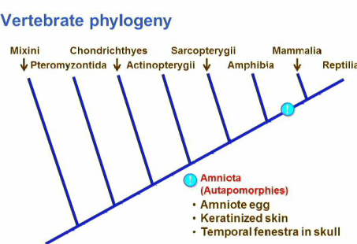
Amniota (Autapomorphies)
- Amniote Egg
  - Won`t get taken advantage of until after the Permian even though it will make its appearance in the Permian
  - All life is going on in aquatic environment if you can get you egg up on land where the only thing is Insects, which a large egg will be too big to eat, they will be safe from Predators
  - So the first organisms that go up on land with their eggs have a distinct advantage
  - Have to have gas exchange across the surface so the egg will be porous
  - The embryo is going to be covered in a sac called the Amnion filled with salt water the amniotic fluid basically a miniature ocean
  - Going to supply the egg with nutrients through the Yolk Gland/ Yolk Sac
  - The Albumen is another protienatous layer around the egg but when it gets broken down creates a lot of metabolic water so it is a water source
  - When all this nutrients are being broken down we do not want the embryo to be polluted with nitrous waste so we have the Allantois
  - Then the zygote can grow into an embryo and develop consuming the nutrients and filling into the space where this nutreients use to be
  - Huge Innovation
- Keratinized Skin
  - Are going to water proof their skin
- Temporal Fenestra in Skull
  - They are going to deal with the jaw muscles

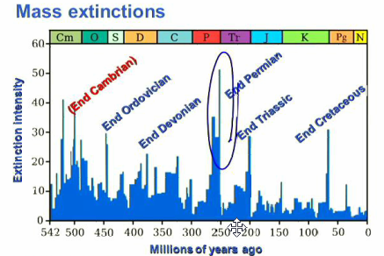
Largest Mass Extinction on the face of the Planet
At the end Permian extinction going to lose 90% of the biodiversity in the oceans and we are going to lose biodiversity on the land. Amniote egg will not take off until after this. We will see the planet scrubbed clean.

- Types of Mass Extinction
  - Mass Extinctions massive change on the face of the planet loose of 50% of the biodiversity of the planet, genera or families
  - Background Extinction there have been a tone extinctions going on the same time and organism does not live for ever animals are always going extinct. There are only a few animals that we call living fossils. There are local extinctions. These extinction make massive change on the face of the planet
- Causes of Mass Extinction
- Asteroid impacts
The huge craters that we see on the earth surface never seem to match up with carbon dating of the rocks
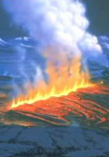
- Elevated Carbon Dioxide common to all mass extinctions in the change in the carbon cycle of the oceans greats green-house gasses and this warming triggers plant growth and then when they degrade the ocean become Anoxic
- Flood basalt
- Pieces of the planet when the continents started pulling apart from each other where the earth’s crust is very thin it erupts in kilometer long lengths
- spews molten material in thousands of square kilometers
- Ex Siberia traps still deceite today,
- Ex Going to have one happen when Africa and South American split apart and are going to have piece stuck on each side
-Are going to have instantaneous change in the atmosphere huge amount of green-house gasses added in a relatively short geological time
-But have to be occurring in specific locations at the hot spots
-When you go and age the Flood Basalts they tend to coincide with all the mass extinctions
- Volcanoes
- exploded and released green-house gasses and set the extinction into play
- But we now know that you would need many to volcanoes go off at the same time for them to have an effect on adding to the green-house gasses
-And when you look at the fossil records we do not see large amount of ash in the sediment
- Gas hydrates
- Methanogens are the bacteria that in extreme environments formed in the Archean
-That were hiding in the muck at the bottom of the oceans under great water pressure and produced methane gas
- Because they are under extreme pressure in the depths of the oceans methane gas compresses into crystals called Gas Hydrates
- Energy Industry wants to tap into it because they are filled with huge amounts of natural gas
- Ocean level was changing and the water level dropped the methane level in the water columns that the Bacteria produced diminished and the methane gas was released into the oceans which is another source of the greenhouse gasses
- Marine Anoxia
- Sea Level changes
The Permian Extinction was so bad because it was a combination of Flood Basalts, Gas Hydrates, and the decreasing level of carbon dioxide that drove the oceans into anoxic condition and as the Sea Levels diminished even more Methane Hydrates in other words it was the perfect storm

What is happening at this time is African and South American sub continents are splitting from each other

Groups that survive
Characteristics
- They are always small organisms
- That are distributed meaning that there is always a pock that they can survive in
- They are always generalists and never specialist because if you are a specialise then you are probably relying on other organisms as well and if they disappear then you will as well
- Permian Mass Extinction The plants have not been affect by these mass extinctions for the first thing they are not up on land yet but they also have spore that are distributed around the planet meaning that there will be some spores that survive
- Cenozoic Mass Extinction The insects also survive mass extinction they are small they have global distribution
- What we are seeing in a mass extinction is the highly specialized organism that are lost the generalises survive and they inherit the environment and the they become specializations and how we get we can get a reignotilization of the planet after these mass extinctions

