Progress Report 1
Nicholas Kicz 6276530
CVG 4113
Professor Seidou
University of Ottawa

- Location
For my location I have chosen an area in the suburb of Kanata. This site contains mainly residential small lots, with some commercial area, and apartment housing. This site is connected directly to the city’s main water distribution system and offers lots of area for future expansion.
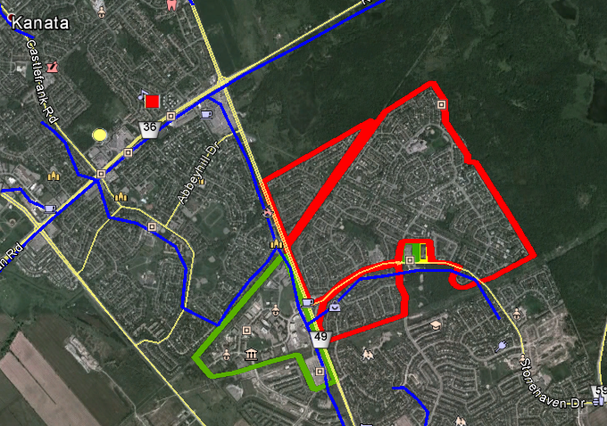
Figure 1: Study Area-Kanata

- Population Forecasting
The population growth for Kanata is seen in the census data provided in tutorial 1, and is illustrated in table 1 shown below. This data produced the relationship of population vs time shown in figure 2.
Table 1: Census Data

Figure 2: Population Growth for Kanata
The relationship above is border line between geometric or arithmetic. Upon further investigation it was found that the sum of the squared error of the two relationship types was less for arithmetic than for geometric. This indicates a stronger relationship. It can also be observed besides the slight curve in the 1980’s it is a mainly linear growth. Below is the comparison of each analysis. Therefore the future growth can be estimated using an arithmetic relationship.

 |  | Geometric
Year | Population | k | Population | Error | Square Error
1976 | 11740
1981 | 18425 | 1.0943289 | 15711 | -2714 | 7365796
1986 | 25985 | 1.0711815 | 24657 | -1328 | 1763584
1991 | 35440 | 1.0640308 | 34774 | -666 | 443556
1996 | 45620 | 1.0517979 | 47428 | 1808 | 3268864
2001 | 56125 | 1.0423179 | 61051 | 4926 | 24265476
2006 | 67100 | 1.0363662 | 75109 | 8009 | 64144081
 | Avg | 1.0600039
 | sum of error square |  | 37107276
Table 2: Geometric Analysis

 |  | Arithmetic
Year | Population | k | Population | Error | Square Error
1976 | 11740
1981 | 18425 | 1337 | 20967 | 2542 | 6461764
1986 | 25985 | 1512 | 27652 | 1667 | 2778889
1991 | 35440 | 1891 | 35212 | -228 | 51984
1996 | 45620 | 2036 | 44667 | -953 | 908209
2001 | 56125 | 2101 | 54847 | -1278 | 1633284
2006 | 67100 | 2195 | 65352 | -1748 | 3055504
 | Avg | 1845.3333
 | sum of error square |  | 11834130
Table 3: Arithmetic Analysis

- Population Estimation
Before estimating for the future I first calculated the approximate population of my study area using google earth and table 4 shown below. By using the area of each polygon shown in figure 1 and multiplying by a specific population density an approximation of the population can be made.
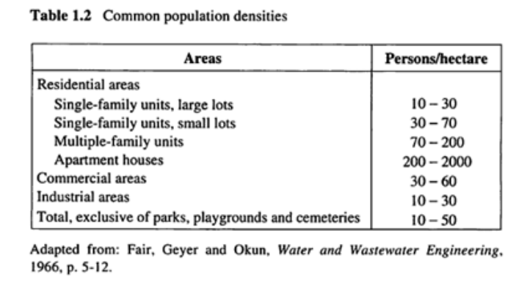
Table 4: Population Densities
My Approximate population is as follows:

Land Use | Area (hec) | Average | Population
Residential Small Lots | 227.4 | 50 | 11370
Commercial | 56.8 | 45 | 2556
Apartment House | 1.6 | 300 | 480
 |  | Total | 14406

Table 5: Study Area Current Population
- Forecasting the Future
Now that I have a current population I can use my arithmetic model to estimate the future population. Since I plan for future expansion of the system I will design for a 20 year period. The population will be estimated up to the 2034. The model is based on a growth factor K.
$$K=\frac{P\left(t+ ∆t\right)-P\left(t\right)}{∆t}$$

And future population can be found by:
$$P\left(t+ ∆t\right)=P\left(t\right)+K*∆t$$
The population for each land was also found using the proportion of that land use to the total land. The total forecast can be seen in the table below.
Table 6: Future Population Forecast
As shown in table 6 my population will increase to 51313 people in the year 2034. This will require a total land increase of 572.1 hectares for residential units, 157.6 hectares for commercial use, and 4 hectares for apartment housing.

