Chapter 1: Marketing: Creating and Capturing Customer Value
Marketing: the activity, the set of institutions, and processes for creating, communicating, delivering and exchanging offerings that have value for customers, clients, partners and society at large
Needs: states of felt deprivation (i.e. I am hungry)
Wants: the form human needs take as shaped by culture & individual personality (i.e. I want a hamburger, fries, soft drink, etc)
Demands: human wants that are backed by buying power (i.e. I have money to buy this meal, and I am willing to get it)
Market Offerings: some combination of products, services, information or experiences offered to a market to satisfy a need or want
Marketing Myopia: the mistake of paying more attention to the specific products a company offers than to the benefits and experiences produced by these products
Exchange: the act of obtaining a desired object from someone by offering something in return
Market: the set of all actual & potential buyers of a product or service
Marketing Management: the art & science of choosing target markets and building profitable relationships with them
Production Concept: the idea that consumers will favour products that are available & highly affordable and that the organization should therefore focus on improving production and distribution efficiency
Product Concept: the idea that consumers will favour products that offer the most quality, performance and features and that the organization should therefore devote its energy to making continuous product improvements
Selling Concept: the idea that consumers will not buy enough of the firm’s products unless it undertakes a large-scale selling and promotion effort
Marketing Concept: the marketing management philosophy that achieving organizational goals depends on knowing the needs & wants of target markets and delivering the desired satisfactions better than competitors do
Societal Marketing Concept: the idea that a company’s marketing decisions should consider consumers’ wants, the company’s requirements, consumers’ long-run interests, and society’s long-run interests
Customer Relationship Management: the overall process of maintain profitable customer relationships by delivering superior customer value & satisfaction (it costs 5-10x more to attract a new customer than it does to keep a current customer satisfied)
Customer-Perceived Value: the customer’s evaluation of the difference between all the benefits and all the costs of a market offering relative to those of competing offers
Customer Value: benefit that the customer gains from using a product compared to the cost of obtaining a product
Customer Satisfaction: the extent to which a product’s perceived performance matches a buyer’s expectations
Consumer-Generated Marketing: marketing messages, ads and other brand exchanges created by consumers themselves – both invited and uninvited
Partner-Relationship Management: working closely with partners in other company departments and outside the company to jointly bring greater value to customers
Customer Lifetime Value: the value of the entire stream of purchases that a customer would make over a lifetime of patronage
Share of Customer: the portion of the customer’s purchasing that a company gets in its product categories
Customer Equity: the total combined customer lifetime values of all of the company’s customers
Chapter 2: Company and Marketing Strategy: Partnering to Build Customer Relationships
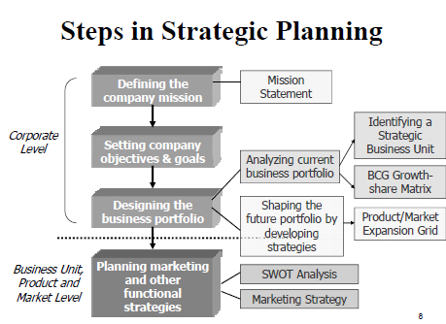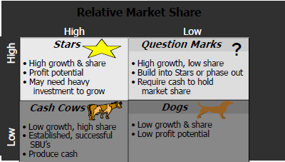
Stars = build. Question marks = hold. Cash cows = harvest. Dogs = divest.
Strategic Planning: the process of developing and maintaining a strategic fit between the organization’s goals and capabilities & its changing marketing opportunities
Mission Statement: a statement of the organization’s purpose – what it wants to accomplish in the larger environment
Business Portfolio: the collection of businesses and products that make up the company
Portfolio Analysis: the process by which management evaluates the products & businesses that make up the company
Growth-Share Matrix: a portfolio-planning method that evaluates a company’s strategic business units in terms of its market growth rate and relative market share. SBUs are classified as stars, cash cows, question marks or dogs
Product/Market Expansion Grid: a portfolio-planning tool for identifying company growth opportunities through market penetration, market development, product development or diversification
Market Penetration: a strategy for company growth by increasing sales of current products to current market segments without changing the product
Market Development: a strategy for company growth by identifying and developing new market segments for current company products
Product Development: a strategy for company growth by offering modified or new products to current market segments
Diversification: a strategy for company growth through starting up or acquiring businesses outside the company’s current products and markets
Downsizing: reducing the business portfolio by eliminating products or business units that are not profitable or that no longer fit the company’s overall strategy
Value Chain: the series of departments that carry out value-creating activities to design, produce, market, deliver & support a firm’s products
Value-Delivery Network: the network made up of the company, suppliers, distributers & ultimately, customers who “partner” with each other to improve the performance of the entire system
Market Segmentation: dividing a market into distinct groups of buyers who have different needs, characteristics, or behaviors and who might require separate products or marketing programs
Market Segment: a group of consumers who respond in a similar way to a given set of marketing efforts
Market Targeting: the process of evaluating each market segment’s attractiveness and selecting one or more segments to enter
Positioning: arranging for a product to occupy a clear, distinctive & desirable place relative to competing products in the minds of target consumers
Differentiation: actually differentiating the market offering to create superior customer value
Marketing Mix: the set of controllable, tactical marketing tools – product, price, place & promotion – that the firm blends to produce the response it wants in the target market
SWOT Analysis: an overall evaluation of the company’s strengths (S), weaknesses (W), opportunities (O), and threats (T)
Marketing Implementation: the process that turns marketing strategies and plans into marketing actions to accomplish strategic marketing objectives
Marketing Control: the process of measuring and evaluating the results of marketing strategies & plans and taking corrective action to ensure that objectives are achieved
Return on Marketing Invesment (or Marketing ROI): the net return from a marketing investment divided by the costs of the marketing investment
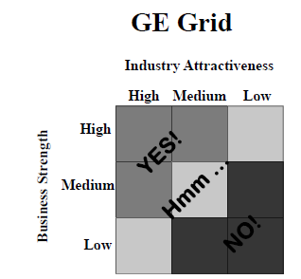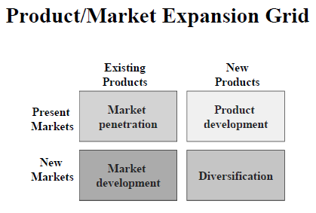
Chapter 3: Analyzing the Marketing Environment
Marketing Environment: the actors & forces outside marketing that affect marketing management’s ability to build and maintain successful relationships with target customers
Microenvironment: the actors close to the company that affect its ability to serve its customers – the company, suppliers, marketing intermediaries, customer markets, competitors & publics
Macroenvironment: the larger societal forces that affect the microenvironment – demographic, economic, natural, technological, political & cultural forces
Marketing Intermediaries: firms that help the company promote, sell & distribute its goods to final buyers
Public: any group that has an actual or potential interest in or impact on an organization’s ability to achieve its objectives
Demography: the study of human population in terms of size, density, location, age, gender, race, occupation and other statistics
Baby Boomers: the 9.8 million Canadians born during the baby boom following World War II and lasting until the mid-1960s
Generation X: the 7 million Canadians born between 1967 and 1976 in the “birth death” following the baby boom
Millenials (or Generation Y): the 10.4 million children of the Canadian baby boomers, born between 1977 and 2000
Economic Environment: factors that affect consumer buying power & spending patterns
Engel’s Laws: differences noted over a century ago by Ernst Engel in how people shift their spending across food, housing, transportation, health care & other goods and services categories as family income rises
Natural Environment: natural resources that are needed as inputs by marketers or that are affected by marketing activities
Environmental Sustainability: developing strategies and practices that create a world economy that the planet can support indefinitely
Technological Environment: forces that create new technologies, creating new product & market opportunities
Political Environment: laws, government agencies, and pressure groups that influence and limit various organizations and individuals in its given society
Cultural Environment: institutions and other forces that affect society’s basic values, perceptions, preferences and behaviors
Chapter 5: Managing Marketing Information to Gain Customer Insights
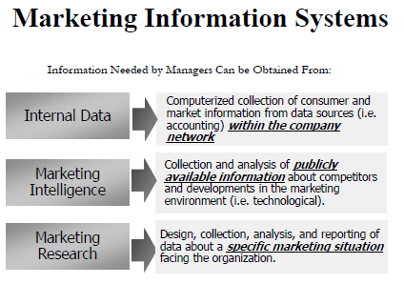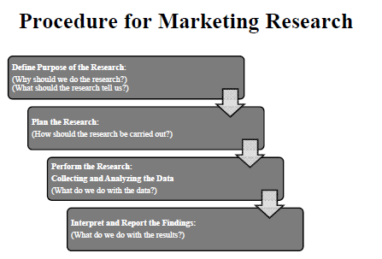
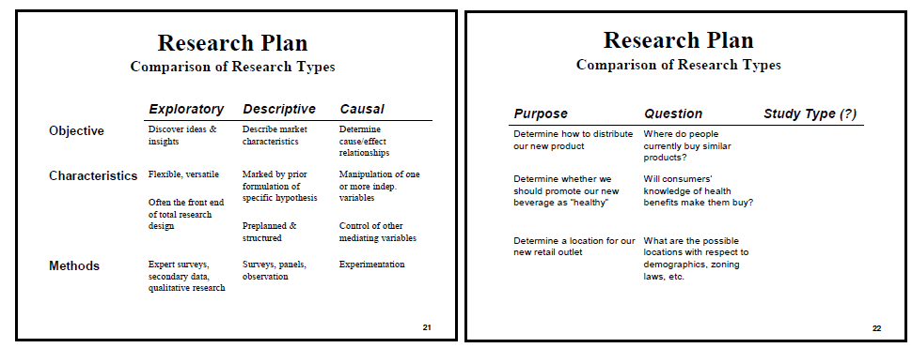
Customer Insights: fresh understandings of customers and the marketplace derived from marketing information that become the basis for creating customer value and relationships
Marketing Information System (MIS): people, equipment & procedures that gather, sort, analyze, evaluate & distribute needed, timely, and accurate information to marketing decision makers; provides information to the company’s marketing and other managers and external partners such as suppliers, resellers, and marketing service agencies
Internal Databases: electronic collections of consumer and market information obtained from data sources within the company’s network
Marketing Intelligence: the systematic collection and analysis of publicly available information about consumers, competitors, and developments in the marketing environment
Marketing Research: the systematic design, collection, analysis and reporting of data relevant to a specific marketing situation facing an organization
Exploratory Research: marketing research to gather preliminary information that will help define problems and suggest hypotheses
Descriptive Research: marketing research to better describe marketing problems, situations, or markets, such as the market potential for a product or the demographics and attitudes of consumers
Causal Research: marketing research to test hypotheses about cause-and-effect relationships
Secondary Data: information that already exists somewhere, having been collected for another purpose
Primary Data: information collected for the specific purpose at hand
Commercial Online Databases: computerized collections of information available from online commercial sources or via the internet
Observational Research: gathering primary data by observing relevant people, actions and situations
Survey Research: gathering primary data by asking people questions about their knowledge, attitudes, preferences, and buying behavior
Experimental Research: gathering primary data by selecting matched groups of subjects, giving them different treatments, controlling other factors and checking for differences in group responses
Focus Group Interviewing: personal interviewing that involves inviting six to ten people to gather for a few hours with a trained interviewer to talk about a product, service, or organization. The interviewer “focuses” the group discussion on important issues
Online Marketing Research: collecting primary data online through Internet surveys, online focus groups, web-based experiments, or tracking consumers’ online behavior
Online Focus Groups: gathering a small group of people online with a trained moderator to chat about a product, service, or organization and gain qualitative insights about consumer attitudes & behavior
Sample: a segment of the population selected for marketing research to represent the population as a whole
Customer Relationship Management (CRM): managing detailed information about individual customers and carefully managing “touchpoints” to maximize customer loyalty
Projective Techniques: i.e. word association, sentence completion, drawings, picture response
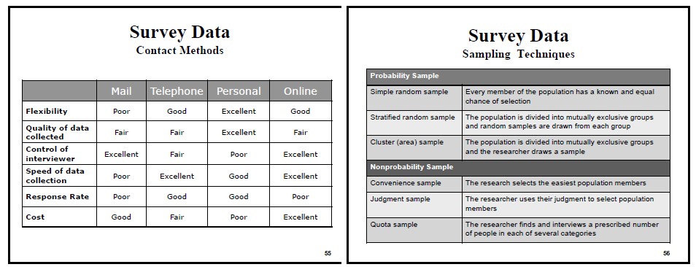
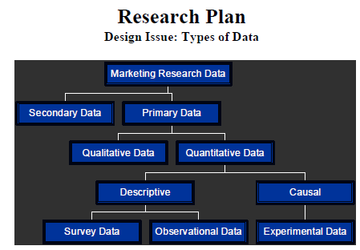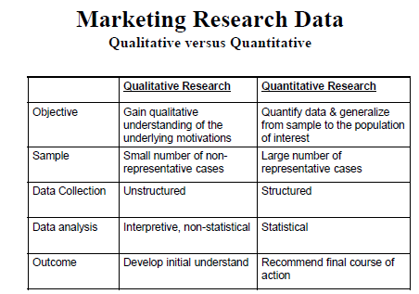

Chapter 6: Consumer Markets and Consumer Buyer Behavior
Consumer Buyer Behavior: the buying behavior of final consumers – individuals and households that buy goods and services for personal consumption
Consumer Market: all the individuals and households who buy or acquire goods & services for personal consumption
Culture: the set of basic values, perceptions, wants and behaviors learned by a member of society from family and other important institutions
Subculture: a group of people with shared value systems based on common life experiences & situations
Social Class: relatively permanent and ordered divisions in a society whose members share similar values, interests, and behaviors
Group: two or more people who interact to accomplish individual or mutual goals
Opinion Leader: a person within a reference group who, because of special skills, knowledge, personality, or other characteristics, exerts social influence on others
Online Social Networks: online social communities – blogs, social networking websites, or even virtual worlds – where people socialize or exchange information and opinions
Lifestyle: a person’s pattern of living as expressed in his or her activities, interests & opinions
Personality: the unique psychological characteristics that lead to relatively consistent and lasting responses to one’s own environment
Brand Personality: the specific mix of human traits that maybe attributed to a particular brand
Motive (Drive): a need that is sufficiently pressing to direct the person to seek satisfaction of the need
Perception: the process by which people select, organize, and interpret information to form a meaningful picture of the world
Learning: changes in an individual’s behavior arising from experience
Belief: a descriptive thought that a person holds about something
Attitude: a person’s consistently favourable or unfavourable evaluations, feelings and tendencies toward an object or idea
Complex Buying Behavior: consumer buying behavior in situations characterized by high consumer involvement in a purchase and significant perceived differences among brands
Dissonance-Reducing Buying Behavior: consumer buying behavior in situations characterized by high involvement but few perceived differences among brands
Habitual Buying Behavior: consumer buying behavior in situations characterized by low consumer involvement and few significantly perceived brand differences
Variety-Seeking Buying Behavior: consumer buying behavior in situations characterized by low consumer involvement but significant perceived brand differences
Need Recognition: the first stage of the buyer decision process, in which the consumer recognizes a problem or need
Information Search: the stage of the buyer decision process in which the consumer is aroused to search for more information; the consumer may simply have heightened attention or may go into an active information search
Alternative Evaluation: the stage of the buyer decision process in which the consumer uses information to evaluate alternative brands in the choice set
Purchase Decision: the buyer’s decision about which brand to purchase
Post-purchase Behavior: the stage of the buyer decision process in which consumers take further action after purchase based on their satisfaction or dissatisfaction
Cognitive Dissonance: buyer discomfort caused by post-purchase conflict
New Product: a good, service or idea that is perceived by some potential customers as new
Adoption Process: the mental process through which an individual passes from first hearing about an innovation to final adoption

Chapter 10: New-Product Development and Product Life-Cycle Strategies
New-Product Development: the development of original products, product improvements, product modifications, and new brands through the firm’s own product-development efforts
Idea Generation: the systematic search for new-product ideas
Idea Screening: screening new-product ideas to spot good ideas and drop poor ones as soon as possible
Product Concept: a detailed version of the new-product idea stated in meaningful consumer terms
Concept Testing: testing new-product concepts with a group of target consumers to find out if the concepts have strong consumer appeal
Marketing Strategy Development: designing an initial marketing strategy for a new product based on the product concept
Business Analysis: a review of the sales, costs, and profit projections for a new product to find out whether these factors satisfy the company’s objectives
Product Development: developing the product concept into a physical product to ensure that the product idea can be turned into a workable market offering
Test Marketing: the stage of new-product development in which the product and marketing program are tested in realistic market settings
Commercialization: introducing a new product into the market
Customer-Centred New-Product Development: new-product development that focuses on finding new ways to solve customer problems and create more customer-satisfying experiences
Team-Based New-Product Development: an approach to developing new products in which various company departments work closely together, overlapping the steps in the product-development process to save time and increase effectiveness
Product Life Cycle: the course of a product’s sales and profits over its lifetime. It involves five distinct stages: product development, introduction, growth, maturity and decline
Introduction Stage: the product life-cycle stage in which the new product is first distributed and made available for purchase
Growth Stage: the product life-cycle stage in which a product’s sales start climbing quickly
Maturity Stage: the product life-cycle stage in which sales growth slows of levels off
Decline Stage: the product life-cycle stage in which a product’s sales decline

