BIOL 1F90

Experiment #5 - Archaea: Characterization of Halophiles

Student Name: Brittany Barnes

Student Number: 5408224

Lab Section: 35

Date Experiment Performed: January 13, 2014

Lab Partners:
Kayla Hutchinson
Fallon Fersaud
Ashley Maulucci

Abstract

Halobacterium salinarum and Haloferax volcanii come from the domain called Archaea and are considered to be halophilic, because they thrive in extreme environments. In this lab experiment, several tasks took place. In order to be able to observe the colony morphology of both Archaea, they were grown on an agar surface that allowed them to form colonies of characteristic colour and appearance. In order to observe the physiology of both Archaea on the effect of salt concentration, pH, and temperature, they needed to be placed on agar plates and incubated for two weeks. Being incubated for two weeks, allowed the halophilic archaeal cultures to grow.
The objective of this experiment was to determine the morphological and biochemical characteristics along with the growth requirements of the halophilic Archaeans; Halobacterium salinarum NRC-1 and Haloferax volcanii DS2.

Introduction

The domain, Archaea, possesses prokaryotic cells and has a cell wall that contains no peptidoglycan. Archaea contain rRNA that is unique to the Archaea as indicated by the presence of molecular regions. Archaea usually live in extreme environments and include methanogens, extreme halophiles, and hyperthermophiles. One reason for this is that the ether-containing linkages in the Archaea membranes are more stable and are able to withstand higher temperatures and stronger acid concentrations. The other two domains of life are Bacteria and Eukarya. Unlike the Bacteria and the Eukarya domains, the Archaea domain has membranes composed of branched hydrocarbon chains that are attached to glycerol by ether linkages. Bacteria and Eukarya domains have membranes composed of unbranched fatty acid chains that are attached to glycerol by ester linkages. Eukarya cell walls contain no peptidoglycan, whereas the Bacteria cell walls contain peptidoglycan. Bacteria contain rRNA that is unique to the Bacteria and Eukarya contain rRNA that is unique to the Eukarya. Bacteria and Eukarya domains cannot live in extreme environments like the Archaea domain can, because of their ester-containing linkages (Kaiser, 2011).
Most archaeans are considered to be extremophiles, because they live in extreme environments. Extremophiles is an organism that is adapted to living in conditions of extreme temperature, pressure, or chemical concentration, as in highly acidic or salty environments. Halophiles are aerobic microorganisms that live and grow in high saline and salty environments. Some environments that halophiles live in are the Great Salt Lake in Utah, Owens Lake in California, and the Dead Sea.
Halobacterium salinarum is a halophilic and thermophilic model organism, which is commonly mistaken to be a bacterium because of its name. They share certain qualities of both domains, because they have gas vesicles, flagella, and a cell wall like bacteria, but it can survive in high saline environments as well as high temperatures like other Archaeans. Halobacterium salinarum are often found in places with high salt concentration like San Francisco Bay, the Great Salt Lake, Yellowstone National Park (Baker et al., 2011). Haloferax volcanii is a moderately halophilic Archaean that grows optimally at a salt concentration around 2.2 _{M} and a temperature around 45 degrees Celsius. It was isolated from the Dead Sea in 1975 and is a very versatile species that can grow in synthetic medium with a variety of carbon sources.
In this experiment, the morphological and biochemical characteristics along with the growth requirements of the halophilic Archaeans; Halobacterium salinarum NRC-1 and Haloferax volcanii DS2 were determined. To carry out this experiment, the workplace needed to be kept sterile at all times to avoid contamination in the cultures. Most of the colony morphology, physiology, biochemical tests and antibiotic sensitivity of the halophilic Archaeans were observed during the experiment, while some were observed after being incubated for two weeks.

Materials and Methods

Methods and materials used in this experiment can be found in the BIOL 1F90 Laboratory Manual (Martin, 2014), Experiment #5, pages 2 to 12.

Results

Table 1: The Colony Morphology, Culture Physiology, Biochemical Test Results and Antibiotic Sensitivity Results.
Characteristic | Halobacterium salinarum NRC-1 | Haloferax volcanii DS2
Colony morphology
Pigment | Pink | Orange
Density | Translucent | Opaque
Consistency | Smooth, Friable | Smooth, Mucoid
Form | Punctiform | Circular
Elevation | Flat | Convex
Margin | Entire | Entire
Motility | Motile | Not Motile
Presence of gas vesicles | + | -
Physiology: Effect of salt on growth (% w/v / Molarity)
5 % / 0.9 M | - | +
12 % / 2.1 M | + | +
18 % / 3.1 M | + | +
25 % / 4.3 M | + | +
Physiology: Effect of pH on growth
pH 3 | - | -
pH 5 | + | +
pH 7 | + | +
pH 9 | + | +
Physiology: Effect of temperature on growth
5˚C | - | -
20˚C | - | -
42˚C | + | +
50˚C | - | +
60˚C | - | -
Biochemical Tests: Acid production from sugars
Dextrose | - | +
Lactose | - | +
Maltose | + | +
Sucrose | - | +
Other Biochemical tests
Catalase Activity | - | -
Oxidase Activity | - | d
Starch Hydrolysis | + | +
Casein Hydrolysis | + | +
Gelatin Hydrolysis | - | +
Urease Activity | + | +
Citrate Utilization | - | +
H₂S Production | - | +
Indole Production | - | -
Antibiotic Sensitivity
Bacitracin | S | S
Penicillin | R | R
Tetracycline | R | R
Vancomycin | R | S

In Table 1, one can observe that the Halobacterium salinarum NRC-1 and Haloferax volcanii DS2 are similar in terms of the effect of pH on their growth. However, the two Archaeans differ in their colony morphology, the effect of salt and temperature on their growth, their acid production from sugars and other biochemical tests, as well as their antibiotic sensitivity.

Table 2: A Summary Table of the Physiological Characteristics of Halobacterium salinarum and Haloferax volcanii.
Physiological Characteristic | Halobacterium salinarum NRC-1 | Haloferax volcanii DS2
Temperature Requirements | Mesophilic | Mesophilic
pH Requirements | Neutrophilic | Neutrophilic
Nutrition Type | Photoautotrophic | Photoheterotrophic
Oxygen Requirements | Strict Anaerobe | Strict Anaerobe

In Table 2, one can observe that the Halobacterium salinarum NRC-1 and Haloferax volcanii DS2 are both mesophilic, neutrophilic and strict anaerobic. The only difference between the two Archaeans is that the Halobacterium salinarum NRC-1 is photoautotrophic and the Haloferax volcanii DS2 is photoheterotrophic.

Table 3: A Summary Taxonomy Table for Halobacterium salinarum and Haloferax volcanii.
 | Halobacterium salinarum NRC-1 | Haloferax volcanii  DS2
Domain | Cellular Organisms | Cellular Organisms
Kingdom | Archaea | Archaea
Phylum | Euryarchaeota | Euryarchaeota
Class | Halobacteria | Halobacteria
Order | Halobacteriales | Halobacteriales
Family | Halobacteriaceae | Halobacteriaceae
Genus | Halobacterium | Haloferax
Species | H. salinarum | H. volcanii
Strain | NRC-1 | DS2

In Table 3, one can observe that the Halobacterium salinarum NRC-1 and Haloferax volcanii DS2 are common in the sense that they are from the same Domain, Kingdom, Phylum, Class, Order, and Family. The only taxonomy traits that separate the two Archaeans are the Genus, Species, and Strains.

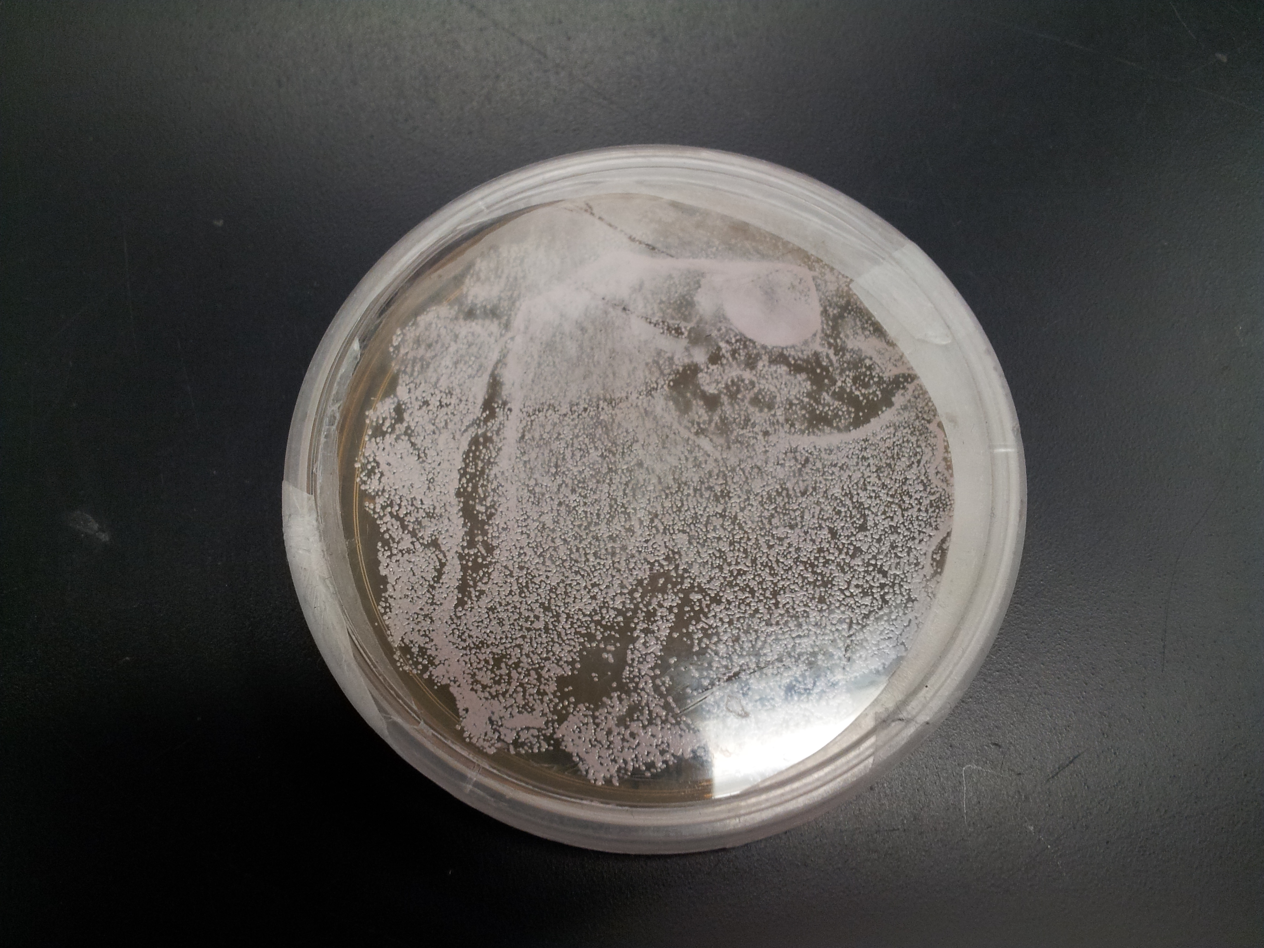
Figure 1: Halobacterium salinarum Plate. (Photo taken by Ashley Maulucci)

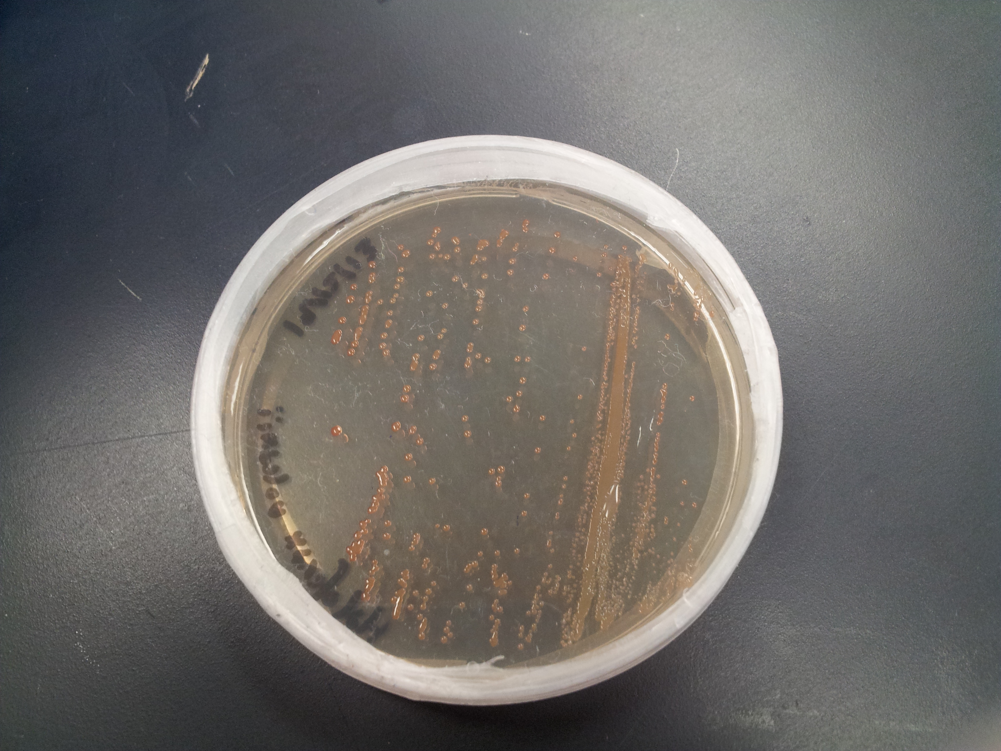
Figure 2: Haloferax volcanii Plate. (Photo taken by Ashley Maulucci)

Discussion

Based on the effect of salt on growth results, Halobacterium salinarum and Haloferax volcanii are considered to be true halophiles, because both Archaeans showed a presence of growth in the experiment (refer to Table 1). Halophiles (from the Greek, hal, meaning sea or salt, and philos, meaning loving) growth depends on the presence of salt and is distinguished by their requirement of high salinity conditions for growth. Since Halobacterium salinarum and Haloferax volcanii are halophilic archaea, they are considered to be extreme halophiles, which grow best at the highest salinities of 3.4-5.1 _{M} NaCl (DasSarma, 2012). Halophilic Archaea are able to adapt to their environment due to having a large concentration gradient. They are one of only a very few known organisms that accumulate potassium (K⁺) intracellularly to balance the external sodium (Na⁺) concentration, and this is maintained against a large concentration gradient as the external K⁺ concentration is normally much lower in nature environments than Na⁺ (Dyall-Smith, 2008).

Based on the catalase and oxidase tests of Halobacterium salinarum and Haloferax volcanii, the oxygen requirements classify the Archaeans as strictly anaerobic (refer to Table 2). This means that they are intolerant to oxygen and will not grow in the presence of oxygen. However, the experimental results conflict with what is stated in literature. In an advanced article called Halophiles, it states that Halobacterium salinarum is a facultative anaerobe and grows utilizing respiration of dimethoxylsulfoxide and trimethylamine N-oxide, fermentation of different sugars, breakdown of arginine and light energy, mediated by retinal pigments (DasSarma, 2012). Between Halobacterium salinarum and Haloferax volcanii, Halobacterium salinarum produced gas vesicles and was considered to be motile, whereas Haloferax volcanii did not produce gas vesicles and was considered to be non-motile (refer to Table 1). The cellular structure that contributes to motility is a bundle of rigid, helical flagella (Dyall-Smith, 2008). There would be an advantage for cells to produce gas vesicles and be motile to best fulfill their oxygen requirements. In regards to gas vesicles, they buoy cells towards oxygen-rich surface layers in hypersaline water bodies to prevent oxygen limitation (Oren, 2012).

Halobacterium salinarum has a temperature requirement that is mesophilic and a pH requirement that is neutrophilic (refer to Table 2). It is mesophilic, because the Archaean lives in a warm place around 37 degrees Celsius. It is neutrophilic, because the Archaean lives in seawater, which is a neutral to slightly alkaline pH of 7.2 - 7.5 (Dyall-Smith, 2008). For Halobacterium salinarum to survive in these environments without osmotic stress tearing their cell walls apart when salt levels change, they have osmoprotectants, which helps to equilibrize them with their environment. These osmoprotectants allow the Halobacterium salinarum to pump large amounts of salt into its cell (Baker et al., 2011). Haloferax volcanii has a temperature requirement that is mesophilic and a pH requirement that is neutrophilic (refer to Table 2). It is mesophilic, because it is a type of haloarchaea that enjoys living in warm temperatures, 45 degrees Celsius being its optimal temperature for growth. It is neutrophilic, because the Archaean lives in seawater, which has a pH range of 7.2 - 7.5 (Dyall-Smith, 2008). Haloferax volcanii has many features that allow them to interact in a unique way with their environment, which is why they are able to live in extreme environmental conditions. Among these adaptations is their ability to lie dormant for long periods of time in the event that environmental conditions are too unfavorable. The ability to lie dormant and to have unparalled DNA repair mechanisms are the cellular mechanisms that are responsible for the absence of growth at certain temperatures and pH values in Haloferax volcanii.

Halobacterium salinarum is photoautotrophic (refer to Table 2), because it uses light as its energy source and CO₂ as its carbon source. Halobacterium salinarum supplements its lifestyle with light energy to drive phosphorylation to make ATP without using photosynthesis. Rather than using chlorophyll, this Archaean uses bacteriorhodopsin. This is a pigment made of protein and an organic molecule called retinal. This pigment has a maximum absorption at 280nm in the UV range, but in the visible range it absorbs maximally at 570nm (Koning, 1994). Haloferax volcanii is photoheterotrophic (refer to Table 2), because it uses light as its energy source and organic chemicals as its carbon source. Haloferax volcanii lacks the genetic capacity to produce bacteriorhodopsin (Ortenbery and Mevarech, 2000), so it uses sunlight through photosynthesis. Halophilic archaea generally live in nutrient-poor environments. This is because most organisms are not able to survive in the type of environments that halophilic archaea live in, which are very high in salinity and salt. The biochemical test results for dextrose, lactose, and sucrose for Halobacterium salinarum are negative, which means that the culture medium remained a reddish colour with a pH of 7.4 (refer to Table 1). The biochemical test result for maltose for Halobacterium salinarum is positive, which means that the culture medium appeared yellow since the production of acid end-products from sugar metabolism lowered the pH of the medium (refer to Table 1). The biochemical test results for dextrose, lactose, maltose, and sucrose for Haloferax volcanii are positive, which means that the culture medium appeared yellow (refer to Table 1). The biochemical test result for starch hydrolysis for Halobacterium salinarum is positive and is indicated by colourless areas around growth, whereas for Haloferax volcanii is negative and shows no colourless areas around growth and the plate took on a blue-black colour (refer to Table 1). The biochemical test result for citrate utilization for Halobacterium salinarum is negative and the culture medium remains green, whereas for Haloferax volcanii is positive and the culture medium appears blue due to the formation of alkaline by-products thereby raising the pH of the medium (refer to Table 1).

The four following antibiotics were used in this experiment: Bacitracin, Penicillin, Tetracycline and Vancomycin. Bacitracin’s mode of action is cell wall synthesis, which interferes with the dephosphorylation of the C55-isoprenyl pyrophosphate (which carries the building blocks of the peptidoglycan bacterial cell wall) outside of the inner membrane (DasSarma, 2007). This explains why Halobacterium salinarum and Haloferax volcanii are both sensitive to the antibiotic, Bacitracin (refer to Table 3). All Penicillin derivatives produce their bacteriocidal effects by inhibition of bacterial cell wall synthesis, which is its mode of action. This explains why Halobacterium salinarum and Haloferax volcanii are both resistant to the antibiotic, Penicillin (refer to Table 3). The Tetracycline’s are a family of antibiotics that inhibit protein synthesis by preventing the attachment of aminoacyl-tRNA to the ribosomal acceptor site. Tetracyclines are broad-spectrum agents, exhibiting activity against a wide range of gram-positive and gram-negative bacteria, atypical organisms (Chopra and Roberts, 2001). This explains why Halobacterium salinarum and Haloferax volcanii are both resistant to the antibiotic, Tetracycline (refer to Table 3). Vancomycin has a unique mode of action inhibiting the second stage of cell wall synthesis of susceptible bacteria (Watanakunakorn, 1984). The antibiotic sensitivity results for Halobacterium salinarum and Haloferax volcanii differ from one another. Halobacterium salinarum was resistant to the antibiotic of vancomycin, whereas Haloferax volcanii was sensitive to the antibiotic of vancomycin (refer to Table 3).

Conclusion

The colony morphology of Halobacterium salinarum and Haloferax volcanii were observed. The physiology of the Halobacterium salinarum and Haloferax volcanii on the effect of salt, pH, and temperature on growth were observed as either a positive (+) or a negative (-) growth. The biochemical tests of Halobacterium salinarum and Haloferax volcanii were observed as a positive (+), negative (-), weak (w), or delayed (d) growth. The antibiotic sensitivity of Halobacterium salinarum and Haloferax volcanii were observed as sensitive (S) or resistant (R).

Literature Cited

- Baker, Kevin et al. “Halobacterium salinarum.” Baliga Lab: Systems

Education Experiences. Institute for Systems Biology, 2011. Web.

9 Feb. 2014.

- Chopra, Ian and Roberts, Marilyn. “Tetracycline Antibiotics: Mode of Action,

Applications, Molecular Biology, and Epidemiology of Bacterial

Resistance.” Microbiol Mol Biol Rev 65.2 (2001): 232-260. Web.

9 Feb. 2014.

- DasSarma, Priya and DasSarma, Shiladitya. “Antibiotics in Action: Teacher’s

Manual with Student Guide.” Carolina: World-Class Support for Science

and Math. 15-4776. Carolina Biological Supply Company, 2007. Web.

9 Feb. 2014.

- DasSarma, Priya and DasSarma, Shiladitya. “Halophiles.” John Wiley and

Sons, Ltd (2012): 1-11. Web. 9 Feb. 2014.

- Dyall-Smith, Dr. M. “The Halohandbook: Protocols for haloarchaeal

genetics.” Protocols for halobacterial genetics 7.0 (2008): 1-144. Web.

9 Feb. 2014.

- Kaiser, Dr. G. “I. Introduction: C. Classification: The Three Domain Systems.”

Doc Kaiser’s Microbiology. Gary E. Kaiser, 2011. Web. 9 Feb. 2014.

- Koning, Ross E. “Kingdom Archaea.” Plant Physiology Information Website.

Ross E. Koning, 1994. Web. 9 Feb. 2014.

- Oren, Aharon. “The Function of Gas Vesicles in Halophilic Archaea and

Bacteria: Theories and Experimental Evidence.” Life 3 (2013): 1-20.

Web. 9 Feb. 2014.

- Ortenbery, Ron and Mevarech, Moshe. “Evidence for Post-translational

Membrane Insertion of the Integral Membrane Protein Bacterioopsin

Expressed in the Heterologous Halophilic Archaeon Haloferax volcanii.”

The Journal of Biological Chemistry 275.30 (2000): 22839-22846. Web.

9 Feb. 2014.

- Watanakunakorn, C. “Mode of action and in-vitro activity of vancomycin.” US

National Library of Medicine: National Institutes of Health. NCBI, 1984.

Web. 9 Feb. 2014.

