- Chandler
- Claims:
- -Successful firms capitalize on economies of scale and scope, create management structures and invest in research and development
- -Once a firm loses the opportunity to be a first mover, it is hard to regain competitive advantage
- Concept list:
- -Economies of scale and scope
- -Invest in marketing and distribution
- -Geographical expansion in product expansion
- -First movers

-R&D

-Entrepreneurial enterprise-staying small

-Diversification, related and unrelated

-Separation of top vs. middle managers

-Entrepreneurial enterprises becoming managerial

Secondary claims:

-Growth through unrelated diversification is a poor business strategy

-Business ownership patterns have diminished the likelihood of many firms’ long-term success

Greiner

Claims:

-Organizational growth is characterized as a series of developmental phases

-Management practices that work well in one phase bring on a crisis in the next

Concept list:

-Evolution and revolution

-Leadership, autonomy, control, red tape, “?”- crises

-Creativity, direction, delegation, coordination, collaboration- phases of growth

-Organizational structure; management style

Employees examples of red tape:

-Each department has its own agenda, and departments don’t cooperate to help other departments get the job done

-Top managers are dangerously ill-informed and insulated from what is happening on the front lines or in “the field”

-Quantitative measurements are favored over qualitative measurements, so the concentration is on quantities of output, with less and less concern for quality of output

-Both employees and customers are treated more as numbers than people

Porter

Operational effectiveness: You perform activities better than your competitors

Strategy: You perform different activities from your competitors, or the same activity in different ways

-Operational effectiveness is necessary, but not sufficient for long-term success

Strategy- Importance of uniqueness

-Variety-based positioning= Be unique by having distinctive products or services

-Needs-based positioning= Be unique by targeting a special group of customers

-Access-based positioning= Be unique by reaching your customers in special ways

- Operational Effectiveness vs. Strategy
- Operational Effectiveness- Be able to produce something the cheapest and fastest way possible better than the competition. But for the long-term success, in order to be successful, a company needs strategy. Strategy is being able to be unique its what sets that specific company away from others.
- Ex: IKEA- very efficient company, cheap furniture for younger people. Strategy sets it apart from other furniture stores by targeting younger/working class customers. Other stores make you wait weeks to get product, IKEA gives you product right away.

- Variety-based positioning
- Focusing on a specific, unique product.
- Ex: Apple- computers with no viruses, etc.

- Access-based positioning
- Company chooses to differentiate itself by choosing customers geographically.
- Ex: Movie theater in small town where no theater existed before. They can use older, cheaper technology because they are not competing with other theaters.
- Ex 2: Dell used to sell computers exclusively online. Was able to avoid fees of selling in stores and consequently sell for less.

- Trade-offs/Straddling
- Once a company chooses its strategy, it sticks to it and gives up chance at other strategy.
- Ex: IKEA gives up opportunity to sell to higher income people with higher quality furniture.
- Straddling- imitation. Company keeps its positives while trying to add strengths and positives from other companies.
- Benchmarking is the step before straddling. Slightly improving your product based on a competitor’s advantage.
- Ex: offering a 3 year warranty instead of the current 1 year warranty because your competitor offers it.

- Strategic Fit/Continuity
- Many aspects of a company can coincide and help each other out- many different ways of generating revenue working together.
- Protects company from imitation and ensures continuity.
- Ex. Disney Theme park has stores that sell Disney merchandise, such as t-shirts, pencils, etc. as well as Disney channel.

- Sustained competitive advantage
- -Achievable when you have operational effectiveness and competitors cannot copy your approach
- Many CEOs don’t have a strategy…
- -Afraid of making trade-offs
- -Seduced by the concreteness of operational effectiveness
- -Tempted to grow by broadening (growth trap) vs. deepen position and maintain strategic continuity
- -“Benchmarking best-practices” and “outsourcing” lead to easy imitation competitive convergence
- -Strong leaders and strong choices are essential

Sustained competitive advantage “The strategic agenda demands discipline and continuity; its enemies are distraction and comprimise”

Collins & Porras: Vision

Core ideology: Enduring character; glue that holds organization together

Core values: Beliefs about what is important

Core purpose: Ideals that underlie the work of the company, description of what actually exists, not just what we wish existed, getting people to share the core ideology

Examples of core values

Walt Disney:

-No cynicism

-Nurturing and promulgation of “wholesome American values”

dreams and imagination

-Fanatical attention to consistency and detail

-Preservation and control of the Disney magic

Sony:

-Elevation of the Japanese culture and national status

-Being a pioneer- not following others; doing the impossible

-Encouraging individual ability and creativity

Examples of core purpose

Hewlett Packard:

-To make technical contributions for the advancement and welfare of humanity

Walt Disney:

-To make people happy

Wal-Mart:

-To give ordinary folk the chance to buy the same things as rich people

Merck:

-To preserve and improve human life

Envisioned future: BHAGs

-Audacious, vivid goals stimulate progress

-Spur passion and team spirit

-Difficult but not impossible to achieve

-Companies need to build a strong organization with people capable of achieving goals

-Avoid the “we have arrived” syndrome

Examples of BHAGs

Wal-Mart (1990):

-Become a $125 billion company by 2000

Nike (1960)

-Crush Adidas

Stanford University (1940):

-Become the Harvard of the West

Herzberg

Concepts on how to motivate employees

Negative KITA:

-Physical punishment (not practiced in North America)

-Reprimanding employees

Positive KITA:

-Less working hours

-Spiraling wages

-Fringe benefits (medical coverage, stock options, etc.)

-Human relations training of managers

-Sensitivity training

-Communications

-Two-way communication

-Job participation (“feeling of achievement”)

-Employee counseling

Hygiene (KITA) factors vs. Motivation factors

Herzberg’s main point Hygiene (KITA) factors may get an employee to do what you want them to do at the moment, but they do not create continuous motivation. Motivation factors do.

Motivation factors:

-Achievement

-Recognition

-Work itself

-Responsibility

-Opportunities for advancement

-Growth

Motivators lead to job satisfaction, absence of hygiene factors lead to job dissatisfaction

How can management create satisfying jobs for employees?

Not through job enlargement (achieved by horizontal job loading)

Examples of job enlargement:

-Increasing amount of production expected

-Adding routine clerical tasks that do not provide sense of achievement

-Rotating jobs that do not provide increased responsibility

-Removing difficult tasks from the job in order to obtain more results on easy tasks

Through job enrichment (achieved by vertical job loading)

Principles of job enrichment:

-Removing some controls while retaining accountability

-Increasing individual accountability

-Putting a person in charge of a complete natural unit of work

-Granting additional authority (job freedom)

-Introducing new and more difficult tasks

-Assigning specific tasks enabling individuals to become experts (and grow)

Kaplan & Norton: The balanced scorecard 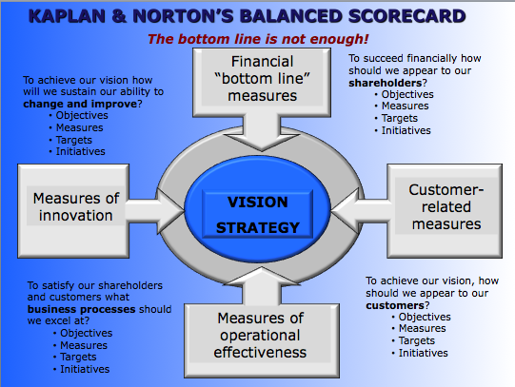

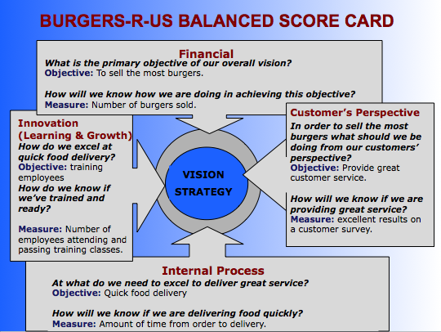

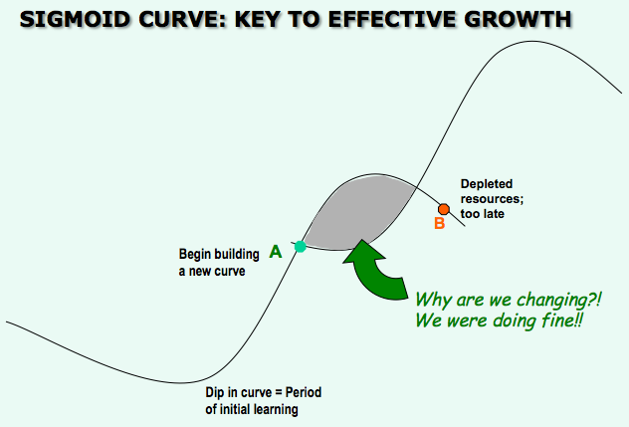

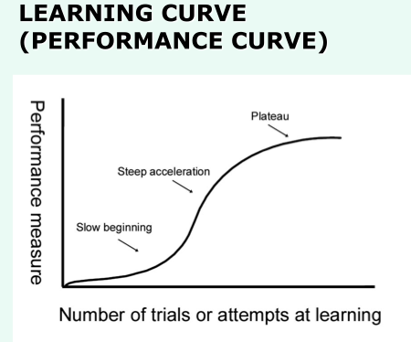

Managing Change

Think of a time when you had a significant change of mind or had to consider making an important move. Model your thought process, and predictors of your successful (or failed) change using the sigmoid curve

-Initial dip in curve

-Point A (and B)

-The second curve

-Shaded area between curves

Mintzberg- The manager’s job: myth and reality

Myths:

-The manager is a reflective, systematic planner

-The effective manager has no regular duties to perform

-The senior manager needs aggregated information, which a formal management information system best provides

-Management is a science and a profession

Realities:

-Managers’ activities are characterized by brevity, variety, and discontinuity. They are strongly oriented to action and dislike reflective activities

-Management works involves performing a number of regular duties, including ritual and ceremony, negotiations and processing of soft information

-Managers strongly favor verbal media, telephone calls, and meeting over documents

-The managers’ programs- to process information and make decisions are not formalized in any computer system, but are located in their brains

Three categories of managerial roles

Interpersonal roles:

-Figurehead

-Leader

-Liaison

Informational roles:

-Monitor

-Disseminator

-Spokesperson

Decision roles:

-Entrepreneur

-Disturbance-handler

-Resource-allocator

-Negotiator

Educating managers: the business case method is the most effective way

Articles for final:
- Wireless Carrier Pigeons
- When Dov Cries
- Cleaning Solutions

