Collins and Porras
A well-conceived vision requires 2 components: Core ideology and envisioned future.
- Core ideology (Values and purpose) : Needs to be inspirational to people inside the organization
-Core values: defines what they stand for
-Core purpose: Why is exists? How does it inspire people? “To solve unsolved problems” “To help leading companies to be more successful”
Core competence: Your company’s capabilities. What it can and cannot do. Unlike Core ideology, competence changes over time.

QUALITY IS NOT A CORE VALUE. Companies do not change core value in case of market change.
- Envisioned future:
- 10-30 year audacious goals (BHAG), has to be realistic but innovative
-vivid descriptions of what it be like to achieve the goal
Bhag: Clear and compelling, thinking beyond capabilities.

Merck’s BHAG: Transforming from a chemical manufacturer to one of the biggest drug companies in the world.

EXAMPLES OF VIVID DESCRIPTION
Henri Ford : “No man will ride horses and everybody, even the poor, will own my cars”

Winston Churchill: “Europe will be free if we stand up to Hitler.”

Core ideology is not business related. Raising our profit by 20% is not a core purpose or a core value.

We’re arrived syndrome: They reached their goals, but they don’t know what to do next.

French and Raven: Social power
5 basis of O`s (other) powers: Reward, Coercive, Legitimate, Referent, Expert

Reward: It can be used as an incentive to increase production

Coercive: P will be punished by O if he fails to conform. Ex: Firing a worker for underperforming.

Legitimate: Ex: In some cultures, a gender or an age group rules. Judge has the right to levy fines, priest preaches. Hierarchy . When O enforces his powers, he will use attractiveness.

Referent: Peer pressure.
Expert: Seeking advice from an expert. Example: Asking a native villager for directions, asking a dietician on diet, etc.

Kaplan and Norton:
Balance scorecard:
How do customers see us (customer) ? What must we excel at (internal)? Can we continue to improve and create value (innovation)? How do we look to shareholders (financial)?
Financial: Results of actions already taken
Operating measures: Customer satisfaction, internal process, innovation and improvement
What does the scorecard do?
It helps companies become customer oriented, shortening response time, improving quality, emphasizing teamwork, reduce product launch time, managing long term.
It also lets managers see if improvement in one area may have been achieved at the expense of another.

Customers: Time, quality, performance and service
Internal aka operational (Where to excel)?: What must be done internally to meet customer`s expectations. Factors that affect cycle time, quality, employee skills and productivity.
Employee`s actions are key to achieve timely goals. Managers need to decompose overall cycle time, quality, product and cost management to ensure that lower level employees have a target for improvement activities, which will contribute company`s overall mission.

Innovation and learning: Can we continue to improve and create value?
Introduce products rapidly, manufacturing improvements. Goal is to achieve manufacturing improvement of new products and not of old existing products.
Financial: How do we look at shareholders?
It has to do with profitability and growth. Critics say it does not necessarily improve customer satisfaction nor quality.

You can improve delivery time, productivity, rate of defects, but that does not necessarily improve a company from a financial perspective.

An excellent set of balanced scorecard measure does not guarantee success.
Companies should specify how improvements in quality, cycle time, delivery time will lead to higher market share, operating margins and asset turnover.

The balance scorecard puts vision and strategy at the center. Balance scorecard helps managers understand interrelationships which leads to improved decision making and problem solving.

Sigmoid curve by Hendy
Point A: There is time and resources to improve before going downhill.

Point B: Going down, resources are depleted, energies are low. For an individual, getting laid off is point B. Company needs to start making changes. Point B means too late.

First curve: Going up

Second curve: Changes made, taking another path. You should always assume that you`re near the peak of the first curve, at point A, and should therefore starting to prepare for second curve. I.E organizations should assume that their present strategies need to be replaced within 2 years. You go on a different direction than your first curve, not repeat it.

Shaded area in curve: Time of confusion. 2 ideas are competing, 2 group of people are in conflict.

Curvilinear logic: Everything in real life is like Sigmoind curve, everything has ups and downs, nothing lasts forever. For curvilinear logic to work, there has to be life beyond the organization for the leaders of the first curve.

Kaizen = continuous improvement

Second curve thinking: generalizing: You have to start planning about the future, look at different scenerios. Generalizations such as: Men don`t care, women are bad leaders, using he as a pronoun back in the day because most workers were men, etc. is not second curve thinking. You don`t deal with the present on second curve, you have to start thinking about scenarios and alternatives.
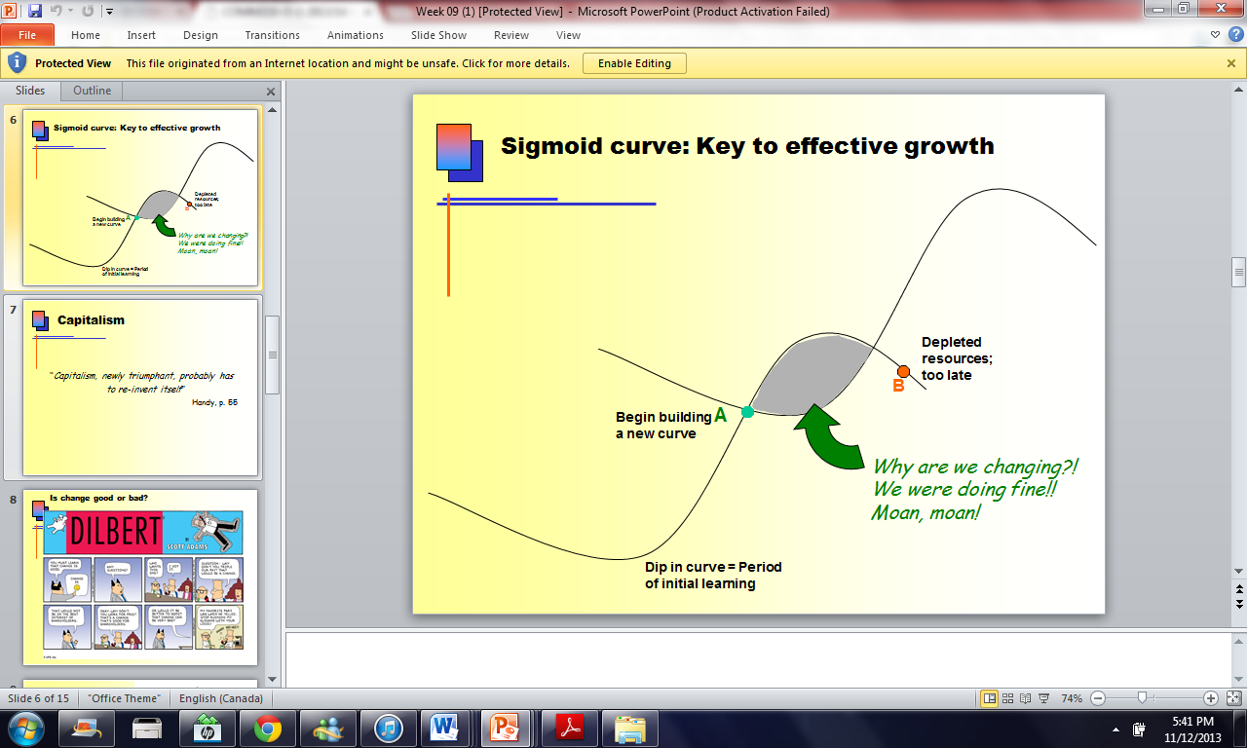

How do you motivate empoyees? Hertzberg KITA= kick in the ass
Negative physical Kita: You directly criticize employees. It can lead the employee to retaliate.

Negative psychological Kita: You criticize the employee indirectly. If he retaliates, he could seem paranoid. It also motivates you, the critic.
Postive Kita: Rewards, dog biscuits. You want to motivate the employee, but you`re not motivating him for himself, but rather for the best of the company.
Myths
Motivated people seek more hours of work, not fewer.
Rising wages doesn`t always motivate. Reducing wages, however could.
Fringe benefits are not motivating employees, they are spoiling them.
Employees sometimes do not appreciate what they are doing.
Although management and employees communicate and understand each other better now compared to the past, it still isn`t a factor to motivate employees.
Making employees feel that they have achieved something doesn`t always motivate them .
Counselling employees does not help them motivate in the job.
The opposite of job satisfaction is not job dissatisfaction, but rather, no job satisfaction. The opposite of job dissatisfaction is not job satisfaction, but rather, no job dissatisfaction.

Hygiene vs Motivators
Motivators are the primary cause of satisfaction (81% according to a study mentioned by Herzberg).
Hygiene is the primary cause of unhappiness at the job according to a study mentioned by Herzberg.
Motivators: achievement, recognition, work itself, responsibility, growth
Hygiene factors (dissatisfactors) : Company policy, supervision, interpersonal relationships, working conditions, salary, status and security

The Motivation-hygiene theory suggests that work be enriched to bring about effective utilization of personnel
Industrial engineers= The industry is organized in a manner where employees can get their work done in a the most efficient way. They believe that humans are economically motivated.
Horizontal job loading:
Management reduces the personal contribution of employees rather than giving them opportunities for growth.
Approaches of horizontal job loading:
-Make employees increase their productivity at the same rate for everyone
-Adding a meaningless task to the routine one
-rotating the assignments of a number of jobs
-subtract the most difficult job

Vertical job loading:
Responsibility and achievement = Removing some controls while retaining accountability
Responsibility and recognition= Increasing the accountability of individuals at work
Responsibility, achievement and recognition = Giving a person a complete natural unit of work (division are and so on)
Responsibility, achievement and recognition = granting additional authority to employees in their activity, job freedom
Internal recognition = making periodic reports directly available to the workers themselves rather than to supervisors
Growth and learning = introducing new and more difficult tasks not previously handled
Responsibility, growth and advancement = assigning individuals to specific or specialized tasks enabling them to become experts.

The vertical job loading was used in an experiment vs control group (people doing their job in a more traditional way). The vertical loading group was more successful in the long run and more happy.
Job enrichment:
- Select jobs, approaching them with the conviction that they can be changed
- Brainstorm possible changes
- Screen to remove hygiene suggestions & horizontal loading
- Avoid direct participation by the employees whose jobs are to be enriched
- Be prepared for an initial drop in performance
- Expect first-line supervisors to experience some anxiety

- Limitations to Herzberg:
  - motivation and hygiene factors are difficult to measure and operationalize
  - worker characteristics affecting response to job enrichment are left out of theory
  - Herzberg leaves out employee involvement in the job enrichment process – lack of congruence in design

Enduring Logic of Industrial success Chandler
Rockefeller’s goal was the cost advantages that could be realized by placing the companies’ refining facilities under a single management.
Thanks to economies of scale (producing a large amount so that the unit per price is lower), the unit cost per gallon dropped.
Bayer used economies of scope (producing different varieties of products) to reduce production costs.
Managerial enterprise: Large industrial concerns in which operating and investment decisions are made by a hierarchy of salaried managers governed by board of directors.
Size alone is not enough to fully exploit cost advantage. They had to create national and international marketing and distribution organizations and had to recruit teams managers (lower, middle and top).
Those who did not make first investments were rarely competitive at home or in international markets or in their industry.

First movers are already established, challengers had to make effort to capture market.
Long term management strategy was to grow by moving into related markets or moving abroad.
Geographic expansion = economies of scale
Moving into relating products = economies of scope
Britain fell in the chemical industry because it failed to make investments in production, distribution and management.
Buying your rivals = lower costs.
The window is closing when making first mover investment. Cease the opportunity while it lasts.
Keiretsu = group of allied, independent companies with their own bank and trading companies
Size does not always guarantee success, it is all about managerial decisions.
Diversification (acquiring a business in which they had few or any managerial capabilities) is a mistake.
More diversification led to more divestiture (selling their operating branches)
FIRST MOVERS ARE NOT INVENTORS. FIRST MOVERS ARE INVESTORS .Often, there is more than one first mover in an industry.

Manager’s Job, Mintzberg
Myth 1: The managers is a systematic planner.
Fact: Managers work at an unrelenting pace.

Myth 2: Managers have no regular duties to perform. Good manager orchestrates everything in advance
Fact: Managers have regular duties to perform, including negotiations and processing soft information that links the organization with its environment.

Myth 3: The senior manager needs aggregated (MIS) information
Fact: Managers prefer verbal media, telephone calls and meeting over documents.

Myth 4: Management is a science and a profession.
Fact: Management is more of a judgement based profession than science.

Management has not changed in 100 years.

- MYTHS:
  - Managers plan, organize, coordinate & control
- REALITIES:
  - Interpersonal roles
    - Figurehead, Leader, Liaison
  - Informational roles
    - Monitor, Disseminator, Spokesperson
  - Decisional roles
    - Entrepreneur, Disturbance-handler,
Resource-allocator, Negotiator

Managerial roles:
- Figurehead= going to weddings, taking someone to lunch
- Leader = hiring and training staff
- Liaison = Making outside contact
- Monitor = What your subordinates are doing, getting information
- Disseminator = Passing information to subordinates
- Spokesperson= Sending information to external parties
- Entrepreneur = How to improve the unit
- Disturbance-handler = responding to problems
- Resource-allocator = Who will get what , time is an important resource, how work is divided
- Negotiator

Manager’s effectiveness is significantly influenced by their insight into their own work.

Problems:
-The manager is challenged to find systematic ways to share privileged info.

Schools have not trained managers. There is too much theory and not enough practice.

1. Share my experience & special skills
2. Tell them that they have commitments to meet
3. Give them tough, undesirable jobs to do
4. Make them feel like I approve of them
5. Make them feel important
6. Give them a good peer evaluation
7. Provide good technical suggestions
8. Make them recognize they have tasks to accomplish
9. Provide them with special benefits
10. Make things unpleasant for them
11. Influence their getting a pay increase
12. Make them feel they have commitments to meet
13. Make the work difficult for them
14. Provide them with good task-related advice
15. Make them feel personally accepted

Building deep supplier relationship Liker and Choi
Keiretsu = Close-knit networks of vendors that continuously learn, improve, and prosper along with parent company.
Toyota and Honda had joint ventures within suppliers. The better performing supplier would get the larger contract.
- Companies should build long lasting mutually beneficial relationships with suppliers based on:
  - Collaboration
  - Respect
  - Co-prosperity
- The underlying values are:
  - Trust, Improvement, Empathy and Discipline

Hierarchy
- Conduct joint improvement activities
Devoting more time into training. The aim is to open communication channels and create relationships.
- Share information intensively but selectively
Toyota and Honda believe that sharing a lot of information with everyone ensures that no one will receive the right information when it’s needed.
- Develop suppliers’ technical capabilities
Honda and Toyota don’t have many suppliers in India and China because they believe that technical capability is more important than cost.
- Supervise your suppliers
In Japan, if suppliers can’t find solutions to problems, manufacturers help.
- Turn supplier rivalry into opportunity
US manufacturers would turn vendors against each other, and then do business with the last supplier standing. Japanese manufacturers encourages collaboration within the rivalry.

- Understand how your suppliers work

Greiner: Evolution and revolution
Managerial problems and practices are rooted in time. They do not last throughout the life of an organization.

Creativity: Birth of the organization -> Crisis of leadership: Who will lead the company? -> Direction-> Crisis of autonomy-> Delegation -> Crisis of control -> Coordination -> Red tape crisis: Organization is too large and complex -> Collaboration: More flexible approach to management

Growing stage of companies last 3 to 15 years.

Many managers leave not because they are bad, but they don’t fit with the organization’s culture.

DYER:
SPAARC= Sufficiency (number) , Precision (using %) , Accuracy, Authority, Representativeness (is there a bias in stats? ) , Clarity (what do these numbers mean??)

Underlying assumptions= assuming
Value assumption = Assumption based on your values ex: war is wrong
Reality assumption = assumptions that are determined by logic ex: Athletes require a lot of training
Causal claim = What causes what? Ex: A tornado forced Japan to rebuild.
- Causal explanation = Author’s interpretation of cause & effect relationships
- Rival causes: The same evidence can be consistent with different interpretations

Techniques of persuasion:
- Limit claims you cannot rebut
  - Acknowledging limitations makes your writing MORE persuasive
    - Limits to generalizations
    - Level of probability less than 100%
    - Re-defining terms
- Rhetoric – use of language to convince
  - Detail (evidence and assumptions)
  - Tone (scholarly vs. narrative)
  - Vividness (being concrete draws attention)

  - Anticipate objections based on
    - negative evidence
    - alternative causes
    - conflicting assumptions
  - Counter-argue objections

Writing a persuasive essay:
- Outline your (contestable) claim and sub-claims
  - Ask yourself: “Why do I think this claim is true?” List reasons
  - Logic of your argument must be crystal clear
- Arrange your evidence
  - 2-3 pieces of evidence for each sub-claim (sufficient; accurate)
    - Views of experts; Quotes from interviews (authoritative; precise)
    - Statistics (precise)
    - Examples from your own experience, diverse variety of others (representative)
    - Detailed descriptions / background information (precise)
  - Give each section of your essay a meaningful subtitle (clear)
  - Any negative evidence? Do you anticipate readers’ objections? Do you need more evidence?
- Write your first draft
  - Don’t try for perfection the first time
    - The DOWN draft and the UP draft
  - Be careful not to plagiarize!!!
- Revise your work
  - Team contributions have to be integrated – similar style
  - Write your introductory sentences – engage the reader’s interest and attention
  - Write your concluding sentences – a strong ending tells people what they have learned
  - Add visual aids (charts, photos, clipart, concept maps)
- Full list of references
- “Writing to change the world” (Mary Pipher)
  - Writing can make a difference in the world
  - Promote broad discussion of a topic you are passionate about
- Persuasive writing, NOT propaganda
  - Propaganda wants passive agreement; tells people what to think
  - Persuasive writing for change expands the readers’ knowledge so that they see the world more accurately
    - Include questions, contradictory evidence, alternate viewpoints
  - Create a story that makes readers care about the issue – vivid descriptions of the experiences of real people
  - “Passionate and well-articulated ideas can and do change the world for better or worse” (Pipher, p. 9)

FINAL NOTE: CALL IT BARNEY’S THEORY ON SUSTAINED COMPETITIVE ADVANTAGE ON THE EXAM!!!!!!!

