Multiple choices 80 questions 1 mark each
Short answer question 20% (1 or 2 questions)

Exam is two hours

Exam is from Product Chapter (chap 8) to Global Chapter (chap 16)
Chapter 17 is not examinable
Retail Chapter don’t expend to much time

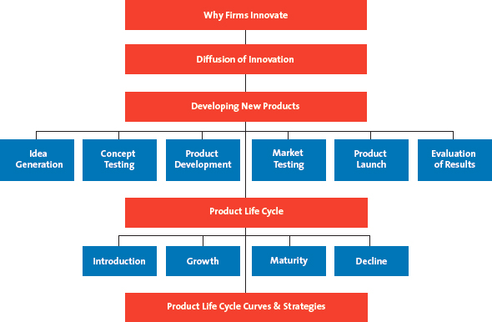
Chapter 8
Product: Anything that is of value to a consumer and can be offered through a marketing exchange.

Why Do Firms Create New Products?
New market offerings provide value to both firms and customers. new product,” we don't necessarily mean that the product has never existed before; completely new-to-the-market products represent fewer than 10 percent of all new product introductions each year.
Innovation: The process by which ideas are transformed into new products and services that will help firms grow.
Although innovation strategies may not work in the short run—some estimates indicate that only about 3 % of new products actually succeed

Changing Customer Needs
When they add new products to their offerings, firms can create and deliver value more effectively by satisfying the changing needs of their current and new customers or simply by keeping customers from getting bored with the current product or service offering
For example, Unilever's Dove Beauty Bar product line successfully extended the brand into hair, face, and skin-care lines, all under the Dove umbrella.

Market Saturation
The longer a product exists in the marketplace, the more likely it is that the market will become saturated. Without new products or services, the value of the firm will ultimately decline.

Managing Risk Through Diversity
Through innovation, firms often create a broader portfolio of products, which helps them diversify their risk and enhance firm value better than a single product can. If some products in a portfolio are doing poorly, others may be doing well. Firms with multiple products are better able to withstand external shocks, including changes in consumer preferences or intensive competitive activity. For example: 3M and Kellogg’s

Fashion Cycles
In industries that rely on fashion trends and experience short product life cycles—including apparel, arts, books, and software—most sales come from new products. Consumers of computer software and video games demand new products in much the same way that fashion mavens demand new apparel styles.

Innovation and Value
New product introductions, especially new-to-the-world products that create new markets, can add tremendous value to firms.
- Pioneers: New product introductions that establish a completely new market or radically change both the rules of competition and consumer preferences in a market; also called breakthroughs.

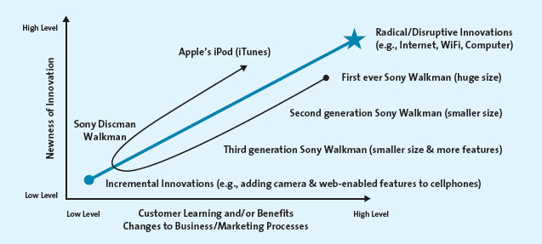
- First movers: Product pioneers that are the first to create a market or product category, making them readily recognizable to consumers and thus establishing a commanding and early market share lead.
Consumers used the Sony Walkman for mobile music, which required them to buy and carry tapes or CDs. Apple's iPod eliminated the need for CDs with its iTunes service—a radically new service associated with a digital mobile device
Studies also have found that market pioneers can command a greater market share over a longer time period than later entrants can. This finding does not imply, however, that all pioneers succeed. In many cases, imitators capitalize on the weaknesses of pioneers and subsequently gain advantage in the market.

Adoption of Innovation
The process by which the use of an innovation—whether a product or a service—spreads throughout a market group.

Diffusion of innovation: The process by which the use of an innovation, whether a product or a service, spreads throughout a market group over time and over various categories of adopters.
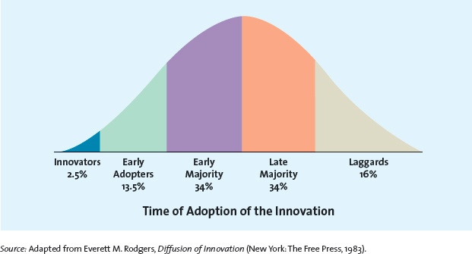
- Innovators: Those buyers who want to be the first to have the new product or service.
These buyers enjoy taking risks, are regarded as highly knowledgeable, and are not price sensitive. These innovators are crucial to the success of any new product or service because they help the product gain market acceptance.

- Early adopters: The second group of consumers in the diffusion of innovation model, after innovators, to use a product or service innovation; generally don't like to take as much risk as innovators but instead wait and purchase the product after careful review.
- Early majority: A group of consumers in the diffusion of innovation model that represents approximately 34% of the population; members don't like to take much risk and therefore tend to wait until bugs are worked out.

- Late majority: The last group of buyers to enter a new product market. When they do, the product has achieved its full market potential and sales tend to level off or may be in decline.

- Laggards: Consumers who like to avoid change and rely on traditional products until they are no longer available. In some cases, laggards may never adopt a certain product or service.

Using the Adoption Cycle
Firms can predict which types of customers will buy their new product or service immediately after its introduction, as well as later as the product gets more and more accepted by the market. With this knowledge, the firm can develop effective promotion, pricing, and other marketing strategies to push acceptance among each customer group.
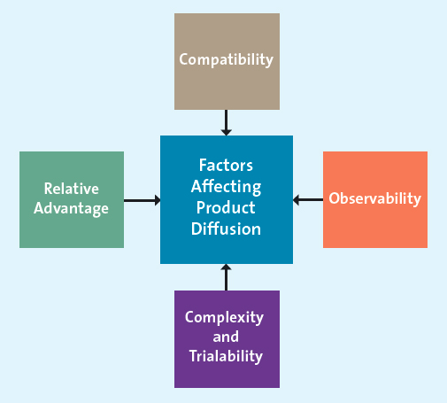

- Relative Advantage: If a product is perceived to be better than substitutes, then the diffusion will be relatively quick.

- Compatibility: Most business professionals and executives have to make decisions in a timely fashion and be able to communicate their decisions in a timely manner also; they need real-time information to do this

- Observability: The ubiquitous Starbucks logo can be easily seen on cups in and around Starbucks stores. On the one hand, when products are easily observed, their benefits or uses are easily communicated to others, thus enhancing the diffusion process

- Complexity and Trialability: Products that are relatively less complex are also relatively easy to try. These products will generally diffuse more quickly than those that are not.

How Firms Develop New Products
The new product development process begins with the generation of new product ideas and culminates in the launch of the new product and the evaluation of its success. Marketing plays a crucial role in the new product development process by communicating customer needs and wants and marketplace preferences and attitudes to the research and development (R&D) and engineering group

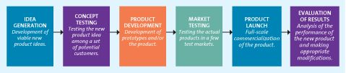

Idea Generation
To generate ideas for new products, a firm can use its own internal R&D efforts, collaborate with other firms and institutions, license technology from research-intensive firms, brainstorm, research competitors' products and services, and/or conduct consumer research
Sometimes new product ideas come from employees, customers, suppliers, and partners or are generated by attending trade shows and conferences.

Internal Research and Development
Many firms have their own R&D departments, in which scientists work to solve complex problems and develop new ideas. The product development costs for firms are quite high, and the resulting new product or service has a good chance of being a technological or market breakthrough.

Licensing
For many new scientific and technological products, firms buy the rights to use the technology or ideas from other research-intensive firms through a licensing agreement. This approach saves the high costs of in-house R&D, but it means that the firm is banking on a solution that already exists but has not been marketed.

Brainstorming
Firms often engage in brainstorming sessions during which a group works together to generate ideas. One of the key characteristics of a brainstorming session is that no idea can be immediately accepted or rejected.

Competitors' Products
A new product entry by a competitor may trigger a market opportunity for a firm, which can use reverse engineering to understand the competitor's product and then bring an improved version to market.
- Reverse engineering: Involves taking apart a competitor's product, analyzing it, and creating an improved product that does not infringe on the competitor's patents, if any exist. For example: China

Customer Input
Listening to the customer is essential for successful idea generation. Prior studies have found that as much as 85 percent of all new business-to-business (B2B) product ideas come from customers. For example: Starbucks
- Lead users: Innovative product users who modify existing products according to their own ideas to suit their specific needs.

Concept Testing
- Concepts: Brief written descriptions of a product or service; its technology, working principles, and forms; and what customer needs it would satisfy.
- Concept testing: The process in which a concept statement that describes a product or a service is presented to potential buyers or users to obtain their reactions.
Some concepts never make it past this stage, particularly if respondents seem uninterested. Those that do receive high evaluations from potential consumers, however, move on to the next step, product development.

Product Development
Product development: Entails a process of balancing various engineering, manufacturing, marketing, and economic considerations to develop a product; also called product design.
Product design: See product development.
Prototype: The first physical form or service description of a new product, still in rough or tentative form, that has the same properties as a new product but is produced through different manufacturing processes, sometimes even crafted individually.
Alpha testing: An attempt by the firm to determine whether a product will perform according to its design and whether it satisfies the need for which it was intended; occurs in the firm's R&D department.
Beta testing: Having potential consumers examine a product prototype in a real-use setting to determine its functionality, performance, potential problems, and other issues specific to its use.

Market Testing
The firm has developed its new product or service and tested the prototypes. Now it must test the market for the new product with a trial batch of products; although, as mentioned earlier, companies sometimes skip this step because of competitive, timing, or cost pressures.
- Premarket test: Conducted before a product or service is brought to market to determine how many customers will try and then continue to use it.
- Test marketing: Introduces a new product or service to a limited geographical area (usually a few cities) prior to a national launch.

Product Launch
If the market testing returns with positive results, the firm is ready to introduce the product to the entire market. For example: Frito Lays (Curry and Wasabi Chips in Vancouver and Toronto)

Promotion
The test results help the firm determine an appropriate integrated marketing communications strategy.⁴⁶ For products that are somewhat complex or conceptually new, marketers may need to provide for more consumer education about the product's benefits than they would for simpler and more familiar products.

Place
The firm must have an adequate quantity of products available for shipment and to keep in stock at relevant stores. The product offering should also be as complete as possible.

Price
The firm needs to ensure that it gets the price right. It is sometimes easier to start with a higher price and offer promotions (e.g., coupons, rebates) and then over time to lower the price than it is to introduce the new product at a low price and then try to raise it.

Timing
The timing of the launch may be important, depending on the product. For example: Hollywood launch new titles before the summer.

Evaluation of Results
After the product has been launched, marketers must undertake a critical postlaunch review to determine whether the product and its launch were a success or a failure and what additional resources or changes to the marketing mix are needed, if any. Firms measure the success of a new product by three interrelated factors: (1) its satisfaction of technical requirements, such as performance; (2) customer acceptance; and (3) its satisfaction of the firm's financial requirements, such as sales and profits.

The Product Life Cycle
Product life cycle: Defines the stages that new products move through as they enter, get established in, and ultimately leave the marketplace and thereby offers marketers a starting point for their strategy planning.
- Introduction stage: Stage of the product life cycle when innovators start buying the product.
- Growth stage: Stage of the product life cycle when the product gains acceptance, demand and sales increase, and competitors emerge in the product category.
- Maturity stage: Stage of the product life cycle when industry sales reach their peak, so firms try to rejuvenate their products by adding new features or repositioning them.
- Decline stage: Stage of the product life cycle when sales decline and the product eventually exits the market.
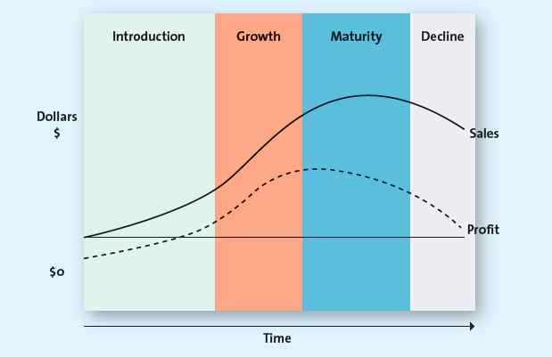

Characteristics of Different Stages of the Product Life Cycle
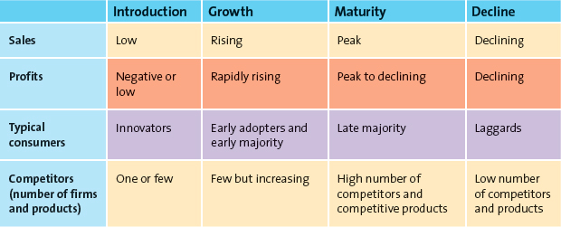

Introduction Stage
The introduction stage for a new, innovative product or service usually starts with a single firm, and innovators are the ones to try the new offering. For example: Telephone (Bell), Walkman (Sony), iTunes (Apple), RIM(BlackBerry)

BIM introducing strategy
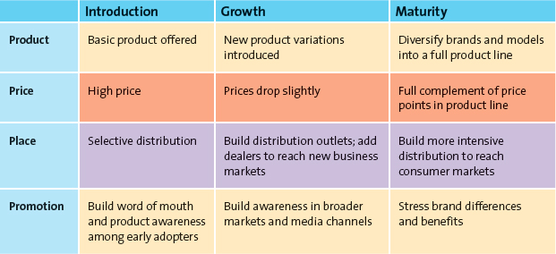

Growth Stage
The growth stage of the product life cycle is marked by a growing number of product adopters, rapid growth in industry sales, and increases in both the number of competitors and the number of available product versions. The market becomes more segmented and consumer preferences more varied, which increases the potential for new markets or new uses of the product or service.
Also during the growth stage, firms attempt to reach new consumers by studying their preferences and producing different product variations—varied colours, styles, or features

Maturity Stage
The maturity stage of the product life cycle is characterized by the adoption of the product by the late majority and intense competition for market share among firms. Marketing costs (e.g., promotion, distribution) increase as these firms vigorously defend their market share against competitors. At the same time, they face intense competition on price as the average price of the product falls substantially compared with the shifts during the previous two stages of the life cycle.
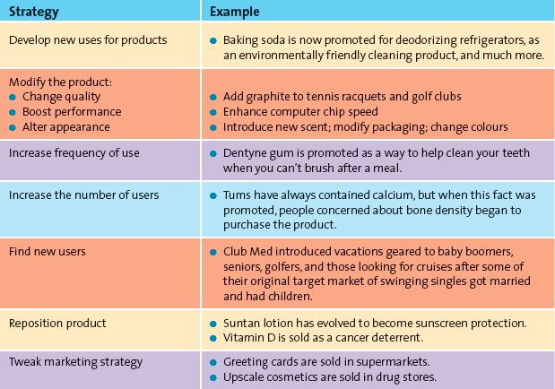

Entry into New Markets or Market Segments
Because the market is saturated at this point, firms may attempt to enter new geographical markets, including international markets, that may be less saturated.

Development of New Products
Despite market saturation, firms continually introduce new products with improved features or find new uses for existing products because they need constant innovation and product proliferation to defend market share during intense competition.

Decline Stage
Firms with products in the decline stage either position themselves for a niche segment of diehard consumers or those with special needs, or they completely exit the market. The few laggards who have not yet tried the product or service enter the market at this stage.

The Shape of the Product Life Cycle Curve
In theory, the product life cycle curve is assumed to be bell-shaped with regard to sales and profits. In reality, however, each product or service has its own individual shape; some move more rapidly through their product life cycles than others, depending on how different the product or service is from products currently in the market and how valuable it is to the consumer.

Variations on the Product Life Cycle Curve
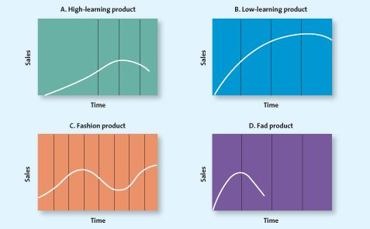

Strategies Based on Product Life Cycle: Some Caveats
The most challenging part of applying the product life cycle concept is that managers do not know exactly what shape each product's life cycle will take, so there is no way to know precisely what stage a product is in.

Chapter 11
Price is the only element of the marketing mix that generates revenue.

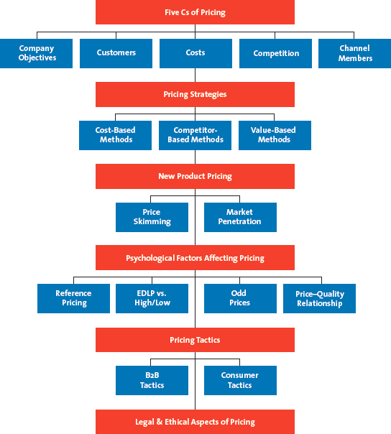

The Five Cs of Pricing
Successful pricing strategies are built through the five critical components: company objectives, customers, costs, competition, and channel members
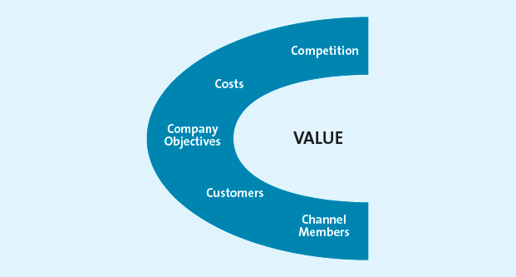

Company Objectives
By now, you know that different firms embrace different goals. Walmart, for example, wants to be seen as a value-based company and so uses every day low pricing (EDLP), whereas Holt Renfrew's high prices reflect its high-fashion image. Each firm then embraces an objective that seems to fit with where management thinks the firm needs to go to be successful, in whatever way they define success. These specific objectives usually reflect how the firm intends to grow.

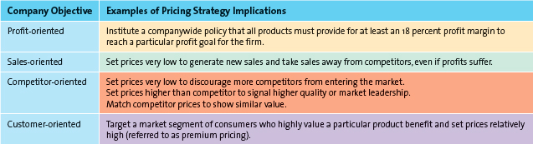

Profit orientation
A company objective that can be implemented by focusing on target profit pricing, maximizing profits, or target return pricing.
- Target profit pricing: A pricing strategy implemented by firms when they have a particular profit goal as their overriding concern; uses price to stimulate a certain level of sales at a certain profit per unit.
- Maximizing profits strategy: A mathematical model that captures all the factors required to explain and predict sales and profits, which should be able to identify the price at which its profits are maximized.
- Target return pricing: A pricing strategy implemented by firms less concerned with the absolute level of profits and more interested in the rate at which their profits are generated relative to their investments; designed to produce a specific return on investment, usually expressed as a percentage of sales.

Sales orientation
A company objective based on the belief that increasing sales will help the firm more than will increasing profits.

Competitor orientation
A company objective based on the premise that the firm should measure itself primarily against its competition.
- Competitive parity: A firm's strategy of setting prices that are similar to those of major competitors.

Customer orientation
Pricing orientation that explicitly invokes the concept of customer value and setting prices to match consumer expectations.

Customers
The second C of the five Cs of pricing is the most important because it is about understanding consumers' reactions to different prices. Consumers want value, and as you may recall, price is half of the value equation.

Demand Curves and Pricing
- Demand curve: Shows how many units of a product or service consumers will demand during a specific period at different prices.
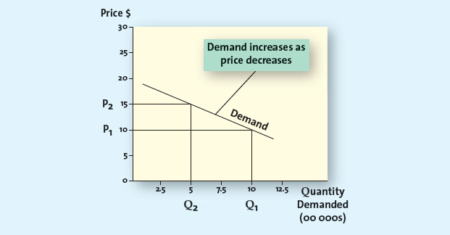
- Prestige products or services: Those that consumers purchase for status rather than functionality.
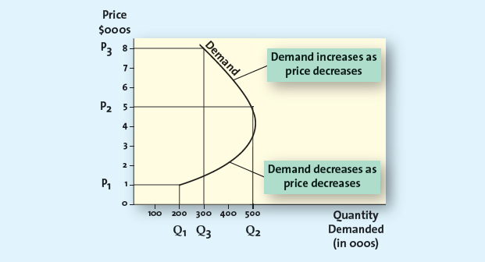

Price Elasticity of Demand
Although we now know something about how consumers react to different price levels, we still need to determine how consumers respond to actual changes in price. Consumers are generally less sensitive to price increases for necessary items, such as milk, because they have to purchase these items even if the price climbs.
- Price elasticity of demand: Measures how changes in a price affect the quantity of the product demanded; specifically, the ratio of the percentage change in quantity demanded to the percentage change in price.
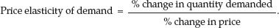
- Elastic: Refers to a market for a product or service that is price sensitive; that is, relatively small changes in price will generate fairly large changes in the quantity demanded.
- Inelastic: Refers to a market for a product or service that is price insensitive; that is, relatively small changes in price will not generate large changes in the quantity demanded.

Factors Influencing Price Elasticity of Demand
We have illustrated how price elasticity of demand varies across different products and at different points along a demand curve, as well as how it can change over time.

Income effect: Generally, as people's income increases, their spending behaviour changes: They tend to shift their demand from lower-priced products to higher-priced alternatives
- Income effect: Refers to the change in the quantity of a product demanded by consumers because of a change in their income.

Substitution effect: Refers to consumers' ability to substitute other products for the focal brand, thus increasing the price elasticity of demand for the focal brand.
The greater the availability of substitute products, the higher the price elasticity of demand for any given product will be.
Keep in mind that marketing plays a critical role in making consumers brand loyal, making the price elasticity of demand for some brands very low

Cross-price elasticity: The percentage change in demand for Product A that occurs in response to a percentage change in price of Product B; see complementary products.
- Complementary products: Products whose demand curves are positively related, such that they rise or fall together; a percentage increase in demand for one result in a percentage increase in demand for the other.

- Substitute products: Products for which changes in demand are negatively related—that is, a percentage increase in the quantity demanded for Product A results in a percentage decrease in the quantity demanded for Product B.

Costs
To make effective pricing decisions, firms must understand their cost structures so they can determine the degree to which their products or services will be profitable at different prices. In general, prices should not be based on costs because consumers make purchase decisions based on their perceived value

- Variable costs: Those costs, primarily labour and materials, which vary with production volume.
CD example, the variable costs include the labour needed to burn each CD; the costs of the blank CDs, jewel cases, and labels; and royalties paid to the artist. Each of these costs is incurred each time the producer makes a new CD.

- Fixed costs: Those costs that remain essentially at the same level, regardless of any changes in the volume of production.
Typically, these costs include items such as rent, utilities, insurance, administrative salaries (for executives and higher-level managers), and the depreciation of the physical plant and equipment.

- Total cost: The sum of the variable and fixed costs

Break-Even Analysis and Decision Making
- Break-even point: The point at which the number of units sold generates just enough revenue to equal the total costs; at this point, profits are zero.

How do we determine the break-even point? Although profit, which represents the difference between the total cost and the total revenue (total revenue or sales = selling price of each unit sold × number of units sold)

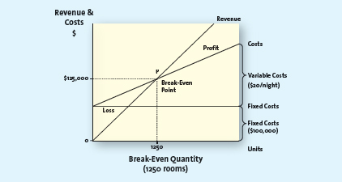

- Contribution per unit: Equals the price less the variable cost per unit; variable used to determine the break-even point in units.

Competition
Because the fourth C, competition, has a profound impact on pricing strategies,12 we use this section to focus on its effect, as well as on how competitors react to certain pricing strategies.

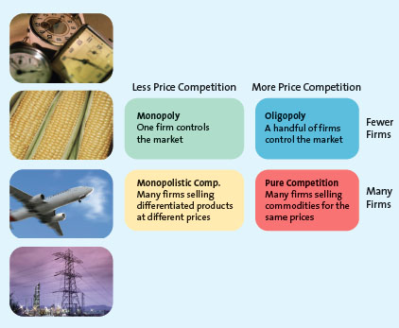
- Monopoly: Occurs when only one firm provides the product or service in an particular industry.
- Oligopolistic competition: Occurs when only a few firms dominate a market.
- Price war: Occurs when two or more firms compete primarily by lowering their prices.
- Monopolistic competition: Occurs when many firms sell closely related but not homogeneous products; these products may be viewed as substitutes but are not perfect substitutes.
- Pure competition: Occurs when different companies sell commodity products that consumers perceive as substitutable; price usually is set according to the laws of supply and demand.

Channel Members
Channel members—manufacturers, wholesalers, and retailers—can have different perspectives when it comes to pricing strategies. Consider a manufacturer that is focused on increasing the image and reputation of its brand but working with a retailer that is primarily concerned with increasing its sales.
- Grey market: Employs irregular but not necessarily illegal methods; generally, it legally circumvents authorized channels of distribution to sell goods at prices lower than those intended by the manufacturer.

Other Influences on Pricing

The Internet
The shift among consumers to acquiring more and more products, services, and information online has made them more price sensitive and opened new categories of products to those who could not access them previously.

Economic Factors
Two interrelated trends that have merged to impact pricing decisions are the increase in consumers' disposable income and status consciousness. Some consumers appear willing to spend money for products that can convey status in some way.

- Cross-shopping: The pattern of buying both premium and low-priced merchandise or patronizing both expensive, status-oriented retailers and price-oriented retailers.

On a more local level, the economy still can influence pricing. Competition, disposable income, and unemployment all may signal the need for different pricing strategies.

Pricing Strategies
Coming up with the “right” price is never easy. Firms embrace different objectives, face different market conditions, and operate in different manners; thus, they employ unique pricing strategies that seem best for the particular set of circumstances in which they find themselves.

Cost-Based Methods
- Cost-based pricing method: Determines the final price to charge by starting with the cost, without recognizing the role that consumers or competitors' prices play in the marketplace.

Competitor-Based Methods
- Competitor-based pricing method: An approach that attempts to reflect how the firm wants consumers to interpret its products relative to the competitors' offerings.
- Premium pricing: A competitor-based pricing method by which the firm deliberately prices a product above the prices set for competing products to capture those consumers who always shop for the best or for whom price does not matter.

Value-Based Methods
- Value-based pricing method: An approach that focuses on the overall value of the product offering as perceived by consumers, who determine value by comparing the benefits they expect the product to deliver with the sacrifice they will need to make to acquire the product.

Improvement Value Method
- Improvement value: Represents an estimate of how much more (or less) consumers are willing to pay for a product relative to other comparable products.

Cost of Ownership Method
- Cost of ownership method: A value-based method for setting prices that determines the total cost of owning the product over its useful life.
For example: Consider, for example, that an energy-efficient fluorescent light bulb costs $3 and is expected to last 6000 hours. Alternatively, a conventional light bulb costs $1 but its average life is only 1500 hours. Even though the fluorescent bulb is expected to last four times longer than a conventional bulb, it costs only three times as much.

Although value-based pricing strategies can be quite effective, they also necessitate a great deal of consumer research to be implemented successfully. Sellers must know how consumers in different market segments will attach value to the benefits delivered by their products. They also must account for changes in consumer attitudes because the way customers perceive value today may not be the way they perceive it tomorrow.

New Product Pricing
Developing pricing strategies for new products is one of the most challenging tasks a manager can undertake.
When the new product is just another “me-too” product, similar to what already appears on the market, this job is somewhat easier. But when the product is truly innovative, or what we call “new to the world,” determining consumers' perceptions of its value and pricing it accordingly becomes far more difficult.

Price Skimming
- Price skimming: A strategy of selling a new product or service at a high price that innovators and early adopters are willing to pay to obtain it; after the high-price market segment becomes saturated and sales begin to slow down, the firm generally lowers the price to capture (or skim) the next most price-sensitive segment.
This process can continue until the demand for the product has been satisfied, even at the lowest price points. Luxury products are often an exception.

For price skimming to work, the product or service must be perceived as breaking new ground in some way, offering consumers new benefits currently unavailable in alternative products
For a skimming pricing strategy to be successful, competitors cannot be able to enter the market easily; otherwise, price competition will likely force lower prices and undermine the whole strategy.

Market Penetration Pricing
- Market penetration pricing: A pricing strategy of setting the initial price low for the introduction of the new product or service, with the objective of building sales, market share, and profits quickly.
- Experience curve effect: Refers to the drop in unit cost as the accumulated volume sold increases; as sales continue to grow, the costs continue to drop, allowing even further reductions in the price.
First, the firm must have the capacity to satisfy a rapid rise in demand—or at least be able to add that capacity quickly. Second, low price does not signal high quality. Of course, a price below their expectations decreases the risk for consumers to purchase the product and test its quality for themselves. Third, firms should avoid a penetration pricing strategy if some segments of the market are willing to pay more for the product; otherwise, the firm is just “leaving money on the table.”

Psychological Factors Affecting Value-Based Pricing Strategies
When consumers are exposed to a price, they assign meaning to it by placing it into a category, such as “expensive,” “a deal,” “cheap,” “overpriced,” or even “fair.”

Consumers' Use of Reference Prices
- Reference price: The price against which buyers compare the actual selling price of the product and that facilitates their evaluation process.

- External reference price: A higher price to which the consumer can compare the selling price to evaluate the purchase.
Typically, the seller labels the external reference price as the “regular price” or an “original price.” When consumers view the “sale price” and compare it with the provided external reference price, their perceptions of the value of the deal will likely increase.

- Internal reference price: Price information stored in the consumer's memory that the person uses to assess a current price offering—perhaps the last price he or she paid or what he or she expects to pay

Everyday Low Pricing (EDLP) Versus High/Low Pricing
- Everyday low pricing (EDLP): A strategy companies use to emphasize the continuity of their retail prices at a level somewhere between the regular, nonsale price and the deep-discount sale prices their competitors may offer.
- High/low pricing : A pricing strategy that relies on the promotion of sales, during which prices are temporarily reduced to encourage purchases.

Odd Prices
- Odd prices: Prices that end in odd numbers, usually 9, such as $3.99.

The Price–Quality Relationship
Consumers rely on price to judge quality. When consumers know the brands, have had experience with the products, or have considerable knowledge about how to judge the quality of products objectively, price becomes less important. For example Italian Dinner and beans!

Pricing Tactics
It is important to distinguish clearly between pricing strategies and pricing tactics. A pricing strategy is a long-term approach to setting prices broadly in an integrative effort (across all the firm's products) based on the five Cs (company objectives, customers, costs, competition, and channel members) of pricing.
- Pricing tactics: Short-term methods, in contrast to long-term pricing strategies, used to focus on company objectives, customers, costs, competition, or channel members; can be responses to competitive threats (e.g., lowering price temporarily to meet a competitor's price reduction) or broadly accepted methods of calculating a final price for the customer that is short term in nature.

Business-to-Business Pricing Tactics and Discounts
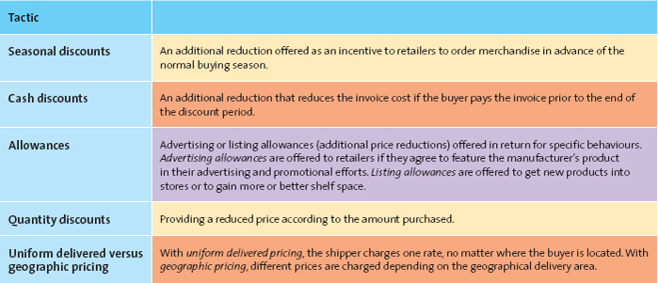

Seasonal discount:
Pricing tactic of offering an additional reduction as an incentive to retailers to order merchandise in advance of the normal buying season.

Cash discount:
- Tactic of offering a reduction in the invoice cost if the buyer pays the invoice prior to the end of the discount period.

Allowance:
- Advertising allowance: Tactic of offering a price reduction to channel members if they agree to feature the manufacturer's product in their advertising and promotional efforts.
- Listing allowances: Fees paid to retailers simply to get new products into stores or to gain more or better shelf space for their products.

Quantity discount:
- Pricing tactic of offering a reduced price according to the amount purchased; the more the buyer purchases, the higher the discount and, of course, the greater the value.
- Cumulative quantity discount: Pricing tactic that offers a discount based on the amount purchased over a specified period and usually involves several transactions.
- Noncumulative quantity discount: Pricing tactic that offers a discount based on only the amount purchased in a single order.

Uniform Delivered Versus Geographic Pricing
- Uniform delivered pricing: The shipper charges one rate, no matter where the buyer is located.

- Geographic pricing: The setting of different prices depending on a geographical division of the delivery areas.

Pricing Tactics Aimed at Consumers
When firms sell their products and services directly to consumers, rather than to other businesses, the pricing tactics they use naturally differ.

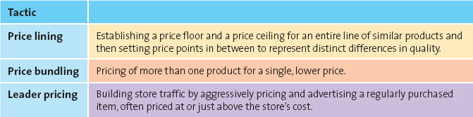
- Price lining: Consumer market pricing tactic of establishing a price floor and a price ceiling for an entire line of similar products and then setting a few other price points in between to represent distinct differences in quality.

- Price bundling: Consumer pricing tactic of selling more than one product for a single, lower price than what the items would cost sold separately; can be used to sell slow-moving items, to encourage customers to stock up so they won't purchase competing brands, to encourage trial of a new product, or to provide an incentive to purchase a less desirable product or service to obtain a more desirable one in the same bundle.

- Leader pricing: Consumer pricing tactic that attempts to build store traffic by aggressively pricing and advertising a regularly purchased item, often priced at or just above the store's cost.

Consumer Price Reductions
The final price a customer pays for a product or service often has been adjusted from the original price because marketers have used various techniques designed to enhance value.

Markdowns
Reductions retailers take on the initial selling price of the product or service.

Quantity Discounts for Consumers
Size discount: The most common implementation of a quantity discount at the consumer level; the larger the quantity bought, the less the cost per unit (e.g., per gram).

Seasonal Discounts
Seasonal discounts are price reductions offered on products and services to stimulate demand during off-peak seasons

Coupons and Rebates
Coupon: Provides a stated discount to consumers on the final selling price of a specific item; the retailer handles the discount.

Rebate: A consumer discount in which a portion of the purchase price is returned to the buyer in cash; the manufacturer, not the retailer, issues the refund.

Legal and Ethical Aspects of Pricing
Prices tend to fluctuate naturally and respond to varying market conditions. Thus, though we rarely see firms attempting to control the market in terms of product quality or advertising, they often engage in pricing practices that can unfairly reduce competition or harm consumers directly through fraud and deception

Deceptive or Illegal Price Advertising
Although it is always illegal and unethical to lie in advertising, a certain amount of “puffery” is typically allowed. But price advertisements should never deceive consumers to the point of causing harm.

Deceptive Reference Prices
If the reference price is bona fide, the advertisement is informative. If the reference price has been inflated or is just plain fictitious, however, the advertisement is deceptive and may cause harm to consumers.

Loss Leader Pricing
Loss leader pricing takes the tactic of leader pricing one step further by lowering the price below the store's cost

Bait and Switch
Bait and switch: A deceptive practice of luring customers into the store with a very low advertised price on an item (the bait), only to aggressively pressure them into purchasing a higher-priced item (the switch) by disparaging the low-priced item, comparing it unfavourably with the higher-priced item, or professing an inadequate supply of the lower-priced item.

Predatory Pricing
Predatory pricing: A firm's practice of setting a very low price for one or more of its products with the intent of driving its competition out of business; illegal under the Competition Act.

Price Discrimination
Price discrimination: The practice of selling the same product to different resellers (wholesalers, distributors, or retailers) or to the ultimate consumer at different prices; some, but not all, forms of price discrimination are illegal.

Price fixing
The practice of colluding with other firms to control prices.
- Horizontal price fixing: Occurs when competitors that produce and sell competing products collude, or work together, to control prices, effectively taking price out of the decision process for consumers.

- Vertical price fixing: Occurs when parties at different levels of the same marketing channel (e.g., manufacturers and retailers) collude to control the prices passed on to consumers.

