The Paradigms of Health

Reductionism and Holism

- Reductionist method entails the breakdown of an entity (the human body) to its most fundamental parts (systems)
      - Macroscopic to microscopic (biomedical model of health)
      - Neurology, immunology, endocrinology, pathology, physiology, etc.

- Rationale: understanding these mechanisms should allow us to heal the body when one or more of these systems deviate from the norm (disease or illness of the body)

- Mechanistic, systems approach
      - Evidenced by biotechnology, advanced surgical methods, pharmaceutical intervention, etc.
      - Invasive (bombards a specific system)
      - Tertiary health (treatment is the cornerstone)
      - Deals with symptoms (origins of disease)

- The inherent challenge: this paradigm disempowers the individual
      - The individual loses the sense of having autonomy (control) of their body and well-being

- Holistic method entails the synthesis of the entire entity (the human body), including the surrounding environment in which it interacts
  - Microscopic to macroscopic (unity)
  - Health= synergy of mind, body, and environment

- Unified approach: nutrients, human movement, recovery (regeneration), cognitive and emotional balance, etc
  - Ayurvedic, TCM, naturalpathic, and other alternative medicines
  - Practical and non-invasive (affects many systems at once)
  - Primary health (prevention is the cornerstone)
  - How life expresses itself through the living human body (Origins of health)

- Inherent challenge: due to the number of variables, this paradigm cannot be researched using the traditional scientific method of reductionism
  - not viewed with the same level of belief in the scientific community (belief=proof)

Parallel Pathways

- The path to optimum health and well-being is achieved through both paradigms of health

- Holistic health: balanced lifestyle
  - Healthy diet, sufficient exercise and stretching, quality sleep, stress management, etc

- Reductionist: biomedical intervention should be used when severe or life-threatening illness and disease need to be treated immediately
  - Immediate treatment (ACL surgery)
  - Should not be used to replace autonomy and personal self-responsibility
- Application of both pathways to health gives us the best opportunity for quality of life

Chapter 1 : Promoting Healthy Behaviour Change (Part 1)

What is health?

- A dynamic, ever-changing process
- Interrelated, multidimensional
  - physical, mental, emotional, occupational, social, environmental, and spiritual
- Health and wellness, often used interchangeably (health- to be well)

- Health and Sickness: Defined by Extremes
- Changing views of health:
  - Traditional definition: absence of disease
  - Revised definition: “complete physical, mental, and social well-being, not merely the absence of disease or infirmity.” (World Health Organization, 1947)
- Health: More Than a Statistic
  - Mortality rates: people are living longer
  - Morbidity rates: fewer suffer from infectious disease
  - Main causes of death: shift from infectious to chronic diseases
- Are people truly healthier?
  - Quality of life, the living years

- Prevention: The Key to Future Health
  - Primary prevention: actions designed to stop health problems before they start
  - Secondary prevention: intervention early in the development of a health problem to reduce symptoms or to halt progression
  - Tertiary prevention: treatment or rehabilitation efforts aimed at limiting the effects of a disease

Improving Your Health

- Benefits of Achieving Optimal Health
    - Reduced reliance on health-care system
    - Improved ability to manage stress
    - Stronger immune system
    - Improved fitness levels
    - Improved self-confidence
    - Improved environmental sensitivity (awareness)
    - Enhanced spiritual health
- Making Health-Wise Choices: Key Behaviours
  - Get sufficient rest
  - Eat like a baby (when your hungry)
  - Active living
  - Proper hygiene and safe sex
  - Avoid tobacco and limit alcohol
  - Regular self-exams and medical check-ups

Conceptual Models of Population Health

Definitions :

- Population health: is an approach to health that aims to improve the health of the entire population and to reduce health inequities among population groups (PHAC).
- Social determinants of health: born, grow up, live, work and age, and the systems put in place to deal with illness (WHO).
- Health inequity: are avoidable inequalities in health between groups of people within countries and between countries (WHO).

- Health: Health is a state of complete physical, mental and social well-being and not merely the absence of disease or infirmity (WHO).

Social Ecology Theory :

- The social ecology theory assumes that appropriate changes in the social environment will produce changes in individuals
- SE theory shows that multiple levels of influence are important for understanding tobacco initiation and interventions to prevent uptake and the development of dependency.
- This approach recognizes micro-level to macro-level factors that operate in a synergistic fashion at the level of individuals, groups, organizations, communities, and populations.
- It also accommodates factors that influence individuals through the socio-physical environment

Dr. Deepak Chopra- youtube 2012

Cardiovascular Diseas, Diabetes, and Cancer; Reducing Your Risk

- Cardiovascular Disease (CVD)
- Arteriosclerosis: narrowing, hardened of arteries
  - Atherosclerosis: fatty streaks, calcium, waste products
  - Plaque buildup: BP, cholesterol & TGs, tobacco
- Coronary Heart Disease
  - Ischemia: angina pectoris
  - Coronary thrombosis (clot), collateral circulation, myocardial infarction (MI)

Arteriosclerosis and atherosclerosis are synonyms

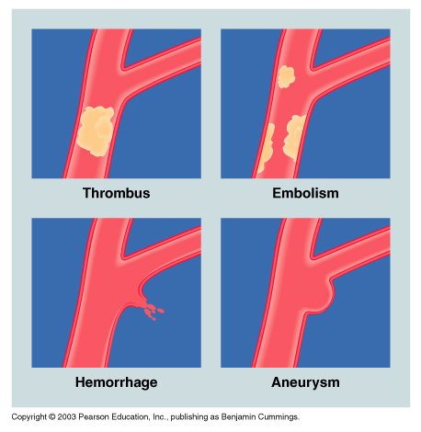

Types of CVD

- Hypertension
  - Essential and Secondary
  - Arrhythmias
    - Irregularity in heartbeat (fast, slow)
    - Caffeine, nicotine
  - Congestive Heart Failure
Heart muscle is damaged or overworked

Controlling Your Risks for Cardiovascular Disease

- Risks You Can Control
  - Smoking
  - Serum cholesterol
  - Ideal weight
  - Exercise
  - Drugs (ERT, ASA)
- Risks You Cannot Control
  - Heredity, Sex, Age, Race

Women and Cardiovascular Disease

- Symptoms in Postmenopausal Women
  - HRT: beneficial for HDL and CVD? Link to cancer?
  - Social stigma and gender bias
  - Symptoms more vague than in men
  - Uncomplicated angina: discomfort, not pain
  - Shoulders, back, stomach, sweating, nausea

New Weapons Against Heart Disease

- Angioplasty versus Bypass Surgery
  - Bypass, longer recovery time
  - Angioplasty, not long lasting
- Thrombolysis
  - Injection, dissolves clot

Diabetes- Incidence and Mortality

- Almost doubled1996-2005: ~4.9% Canadians
- Type 1: autoimmune disease
- Type 2: body unable to utilize
    - 90-95% of cases linked to obesity, inactivity
    - Gestational, during pregnancy
- Risk Factors
  - Family, age, ethnicity (African, First Nations, and Inuuit)
- Controlling Diabetes: insulin, weight, diet, physical activity

Cancer Incidence and Mortality

- Introduction:
  - >150,000 new cases in Canada
  - >70,000 deaths
  - Tumour: malignant or benign neoplasm
- Types of Cancer:
  - Carcinomas, Sarcomas, Lymphomas, Leukemia

- What Causes Cancer?
  - External factors: environmental (ex. carcinogens)
  - Internal factors: oncogenes & protooncogenes
- Smoking, lifestyle, obesity
- Biological Factors
- Occupational and Environmental Factors
- Social and Psychological Factors
- Chemicals in Food

- Smoking
  - Leading cause of preventable death in world
    - Canada: ~1 in 5 deaths, annually
- Obesity
  - Cancer risk increases as obesity increases
    - High BMI and death rates for certain cancers

Types of Cancer

- Lung Cancer
  - Leading cause of premature death
  - Symptoms: pneumonia and bronchitis
  - 13% live 5 years or beyond, after diagnosis
  - Rates improve to 47% with early detection
    - 90% of lung cancers avoided by not smoking

- Breast Cancer: risk increases with age (risks double every decade after age 50)
  - Prevention
    - physical activity
    - regular self examination & mammography
  - Treatment
    - lumpectomy, mastectomy, radiation, chemotherapy

- Colon and Rectum Cancer
  - Bleeding, bloody stool, changes in bowel movement
  - 40+ with family history are at increased risk
- Prostate Cancer
  - Symptoms, difficult to differentiate: urine flow, pain, blood
  - Five year survival rate of 80% (annual check-up age 40)
- Skin Cancer
  - Basal (squamous) cell or malignant melanoma
  - ABCD Rule- asymmetry, border, colour, diameter

Cancer’s Seven Warning Signs

- Change in bowel or bladder habits
- A sore that does not heal
- Unusual bleeding
- Lump (breast or other body part)
- Indigestion or difficulty swallowing
- Distinct change in wart or mole
- Nagging cough (hoarseness)

Infectious and Noninfectious Conditions: Risks and Responsibilities

*Not responsible for reading STIs, not on exam

Infectious Disease Risk Factors

- Risk Factors You Cannot Control
  - Heredity, aging, environment
- Risk Factors You Can Control
  - Stress
  - Dietary intake and physical inactivity
  - Sleep and personal hygiene
  - Drugs and high risk behaviours

The Pathogens : Routes of Invasion

- Common Bacterial Infections
  - Staphylococcal, streptococcal, pneumonia, Legionnaire’s disease, tuberculosis, periodontal diseases
- Common Viral Infections
  - Common cold, influenza, mononucleosis, hepatitis, mumps, chicken pox, measles
Your Body’s Defences : Keeping You Well

- Physical and Chemical Defences
  - Skin, linings (mucous membranes), secretions (tears)
- The Immune System
  - Antibodies: immunoglobulins
  - Cell-mediated immunity: lymphocytes, macrophages
- Autoimmune Diseases
  - Immune system targets own tissues
  - Ex: rheumatoid arthritis, AIDS
- Fever: >37C; destroys some disease-causing organisms; stimulates WBC production
- Pain: stops action = prevents further injury
  - Direct or referred; accompanied by inflammation
- Vaccines: inoculation with killed or weakened pathogens (antigens); prevent or lessen effects of disease

Acquired Immune Deficiency Syndrome (AIDS)

- How HIV Is Transmitted
  - High risk behaviours, exchange of body fluids; blood transfusion; injecting drugs; mother-to-infant transmission
- Symptoms of the Disease
  - Infants, newborns: immune system not fully developed
  - HIV+ to AIDS in 8-10 years (with no treatment)
- Preventing HIV Infection
  - Responsible sex and drug use

Noninfectious Diseases

- Chronic diseases: pain, disability; does not result in death
- Not transmitted by pathogen or contact
- Usually develop over a long period of time
- Lifestyle, personal health habits, major contributing factors
- Prevention and control to minimize effects

Respiratory Disorders

- Hay Fever: Sneezing; itchy, watery eyes and nose
  - Ragweed and flowers
- Asthma: Shortness of breath, & coughing spasms
  - Dust, pollen, stress, exercise
- Chronic Bronchitis: Inflammation of bronchial tubes
  - Cough, shortness of breath (cigarette smoking)
- Emphysema: Gradual destruction of alveoli
  - Difficulty breathing (cigarettes, air pollution)

Neurological Disorders

- Headaches
  - Tension, migraine (more localized to a certain part of the head compared to tension headaches), secondary, psychological
- Seizure Disorders
  - Epilepsy: abnormal electrical brain activity
  - Types: grand mal (major seizure, loss of consciousness, convulsions), petit mal , psychomotor, Jacksonian (lose function of one side of the body)

Digestion-Related Disorders

- Diabetes: >2 million Canadians (increasing cases)
  - Aging, rising obesity, sedentary lifestyle, ethnicity (eg inuit, aboriginal)
- Colitis and Irritable Bowel Syndrome (IBS): food & stress
  - Colitis: inflammation mucous membranes of colon
    - Bloody diarrhea, stomach cramps, nausea, fever
  - IBS: nausea, pain, gas, diarrhea
    - Stress management & healthy habits to help control
- Diverticulosis: bulges in the walls of the intestine
  - Infection, pain; bleeding, chronic obstruction
- Ulcers: stomach, intestinal lining (digestive juices)
  - High stressed, fatty foods & excessive alcohol (antibiotics)
  - Viral infection
- Gallbladder Disease: infection or overuse
  - Reduced ability to digest fats; gallstones form

Musculoskeletal Disorders

- Arthritis: painful inflammatory disease of joints; >4 million
  - Osteoarthritis, rheumatoid arthritis
- Fibromyalgia: Chronic rheumatological pain (unknown)
- Low Back Pain (LBP)
  - About 80% of people will experience
  - Risk factors: age, body type, poor posture
  - Prevention: posture, mattress, shoes, ergonomics, physical activity
  - Within the lumbar spine

Other Maladies

- Chronic Fatigue Syndrome (CFS)
  - Symptoms include feeling tired all the time, headaches, fever, and sore throat
  - Possible psychological factors
- Job-Related Disorders
  - Computers: eye strain, back, neck, shoulder pain
  - Carpal tunnel syndrome: irritation of median nerve, wrist

Tuesday Sept 24, 2013
Chapter 16
Life’s Transitions : The Aging Process

Redefining Aging

Gerontology and Age-Related Characteristics
• Biological-functional age; Psychological; Social; Chronological
• What is Normal Aging?
• Young-old, middle-old, old-old

What is normal aging? Who are the elderly?

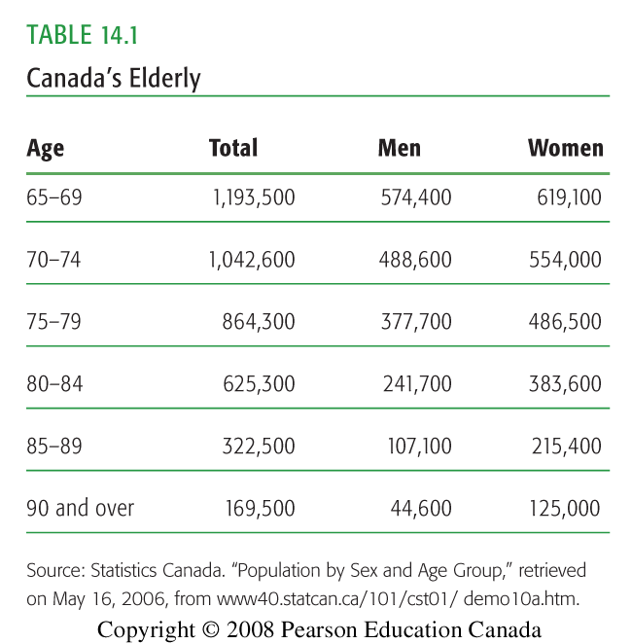

65-74 group : (1 200 000-1 000 000) highest amount of elders in this age category, more women than men
74-85 group : (900 000- 600 000) more women than men
85+ group : (200 000) way more women than men

*** as the age increases, women tend to stay alive longer than men

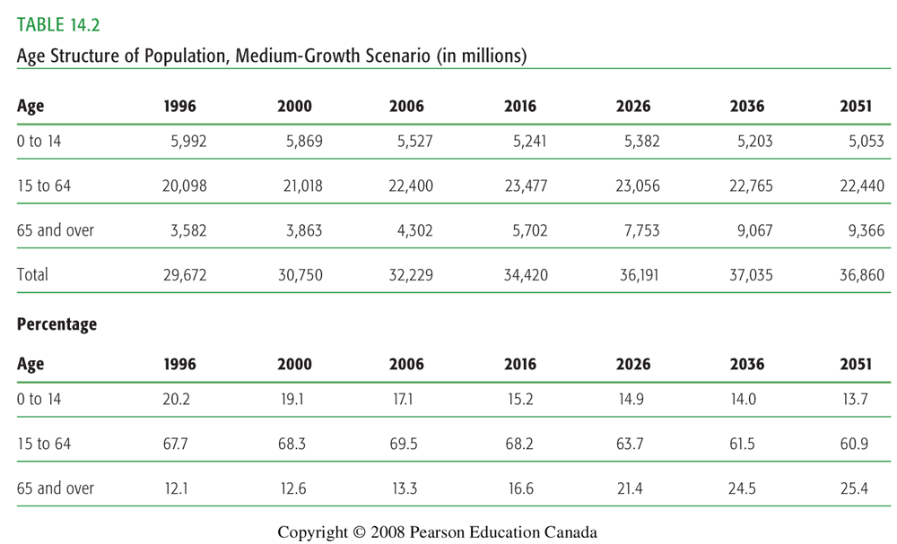
0-14 group : as the years pass, steady decrease by 2051
15-64 group : relative consistency, slight bell curve
65+ group : drastically increase as the years pass

therefore : life expectancy for elders is awesome in 2051 compared to that generations youth.. boohoo

Theories on Aging

Biological Theories
• Wear-and-tear-degeneration due to pollution, break down of tissue, stress
Cellular- cell replication ends at a certain point for an individual
Autoimmune- immune system becomes less effective as we age: stress, diet, etc
Genetic mutation – increase age, increase mutation

• Psychosocial Theories
• Personality development/adaptation and adjustment
• Developmental Model
• Coping skills of life stresses from childhood on

Physical & Mental Changes

- Skin
- Intelligence
- Memory
- Adaptability
- Depression
- Dementia
- Alzheimer's disease

- Bones and joints
- Urinary tract-bladder control
- Heart and lungs
- Vision- cataracts, macular degeneration, glaucoma
- Hearing-differentiating sounds
- Taste- approx. 2/3 tastebuds lost
- Smell and touch
- Mobility
- Sexuality

Health Challenges of the Elderly

• Alcohol use: abuse
• Prescription Drugs & Over-the-Counter Remedies
• Physical Activity: diminished, sarcopenia (decrease in quality and quantity of muscle tissue)
• Dietary Concerns: calcium, vitamin D, protein
• Gender Issues: women live alone, comorbidity (presence of many diseases at once)

The Process of Dying

Thanatology- study of death and dying

Coping Emotionally with Death
• Elisabeth Kübler-Ross:
1. Denial (“Not me, there must be a mistake”)
2. Anger (“Why me?”)
3. Bargaining (“If I am allowed to live, I will..”)
4. Depression (“It is really happening to me and there is nothing I can do”)
5. Acceptance (“I am ready”)

Social Death- person is not treated as an active member of society

• Near-Death Experiences:
  - Resistance
  - Life review
  - Transcendence: “seeing a light”, about to die but you don't
• Coping with Loss
- Bereavement- loss or deprivation experienced when a loved one dies
- Disenfranchised grief-mourning in private eg: secret lover dies, your married
- Grief: Mental state of distress that occurs in reaction to significant loss
- Mourning –behavior patterns for the expression of grief
- Grief work- process of accepting reality of person’s death and coping with memories of the deceased

What is “Normal” Grief?

- Tightens in throat
- Shortness of breath
- Urge to sigh
- Emptiness in the abdomen
- Muscular weakness
- Intense anxiety

The Process of Dying

Coping with Grief
• Stronger support system = smoother progression through the stages of grief

• Tasks of Grief (Worden’s Model)
• Accept reality of loss
• Work through pain of grief
• Adjust to environment
• Emotionally relocate deceased, move on

When an Infant or Child Dies
• Bereaved siblings
• Quasi-Death Experiences- break up, divorce, abduction, moving, retirement home
• Separation, termination, loss, change in self-perception
• Right-to-die issues-continue to treat person or remove intervention so the person can die naturally

Oct 1, 2013
Chapter 5
Nutrition : Eating for Optimum Health

The Nutrients in Food

6 essential nutrients :

MACRO
- Carbohydrates
- Amino acids
- Lipids

MICRO
- Water
- Vitamins
- Minerals

Calorie Values of Energy Nutrients

Nutrient (substrate): Energy:
Carbohydrate (sugars) 4 Cal/g
Fat (lipids) 9 Cal/g
Protein (amino acids) 4 Cal/g
*Alcohol (ethanol) 7 Cal/g

The Digestive Process in Summary

- Mouth: mechanical digestion, saliva (amylase) “ase” ending=enzyme
- Esophagus: peristalsis (smooth muscle)
- Stomach: (chemical digestion, HCL)
- Small intestine: absorption
  - Liver: filters, distributes nutrients; bile
  - Pancreas: insulin, glucagon
- Large intestine: digestive waste, some absorption
- Digestive process: approximately 24 hours

Obtaining Essential Nutrients

- Carbohydrates (sugars)
  - Simple carbohydrates
    - Monosaccharides: glucose, galactose, fructose
    - Disaccharides: maltose, lactose, sucrose
  - Complex carbohydrates
    - Grains, cereals, breads, pastas, legumes (beans)
    - Polysaccharides: fibre, starch, glycogen
    - Fibre: 25 g/day women, 38 g/day men
- Fats (lipids)
  - Triglycerides ~95% of lipid family; 5% sterols (cholesterol)
  - Saturated (fats) vs. Unsaturated (oils)
  - Lipoproteins: HDL/LDL
  - Transport vitamins: A, D, E, K
- Proteins (amino acids)
  - Essential, Non-Essential amino acids
  - Complete (20: meat, meat derived products); Incomplete (>20: plant-based products)
  - Plant sources: legumes, grains, nuts & seeds
- Recommendation: ~0.8g/kg bodyweight
- Water
  - Approx. 50-60% of body composition
  - Minimum 6 glasses a day (ideally water)
- Vitamins
  - Fat soluble: absorb through intestinal tract with help of fat (A, D, E, K)
  - Water soluble: dissolves easily in water (B complex, C)
- Minerals
  - Growth and metabolism
  - Macrominerals (>5grams in the body)
    - (7) Calcium, phosphorus, potassium, sulfur, sodium, chloride, magnesium
  - Trace minerals (<5grams in the body)
    - (15) Iron, zinc, iodine, selenium, fluoride
- Minerals (continued)
  - Calcium
      - Milk products, green vegetables
      - Carbonated drinks may cause excretion
      - Vitamin D increases absorption
      - Osteoporosis
  - Iron
      - Vitamin C will increase absorption
      - Caffeine prevents absorption
      - Anemia
- Changing the Meat & Potatoes Person
  - Eating red meat, main dish, 5x/week = 4 times risk of colon cancer (vs. those eating red meat 1x/month)
  - Fruits and vegetables (phytochemicals): antioxidants
  - Organic grown foods?
  - About 4% of Canadians are vegetarians
    - Legumes are important
    - Many types of vegetarians

Food Safety: A Growing Concern

- Food allergies
  - Reactions: hives, rash, swelling, itchiness, vomiting, irregularity in breathing, shock, etc.
  - Common: legumes (soy), nuts, shellfish, eggs, wheat, and milk
- Food intolerances
  - Do not involve the immune system
- Minimizing Food-borne Illness
  - Eat red meat, seafood, and poultry within 1 to 2 days; leftovers within 3 days
  - Hot foods hot, cold foods cold
  - Refrigerate cooked food within 2 hours
  - Thaw food in the refrigerator
  - Avoid cross-contamination (soap, hot water)

Eating Well as a University or College Student

- When Funds Are Short
  - Fruits and vegetables, canned or frozen
  - Sales, discount/bulk food chains
  - Buy in volume, freeze; cook large meals and freeze/store smaller portions
- Healthy Eating in the Dormitory (“The Freshman 15”)
  - Eat small and frequent meals (do not skip meals)
  - Emotional eating (ex. during exams)
  - Social events (alcohol and high fatty foods)
- Fast Foods: Eating on the Run
  - Nutritional analyses, if possible
  - Skinless, non-fried meats
  - Minimize all types of fried foods
  - Minimize mayo, sauces, salad dressings, etc.
  - Less processed food, more unprocessed foods
  - High fiber, lots of liquids = satiation (feeling full)

Healthy Eating

- Hunger vs. Appetite
- Balanced Diet:
  - 55-60% carbs
  - 30% fats
  - 10-15% protein
- A, B, C, M, V

The Nutrition Facts Panel
- Servings per container
- Macronutrients
- Vitamin A, C; Calcium, Iron
- Daily Values
- Ingredients list

The trend in North America has been toward consuming larger food portions!
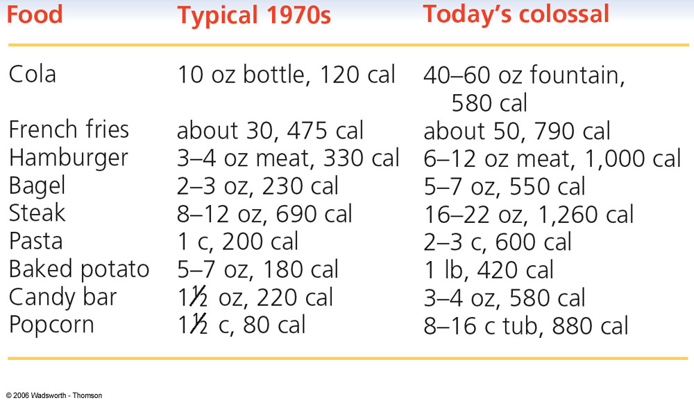

Keep in Mind

Frequency
ex. 3 feedings per day vs. 6 feedings per day
Quantity
ex. 2 egg white omelette and water vs. 5 strips of bacon, 2 sausage links, and 2 slices of buttered white toast
Quality
ex. grilled slices of zucchini vs. deep-fried zucchini sticks dipped in sour crème

Oct 10, 2013
HSS 1101 :B
Ch. 4- Personal Fitness
Improving Your Health Through Physical Activity

Introduction

- Canada's Physical Activity Guide to Healthy Active Living: PHAC & CSEP
  - 60+ minutes of moderate intense activity, daily!
  - Participaction Canada, health promotion
  - ~50% Canadians are physically inactive
- ~20% of teens sufficiently active for optimal growth and development

Health and Performance Components

- Performance (functional) components: agility, power, coordination, balance, speed, reaction time
- Muscle Contractions
    - isometric, concentric, eccentric
- Stretching: flexibility and ROM
    - Static (isometric)
    - Ballistic (dynamic/sports-specific)
    - PNF (contract-relax)
Energy Pathways

ATP - CP (alactic system: anaerobic) high intensity short duration
Up to first 15 seconds
Glycolysis (lactic system: anaerobic)
15 – 90 seconds

Glycolysis (aerobic)
90 – 180 seconds
Oxidative (beta oxidation: aerobic)
180 seconds+ low intensity long duration

Types of Exercise

“Cardio” training (Aerobic threshold):
Speed walking Jogging
Light running Swimming
Cross-country skiing Interval training

“Resistance” training (Anaerobic threshold):
Circuit-training Plyometrics
Calisthenics Bodybuilding
Weightlifting Powerlifting
Improving Cardiorespiratory Endurance

- Cardiorespiratory Endurance:
- Max HR: (220-age) x %intensity
- Aerobic Power:
- VO2%: lactate threshold
- Graded Exercise Test:
- Aerobic capacity: sustaining maximum work load

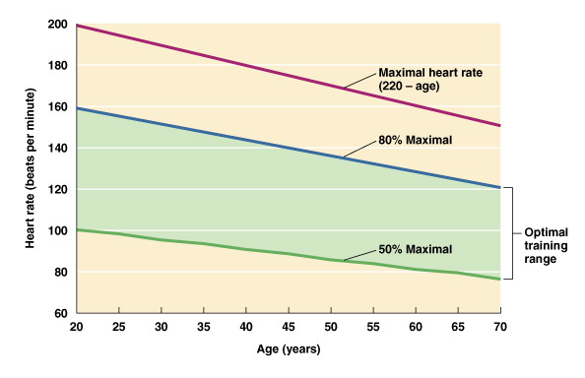
Improving Muscular Strength and Endurance

- Muscular Strength and Endurance
    - Strength: one repetition maximum (1RM)
    - Power: strength/time
    - Endurance: duration of work, given fixed load
- Principles of Strength Development
    - The Overload Principle: Hypertrophy
    - The Specificity of Training Principle

Fuel for Physical Activity

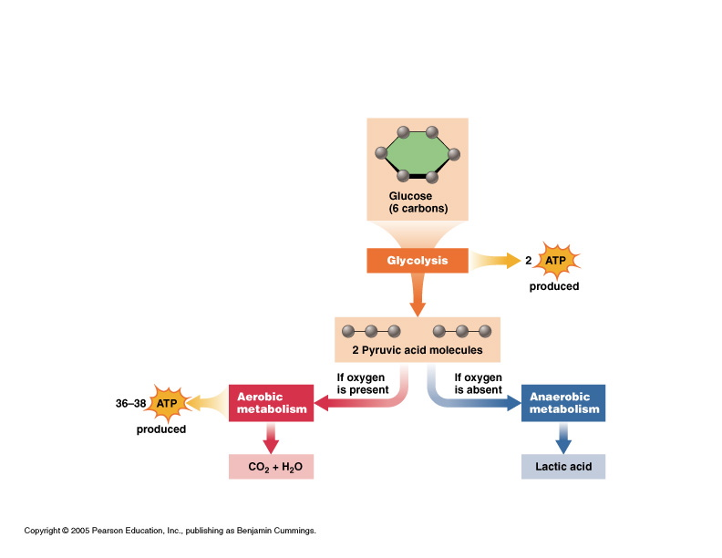
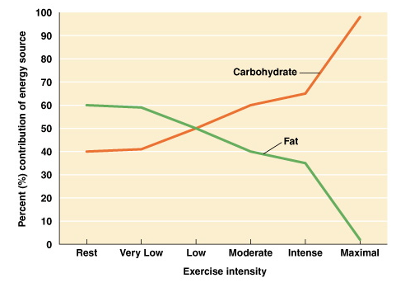
Scenario 1: brisk walking, 30 minutes @ 40% VO2 Max
- Higher oxidative efficiency
- Percentage of calories derived from lipids: 80%
- 100 calories utilized
- Absolute calories from lipids: 80 calories
Scenario 2: running, 30 minutes @ 80% VO2 Max
- Lower oxidative efficiency
- Percentage of calories derived from lipids: 40%
- 200 calories utilized
Absolute calories from lipids: 80 calories

Sound Fitness Program

- Three variables to consider:
1) Frequency, 2) Intensity, 3) Duration
- Recall: 1) Macro plan, 2) Micro plan
- Recall: For healthy weight management, shift in body composition, anaerobic training is the priority

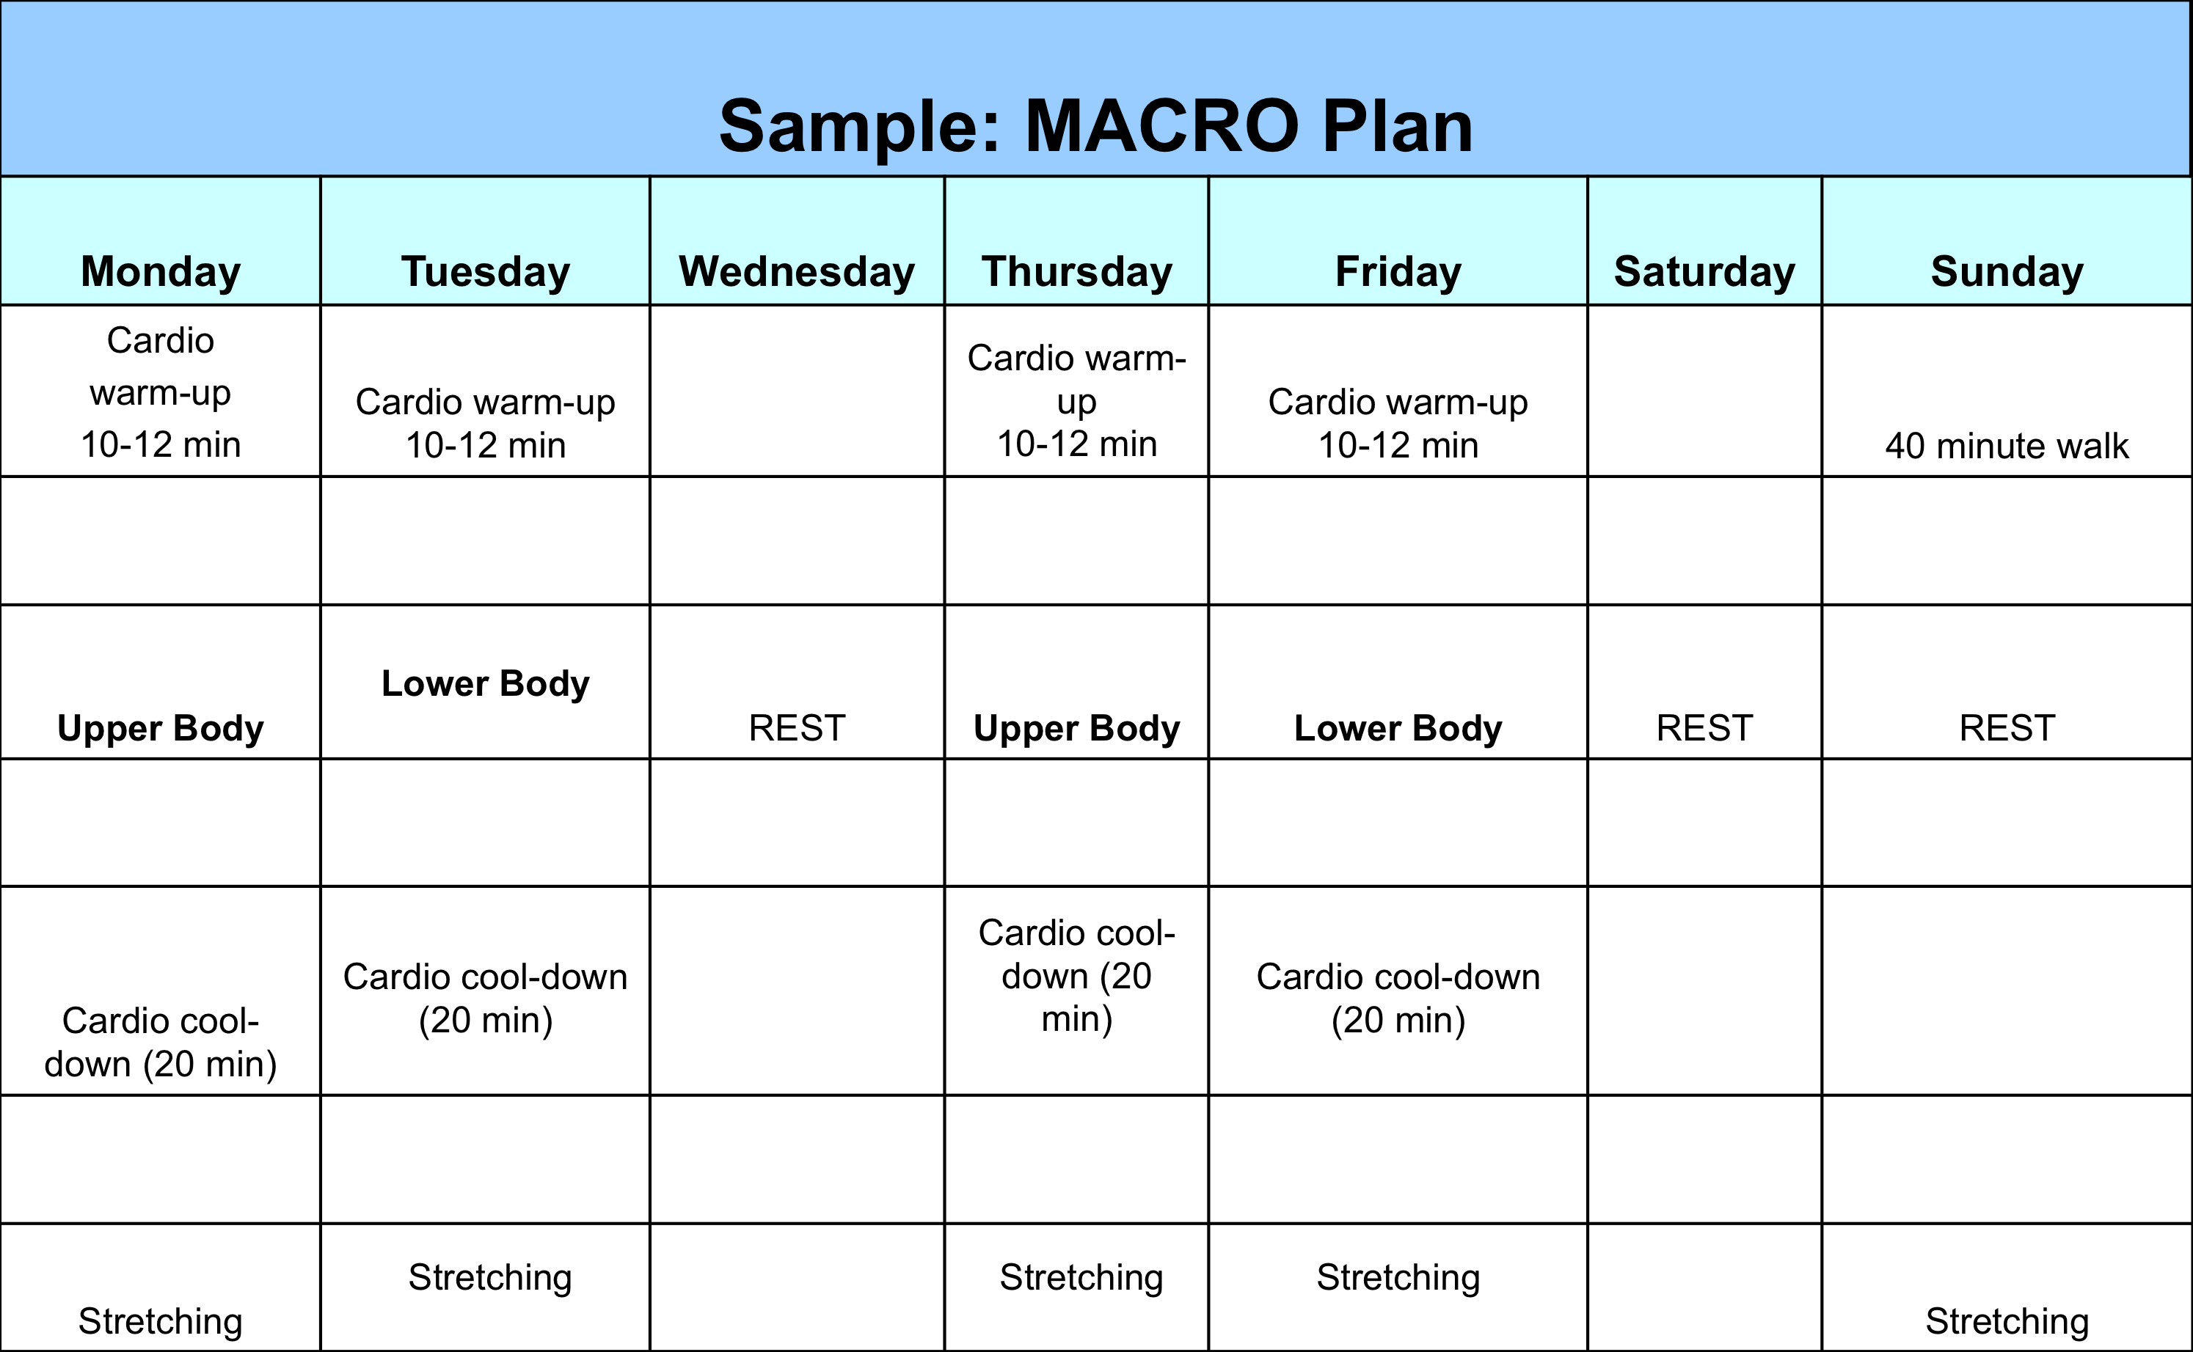

Sample: MICRO Plan
Day 1 – Upper Body Sets Reps
Pulldowns 3-4 6-9
Seated row 3-4 6-9
Chest press 2-3 8-10
Military press 2-3 8-10
Lateral shoulder raises 3-4 8-12
Reverse flyes (posterior shoulders) 4 12
Biceps curls 2-3 10-12
Triceps extensions 2-3 10-12
Core:
trunk flexion 3-4 12-15
trunk extensions 2-3 12-15
Day 2 – Lower Body
Seated leg press 4 8-10
Walking lunges 2-3 15
Leg curls 3-4 8-10
Single leg presses 1-2 12
Adductors 2 10-12
Abductors 2 10-12
Calf raises (seated leg press machine) 3-4 8-12
Core:
trunk flexion 3-4 12-15
trunk extensions 2-3 12-15

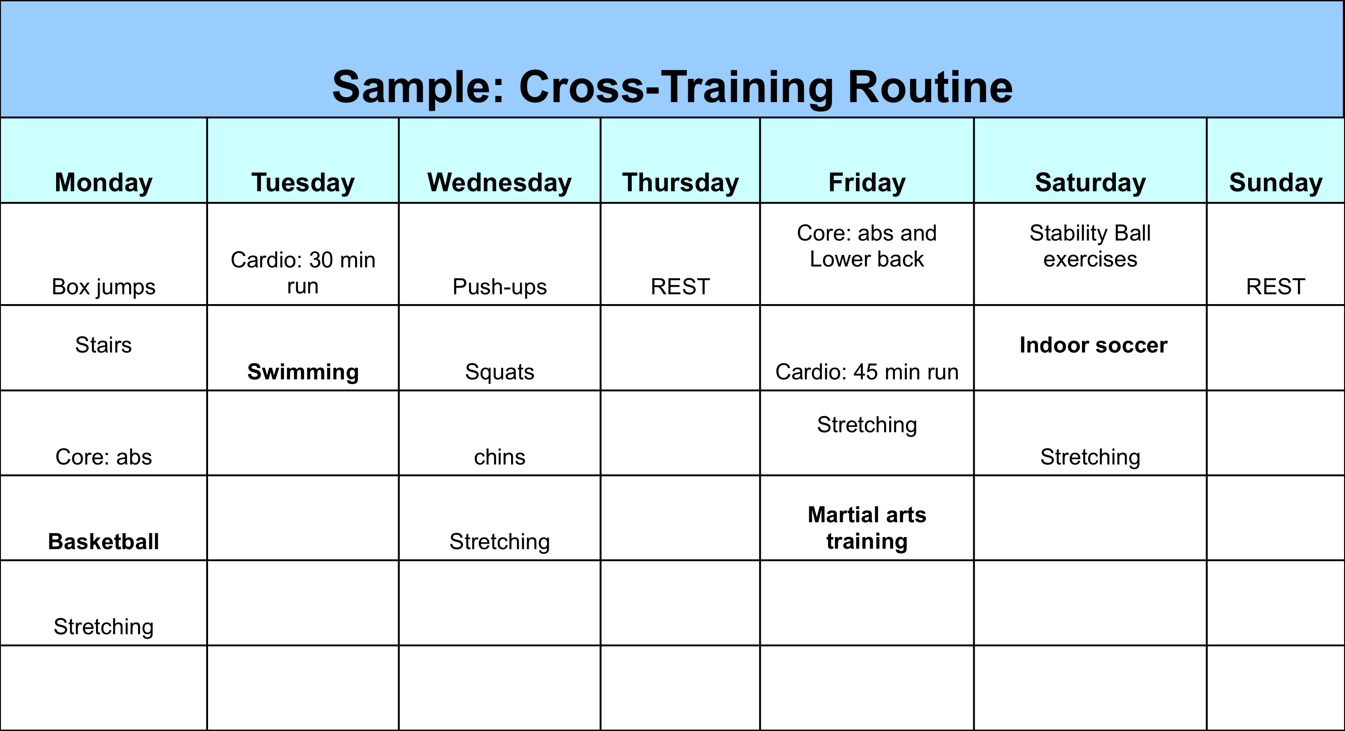

Fitness Injuries

- Causes
  - Overuse injuries vs. traumatic injuries
- Common Overuse Injuries
  - ex. plantar fasciitis, “runner’s knee”
- Treatment
  - Rest, ice, compression, and elevation
- Exercising in the Heat
  - Avoid dehydration; appropriate clothing
  - Three heat stress illnesses
    - cramps, exhaustion, heat stroke
- Exercising in the Cold
  - Prevention: wear appropriate clothes, hydration

Oct 22, 2013
HSS 1101
Chapter 6
Managing Your Weight :
Finding a Healthy Balance

The Body’s Energy Balance

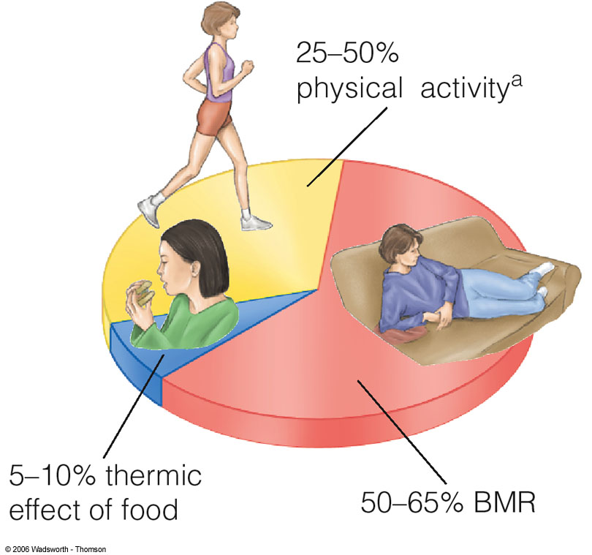

Overweight and Obesity

BMI =(weight in kg)/(height in m²)
BMI = [(weight in lb)/(height in in²)] x 705
  - 18.5 to 24.9 = healthy weight
  - 25 to 29.9 = overweight
  - 30 to 34.9 = obese class 1
  - 35 to 39.9 = obese class 2
  - 40+ = obese class 3 (morbid obesity)
*More than 50% of adult Canadians are overweight

Body Weight & Composition – Central Obesity
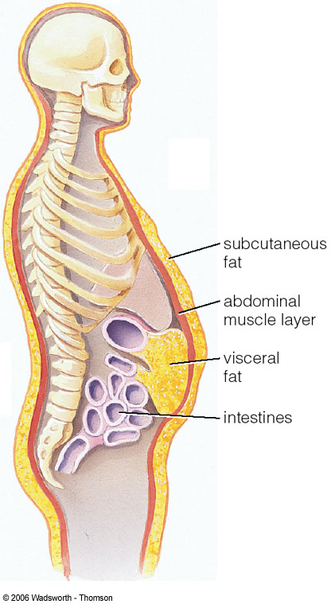

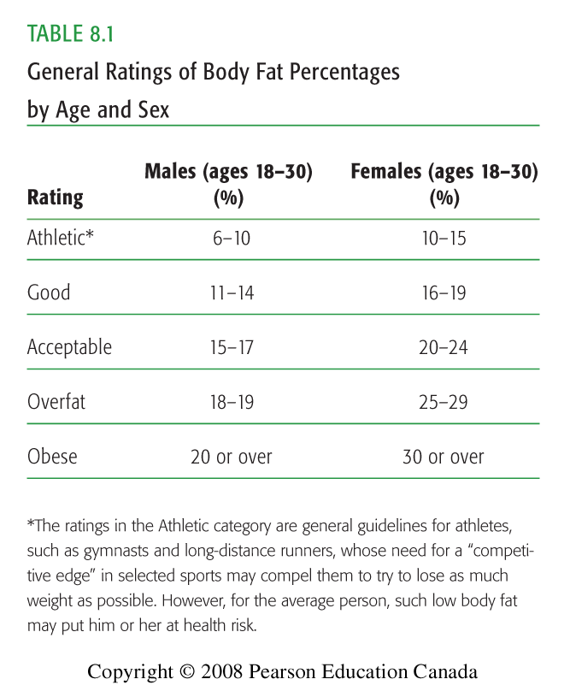

Risk Factors for Obesity

- Heredity and Genetic Factors
  - Body type: endomorph, mesomorph, ectomorph
  - Children of obese parents = increased risk
  - “Set-point” theory
- Endocrine Influences
  - <2% of obesity cases endocrine related

Managing Your Weight

- Avoid quick weight-loss programs
- Very low-calorie diets (vlcd), starvation
- >50% Canadians sedentary during leisure time
- Labour-saving devices reduce activity
- Food = a major part of our socialization

Eating Disorders

Eating Disorders
- Abnormal attitudes toward one’s body weight and shape
- Severe disturbances in eating behaviours
- Unhealthy efforts to control weight
- Anorexia Nervosa
  - 0.5% to 1% of adolescent females are anorexic
  - Medical problems (e.g. damage to bones, muscles)
- Bulimia Nervosa
  - 1-3% of adolescent and young females
  - Cycles of binge eating then purging to prevent calorie absorption
Disordered Eating
- Abnormal eating behaviours not diagnosed clinically
- Binge Eating Disorder
  - Binge eat but do not purge
  - Normal attitudes towards dieting, weight and shape
- Anorexia Athletica
  - Compulsive, extreme exercising: physical symptoms
- Treating Eating Disorders:
  - Early diagnosis and recognition are best predictors of success
  - Multidimensional approach usually involving family & friends, including medical personnel
  - May require hospitalization, psychotherapy

Body Composition- Volume and Density

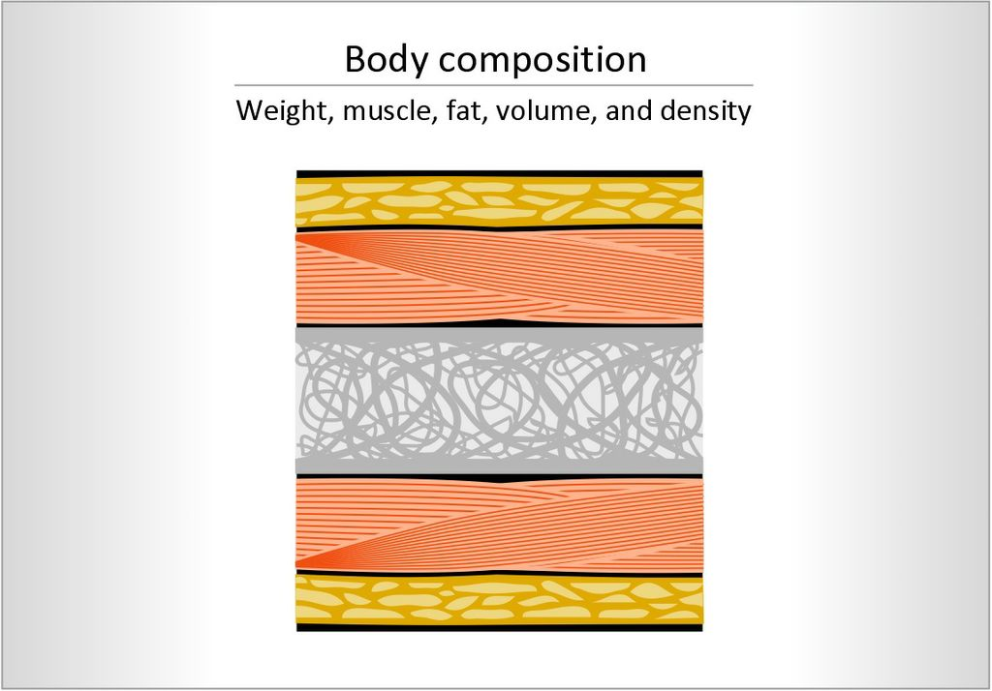

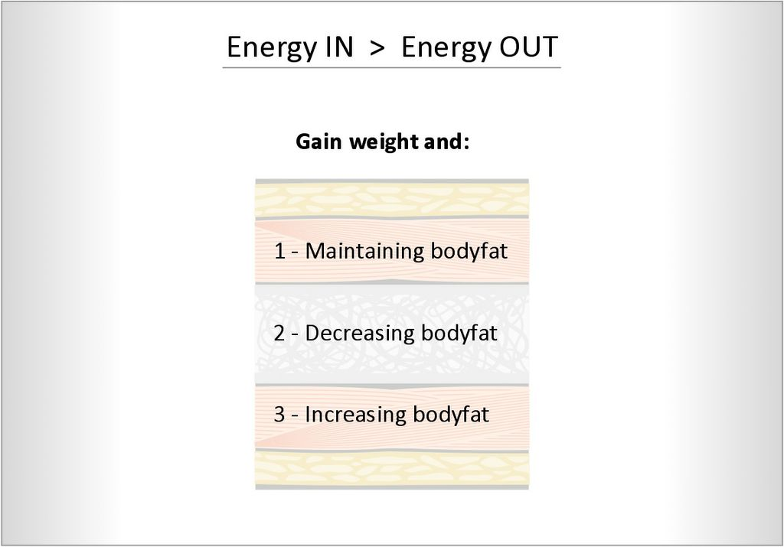
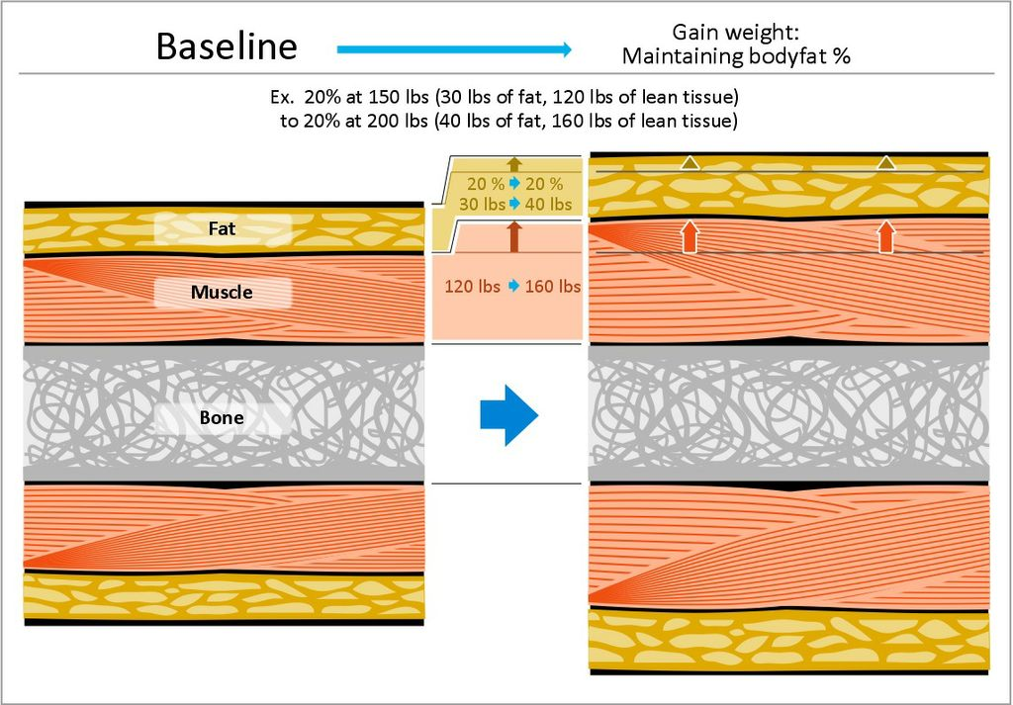

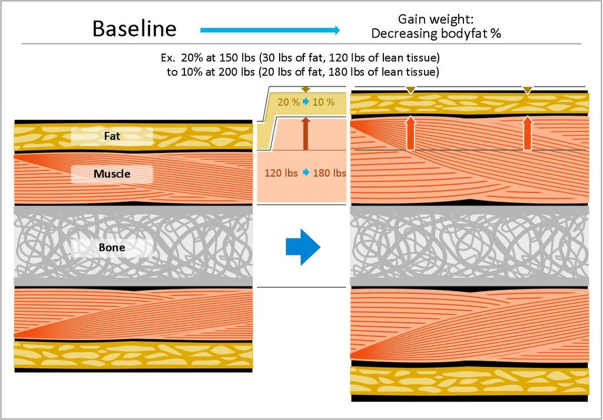

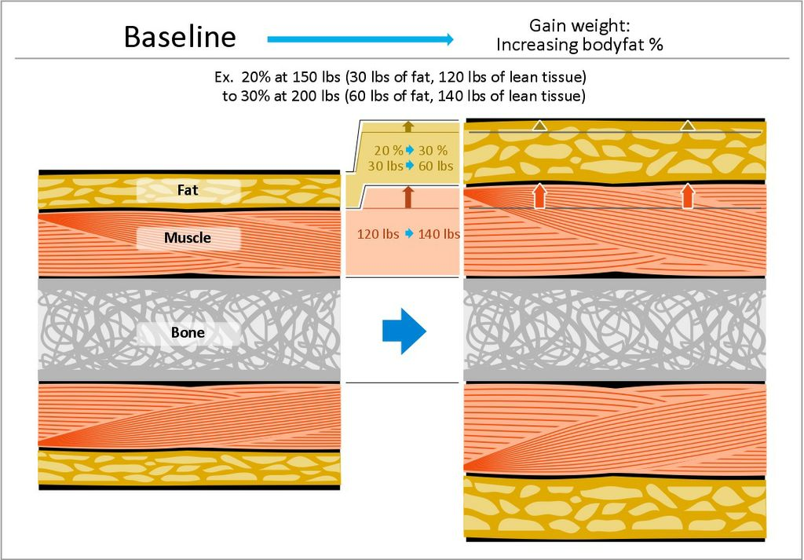

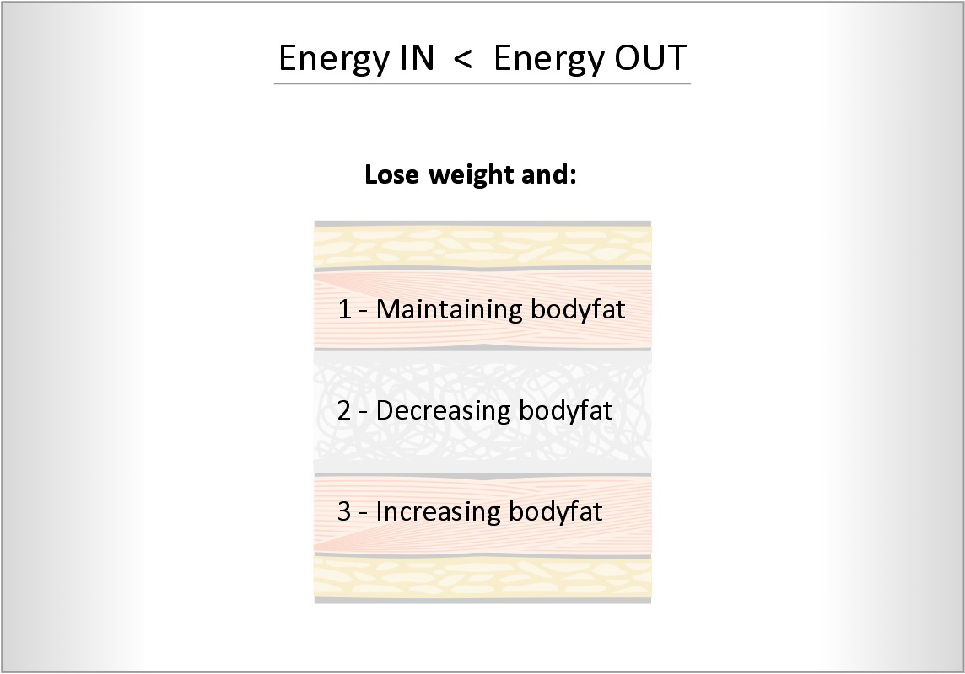

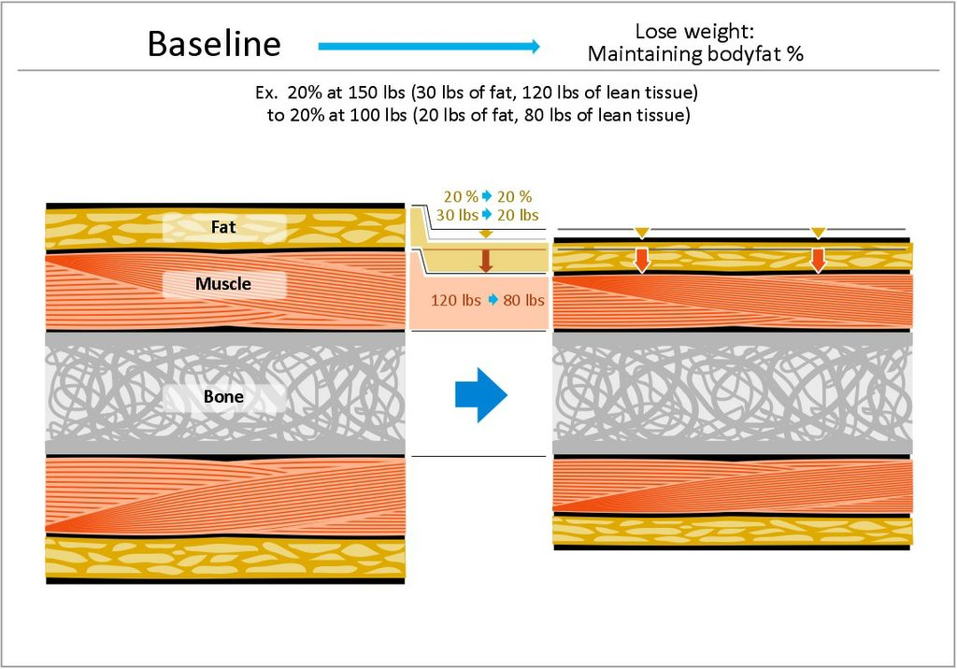

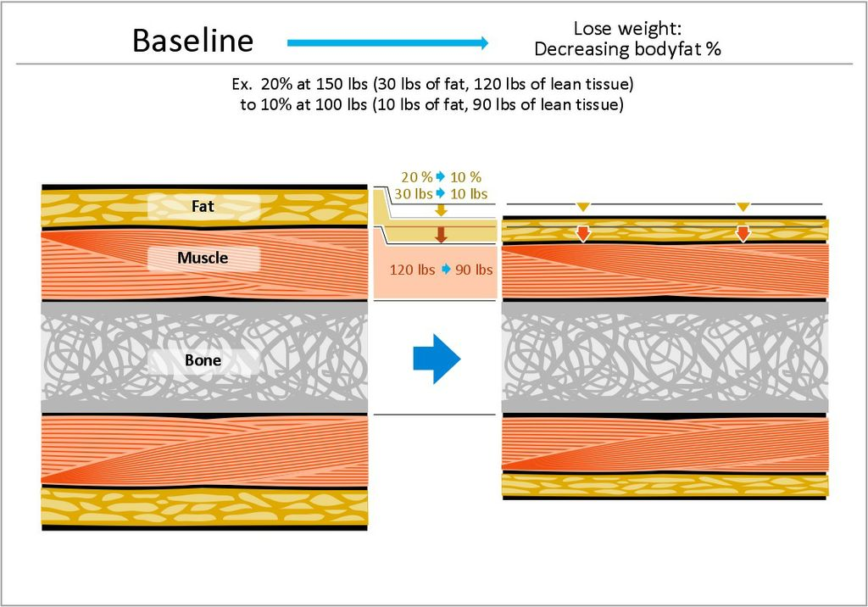

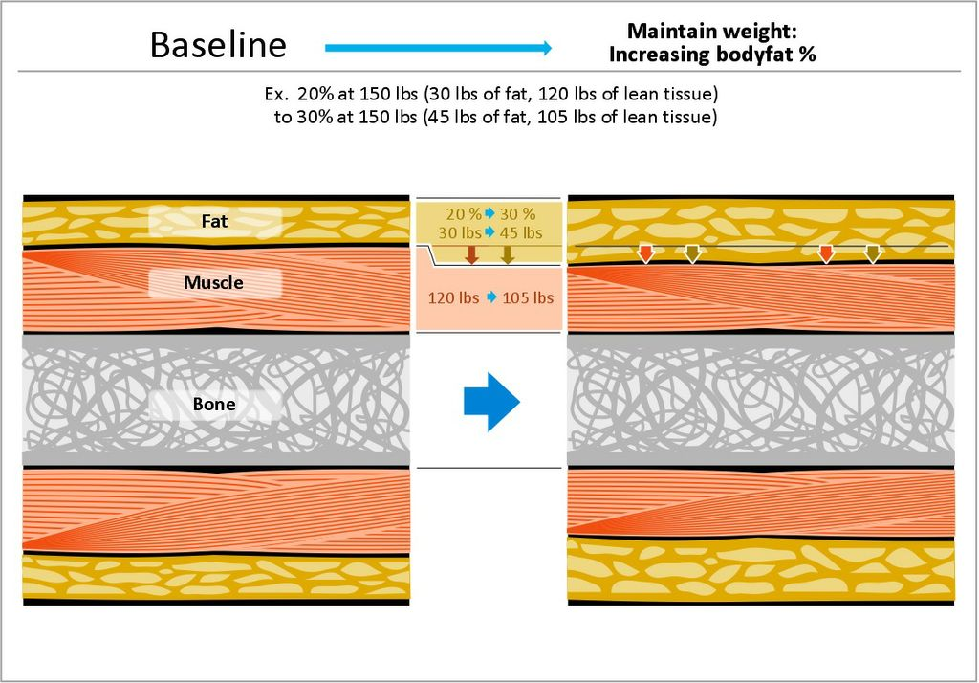

Oct 29, 2013
HSS 1101 :B
Ch. 10 : Alcohol, Tobacco, Caffeine :
Unacknowledged Drugs with Risk for Addictions

Alcohol: An Overview

- 4/5 Canadians report alcohol consumption
- Costs to Society
  - $18 billion in sales (2007)
  - 2.8 billion liters sold (2004)
  - Estimated health costs: $14.6 billion
- Alcohol and Post-Secondary Students:
  - 94.5% consume alcohol (1/3 heavy drinkers)

Drinking guidelines (per week)
- Men: maximum 14 standard-sized drinks
  - 30% report exceeding guidelines
- Women: maximum 9 standard-sized drinks
  - 15% report exceeding guidelines
- Heavy drinking: >15 drinks/week
- Binge drinking: >4 - 5 drinks in succession
- Recommendation: no more than 2 drinks per day

Physiological and Behavioural Effects of Alcohol

Behavioural Effects
- Blood Alcohol Concentration (BAC): ratio of alcohol to total blood volume (physiological and behavioural effects)
  - >0.08 (balance, speech, vision, and hearing impaired)
- Effects vary: the setting, the individual
  - Learned behavioural tolerance: person appears sober despite a high BAC
- Factors that influence absorption:
1) Amount consumed in a given time
2) Size, sex, body build, and metabolism
3) Type and amount of food in the stomach
- Women and Alcohol
  - % body fat: higher percent body fat increases BAC
  - Women: less alcohol dehydrogenase
  - More lean tissue can absorb alcohol better, don’t feel the effect as much as a body build with more fat (aka more fat= more drunk)

- Immediate Effects of Alcohol
  - Depressant
  - Diuretic: water from cerebrospinal fluid (dehydration)
  - Hangover (rest)
- Long-Term Effects of Alcohol
  - Effects on Nervous System
    - Atrophy (loss of brain tissue), some loss of intellectual ability
  - Cardiovascular Effects
    - Elevated BP, irregular heartbeat, cardiomyopathy (
Long-Term Effects of Alcohol (continued)
- Liver disease: fatty liver, fibrosis, cirrhosis
- Cancer: GI tract
- Other effects:
  - Irritant to gastrointestinal system
  - Blocks absorption of nutrients
  - Impairs ability to fight bacteria and viruses (immune system \/)
Fetal Alcohol Spectrum Disorders (FASD)
- 1 to 6 per 1000 births
- Fetal alcohol syndrome (FAS)
- Fetal alcohol effects (FAE)
Drinking and Driving
- >1,350 Canadians die yearly
- Leading cause of death for 5 - 34 year olds
  - 15 - 29 year olds account for 38% of fatalities

Alcoholism

- Alcohol abuse
  - Addiction: tolerance, dependence, withdrawal symptoms
  - 6.2% report binge drinking at least once/week
    - Men 18-24 most likely to report binge drinking
  - Biological and family factors
  - Social and cultural factors
- Effects of Alcoholism on the Family
  - Peer pressure, emotional and social problems, family attitudes
  - Assume a “role”: hero, scapegoat, lost child, or mascot
  - Women and Alcoholism
  - Females approaching rate of male alcoholics
  - Some differences: life stress, later in life, drug intervention, less social support (treatment, recovery)

Smoking

Facts
- By 2020, tobacco expected to kill more people than any single disease
  - #1 preventable cause of death in Canada
- Smoking, most common form of tobacco use:
  - Nicotine, tar, CO, and 5,000 other chemicals
Daily smokers: 15 cigarettes per day
Physiological Effects of Nicotine
  - Stimulant (CNS, adrenal glands) and appetite suppressant
  - Increases HR & RR
  - Constricts vessels = increased BP and risk of blood clots
Smoking: A Learned Behaviour
  - 85% start before age of 16
  - “Trying smoking”-to-daily smoking, approx. 2-3 years
  - Tobacco promotions (marketing, advertising targets)
- Smokeless Tobacco
  - As addictive as cigarettes
  - Leukoplakia: white patches inside the mouth
  - Dental problems; impairs smell and taste
- Environmental Tobacco Smoke
  - Most deaths of all environmental pollutants
  - Secondhand smoke
  - Exposed children: greater risk of respiratory problems (because they aren’t as developed)
- Breaking the Nicotine Addiction
  - Irritability, restlessness, and intense cravings
  - Different interventions
  - Nicotine replacement products
- Benefits of Quitting
  - Body repairs immediately (energy, sleep, taste, smell)
  - After 1 year, risk for lung cancer and stroke decrease
  - After 10-15 years (full lifespan, CVD risks of nonsmoker)

Caffeine

- Most widely consumed drug in Canada
- Stimulant: wakefulness, insomnia, irregular heartbeat, dizziness, nausea, and indigestion
- Caffeine Addiction
  - Can develop dependency (caffeinism)
  - Coffee withdrawal may cause severe headaches
- The Health Consequences of Long-Term Caffeine Use
  - No strong evidence to suggest moderate intake (3 cups or less per day) is harmful

November 5, 2013
HSS 1101:B

Chapter 2
Psychosocial Health:
Achieving Mental, Emotional, Social, and Spiritual Wellness

Psychosocial Health

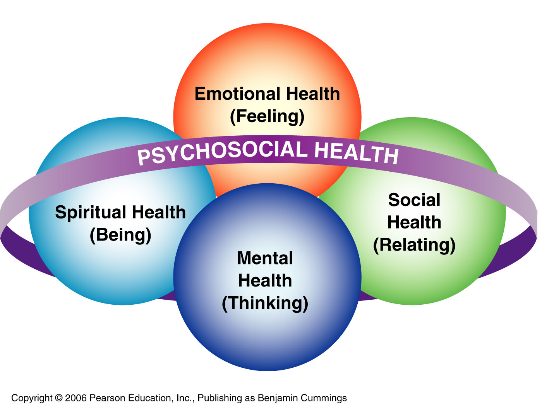

Defining Psychosocial Health

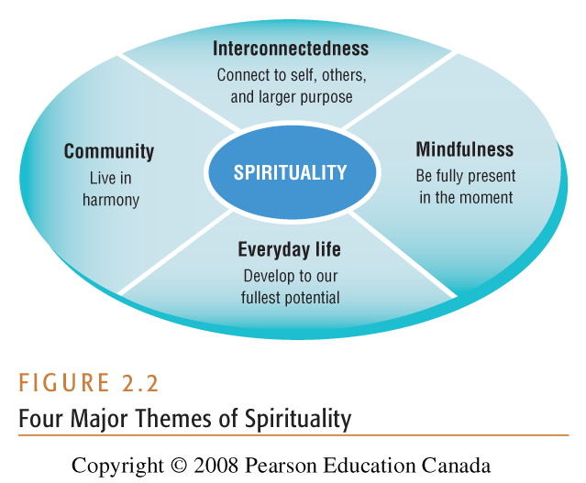
Factors Influencing Psychosocial Health

• External Influences: Family and Environment

• Internal Influences: Self-Efficacy and Self-Esteem
• Learned helplessness vs. optimism
• Personality factors

• Does Laughter Enhance Psychosocial Health?
• Less depressed, positive mood
• Sense of belonging, social cohesion

When Things Go Wrong

• Mental Illnesses
• Disorders that disrupt thinking, feeling, moods, behaviours, and cause degrees of impaired functioning in daily life

• Fact
• Increasing Canadians turning to mental health professionals

• Depression
• 6% of adult Canadians 18+ have experienced an episode

• Two acknowledged forms of depression
• Endogenous: biochemical origin
• Exogenous: caused by an external event

• Treating Depression
• Lifestyle modification
• Cognitive and interpersonal therapy; support group
• Antidepressants

• Obsessive-Compulsive Disorders
• Obsessive thoughts
• Uncontrollable repetitive behaviours

• Anxiety Disorders
• Generalized anxiety disorder
• Phobias
• Post-Traumatic Stress Disorder

• Seasonal Affective Disorder (SAD)
• 2-3% of Canadians suffer from SAD
• 25% of Canadians report mild winter blues
• People between 20-40 are most vulnerable
• Irritability, apathy, and cravings for carbohydrates

Suicide

Warning Signals
• Recent loss and inability to let go of grief
• Change in personality, behaviour, and sleep
• Expressions of self-hatred

• Taking Action to Prevent Suicide
• Monitor warning signals; take threat seriously
• Ask directly, “Are you thinking of hurting yourself?”
• Tell the persons friends, family, counselor, etc.

Seeking Professional Help

Mental Health Professionals
Psychiatrist, Psychologist, Nurse Practitioner, Social Worker, Counselor, Life Coach

When You Begin Therapy
Do not expect to be given answers
Participate actively and take responsibility
Be honest to yourself

Being Human

- Repression, Regression, Displacement, Transference, Projection

- Overcoming conditioned/reflexive thoughts, feelings, and actions:
-Modeling: vicarious learning
-Conditioning: rewards and punishment
-Exposure: flooding, systematic desensitization
-Relaxation techniques: arousal regulation

- Process of experience > content of experience

- Positive worth of a person, held constant

- Positive intention motivates all behavior

- No such thing as failures, only experiences

November 14, 2013
HSS 1101
Chapter 3 : Managing Stress
Toward Prevention and Control

What is Stress?

- Stressor
  - Event or condition that forces us to adjust
  - Adjustment and strain
- Eustress vs. Distress
- The Mind-Body Connection
  - Stress and impaired immunity
Psychoneuroimmunology (PNI)

The General Adaptation Syndrome

- Stage 1: Alarm Phase
  - Triggered ANS; SNS (fight/flight response)
- Stage 2: Resistance Phase
  - Immediately follows alarm phase
  - Body has reacted to a stressor; begins adjusting and regaining equilibrium (PNS)
- Stage 3: Exhaustion Phase
  - Energy stores depleted
  - Chronic depletion = burnout and illness

Stress Response Process

Stressor (Stimulus)
⬇
Cognitive Appraisal
⬇
Experienced Physical & Psychological Strain
⬇
Health Outcomes

Source of Stress

- Self-imposed stress
  - Self-concept: emotional response to stress
  - Personality types and hardiness: efficacy, commitment, challenge, connectedness
- Environmental stress
  - Natural disasters, noise, pollution, infrastructure
- Potential symptoms of Stress Overload
  - Social withdrawal, drug use, sleep disturbances, emotional eating, apathy

A Decision-Making Model for Stress Reduction

- What is distressing me?
- What am I willing to do about it?
- How am I handling the situation?
- What am I going to do about it?
- How have I put my plan into action?
- What results can I expect (see)?

Stress Management

- Assessing stressors
  - control, cost-benefit analysis, opportunity cost, and list of priorities
- Recognizing & changing your responses
  - Introspection and decide how you want to feel
- Learning to Cope
  - coping mechanism (sex, exercise, food, etc)
- Downshifting
  - Simplify: back to basics (values, expectations)
- Emotional responses
  - Self-talk; laugh and cry
- Social Interactions
  - Friends and network of social support
- Taking Mental Action
  - Changing the way you think (reframing)
- Taking Physical Action
  - Physical activity, relaxation, eating well
- Learning time management (ex. excel file)
  - Prioritize daily life responsibilities
  - Do not give into interruptions, say “no”
  - Value your time
- Alternative Stress Management Techniques
  - Hypnosis, Massage, Meditation

Other Common Stress Management Techniques

- Yoga
- Guided imagery (visualization)
- Progressive muscle relaxation
- Breathwork
- Various therapies (sound, light, aromatherapy)
- Counseling (psychotherapy) and life coaching

November 21, 2013
HSS 1101
Complementary & Alternative Medicine:
Traditional Chinese Medicine and Ayurveda

Traditional Chinese Medicine (TCM)

- Circa 3,000-4,000BC
- Basic concepts (Omura, 1982):
  - Opposing forces (Yin-Yang); Tao (the Way)
  - The five elements; application to medicine
- Acupoints: areas on the body where there is accumulation of energy (qi)
  - Qi (“Chi”): vital energy, life force (flux)
  - Pulse, indicates energy flow through organs
  - Flowing = healthy; stagnation = disease

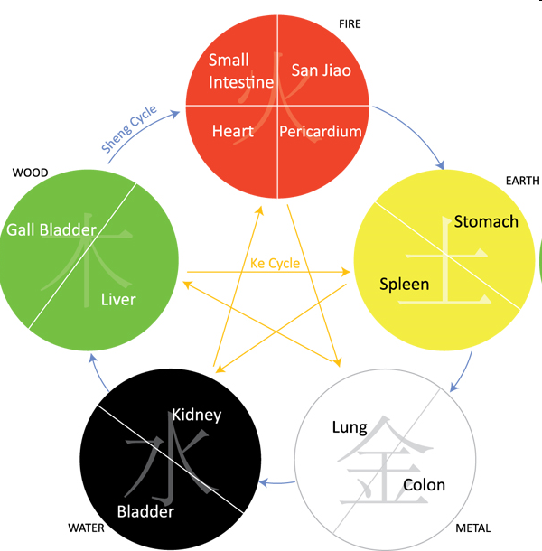
creation (moving from one circle to the next) eg earth creates metal
destruction (moving from 2 circles at a time, follow star pattern) eg water destructs fire
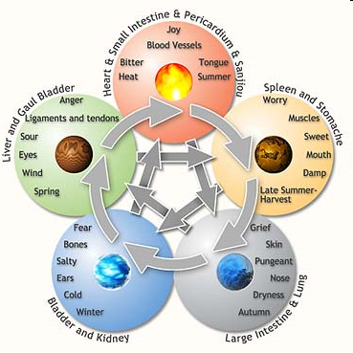

- Water:
  - problems with urinary tract, infertility, hypertension, endocrine disorder
- Wood:
  - fibromyalgia, vision problems, headaches
- Fire:
  - insomnia, CVD, digestive problems
- Earth:
  - eating disorders, sinus problems, GI disorder
- Metal:
  - asthma, bowel disorder

- Using the concepts for healing disease
  - environment affected health
  - external observation diagnoses, palpation of pulse, treatment & prevention of chronic conditions
  - restoration of bodily harmony through flow of Qi: Acupuncture, acupressure (Shiatsu), and herbs
  - Tai Chi (moving meditation): relaxation and diaphragmatic breathing to achieve body’s natural homeostasis

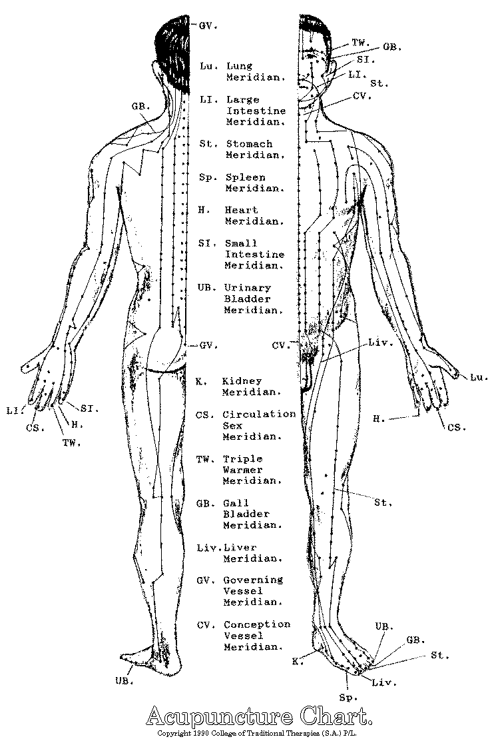

Ayurveda

- Oldest system of natural medicine; life science (~5000BC)
  - Similar to TCM: treating imbalance with complement
- Doshas (three body types)
  - Vata (Ecto): dry energy; air and space
  - Pitta (Meso): hot energy; fire and water
  - Kapha (Endo): heavy energy; water and earth
- Each dosha has five sub-doshas
  - Practitioner uses this to diagnose and treat specific areas of body
- Metabolic principles of functioning:
  - Most people are a combination of the three doshas
  - Exercise, relaxation, and diet dictated by body type

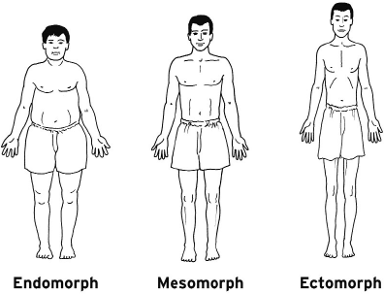

- Kapha dosha
  - Solid and powerful; slow & steady energy level; calm disposition
  - Tendency to gain weight; 8+ hours of sleep
  - Chest congestion and blocked sinuses
- Pitta dosha
  - Fast metabolism; energetic; medium build and strength
  - Irritable, aggressive
  - Sharp intellect and articulate in speech; orderly and precise
  - Prone to excess sweating
- Vata dosha
  - Thin physique and very active (mentally and physically)
  - Difficulty falling asleep and staying rested
  - Quick to learn but also quick to forget
  - Trouble with intestinal gas

- Ayurveda and Yoga
  - Yoga: bind, join, unite, control (beyond artificial separation)
    - Mind and body; the individual and the universe
  - Critical self-inquiry, inner consciousness = understanding of reality
  - Faith = actual lived experience
- Different psychological types; yoga addresses these types (breathing and internal focus):
  - Introvert/extrovert, emotional/analytic, contemplative/active

