Anatomy & Physiology
  - Section 1.1, 1.2, 1.3

Anatomy
- The structure of body parts
- Their relationships to one another
  - Subdivision
    - Gross anatomy (visible to the naked eye)
    - Microscopic anatomy (cytology & histology)
    - Developmental anatomy
    - Specialized branches of anatomy
Physiology
- Function of the body parts
  - Topics: based on organ systems (renal physiology)
  - Focus: events at the cellular and molecular levels
  - Principles: basic physical and chemical principles (electrical currents, pressure, movement)
Principles of complementarity
Anatomy & Physiology are inseparable
- Function always reflects structure
- What a structure can do depends on its specific form
Interdependence of body cells
Humans are multicellular
- To function we must keep individual cells alive
- All cells depend on organ systems to meet their survival needs
Atoms -> molecules ->organelle->smooth muscle cell->smooth muscle tissue->blood vessel-> body
Chemical level -> cellular level -> tissue level -> organ level->organ system level -> organismal level
Relationships of organ systems
- All body functions spread among different organ systems
- Organ systems cooperate to maintain life

Integumentary System
- Forms external body covering
- Protects deeper tissues from injury
- Synthesizes vitamin D
- Houses cutaneous receptors, sweat, and oil glands
Skeletal System
- Protects and supports body organs
- Provides a framework for muscles to contract
- Blood cells are formed within bones
- Bones store minerals
Muscular System
- Allows locomotion, facial expression
- Maintain posture
- Produces heat
Nervous System
- Fast acting control system of body
- Responds to internal and external changes activation appropriate muscles and glands
Endocrine System
- Secrete hormones regulating growth, reproduction and metabolism
Cardiovascular System
- Heart pumps blood
- Blood vessels transport blood carrying oxygen, CO2, nutrients and waste
Lymphatic System
- Picks up fluid leaked from blood vessels and returns it to blood
- Dispose of debris in lymphatic stream
- Houses white blood cells involved in immunity
- Immune response mounts attack against foreign substances
Respiratory System
- Keeps blood constantly supplied with oxygen
- Removes CO2
- Exchange through walls of the air sacs of the lungs
Digestive System
- Breaks down food into absorbable units entering blood to distribute
- Indigestible foodstuffs are eliminated as feces
Urinary System
- Eliminates nitrogenous wastes from the body
- Regulates water electrolytes and acid-base balance of the blood
Reproductive System
  - Male:
    - Testes: sperm and male sex hormone
    - Ducts and glands: sperm to female reproductive tract
  - Female:
    - Production of offspring
    - Ovaries: eggs and female sex hormones
    - Remaining: fertilization and fetus development
    - Mammary glands: milk to nourish
Necessary Life Functions
- Maintaining boundaries (plasma membrane, skin)
- Movement (skeletal, cardiac & smooth muscle)
- Responsiveness (withdraw reflex, breathing control)
- Digestion (food breakdowns and absorption)
- Metabolism (catabolism & anabolism)
- Excretion (removal of waste, urea CO2, feces)
- Reproduction (growth, repair, production of offspring)
- Growth (increase size of body part or organism)
Survival Needs
Appropriate amounts necessary for life, too little, too less = harmful
- Nutrients: chemicals for energy and cell building
- Oxygen: essential for energy release (ATP production)
- Water: chemical reactions, secretions & excretions
- Normal body temperature: 37 degrees affects rate of chemical reactions
- Appropriate atmospheric pressure: for adequate and gas exchange in lungs
Anatomical Position
- Body erect
- Feet slightly apart
- Palms facing forward, thumbs away from body
- Right and left directions viewed by observer
Orientation & Directional Terms
- Superior (cranial)
- Inferior (caudal)
- Ventral (anterior)
- Dorsal (posterior)
Orientation
- Medial
- Lateral
- Intermediate
Direction
- Proximal
- Didal
- Superficial (external)
- Deep (internal)
Anterior/Ventral
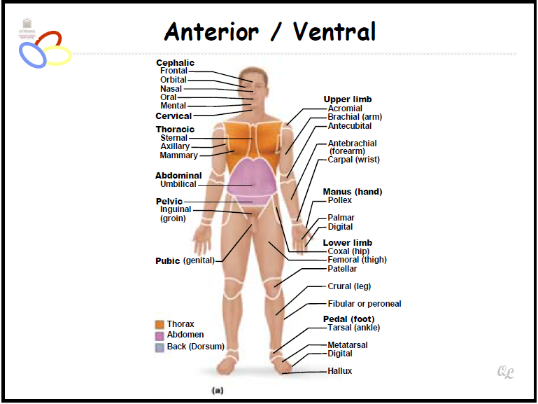

Posterior/Dorsal
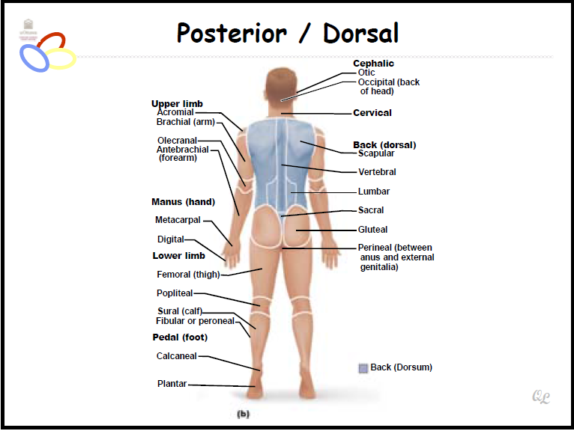

Regional Terms
Two major divisions of body
- Axial : head neck trunk
- Appendicular : limbs
Anatomical Variability
- Humans differ externally and internally
  - 90% of all body structures match description
  - Nerve or blood vessel may be out of place
  - Small muscle may be missing
- Extreme variations inconsistent with life

Body Planes & Sections
- Body plane
  - Flat surface along which body may be cut
- Sections
  - Cuts or sections made along body place
Body Planes
- Frontal plane (through torso)
- Median (midsagittal) plane (torse, inferior view)
- Transverse plane
Body cavities
Closed to environment
- Dorsal body cavity
- Ventral body cavity
Dorsal & Ventral Body Cavities
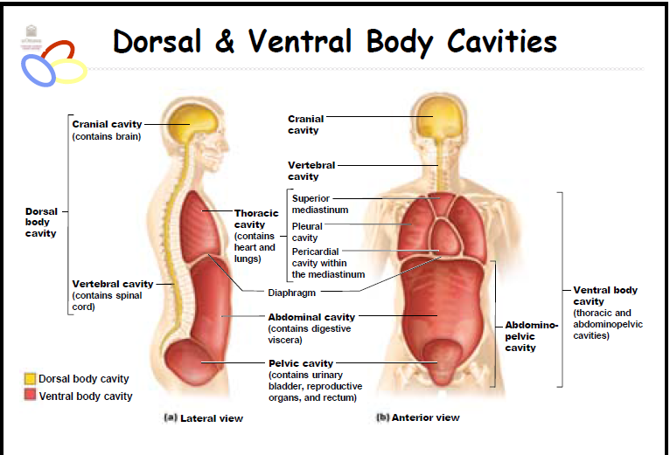

Serous Membrane Relationships
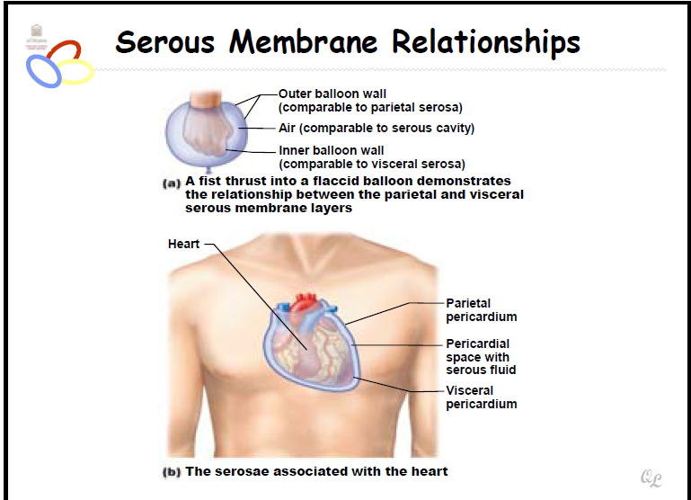

4 Abdominopelvic quadrants
- Right upper quadrant
- Left upper quadrant
- Right bottom quadrant
- Left bottom quadrant
9 Abdomniopelvic regions
- Right hypochondriac region
- Epigastric region
- Left hypochondriac region
- Right lumbar region
- Umbilical region
- Left lumbar region
- Right iliac (inguinal) region
- Hypogastric (public) region
- Left iliac (inguinal) region
Other Body Cavities
- Exposed to environment
  - Oral and digestive cavities
  - Nasal cavity
  - Orbital cavities
  - Middle ear cavities
- Not exposed to environment
  - Synovial cavities
TEXTBOOK
Anatomy: studies the structure of body parts and their relationships to one another, certain appeal because its concrete, body structures can be seen, felt, examined
Physiology: concerns the functions of the body; how the body parts work and carry out their life sustaining activities. Explained only in terms of the underlying anatomy
Topics of Anatomy
- Broad field with many subdivisions
  - Gross/macroscopic anatomy: study of large body structures visible to naked eye, heart, lungs, kidneys. Approached in different ways
    - Regional anatomy: all the structures (muscles, bones, blood vessels, nerves) in a particular region of the body such as the abdomen or leg are examined at the same time
    - Systemic anatomy: body structure is studied system by system, when studying cardiovascular system you would examine the heart and the blood vessels of the entire body
    - Surface anatomy: study of internal structures as they relate to the overlying skin surface, use surface anatomy when you identify the bulging muscles beneath a bodybuilders skin and clinicians use it to locate appropriate blood vessels for pulse and draw blood
    - Microscopic anatomy: deals with structures too small to be seen with naked eye, thin slices of cell tissue examined under microscope, subdivisions-
      - Cytology: considers the cells of the body
      - Histology: the study of tissues
    - Developmental anatomy: traces structural changes that occur in the body throughout the life span
      - Embryology: concerns developmental changes that occur before birth
Pathological anatomy: studies structural changes caused by disease
Radiographic anatomy: studies internal structures as visualized by X-ray images

Topics of Physiology
- Consider operation of specific organ systems, focuses on events at cellular or molecular level.
  - Renal physiology: concerns the kidney function and urine production
  - Neurophysiology: explains the workings of the nervous system
  - Cardiovascular: examines the operation of the heart and blood vessels
Principle of complementarity of structure and function: function always reflects structure
Levels of structural organization
- Human body has many levels of structural organization
  - Chemical level: atoms, tiny building blocks of matter, combine to form molecules such as water and proteins, molecules associate in specific ways to form organelles, basic components of microscopic cells. Cells are smallest units of living things
  - Cellular level: all cells have some common functions, individual cells vary in size, functions, shape
  - Tissue level: tissues are groups of similar cells that have a common function. There are 4 basic tissue types in the body
    - Epithelium – covers the body surface and lines its cavities
    - Muscle – provides movement
    - Connective tissue – supports and protects body organs
    - Nervous tissue - provides a mean of rapid internal communication by transmitting electrical impulses
  - Organ level: organ is discrete structure composed of at least two tissue types, performs a specific functions for the body, extremely complex functions become possible. Stomach: its lining is an epithelium that produces digestive juices, the bulk of its wall is muscle, churns and mixes stomach contents, its connective tissues reinforce the soft muscular walls. Its nerve fibers increase digestive activity by stimulating muscle to contract and glands to secrete more juices.
  - Organ system level: organs that work together to accomplish a common purpose. The heart and blood vessels of the cardiovascular system circulate blood continuously to carry oxygen and nutrients to all body cells.
  - Organismal level: the organism. The living human being, represents the sum total of all structural levels working together to keep us alive.
Necessary functions of life
- Maintaining boundaries
- Movement
- Responsiveness
- Digestion
- Metabolism
- Excretion
- Reproduction
- growth
Survival Needs
- nutrients
- oxygen
- water
- normal body temperature
- appropriate atmospheric pressure
Homeostasis
- dynamic state of equilibrium in which internal conditions vary but always within relatively narrow limits, the body is in this state when its needs are adequately met and it is functioning smoothly.
  - Homeostatic control : communication within the body is essential – by nervous and endocrine system
    - All homeostatic control mechanisms are processes involving 3 components that work together
- Receptor: sensor that monitors the environment and responds to changes, stimuli, by sending information, input, to second component. Input flows from receptor to second component along afferent pathway
- Control center: determines the set point, range at which the variable is to be maintained, analyzes the input received and determines the appropriate response or course of action. Information, output, then flows from the control center to third component along the efferent pathway
- Effector: provides the means for the control centre’s response to the stimuli. The results of the response then feedback to influence the effect of the stimulus, either reducing it (neg. feedback) or enhancing it (pos. feedback)
- Negative feedback
  - The output shuts off the original effect of the stimulus or reduces its intensity.
  - Cause the variable to change in a direction opposite to that of the initial change, returning it to it’s ‘’ideal’’ value.
  - Home heating system connected to a temperature sensing thermostat, the thermostat houses both the receptor and the control center, if the thermostat is set at 20ᵒC, the heating system (effector) is triggered ON when the house temperature drops below that setting. As the furnace produces heat and warms the air, the temperature rises, and when it reaches 20ᵒC the thermostat triggers the furnace OFF.
  - Withdrawal reflex
  - Endocrine system is important, hormonal negative feedback mechanism is control of blood sugar rises, receptors in the body sense this change and the pancreas secretes insulin into the blood. This change in turn prompts body cells to absorb ore glucose, removing it from the bloodstream. As blood sugar falls, the stimulus for insulin release ends.
- Positive feedback
  - Result enhances the original stimulus so that the response is accelerated
  - The change that results proceeds in the same direction as the initial change which carries the variable to deviate further and further from the original value
  - Oxytocin, hypothalamic hormone, intensifies labor contractions during the birth of a baby. Oxytocin causes the contractions to become both more frequent and more powerful. The increased contractions cause more oxytocin to be released, which causes more contractions, and so on until the baby if finally born. The birth ends the stimulus for oxytocin release and shuts off the positive feedback mechanism.
Homeostatic imbalance
- Disease can be regarded as a result of its disturbance – imbalance
- As we age our body’s control systems become less efficient, internal environment becomes less and less stable
- Occurs when negative feedback mechanisms are overwhelmed and destructive positive feedback mechanisms take over

Cells & Tissues
  - Ch.3: pg 62-63, 81-93 Ch.4: pg 116-142

Cell theory
- The structural and functional unit of life
- Organismal functions depend on individual & collective cell functions
- Biochemical activities of cells are dictated by their shapes or forms, and specific subcellular structures
- Continuity of life has cellular basis
Cell diversity
- Trillion of cells
- Over 200 types
- Differ in
  - Size
  - Shape
  - Subcellular components
  - Functions
Generalized cell
- All cells have some common structures & functions
  - Basic parts of human cells
    - Plasma membrane: flexible outer boundary
    - Cytoplasm : intracellular fluid & organelles
    - Nucleus : control centre
Plasma membrane
- Plays dynamic role in cellular activity
- Separates intracellular from extracellular
  - Lipid bilayer
    - Phospholipids
    - Glycolipids
    - Cholesterol
  - Membrane proteins
    - Integral
    - Peripheral
  - Glycocalyz
    - Biological marker
- Lipid bilyarer & proteins in constantly changing fluid mosaic

Cytoplasm
- Between plasma membrane and nucleus
  - Cytosol
    - Water with solutes
  - Organelle
    - Metabolic machinery of cell; each with specialized function; either membranous or nonmembranous
  - Inclusions
    - Vary with cell type: glycogen granules, pigments, lipid droplets, vacuoles, crystals
Cytoplasmic organelles
- Membranous
  - Mitochondria: power house of the cell, providing most of its ATP supply. Enclosed by 2 membranes. Outer and inner, the inner membrane folds inwards forming shelf like cristae that protrude into the matrix. Contain their own DNA, RNA and ribosomes and are able to reproduce themselves.
  - ER : interconnected tubes enclosing fluid filled cavities. Can be Rough or Smooth
  - Golgi apparatus: stacked and flattened membranous sacs, ‘’traffic director’’ for cellular proteins. To modify, concentrate and package the proteins and lipids made at the RER
  - Peroxisomes: contain powerful enzymes
  - Lysosomes: containing activated digestive enzymes.
- Non-membranous
  - Ribosomes: composed of proteins, sites of protein synthesis, some float freely in cytoplasm while others are attached to membranes.
  - Cytoskeleton: cell skeleton, elaborate network of rods running through the cytosol and hundreds of accessory proteins, supports the cell structure and providing machinery to generate various cell movements. 3 types of rods in the cytoskeleton
      - Microfilaments
      - Intermediate filaments
      - Microtubules
  - Centrioles: minute body found near the nucleus which contains paired organelles called centrioles.
Mitochondria
- Double membrane structure with inner shelf life cristae
- Provide most of cells ATP via aerobic cellular respiration
- Contain their own DNA, RNA, ribosomes
- Similar to bacteria, capable of cell division (fission)

Ribosomes
- Site of protein synthesis
- Granules containing protein &rRNA
- Free ribosomes synthesize soluble proteins that function in cytosol or other organelles
- Membrane-bound ribosomes forming rough ER synthesize proteins to be incorporated into membranes, lysosomes, or exported from cell
Endoplasmic Reticulum ( ER )
- Interconnected tubes & parallel membranes enclosing cissterns
- Continuous with outer nucleus membrane
  - Rough ER produces all protein secreted from cell
  - Smooth ER involved in lipid, glycogen metabolism & detoxification processes

Golgi Apparatus
- Stacked & flattened membranous sacs
- Modifies, concentrates, and packages proteins & lipids from the rough ER
- Transports vessels from ER fuse with convex cis face; proteins modified tagged for delivery, sorted, packaged in vesicles
Peroxisome
- Membranous sacs containing powerful oxidases & catalases
- Detoxify harmful or toxic substances
- Catalylsis and synthesis of fatty acids
- Neutralize dangerous free radicals (highly reactive chemicals with unpaired electrons)
  - Oxidases convert to H₂O₂ (toxic)
  - Catalases convert H₂O₂ to water & oxygen
Lysosomes
- Spherical membranous bags containing digestive enzymes, ‘’safe’’ site for intracellular digestion
- Digest ingested bacteria, viruses and toxins
- Degrade non-functional organelles
- Destroy cells in injured or non-useful tissue
- Metabolic functions break down and release glycogen
- Break down bone to release Ca²⁺
Endomembrane system
- Overall function to produce, degrade, store and export biological molecules and to degrade potentially harmful substances
- Includes ER, golgi apparatus, secretory vesicles, lysosomes, nuclear and plasma membranes

Centrosome & centrioles
- Centrosome ’cell centre’’ near nucleus
- Generates microtubules, organizes mitotic spindle
- Contains paired centrioles – organelles, small tubes formed by microtubules
- Centrioles form basis of cilia and flagella
Cytoskeleton
- Elaborate series of rods throughout cytosol
- Proteins links rods to other cell structures.
Cellular extensions
- Cilia
  - Whiplike, motile cellular extensions on the surfaces of some cells
- Flagella
  - Long cellular projections that move the cell itself through the environment
- Microvilli
  - Fingerlike extensions of the plasma membrane that increase surface area
The nucleus
- Contains the cellular DNA and determines the kids and amounts of proteins to be synthesized in a cell
- Most cells are uninucleate
- Few are multinucleate
- Red blood cells are anucleate
- Three structure of the nucleus
  - Nuclear envelope
  - Nucleoli
  - Chromatin
Tissue – living fabric
- Individual body cells are specialized
  - each type of cell performs specific functions that maintains homeostasis
- Tissue
  - group of cells similar in structures that perform common or related functions
- histology
  - study of tissues and their cellular organization (fixed, sliced, stained)

Primary tissue types
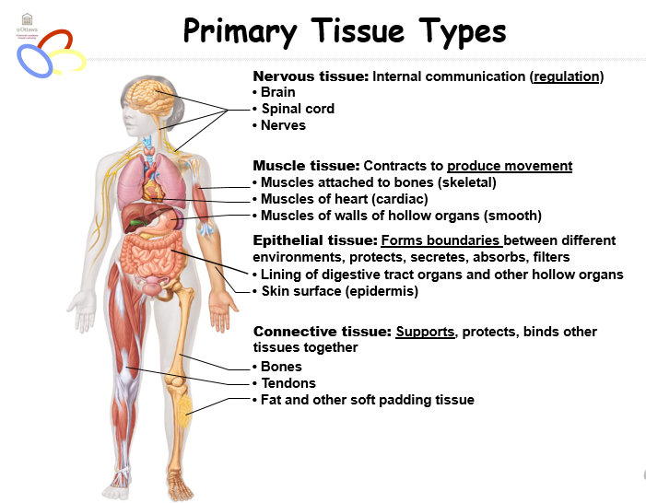
Epithelial Tissue (Epithelium)
- two main types (by location)
  - covering and lining epithelia on external and internal surfaces
  - glandular epithelia secretory tissue in glands
- form boundaries
  - protection, absorption, filtration, excretion, secretion, sensory reception.

Characteristics of Epithelium
- polarity (apical and basal)
- specialized contacts
- supported by connective tissues
- innervated but avascular
- can regenerate

Classification of Epithelium
- all epithelia tissue have two names
  - one indicates number of cell layers
    - simple epithelia (single layer of cells)
    - stratified epithelia (two or more layers of cells)
  - one indicates shape of cells
    - squamous (flattened and scale like, nucleus flattened)
    - cuboidal (box like, round nucleus)
    - columnar (tall, column shaped, elongated nucleus)
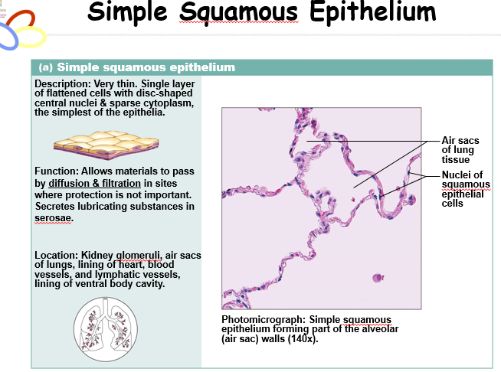
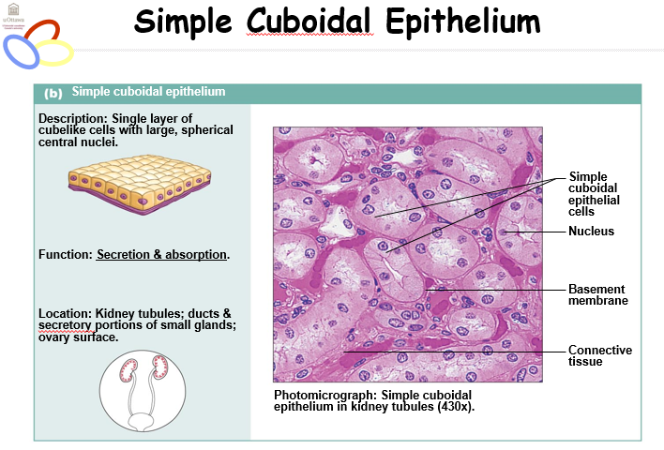
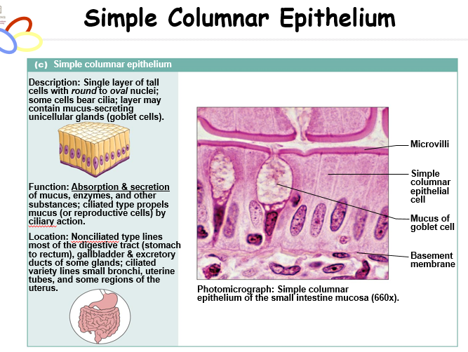
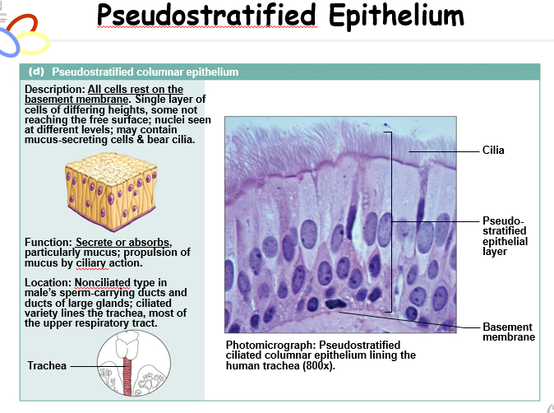
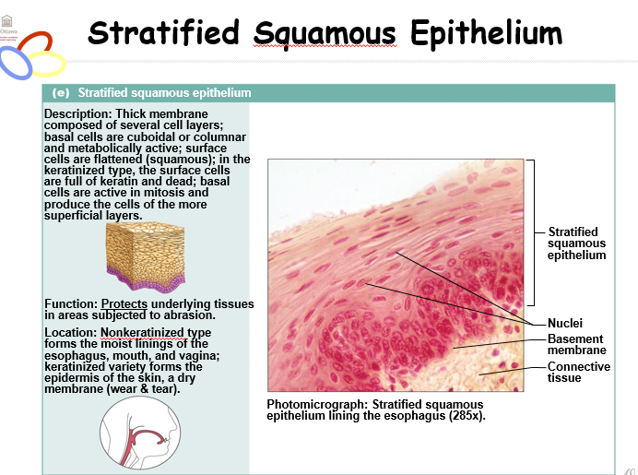
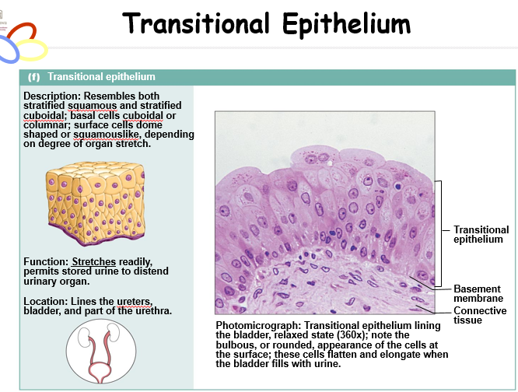
Glandular Epithelium
- gland: one or more cells that make and secrete an aqueous fluid
- classification
  - site of product release
  - endocrine glands ductless
  - exocrine glands (sweat, salivary, mammary, liver,)
- relative number of cells ( uni or multi)
- methods of secretion
    - merocrine – exocytosis
    - holocrine – cell rupture
    - apocrine – cell apex pinches off
Connective Tissue
- characteristics make connective tissues different from other primary tissues
- mesenchyme embryonic tissue as their common tissue organ
- varying degrees of vascularity blood vessels
- extracellular matrix
  - not composed mainly of cells
  - largely nonliving extracellular matrix separates cells
Structure elements
- three elements
- ground substance
- fibres
- cells
Major functions
- binding and support
- protecting
- insulating
- storing reserve fuel (fat cells)
- transporting substances (blood)
Connective Tissue Proper
- all connective tissues except bone, cartilage and blood
- two subclasses
- loose connective tissues
  - areolar: support and bind body parts, universal packing material between other tissues, widely distributed, provide reservoir of water and salts, defend against inflection, store nutrients as fat, fibroblasts, loose arrangement of fibres, ground substance, when inflamed it soaks up fluid
  - Adipose:
    - White fat: similar to areolar but greater nutrient storage, adipocyte stores nutrients, richly vascularized, nutrient storage, protection and insulation
    - Brown fat: rich in mitochondria, use lipid fuels to heat bloodstream to warm the body
  - Reticular: resembles areolar, network of reticular fibers, fibroblasts called reticular cells, forms the internal framework of the lymph nodes, spleen and bone marrow, supports free blood cells
- dense connective tissues
  - regular: closely packed bundles of collagen fibres running parallel to direction of pull (make up tendons and ligaments), white structures with great resistance to pulling, fibers slightly wavy so stretch a little, fibroblasts manufactures fibers and ground substance, few cells, poorly vascularized
  - irregular: same elements as dense but bundles of collagen are thicker and irregularly shaped, resists tension from many directions, dermis, fibrous joint capsules, fibrous coverings of some organs
  - elastic: more stretchy than dense, many of larger arteries have in the walls

Cartilage
- Chondroblasts & chondrocytes
- Tough yet flexible
- Lacks nerve fibers
- Up to 80% water (can rebound after compression)
- Avascular: Receives nutrients from membrane around it (perichondrium)
  - Three types
    - Hyaline cartilage
    - Elastic cartilage
    - Fibrocartilage
Bone
- Also called osseous tissue
- Supports and protects body structures
- Stores fat and synthesizes blood cells in cavities
- More collagen than cartilage
- Has inorganic calcium salts
- Osteoblasts produce matrix
- Osteocytes maintain the matrix
- Osteons – structural units
- Richly vascularized
Blood
- Most atypical connective tissue, a fluid
- Red blood cells are most common cell type
- Also contains white blood cells and platelets
- Fibers are soluble proteins that precipitate during blood clotting
- Functions in transport
Muscle Tissue
- Highly vascularized
- Responsible for most types of movement
  - 3 types
    - Skeletal muscle tissue
      - Voluntary
    - Cardiac muscle tissue
      - Heart, involuntary
    - Smooth muscle tissue
      - Mainly in walls of hollow organs other than the heart, involuntary

Nervous Tissue
- Main component of nervous system
  - Brain, spinal cord, nerves
- Neurons
  - Specialized nerve cells that generate and conduct nerve impulses
- Neuroglia
  - Support, insulate and protect neurons
Covering and Lining Membranes
- Composed of at least two primary tissue types
  - An epithelium bound to underlying connective tissue proper
  - Simple organs
- Cutaneous Mucous Serous membranes
Textbook
- Robert Hooke first observed plant cells with a crude microscope 1600s
- 2 German scientists, Matthias Schleiden and Theodor Schwann proposed that all living things are composed of cells
- Rudolf Virchow extended this idea by contending that cells arise only from other cells
Cell theory
- Cell is that basic structural and functional unit of living organisms, when you define cell properties, you define the properties of life
- The activity of an organism depends on both the individual and collective activities of its cells
- According to the principle of complementarity of structure and function, the biochemical activities of cells are dictated by their shapes or forms, and by the relative number of their specific subcellular structures
- Continuity of life from one generation to another has a cellular basis

Tissue class and example | Subclasses | Cells | Matrix | General features
Connective tissue | 1)Loose  - areolar  - adipose  - reticular  2)Dense  - regular  - irregular  - elastic | Fibroblasts  Fibrocytes  Defense cells  Adipocytes | Gel-like ground substance  All three fiber types:  -Collagen  -Reticular  -Elastic | 6 different types vary in density and fiber types  Functions as binding tissues  Resist mechanical stress, tension  Provides reservoir for water and salts  Nutrient, fat, storage
Cartilage | 1)Hyaline  2)Elastic  3)Fibrocartilage | Chrondroblasts found in growing cartilage  Chondrocytes | Gel-like ground substance  Fibers; Collagen, elastic in some | Resists compression because of the large amounts of water held in the matrix  Functions to cushion and support body structures
Bone tissue | 1)Compact bone  2)Spongy bone | Osteoblasts  Osteocytes | Gel-like ground substance calcified with inorganic salts  Fiber; collagen | Hard tissue that resists both compression and tension  Functions in support
Blood |  | Erythrocytes (RBC)  Leukocytes (WBC)  Platelets | Plasma  No fibers | A fluid tissue  Functions to carry O2, CO2, nutrients, wastes and other substances (hormones)

Cellular Physiology of Nerve and Muscle
  - 2.1 pg.62-79 2.1.1 2.2
Fluid mosaic model
- Not rigid can change its shape, fluidity associated with the membrane
- A lipid bilayer (phospholipids), within the membrane there are tons of proteins, either go through or stay on surface or on the inside
- Hydrophilic and hydrophobic properties
- Integral membrane proteins – span plasma membrane: hydrophilic & hydrophobic regions, channels, transporters, carriers, receptors, enzymes
  - hydrophillic facing outward (likes water contact), hydrophobic is facing inwards (doesn’t like water contact)
  - Lipid bilayer is inert, no charge
Membrane component roles
- Integral membrane proteins – transmit information across bilayer
- Phospholipids – bilayer, barrier function
- Peripheral proteins – attached to integral membrane protein, may be enzymes, linkers or adaptors regulate signals and shape changes. Peripheral proteins are outside bilayer
- Cytoskeleton – made up of a variety of contractile like proteins, interact with cytoplasmic phase, provide strength, interacts with receptors, channels
- Glycocalyx – carbohydrate moieties proteins and phospholipids on extracellular surface ‘’sugar coating’’ on membrane – glycocalyx changes when cell becomes cancerous, can even change repeatedly to avoid recognition by immune system.
- Cholesterol – impacts membrane fluidity and structures
Some functions of plasma membrane proteins
- Transport
- Enzyme activity
  - Sensitive to environment outside cell or change to lipid bilayer, changes performance
- Receptors for signal transduction
- Intercellular joining
  - Forming muscle, tissue.
- Cell-cell recognition
- Attachment to extracellular membrane
Membrane junctions
- Tight junctions
  - Nothing can seep between them, cell fusion meditated by integral membrane proteins of PM in adjacent cells to form impermeable junctions. Prevent passing of molecules through extra cellular space between adjacent cells. Only things that you want to go through not things that you don’t want
- Desmosomes
  - transmission of force between cells, anchoring proteins, molecular linking of cells to resist mechanical stress, plaque, linker filaments-cadherins keratin filaments- intermediate filaments,
- Gap junctions
  - allow membrane of one cell to be held in opposition to other, forms channels between two different cells, allows molecules to go from one cell to the other, molecular channels between cells to allow passage of cytoplasmic molecules – metabolic and electrical coupling, connexions, important in electrically-excitable tissues. Allows for information metabolic products to go through one cell to other.
Functions of the plasma membrane
- effective barrier between the intracellular and extracellular fluids
- signal transduction
- allows the cell to respond to changes in the extracellular fluid
- site of cell to cell interaction and recognition
Plasma membrane – the transporter
- selectively permeable barrier between interstitial fluid and cytoplasm hydrophobic environment -> what about water soluble substances? Lipid soluble goes through easily.
- Interstitial fluid is a filtrate of blood – contains salts, sugars, amino acids, vitamins, hormones, metabolise, gases such as oxygen, and carbon dioxide
- To maintain homeostasis and function normally a cell must have exact needs in the right amounts
Passive process
- Diffusion
  - Tendency of molecules or ions to scatter evenly throughout the environment
  - Molecules have kinetic energy
  - How is diffusion rate influenced by:
    - Gradient slope
    - Molecules size
    - Temperature
Simple diffusion across the plasma membrane
- Nonpolar, lipid-soluble, oxygen, carbon dioxide, fats, urea, alcohol
- O2 and CO2 follow gradients into and out of cells
Facilitated diffusion using a physiological example
- Features of facilitated diffusion
  - Specific
  - Not ATP requiring
  - Limited by carrier saturation
  - Movement down concentration gradient
  - Can be inhibited by certain substances
- Carrier mediated
  - Lipid insoluble molecules too large to pass through membrane pores/channels
  - What is the most well-known substance that is transported by carrier mediated facilitated diffusion? -> glucose
- Channel mediated
  - Selective due to pore size, charges of amino acids that line channels
  - Some are always open (leakage channels)
  - Opening of other is controlled (gated channels)
  - But movement always down concentration gradient
  - Can be inhibited can show saturation and are usually specific
- Process filtration
  - Water and solutes forced through membrane or capillary wall by fluid or hydrostatic pressure
  - Fluid out of capillaries to cells of tissues to form urine
  - Not selective- only RBCs and large protein molecules don’t get through
Primary active and secondary active transport, passive transport, symport and antiport
- ATP used because substance is
  - Too large
  - Lipid insoluble
  - Moving against the gradient
- Active transport
  - Requires a carrier and combines specifically and reversibly with substances, solute pumps move substances (amino acids, Na, K, Ca) against concentration gradients
- Many active transport systems are coupled systems
- Symport: Na and AA or glucose, Na, K, 2Cl cotransporter, substances go in the same direction
- Aniport: ATPase, Na, K, substances go opposite directions, taking something out and something else comes in.
- Primary active transport
  - [K] is 10-20x higher inside cell than outside
  - [Na] higher outside cell than inside
  - Gradients essential to maintain normal cell function/responsiveness/volume
  - Maintenance of this gradient challenged by:
    - Slow leakage of K and Na along concentration gradients
    - Stimulation of muscle and nerve cells
  - Na/K/ATPase functions continuously to maintain Na and K gradients
  - 3 Na ions are pumped out for every 2 K ions pumped in moving against gradients to maintain cell responsiveness
- Secondary active transport
  - Transport of a solute is not couple directly to energy yielding reactions
  - Transport of an ion or amino acid as Na leaks back into cell along its concentration gradient
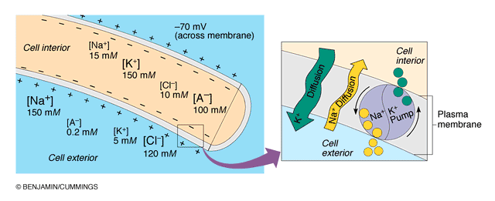
  - Gradient drives transport but gradient would not exist except for Na/K/ATPase

- Exocytosis, endocytosis as active transport mechanisms
  - Generally called vesicular transport
  - ATP requiring
    - Exocytosis
      - Secretion of hormones, neurotransmitters, mucus, ejection of waste
      - Substance is enclosed in a vesicle, vesicle moves to PM, fuses with PM, ruptures, releasing contents outside of cell
    - Endocytosis
      - Means by which large particles enter a cell
      - ATP requiring energy for moving vesicle movement
      - Vesicle enclosed substance, pinches off and moves into cytoplasm where contents are digested.
Osmosis and explain its role in fluid homeostasis
- Unassisted diffusion of water from area of low to high solute concentration across semipermeable membrane
- Polar but small enough for most pores aquaporin
- Net movement due to water concentration gradient
- Water concentration goes down in response to high number of solute particles in solutions (osmolarity)
- Animal cells swell or shrink in response to water movement until equilibrium or rupture
    - Osmolarity: total concentration of solute particles in a solution
    - Tonicity: concentration of no penetrating solute particles in a solution = ability of solution to change the shape of a cell bathed by that solution
Regions of the neuron and associate with functions of reception, propagation, transmission
Three functional regions (plasma membrane very important in all regions)
  - Receptive region
  - Conducting region
  - Secretory region
- Neuron cell body
  - Large spherical nucleus and granular cytoplasm -> biosynthetic centre
  - Extensive RER and ribosome clusters (nissl bodies) also elaborate Golgi and lots of mitochondria
  - CNS/PNS as a whole
- Neuron processes
  - Dendrites
  - Axons
  - Axonal terminals
    - Tract: bundle of nerve processes in CNS
    - Nerve: bundle of nerve processes in PNS

- Dendrites
  - Short tapering branched extensions; usually hundreds/cell body
  - Enormous SA for reception from other neurons
  - Conduct impulses towards cell body
  - Short distance graded potentials
- Axon
  - Arises from axon hillock, variable length
  - Rate of conduction increases with axon diameter
  - Usu. 1 axon/neuron branches at end which end in axonal terminals
  - Neurotransmitters convey information from one axon to the next
  - Axon has same organelles as cell body but no Nissl bodies, axons quickly degenerate if cut
  - Elaborate cytoskeleton in axon to move material to and from:
    - Anterograde: mitos, cytoskeleton, membrane parts
    - Retrograde: organelles to be degraded/recycled
Resting membrane potential of an excitable cell in terms of differential permeability of cell membrane
Creating of resting membrane potential RMP
Fundamental principles of electricity:
- Voltage: electrical potential energy due to separation of oppositely charged particles
- Resting membrane potential: all cells polarized resting membrane potential cell type dependent negative
Measurement of resting membrane potential
- RMP for a neuron is -40 to -90 mV
Channels in plasma membranes:
- Passive or leakage channels: always open
- Active or gated channels: signal required to open/close
  - Chemically gated (neurotransmitter/hormone)
  - Voltage-gated (change in membrane potential)
Channels ion specific: channels open -> ions move in response to electrochemical gradients
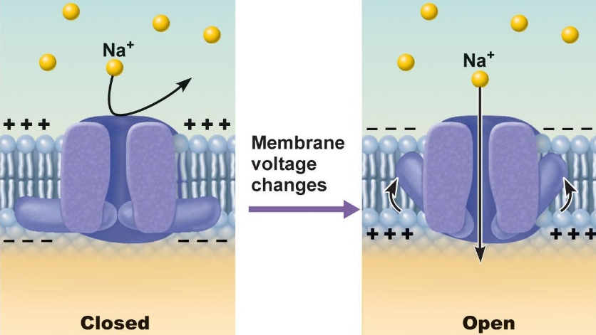

Neurons and muscle cells communicate by changing membrane potentials
Two types of signals
- Graded potentials
  - Short lived depolarisations or hyperpolarisations current decreases with distance traveled graded because magnitude determined by strength of stimulus
Initial stimulus depolarizes local area of membrane -> decremental movement of ions on either side of membrane propagates signal for short distance

- Action potentials
  - Propagation of an action potential
    - AP must traverse length of neuron to signal next neuron
    - Propagation rather than conduction of an action potential
    - Unidirectional

Depolarization and hyperpolarization
- Depolarization: increases the probability of producing nerve impulses
- Hyperpolarization: decreases the probability of producing nerve impulses
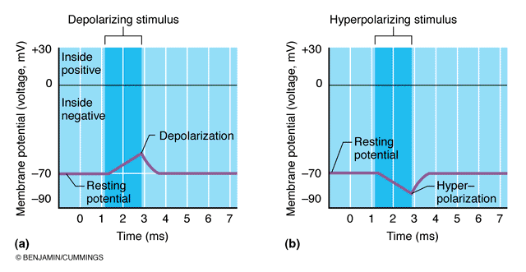

Describe and graph a typical action potential (threshold, hyperpolarization undershoot, absolute refractory period, relative refractory period)
- A brief reversal of membrane potential, total amplitude = ~100 mV (from -70 to 30 mV)
- Cells with excitable membranes (neurons) can generate action potentials; in neurons, only axons can generate action potentials
- Voltage gated channels on axons open and close in response to local currents
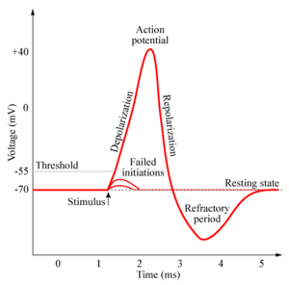

Generation of action potential
Transient increase in Na permeability -> restoration of Na impermeability -> transient increase in K permeability
- Depolarization phase
  - Increase in Na permeability:
    - resting state: voltage gated Na and K channels closed; normal leakage
    - Local depolarization : voltage gated Na channels open
  - Decrease in Na permeability
    - As membrane potential passes 0 mV inside positively resists further Na entry
    - Na gates begin to close, turning point in spike
    - Cell will now begin to repolarize
- Repolarization phase
  - Increase in K permeability
    - K leaves cell along electrochemical gradient and repolarises cell
    - Slow gates: so slow that do not close quickly enough after hyperpolarization
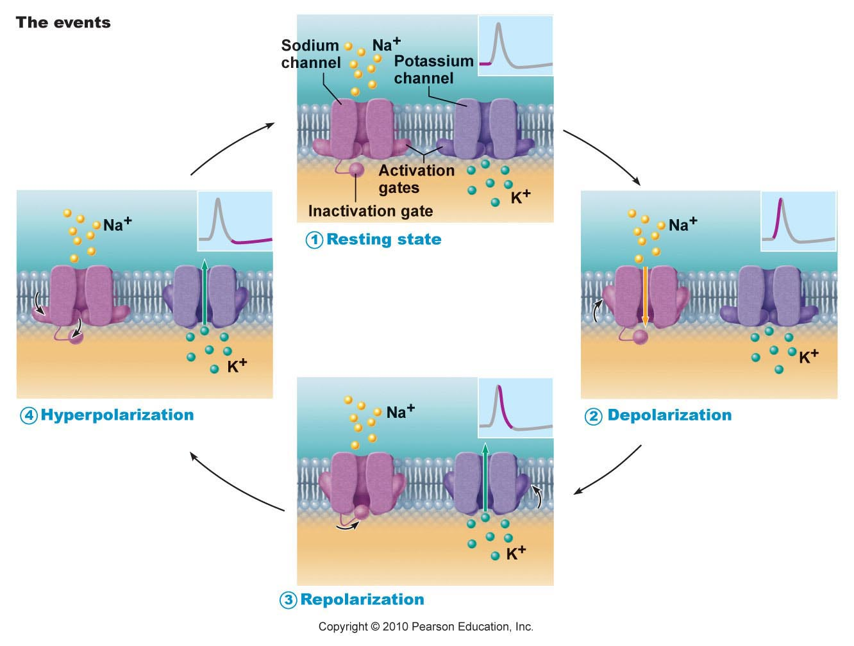
    - Na, K pumps quickly restore ion gradient across membrane

Threshold and all or none phenomenon
- Outward K current = inward Na current ( ~20 mV of depolarization)
- Local depolarization (graded) must sum to reach threshold or no AP
- AP all the same size stimulus intensity is indicate by AP frequency
- More pain -> greater frequency of the stimulus, opening and closing quicker rate

Absolute and Relative Refractory Periods
- Absolute RP: Na gates open and second depolarization impossible
- Relative RP: Na gates closed but K gates open; can only be stimulated by a very strong stimulus (greater than threshold); a means of increasing frequency when incoming stimulus is strong
Myelin sheath:
  - White lipid protein insulates and protects peripheral nerves
  - Increases rate of impulse propagation 150x
Schwann cells:
  - Membranes < 25% protein
  - Has role not just in making fat, important for regenerate activity, if you cut phereiheral nerve there may be regeneration.
  - Sit on top of axon
Node of Ranvier:
  - a gap in the myelin sheath of a nerve, between adjacent Schwann cells
  - not mylenated, need rapid depolarization to pass along to next set of nodes
Saltatory conduction:
  - propagation of action potentials along myelinated axons from one node of Ranvier to the next node, increasing the conduction velocity of action potentials without needing to increase the diameter of an axon
  - hops fom one axon to the next and so on
  - current moves
- dendrites are almost never myelinated
Oligodendrocytes (speciazlied glial cell):
  - a glial cell similar to an astrocyte but with fewer protuberances, concerned with the production of myelin in the central nervous system
  - found in central nervous system
  - produce fat then insulates the axon in CNS
  - reach different protists and get different axons myelinated
- microgllia : surveillance of CNS, protecting the body from invasion of foregins substanaces. Removes bacteria and viruses by exocytosis
- damage to CNS in terms of axon difficult to repair (try with stem cells)
*Multiple Sclerosis :
- persistent inflammatory response in which myelin sheaths gradually destroyed due to immune system or viral infections
- cycles of relapse and remission: flare-ups and then some healing and myelin regeneration; due to myelin around axon can regenerate depending where damage is, sometimes cant keep up with damage, classic case wehre you take away the insulator so now we don’t have rapid condcuction because the ions can move without crossing the cell membrane theres not myeline to prevent leaking axons so not myeline to protect escape of charge, so problems with conduction. axons develop more Na⁺ channels in demyelinated areas
- blindness (optic nerve defect), muscle weakness (not stimulating them, charges not coordinated), clumsiness, urinary incontinence
- ultimately myelin destruction is permanent and axons “drop out” or degenerate
  - Therapy:
(1) reduce inflammatory destruction
(2) manage symptoms physiotherapy
(3) promote repair of damaged myelin
Mechanism of synaptic transmission
- The synapse
  - Junction between 2 neurons or neuron + effector, when two neruons communicate its because they can make a synapse, one neuron with dendrite and other with axon the close connection is called the synapse
  - Majority of communication due to neurotransmitters ( different neurons have terminals that have vesicles – own neuronstramsitters for each neuron group )
  - Ca responsible for fuions, at the vescle, when fuse emptry contents into the synaptic cleft
  - Neurotransmitters release and it hits the receptor which carries out the information transfer from one axon cell body, to neighbouring one
  - Presynaptic vs postsynaptic neuron (most neurons are both)
  - 2 types of syanapses
    - Electrical: less common; like gap junctions. Direct current flow – protein channels. Rapid transmission (electrically coupled). The neurons are synchronized. Primarily embryonic, eye movement, in non-nervous tissue, found in cardiac & smooth muscles wehre it can synchronize contractions
    - Chemical: release and binding of neurotransmitters (functions to open or close ion channels that influence membrane permeability and consequently membrane potential) whole concept is to depolarize membrane so that we have a change in membrane potential due to ion movment
    - 2 parts
      - Axonal terminal: structure of a neuron, sending nerve signals to different parts of the body, as they contain synapses where neurotransmitters are unconfined for communication purposes with other neurons.
      - Receptor region: respond to light, heat, or other external stimulus and transmit a signal to a sensory nerve
*neurotransmission is unidirectional – only one direction because at the synapse its going one way, because the neuron release goes to the one that senses it, goes along the axon, cant go backwards, area is refractory will stimulate the receving one, once you get to terminal its one way.

Mechanism of synaptic communicaton
- Initiation
  - Ca gates open in presynaptic terminal
  - Neurotransmitter release
  - Neurotransmitter binds to postsynaptic receptors
  - Ion channels open in postsynaptic membranes (membrane of neurons being excited)
  - Greater the stimulus more vesicles will be released, more ions to activiate ion channel
- Termination 3 options
  - Degradation by enzymes of postsynaptic membrane (acetylcholine released into synaptic cleft breking down to acetate and choline, choline taken back up, redo process) transmistter can diffuse away from synapse
  - Reuptake by presynaptic terminal (norepinephrine)
  - Diffusion away from synaptic site (nitric oxide)
- Synaptic dealy
  - Slowest (rate limiting) step of neurotransmission
  - Time for neurotransmitter release, diffusion & receptor binding 0.3 – 5.0 ms
  - Signal gets delayed in synapse, looking at diffusion, transport, release process, things travelling slowly diffusing over one cell to another, we are slowing everything down.
Postsynaptic potentials
- Channels respond to chemicals rather than changes in membrane potential channels mediate local changes in membrane potential : graded per amount of neurotrasmitters
Two types of PSPs
- Excitatory postsynaptic potentials (EPSPs) : neurotransmistter binding -> membrane depolarization -> opens one channel for both Na and K electrochemical gradient for Na steeper than for K.
*what is generated is not an action potential, only axonal membranes can generate action potentials. Get local, graded depolarizations called EPSPs; if its strong enough to reach axon hillock, then we get action potential
- Inhibitory postsynaptic potentials (IPSPs) : neurotransmitter binding -> membrane hyperpolarization by increasing permeability to K or Cl
Summation by postsynaptic neuron
- Single excitatory postsynaptic potential cannot generate an action potential
- Two types of summations (EPSPs & IPSPs)
  - Temporal: occurs when a single presynaptic neuron fires many times in succession, causing the postsynaptic neuron to reach its threshold and fire (using one single shovel to fill up the hole over time)
  - Spatial : occurs when excitatory potentials from many different presynaptic neurons cause the postsynaptic neurons to reach its threshold and fire (using many shovels to fill up one hole at once)
- Axon hillock = neural integrator (numerous ESPSs & IPSPs)
- *The most effect synapses : clostes to the axon hillock

Physiology of Muscles
  - 2.3.1 2.3.2 2.3.3 2.3.4 2.3.5

Cardiac Muscle | Skeletal Muslce | Smooth Muscle
Only in the heart  Striated, involuntary  Pacemaker sets rate of contraction  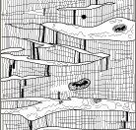  Nueral input can increase rate | Attach to and over bony skeleton  Longest muscle fibers  Striated, voluntary  Can contract rapidly, tires easily, and must rest  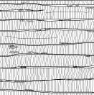  Strong, adaptable | Walls of hollow, visceral organs  Nonstrirated, involuntary  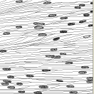  Slow, sustained contractions
Common features of Muscle Cells
- Elongated cells = muscle fibers
- Terminology : ‘’myo-, sacro-‘’ muscle contraction depends on actin and myosin myofilaments
Functional characteristics of Muscle
- Excitability (irritability) : ability to receive and respond to a stimulus
  - Stimulus: usually a chemical (NT, hormone, PH)
  - Response: AP along sarcolemma (the fine transparent tubular sheath that envelops the fibers of skeletal muscles) and muscle contraction
- Contractility: ability to shorten forcibly when adequately stimulated
- Extensibility : ability to be stretched or extended
- Elasticity: ability to resume resting length after being stretched
Muscle functions
- Generate movement: locomotion, manipulation, blood flow and pressure, respiration, propelling of food, urine etc…
- Maintain posture: constantly working against gravity
- Joint stabilization: eg: shouldres, knees when moving parts of skeleton
- Generation of heat: maintenance of body temperature esp: skeletal muscle (at least 40% of body mass)
Microscopic anatomy of skeletal muscle fiber
- Long cylindrical cell with many oval nuclei
- Muscle cell is said to be a syncytium (a single cell or cytoplasmic mass containing several nuclei, formed by fusion of cells or by division of nuclei)
- Distributed right underneath the sarcolemma
- Work as a unit work together to generate force
- Huge cells diamtere of 10-100 um and in cm as well
- Sarcoplasm contains lots of glycogen and myoglobin (a red protein containing heme that carries and stores oxygen in muscle cells. It is structurally similar to a subunit of hemoglobin)
- Lots of myofirbils (working units) extensive sarcoplasmic reticulum (elaborate membrane stractures); T-tubules
- Plasma membrane aka sarcolemma in muscle cells
Myofribirls
- Major component of muscle
- Each muscle fiber (cell) consist of parallel myofribrils
- ~80% of cell volume (100s to 1000s per cell)
- Allows the muscle to contract, shorten
- Muscle cells fuse to make long fibers, fibers wrapped in connective tissues; endomysium
- Single fibre wrapped, wrapped again, wrap again – helps with the wear and tear of muscle usage. Necessary in order to give muscle structure and function
- Blood supply goes through muscle fibers
- Myofilaments (actin and myosin) arranged in a pattern, forming end to end sacromeres (extend from one Z disc to the next Z; sacromeres give this muscle type the name ‘’striated muslce’’
- Actin and myosin slide over eachother, where there is overlap light doesn’t go through A band. Where light goes through is I band. ( light and dark striations )
- Z lies come close together during contractions of muscles
- Structure limits the amount of shortening
- More engangment with myosin and actin = more shortening, less internaction = less shortening
  - Myofilaments
    - Actin: thin filaments across I band and partly into A band
    - Myosin: thick filaments entire width of A band
Zones and lines
- Z disc: anchors thin filaments and connects all myofibrils of a cell, anchoring section
- H zone: area with no thin filaments (relaxed muscle), theres myosin but no actin
- M line: fine strands connecting adjacent thick filaments, no overlap between actin and myosin, allows arrangement of myosin to be stable in order for reaction
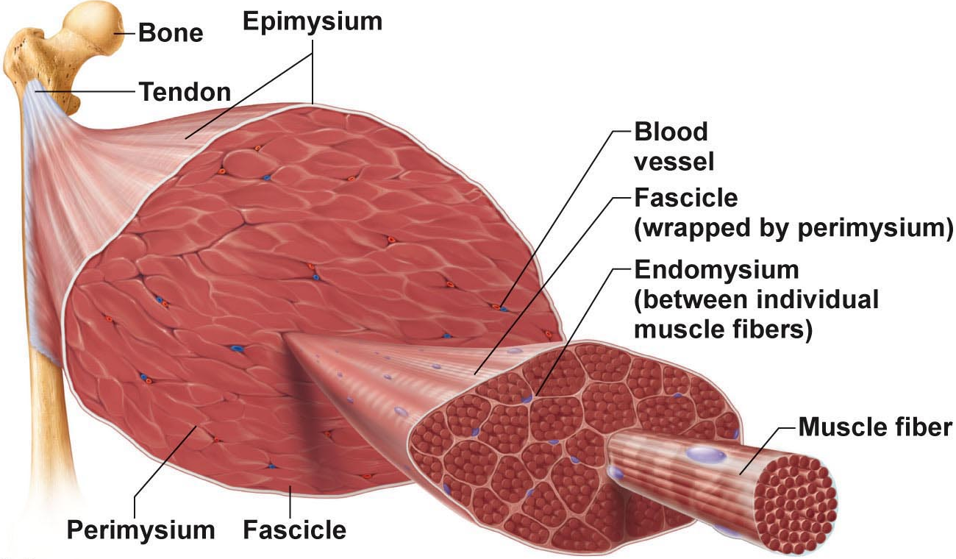

Ultrastructure and molecular composition of myofilaments
  - Thick myosin filaments (16 nm)
    - Rod like tail 2 heavy chains + 2 globular heads ends of heavey chains + 4 light chains = cross bridges
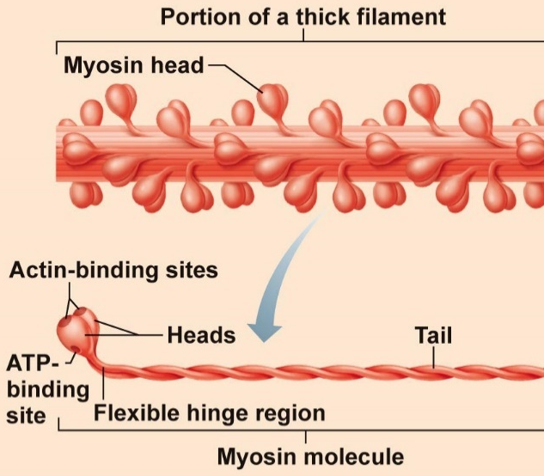
  - Cross bridges are the business ends of the thick filaments; each thick filaments = ~200 myosins, arrayed so central part smooth and each end studded with many myosin heads, myosin heads contain ATPase (enzyme breaks down ATP)

Thin filaments (7-8 nm)
    - Binding sites for myosin (crossbridges)
    - Strands are F-actin; 2 strands wound as a helix
    - G – globular actin
    - F – formentus actin
Additional compoents
Tropomyosin: 2 strands
  - Stiffen filament
  - Goes through the long of the filament
  - Blocks crossbridge binding
  - Lies on actin normally where myosin would bind
Troponin: 3 polypeptide complex subunits
  - Senses the amount of calcium in the cell, when the [Ca] goes up, TnC senses it, tells TnT to relieve the inhibiton,
- Troponinl: binds tropomyosin
- TroponinT: inhibition binding subunit get the inhibiton off and actin is exposed so myosin can bind
- TroponinC: senses the increase in [Ca], tells tropomyosin
Sarcoplasmic recticulum
- Specialized from ER
- Elaborate wed of ER around each myofibril inside PM
- Most SR tubules run longitudinally; pairs of terminal cisternae across A-I junctions
- Role: regulate intracellular Ca storage depot for Ca, relases it when muscle stimulated to contract
T Tubules
- At A-I junction (z disc) sarcolemma penetrates cytoplasm to form hollow elongated tubes
- T-tuble : tranverse tubule (lumen continuous with extra cellular space)
- Triad: group of 3 structures – 2 terminal cisternae + 1 T-tubule (middle) allows rapid depolariazion of plasma membrane regulated by calcium release
- T system: thousands (2/sarcomere) of T tuble in a single muscle cell
- T-tubules allow you to carry a signal, part of plasma membrane, deep into the cytoplasm deep into the muscle membrane. If you have a big muscle, elaborate transduction system it sychornizes the response, quick resposnses. Rapid uniform contraction
Sliding Mechanism
- Muscle fibers shortens because sacromers shorten; filaments remain the same length
- Thin filaments slide over thick ones
- Relaxed: only slight overlap of thick and thin filaments
- Contracted: thin filaments penetrate more deeply into A band – Z discs pulled towards thick filaments
- Overall: distance between Z discs is reduced, I bands shorten, H zone disappears, A bands move more closely together, but stay the same length.

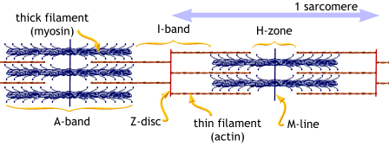

Crossbridg attachment to actin requires Ca, nerve impulse increases [Ca] in muscle cells
How does sliding occur:
- Stimulus to contract got to AP which allows Ca to move in, Ca allows tropomyosin to move out of the way where its not allowed actin to bind
- Myosin cross bridges attach to actin
- Detaches and attaches numerous times to pull thin filaments towards centre of sarcomere
- Muscles shorten as this process occurs simultaneously in all sacromeres
Details on the mechanism
- Intracellular [Ca] low: myosin binding sites on actin blocked by tropomyosin
- Ca influx: binds to troponin >> shape change and brief detachment from actin >> moves tropomysoin away from myosin binding sites >> sites are exposed
- Single power strock of all cross bridges -> 1% shortening
- How much muscle shortening happens on average ?
- Only ½ of myosin heads actively pulling at one time
- Relaxation occurs as SR reclaims Ca, get rid of Ca away from troponin, then torpomyosin will inhibit the binding, relaxation occurs
Excitation-contraction coupling
- exciting of the membrane of the muscle by relase of acetyleCholine to the contraction of the muscle, vesicles fuse because calcium goes into the nerve terminal as you depolarize nerve terminal, hits terminal with sensor on them, dump out neurotransmitters, aCh binds to the junction.
Neuromuscular junction & nerve stimulus
- motor end place – specialized region of muscle cell where the nerve comes to close aquisiton where the ions are dumped out.
- Skeletal muscles stimulated by motor neurons of stomaic ns
- Synaptic cleft in the middle of the fibre
- Neurotransmitter is acetylcholine
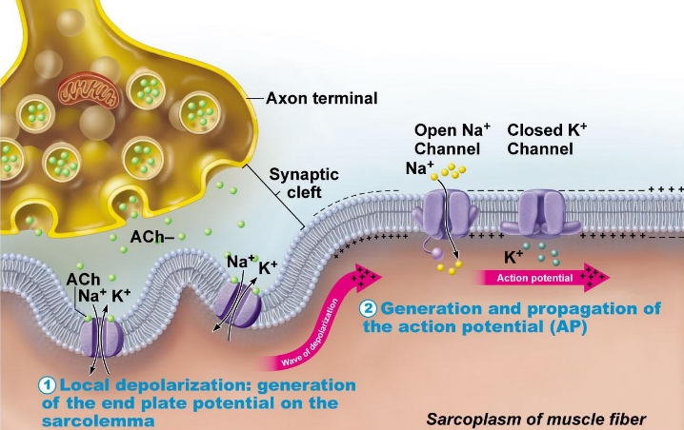
- Events at nerve-muscle synapse identical to those in nerve-nereve synapse

Generation of an AP across sarcolemma
- Chemically gated channels: local depolarization > AP in all directions
- Deopolarization/repolarization with Na, then K as for axon Na/K pump to restore
- Once initiated, AP is unstoppable, all-or-non response of muscle cell AP is brief (1-2 Msec); contraction can be 100 Msec+
- Sodium channel opens when theres depolarization, but contraction happens a bit later because depolarization has to spread all the way around up and down T tubule the muscle wont contract (latent period of contraction)
- Chemically gated channel: Neurotransmitters gate channels depending on the released neurotransmitter
- Sodium channel gated by voltage (membrane potential)
- Sodium potassium pump is an active pump always requiring energy, active transport
Destruction of acetylcholine
- Acetylcholinersterase (AChE) = enzyme on sarcolemma of NMJ
- Ach present in neuromuscular junction is destroyed by Acetylcholineesterase, breaks it down to cholinen and acetate, taken back up the terminal and recycled
- Signal produced, has to move down membrane, tubules, go to recticululm to release calcium to find its myofibrils and has to bind to tirponin C and tropomyosin has to move out of the way
- Reduce the amount of receptors of acetylcholine = lless stimulation of muscles
- To increase acetylcholine numbers, block the enzyme, inhibit destroying them, inhibit the acetylcholinesterase

Latent period of excitation-contraction coupling
- Time it takes from the AP peak to the beginning of the contraction, time needed to activate calcium system to optimul.
- Tension development as Ca goes up more interaction
- Relaxation occurs by the mechanism of calcium pump removes Ca into SR against gradient using ATP
Contraction of a whole skeletal muscle
- The motor unit
  - Motor nerve (at least 1/muscle)
  - Hundreds of motor neuron axons
  - Each axon to many axonal terminals
  - Each axonal terminal to NMJ of a single muscle fiber (cell)
  - Average number of muscle fibers to neuron = 150 (range = 4 to hundreds)
  - When neuron fires, all fibers contract
  - Motor unit = 1 motor neuron + all muscle fibers it supplies
Graded muscle responses
- Two types of graded responses
  - Change speed of stimulation
    - Wave summation and tetanus
    - Rapid rate of stimuli: each contraction builds on previous one
    - But AP refractory period is always honoured
    - Tetanus: stimulating the muscles so fast that you get maximum contractions but unable to contract because the actin myosin interaction is always engaged, fused contractions – interstimulus interval too short to allow inter-twitch muscle relaxation- eventually followed by muscle fatigue
    - Primary goal: smooth, continuous contractions
    - Stimulate muscle with motor neuron, speed up stimulation, before relaxation its stiumulated, the calcium didn’t go back to SR so theres more calcium, keeps on buildings depending on how fast you stimulate,
  - Change number of motor unites activated
    - Multiple motor unit summation
    - Means of increasing strength of contraction
    - Threshold stimulus: frist observable response, enough sodium channels open to get contraction
    - Maximal stimulus: strongest stimulus that produces an increase in contractile force (more motor unites recruited)
      - Smallest motor units controlled by most excitable neurons
      - More intense stimulation recruits larger motor units
    - All unites can be recruited simultaneously staggered
  - Muscle tone: even relaxed muscle a bit contracted (tone) due to spinal reflexses activated by stretch receptors (gut muscle, driving muscle) still some calcium for support
Difference between isotonic, isometric contractions
- Isotonic: muscle changes in length and moves load
  - Concentric isotonic contractions:
  - Eccentric isotonic contractions: 50% more foreful, use less ATP and fewer muscle fibers but more prone to delayed onset soreness thant concentric contractions
- Isometric: tension increases but muscle remains same length
  - Most body movements are a mix of isotonic and isometric contractions
  - Realize that in isotonic contractions, the thin filaments are sliding, but in isometric contractions the cross bridges are generating force, but do not move thin filaments
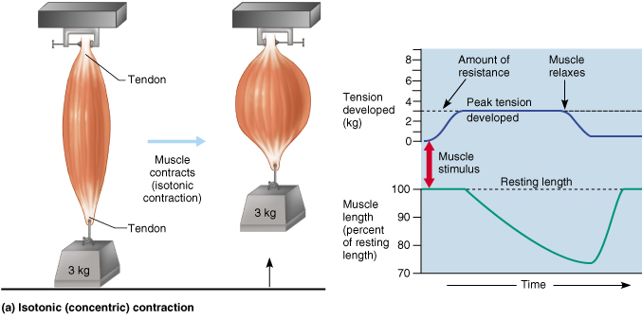
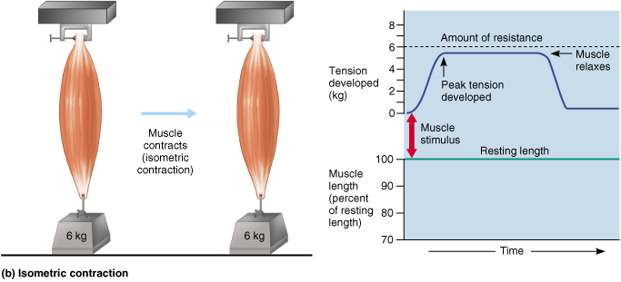

Define the optimal length-tension relationship for muscle in terms of muscle anatomy
- ideal length-tension relationship when muscle slightly stretched, supported by attachement to bones
- Better stretching more the stretch before stimulate = more force of attraction, btter actin-myosin organization which leads to a better response
Indicate the influence of load on the velocity and duration of skeletal muscle contractions
- Veolocity & duration of contraction depends on:
  - Load: the great the load = longer latent period = slower contractions = shorter contraction duration
  - Heavy load takes a while to lift it and start engaging the myosin system only sustain a little while before you get tired

4 sources of energy for muscle contraction and the conditions under which each energy source would be used
- Store ATP
ATP for cross bridge movement & detachement, Ca++ pump, only 4-6 sec store ATP; regenerated immediately and continuously
Glycogen stored in muscle, ATP generated through glycolysis
Creatine phosphate generates ATP quickly found in muscle cells used to mobilize ATP. Turns ADP --> ATP. Replenish the reserve of creatine
- Direct Phosphorylation of ADP by creatine phosphate
CP – unique high energy molecule store in muscles
CP + ADP creatine + ATP
Enzyme = creatine kinase; but CP reseves quickly gone (CP & ATP = 15-20 sec at maximum muscle power
- Aerobic respiration
High ATP yield but slower many steps; requires continuous Oxygen nutrients
- Anaerobic respiration
Only 2 ATP glucose but oxygen not used and is fast
Usually pyruvic acid then enters aerobic pathway; but if ~70% activity for long period blood vessels compressed by muscles and aerobic respiration too slow
Pyruvic acid converted to lactic acid; reconverted back to pyruvic acid once exercise over; aerobic respiration used to replenish ATP stores
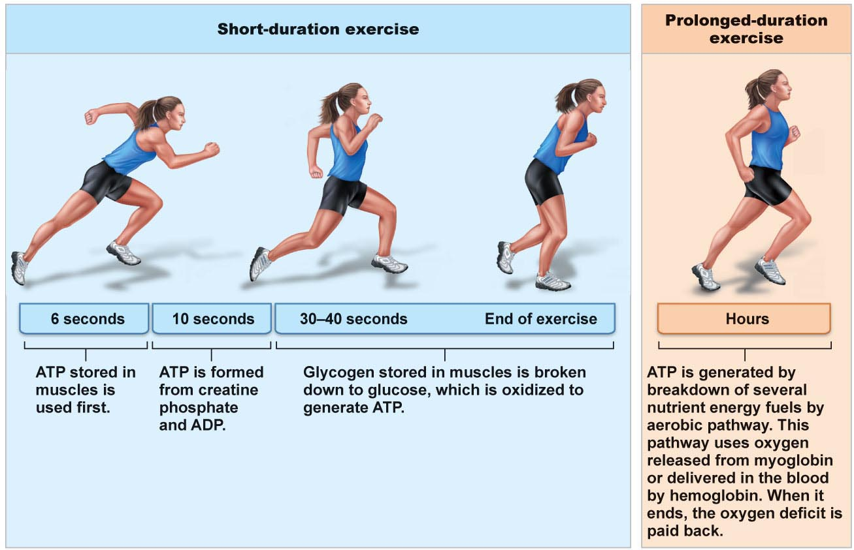
Anaerobic pathway produces ~5% ATP of aerobic pathway, but is 2.5x faster >>
important during vigorous muscle activity

Energy systems used during sport activities
- Weight lifting, diving, sprinting : ATP and CP
- Tennis, soccer, 100M swim: almost entirely anaerobic
- Marathon run, jogging: mainly aerobic, but anaerobic may function until aerobic reaches full effieciency
- Aerobic endurance: length of time a muscle can use aerobic
- Anaerobic threshold: point at which muscle converts to anaerobic
Muscle fatigue
- Stage of physiological inability to contract, results from a relative deficit of ATP (total absence would casue contracture)
- Contributors: build-up of lactic acid, ion imbalances (Na/K pump requires ATP)
- Muscle fatigue happens when energy is gone, state of physiological inability to contract, results from a relative deficit of ATP total absence would cause contractures, theres a debt of oxygen.
Oxygen debt
- Post exercise need to : replenish oxygen reserves, convert lactic acid to pyruvic acid, replace glycogen stores, restock ATP and CP
- Liver converts additional lactic acid to glucose/glycogen (cori cycle)
- Oxygen debt: extra amount of oxygen needed to be taken in to accomplish the above (lactic acid indirectly stimulates respiratory centre of brain)
- New term is excess post exercise oxygen consumption (EPOC) excess O2 you need to take in after exercise in order to replenish
Heat production during muscle activity
- ATP driven muscle contraction 20-25% efficient; dissipated by bodys cooling mechanisms
Muscle fiber types (3 types)
- Slow oxidative fibers
- Thin cells with slow acting myosin ATPases (slow interaction generate force slowly) contract slowlyl (red = lots of myoglobin able to extact O2 from blood efficiently) primary energy fuel is fat. Lots of mitos, capillaries, aerobic enzymes: oxidative. Fatigue-resistant, but not powerful (thin) – slow twitch muscle (heart)
- Fast glycolytic fiberes
- large, pale (white) little myoglobin & diameter 2x that of slow oxidative fibers; fast acting myosin ATPases & contract quickly, not a lot of myoglobin, few mitochondria; lots of glycogen reserves, use glucose: glycolytic. Will fatigue but its powerful
- Fast oxidative fibers
- red or pink, intermediate cell size, fast acting myosin ATPases & contract quickly; high myoglobin content & 02 –dependant; fairly fatigue-resistant

Most body muscles have a mixture of fiber types; genetics can alter distributions & athletic strengths.
Compare and contrast the structural organization and the contractile response of smooth muscle with that of skeletal muscle
- Walls of all hollow organs except heart
- Architecture allows for maximal contractions, thin ends fat middle due to unstructured actin and myosin
- Two types of muscle: circular and longitudinal
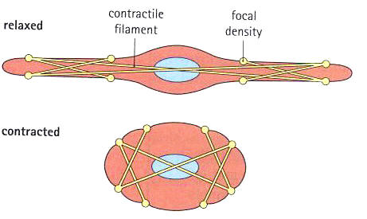
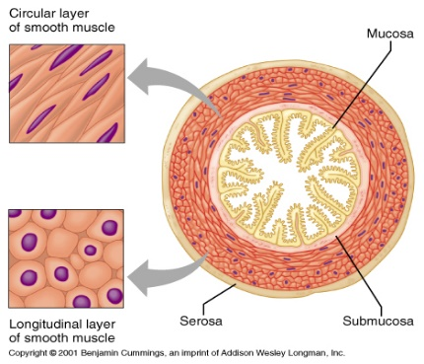

Arrangement of fibers & microscopic structure
- Small spindle shaped cell one centrally located nucleus
- Diameter 2-10um, length 100-500um
- Cells separated by fine CT; sheet of closely opposed fibers; usually at least 2 sheets with opposite orientations
- Alternating contractions of opposing layers provide mixing, peristalsis, expelling varicosities instead of NMJs bulbous swelling of autonomic ns- release NT into wide synaptic cleft near smooth muscle cells – diffuse junctions
- SR less developed than in skeletal muscle; few/no T tubules; but SR touches sarcolemma & smooth muscle cells have large SA/volume ratio
- No striations, but do have interdigitating thick & thin filaments:
    - Ratio of thick:thin = 1:13 (smooth vs 1:2 (skeletal) but smooth muscle myosin has actin-gripping heads along entire length >> strength
    - Tropomyosin but no troponin (calmodulin instead Ca sensitive also)
    - No sacromeres: thick & thin filaments spiral down smooth muscle cell
    - Noncontractil intermediate filaments and dense bodies (attach to thin filament)
  - Skeletal muscles= organized structures
Contraction of smooth muscle
  - Mechanism:
    - Electrical coupling via gap junctions > slow, synchronized contractions
    - Some smooth muscle cells are pacemaker cells (can excite themselves)
    - Transfer of chemical information
  - Actin and myosin interact by sliding filament mechanism
  - Final trigger is rise in intracellular Ca++
  - Sliding process is energized by ATP
    - Contraction of smooth muscle is slow (30x) sustained, fatigue-resistant (24h maintenance of tone of blood vessels, visceral organs)
    - Few mitos; most ATP generated aerobically
    - Slower than slow twitch muscle, needs little energy
Special features of smooth muscle contraction
- Response to stretch: more stretch (120% resting length) >> more vigorous contraction – stretching can induce brief contraction (gut) or can have stetch relaxation response (filing)
- Length and tension changes: stretches more than skeletal; can generate more tension than skeletal (contracts in a corkscrew-like manner) (150% vs 60%)
- Hyperplasia: eg. Estrogen & uterine smooth muscle cells
Uniary smooth muscle
- Visceral muscle; more common
  - Contracts as a unit and rhythmically
  - Electrically coupled by gap junctions
  - Often spontaneous action potentials
  - All other smooth muscle characteristics
Multiple smooth muscle
- Large airways to lungs, large arteries, arrector pili muscles of skin hair follicles, integral eye musles for focus
  - Rarely have gap junctions or spontaneous synchronized contractions
  - Muscle fibers strucally independent of each other
  - Richly supplied with nerve endings, each forms a motor unit with a number of muscle fibers
  - Respond to neural stimulation with graded contractions (still regulated by autonomic ns hormones)

Homeostasis
  - 3.1 3.2 3.3

Walter Cannon: ability of the body ‘’to maintain relatively stable internal conditions even though there is continuous change in the outside world’’
- Not unchaning – rather a dynamic state of equilibrium involving many systems
  - Adequate blood levels of vital nutrients
  - Heart activity/blood pressure monitored & adjusted as needed
  - Wastes must not accumulate
  - Maintenance of body temperature
- Maintenance of relatively stable internal conditions
  - Dynamic state of equilibrium, maintained by all organ systems
Homeostatic control mechanism
- Continuous monitoring & regulation of all factors that can change (variables)
- Communication for the monitoring & regulation
- Functions of nervous and endocrine systems (communicate via nerve impulses & hormones)
Elements of control mechanism
- Receptor (sensor)
  - Monitors environment
  - Responds to stimuli (cause changes in controlled variables)
- Control centre
  - Determines set point at which variable is maintained
  - Recives input from receptor
  - Determines appropriate response
- Effector
  - Receives output from control cener
  - Provides the means to respond
  - Reducing the stimulus (negative feedback) enhancing it ( positive feeback)
Negative feeback
- Most feeback mechanisms in our body to reduce or shut off original stimulus (variable changes in opposite direction of initial change)
  - regulation of body temperature (nervous system mechanism)
  - regulation of blood volume by ADH (endocrine system mechanism)

positive feeback
- enhances or exaggerates original stimulus
  - output is further stimulated
  - change occurs in the same direction as the original response
- exhibits a cascade or amplifying effect
- usally controls infrequent events that do not require continuous adjustment
  - platelet plug formation and blood clotting
  - enhancement of labour contraction by oxytocin
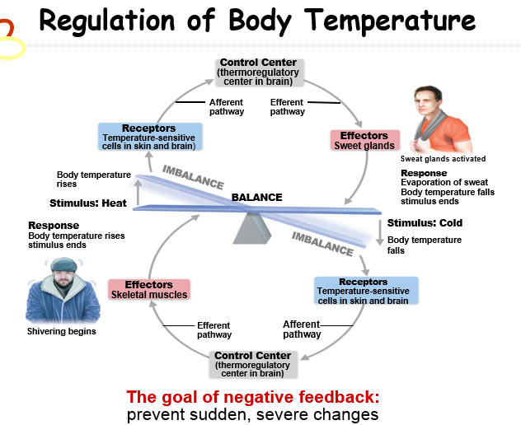

Formation of a platelet plug
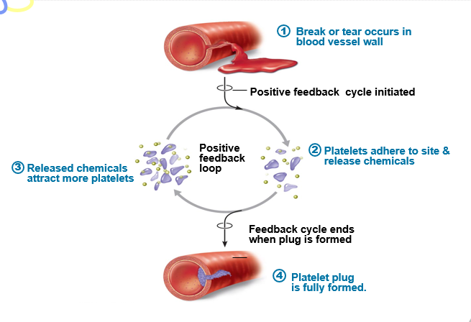
Homeostatic imbalance
- increase risk of disease
- produce changes associated with aging
  - control systems less efficient
- overwhelmed negative feedbacks
  - destructive positive feedback takes over (heart failure)
    - most disease seen as a disturbance of homeostatic imbalance
    - aging associated with progressive decrease in our ability to maintain homeostasis (greater risk for illness)
Autonomic nervous system
- consists of motor neurons to
  - innervate smooth and cardiac muscles, glands
  - make adjustments to ensure optimal support for body activites
  - operate without our awareness
- also called involuntary nervous system or general visceral motor system
  - auto = self nom= govern

stomatic versus autonomic
- both have motor fibers
- differ in
  - effectors
  - efferent pathways and ganglia
  - target organ responses to neurotransmitters
- ANS
  - Shunt blood to more needy areas
  - Speed/slow heart rate and respiratory rates
  - Adjust blood pressure, body temperature
  - Increase/decrease gastric secretions
Roles of parasympathetic divison
- Active in non-stressful situations (resting and digesting)
- Promotes housekeeping activities and conserves body energy (digestion, defecation, diuresis)
- As in person relaxing or reading after a meal
  - Low blood pressure, heart and respiratory rates
  - High in gastrointestinal tract activity
  - Pupils constricted
Roles of sympathetic division
- Mobilizes body during activity (fight-flight system)
- Exercise, excitement, emergency, embarrassment
- Increased heart rate, dry mouth, cold and sweaty skin, dialated pupils
- During vigorous physical activity
  - Shunts blood to skeletal muscles and heart
  - Dialates bronchioles
  - Causes liver to release glucose
Neurotransmitters
- Cholinergic fibers realse neurotransmitter Ach
  - All ANS preganglionic axons
  - All parasympathetic postganglionic axons at effector synapse
- Adrenergic fibers release neurotransmitter Norepinephrine
  - Most sympathetic postganglionic axons
  - Exception: sympathetic postganglionaic fibers secrete Ach at sweat glands
Interaction of autonomic divisions
- Most visceral organs have dual innervation (opposite effects)
- Dynamic antagonism allows for precise control of visceral activity (homeostatis)
  - Sympathetic divions:
    - increase heart, respiratory rates and inhibits digestion and elimination
  - Parasympathetic division:
    - decreases heart and respiratory rates and allows for digestion and discarding of wates
parasympathetic tone
- Parasympathetic divison normally dominates heart smooth muscle of digestive and urinary tract organs, activates most glands except for adrenal and sweat glands
  - Slows the heart
  - Dictates normal activity levels of digestive and urinary tracts
- Sympathetic deivions can override these effects during times of stress
- Drugs that block parasympathetic responses increase heart rate and cause fecal and urinary retention
Sympathetic tone
- Sympathetic divion controls blood pressure, even at rest
- Vascular system ~ entirely innervated by sympathetic fibers
- Sympathetic fibers fire more rapidly to constrict blood vessels and cause blood pressure to rise
  - Keeps blood vessels in continual state of partial constriction
- Sympathetic fibers fire less rapidly to prompt vessels to dilate to decrease blood pressure
- Alpha-blocker drugs interfere with vasomotor fibers
  - Used to treat hypertension

Unique role of the sympathetic
- Some receive only sympathetic fibers (adrenal medulla, kidneys, sweat glands, arrector pili muscles & most blood vessels)
- Sympathetic division controls
  - Thermoregulatory response to heat
  - Relase of renin from kidneys (BP goes up)
  - Metabolic effects
    - Increases metabolic rates of cells
    - Reaise blood glucose levels
    - Mobilizes fats for use as fuels
Localized versus diffuse effects
- Parasympathetic division:
  - Short lived, highly localized control over effectors – Ach quickly destroyed by achetylcholinesterase
- Sympathetic divison:
  - NE activiated more slowly than Ach
  - NE & epinephrine hormones from adrenal medulla prolong effects

