Lecture 6
Chapter 8 - Communication, Language, and Speech Disorders

- "Speech is the representation of the mind, and writing is the representation of speech.“ Aristotle
- 70-80% of inmates have some form of language disability

AIM #1: Historical Overview and Introduction
- 1800 – Elocution
- have every one speek very correctly with proper excuation
- 1872 - School of Vocal Physiology (Alexander Bell)
- Students who were deaf or who had stutters or articulation problems (not much oral language)
- Goal was for them to develop oral language
- * 1925 – American Speech and Hearing Association (ASHA)
- defined what language disorders were and starting to try to do things about it
- Paul Broca (1861)
- Patient that could only say “Tan”
- When he died he found that in in leftfrontal cortex there was a lesion
- Carl Wernicke (1876)
- Found problem in left temporal lobe

Historical Overviews
- Everyone agrees about what children actually do
- Debate about how children acquire language

- Behaviourists View
- Language is a subset of other learned behaviours
- Believes in the stimulus response view
- Social Learning View
- Behaviourists view + imitation
- children are easily able to imitate thus aid in learning language
- Cognitive biological View (Chomsky - 1960 -70’s)
- examined the rules and sequences governing the acquisition of language
- Grammar innate to the human brain
- Innate language acquisition device that is unique to and present in all humans
- All that we need is the exposure to language and the “device” is activated and we pick up language
- ALL children go through the same pattern and milestones that kids go through when learning language
  - programed to pick up language that they are exposed to
- Pragmatics View (current view)
- Social aspects of language
  - As children learn language they learn primarily from social and naturalistic environments
- Exposure to language
- Bilingual/bicultural language acquisition
- Cognitive View
- depends on the child’s exposure to language
- more language a child hears, and the greater complexity; the more likely the child will learn the structural properties of language

Discussion: Is Language unique to humans?
- Yes
- No other species have an arbitrary symbol system
- No
- Animals are able to communicate

Language in Bonobos? (Savage - Rumbaugh)
- Share 98-99% human genes
- Approach is to let animals pick up language symbols in “normal” conversation
- Apes don’t have vocal boxes so decided to teach them sign language
- Grammar and syntax are very important in language
- apes were unable to make this distinction
- some people think apes can speak because they were not taught language in the right way
- Bonobos taught language through symbol system
- Bonobos understanding of new sentences is about the level of a 2.5 year old child

Communication vs. Language
- Birds do it
- Referential communication
- Alarm calls for when predators are around
- chickadee - more sylobys at the end of their call means a more serious predator
- Bees do it
- So do dolphins, monkeys, apes and humans
- all sorts of mobile communicate

Communication
- Exchange of thoughts, information, and ideas between 2 people
- requires 3 things: Sender Message Receiver
- sender imitates the communication and determines the message and the receiver gets the message and must interpret it to understand what is means
- communication can be done by most species
- includes the Information Processing Model
- input hearing or seeing
- central processing thinking about and understanding
- output speaking, singing or witting
- executive function decision making
- emotional context emotions that must be factored in to correctly understand the message

Diversity in Communication
- many ways of sending languages for human species
- can be together or apart

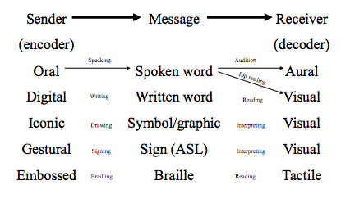

Language
- A system of symbols organized into conventional patterns (grammar and syntax) to communicate meaning
- Receptive language
  - Ability to take a message and understand it
  - Intuitive; what you are taking out of messages that are coming in
- Expressive language
  - Ability to produce a message to send
  - Communicating a message to another person
Building blocks of Language
Phonology | Sounds
Morphology | Words
Syntax | Sentence/Grammar
Semantics | Meaning
Pragmatics | Meaning in Context

Language Form
- the form that a language takes can be seen in the sounds, words and grammar that underlie the language
1. Phonology (smallest unit)
- Sound system
- Individual units of sound for a work (smallest unit of speech)
2. Morphology (words)
- Meaning to words
- rules that address how words are formed and the structure of words
- System of word building (prefix, suffix)
3. Syntax (sentences)
- Order and combination of words (sentence building)
- AKA Grammar
- the rules that guide how words are combined to form sentences and the relationships of components within the sentence
Language Content
- the information being communicated
4. Semantics (Meaning)
- Information being communicated
- Meaning of words and sentences

Language Function
- the use of language; language as appropriate communication within a given society and specific content
5. Pragmatics (meaning in context)
- Meaning in a context
- “Hi are you in my Psych 2043 class?”
- address the social context (helps clarify meaning of communication)
6. Supralinguistics
- Meaning when the literal meaning is not the intended meaning
  - i.e. sarcasm
- sophisticated analysis of meaning when the literal meaning of the word or phrase is NOT the intended meaning

Speech
- Mechanical production of language/ sound
- English speakers speak 150 words per minute
- 14 phonemes per second using about 100 muscles
- Oral production of the words of a given language
- Articulation
  - Clear pronunciation of words
- Fluency
  - Appropriate flow of words; steady stream of conversation
- Voice
  - Normal fluxuations, sounds in voice (pitch, loudness and resonance); intonation and quality of sound

- Production of speech
- Though occurs in the brain
- It is translated into symbols and sent to the larynx area for phonation and resonation; which takes place in the vocal tract
- Then air is sent to be modified by movements of the tongue and passage over the teeth and lips which combine to from sounds, words and sentences (articulation)
- 4 processes involved in speech production:
  - Respiration
    - (breathing) generates the energy that produces sound
  - Phonation
    - the production of sound by the vibration of the vocal cords
  - Resonation
    - gives the voice a unique characteristic that identifies the speaker (it is the product of sound traveling through the speakers head and neck)
  - Articulatoin
    - the movement of the mouth and tongue that shapes sound into phonemes, which combine to make speech

AIM #2: Neural Basis

Global Brain Areas
- Frontal Lobe
- Temporal Lobe
- Parietal Lobe
- Occipital Lobe

The Linguistic Brain

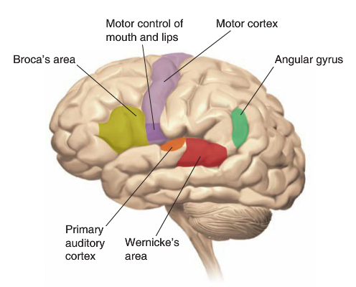
1. Broca’s Aphasia production of language
- Good comprehension
- Poor production of language
- Slurred and slow/absent speech
- Lesions
- Still able to comprehend speech but have difficulty producing speech (spoken)
- Adjacent to the motor control at mouth and lips (in frontal cortex)

2. Wernicke’s Aphasia comprehension of language
- Inability to comprehend speech or produce comprehensible speech
- “Word salad”
- can talk a lot but it doesn’t mean anything
- Problem: Unable to understand and comprehend speech
- In temporal lobe

Broca’s vs. Wernicke’s
- Example to illustrate the difference:
- Experimenter: “What do you do with a cigarette?”
- Patient with Damage to Broca’s Area:
- “uh…… uh…….. Cig… uhh….. Cigarette…..Smoke….. It.”
- difficulty producing speech
- Patient with Damage to Wernicke’s Area:
- “This is a segment of a pegment. Soap a cigarette.”
- meaningless spoken languag

3. Conduction Aphasis
- Damage to Arcuate fasciculus (AF)
- nerve fibers that connects wernikie’s to broca’s area
- Good receptive language
- Poor expressive language
  - CANNOT repeat words
  - Drop/substitute phonemes
    - Snowballsnowwall

Speaking a Written Word
- Primary Visual cortex Wernicke Broca Motor

Speaking a Heard Word
- Primary Auditory cortex WernickeBrocaMotor

97% Left Hemisphere (of individuals)
- Broca’s and Wernike’s areas are predominantly lateralized in the left side of brain
- Confirmed by Penfield in the 1950s
  - Electrical stimulation of brain blocked language
- The Wada Test
  - Injection of anesthetic into the right or left carotid artery that puts that side of the brain to sleep

Exception to 97% rule
- People who are learning complex picture based written language
- Pictorial languages are more balances b/w left and right
- Chinese and mandarin
- Babies and left handed people are more balances

Right Side of the Brain
- PET studies have shown that both sides are activated during language tests
- The corresponding structures on the right side seem to be involved in the emotional layers of language
- Aprosodia

Other Language Impairments
- Other areas of Association cortex are involved in other aspects of language
- Verb impairment
  - Have difficulty with verbs, but NOT nouns
    - “I watch TV” (can’t do)
    - “My watch is fast” (perfectly fine)
- Foreign Accent Syndrome
  - Suggests there is a specific area of the brain for the “sound” of a language
  - Get stick with a accent of a language that they have never had before (possible after waking up from Acoma)

AIM #3: Typical Language Development

Language Development
- Takes until a child is about 8 years of age to be able to produce all the oral speech sounds (vowel, consonants, diphthongs, and blends)

Infants: Pre-linguistic System
- Ways of communicating between infant and caregiver
- Smiles
- Eye contact
- Gestures
- Sounds
- Phoneme discrimination
  - “b” and “p” by 1 month
  - Picking out difference in sounds
- Can different the units of words
  - Advanced system for picking out regularities in speech (sistical regulaties of words)
  - Picking out the phonemes that tend to go together
    - e.g. pretty vs preby (not a word)

Language Development
- Intertwined with social and general cognitive growth
- Motherese/Parentese
  - “baby talk”; higher pitched; more eye contact; slower speech

Chronological Age | Typical Expectations
0 - 3 moths | - Cooing; primarily vowels
6 months | - Babble (ba ba, da da, repetitious)  - Requires fine motor control of tongue and lips to blend vowels and consonants  - Babbling seems to be a universal (although it will sound different depending on the language)  - Deaf infants will babble  - 90% of babies are both into families with parents that are able to hear  - Exception: Autistic or neurologically damaged
8 months | - Echolalia; Immediate imitation of speech sounds
12 months | - First word  - Coordination of breath control and movement of lips and tongue  - Starting to learn words from context and associations with environmental cues (not just voice learning)  - Vocabulary explosion starts  - After child says first word there is a large increase in speaking abilities
12 - 18 months | - Holophrastic use  - Single words for more complex ideas  - “Juice” for “I want to drink juice”
18 - 14 months | - Telegraphic Speech  - Only essential aspects of the message are included  - Regularize the rules of language (Don’t yet know the exceptions)  - “E.g. He runned”
3 years | - More sophisticated grammar  - Understand about ¾ of language
4 years | - Mastered enough syntax, semantics, and pragmatics to be considered proficient language users

Bilingual children
- Learning 2 languages at once may cause the child to have fewer words in each language and it may appear to be delayed in vocabulary or language accusation when only one language is being assessed; may lead to misdiagnosis
- may also be some delay in their phonemic awareness (relationship between letters and sounds)
- “delays” are a normal by-product of learning more then one language
- Dialects
  - variations in pronunciation, vocabulary or syntax (symbol system) used by a group of individuals that reflects and is determined by shared regional, social or cultural factors
  - small differences in standard literary usage
    - e.g. “we be there tomorrow”
  - NOT a sign of a speech disorder; part of linguistic diversity of society
    - may mask a delay or disorder
  - teachers should model standard literary usage when speaking but should allow children to use dialects in informal language

Gradually Becoming Experts in Native Tongue
- born with ability to discriminate between phonemes of all languages; and they loose this ability around the age of 1
- Up until 6 months of age, babies are happy to listen to any language of speech
- Around 9 months they prefer to listen to their native speech (start comprehension of own language)
- Beginning to comprehend speech but cannot produce it
- At about a year, infants loose the ability to discriminate universal phonemes (start producing their actual words)
- Language generalist Specialists

Early Language Environment is Important
- Quality of adult-child interactions is the single most important influence on a child’s language development
- Children of high verbal mothers
- 130 more words at 20 months
- 300 more words at 24 months
- Parents can support child’s communication
- recasting: modeling the correct pronunciation
- following directives: responses by the adult to build on what the child is communicating
- natural environments support language development (increase child’s amount of talking; thus increasing accuracy and vocabulary)

Atypical Development of language
- Adults tend to speak less to non/low verbal infants and tend to talk more for them
- this is bad; child needs to practice language
- These are the infants that could benefit most from increased verbal exchanges
- Language difficulties interfere with communication and can affect formation of a child’s friendships, school success and self-esteem

Transitions for students with Communication Disorders
- children with primary articulation disorders have few related problems as adults
- children with severe disorders and language deficits continue to have problems as adults
- early support can help minimize secondary problems
- in some cases it can help a child overcome the speech disorder
- transition form high school to college to work needs support services
- clinics and help sessions
- job coaches

AIM #4: Atypical Speech/Language Disorders

Prevalence
- Who knows?
- Researchers disagree on definitions and classifications of disabilities
- Varied terminology of disabilities
- Often the primary problem is a different disability (IDD, Autism, Deaf/Blind)
  - High co-occurrence with other disabilities
  - law requires that speech-language therapy be available as a related service for children with disabilities if they need it
  - Related service: support services that are required to assist the child in benefiting from special education
- younger children are over identifier due to mild speech disorders

Genetics and Communication Disorders
- children of families with communication disorders tend to have significantly lower scores in comprehension with their age-matched peers
- interaction between genetics and environment plays a major role in language development; influences child’s acquisition rates

Children with disabilities
- About 20% receive support for speech/language disorders
- Primary placement is in the general classroom
- Evaluation of language is “part science and part art” Robert Owens Jr., 1991

Classification of Disorders
- Important to distinguish between commination, speech and language disorders because they require different interventions
- Communication Disorders
- Impairment in ability to receive, send, process and comprehend concepts of verbal, nonverbal and graphic symbols
- May be developmental or acquired
- Often related to other areas of disability (i.e. autism, learning disabilities, visual impairments, and physical disabilities)
  - My result in a primary disability or may be secondary to other disabilities
- Speech Disorders
- An impairment of the articulation of speech sounds, phonological processing, fluency and/or voice
- Disorders of articulation
- atypical production of speech sounds characterized by substitutions, omissions, auditions or distortions that may interfere with intelligibility
- Disorders of fluency and speech timing
- an interruption in the flow of speaking characterized by atypical rate, rhythm, and repetitions in sounds, syllables, words, and phrases
- my be accompanied by excessive tension, struggle behavior and secondary mannerisms
- Disorders of voice
- characterized by the abnormal production and/or absence of vocal quality, pitch, loudness, resonance and/or duration, which is inappropriate for an individuals age and/or sex
- Language Disorders (>6mos behind the milestones)
- impaired comprehension and/or use of spoken, written and/or other symbol systems
- Form
- Phonology (sounds)
- Morphology (words)
- Syntax (sentence)
- Content
- Semantics (meaning)
- Function
- Pragmatics (meaning in context)
- Neurological problems underlie most of the most serious language disorders

Aphasia
- Inability to communicate effectively with verbal language because of comprehension and/or production difficulties
- Can be acquired (usually stroke or head trauma) or developmental

Mutism
- Total absence of speech
- Elective
  - Child used to be able to speak but is no longer able/wants to
  - Traumatic event
  - Deep disturbance of psychological functioning resulting in children that don’t speak, or only speak in certain circumstances
- Selective
  - Generally normal language development
  - Only speak with a small group of peers/relatives
    - I.e. do not speak in class
  - Usually grouped as an anxiety disorder

Cleft Palate
- Palate separates the respiratory and digestive system
- Cleft palate occurs when roof of mouth has not joined completely during prenatal development
- may affect only one side (unilateral) or both sides (bilateral)
- usually repaired by sugary within the first 18 months
- 50 - 75% require speech intervention at some point in their life
- Difficulties eating
- 25-60% suffer hearing loss
- Difficulty getting enough air pressure to make some consonants (p, b, s, z, ch)
- Make fewer and less complex sounds and receive limited motor feedback from their babbling
- Even after restorative surgery, still require intervention

Articulation Disorders
- Problem in the production of speech sounds
- Substitutions
  - intended phoneme is replaced by another phoneme
  - e.g. w for r (wight for right) or w for l (wove for love)
- Distortions
  - a mis-production makes a phoneme sound different but not different enough to change the production into a phoneme with a different meaning
  - e.g. bru for blue
- Omissions
  - certain sounds are omitted/forgotten completely
  - e.g. pay for play
- Additions
  - addition of extra sounds
  - e.g. footsball

Common Articulation Errors
- We yive in a yeyow house. (Substitution)
- I like dis ball. (Substitution)
- Did you see the wed twuck? (Substitution)
- Oh, ook at the kitty. (Omission)
- Did you see the moufse? (Addition)
- I am seben years old. (Substitution)
- I have fi fingers. (Omisson)
- Can we play footsball. (Addition)

Disorders of Voice
- inappropriate variation in quality, pitch or loudness of a persons voice
- generally called dydphonia
- can be related to phonation, resonation or both
- problems wit resonation include: hypernasality (excessive nasal-sounding speech) and hyponasility (speech that sounds as if the speaker has a bad cold)

Disorders of Speech Fluency
- Stuttering is the most common fluency disorder
- characterized by:
- repetitions of words or word parts
- prolongations of speech sounds
- interjections of sounds
- stopped or blocked speech where the sound does not come out
- speech-language pathologist needed to assess abilities and implement support programs
- focus on teaching behaviors to help monitor and control speech rate, control breathing and reduce tension during speaking

Auditory Processing Deficit
- Prevents children from processing sounds
- Both speech and non-speech sounds
- Confuses related sounds like “t” and “d”
- Once they hear a sound they fail to assign meaning to the sound
- Language is going too fast

FastForWard
- Intervention tool for auditory processing deficit
- Videogame that slows down phonemes to level of child; that allows child to discriminate between phonemes; get faster and faster as child gets better
- 4-8 week intervention, $2,000
- 100 minutes per day
- Supervised by a trained audiologist/special ed teacher
- Tailored speeding up as the child progresses
- First person review for FastForWard
    - 9 year old Benji
    - 2 weeks into the program
    - “Everyone sounds strange. I can understand their words”
    - gains in academic scores and doing better behaviourally

Secondary Problems
- Targets of bullying
- Associated behavioral problems (30-60%)
- Withdraw from social contact
- Resort to using gestures or body language for communication
- School can become a hostile place to be

Assessment and Identification
- comprehensive assessment of child’s ability to communicate includes both receptive and expressive language
- includes formal (diagnostic tests, clinical evaluations) and informal (systematic observations)
assessments
- speech-pathologist responsible for identification, diagnosis, design/ implementation of treatment plan
- Culturally or linguistically diverse backgrounds
- in families where English is not the primary language, children are likely to encounter difficulty in using English in school
- vary in English competence thus assessment should involve specialist who is bilingual or bicultural
- i.e. if dialect of children are not taken into account; they will have low scores
- when a bilingual specialist is not available, a neutral mediator sits in to assist the evaluator and help communicate with the family
AIM #5: Communication in the Vegetative State

Disorders of Consciousness
- “some of the least understood and most ethically troublesome conditions in modern medicine” Adrian Owen

Vegetative State
- “Wakeful, but unaware”
- usually need feeding tube
- have sleep and wake cycles
- No reproducible evidence of purposeful behavior in response to external stimulation
- Fail ability to perform command following
- What if you are aware, but can’t produce the motor sequence to command follow?

Kate
- 1st person in a vegetative state to be scanned
- Pictures of friends and family
- Brain responded “normally”
- WHY?
  - is she aware or is it just a brain reflex?

- They took a bunch of controls and asked them to:
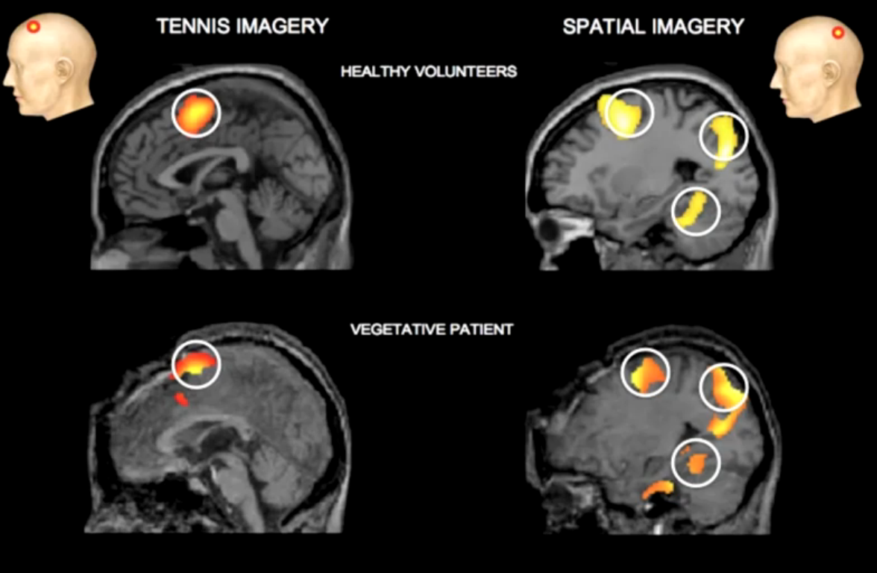
1) Imagine playing tennis
- Premotor cortex activation
- Same areas as if actually playing tennis
2) Imagine walking around your house
- Activated parietal lobe and parahippocampal gyrus
- Same areas as if actually walking around the house
- Then compared activation of controls to activation in an individual in a vegetative state
- Brain activity is very similar to controls

- Found that about 20% of individuals in a “vegetative state” were actually “conscious”

Can this be used as a Communication Tool?
- At first, just using “Imagine playing tennis if you want to say yes”.
- The experimenter tried to guess her husband’s name by looking at the brain activation

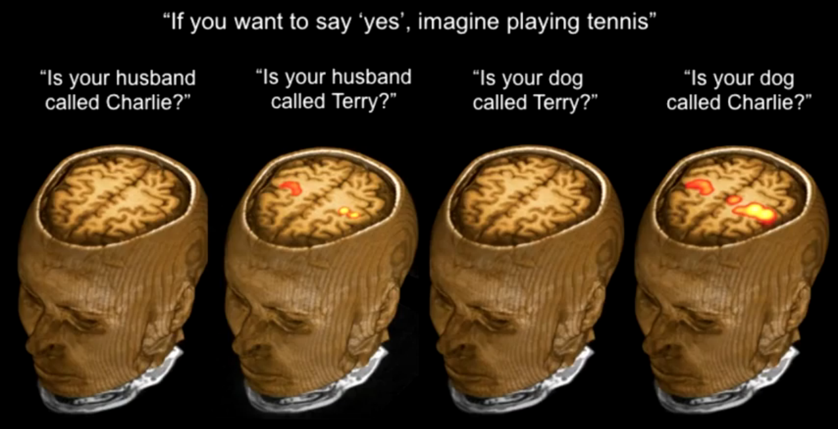
- brain is active when person is trying to say yes

Then Progressed to Yes/No system
- If want to say YES = imagine playing tennis
- Activates one part of the brain
- If want to say NO = imagine walking around house
- Activates different part of the brain
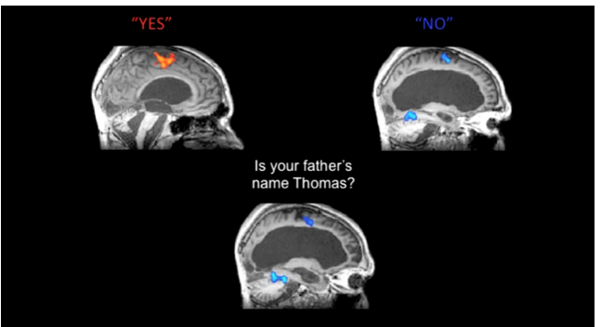

Yes/N0 Results
- Asked 5 questions in a row
- All 5 answers were verified by the family afterwards
- Patient scored 100% correct
- “Wakeful but unaware?”
- Wakeful, and aware, but unable to physically respond at the motor level
A Powerful Tool
- We now have a communication system for those in vegetative states
- As long as questions are phrased in Yes/No format

Returning to Kate
- Made a very rare, and remarkable recovery form vegetative states
- Physically – severely limited
- Cognitively – Most functioning returned
  - Can use a letter board to communicate
  - Can also use a computer and can send e-mails

YELLOW PAGES - EDUCATIONAL RESPONSES
Tier 1: The General Education Classroom
- most children with a speech/ language disorder are served in the general classroom
- inclusion techniques used
- general education classroom and inclusion with typically developing peers provides a rich language environment that can enhance the communication of all children
- teachers should try:
- create a supportive environment
- use cooperative learning strategies to promote student- to - student communication
- small group arrangements to promote conversations about what is bing learned

Tier 2: Collaborative Interventions
- working with small group of children
- give explicit instruction on the “language routines”, rules of participation
- allow them to get comfortable enough to use skills
- English-language learners (ELL) teachers
- review key vocabulary
- preliminary activities help children feel more confident to participate in seminars
- “Planned participation”
- create planned opportunities for child to participate in speaking activities that are appropriate for practicing newly acquired fluency skills at increasing levels on complexity
- Speech-language pathologists
- increasingly working with children in general classroom
- may alert child to pay attention to instructions, encourage them to ask questions and participate in discussions
- helps family facilitate communication with child in natural settings
- help classroom teachers use tools to promote new language acquisition

Tier 3: Individualized Educational Services
- Individualized education program (IEP) specifies services needed for success
- Speech-language pathologists must be able to address problems with:
- articulation, fluency voice and language disorders
- cleft plate, intellectual/developmental delays, cerebral palsy, learning disabilities, and deaf

Role of the Speech-language pathologists
- support children who have communication needs by:
- providing individual therapy
- consulting with teacher about effective strategies in the classroom
- working with class on creating support
- work with family
- work with vocational teachers and counselors to establish goals

Term | Disorder
Apraxia | Impairment in the ability to plan the movement for speech
Aphasia | Impairment in the ability to communicate due to brain damage
Dysarthria | Articulation or voice disorder due to impaired motor control problems of throat, tongue or lips
Anarthria | Loss of the ability to speak
Dysphonia | A disorder of voice quality
Stuttering | A disorder of fluency: repetitions, prolongations and hesitations of sounds and symbols

Specific Strategies to Support English-Language Learners
- Many strategies can be used to support bilingual children in the classroom
- meeting the need of children who are ESL and have communication disorders is a collaborative effort of teacher, bilingual specialist, special education teacher, speech-language pathologist and parents
- Blissymbols
- computerized communication system that uses graphic symbols or “blisswords” to help the child communicate
- point or touches words they want to say and forms sentences to express thoughts

Assistive Technology
- Assistive technology: approaches and devices that support communication and help the child express thought, needs, wants and ideas
- Argumentative Communication
- strategies used to prompt or promote the development of speech by helping the child use words to communicate
- Alternative Communication
- communication must be seen/ physically represented - such as gestures, body language, sign language and communication boards
- do NOT provide sound output
- E.g. American Sign Language (ASL) - gestures that contain meaning
- E.g. Communication boards - vary in complexity form a set of simple pictures to sophisticated groups of letters, words and pictures that can produce speech

