STUDENT NAME: ………………..…………..
STUDENT NUMBER: …………………………

ANP 1107
Midterm #1

Date: June 1, 2011 Instructor:
Time: 11:30 h Dr. J. Komorowski
Duration: 1 hr 20 min
INSTRUCTIONS:
- 42 multiple choice questions (1 mark/1 correct answer per question), two labelling question (2.5 + 1.5 = 4 marks), three definitions (3 marks) and one descriptive question (5 marks) = 46 QUESTIONS TOTAL = 54 marks total possible plus one BONUS mark (2 marks).

- Please use the computer sheet for the multiple choice questions, but answer the labelling/written questions right on the exam itself as well.

- Please put your name and student number at the top of each page of this exam and on your computer sheet and hand in everything when you have finished.

- Make sure this exam is complete. This exam contains 11 pages. The excuse of missing a page will not be accepted after the exam.

GOOD LUCK!!!!!!!

    - Digestion of which of the following would be affected if the pancreas were severely damaged?
- disaccharides
- lipids
- proteins
- both B) and C)
- all of the above would be affected equally
    - Which of the following is true about saliva and salivation?

- about 70% of saliva’s content is water
- salivation is controlled by the sympathetic division of the autonomic nervous system.
- saliva is slightly acidic
- saliva contains amylase, pepsin and trypsin
- saliva’s pH is alkaline (>7)

    - Which of the following is true about the oxidative phosphorylation?

- It takes place in the mitochondrial matrix
- Its main purpose is production of ATP
- Its main purpose is production of CO2 and H2O
- It does not require oxygen
- It takes place in the cytosol

    - Digestion of lipids requires :
- bile
- pancreatic amylase
- acidic pH
- intact stomach
- Which of the following is the correct order for the pathway that food follows through this area of the GI tract?
- pylorus, duodenum, ileum, jejunum, cecum
- jejunum, duodenum, cecum, ileum, pylorus
- pylorus, duodenum, jejunum, ileum, cecum
- ileum, jejunum, cecum, duodenum, pylorus
- jejunum, duodenum, pylorus, cecum, ileum
- Which of the following is true about vitamin K?
- Vitamin K is produced by the liver
- Vitamin K is produced by bacteria living in the large intestine
- All vitamin K present in our body is delivered with food
- Vitamin K requires the intrinsic factor for its transport and absorption
- Which of the following (A or B) represents the absorptive state?
TG
TG
FA
Glycerol
Lipoprotein
lipase
A.
B.
FA
Glycerol
Hormone
sensitive
lipase
VLDL
Chylomicrones
- Katherine just underwent stomach bypass surgery. Which of the following nutrients will not be absorbed from her small intestine as a result of this surgery?
- Proteins
- Lipids
- Carbohydrates
- Vitamin A
- Vitamin B12
- The type of epithelium present in the mouth is:
- simple columnar
- simple squamous
- stratified squamous
- transitional
- pseudostratified ciliated columnar
- Which of the following statements is TRUE?
- The function of the enzyme dipeptidase is to begin digestion of proteins.
- The mucosa is found only in the small intestine because this is the only part of the gastrointestinal tract in need of mucus.
- Chemical digestion involves processes such as segmentation.
- The main cause of stomach (peptic) ulcers is stress
- Fibre in the food increases fecal bulk and speeds the movement of the indigested content through the large intestine
- The first organ to receive the blood-borne products of digestion is the:
- heart
- brain
- liver
- pancreas
- The difference between the effects of secretin and the effects of CCK on the pancreas is that:
- secretin stimulates secretion of pancreatic juice, while CCK inhibits secretion of pancreatic juice and closes hepatopancreatic sphincter
- secretin stimulates secretion of pancreatic juice rich in bicarbonate, while CCK stimulates secretion of pancreatic juice rich in digestive enzymes.
- secretin causes dilation of the pancreatic duct, while CCK causes constriction of the duct.
- secretin is released in the stomach, while CCK is released in the small intestine
- Cholecystokinin:
- inhibits release of bile from the gallbladder
- stimulates stomach’s motility and induces opening of the pyloric sphincter
- induces production of bile by the liver
- induces release of the pancreatic enzymes to the small intestine
- is produced by the enteroendocrine cells of the liver
- You have just eaten a bowl of pasta with meat and olive oil based sauce and drank a glass of cranberry juice. Which of the following glands would be involved in digestion of this meal?
- Pancreatic exocrine glands
- Salivary glands
- Gastric juice
- All of the above
- Which of the following is NOT a brush border enzyme?
- lactase
- amylase
- sucrase
- dipeptidase
- maltase
- Which of the following statements is FALSE?
- Hormone sensitive lipoprotein lipase is activated by insulin
- Protein enzymes involved in digestion are produced in an inactive form
- Glucose can be converted into building blocks for triglycerides.
- It is possible to obtain all of the amino acids that the body needs if one is a vegetarian.
- The number of taste buds decreases with age
- Deamination is the process whereby the amine group of an amino acid is:
- removed from amino acid and converted to urea
- transferred to fatty acid and used for amino acid production
- converted to ammonia
- transferred to a keto acid
- The order of events during lipid absorption is:
- chylomicron->intestinal epithelium->micelle->lacteal->blood
- micelle->intestinal epithelium->chylomicron->lacteal->blood
- micelle->chylomicron->intestinal epithelium->micelle->blood
- lacteal->chylomicron->intestinal epithelium->micelle->blood
- chylomicron->intestinal epithelium->micelle->blood->lacteal
- Which of the following pairs of digestion actions correctly describes two of the functions of the large intestine?
- water absorption and bacterial action
- acid secretion and bacterial action
- bicarbonate secretion and bacterial action
- mixing action and intestinal hormone production
- Which of the following is/are paired CORRECTLY?
- gastrin // stimulation of bile release by the gallbladder
- lactase // protein digestion
- secondary active transport // intestinal absorption of amino acids
- omega 3 fatty acids//butter and meat
- essential amino acid // must be synthesized in the liver
- Which of the following occurs during the cephalic phase of gastric secretion?
- The sight, smell, thought or taste of food triggers parasympathetic impulses
- Chemoreceptors detect a change in the pH of gastric juice
- Stretch receptors detect distension of the stomach
- Chemoreceptors detect fatty acids in the duodenum
- CCK is released by enteroendocrine cells
- All of the following are FALSE about type 2 diabetes mellitus, EXCEPT:
- most people suffering from type 2 diabetes mellitus must take exogenous insulin
- uncontrolled type 2 diabetes is characterized by hyperglycemia and ketonuria
- in late stages, management of the disease may require insulin injections
- people suffering from type 2 diabetes have low levels of circulating fatty acids
- excessive accumulation of adipose tissue is believed to contribute to insulin resistance and development of type 2 diabetes mellitus
- Which of the following is true about pepsinogen?
- It is produced by the pancreas
- It is produced by the epithelial cells of the duodenum
- It requires HCL for its conversion to pepsin
- It requires bicarbonate for its activation
- If you have not been eating for 12 hours but remained physically and mentally active during this period of time, your physiological adaptations to this situation will include:

  - increased formation of glycogen
  - increased formation of structural materials
  - increased production of insulin
  - increased production of glucagon and catecholamines

- Umami :

- is derived from the tongue’s/palate’s ability to detect sweet taste
- is the 5th sense of taste derived from the tongue’s and palate’s ability to detect glutamate
- is a digestive enzyme
- is the type of carbohydrate-rich Japanese food that induces sensation of olfactory delight

- Increased activity of the sympathetic nervous system will:
- decrease the production of digestive juices and decrease intestinal motility
- increase the production of digestive juices and increase intestinal motility
- increase only the production of those digestive juices rich in buffers
- have no effect on the digestive system
- increase the movement of food through the alimentary canal
- Anabolism includes reactions in which:
- carbohydrates are metabolized to yield ATP
- larger molecules or structures are built from smaller ones
- structural proteins are used as a potential energy source
- ketone bodies are formed
- B) and D)
- Increased production of ketone bodies may indicate:
- increased intake of fatty acids, proteins and uncontrolled type 2 diabetes mellitus
- decreased production and storage of glycogen and type 2 diabetes mellitus
- decreased intake of carbohydrates, starvation or uncontrolled type 1 diabetes mellitus
- decreased intake of fatty acids, high carbohydrate diet and type 2 diabetes mellitus
- dietary restrictions and hypothyroidism
- Which of the following enzymes acts in the mouth?
- amylase
- enterokinase
- pepsin
- dextrinase
- trypsin
- The intestinal absorption of short chain fatty acids occurs via:
- secondary active transport
- simple diffusion
- osmosis
- bulk flow
- endocytosis
- Which of the following is true about the pancreatic hormones?

  - Glucagon increases glycogenesis
  - Insulin increases lipolysis
  - Glucagon is released when blood glucose levels drops below the normal level
  - Insulin is released in response to fasting

- Thyroglobulin is:

  - the major component of colloid inside thyroid follicles
  - another name for thyroid hormone
  - the major stimulus for release of thyroid hormones
  - the protein that transports thyroid hormones in blood

- During fasting…………………………………………..can be converted to glucose.
- glycerol and fatty acids
- glycerol and some amino acids
- glucagon and fatty acids
- ketone bodies and glucagon
- All of the following statements concerning thyroid hormones are correct EXCEPT:
- synthesis of thyroid hormones requires iodide trapping by the thyroid follicular cells
- the thyroid gland stores several months worth of thyroid hormones as colloid
- elevated levels of thyroxine inhibit the release of TSH
- secretion of thyroid hormones is stimulated by TSH released from the anterior pituitary
- Grave’s disease is characterised by high level of TSH and low levels of thyroid hormones
- Acetyl-CoA entering the Kreb's cycle CAN come from which of the following sources?
- B-oxidation of fatty acids
- pyruvic acid
- amino acids
- B) and C)
- All of the above

- Lipogenesis:

  - is stimulated by glucagon
  - can use excess dietary glucose and amino acids as a substrate
  - releases energy
  - all of the above
  - occurs when cellular ATP and glucose levels are low

- Which of the following statements is TRUE?
- Triglycerides and cholesterol circulate freely in the bloodstream.
- The pancreas is the primary source of VLDLs.
- Diets high in cholesterol tend to lead to high HDL levels.
- VLDLs are the only transporters of triglycerides
- Triglycerides are the main constituent of chylomicrons and VLDLs
- Type 1 diabetes mellitus is associated with:
- accelerated rate of entry of glucose into the skeletal muscle and adipose cells
- increased secretory activity of pancreatic B cells
- an autoimmune destruction of pancreatic B cells
- insulin resistance
- polycystic ovarian disease in female patients
- Which of the following statements is true?

  - HDLs have cardioprotective effect because they remove cholesterol from blood vessels
  - High levels of LDL may lead to heart attack and other cardiovascular problems
  - After depositing triglycerides in target tissues, chylomicron remnants return to the liver
  - All of the above

- Which of the following is/are NOT function(s) of the liver?
- synthesis of plasma proteins
- detoxification of substances such as drugs or alcohol
- storage of glucose as glycogen
- production of lipoproteins for cholesterol and triglyceride transport
- production of hormones

- Which of the following (A, B, C, D, or E) represents pylorus?

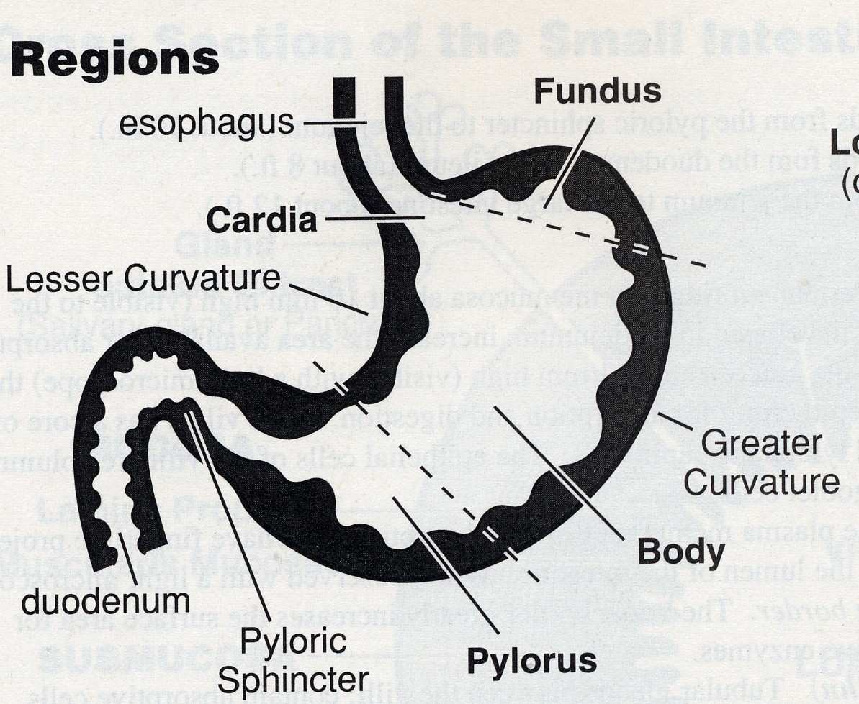
A.
B.
C.
D.

E.

- Which of the following (A, B, C, D or E) represents ketone bodies?
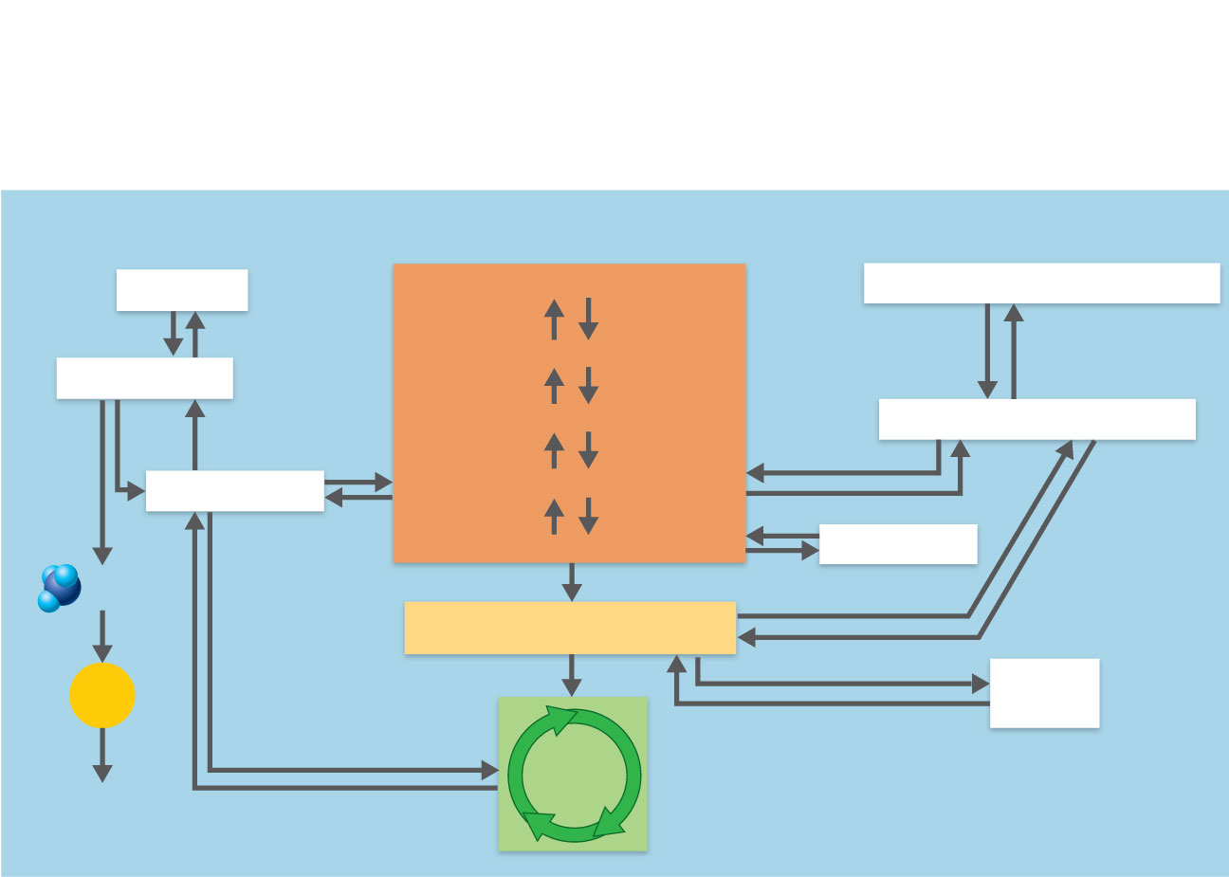
Glycogen
Glucose
Pyruvic acid
Proteins
Triglycerides
A.
B.
C.
D.
E.

- Please label the structures indicated by arrows (0.5 mark each proper label; 2.5 marks total):
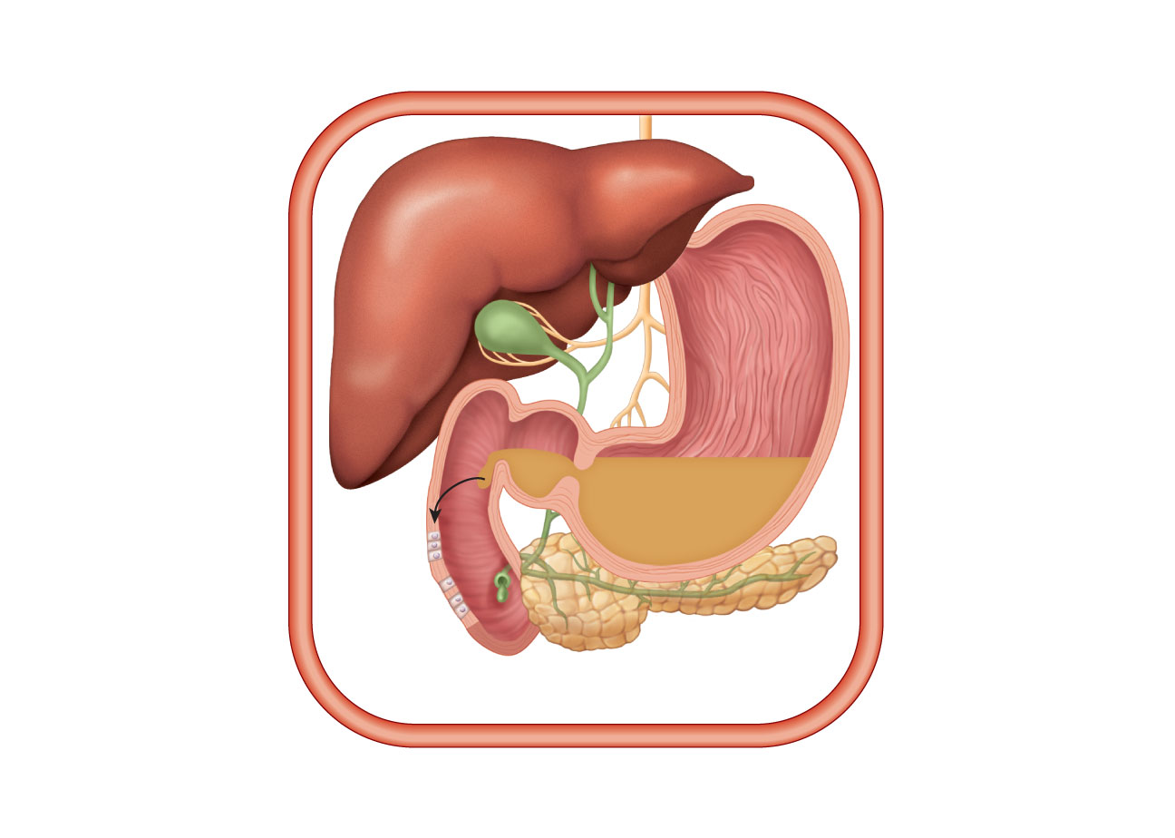

- Please label the following structures (1,5 mark):
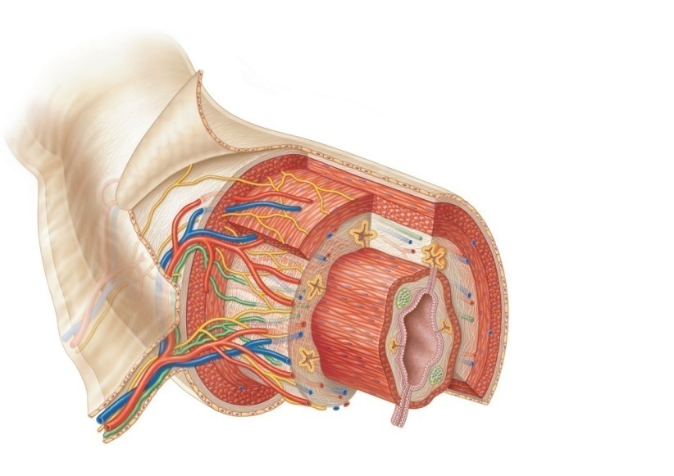
A.
B
C

- Describe briefly, in a point form, five (5) major actions of insulin (5 marks)

- Please define three (3) of the following terms (1 mark each correct answer, 3 marks total):

USE THE NEXT PAGE!!!
  - Chylomicron
  - Gluconeogenesis
  - Portal circulation
  - Glycolysis
  - Peristalsis

BONUS (2 marks):NEXT PAGE
List four(4) most typical signs and symptoms of hypothyroidism in neonates (new born babies) .

