Chapter 5: Stress
Definitions
  - Stress: The psychological response to demands when there is something at stake for the individual, and when coping with these demands would tax or exceed the individual’s capacity or resources
  - Stressors: Demands that cause the stress response
    - Hindrance Stressors: Stressors that tend to be appraised as thwarting progress towards growth and achievement
      - Role Conflict: Others’ having differing expectations of what an individual needs to do in a role (Work)
      - Role Ambiguity: A lack of direction and information about what needs to be done in a role (Work)
      - Role Overload: An excess of demands on an employee preventing him or her from working effectively (Work)
      - Daily Hassles: Minor day-to-day demands that interfere with work accomplishments (Work)
      - Work-Family Conflict: A form of role conflict in which the demands of a work role hinder the fulfillment of the demands in a family role (or vice versa) (Non-Work)
      - Negative Life Events: Events such as a divorce or death of a family member that tend to be appraised as a hindrance (Non-Work)
      - Financial Uncertainty: uncertainties with regard to the potential for loss of livelihood, savings, or the ability to pay expenses (Non-Work)
    - Challenge Stressors: Stressors that tend to be appraised as opportunities for growth and achievement
      - Time Pressure: The sense that the amount of time allotted to do a job is not quite enough (Work)
      - Work Complexity: The degree to which job requirements tax or just exceed employee capabilities (Work)
      - Work Responsibility: The number and importance of the obligations that an employee has to others (Work)
      - Family Time Demands: The amount of time committed to fulfilling family responsibilities (Non-Work)
      - Personal Development: Participation in activities outside of work that foster growth and learning (Non-Work)
      - Positive Life Events: Events such as marriage or the birth of a child that tend to be appraised as a challenge (Non-Work)
    - To Reduce Stressors:
      - Job Sharing: When two people share the responsibilities of a single job
  - Strains: Negative consequences of the stress response
    - Physiological Strains: Reactions from stressors that harm the human body (ex. Illness, high blood pressure, coronary artery disease, headaches, back pain, stomach-aches)
    - Psychological Strains: Negative psychological reactions from stressors such as depression, anxiety, and anger (ex. Depression, anxiety, irritability, forgetfulness, inability to think clearly, reduced confidence, burnout)
      - Burnout: The emotional, mental, and physical exhaustion from coping with stressful demands on a continuing basis
    - Behavioural Strains: Patterns of negative behaviours that are associated with other strains (ex. Alcohol and drug use, teeth grinding, compulsive behaviours, overeating)
    - To Reduce Strains:
      - Relaxation Techniques: Calming activities to reduce stress
      - Cognitive-Behavioural Techniques: Various practices that help workers cope with life’s stressors in a rational manner
      - Health and Wellness Programs: Employee assistance programs that help workers with personal problems such as alcoholism and other addictions
  - Transactional Theory of Stress: A theory that explains how stressful demands are perceived and appraised, as well as how people respond to the perceptions of appraisals

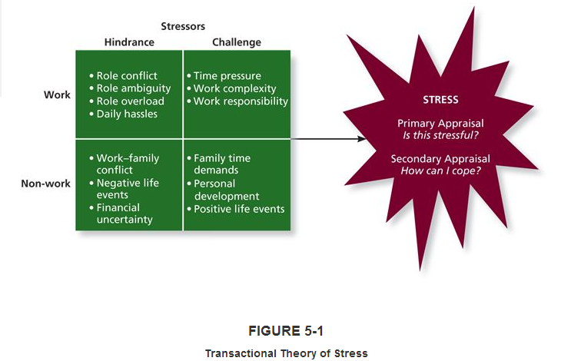
  - Primary Appraisal: Evaluation of whether a demand is stressful and, if it is, the implications of the stressor in terms of personal goals and well-being
  - Benign Job Demands: Job demands that are not appraised as being stressful
  - Secondary Appraisal: When people determine how to cope with the various stressors they face
  - Coping: Behaviours and thoughts used to manage stressful demands and the emotions associated with the stressful demands
    - Behavioural Coping: Physical activities used to deal with a stressful situation
    - Cognitive Coping: Thoughts used to deal with a stressful situation
    - Problem-Focused Coping: Behaviours and cognitions of an individual intended to manage the stressful situation itself
    - Emotion-Focused Coping: Behaviours and cognitions of an individual intended to help manage emotional reactions to the stressful demands
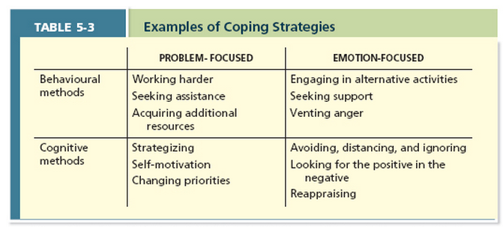

  - Type A Behaviour Pattern: People who tend to experience more stressors, to appraise more demands as stressful, and to be prone to experiencing more strains
  - Social Support: The help people receive from others when they are confronted with stressful demands
  - Instrumental Support: The help people receive from others that can be used to address a stressful demand directly
  - Emotional Support: The empathy and understanding people receive from others that can be used to alleviate emotional distress from stressful demands
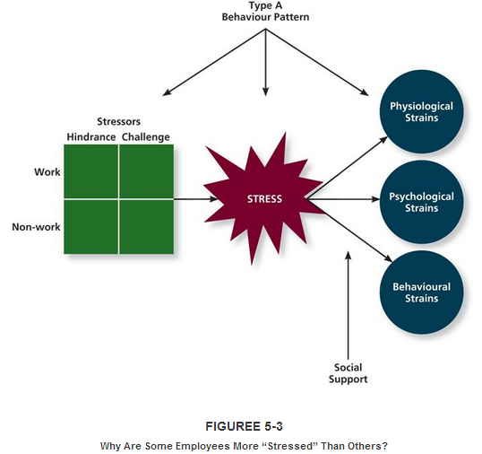
  - Stress Audit: An assessment of the sources of stress in the workplace
  - Training Interventions: Practices that increase employees’ competencies and skills
  - Supportive Practices: Ways in which organizations help employees manage and balance their demands

Chapter 6: Motivation
Definitions
  - Motivation: A set of energetic forces that determine the direction, intensity, and persistence of an employee’s work effort
  - Engagement: A widely used tern in contemporary workplaces that has different meanings depending on the context; most often refers to motivation, but it can refer to affective commitment
  - Expectancy Theory: A theory that describes the cognitive process employees go through to make choices among different voluntary responses
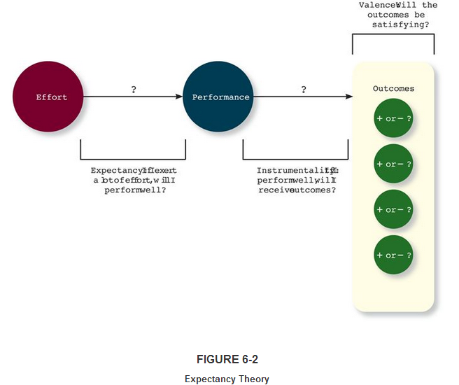

  - Expectancy: The belief that exerting a high level of effort will result in successful performance on some task
    - Self-Efficacy: The belief that a person has the capabilities needed to perform the behaviours required on some task
  - Instrumentality: The belief that successful performance will result in some outcome or outcomes
  - Valence: The anticipated value of the outcome(s) associated with successful performance
    - Needs: Groupings or clusters of outcomes viewed as having critical psychological or physiological consequences
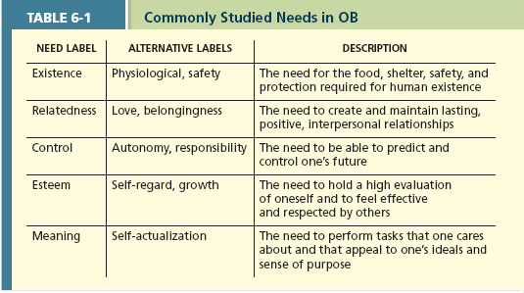

  - Extrinsic Motivation: Desire to put forth work effort due to some contingency that depends on task performance
  - Intrinsic Motivation: Desire to put forth work effort due to the sense that task performance serves as its own reward
  - Meaning of Money: The idea that money can have symbolic value (ex. Achievement, respect, freedom) in addition to economic value
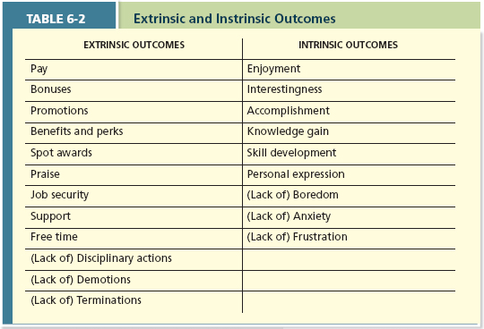

  - Goal Setting Theory: A theory that views goals as the primary drivers of the intensity and persistence of effort
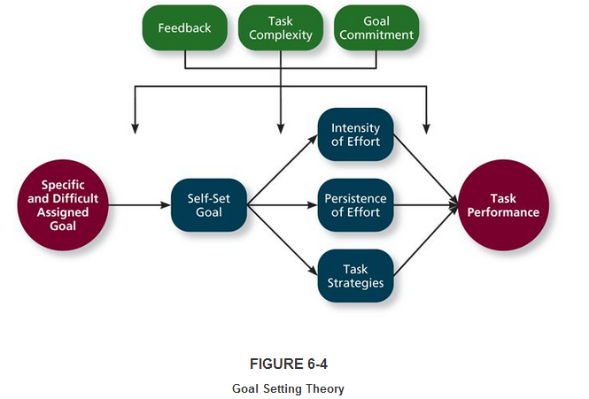
  - Specific and Difficult Goals: Goals that stretch an employee to perform at his or her maximum level while still staying within the boundaries of his or her ability
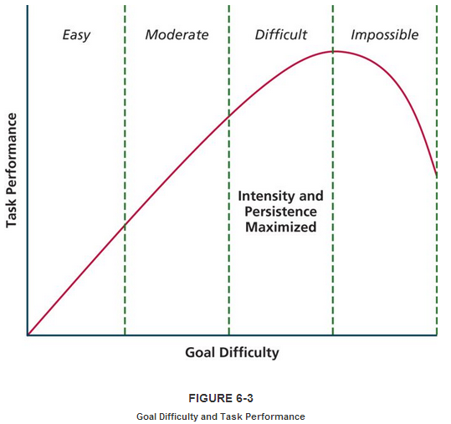
  - Self-Set Goals: The internalized goals that people use to monitor their own progress
  - Feedback: In goal setting theory, it refers to the progress updates on work goals
  - Task Complexity: The degree to which the information and actions needed to complete a task are complicated
  - Goal Commitment: The degree to which a person is determined to reach the goal
  - S.M.A.R.T. Goals: Acronym that stands for Specific, Measurable, Achievable, Results-based, Time-sensitive goals
  - Equity Theory: A theory that suggests that employees create a mental ledger of the outcomes they receive for their job inputs, relative to some comparison other
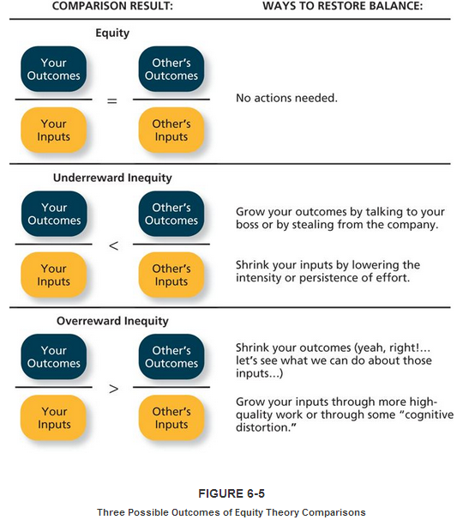
  - Comparison Other: Another person who provides a frame of reference for judging equity
  - Equity Distress: An internal tension that results from being over rewarded or under rewarded relative to some comparison other
    - Cognitive Distortion: A re-evaluation of the inputs an employee brings to a job, often occurring in response to over reward inequity or equity distress
  - Internal Comparisons: Comparing oneself to someone in your same company
  - External Comparisons: Comparing oneself to someone in a different company
  - Psychological Empowerment: An energy rooted in the belief that tasks are contributing to some larger purpose
    - Meaningfulness: A psychological state reflecting one’s feelings about work tasks, goals, and purposes, and the degree to which they contribute to society and fulfill one’s ideals and passions
    - Self-Determination: A sense of choice in the initiation and continuation of work tasks
    - Competence: The capability to perform work tasks successfully
    - Impact: The sense that a person’s actions “make a difference” – that progress is being made toward fulfilling some important purpose

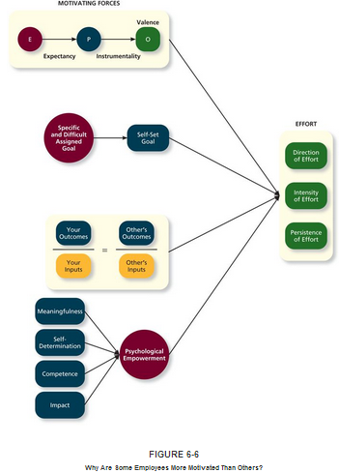

Chapter 7: Trust, Justice, and Ethics
Definitions
  - Trust: The willingness to be vulnerable to an authority based on positive expectations about the authority’s actions and intentions
    - Disposition-Based Trust: Trust that is rooted in one's own personality, as opposed to a careful assessment of the trustee's trustworthiness
      - Trust Propensity: A general expectation that the words, promises, and statements of individuals can be relied upon
    - Cognition-Based Trust: Trust that is rooted in a rational assessment of the authority's trustworthiness
      - Trustworthiness: Characteristics or attributes of a person that inspire trust, including competence, character, and benevolence
      - Ability: The skills, competencies, and areas of expertise that enable an authority to be successful in some specific area
      - Benevolence: The belief that an authority wants to do good for a trustor, apart from any selfish or profit-centre motive
      - Integrity: The perception that an authority adheres to a set of values and principles that the trustor finds acceptable
    - Affect-Based Trust: Trust that depends on feelings toward the authority that go beyond any rational assessment of trustworthiness

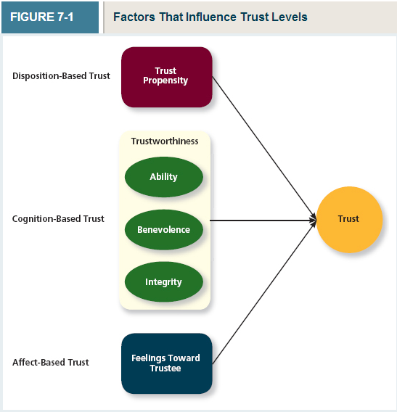
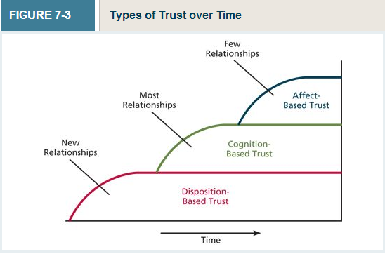
  - Justice: The perceived fairness of an authority’s decision making
    - Distributive Justice: The perceived fairness of decision-making outcomes
    - Procedural Justice: The perceived fairness of decision-making processes
    - Interpersonal Justice: The perceived fairness of the interpersonal treatment received by employees from authorities
    - Informational Justice: The perceived fairness of the communications provided to employees from authorities
  - Ethics: The degree to which the behaviours of an authority are in accordance with generally accepted moral norms
    - Whistle-Blowing: Employees' exposing illegal or immoral actions by their employer
    - Four-Component Model: A model that argues that ethical behaviours result from the multistage sequence or moral awareness, moral judgement, moral intent, and ethical behaviour
      - Moral Awareness: Recognition by an authority that a moral issue exists in a situation
        - Moral Intensity: The degree to which an issue has ethical urgency
        - Moral Attentiveness: The degree to which people chronically perceive and consider issues or morality during their experiences
      - Moral Judgement: When an authority can accurately identify the 'right' course of action
        - Cognitive Moral Development: As people age and mature, they move thought several states of moral development, each more mature and sophisticated than the prior one
        - Moral Principles: Prescriptive guides for making moral judgements
      - Moral Intent: An authority's degree of commitment to the moral course of action
        - Moral Identity: The degree to which a person views himself or herself as a moral person
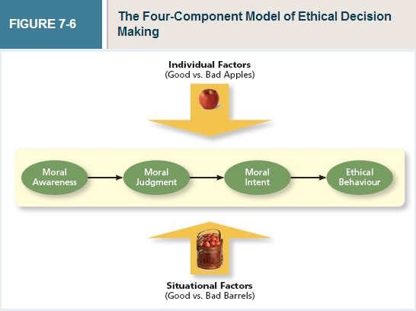
  - Economic Exchange: Work relationships that resemble a contractual agreement by which employees fulfill job duties in exchange for financial compensation
  - Social Exchange: Work relationships that are characterized by mutual investment, with employees willing to engage in 'extra mile' sort of behaviours because they trust that their efforts will eventually be rewarded
  - Corporate Social Responsibility: A perspective that acknowledges that the responsibility of a business encompasses the economic, legal, ethical and citizenship expectations of society

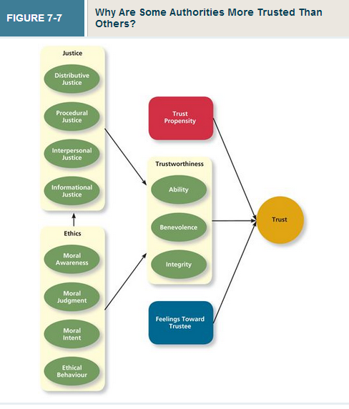
Chapter 8: Learning and Decision Making
Definitions
  - Learning: A relatively permanent change in an employee's knowledge or skill that results that experience
    - Expertise: The knowledge and skills that distinguish experts from novices
    - Explicit Knowledge: Knowledge that is easily communicated and available to everyone
    - Tacit Knowledge: Knowledge that employees can only learn through experience
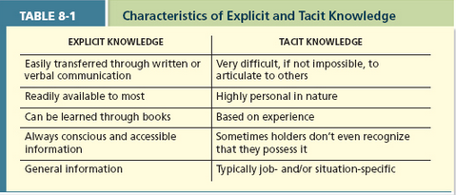
  - Contingencies of Reinforcement: Four specific consequences used by organizations to modify employee behaviour (Reinforcement Learning)
    - Positive Reinforcement: A reinforcement contingency in which a positive outcome follows a desired behaviour, ex: reward - promotion (Reinforcement Learning)
    - Negative Reinforcement: A reinforcement contingency in which an unwanted outcome is removed following a desired behaviour, ex: boss removing a duty because you're doing so well at another job (Reinforcement Learning)
    - Punishment: An unwanted outcome that follows an unwanted behaviour, ex: suspension for showing up late (Reinforcement Learning)
    - Extinction: The removal of a positive outcome following an unwanted behaviour, ex: co-workers thinking you're cool or cheering you on when you do something funny but against the rules, boss punishes other workers for promoting your behaviour and therefore it gets removed (Reinforcement Learning)
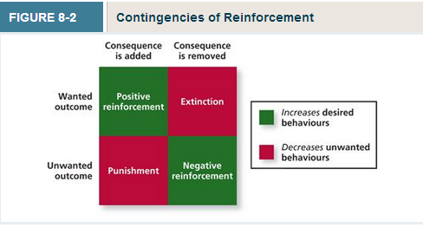
  - Schedules of Reinforcement: The timing of when contingencies are applied or removed (Reinforcement Learning)
    - Continuous Reinforcement: A schedule of reinforcement in which a specific consequence follows each and every occurrence of a certain behaviour (Reinforcement Learning)
    - Fixed-Interval Schedule: A schedule whereby reinforcement occurs at fixed time periods (Reinforcement Learning)
    - Variable-Interval Schedule: A schedule whereby reinforcement occurs at random periods of time (Reinforcement Learning)
    - Fixed-Ratio Schedule: A schedule whereby reinforcement occurs following a fixed number of desired behaviours (Reinforcement Learning)
    - Variable-Ratio Schedule: a schedule whereby behaviours are reinforced after a varying number of them have been exhibited (Reinforcement Learning)
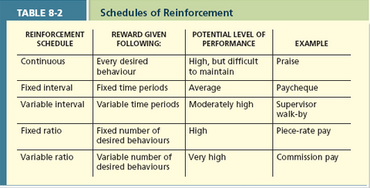
  - Social Learning Theory: Theory that argues that people in organizations learn by observing others (Observation Learning)
  - Behaviour Modelling: When employees observe the actions of others, learn from what they observe, and then repeat the observed behaviour (Observation Learning)
  - Learning Orientation: A predisposition or attitude according to which building competence is deemed more important by an employee than demonstrating competence (Goal Orientation Learning)
  - Performance-Prove Orientation: A predisposition or attitude by which employees focus on demonstrating their competence so that others think favourable of them (Goal Orientation Learning)
  - Performance-Avoid Orientation: A predisposition or attitude by which employees focus on demonstrating their competence so that others will not think poorly of them (Goal Orientation Learning)
  - Decision Making: The process of generating and choosing from a set of alternatives to solve a problem
    - Programmed Decisions: Decisions that are somewhat automatic because the decision maker's knowledge allows him or her to recognize the situation and the course of action to be taken
    - Intuition: An emotional judgement based on quick, unconscious gut feelings
    - Crisis Situation: a change - sudden of evolving - that results in an urgent problem that must be addressed immediately
    - Non-Programmed Decisions: Decisions made by employees when a problem is new, complex, or not recognized
    - Rational Decision-Making Model: A step-by-step approach to making decisions that is designed to maximize outcomes by examining all available alternatives
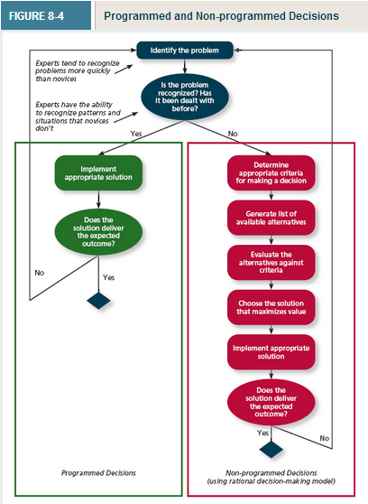
  - Limited Information
    - Bounded Rationality: The notion that people do not have the ability or resources to process all the available information and alternatives when making a decision
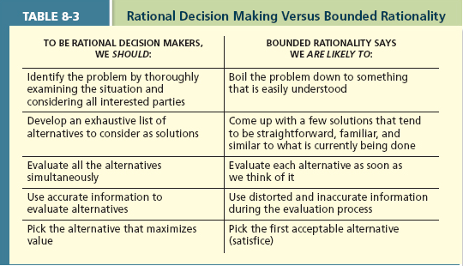
  - Satisficing: What a decision maker is doing who chooses the first acceptable alternative considered
  - Faulty Perceptions
    - Selective Perception: The tendency for people to see their environment only as it affects them and as it is consistent with their expectations
    - Projection Bias: The faulty perception by decision makers that others think, feel and act as they do
    - Social Identity Theory: A theory that people identify themselves according to the various groups to which they belong and judge others according to the groups they associate with
    - Stereotype: Assumptions made about others based on their social group membership
    - Heuristics: Simple and efficient rules of thumb that allow one to make decisions more easily
    - Availability Bias: The tendency for people to base their judgements on information that is easier to recall
  - Faulty Attributions
    - Fundamental Attribution: The tendency for people to judge others' behaviours as being due to internal factors such as ability, motivation, or attitudes
    - Self-Serving Bias: When one attributes one's own failures to external factors and successes to internal factors
    - Consensus: Used by decision makers to attribute cause; whether other individuals behave the same way under similar circumstances
    - Distinctiveness: Used by decision makers to attribute cause; whether the person being judged acts in a similar fashion under different circumstances
    - Consistency: Used by decision makers to attribute cause; whether this individual has behaved this way before under similar circumstances
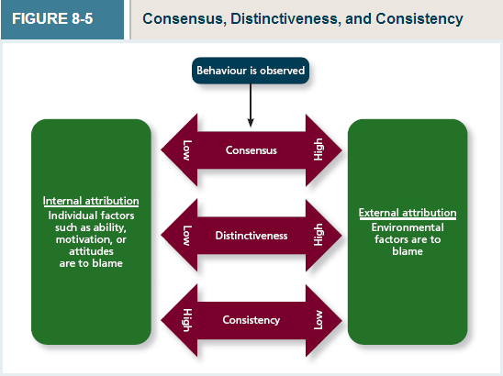
  - Escalation of Commitment: A common decision-making error, in which the decision maker continues to follow a failing course of action
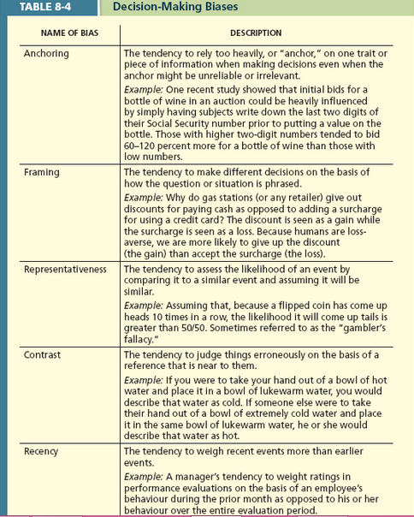
  - Training: A systematic effort by organizations to facilitate the learning of job-related knowledge and behaviour
  - Knowledge Transfer: The exchange of knowledge between employees
  - Behaviour Modelling Training: When employees observe the actions of others, learn from what they observe, and then repeat the observed behaviour
  - Communities of Practice: Groups of employees who learn from one another through collaboration over an extended period of time
  - Transfer of Training: Occurs when employees retain and demonstrate the knowledge, skills, and behaviours required for their job after training ends
  - Climate for Transfer: An organizational environment that supports the use of new skills


