Definitions/Terms:

INTRO
- Organizational Behaviour: Field of study devoted to understanding, explaining and ultimately improving the attitudes and behaviours of individuals and groups in organizations
- Human Resources Management: Field of study that focuses on the applications of OB theories and principles in organizations
- Strategic Management: Field of study devoted to exploring the product choices and industry characteristics that affect an organization's profitability
- Scientific Management: Using scientific methods to design optimal and efficient work processes and tasks
- Bureaucracy: An organizational form that emphasizes the control and coordination of its members through strict chain of command, formal rules and procedures, high specialization, and centralized decision making
- Human Relations Movement: Field of study that recognizes that the psychological attributes of individual workers and the social forces within work groups have important effects on work behaviours

CHAPTER 2 Job Performance
- Job Performance: Employee behaviours that contribute either positively or negatively to the accomplishment or organizational goals
  - Task Performance: Employee behaviours that are directly involved in the transformation of organizational resources into the goods or services that the organization produces
    - Routine Task Performance: Well-known or habitual responses by employees to predictable task demands
    - Adoptive Task Performance: Thoughtful responses by an employee to unique or unusual task demands
    - Creative Task Performance: Ideals or physical outcomes that are both novel and useful
    - Job Analysis: A process by which an organization determines requirements of specific jobs
      - List of all the activities involved in a job is generated
      - Each activity on this list is rated by "subject matter experts" based on importance and frequency of the activity
      - The activities that are rated highly in terms of their importance and frequency are retained and used to define task performance
- Citizenship Behaviour: Voluntary employee behaviours that contribute to organizational goals by improving the context in which works takes place
  - Interpersonal Citizenship Behaviours: Going beyond normal job expectations to assist, support, and develop co-workers and colleagues
    - Helping: assisting co-workers who have heavy workloads, aiding them with personal matters, and showing new employees the ropes when they are first on the job
    - Courtesy: Sharing important information with co-workers
    - Sportsmanship: Maintaining a positive attitude with co-workers through good and bad times
  - Organizational Citizenship Behaviours: Going beyond normal expectations to improve operations of the organization, as well as defending the organization and being loyal to it
    - Voice: Speaking up to offer constructive suggestions for change, often in reaction to a negative work event
    - Civic Virtue: Participation in company operations at a deeper-than-normal level through voluntary meetings, readings, and keeping up with news that affects the company
    - Boosterism: Positively representing the organization when in public.
- Counterproductive Behaviour: Employee behaviours that intentionally hinder organizational goal accomplishment
  - Property Deviance: behaviours that harm the organization's assets and possessions
    - Sabotage: purposeful destruction of equipment, organizational processes, or company products
    - Theft: stealing company products or equipment from the organization
  - Production Deviance: intentionally reducing organizational efficiency of work output
    - Wasting Resources: using too many materials or too much time to do too little work
    - Substance Abuse: The abuse of drugs or alcohol before coming to work or while on the job
  - Political Deviance: behaviours that intentionally disadvantage other individuals
    - Gossiping: casual conversations about other people in which the facts are not confirmed as true
    - Incivility: communication that is rude, impolite, discourteous, and lacking good manners
  - Personal Aggression: hostile verbal or physical actions directed toward other employees
    - Harassment: unwanted physical contact or verbal remarks from a colleague
    - Abuse: employee assault or endangerment from which physical and psychological injuries may occur
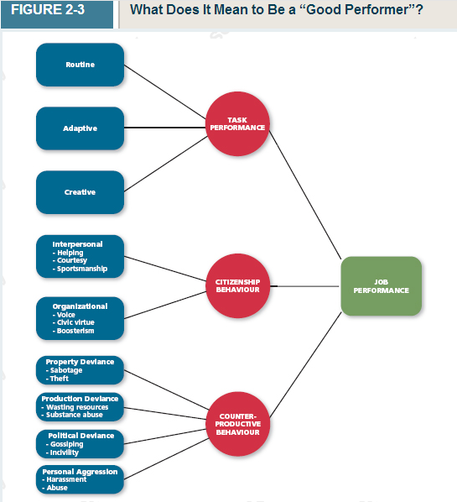
Performance Management
- Management By Objectives: A management philosophy that bases employee evaluations on whether specific performance goals have been met
- Behaviourally Anchored Rating Scales (BARS): Use of examples of critical incidents to evaluate an employee's job performance behaviours directly
- 360-Degree Feedback: A performance evaluation system that uses ratings provided by supervisors, co-workers, subordinates, customers, and the employees themselves
- Forced Ranking: a performance management system in which managers rank subordinates relative to one another

CHAPTER 3 Organizational Commitment
- Organizational Commitment: An employee's desire to remain a member of an organization
  - Affective Commitment: An employee's desire to remain a member of an organization due to a feeling of emotional attachment (want to)
    - Erosion Model: A model that suggests that employees with fewer bonds with co-workers are more likely to quit the organization
    - Social Influence Model: A model that suggests that employees with direct linkages to co-workers who leave the organization will themselves become more likely to leave
  - Continuance Commitment: An employee's desire to remain a member of an organization due to an awareness of the costs of leaving (have to)
    - Embeddednes: an employee's connection to and sense of fit in the organization and community
  - Normative Commitment: An employee's desire to remain a member of an organization due to a feeling of obligation (ought to)
  - Focus of Commitment: the people, places, and things that inspire a desire to remain a member of the organization
- Withdrawal Behaviours: Employee actions that are intended to avoid work situations
  - Responses to negative work events:
    - Exit: a response to a negative work event in which one becomes often absent from work or voluntarily leaves the organization
    - Neglect: A passive, destructive response to a negative work event in which one's interest and effort in work decline
    - Voice: a response to a negative work event in which an employee offers constructive suggestions for change
    - Loyalty: A passive response to a negative work event in which one publicly supports the situation but privately hopes for improvement
  - Psychological Withdrawal: Mentally escaping the work environment
    - Daydreaming: A form of psychological withdrawal in which one's work is interrupted by random thoughts or concerns
    - Socializing: A form of psychological withdrawal in which one verbally chats with co-workers about non-work topics
    - Looking Busy: A form of psychological withdrawal in which one attempts to appear consumed with work when not performing actual work tasks
    - Moonlighting: A form of psychological withdrawal in which employees use work time and resources to do non-work-related activities
    - Cyberloafing: A form of psychological withdrawal in which employees surf the internet, e-mail, and instant messages to avoid doing work-related activities
  - Physical Withdrawal: A physical escape from the work environment
    - Tardiness: A form of physical withdrawal in which employees arrive late to work or leave work early
    - Long Breaks: A form of physical withdrawal in which employees take longer-than-normal lunches or breaks to spend less time at work
    - Missing Meetings: A form of physical withdrawal in which employees neglect important work functions while away from the office
    - Absenteeism: A form of physical withdrawal in which employees do not show up for an entire day of work
    - Quitting: A form of physical withdrawal in which employees voluntarily leave the organization

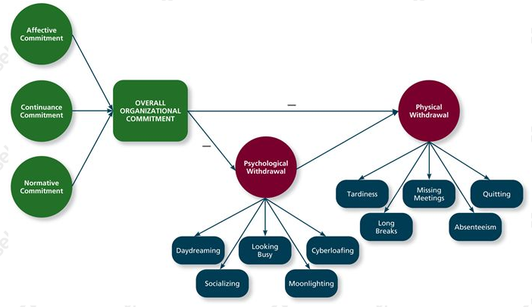

How do all those behaviours relate to one another?
- Independent Forms Model: a model that predicts that the various withdrawal behaviours are uncorrelated, so that engaging in one type of withdrawal has little bearing on engaging in other types
- Compensatory Forms Model: A model indicating that the various withdrawal behaviours are negatively correlated, so that engaging in one type of withdrawal makes one less likely to engage in other types
- Progression Model: A model indicating that the various withdrawal behaviours are positively correlated, so that engaging in one type of withdrawal makes one more likely to engage in other types.

- Psychological Contracts: employee beliefs about what employees owe the organization and what the organization owes them
  - Transactional Contracts: psychological contracts that focus on a narrow set of specific monetary obligations
  - Relational Contracts: Psychological contracts that focus on a broad set of open-ended and subjective obligations
- Perceived Organizational Support: The degree to which employees believe that the organization values their contributions and cares about their well-being

CHAPTER 4 Job Satisfaction
- Job Satisfaction: A pleasurable emotional state resulting from the appraisal of one's job or job experiences; represents how a person feels and thinks about his or her job
  - Values: things that people consciously or unconsciously want to seek or attain
    - Pay
    - Promotions
    - Supervision
    - Co-workers
    - The work itself
    - Altruism
    - Status
    - Environment
  - Value-percept Theory: a theory that argues that job satisfaction depends on whether the employee perceives that his or her job supplies those things that he or she values
    - Dissatisfaction = (V_{want} - V_{have}) X (V_{importance})
    - Pay Satisfaction: employees' feelings about the compensation for their jobs = (Pay_{want} - Pay_{have}) X (Pay_{importance})
    - Promotional Satisfaction: Employees' feelings about how the company handles promotions = (Promotion_{want} - Promotion_{have}) X (Promotion_{importance})
    - Supervision Satisfaction: Employees' feelings about their boss, including his or her competency, communication, and personality = (Supervision_{want} - Supervision_{have}) X (Supervision_{importance})
    - Co-Worker Satisfaction: Employees' feelings about their co-workers, including their abilities and personalities = (Co-worker_{want} - Co-worker_{have}) X (Co-worker_{importance})
    - Satisfaction With The Work Itself: Employees' feelings about their actual work tasks = (Work_{want} - Work_{have}) X (Work_{importance})
      - Job Characteristics Theory: a theory that argues that five core characteristics (variety, identity, significance, autonomy and feedback) combine to result in high levels of satisfaction with the work itself
        - Meaningfulness of Work: a psychological state indicating the degree to which work tasks are viewed as something that counts in the employee's system of philosophies and beliefs
          - Variety: the degree to which a job requires different activities and skills
          - Identity: the degree to which a job offers completion of a whole, identifiable piece of work
          - Significance: the degree to which a job really matters and impacts society as a whole
        - Responsibility of Outcomes: a psychological state indicating the degree to which employees feel they are key drivers of the quality of work output
          - Autonomy: the degree to which a job allows individual freedom and discretion regarding how the work is to be done
        - Knowledge of Results: a psychological state indicating the extent to which employees are aware of how well or how poorly they are doing
          - Feedback: in job characteristics theory, the degree to which the job itself provides information about how well the job holder is doing
        - Moderators
        - Knowledge and Skill: The degree to which employees have the aptitude and competence needed to succeed on their job
        - Growth Need Strength: The degree to which employees desire to develop themselves further

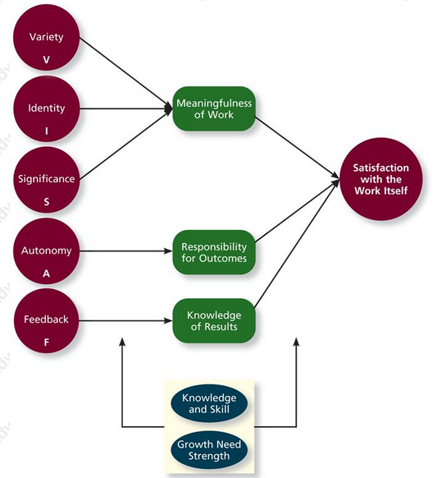
- Based on the Job Characteristics Theory employers usually examine the results of a satisfaction potential score and may end up introducing:
- Job Enrichment: When job duties and responsibilities are expanded to provide increased levels of core job characteristics (VISAF = variety, identity, significance, autonomy and feedback)
- Mood: States of feeling that are mild in intensity, last for an extended period of time, and not directed at anything
- Affective Events Theory: A theory that describes how workplace events can generate emotional reactions that impact work behaviours
- Emotions: Intense feelings, often lasting for a short duration, that are clearly directed at someone or some circumstance
  - Positive Emotions: Employees' feelings of joy, pride, relief, hope, love and compassion
  - Negative Emotions: Employees' feeling or fear, guilt, shame, sadness, envy and disgust
- Emotional Labour: The management of their emotions that employees must do to complete their job duties successfully
- Emotional Contagion: The idea that emotions can be transferred from one person to another
- Life Satisfaction: The degree to which employees feel a sense of happiness with their lives in general
- Job Descriptive Index (JDI): A facet measure of job satisfaction that assesses an individual's satisfaction with pay, promotion opportunities, supervision, co-workers, and the work itself.

