Module 1: Understanding MIS

- Moores Law
  - number of transistors per square inch on an integrated chip doubles every eighteen months
  - Due to the impact of Moore's Law, the price/performance ratio of computers has fallen dramatically over the past decade, and computers have shrunk dramatically in both size and cost while computing power has increased drastically.
  - data storage and data transmission are essentially free today.
  - Due to this, any routine skill will be outsourced to the lowest bidder
- Information system
  - A system is a group of components that interact to achieve some purpose. An information system (IS) is a group of components that interact to produce information.
  - Hardware, software, data, people and procedures.
- Management Information Systems:
  - Management information systems refer to the development and use of information systems that help businesses achieve their goals and objectives. This definition has three key elements: development and use, information systems, and business goals and objectives.

- Information technology
  - the products, methods, inventions, and standards that are used to produce information
    - Difference: people
      - IT refers to methods, inventions, standards, and products. IT refers to raw technology, and it concerns only the hardware, software, and data components of an information system. In contrast, an information system is a system of hardware, software, data, procedures, and people that produce information. IT, by itself, will not help an organization achieve its goals and objectives. It is only when IT is embedded into an IS—only when the technology within the hardware, software, and data is combined with the people and procedure components—that IT becomes useful.
- Abstract reasoning
  - Abstract reasoning is the ability to make and manipulate models
- System Thinking
  - The ability to model components of a system, to connect the inputs and outputs among those components into a sensible whole that reflects the structure and dynamics of the phenomenon observed.
- Security
  - Depends on the behavior of its users

Definitions:

- Business process
  - is a network of activities, roles, resources, repositories, and data flows that interact to accomplish a business function.
- Activities
  - collections of related tasks that receive inputs and process those inputs to produce outputs
- Roles
  - Set of procedures
- Decision
  - Questions that can be answered yes or no
- Repository
  - Collection of business records

MODULE 2: HARDWARE AND SOFTWARE

- Networking
  - LAN (Local Area Network)
    - Linking many personal computers together
    - Shared access to data
  - WAN (Wide Area Networks)
    - The interet, email, browsing
- Principles
  - Price and performance advances
  - Small is powerful
  - Network
- Bits
  - 8-bit chunks
  - Binary bits used to represent data, zero or ones
- CPU
  - Transfers program or data from disk to main memory
    - Moves instructions from main memory via data channel or bus
  - Has small amount of very fast memory called cache
  - Expressed in hertz
- Memory
  - Contains program instructions
  - OS instructions
- Cloud Computing
  - Hardware, software and applications are provided as a service through a web browser
  - The cloud is a metaphor for the Internet, which makes software and data services available from any location at any time.
  - Builds upon the concept of grid computing
    - Several computers are used to address a single problem at the same time
- APPLICATIONS
  - One-of-a-kind application software
    - Designed for a specific, unique need, ex: IRS software
  - Other (Dual category) app software
    - CRM software
      - How to acquire software?
        - Buy off the shelf, buy off the shelf with alterations, tailor made
  - Horizontal-market application software
    - Provides capabilities common across all organizations and industries
      - Ex: word, acrobat
  - Vertical
    - Serves the need of specific industry
      - Ex: appointment scheduling software
- Firmware
  - Software installed into devices
- BIOS (Basic Input/output System)
  - Used when is initially booted up
- Difference between a thin and thick client
  - Amount of code that must run on the client computer
    - Nothing more than a browser on a computer, thin client.
  - Thick: outlook
- Viruses
  - Computer program that replicates itself
- Macro Viruses
  - Attached themselves to various types of documents
- Worm
  - Virus propagates using
- Zombies
  - Susequent computers infected with worm or virus.

Module 3:

- Competitive Strategy
  - The CS is followed by an organization derived from its structure.
  - CS determines its value chains

- Bargaining power
  - Coffee plantser during a season of frost that decreases productions
- Porter
  - Five forces:
    - Developed to determine the potential profitability of an industry
      - Grouped into two types:
        - Competition forces
        - Supply chain bargaining power
    - Must be consistent with the organizations strategy
    - Value:
      - amount of money that a customer is willing to pay for a resource, product, or service
    - Organizational strategy begins with an assessment of the fundamental characteristics and structure of an industry. A model used to assess an industry structure is Porter's five forces model. Porter's five competitive forces can be grouped into two types: forces related to competition and forces related to supply chain bargaining power.
      - The competitive forces are:
        - competition from vendors of substitutes,
        - competition from new competitors, and
        - competition from existing rivals.
      - The bargaining power forces include the
        - bargaining power of suppliers and
        - the bargaining power of customers.
      - The intensity of each of the five forces determines the characteristics of the industry, how profitable it is, and how sustainable that profitability will be. Organizations examine these five forces and determine how they intend to respond to them. That examination leads to competitive strategy.
    - 4 strategies
      - An organization responds to the structure of its industry by choosing a competitive strategy. Porter followed his five forces model with the model of four competitive strategies. According to Porter, a firm can engage in one of these four fundamental competitive strategies. An organization can focus on being the
        - cost leader, or
        - it can focus on differentiating its products from those of the competition.
        - the cost or differentiation strategy across an industry or
        - it can focus its strategy on a particular industry segment.
      - According to Porter, to be effective the organization's goals, objectives, culture, and activities must be consistent with the organization's strategy.
    - Competitive Advantage strategies
      - a. Establishing high switching costs-organizations can lock in customers by making it difficult or expensive for customers to switch to another product.
      - b. Lock in suppliers-organizations can lock in suppliers by making it difficult to switch to another organization, or, stated positively, by making it easy to connect to and work with the organization.
      - c. Creating entry barriers-competitive advantage can be gained by creating entry barriers that make it difficult and expensive for new competition to enter the market.
      - d. Establish alliances-another means to gain competitive advantage is to establish alliances with other organizations.
      - e. Finally, by creating better business processes, organizations can gain competitive advantage by reducing costs.

- Porters Value Chain
  - Network of value-creating activities
    - Primary Activities
      - Activities where value is added directly to the product (OOMIS)
        - Operations
        - Outbound Logistics
        - Marketing and Sales
        - Inbound logistics
        - Service
    - Support Activities
      - Support primary
        - Firm Infrastructure
        - Human Resources
        - Tehnological Development
        - Procurement
  - Value chain helps increase productivity, more efficient or more effective supporting activities, increase margin enjoyed by the company, information systems increase productivity by offering new and improved services, primary activities.
    - If its margin is positive, company must retain its present practices

Module 6: Database and Content Management

- Database
  - Self-describing collection of integrated records
    - Hierarchy
      - Bytes (characters)
      - Columns/Fields
      - Rows/Records
      - Tables/Files
      - Database
    - Components
      - Tables +Relationships among rows + Metadata
    - Keys
      - Columns that identify unique row in table
      - Each table has a key
    - Foreign Keys
      - Keys in a different table that he on in which they reside
- DBMS (Database Management System)
  - Program that creates, processes and administers a database. (Access)
  - DBMS and database are two different things
- Database Application
  - Collection of forms, reports, queries and application programs that process a database
  - Databases can have more then one application
- 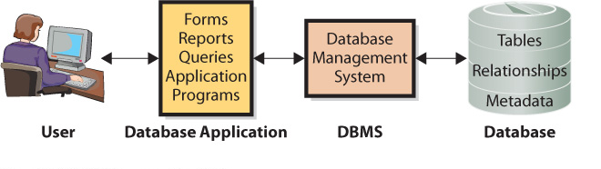
- Difference between Enterprise and Personal DBMS
  - Enterprise DBMS
    - Process large organizations and workgroup databases
    - Support many users and many database applications
  - Personal DBMS
    - Designed for smaller, simpler database applications
    - Supports fewer than 100 users

MODULE 7: NETWORKS AND COLLABORATION
- Collaboration
  - When two or more people work together to achieve a common goal, result or product.
- Network externality
  - The more people on a network, the more valuable it becomes.
- Transmission Media
- Types of network
  - Lan
    - Computers connected at a single physical site
  - WAN
    - Computer connected between two or more sepeated sites
  - Internet
    - Network of networks

- LAN
  - Switch is used to connect all the computers
  - Each LAN device has NIC that connects the device’s circuitry to the network cable.
    - Each NIC has its own MAC (media access control address)
      - Wire connecting everything is unshielded twisted pair (UTP) cable
        - Can be replaced by optical fibre cable
      - NIC Uses IEEE 802.3 (ETHERNET) Protocol
  - WNIC, wireless lan, requires one or more access points (APs)
    - The AP then connects users to the wired network
      - Uses 802.11 protocol (aka WI-FI) & 802.3

- The Internet
  - It is a WAN
  - ISP = internet service provider
  - TLD = top level domain
    - .ca, .com
  - URL = uniform resource locator
  - IP address= numbered address for each machine connected to the network
  - DHCP SERVER
    - Dynamic Host Configuration Protocal server is a computer or router that host a program called DHCP.
    - Assigns a temporary IP address to your computer
    - When you disconnect the ip address is available again.
  - Domain names
    - Converts human-friendly URLs into a computer-friendly IP addresses
  - Connecting to an ISP
    - Through regular telephone line, DSL (special tel line), through cable tv line
    - All three of these are digital, they must be turned into analog using a MODEM
      - MODEMS
        - Dial up
        - DSl (digital subscriber lines
          - Do not interfere with phone lines, faster than dialup
        - Cable modems
          - High speed data transmission
  - 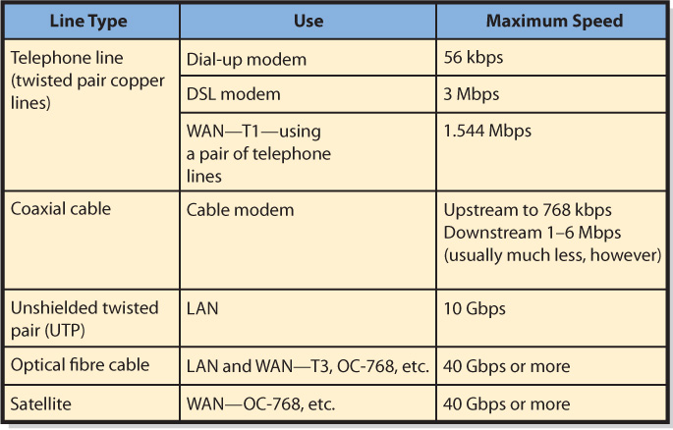
  - Email
    - TCP/IP four-layer scheme
      - Layer 1 is used to transmit data within a single network
      - Layer 2 &3 are used for data transmission across an internet
      - Layer 4, provides protocols that help different applications interact with each other and the person using the computer
    - Steps
- Getting internet access and pressing send/receive
  - Layer 4, SMTP (simple mail transfer protocol
- Break apart messange and get ready for transport
  - Layer 3, TCP (transmission control program)
- Send and receive packets
  - Layer 2, internet protocol (IP)
- Reassemble packets and display message
  - Firewalls
    - Computing device that prevents unauthorized network acces
      - Perimeter: firewals sit outside organizational network
      - Internal are inside network
      - Packet-filtering: examine source address, destination address, and other data before allowing message to pass
  - Encryption
    - Process of transforming clear text into coded unintelligible text for secure storage or communication
      - Types
        - Symmetric: the same key is used to encode and decode
        - Asymmetric: different leys are used; one encored the message, and the other decodes
  - Virtual Private Network (VPN)
    - Uses the internet or private internet to create appearance of private point-to-point connection called the tunnel
    - Secure, encrypted communications

MODULE 8:

