Module 1

Computer: A data processing device that performs four major functions:

1. It gathers data, or allows users to input data.

2. It processes that data into information.

3. It outputs data and information.

4. It stores data and information.

Data versus information:

- Data is a representation of a fact, figure, or idea. Data can be a number, a word, a picture, or even a recording of sound. For example, the number 6125553297 and the names Derek and Washington are pieces of data.
- Information is data that has been organized or presented in a meaningful fashion. When your computer provides you with a contact listing that indicates Derek Washington can be reached by phone at (612) 555-3297, the data mentioned earlier suddenly becomes useful — that is, it becomes information.
Ex: When you first arrive at school you give the clerk data such as your name and id number to create a student id card. The computer processes the data and prints the card.

Bits and Bytes:
To process data and information, computers work in binary language which consists of the digits 0 and 1. Everything a computer processes is broken down into binary language.
Each 0 and 1 is considered binary digits (bit).
Eight binary digits creates one byte. For example the letter K is represented by the byte 01001011.

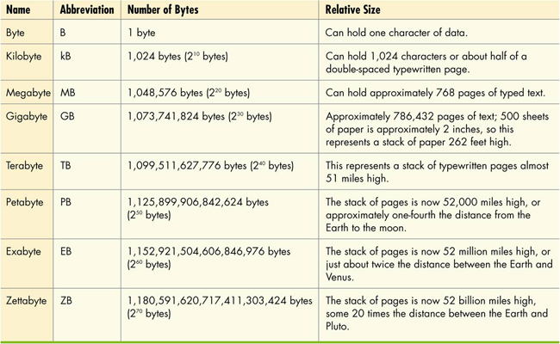

Hardware and software:

Hardware is any part of the computer that you can physically touch.

- Hardware components consist of the system unit and peripheral devices, such as monitors and printers that are connected to the computer.
- Other hardware devices, such as routers, help a computer communicate with other computers to facilitate sharing documents and other resources.
- Together, the system unit and peripheral devices perform four main functions: they enable the computer to input data, process that data, and output and store the data and information.

Software is the set of computer programs that enables the hardware to perform different tasks. It can be divided into two broad categories: application and system.

1- Application software is the set of programs you use on a computer to help you carry out tasks. For example, writing a research paper.

2- System software is the set of programs that enables your computer's hardware devices and application software to work together. The most common type of system software is the Operating system.

Operating system (OS) -- the program that controls the way in which your computer system functions. It manages the hardware of the computer system such as the monitor and the printing also providing means for which users can interact with the computer itself.

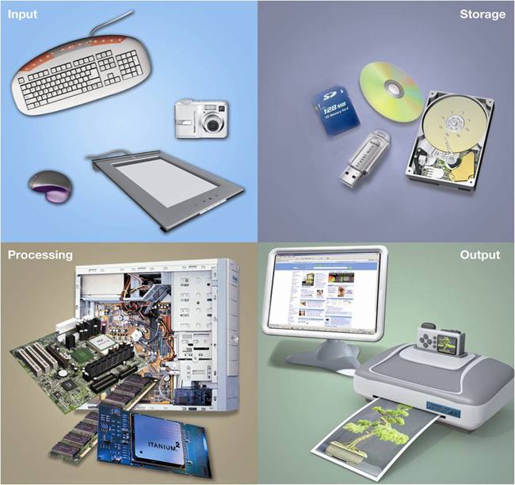

Types of Computers:

Notebook computer is a portable computer powered by batteries and has a keyboard, monitor, and other devices integrates into a single compact case (laptop).

Netbook is smaller more lightweight version a notebook that has a longer battery life.

Tablet PC is similar to a notebook but features a touch sensitive screen.

Desktop Computer is intended for use at a single location. Consist of separate case that houses the main components plus peripheral devices (monitor keyboard, etc.)

Mainframe is a large expensive computer that supports hundreds of users simultaneously. They excel at executing many different computer programs at the same time.

Supercomputer is a specially designed computer that can performs complex calculations extremely rapidly. Supercomputers are designed to execute few programs as quickly as possible whereas main frames are designed to handle more programs at once but at a slower pace.

Embedded computer is a specially designed computer chip that resides in another device such as in a car or in thermostat.

Input Devices:

Input Devices enables one to enter data and instructions into the computers. The most common example would be a keyboard, mouse or microphone.
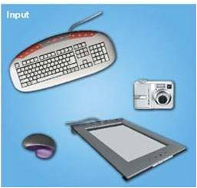

QWERTY keyboard is the most common keyboard in desktop and notebook computers.

- Enhanced keyboard features include number, function, and navigation keys.
- Notebook keys have alternate functions when used in conjunction with the F (function) keys.

Optical mouse uses an internal sensor or laser to detect the mouse's movement. The sensor sends signals to the computer telling it were to move the pointer on the screen. They are often preferable because they have fewer moving parts which lessen the chance of dirt getting in the way.

Trackball Mouse has the roller ball on top or on the side of the mouse which allows it to remain stationary.

Most notebook computers do not have a mouse but instead have a touch pad or a track point device.

New Mouse features:

- Magnifier: Pulls up a magnification box that you can drag around the screen to enhance the viewing of hard-to-read images. This feature can be used by people with visual disabilities.
- Customizable buttons: Extra buttons on the mouse can be programmed to perform the functions you use most often to help you speed through tasks.
- Web Search: Allows you to quickly highlight a word or phrase and then press the search button (on the mouse) to start a Web search.
- File storage: Includes a wireless USB receiver that contains flash memory to store or back up your files (for example, a USB drive).

Image Input:
Digital cameras, scanners camcorders and cell phones are common devices for capturing pictures and video and are all considered to be input devices.

Sound Input:
Equipping one's computer with a microphone device allows you to capture sound waves and transfer them to digital format on your computer. They can be used for a variety of things such as podcasts, video conferencing, etc.
Unidirectional microphones pick up sound from only one direction.
Omni directional microphones pick up sounds from all directions at once.

Input devices for the physically challenged:
- Visually impaired users can input data
  - from voice recognition
  - by using large keyboards
  - by using touch-screen keyboards
- Users with severe motor control problems can use
  - special trackballs designed for one-finger use that can be mounted anywhere
  - head-mounted pointing devices, when arm motion is severely restrained

Output Devices:

Output device enables you to send processed data out of your computer in the form of text, pictures, sounds, or video.
A common output device would a monitor or display which displays text, graphics, and video as soft copies (copies you can only see on the screen).
Printers are also output devices which create hard copies (copies that you can touch) of text and graphics.
Speakers and Earphones are the output devices for sound.

Monitor Types:

LCD (liquid crystal display) is the most common type also called a flat panel monitor.

LED (light emitting diode) technology is used in some monitors which are more energy efficient and provide better colour accuracy often having thinner panels than traditional LCD monitors.

CRT (cathode ray tube) monitors have been mostly replaced as they have become legacy technology; technology that while still functional uses techniques, parts, and methods from an earlier time that is no longer popular.

How LCD monitors work:

Monitor screens are girds made up of millions of tine dots each called a pixel.

Each pixel is comprised of three subpixels of red, blue and green which create the images you see on the monitor when they are illuminated.

LCD monitors are made of two sheets of material filled with a liquid crystal solution. A fluorescent panel at the back generates light waves. When an electric current passes through the liquid crystal solution, the crystals move around and either block the fluorescent light or let in shine through.

The various combinations of the three colours make up the components of colour one sees on the monitor.

Factors that affect quality of an LCD monitor:

Aspect Ratio is the width-to-height proportion of monitor. Traditionally aspect has been 4:3 but newer monitors can be 16:9 or 16:10.

Resolution is clearness or sharpness of the image. Reflects the number of pixels on screen. Standard LSD monitor may have a maximum resolution of 1,600 x 1,200. Meaning 1,600 vertical columns with 1,200 in each of them.

Contrast Ratio is a measure of the difference in light intensity between the brightest white and darkest black that the monitor can produce. Preferable contrast ratio is between 400:1 and 1,000:1.

Viewing Angle which is measured in degrees tells how far you can move to the side of th monitor before the image quality degrades to unacceptable levels. For monitors 17 inches and more recommended viewing angle is at least 150 degrees.

Brightness is measured as candelas per square meter (cd/m²) or nits. It is the measure of the greatest amount of light showing when the monitor is displaying pure white.

Response time is the measurement in milliseconds of the time it takes for a pixel to change colour.

The bigger the monitor the more you can display. The bigger the panel the larger number of pixels it can display. For blue ray, you will require a monitor with at least a 1920 x 1080 resolution.

Different types of printers:

Nonimpact printer sprays ink or uses laser beams to transfer marks onto the paper.

Impact printer has tiny hammer like keys that strike the paper through an inked ribbon, making marks on the paper.

Inkjet printer is the standard type of printer found in most homes. They are popular because they are affordable and produce high quality colour printouts quickly and quietly. They work by spraying tiny drops of ink onto papers.

Laser printers are most often used in offices or classrooms for their high printing speed and higher quality printouts. It uses laser beams and static electricity to deliver a toner onto areas of the page. More economical than inkjet because you don't have to be constantly buying ink.

Plotter is a printer that produces oversized pictures that require drawing of precise and continuous lines.

Thermal printer works by melting wax-based ink onto ordinary paper or by burning dots onto specially coated paper. Used in stores to print receipts or in airports.

Factors to think about when choosing a printer:

- Speed (ppm): A printer’s speed determines how many pages it can print per minute (called pages per minute, or ppm). Printing speeds range from 8 to 30 ppm for both laser and inkjet printers.
- Resolution (dpi): A printer’s resolution (or printed image clarity) is measured in dots per inch (dpi). The higher the dpi, the greater the level of detail and quality of the image. For general-purpose printing, 300 dpi is sufficient; for printing photos, 1,200 dpi is better.
- Color output: Some printers come with a single ink cartridge for all colors; others have two ink cartridges, one for black and one for color. The best setup is to have individual ink cartridges for each color, so you can replace only the specific color cartridge that is empty.
- Use and cost: If you will be printing mostly black-and-white, text-based documents or will be sharing your printer with others, a black-and-white laser printer is best because of its printing speed and overall economies for volume printing. If you’re planning to print color photos and graphics, an inkjet printer or color laser printer is a must, even though the cost per page will be higher.
- Cost of consumables: You should investigate carefully the cost of consumables (printer cartridges and paper) for any printer you are considering purchasing.

Sound Output:

A Speaker is an output device for sound.

A Surround-sound speaker is a system of speakers and audio processing that envelops the listener in a full 360 degree field of sound.

Processing and Memory on the Motherboard:

The Motherboard is the main circuit board that contains the central electronic components of the computer, including the computer's processor, its memory and the many circuit board that help the computer function.
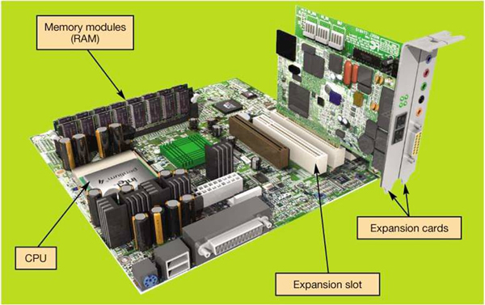

On a desktop, the motherboard is located inside the system unit, the metal plastic case that also houses the power source and all storage devices.

The motherboard also includes the central processing unit (CPU).

Expansion cards or adapter cards are circuit boards that provide additional functionality such as sound or video cards.

A sound card provides connection to the speakers and microphone while a video card provides a connection for the monitor. A modem card provides the computer with a connection to the internet. A network interface card enables your computer to connect with other computers or to a cable modem to facilitate high speed internet connection.

RAM or Random Access memory is the place in the computer where programs and data the computer is currently using are stored. The processor can request RAM's contents, which can be located, opened and delivered to the CPU for processing. In a motherboard RAM can be identified as a series of small memory cards plugged into slots.

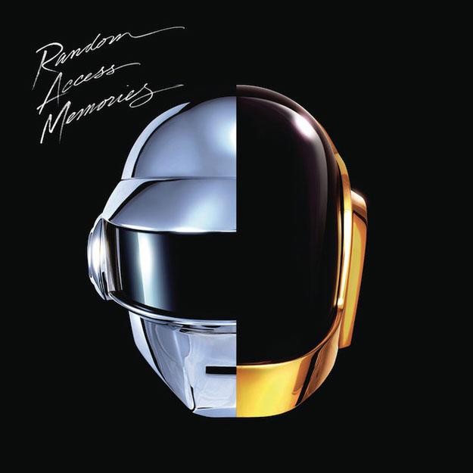

RAM is a temporary or volatile storage location. To save data permanently you need to save it to the hard drive or to another permanent storage device. RAM can be thought of as the computer's temporary memory.

The motherboard also contains ROM or Read-Only Memory which holds all the instructions a computer needs to starts up when it is powered on. The instructions in ROM are permanent and are therefore considered non-volatile storage.

The CPU or Central Processing Unit controls all the functions performed by the computer's other components and processes all the commands issued to it by software instructions. Sometimes referred to as the brains of the computer.

How is processor speed measured:

Processor speed is measure in the units of Hertz (Hz) meaning machine cycles per second. A machine cycle is the process of the CPU getting the data or instructions from Ram and decoding the instructions into something the computer can understand.

Older machines ran at speeds measure in megahertz whereas current systems run at speeds measured in gigahertz or billions of machine cycles per second.

Another factor that determines CPU performance is the number of cores or processing paths a processor has (Single, dual, Quad,...).
Storing Data and Information:

To save data permanently you needs to save it to the hard drive or to an external storage device which is located in a space called the drive bay.

Internal drive bays cannot be seen or accessed from outside the system unit. An internal hard drive usually holds all the permanently stored programs and data.

External drive bays can be seen and accessed from outside the system unit. They house CD and DVD drives for example.

The hard drive is a computer's primary device for permanent storage of software and documents. It is a form of non-volatile storage meaning it holds data and instruction permanently.

An external hard drive is essentially a hard drive however it is made portable often used to back up data contained on internal hard drives in case of problems.

The Optical drive is often included on computers which can read CDs DVDs or Blue-Rays.

A flash drive is a way of storing portable data. Flash drives plug into USB ports. Some computer's now include a flash memory card such as a memory stick which allow one to transfer digital data between your computer devices. Some hard drives are based on solid state drive (SSD) which does not have any spinning platter or motors so they are more efficient and quieter.

Types of ports:

A USB or universal serial bus port is the most common type of port used to connect input and output devices to the computer because it is able to transfer data so quickly.

Other types of ports include FireWire 400 and FireWire800. The 400 moves data at 400Mbps while the 800 does 800Mbps.

A connectivity port gives you access to networks and the Internet. It is also known as an Ethernet port used to connect your computer to a digital subscriber line (DSL) or cable modem, or a network.

Other ports often on the back or side of the computer include audio and video ports. The VGA or video graphics array is a port to which CRT monitors connect. Newer LCD monitors however connect to a DVI or digital video interface and S-video (supervideo) ports. Audio ports are simply where you connect speakers or headphones.

The HDMI or high definition multimedia interface is a compact audio-video interface that carries both high definition video and uncompressed digital audio in one cable.

If one is looking to add ports onto a computer, one may install expansion cards in the system unity to provide additional slots. Like other expansion cards, these cards clip onto an open expansion slot in the motherboard.

If there are no open slots on the motherboard one may then use an expansion hub a device that connects to one port, such as a USB port to provide additional port slots.

Power controls:

The Power supply which is housed inside the system unit, transforms the wall voltage to the voltages require by the computer chips.

A cold boot occurs when powering on your computer from a completely turned off state.

When a computer enters sleep mode all of the documents, applications and data you were using remain in RAM where they are all quickly accessible when you start your computer.

Hibernate is a power-saving mode that stores your data in memory and saves it to your computer's hard drive. In both cases the computer enters a state of greatly reduced power.

Windows 7 has the option for what is called a warm boot in other words restarting the syste, when it's powered on.

- In terms of computing, ergonomics refers to how you set up your computer and other equipment to minimize your risk of injury or discomfort.
- The following are some guidelines that can help you avoid discomfort, eyestrain, or injuries while you’re working at your computer:
  - Position your monitor correctly. This should be at least 25 inches from your eyes and at eye level or so that it is at an angle 15 to 20 degrees below your line of sight.
  - Purchase an adjustable chair. Adjust the height of your chair so that your feet touch the floor. The chair should include back support.
  - Assume a proper position while typing. Your wrists should be flat with respect to the keyboard, and your forearms should be parallel to the floor. Specially designed ergonomic keyboards and wrist rests can help you achieve the proper position for your wrists.
  - Take breaks from computer tasks.
  - Ensure that the lighting is adequate.

Module 2

The Internet is the largest computer network in the world, actually a network of networks that connects billions of computers globally.
The concept of the internet was first developed during the midst of the cold war as the United States became increasingly reliant on computers. The internet was created to establish a form of military communications.

Web versus Internet:

The World Wide Web or WWW is simply a component of the internet which one uses to access information over the internet.

The web can be distinguished from the internet for its common communication protocols that enable different computers to talk to each other and display information in compatible formats and special links that enable users to navigate from one place to another.

The web was actually invented many years after the internet in 1989 by Tim Berners-Lee who wanted a method for linking his research documents so online researchers could access them. Lee developed the first Web browser, software that enables a user to display and interact with text and other media on the web.

The internet experienced explosive growth in the mid 1990s. By 1997, Internet access was global.

Web sites are locations on the internet. In January 2010, there were than 732 million websites.

Forms of Internet communication:

E-mail is a written message that is sent and received over the internet. Today, it is the most common former of electronic communication because it is fast and convenient.

There are two types of e-mail, client based and web based. Client based e-mail such as Microsoft outlook are software programs running on your computer that require access to your ISP which acts as an electronic post office. You can only view the content if the software is installed on the computer. Web based on the other hand such as Gmail allows accessibility from any computer that can access the internet.

It is imperative to use caution when sending e-mails as there are many privacy issues (obviously). Any e-mail you send to someone can be forwarded. Employers may also monitor your e-mail if you are using a non-private client.

For Elderly people who have never written an e-mail before:

- Be concise and to the point
- Use spell-check
- Avoid texting abbreviations
- Include meaningful subject line
- Use smilies (emoticons) sparingly to convey emotion never
- Include signature line with contact information
- Do not type in all capital letters, which is interpreted as shouting.

Instant messaging (IM) services are programmes that enable you to communicate with someone in real time with other who are online.

Most IM services such as Facebook Chat, AOL's AIM, and Windows Live Messenger are proprietary meaning you can only chat with people who share the same IM service.

A chat room is a form of synchronous communication in which online conversations occur in real time and are visible to everyone in the chat group.

A newsgroup is similar to a discussion groups or forum in which people create threads (conversations) and then members post and reply to contribute to the discussion.

Internet Relay Chat (IRC) is primarily a means of synchronous group communication used in discussion forums.

Web 2.0 describes an evolved type of Web interactions between people, software and data. It is a trend of new applications to combine functionality of multiple applications where the user is also a participant.

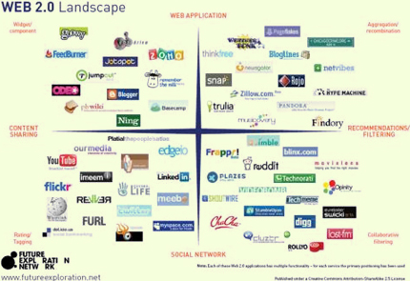

Social Networking is a means by which people use the Internet to communicate and share information among their immediate friends and meet and connects with others through common interests, experiences and friends. There a huge concerns over privacy issues among social networking sites such as Facebook.

A weblog or blog is a personal log or journal posted on the Web. Blogs are often simple to create, manage and read and can be created by anyone.

The popularity of blogs has brought about a problem in the form of spam blogs which are artificially created blog sites filled with fake articles and stolen texts with the sole intention of increasing traffic to a particular site.

A wiki is a type of website that allows users to change its contents by adding, removing or editing the content. Wikis provide an excellent source for collaborative writing as well as for business collaboration.

A podcast is a clip of audio or video that is broadcast over the internet using compressed audio and video files such as MP3s and MP4s. Such content might include radio shows, audio books, magazines and educational programs.

RSS or Really Simple syndication is an XML-based format that facilitates the delivery of frequent content updates on web pages. Using RSS, Web content can be formatted in such a way that aggregators can find it and download the new content to your computer. Aggregators are software programs hat go out and grab the latest update son web material according to your specifications.

A webcast is the broadcast of audio or video content over the Internet. Unlike podcasts that are pre-recorded and available for download, a webcasts is live or one time event.

Netiquette (whoever wrote this slide clearly doesn't know the internet very well):

- Introducing yourself when entering a chat room
- Specifically address the person to whom you are talking
- Refrain from swearing, name-calling, and using explicit or prejudiced language
- Do not post the same text repeatedly with the intent to disrupt the chat, a behaviour called flooding.

Web Entertainment:

Multimedia is anything that involves one or more forms of media in addition to text and is the reason people are drawn to the internet and the web for the most part. Multimedia can include graphics, audio files, websites, video files and more.

Media content files are often very large therefore, to make the watching or listening of live audio and video, we need streaming media.
Streaming audio continuously feeds and audio file to your browser so you avoid having to wait for the entire files to download.

Streaming video continuously feeds video files to your browser so that you can watch large files as they download instead of first having to download the files completely.

Often in order to view multimedia fires, one might require a plug-in which allows a user to view multimedia files such as YouTube videos or podcasts. Popular plug-ins includes, adobe reader, flash player, QuickTime, etc.

E-Business:

E-commerce or electronic commerce is the process of conducting business online such as through advertising and selling products. Ex: Amazon.com

A significant portion of e-commerce consists of business to business (B2B) which consists of businesses buying and selling goods and services from other businesses. For example, the Omaha paper company sells paper online to other companies.

The other portion of e-commerce consists of consumer-to-consumer (C2C) business which consists of consumers selling to each other through online auction sites such as Ebay.

Approximately $100 billion each year is spent on goods purchased over the internet accounting for 25% of all retail sales.

More than 50% of U.S. households conduct some form of online banking. Today, anything you can do inside a bank you can also do through online banking.

How to tell if a website is secure for online shopping?

1-Shop at well-known reputable sites

2-Avoid making online transactions using public computers

3-Pay by credit card, not debit card as federal consumer credit laws protect credit card users

4-Check the return policy

- Online transactions can be safer than traditional retail shopping.
  - VeriSign is a company that certifies that online transactions are secure. Businesses hire security companies such as VeriSign to certify that their online transactions are secure. Thus, if a website displays the VeriSign seal, you can usually trust that the information you submit to the site is protected.
  - Another indication that a website is secure is the appearance of a small icon of a closed padlock (IE) or key (Netscape) on the status bar at the bottom of the screen.
- Additionally, the beginning of the URL changes from http:// to https://, the s standing for “secure.”

Getting Around the Web:
A Web browser or browser is software installed on a computer that allows you to locate, view and navigate the Web.
One of the most common browsers in Internet Explorer which has been the most widely used browser since 1999. Others include, Mozilla Firefox, Safari and Google Chrome.
Most web browsers include tabbed browsing which loads all loaded pages in tabs within the same browser window. Users may flip easily from one page to another by clicking on the tabs. Most browsers also include a built in search box.
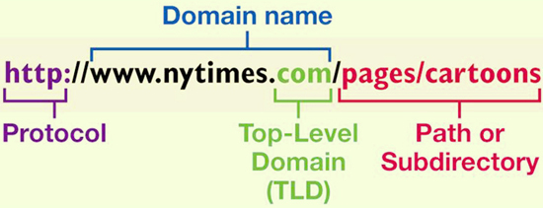
One gains initial access to a website by typing in its unique address known as a URL or Uniform Resource Locator. By typing in the URL of a web site for example, www.popsci.com one may access the home page or main page of the web site.

The URL begins with what is called the hypertext transfer protocol (HTTP). It is the protocol that allows files to be transferred from a web server-- a computer that hosts the web site you are requesting.

Another common protocol used is file transfer protocol (FTP) which is used to upload and download files from your computer to a web server. HTTP files use a web server where as FTP use an FTP file server.

The domain name indentifies the site's host, the location that maintains the computers that store the Web sites files.

The suffix in the domain name after the dot is called the top level domain. It indicates the kind of organization to which the host belongs such as .com, .ca, .net, .org. Each country has its own unique top-level domain.

The subdirectory or the information that follows the domain name usually after a slash indicates a particular path within the Web site. It identifies each different page within a particular web site.

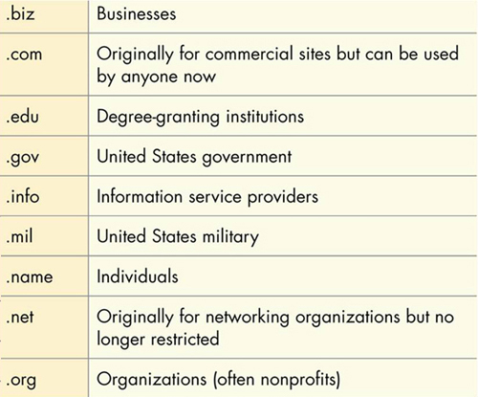

Hyperlinks:

One may jump from one web page to another within a web site by clicking on specially coded elements known as hyperlinks.

Generally, a hyperlink appears in a different colour than the text on the web page. Images can also be hyperlinks.

Some websites offer a service known as a breadcrumb trail which allows users to view a list of pages within a website that they have visited. The history list on a browser's toolbar offers a similar function.

Favorites, Bookmarks and Tagging

The favourites and bookmark features on web browsers offer an easy way to return to a specific web page without having to remember to type in an address.

The live bookmark feature of the Firefox browser adds the technology of RSS feeds to bookmarking. With live bookmarks, the content comes to you, meaning that a live bookmark delivers updates to you as soon as they become available.

Social bookmarking also known as tagging enables one to store, organize and manage bookmarks of Web pages. A social bookmark is a tag that is assigned to a piece of information such as a web page, digital image, or video. A tag describes the item so that it can be found again by browsing or searching.

Search Engines:

A search engine is a set of programs that searches the Web for keywords, specefic words that you wish to look for and then returns a list of web sites on which those keywords are found (Google, Bing, Yahoo).

One can carry out a subject directory a structured outline of Web sites organized by topics and subtopics.

If you can't decide what search engine to use meta search engines search through search engines.

Search engines work through three parts:

The spider constantly collects data on the Web following links in web sites and reading web pages. As the spider collects data, the indexer program organizes the data into a large database. When one uses a search engine, they interact with the third part which is the actual search engine software. The software searches the indexed data pulling out relevant information according to one's search.

Each search engine uses a unique formula or algorithm which explains why you get different results from different search engines.

How to improve search results:

- Place quotation marks around phrases
- Search within a specific web site
- Enter wild card symbols such as the asterisk *. Helpful when needed to search with unknown terms.
- Use the advanced search form

Evaluating Web Sites:
One should never assume that everything you find is accurate and appropriate for use.
Authority: Who is the author of the article or the sponsor of the site?
Bias: Is the site biased? Some sites provide a biased point of view for the purpose of persuading others to buy or sell products rather than to inform
Relevance: Is the information of the site current? Material can last a long time on the Web.
Audience: For what audience was the site originally intended?
Links: Are the links available appropriate? Check out the links provided on the site to determine whether they are still working and appropriate for your needs.

Plagiarism and Copyright Violation, What you can borrow from the Internet
Plagiarism occurs when you use someone else's ideas or words without giving them credit. Avoiding plagiarism means properly crediting all information you obtain from the internet, including words, ideas, graphics, data and audio or video clips.
Copyright Violation is more serious that plagiarism because it is actually punishable by law. It occurs when you use another person's material for your own personal economic benefit or when you take away from he economic benefit of the content creator.
As long as the material is being used for educational purposes only, limited copying and distribution is allowed!

How does the Internet work?
Computers connected to the Internet communicate with one another in turns/ A computer connected to the Internet acts in one of two ways:
It is a client, a computer that asks for data.
It is a server, a computer that receives the request and returns the data to the client.
Because the Internet uses clients and servers is referred to as a client/server network.
Example:
You type in a web site address in your web browser and your computer acts as a client computer as it is requesting information.
Your browser's request for data travels along several pathways to connect to the Internet backbones. All intermediary pathways connect to these backbones.
The data flows along the backbone and then on to smaller pathways until it reaches its destination which is the server computer for the web site you are trying to access.
The server computer returns the requested data to your computer using the most expedient pathway.

Each time you connect to the Internet, your computer is assigned a unique identification number. This number is called the IP address or Internet Protocol address. It is a set of four numbers separated by periods. Ex: 123.45.245.91
The IP address is the means by which all computers connected to the internet identify with each other. Each Web site is assigned an IP address that uniquely identifies it.
Connecting to the Internet:
Home internet users have several options available. Originally, the only means to connect to the Internet was through dial-up connection which connects you to the Internet using a standard telephone line. Dial-up is becoming legacy technology.
Broadband, often referred to as high speed internet is a type of connection that offers a faster means to connect to the Internet at a data transmission rate of 256 Kbps or greater. Dial up in comparison has a maximum of 56 Kbps.
There are also various types of broadband connections:
DSL or digital subscriber line uses a standard phone line to connect your computer to the Internet. DSL allows phone and data transmission to share the same lining in comparison to dial-up where multiple phone lines may be needed if you want to use the internet and speak on the phone at the same time. DSL wires are made of copper wires split into three sections allowing one to carry phone data while the others connect you to the Internet.
Cable uses your television's cable service provider to connect to the Internet.
Fiber-optic service which uses plastic or glass cables transfers data at the soeed of light and has only recently become widely available.
Satellite broadband is used is mostly rural or mountan aread for those who cannot get DSL, cable or Fiber optic service.

A broadband internet connection requires a modem. The modem allows the data to travel on the unused capacity of the transmission medium. For example, a DSL modem separates voice signals from data signals.
The modem is usually located somewhere near the computer and is connected to an expansion card called a network interface card located inside the computer.

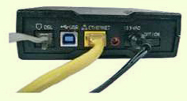

To access the Internet wirelessly, you need to be in a WiFi hot spot and have the right equipment on your mobile device. Most notebooks, phones, tablets come built-in with wireless capabilities. It also possible to set up your own wireless network at home as do many businesses and schools.

Air cards are devices that fit in a USB port or a slot called the express card slot. The air card enables users to have wireless Internet access with notebooks. They require a service plan similar to cell phones.

Comparing Internet Connection Options:

- DSL
  - Average download speed of 1.5 Mbps
  - Maximum download speed of 7 Mbps
  - Lets you access the internet and talk on the same phone line simultaneously
  - Speed drops as you get farther from the phone company's central office
  - Not available on every phone line
- Cable
  - Average download speed of 5 Mbps
  - Maximum download speed of 30 Mbps
  - Speeds are not dependent on distance from central office
  - Line is shared with others in the neighborhood
  - Speeds may vary due to peak/non-peak usage
  - Might require professional installation if cable is not already present
- Fibre optic
  - Average download speed of 20 Mbps
  - Maximum download speed of 50 Mbps
  - Increased speed
  - Service not shared or dependent on distance from central office
  - High cost, but becoming lower as the technology continues to be deployed
  - Not available in all areas

The Future of the Internet

In the future, the Internet will become more accessible because of the prevalence of wireless technology. There is also a concern that there will be no bandwidth left for the exchange of scientific and academic research as the majority of it is spent on e-commerce.

There are currently two major projects underway in the United States to develop advanced Internet technologies for large scale networking.

The LSN or large scale networking program has the aim to fund the R&D of cutting edge networking and wireless technologies to increase the speed of networks.

The Internet 2 is a R&D program that seeks to expand the possibilities of the Internet by developing new Internet technologies and disseminating them as rapidly as possible. The internet 2 backbone supports transmission speeds of up to 8.8 gigabits per second.

In the future we can expect our lives to become increasingly more dependent on the internet.

The uses of the Internet are limited only by our Imaginations!


Module 3 - Application Software: Programs That Let You Work and Play

Software
- The term software refers to a set of instructions that tells the computer what to do. These instruction sets, also called programs, provide the means for us to interact with and use the computer.
- Your computer uses two basic types of software:
- System software: includes software such as Windows and Mac OS X, which help run the computer and coordinate instructions between application software and the computer’s hardware devices. Contains the operating system software and utility programs (programs in the operating system that help manage system resources).
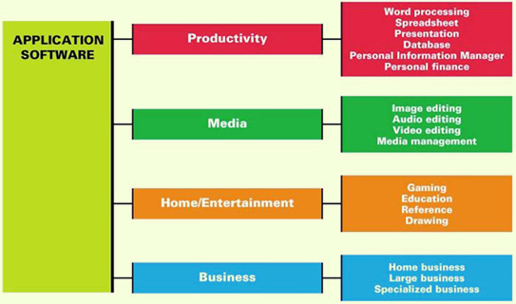
- Application software: is the software you use to do tasks at home, school, and work. such as writing letters, sending e-mail, paying taxes, creating, presentations, editing photos, and taking an online course, to name a few. Includes:
  - Productivity software
  - Specialty software
  - Entertainment software
  - Educational and reference software
  - Personal software

- Productivity software includes programs that enable you to perform various tasks required at home, school or business.
- Microsoft Word and Corel WordPerfect are examples of popular word processing programs. Most students use word processing software for letters, resumes, research paper. Easy to make revisions instead of starting a new document.

Word-Processing Software
Used to create and edit documents
Features include:
    - Quick and easy editing
    - Formatting options
    - Graphics
    - Templates
    - Wizards

    - Examples:
    - Corel WordPerfect
    - Microsoft Word
    - OpenOffice Writer
- Open source software is program code that is publicly available and has a few restrictions.
- Unlike proprietary software, which is neither free nor open source, the code can be copied, distributed or changed without the stringent copyright protections of software products you purchase.
- Free downloads AbiWord and Writer from OpenOffice.org
- Web-based applications: all you need is internet connection, accessible from any computer. They’re great for collaborating and coordinating input from a variety of users on a single document. But little to no formal support like Office.

Spreadsheet Software
- Used to perform calculations and numerical analyses
- Features include:
  - Worksheets with cells
  - Values, formulas and functions
  - Automatic recalculation
  - Help you evaluate different scenarios
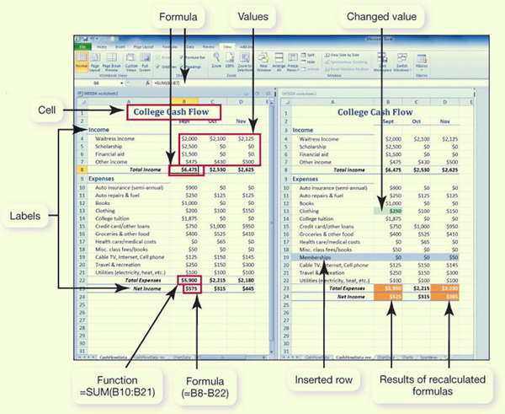
- The basic element in a spreadsheet program is the worksheet, columns and rows of which form boxes called cells. There are several types of data you can enter into a cell:
  - Labels are descriptive text that identifies the components of the worksheet.
  - Values are numeric data entered either directly or as a result of a calculation.
  - Formulas are equations that you build yourself.
  - Functions are formulas that are preprogrammed into the spreadsheet software.
- The primary benefit of spreadsheet software is its ability to recalculate all functions and formulas in the spreadsheet automatically when assumptions are changed.
- Examples:
  - Microsoft Excel
  - OpenOffice Calc
- Text: Any combination of letters, numbers, symbols and spaces. Help identify.
- Values: Numerical data that represent a quantity or an amount and are often the basis for calculations.
- Formulas: Equations that you build yourself using addition, subtraction, multiplication, and division, as well as values and cell references.
- Functions: Formulas that are preprogrammed into the spreadsheet software. Functions help you with calculations ranging from the simple (such as adding groups of numbers) to the complex (such as determining monthly loan payments), without you needing to know the exact formula.
- Many spreadsheet applications also have database capabilities and can sort, filter, and group data.
- Most spreadsheet software allow you to create charts such as pie charts, basic column charts, line charts, sparklines (new with Excel 2010 and show data trends), custom charts, stock charts (investment analysis) scatter chart (statistical analysis), etc.

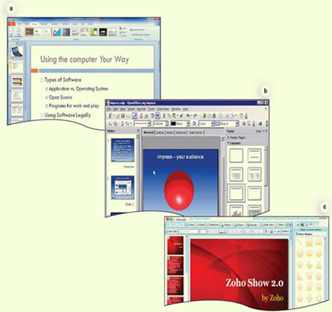
Presentation Software

- Used to create slide shows.
- Features include:
  - Templates and layouts
  - Animations
  - Transitions
- Can use animation effects to control how and when text and other objects enter and exit each slide. Similarly, slide transitions add different effects as you move from one slide to the next during the presentation.
- Examples:
  - Microsoft PowerPoint
  - OpenOffice Impress
  - Zoho Show

Database Software
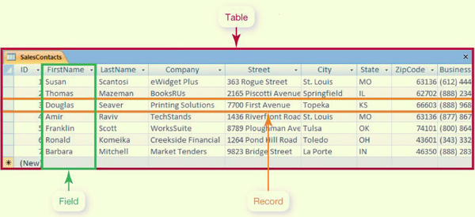
- Used as a complex electronic filing system.
- Features include:
  - Ability to group, sort and retrieve data and generate reports
  - Organized into fields, records and tables
- Examples:
  - Microsoft Access
  - Oracle
  - MySQL

- Unlike spreadsheet software, database software manage larger and more complicated groups of data that contain more than one table; to group, sort, and retrieve data; and to generate reports.
- Traditional databases are organized into fields, records, and tables
- A field is a data category such as “First Name,” “Last Name,” or “Street Address.”
- A record is a collection of related fields such as “Douglas Seaver, Printing Solutions, 7700 First Avenue, Topeka, KS, (888) 968-2678.”
- ” A table groups related records such as “Sales Contacts.”

Note-Taking Software
- Microsoft OneNote
  - Allows students who have Tablet PCs to write their notes directly onto the tablet, using it as an electronic notebook
  - Can be used with a notebook or desktop computer, typing the information onto the sheets, and then the pieces of text can be easily moved around the page
  - Has co-authoring and version tracking capabilities
  - OneNote incorporates new Wiki system
  - There are several free and online note taking options available
  - Evernote (evernote.com), for example, allows you to take notes via the Web, your phone, or your computer and then sync your notes between the Web, your phone, and any computer. You can save text, audio, and images, as well as screen captures, Web pages, and photos. The beauty of Evernote is that everything is searchable.
  - StickyNotes (sticky-notes.net) are digital equivalents to paper sticky notes. These notes can be customized, saved, and shared via e-mail, and they even have reminders.

Personal Information Manager (PIM) Software
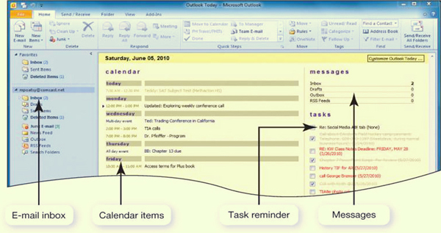
- Used to replace the management tools found on a traditional desk, such as a calendar, address book, notepad and to-do list
- Features include:
  - Calendar, address book, notepad, to-do list
  - Some contain email management features
- Examples:
  - Microsoft Outlook
  - Lotus Organizer
  - Chandler (chandlerproject.org) is another PIM program that is open source and, therefore, free.
  - Many Web-based e-mail clients such as Yahoo!, Google, and AOL have developed coordinating calendar and contacts programs similar to Microsoft Outlook.

Productivity Software Tools
Whether you are working on a word-processing document, spreadsheet, database or slide presentation, there are several tools you can use to increase your efficiency:
- Wizards are step-by-step guides that walk you through the necessary steps to complete a complicated task. At each step, the wizard asks you questions. Based on your responses, the wizard helps you complete that portion of the task.
- Templates are predesigned forms included with software.
- Macros are small programs that group a series of commands to run as a single command. Macros are best used to automate a routine task or a complex series of commands that must be run frequently.

Integrated Software Applications vs. Software Suites
Integrated Software Application
- Single program that incorporates many software programs
- Complex features are not included could be seen as ‘’software light’’
- Less expensive
- Example: Microsoft Works
- Fully featured alternative to individual software programs
- Software Suite
- Collection of stand-alone software programs packaged together
- Share common menus and toolbars
- Integrate well
- Developers: Microsoft, Corel, Apple and Lotus
- Unlike integrated software applications, depending on the version and manufacturer, they may also include other types of applications, such as database programs and desktop publishing software.
- Most people buy software suites because doing so is cheaper than buying each program individually. Since, it’s from the same company, they applications share the same common features, and they work well together.
- Personal financial software
- Tax preparation software such as Intuit TurboTax and H&R Block At Home enable you to prepare your state and federal taxes on your own instead of hiring a professional.
- Tax rate changes, therefore update annually.
- Web-based versions for free for federal forms and instructions. Mint and Yodlee MoneyCenter
- Financial planning software help you manage your daily finances. Intuit Quicken and Microsoft Money are popular examples. Financial planning programs include electronic checkbook registers and automatic bill payment tools.
- Quicken, for example, integrates seamlessly with TurboTax, so you never have to go through your checkbook and bills to find tax deductions, tax-related income, or expenses.
- Multimedia software includes image, video, and audio editing software; animation software; and other specialty software required to produce computer games, animations and movies.

Digital Image-Editing Software (photo editing software)

- Used to edit photographs and other images
  - Remove red-eye
  - Modify contrast
  - Fix scratches
- Examples:
  - Adobe Photoshop
  - Corel PaintShop Pro
  - Google Picasa make posters, collages
  - In Photo Story, you can add text, music, and camera movement to create a fully featured slide show with your images.
  - Adobe Photoshop and Corel PaintShop Pro Photo are fully featured image editing applications. They each offer sophisticated tools for tasks like layering images (placing pictures on top of each other) and masking images (hiding parts of layers to create effects such as collages).
  - With using Adobe Photoshop elements, you can improve the color balance of an image, touch up an image (by removing red-eye, for example), add creative effects to an image, or group images together to create montages.
  - Image editing software such as Adobe Photoshop Elements makes it easy to create (a) calendars, (b) greeting cards and postcards, (c) slide shows
  - Speech recognition software or voice recognition software translates your spoken words into typed text. Dictate documents and e-mails, use voice command. Speech recognition software is complicated. As you speak, the software divides each second of your speech into 100 individual samples (sounds). It then compares these individual sounds with a database (called a codebook) that contains samples of every sound a human being can make. After your voice sounds are assigned values, these values are matched with another database containing phonemes for the language being spoken. A phoneme is the smallest phonetic unit that distinguishes one word from another

Digital Audio Software
- Used to edit audio files in formats such as MP3, WAV, WMA, and AIFF
- Most popular is MP3: Compresses audio file size
- Hundreds of applications allow you to rip, play, and organize MP3s
- Ogg Vorbis (or just OGG) is a free, open source audio compression format alternative.
- Features include recording, editing, adding special effects, and format conversion
- Huge number of free audio files are also available through the phenomenon of podcasting, the distribution of audio files such as radio shows and music videos over the Internet.
- MAGIX Music Maker or Apple GarageBand, you can compose your own songs.
- MP3 recording allows you to record directly from streaming audio and other software or microphone sources to MP3 format.
- CD ripping allows you to create your own CDs and encode to the mp3 format.
- CD burning allows you to create your own CDs from your MP3 collection.
- Encoding and decoding is done by encoders, programs that convert files to MP3 format at varying levels of quality.
- Format conversion programs allow you to convert MP3 files to other digital audio formats such as WAV (short for Waveform audio format), WMA (Windows Media Audio), and AIFF (Audio Interchange File Format).
- Audio editing software includes tools that make editing your audio files as easy as editing your text files. Software such as the open source Audacity (audacity. sourceforge.net) and Sony Sound Forge Pro 10 (sonycreativesoftware.com) enables you to perform such basic editing tasks

Digital Video-Editing Software
- Used to create and edit Windows Media Player, Apple QuickTime, or RealPlayer video files
- Examples:
  - Adobe Premiere Pro
  - Microsoft Live Movie Maker (free trial)
  - Apple iMovie HD
- Buy the application that supports your file format
- Many portable devices play MP4 format.
- The most expensive products (such as Adobe Premiere Pro and Final Cut Pro) offer the widest range of special effects and tools
- Moderately priced video editing programs have enough features to keep the casual user happy. Microsoft Live Movie Maker and Apple iMovie have intuitive drag-and-drop features that make it simple to create professional-quality movies with little or no training.
- Video files come in a number of formats such as flash video (FLV for Youtube), MPEG-1, MPEG-2, and MPEG-4, VCD, SVCD, DVD, AVI, WMV, MOV and even AVCHD (Advanced video coding high definition).
- Videos that you could watch on media players are in the MP4 format (MPEG-4). This format stores digital audio and digital video streams, as well as other items such as text for subtitles and still images.

Media Management Software

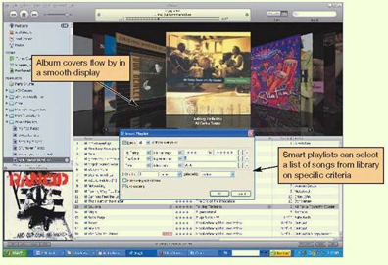
- Software to organize media files
  - Sort, filter and search by artist, album or category
- Examples:
  - Windows Media Player
  - Nullsoft Winamp
  - Apple iTunes
- Manage tracks and generate playlists
- Burn songs to CDs and print liner notes

Online Photo Management
- Web-based sites allow easy management and sharing of digital photos
- Allow creation of photo albums
- Offer professional printing services
- Examples:
- Flickr.com Flickr enables you to link your images to a map so that you can show exactly where you took the images or see where others took theirs.
  - Snapfish.com
  - Kodak.com
  - Shutterfly.com
  - Google Picasa Helps you send images to your friends, your mobile devices, or your blog by automatically resizing a 12-megapixel image to a more manageable size for electronic transmission.

Software Fun for Home

- Computer games require appropriate:
  - Processing power
  - Memory (RAM)
  - Hard disk capacity
  - Sound card
  - Video card
  - Speakers
  - Monitor
  - CD or DVD drive
  - Specialized controllers
  - Entertainment software: designed to provide users with thrills, chills, and all-out fun!
  - Virtual reality programs that turn artificial environments into a realistic experience.
  - Wireless controllers such as Cyborg Evo

Game Rating System
- The Entertainment Software Rating Board (ESRB) provides:
  - Rating symbols
    - Everyone (E)
    - Teens (T)
    - Mature (M)
    - Adult Only (AO)
    - Content descriptors indicate elements in a game that may have triggered a particular rating or be of interest or concern.
  - If you want to try and make video games, multimedia applications such as Adobe e Flash and RPG Maker VX provide tools you need to explore game design and creation.
  - Alice and GameMaker are free

Educational and Reference Software
Educational Software
- Provides instruction or training
- Types include:
  - K-12 education
  - Skill development
  - Test preparation
  - Brain training
  - Simulations (allows to do dangerous things safely, that’s the real benefit)
  - Online courses
  - Course management software such as Blackboard, Moodle, and Angel.
- Brainage and Luminosity are good educational games.

Drawing Software
- Used to create and edit
  - Two-dimensional drawings
  - Technical diagrams
  - Animations
  - Geometric shapes
- Examples:
  - Adobe Illustrator create professional quality creative and technical illustrations. Preferred program for graphic artists.
  - Microsoft Visio used to create technical drawings, maps, basic block diagrams, networking and engineering flowcharts, and project schedules, but it can also be used by the more casual designer.

Business Software for Home and Office
- Programs for home business
  - Accounting software
  - Desktop publishing software
  - Webpage authoring software

Accounting Software
- Helps small-business owners efficiently manage their finances
- Provides tools for tracking accounts receivable and accounts payable
- Includes templates for invoices, statements, and financial reports
- Examples:
  - Intuit QuickBooks
  - Peachtree by Sage
- Accounting software helps small-business owners manage their finances more efficiently.
- In addition, these applications offer inventory management, payroll and billing tools.
- Intuit QuickBooks and Peachtree by Sage, both contain templates for statements, invoices and financial reports.

Desktop Publishing (DTP) Software
- Used to arrange text and graphics for publications
- Features include:
  - Text formatting
  - File importing
  - Graphics tools
  - Web publishing
- Examples:
  - QuarkXPress
  - Adobe InDesign

- Desktop publishing software (DTP) allows you to incorporate and arrange graphics and text in your documents in creative ways.
- QuarkXPress and Adobe InDesign allows professionals to design books and other publications that require complex layouts.
- With text formatting tools, you easily can change the font, size, and style of your text and arrange text on the page in different columns, shapes and patterns. You also can import files into your documents from other sources.
- Desktop publishing programs also include features that allow you to publish to the Web.

Web Page Authoring Software
- Used to create a Web page
- Knowledge of HTML is not necessary.
- Features include:
  - Wizards and templates
  - Reference materials
  - Interactive content
- Examples:
  - Microsoft Expression Web
  - Adobe Dreamweaver
- Office applications can save a document as a Web page.
- Webpage authoring software allows even the novice to design and create interesting and interactive web pages, without knowing any hypertext markup language code (HTML).
- Microsoft Expression Web and Adobe Dreamweaver are two of the programs to which both professionals and casual page designers turn.

Large-Business Software
- Used across a variety of industries
- Includes:
  - Business and marketing plan software
  - Project management software
  - Customer relationship management (CRM) software
  - Enterprise resource planning (ERP) systems
  - Ecommerce solutions
- Planning is a big part of running a successful business. Software programs such as Palo Alto Software’s Business Plan Pro and Marketing Plan Pro help users write strategic and development plans for general business and marketing needs.
- Another category of business planning software is project management software, such as Microsoft Project.
- Customer relationship management (CRM) software stores sales and client contact information in one central database.
- An enterprise resource planning (ERP) system lets a business consolidate multiple systems into one and improve coordination of these business areas across multiple departments. These systems are implemented by third-party vendors and matched directly to the specific needs of a company. Oracle and SAP are well-known companies that sell ERP software.

Mapping Software
- Provides nationwide street maps and directions
- Supplies geographic data for decision making
- Available versions:
  - Online GoogleMaps
  - PC
  - Smartphone
  - GPS devices
  - Many companies use a geographic information system (GIS) to assist them with managing, analyzing, and displaying data, most often in spatial or map form. GIS applies geographical data to provide solutions to complex business situations.

Specialized Business Software
- Vertical market software: Tailored to the needs of a particular industry
- Examples:
  - Estimating software
  - Property management software
  - Scheduling and dispatching software
- Proprietary software can be custom developed for a company.

Computer-Aided
Design (CAD) Software
- Used to create 3-D automated designs, technical drawings and model visualizations
- Industrial use includes:
- Architecture architects can build virtual models of their plans and readily visualize all aspects of design before actual construction.
  - Automotive
  - Aerospace
  - Medical engineering industries
- Example: Autodesk’s AutoCAD
- Helps eliminate costly building errors
- The list of CAD applications keeps growing as more and more industries realize the benefits CAD can bring to their product development and manufacturing processes.
- Many graphics, animations, video and gaming systems use applications from Autodesk called Autodesk 3ds Max and Autodesk Maya to create 3D models with complex textures and lighting models.
- Open source program Blender or Google SketchUp

Getting help with software
- FAQS: frequently asked questions
- Online help allows you to chat over the Internet with an online support team member.
- Integrated help means that the documentation for then product is built directly into the software
- Help menu, found on the menu bar of most applications, lets you choose to search an index or content outline to find out the nature of almost any Microsoft application feature.
- MalekTips, podcasts, YouTube, Photoshop, Itunes; they have an array of multimedia help videos and files

Getting Help with Software
- Types of help:
  - For general help or information about the product, many websites offer frequently asked questions (FAQs), which include answers to the most common questions.
  - Some programs also offer online help and support. Sometimes, online help also allows you to chat with a member of an online support team.
  - Some applications are context-sensitive and offer help based on the task you’re doing or ScreenTips to explain where your cursor is resting.
  - In Microsoft Office applications, on the far top-right of the screen, you’ll find a question mark icon. This takes you to the main Help interface. Integrated help means that the documentation is built directly into the program. You type a question, search for a term, or browse the help topics.
  - There is a Help menu on the menu bar of most applications where you can choose to search an index or content outline to find out the nature of almost any feature.
  - There are also many online sites, such as Malektips.com, that provide a vast array of multimedia help files and tutorials.
Software license
- You buy a license, not the software itself.
- Check license for:
  - Ultimate owner of software
  - Number of installations allowed per license
  - Per computer, per user, or per family (Apple)?
  - Warranties
- Multiuser licenses available
  - Per-seat
  - Concurrent
- You don’t own the software, just the right to use it for own purpose as the only owner.
- License could not be share or extended to install on other computers.
- Concurrent licenses, limit the number of users accessing the software at any given time.
- A computer user who copies an application onto more than one computer is participating in software piracy.
- A free software license, the GNU General Public License, is required and grants the recipients the right to modify and redistribute the software. If it’s under the same terms as original software is known as copyleft.
- All computers come with an operating system and some sort of productivity software.
- Having so many pre-installed programs on your system can degrade the system performance by allocating memory away from active applicants. In notebook computers, it can reduce battery life.
- Pre-installed software is referred to as bloatware.
- After buying computer, create restore discs; in case your computer crashes, and you want the pre-installed software back.
- There is a relatively new trend of on-demand software deployment, referred to as Software as a Service (SaaS). Application is hosted online by the vendor and made available to the customer over the Internet. Applications also referred to as web-based applications, such as ThinkFree, Zoho, GoogleDocs, Office.
- Advantages from Web-based apps: as long as you have an internet browser, you can access your files that are stored online securely. They’re not all free.
- Often, you are able to get a discount on apps if you’re a student who needs the app for a short period of time.

Acquiring Software
- Software can be purchased
  - Through retail stores
  - Online
  - By mail order
- Virtually every new computer comes with some form of application software installed, although the applications depend on the hardware manufacturer and the computer model. You can usually count on your computer having some form of productivity software preinstalled.
- Web-based application software:
  - Hosted on a website
  - Requires no installation on your computer
- Discounted software
- Custom-developed software
- When purchasing, if available, as for a hard copy on a CD or DVD, always try to make a physical copy in case you want to transfer to another computer.
- You can download software specifically for your smartphone by using .NET.

Freeware and Shareware
- Freeware is any copyrighted software you can use for free.
- Some software developers offer beta versions of their software free of charge. Beta versions are still under development. By distributing free beta versions, developers hope to have users report errors or bugs they find in the program. This helps them correct any errors before they launch the software on the market at retail prices.
- Software that allows users to test software (run it for a limited time free of charge) is referred to as shareware. Shareware is not freeware. If you use the software after the initial trial period is over, you will be breaking the software license agreement.
- Open source software is free to use on the condition that any changes you make to improve the source code also must be distributed for free.
- Freeware is any copyrighted software that you can use for free.
- postcardware and e-mailware, request that you leave your thoughts after using the free software.
- A beta version is an application that is still under development. They help developers correct errors before the actual launch.
- Freeware (but in fact it’s not) that could be used within a time period then asked to be purchased is called shareware.

Software Versions
- Numbers are used to represent major and minor upgrades.
  - Major upgrade: Version 2.0
  - Minor upgrade: Version 2.1
- Years (Microsoft Office 2010) and letters (WordPerfect Office X3) are also used.
- When an upgrade is released, consider if it is cost-effective to purchase it.

- Developers add numbers and years to indicate updates, which are made to fix bugs.
- Old versions aren’t always forward compatible, however most newer versions can recognize old files.

System Requirements
- Minimum standards for the operating system, processor, RAM, and hard drive capacity
- Specifications for video card, monitor, CD drive, and other peripherals
- Need sufficient storage, memory capacity, and processing capabilities
- System requirements that specify the minimum recommended standards for the operating system, processor, primary memory (RAM), and hard drive capacity. Sometimes there are other specifications for the video card, monitor, CD drive, and other peripherals.

Installing/Uninstalling Software
- Installing software from CD or DVD
  - Installation wizard
  - Choose full or custom installation
- Downloading software from the web
  - Unzip files
  - Launch setup program
- Uninstalling software
  - Software uninstall utility
- Before using software, you must permanently place it, install it, on your system.
- Deleting or uninstalling software from your system requires that you take certain precautions to ensure you remove all associated programs as well.
- For most programs created for installation on a PC, an installation wizard automatically opens when you insert the disc. By web, it’s zipped.
- Some files may unzip, therefore it’s important to locate file in hardware and remembering the location, and continue to install the application.
- A full installation will copy all the files and programs from the distribution disc to the computer’s hard drive.
- By selecting custom installation, you can decide which features you want installed on the hard drive. Helps to save space on hard drive.
- By deleting only the main file, or only the icon on your desktop, you are not ridding your system of all the pieces of the program.
- For quick access to an application you use often, you can (a) create shortcuts on (b) the desktop or taskbar.

