Chapter 14: Firms in Competitive Markets

Characteristics of Perfect Competition:
1. Many buyers and many sellers
2. The goods offered for sale are largely the same.
3. Firms can freely enter or exit the market.
- Because of 1 & 2, each buyer and seller is a “price taker” – takes the price as given.

- Total revenue (TR)
MR = P is only true for
firms in competitive markets. i.e each one-unit increase in Q causes revenue to rise by P

TR = P x Q
- Average revenue (AR)

- Marginal Revenue (MR):
The change in TR from
selling one more unit.
- If MR > MC, then increase Q to raise profit.
- If MR < MC, then reduce Q to raise profit.
- Rule: MR = MC at the profit-maximizing Q.

If price rises to P₂, then the profit-maximizing quantity rises to Q₂.
The MC curve determines the firm’s Q at any price.
Hence, The MC curve is the firm’s supply curve.

Shutdown: A short-run decision not to produce anything because of market conditions.
- If firm shuts down temporarily,
  - revenue falls by TR
  - costs fall by VC
- So, the firm should shut down if TR < VC.
- Divide both sides by Q: TR/Q < VC/Q
- So we can write the firm’s decision as: P < AVC
Exit: A long-run decision to leave the market. A firm that shuts down temporarily must still pay its fixed costs. A firm that exits the market does not have to pay any costs at all, fixed or variable.
- Sunk cost: a cost that has already been committed and cannot be recovered
- Sunk costs should be irrelevant to decisions; you must pay them regardless of your choice.
- FC is a sunk cost: The firm must pay its fixed costs whether it produces or shuts down.
- So, FC should not matter in the decision to shut down.
- If firm exits the market,
  - revenue falls by TR
  - costs fall by TC
- So, the firm should exit if TR < TC.
- Divide both sides by Q to rewrite the firm’s decision as: Exit if P < ATC
A New Firm’s Decision to Enter the Market
- In the long run, a new firm will enter the market if it is profitable to do so: if TR > TC.
- Divide both sides by Q to express the firm’s entry decision as: Enter if P > ATC
- profit equals (P – ATC) x Q
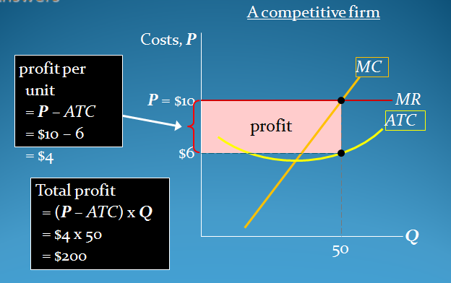
cost per unit = ATC=average total cost?

50 profit maximizing quantity

---------------------------------

P=$3=revenue per unit
Q=30=loss-minimizing quantity

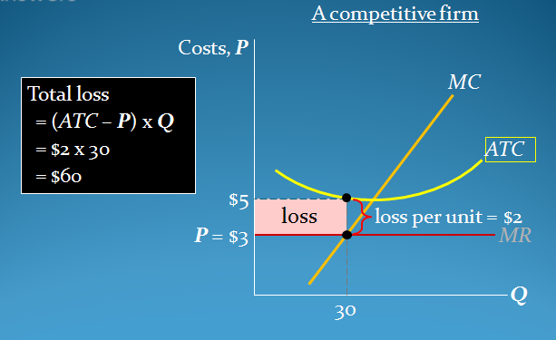
Market Supply: Assumptions
1) All existing firms and potential entrants have identical costs.
2) Each firm’s costs do not change as other firms enter or exit the market.
3)The number of firms in the market is
  - fixed in the short run (due to fixed costs)
  - variable in the long run (due to free entry and exit)
If either of these assumptions is not true, then LR supply curve slopes upward.
- As long as P ≥ AVC, each firm will produce its profit-maximizing quantity, where MR = MC.
- Example: 1000 identical firms. At each P, market Q^{s} = 1000 x (one firm’s Q^{s})
- Entry & Exit in the Long Run: In the LR, the number of firms can change due to entry & exit. If existing firms earn positive economic profit, New firms enter.SR market supply curve shifts right. P falls, reducing firms’ profits.Entry stops when firms’ economic profits have been driven to zero.
  - If existing firms incur losses, Some will exit the market. SR market supply curve shifts left.P rises, reducing remaining firms’ losses. Exit stops when firms’ economic losses have been driven to zero.
- Long-run equilibrium: when the process of entry or exit is complete – remaining firms earn zero economic profit. Zero economic profit occurs when P = ATC.
- Since firms produce where P = MR = MC, the zero-profit condition is P = MC = ATC.
- Recall that MC intersects ATC at minimum ATC. Hence, in the long run, P = minimum ATC.
- Why Do Firms Stay in Business if Profit = 0? Recall, economic profit is revenue minus all costs – including implicit costs, like the opportunity cost of the owner’s time and money.
- Firms Have Different Costs: As P rises, firms with lower costs enter the market before those with higher costs. Further increases in P make it worthwhile for higher-cost firms to enter the market, which increases market quantity supplied. Hence, LR market supply curve slopes upward. At any P, For the marginal firm, P = minimum ATC and profit = 0.For lower-cost firms, profit > 0.
- Costs Rise as Firms Enter the Market: In some industries, the supply of a key input is limited (e.g., there’s a fixed amount of land suitable for farming).The entry of new firms increases demand for this input, causing its price to rise. This increases all firms’ costs.
- Hence, an increase in P is required to increase the market quantity supplied, so the supply curve is upward-sloping.
- CONCLUSION:
- 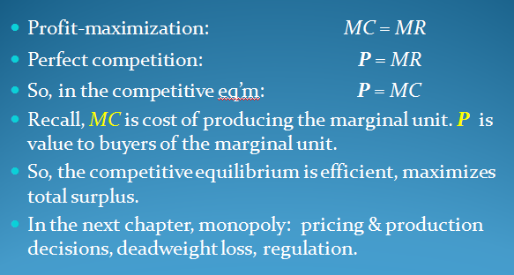
- For a firm in a perfectly competitive market, price = marginal revenue = average revenue.
- If P > AVC, a firm maximizes profit by producing the quantity where MR = MC. If P < AVC, a firm will shut down in the short run.
- If P < ATC, a firm will exit in the long run.
- In the short run, entry is not possible, and an increase in demand increases firms’ profits.
- With free entry and exit, profits = 0 in the long run, and P = minimum ATC.

