Introduction to Sport and Exercise Psychology (September 13)
- Sport psychologists work with ALL athletes to enhance performance
- In order for mental training to produce results it takes daily effort and time
- ALL athletes with serious mental problems need a sports psychologists
  - That being said, if they have a SERIOUS problem they need to see a certified psychologists as sports psychologists are not certified in their department
  - They are under different registries therefore different rules, regulations, etc.
Definition: Sport and Exercise Psychology
- Emphasis varies but includes sport science, performance enhancement, and psychological principles applied to sport settings
- It is an interdisciplinary, scientific and applied field that embraces the integration of sport science and psychological knowledge
Multidimensional Perspective
- Traditional and emerging psychology disciplines impact sport and exercise psychology
  - Psychological examples include cognitive, clinical and counselling, physiological, social, development and health
    - Physiology is 100% related to psychology and the brain, an example is nervousness which stems from the brain therefore results in physically seeing a person shake, or stutter
  - Other academic disciplines influence psychology ie. Computer science, sociology, medicine, women’s studies, education, etc.
Two Primary Objectives
- Understand the effects of psychological and emotional functions on physical performance
  - Ex. How does anxiety impact a basketball player’s shooting abilities?
  - How does visualization influence one’s learning of a gymnastic routine on the balance beam?
  - How does self-confidence influence the continued participation in an exercise program?
- Understand the effects of sport and physical activity on an individual’s psychological and emotional development, health and well-being.
  - Do contact sports increase aggression in young athletes?
    - Hockey and body checking young, football tacking to expend anger and aggression, could they control themselves otherwise?
  - Do physical education classes improve self-esteem in adolescents?
    - Girls in gym class, model figure etc.
Positive Psych in Sport and Exercise
- Focus on what makes life fulfilling
- Examines well-being, satisfaction, fulfillment, pleasure and happiness.
- Similarly, sport and exercise specialist enhance:
  - Performance, social and physical well-being, life satisfaction and positive emotions
Targeted Populations
- older adults, adult exercisers, high performance athletes, recreational-oriented athletes, children and adolescents, individuals with physical or mental deficiencies,
- coaches, instructors, and physical education teachers
- rehab patients
Role of Specialists
Teaching
- employed by universities and colleges
- courses range from introductory to advanced
- provide educational services to community and sport organizations
  - teach sport psyh to different individuals and organizations, even the corporate world
Research
- responsibility to advance knowledge
- scholars design, conduct and evaluate research
- attempt to describe, predict, explain and somewhat change information to be more precise
Consultation
- help individuals, teams, and organizations improve performance
- coach education and certification
- fitness and physical activity centers
- sport medicine and physiotherapy
- hospitals and rehab centers
- full time verses part time
  - very FEW full time consultant just due to the fact that there isn’t much money in the industry
  - also not team pays for coaching staff in offseason there they work short term contracts, such as during season, depending on sport etc.
Types of Consultants
***sport psychologist is not the correct term because for one they are not registered psychologists and two it already puts a negative picture in the athletes head that they have been asked to speak to a psychologist.
Clinical Counsellors
Clinical Psychology focus on assessing and rehabbing serious psychological dysfunctions
Counselling focuses on helping people with adjustment and/or development problems
- provincial and territorial laws regulate the term ‘Psychologist’
- must pass psychological licensing board exams

Sport Science Educators:
- working in university and college settings requires strong teaching and research skills
- academics work in: sport science, research methods, additional courses in psych and/or counselling
History: Six Periods know people not dates and years
The First Years (1895-1920)
- sport psychology begins in the 1890’s (1897)
- first scientific experience is conducted by Normand Triplett
  - noticed the effecting of practising with others
  - coached cyclists and noticed better results when working in groups
- personality traits, acquisition of physical abilities, attention
The Griffith Era (1921-1938)
- establishes sport research laboratory at the University of Illinois
- wrote numerous books and articles
- worked with the Chicago Cubs baseball team
- recognized as the ‘Father of Sport Psychology’
Prep for the Future (1939-1965)
- a graduate program in sport psychology is created
- interest in evaluating precompetitive emotions of athletes
- first world conference of sport psychology in held in Rome
- the ISSP (international society of sport psychology is created)
University Sport Psychology (1966-1977)
- physical education is recognized as an academic discipline
- sport psychology is considered as a sub-discipline (distinct of psychomotor learning)
- *****Bruce Ogilvie works with athletes – becomes the “father of applied sport psychology”
  - Now that they had the information and research material he was the first to start applying it and testing theories on his athletes making the APPLIED part in his title very important
Science and Practice (1978-2000)
- Accelerated evolution of the sport psych field
- 1984- sport psychology makes headlines due to the televised Olympic games
- 1985- 1st fulltime consulting employment
- Creation of numerous academic journals (JASP, JSEP, TSP)
- 1986- creation of AAASP
- 1988- 1st time that sport psychologists accompany American Olympic team
- 1991- consultant certification by AAASP
- 1993- creation of the Canadian Mental Training Registry
Contemporary Psychology (2001-present)
- Exercise psychology gains considerable attention in practice and research
  - Numerous and various related-research programs around the world
- 2006 – creation of the Canadian Sport Psychology Association
  - Importance of exercise and body image?
Orientations of Sport Psych
**they are all so important they cannot be separated and focused on alone, they all need to be focused on
- Psycho-Physiological
  - Emphasizes the psycho-physiological processes of the brain and their influence on the physical ability and behaviours
    - Ex. HR, brain waves, muscular activity
    - Biofeedback – reduce HR in order to improve movement precision
    - Trembling, clammy hands, shaking, speaking much faster
- Socio-Psychological
  - Emphasizes the interaction between environmental factors and the environment and the influence these interactions have on behaviours
    - Ex. NHL players play better away or at home? Buses late, shitty facility, team split up
    - The social context is a factor: interview in person vs over the phone
    - Presentation to the entire group verses a few individuals
- Cognitive-Behavioural – Emphasizes the interaction between cognitive (mental thoughts) and the environment. Links between behaviours and thoughts or ability levels (i.e., Are winners more motivated? Are losers more anxious?)

Present and Future
- Increased focus on development of mental training skills and education
- Increased demands for training in clinical and counselling psychology Ethics and competencies are recognized
- Increased specialization and diversification (ie motivation, exercise counselling, etc.)
  - Assist coach of team and the sport psyh is crossing the line, which hat do you put on when? This is an ETHICS issue
- Greater use of qualitative research methods
- Increased number of mental skills consultants in sport and exercise (most only on part time basis)
- Greater understanding of the benefits of mental training
- Knowledge of sport and exercise psychology has allowed for a broader use in other fields (music, arts, medicine, business etc.
Introduction to Course – Reading
The four assumptions of Sport and Exercise Psychology are questionable
- Namely/Performance enhancement: Performance enhancement is not the only goal of Sports psychology. Can be used to promote health and exercise. Has also been used to teach interpersonal skills, in order to cultivate/improve personal excellence in non-athletic settings
- A coherent identity: Sport psychology is an applied field within the discipline of psychology because not all sports psychologists are professional psychologists
- Clearly agreed academic pathways to professional qualifications: The “twin-track” to qualifying professionally in the field. 1) Through specialized post-graduate training in psychology. 2) Post-graduate training in sport science.
- An established role within the sporting community: In the past, many athletes refused to partake in sports psychology.

The Mental Side to Sport
- The four hypothetical aspects of athletic performance
  - Physical – Refer to the phenomena such as fitness, strength, and stamina which can be measured objectively
  - Technical – Proficiency in which athletes can execute fundamental skills (i.e., the turn in freestyle swimming)
  - Tactical – The strategic aspect to athletic performance (i.e., Planning and decision making)
  - Psychological (aka Mental) – Paradox: “How can something so familiar, yet mysterious”. For example, missing a short putt in golf or a penalty shot due to temporary influence of psychological factors like anxiety. What is going on in your head, when these mental lapses occur
- Three major limitations as research strategies
- Avoid asking leading questions or putting words in their mouths when interviewing
- Be unbiased when editing or analyzing data, as scientists tend to see what they believe
- Since athletes’ insights are invariably sport-specific, they are rather limited in their generality of application (i.e. Each sport has different mental preparation strategies)

What is Mental Toughness?
- Two Definitions from Athletes: 1) “To Perform under pressure”
2) “Having complete control of your emotions and controlling all situations that you can control.”
- Psychological Definition: Referred to such different psychological processes as the ability to cope with pressure, the ability to rebound from failure, a determination to persist in the face of adversity, and form mental resilience.
- The four key components to Mental Toughness (Clough et al 4C’s model):
- Control – The capacity to feel and act as if one could exert an influence in the situation in question
- Commitment – A tendency to take an active role in events
- Challenge – Refers to the perception of change as an opportunity to grow and develop rather than as a threat
- Confidence – Is a component of mental toughness that designates a strong sense of self-belief
  - Combining the four elements, Clough et al, defined mentally tough athletes as people who have a “high sense of self-belief and an unshakeable faith that they can control their own destiny.
- Researchers using qualitative research methodology concluded that mental toughness consisted of both general and specific components.
  - General – A perception of having a “natural or developed psychological edge” that enables an athlete to cope better than his or her opponents with competitive lifestyle and training demands
  - Specific – The capacity to remain more determined, focused, confident and in control than one’s athletic rivals.
What factors influence the mental demands of a given sport?
- The nature and structure of a sport is one of the most important determinants of psychological demands in sport (i.e. Soccer VS Snooker. In soccer you can recover from your own mistakes, while in snooker, you have to depend on your opponent to make another mistake. Soccer is a timed, physical game, while snooker and golf are untimed, which leaves a lot of time for personal reflection. )
Anxiety and Activation (Reading) – Chapter 5
Competitive Anxiety: A Double – Edged Sword
- Pre-competition: Physical changes caused by anxiety include increased muscle tension, heart rate, and respiration rate. Can cause narrowed attention and perception, and diminished cognitive flexibility (makes it difficult to take a balanced look at the situation). Often causes athlete to confuse “possible” with “likely to happen”

Labeling Anxious Feelings and Responses
- Anxiety – Apprehension occurs when one perceive a threat to some value considered essential. The threat may be physical (injury), psychological (shame), or interpersonal (loss of prestige). Diffuse apprehension.
- Fear – The reaction to a specific danger.
- Arousal – The physical level of activation of the person and the intensity of behaviour.
- Stress – The result of the cognitive perception that one does not have the necessary resources to cope with the demands of a specific situation
The Basis of Anxiety
- Biology and environment do play a role in anxiety. Biology must interface with a certain environment to result in anxiety behaviours (i.e. Households with high levels of expectations – parenting styles)
- Charlie Spielberger’s State-Trait Model – Sees anxiety as personal characteristic that makes some people more likely to perceive more situations as threatening and sees dangers looming ahead. Trait Anxiety (ingrained in the persons personality) means that someone is more vulnerable to anxiety and therefore likely to consider many situations as anxiety provoking. State Anxiety is influenced by an outside factor (such as a test or sporting event)
- One of the main activities of anxious subjects is worry, which is the continuous consideration of possible negative events and adverse consequences (bad coping mechanism, rarely leads to solutions)

The Strong Relationship between Anxiety and Performance
The Inverted U
- Addresses the relationship between anxiety and performance
- The theory states that optimal performance occurs at an intermediate level of arousal and that both very low and very high levels of arousal will result in impaired performance
- Explanation: An athlete (or team) who is not aroused sufficiently is unlikely to exert great effort or preserve (i.e., facing a less skilled opponent). On the other end of the spectrum, we have an athlete who is faced with a must win situation that results in very high levels of arousal. Arousal activates both flexor and extensor muscles so that results in the athlete “putting the brakes on themselves” while he is trying to go as fast as possible.
- Flaw with the theory – 1.Does not allow us to predict the outcomes, but rather allows explanations only after the fact (i.e., If someone does not perform well, we assume that arousal levels was not adequate, but how do we know this?). 2.Also, it does not explain how arousal affects performance. 3. Finally, according to the curve, when one reaches a state of increased arousal, their performance deteriorates, which is untrue in most athletes, as that extra level of arousal tends to result in dramatic and rapid decreases in performance

Individual Zones of Optimal Functioning
- Russian Scientist, Yuri Hanin, proposed a model that states than an athlete’s individual optimal zone of functioning (or optimal activation level) can be identified, and as long as the athlete remains within that optimal level, his or her performance can be expected to be optimal
- Individual Zones of Optimal Functioning (IZOF) allow for a description of a variety of emotional states classified as helpful and unhelpful.
- The main criticism of IZOF is that it is not a theory but a descriptive model. Therefore, it does not explain why some people function better when in certain emotional states and others do not. Also, IZOF does not advance our knowledge of how emotions facilitate or interfere with performance in different individuals
- IZOF may be the most helpful tool because of the impact it has on the athlete’s self-awareness and because it give coaches important information about the emotional readiness of an athlete.

Reversal Theory
- Developed by Michael Apter, proposes that the level of arousal is filtered by the perception one has of it. The theory states that individuals can alternate between states at any moment. Thus “reversals”. For example, a low level of arousal, for the same person, can at one time be perceived as pleasant when the person says that he or she is relaxed, at another time it can be perceived as unpleasant when the person is bored.
- Focuses on four states: relaxed, bored, excited, anxious
- The theory does not offer a good rationale for predicting what prompts the reversals in a situation
- Somatic Anxiety – The anxiety that is experience as physical symptoms of nervousness and tension
- Cognitive Anxiety – Defined as worry, preoccupation, and negative expectations
- Intensity of Anxiety – How much of it the athlete experiences
- Frequency of Anxiety – the number of anxiety thoughts in a given time
- Note: There are studies that show frequency increases during the week of competition but the intensity remains constant
- Direction of Anxiety – How people label the symptoms on a debilitative-facilitative axis.
Catastrophe Theory
- This theory states that as arousal increases beyond an optimal level, performance drops rapidly and dramatically to lower levels.
- The catastrophe model has three variables, psychological arousal, cognitive anxiety, and performance. The model predicts that when cognitive anxiety is low, the relationship between physiological arousal increases until a point, after which there is a catastrophic drop in performance. When cognitive anxiety is high, performance improves as physiological arousal increases until a point, after which there is catastrophic drop in performance. When physiological arousal is high, higher cognitive anxiety results in lower performance. When psychological arousal is low, higher cognitive anxiety results in improved performance.
- Flaws – Model does not allow for subjective interpretation of anxiety symptoms. It is very difficult to test and translate into practical applications
Anxiety and Activation (Class Notes) – Chapter 5
Definition
- Arousal: A blend of physiological and psychological activation of an individual’s autonomic nervous system
- Anxiety: Emotional state or reaction when one perceives a threat, resulting in nervousness, worry and/or apprehension while also igniting physiological responses
- Trait Anxiety (chronic – within us): A stable part of characteristic part of personality. Predisposes individual to perceive situations as threatening and therefore increasing one’s state-anxiety
- State Anxiety (situational): Associated with worries and apprehension. Immediate response, which may change from moment to moment
- There is a direct relationship between state and trait anxiety
- Cognitive Anxiety: A mental component of anxiety hat refers to an athlete’s concerns or worries that reduces ability to focus or concentrate (i.e., fear of social comparison or evaluation, fear of failure, lack of loss of confidence)
- Somatic Anxiety (happens automatically based on your emotions): Physiological and affective elements of anxiety that develop directly from autonomic arousal (i.e., increased heart rate, breathing, muscular tension) following the perception of a threatening situation
In Competition
- Coaches do not always understand their influence
  - Their own behaviours and anxious tendencies often influence their athletes’ levels of anxiety
  - Need to learn how to control their own anxiety, and help their athletes do the same

Five Personal Sources of Anxiety:
- Age, experience, and skill level
- Gender
- Trait anxiety (if it is part of your personality)
- Self-confidence
- Self-regulation strategies (Your ability to control your emotions, thoughts and behaviours)

Symptoms of Anxiety
- Cognitive:
  - Uncontrollable worry or apprehensive expectation (« possible » becomes « likely »)
  - Difficulty concentrating
  - Difficulty making decisions
- Emotional:
  - Irritability
  - Negative affect
  - Angry, frustration, despair
- Behavioural:
  - Withdrawal
  - Isolation
  - Rumination
  - Shifting of Activities
  - Avoidance

Theories
- Inverted-U Theory
- Optimal performance occurs at an intermediate level of arousal, both very high and very low levels of arousal will result in impaired performance
- Task Complexity – requires high level of arousal for general task (i.e., weightlifting) and lower levels for fine motor skill tasks (i.e., putt in golf)
- Individual Competency – requires high arousal level for experts and lower level for beginners

- Zones of Optimal Functioning Theory
- Identified based on past experiences
- Optimal intensity state anxiety zone varies among athletes
- State anxiety is individual and athlete dependant
- Zoned athletes have better performances than those outside zone
- Relationship between anxiety and performance differs between athletes
- Anxiety is not always detrimental to sport performance
- ZONES VARY: Zone of optimal performance can vary from .5, thus middle zones are the best zones

- Reversal Theory
  - How arousal affects performance depends on an individual’s interpretation of his or her arousal level
  - Arousal can be interpreted as excitement (pleasant) or as anxiety (unpleasant)
      - Arousal interpreted as pleasant facilitates performance
      - Arousal interpreted as unpleasant hinders performance

- Catastrophe Theory
  - Describes combined influences of cognitive state anxiety and physiological arousal (i.e., somatic anxiety)
  - Recognizes athletic performance is complex
  - Important to try to minimize cognitive state anxiety, and if not, must control somatic state anxiety
  - The notion of the inverted U. The difference is that the Inverted U is a progressive notion. This theory states that there is no gradualism. Either is good or bad, but there is no gradually decline or incline in performance
  - When cognitive anxiety is low
      - Arousal-performance relationship resembles the inverted-U
  - When cognitive anxiety is high
      - Arousal increases beyond an optimal level, resulting in drops in performance that are rapid and dramatic

Direction of Anxiety and Intensity
- Positive view of anxiety can lead to optimal performances
- Interpretation of symptoms is important in understanding the relationship between our anxiety and performance
- Must consider the intensity and direction (negative or positive) of anxiety
- State anxiety is perceived as positive or negative according to our feelings of control
- Anxiety is not a bad word!!!, once we view it in a negative way, it can affect our performance

Recap
- Arousal – Consists of physiological changes and individual interpretations
- Arousal and state anxiety don’t always negatively impact performance
- Can be either positive or negative, depending on their interpretation
- Confidence and feelings of control are critical factors in the positive perception of anxiety
- The interaction between arousal and its interpretation is more important than the activation level itself

Mental Training (September 16)

Psychological Skills Training
- - Definition: learning and development of psychological skills training through psychological methods orientated towards improving performance and well being
- Psychological skills = learned or innate characteristics of the individual that make it possible (or even likely) that he or she will succeed in the sport/activity
  - Ex. Intrinsic motivation, self-confidence, attentional control, arousal control, emotional regulation, and self-awareness, etc.
- Psychological methods (or techniques, strategies) = practices that lead to a psychological skill
  - Ex: visualization, goal setting, relaxation, hypnosis, and self-talk
Goal of PST
- The primary goal of PST is to develop an individual’s ability to self-regulate
  - Achieve short and long term goals by planning , controlling, and adapting one’s thoughts, emotions, and behaviours, in order to achieve and maintain optimal levels of performance and well-being in a continuously changing environment
- Self-regulate = how you perform is 100 % within your control, whether you get many shifts on the ice or not you can control how you play with those shifts.
  - Need to Control nervousness, anger, fear, etc. so that these factors do not affect you actions and behaviour
Importance of PST
- A big part of sport performance is psychological
  - Different mental and emotional issues can present themselves (eg lack of confidence, concentration, motivation, feelings of depression, frustration)
- Psychological factors explain performance fluctuations, despite mastered physical skills remaining stable
  - Mental skills need to be constantly practices to keep performance at an exceptional level, therefore keeping performance fluctuations to a minimum
PST Programs
- Techniques and strategies stem from a variety of sources (psychology, physical education, sport, counselling)
- Potential ability to influence performances and well-being and create ongoing learning opportunities
- Must be individualised and used in a systematic manner
- Must incorporate and implement various means (ex. Imagery, self-talk, and goal setting)
Neglecting PST
- Cannot measure concrete results
- Lack of knowledge – ignores the benefits of teaching or coaching mental skills
- Beliefs that mental skills are innate and therefore not be modified
- Lack of time (not priority)
- Lack of resources
Key features of PST
- Even if PST is highly recommended, individuals must have realistic expectations
  - It is not a magic solution
  - It cannot compensate for a lack of physical, tactical or technical skills
  - Mental skills can be learning but must be practised and integrated into daily routines
Basis of PST
- Research: athletes who have experienced success have a higher developed mental skills, which they use more efficiently than athletes who have not
  - Competition plans
  - Daily goal setting
  - Competition simulations
  - High confidence
  - Positive thoughts
  - Positive imagery
  - Distraction control
- Experience: in general, athletes use strategies to their advantage in order to improve:
  - Activation (tired for interview but you find the energy to get through it)
  - Imagery
  - Confidence
  - Motivation/engagement
  - Concentration
  - Dealing with injuries
  - Strategies highly depend on individuals (orientation, experience, personal factors)
PST Contexts
- Elementary school (relaxation techniques to calm hyperactive students)
- Fitness centers (mental imagery to increase confidence of a client)
- Physiotherapy (goal setting to motivate an injured client)
- Hospital (stress and fear management techniques following an adaptive lifestyle)
- Athletic clubs (focused attention to improve performance)
Who guides PST Programs?
- Qualified consultants in sport and exercise psychology should plan, apply, implement and supervise PST programs
- Coaches and health professionals should support/encourage/promote learning – provide opportunities for the acquisition and repetition of skills in everyday life (ex. Training, competitive, treatment)
- ***you as an individual, as a student, trying to engage in physical activity/relationships
Consultant Characteristics
Efficient:
- Accessible, flexible
- Good working relationship
- Knowledgeable
- Offers concrete and practical insights
- Organizes sessions and follows clients progress throughout the specified timeline
- Reliable and able to adjust to the context
Inefficient:
- the exact opposite to efficient skills
Implementation of PST Programs
- Offseason is ideal (more downtime) or at the onset of the season, training program, or rehabilitation
- Should become a continuous process throughout the season/program – included in the training or treatment
A few considerations
- Level of interest and engagement of participants
- Length of training, season, or treatment
- Time dedicated to mental skills training
- Opportunities to integrate mental skills training in everyday life
- Preferences or resources for individual or group sessions, either formal or informal
Psych Skills Training: 3 phases
-entails the structured and consistent practice of skills and generally has three distinct phases
1) Education phase: athletes recognize importance of mental skills and performance impact
2) Acquisition phase: athletes acquire various psychological skills and learn to employ them
3) Practice phase: implement skills in practice and competition
Required Components
Fundamental: goal setting, engaging/motivation, self-confidence
Cognitive: concentration, distraction control, positive self-talk, imagery, time management
Psychosomatic: stress management, emotional control, relaxation, activation
Social: communication, leadership, cohesion
Program Evaluation
- Regularly (not solely at the end)
- Interview with different individuals, observations, written evaluations (questionnaires)
- Use of information/feedback in order to modify PST programs, if necessary and maximize participant satisfaction
Readings Page 10-22
Differentiating between Psychological Skills and Methods
Psychological skills refer to learned or innate characteristics of the athlete that made it possible for him to succeed in sport. The psychological methods refer to practices that lead to the psychological skills.
Who is the client?
- If the client is the athletic department of a university, then the athletic department defines the nature of the relationship between the sports psychologist and the athlete or coach. If managements wishes to be informed of all ongoing aspects of the PSTP then this is their right.
- If the client is the coach, then the coach defines the nature of the relationship between the sport psychologist and the athlete and coach.
- If the athlete is the client, then the athlete defines the nature of the relationship between the sport psychologist and the athlete.
  - Regardless, of the wishes of the coach or management, consultation between athlete and sport psychologist is confidential and privileged when the client is the athlete.
- Another method is that a member of the organization/team can provide psychological services if they do not have access or money to afford a full time sport psychologist, so in this case the sport psychologist can act as a consultant to that member of the organization giving services to the team
- Side note: athletes must be equally committed to psychological skills training, a coach who says she is willing to commit 15 mins at the end of practice to imagery practice and utilization is not committed.
  - Psychological skills training must be equal to physical training
Performance Routines:
Preshot Routine: take place immediately preceding the initiation of a shot or play
Between play Routines: take place during breaks in the action of games such as tennis, basketball, volleyball
Post Shot Routine: during the period of time immediately following the execution of a motor skill.

Ethics in Sport Psychology
Principle 1: Competence
- Ex. A member trained in exercise and sport science would not attempt to counsel and individual with clinical symptoms of depression.
Principle 2: integrity
- They always present themselves and their credentials accurately and forthrightly. They do not make deceptive or misleading statements about their qualifications, products, fees, research or services.
Principle 3: Professional and Scientific Responsibility
- Ex. Members would take steps to prevent and/or expose unethical conduct in other members
Principle 4: Respect for Peoples rights and dignity
- Members respect fundamental rights and worth, and dignity of all individuals
- An individuals right to confidentiality, privacy, and personal control
- Members are also sensitive to gender, age, race, origin, religion etc.
Principle 5: Concerns for Others Welfare
- Ex members do not take advantage of differences in power and influence between themselves and others
Principle 6: Social Responsibility
- Responsible to share findings with the scientific community
Mental skills taught to athletes:
Goal setting:
- teach athletes how to set systematic goals that are focuses on the process and performance rather than focused on the outcome of competition.
- subjective goals are not related to specific performance in sport, these may be related to just going out and trying ones best.
- objective goals are based on a athletes performance
- outcome goals are related to winning or losing percentage
- performance goals are related to various stats that can help a person improve at what she is trying to do (game film)
- process goals are what an athlete focuses on while performance a sport skill
- ex. Goal of increasing the number of greens hit by 10 percent while going through the same routine before every shot
Imagery:
- Athletes practice the skill by imagining themselves moving to various positions and seeing themselves make offensive and defensive plays
- It is also the ability to use all the senses: tactical, olfactory, auditory, kinaesthetic to recreate and vividly control pictures in the mind
- Athletes use imagery to control emotions when events do not go their way
Relaxation:
- Ability to control anxiety and relax under pressure
- Teach various anxiety reducing techniques
Progressive Relaxation:
- Involves tensioning certain muscle groups and letting go of the tension in those groups throughout the body to achieve a relaxed calm state
Biofeedback
- Hooked up by electrodes to fingers and torso
- The quick feedback provided by the technology allows athletes to see specifically what they are doing that is helpful in managing the arousal
Mediation
- Relax under pressure and learn the skill of meditation, in which athletes use their minds to help control their bodies
Breathing Techniques
- Reduce anxiety and become more relaxed
- Ex. Diaphragmic breathing: nice deep breathes and releasing slowly
- This slow rhythmic breathing helps the athlete to relax
Concentration
- Width of concentration can be broad, narrow, external or internal
Self Talk
- Use positive affirmations
- Practice repeating positive thoughts to themselves to build confidence, it can be used as an instructional component to motivate an athlete to push through a competition when he is fatigued.
Motivation: Sept 20, 2011
Motivation
- is the reason why you do the things you do
- represents a complex process that guides the direction and intensity of ones effort
- direction = indicates whether an individual seeks out, approaches, or is attracted to certain situations
- effort = indicates how much effort a person puts forth in a particular situation
- a fine line exists between direction and effort
  - motivation is a trait, you are either a motivated individual or not - FALSE
  - competence is one motivator for engaging in physical activity - TRUE
  - enjoyment is the best motive to help us understand physical activity – FALSE
Views of Motivation
- trait-centered view – motivated behaviour is dependent on personal characteristics (grown up, family driven)
  - needs, interest, goals, personality
- situation – centered view – situations influence one’s level of motivation (doing it for money)
  - others approach, environment attraction, success vs. defeat
- interactional view – motivation is determined by the overall personal and situational factors (combination)
LEADING TO PARTICIPANT MOTIVATION
Achievement Motivation
- an individual tendency to strive for task success, persist in the face of failure, and experience pride in accomplishments
  - people who go to the gym consistently get better, just because they want to, this is a personal gain
Competitive Drive
- an individuals tendency to strive for satisfaction when making comparisons with some standard excellence in the presence of evaluative others
  - involves a competitive environment where social evaluation is a central factor
  - can also be competition from within (with the self), which is directly related to achievement motivation
    - bad at practice because there is no competition verses in a game, there is no comparison scale, wants to be the best, verses just doing well and getting better
Motivation and Competitive Drive influence:
- activity choices (ex choosing opponents of equal or greater/lesser ability levels)
- effort to pursue goals (eg training frequency)
- intensity of effort in the pursuit of goals
- persistence through adverse situations, failure, or challenge (pushes through or walks away)
Motivation Theories
- Need Achievement Theory
- An interactional view that considers both personal and situational factors as important predictors of behaviour
- Graph in slide show
- Personality Factors
- 2 underlying achievement motives
  - Achieve success (capacity to experience pride or satisfaction in accomplishments)
  - Avoid failure (capacity to experience shame or humiliation as a consequence to failure)
- It is the balance between these 2 motives that guides an individual’s behaviours
B) Situational Factors
- 2 primary considerations
  - Probability for success (depends on who you compete against and task difficulty)
  - Incentive value of success (value you place on success)
- Ex: settings that offer a 50 50 chance of succeeding provide high achievers that most incentive for engaging in achievement behaviour
C) Resultant Tendencies
- Behaviour is derived by considering an individual’s achievement motive levels in relation to situational considerations (ex. Probability of success or incentive value of success)
- 50 50 chance of success
  - Low achievers avoid challenges and opt for either easy tasks where success is guaranteed or for unrealistically hard tasks because no one expects them to win
  - High achievers seek out challenges because they enjoy competing against others of equal ability or performing tasks that are not too easy or difficult
D) Emotional Reactions
- Achieve success = focus on pride of success
- Avoid failure = focus on shame or humiliation of failure
E) Achievement Behaviour
- Motivated by achieving success: seek out achievement situations, look for challenges, enhanced performance
- Motivated by avoiding failure: avoid achievement situations, avoid risks/challengers, poor performance

- Attribution Theory
- cognitive approach to motivation
- assumes that people strive to explain, understand, and predict events based upon their cognitive perception of them
- focuses on how people explain their successes and failures
  - an individuals perception and interpretation of a situation are key elements in determining how he or she explains success or failure
    - success we don’t analyze as much because I mean we won or succeed, while bad performance we analyze over and over to see what happened and went wrong.
  - Chart in power point
- Attributions affect self confidence
  - Attributing failure to external/uncontrollable can? Self confidence
    - Encourage individuals to attribute failure to internal factors (effort) for personal change to occur
  - Attributing success to internal/stable can increase self confidence
    - Encourage athlete to attribute success to abilities in order to develop confidence
- Achievement Goal Theory
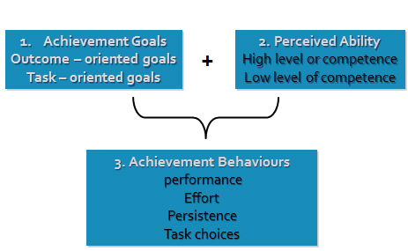
- Motivational orientation is a personality trait guides how an individual perceives his or her ability and sets objectives accordingly
- Task goal orientation (intrinsic)
  - Referencing past performances as origin of competence feelings
  - Opportunities for personal growth and mastery
    - This motivation comes from within out – love for the game, feel of accomplishment, personal results
- Ego Goal Orientation (extrinsic)
  - Comparing with others to gain social status
  - Success comes from outperforming others
    - Try to win trophy, people’s expectations, success for money, grades, scholarships, acceptance from others, fame
- PRE GAME TALK CAN BE QUALIFIED AS BOTH
- 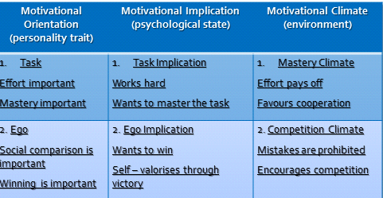
- 4 developmental phases
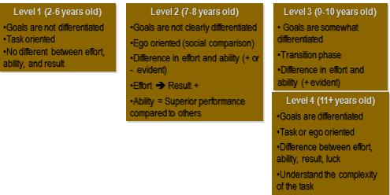
- Task orientation is suggested (regardless of the perceived ability level) in order to compare oneself to his/her own standards rather someone else’s performance
  - ensures great work ethic habits
  - increases perseverance in the face of failure
  - favours optimal performance, satisfaction, enjoyment
- ego orientation is not suggested if individual has low perceived ability levels
  - decreases perception of competence after failure
  - diminishes effort after failure
  - unable to perform well in evaluative situations
  - most significant finding is that intrinsically motivated people lose some enthusiasm when extrinsic incentives are added.
- 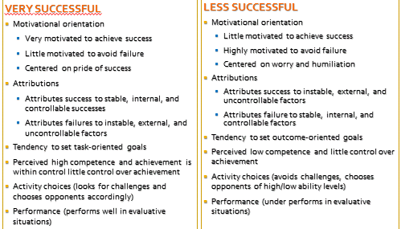
- Professional Implications
  - Recognize interaction between personal and situational factors that influence behaviours
  - Insist on goals oriented towards the task
  - Be aware of the individual’s attributions and correct inaccurate attributions
  - Increase feelings of competence, control, satisfaction and enjoyment
  - Be cognizant that others’ behaviours can directly or indirectly influence one’s motivation
  - Recognize approximate success, effort, emotional and social responses (fair play, responsibility, judgement, and cooperation)
  - Be realistic (other factors, time, financial resources)
  - Long term motivational strategies
    - Push the edge
    - Experience success
    - Change your thinking
    - Get involved
    - Praise others
    - Vary training
    - Put yourself first
    - Find motivated peers
    - Think positively
Reading:
Norman Triplett was credited with the first formal experiment in sport motivation psychology.
- Noticed that bike racers cycle faster in pairs compared to cycling alone.

- Our genetics and our environment make up our motivation (Nature vs. Nurture)

Need achievement theory says we are driven by the need to feel pleasure, acceptance, and competence
(We are naturally motivated by things that reward us)

The time to build motivation is outside competition (not before or during a competitive event) and when the time comes to perform individuals should have an individualized game plan.

- Our genetics and our environment make up our motivation (Nature vs. Nurture)
- Intrinsic feelings – perceptions of autonomy and competence are the most powerful motivators
- Extrinsic motivators – money, ribbons, and trophies are not necessarily negative.
- Flow is the peak for motivation – flow is intrinsically gratifying and that is when we are at our highest level of motivation.
- Self-efficacy- the belief that you can achieve a goal, allows one to overcome “motivation killers”

Intrinsic motivation will lead to great success and extrinsic motivation can also be present but when it becomes a main target motivation will begin to diminish.

According to cognitive psychologists motivation is a decision but can be influenced by both internal and external factors

Types of motivation:
Goal orientation- trying achieving a specific goal (ex. Lose 15 pounds)
Sustainability motivation – feeling of autonomy (self-control) and purpose, continues to play because it’s their choice and it fulfills self interests

Confidence (Sept 23, 2011)
Confidence: the belief that you can successfully perform a desired behaviour
- General self-confidence (trait related)
  - Degree of certainty that an individual typically has about their skills to achieve success
- Specific self-confidence (state related)
  - Degree of certainty that an individual has about their skills to achieve success in a given situation
Bandura’s Self Efficacy Theory
- Self efficacy perception of one’s ability to perform a task successfully
  - A situation- specific form of self confidence
  - Belief in ones capability to organize and execute the course of action required to produce given attainments
    - Self regulation is your ability to control your emotions, thoughts and behaviours, EXAM
- Self efficacy
  - Alone it is not enough to be successful (individual must also want to succeed and have to ability to do so)
  - Considered a reliable determinant of individual and/or team performance
    - Influences activity choices, level of effort, and persistence
    - Individuals who believe in themselves will tend to persevere under adverse conditions
  - Although task specific, it can generalize to other similar skills and situations
  - Related to goal setting
- Self-efficacy sources
  - Performance accomplishments
  - Vicarious experiences (modeling- living through someone else, parents live vicariously through their children)
  - Social persuasion (encouragement, self talk, self thought)
  - Emotional arousal
Harter’s Theory of Competence Motivation don’t know models/charts just theories
- Based on the feeling of competence
- Individuals are motivated by, and attempt to exhibit, skill mastery in achievement situations including sport
- If they are successful, their mastery experiences results in pleasant and heightened confidence
- In turn, these feelings leas to a continued incentive to engage in competitive sport
- Important objective is the individuals perception of his or her own ability levels (perceived competence)
- 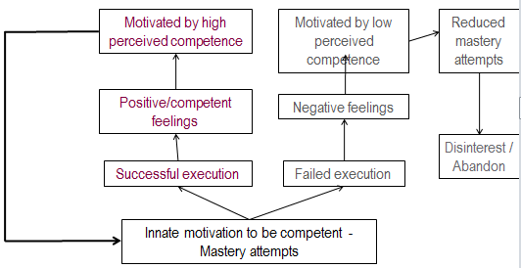

Vealey’s Sport Confidence Model
- self-efficacy is knowing, competence is believing you can do it *******check txt
- recognized for explaining the relation between general sport self-confidence (trait SC) and situation – specific sport confidence (state SC)
- 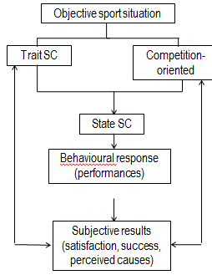

Confidence-Performance Relation
- The inverted-U – performance improves as the level of confidence increases – up to an optimal point, whereupon further increases in confidence produce corresponding decrements in performance
- each individual has an optimal level of self-confidence, which is essential in reaching their personal goals
- performance problems can arise with either too little or too much confidence
  - self-confidence low, performance low
  - self-confidence average performance high
  - self-confidence too high, performance low
Optimal Confidence
- effort : athlete will increase effort level and persevere in order to achieve ultimate goal
- strategy: influences game strategies
  - confident athlete will play to win, take risks, and control the game
  - non confident athlete will play to – not lose – will hesitate, play it safe and avoid making mistakes
- momentum: ability to create positive moments (and overcome negative ones), ability to respond to adversity, sees difficult situations as challenges and responds effectively and with determinations
exam question: women and men have different levels of confidence even though it could be the exact same situation, why do women usually feel less confident than men
- task could be more masculine, or men orientated
- feedback is more ambiguous or unclear
  - due to the fact that women think a lot more than they should and over analyze things
- they are scared they may be judged by their results, such as a social comparison, they don’t enjoy being compared to others
Lack of Confidence
- individual has physical skills to perform, but lack the confidence to do so under pressue
- individual focuses on their short comings rather than their strength (especially during competition)
- self doubts undermine performance (create anxiety, break concentration, cause undecisiveness)
Overconfident
- overconfident individuals are actually falsely confident (confidence is greater than their abilities warrant)
- their performance decline because they believe that they do not have to prepare themselves or exert the effort so successfully complete the task
  - team plays an opponent in the lower standings
  - athletes attempt to cover (hide) self doubt
Building self confidence
- performance accomplishments (realistic expectation, goal setting, simulation, quality training, adjust situations as needed)
- think and act confident (fake it)
- imagery/visualization
- preparation (training, detailed competition plans)
- social climate (positive leadership, modeling, support, encouragement, feedback)
- self – talk
Self-fulfilling prophesy
- it is the notion that expecting something to happen actually helps cause it to happen
- negative self-fulfilling prophesies are psychological barriers that lead to a vicious cycle
ASSOCIATED NOTES FROM READING
- Many great athletes attribute their successes to elevated levels of self belief – British Javelin’s Steve Backley “if you’re slightly down and doubting yourself, then you’ve lost… you’ve lost that battle with yourself to create a highly skilled performance”
- Vealey’s integrative model (theory 3 above) was designed to provide framework from which extensions to confidence literature could be generated and from which interventions could be designed to enhance confidence in athletes
- Anxiety isn’t necessarily bad because combined with confidence leads to awesomeness, but anxiety without confidence leads to poor performance
- High confidence athletes are often hard working and persistent (behaviour)
- Confident indivuiduals found to be more skilled and efficient in using cognitive resources (vealey)
- Confidence individuals remain task-diagnotic when faced with obstacles and seek solutions, whereas less confident individuals become self-diagnostic and focus on their inadequacies (bandura and wood)
- Athletes possessing a strong belief in their ability have reported being able to peak under pressure and cope with adverse situations during competition
- 9 sources of confidence – mastery, demonstration of ability, physical/mental preparation, physical self-presentation, social support, vicarious experience, coach’s leadership, environmental conform, situational favourableness
- Vealey- athlete characteristics and organizational culture of competitive sport found to influence development of confidence in athletes(ex. Social support, physical self presentation more important for collegiate female athletes)
- Since Vealey’s sport confidence models and preliminary sources of sport confidence were based upon perceptions of high school and collegiate athletes, they cannot be readily generalized to other athlete groups
- Superiority to opposition and tactical awareness emerged as types of confidence identified by male athletes
- Gender variations
  - Males – competition outcomes, belief in coach, superiority to opposition (6 out of 7 males)
  - Women – good personal performance, coaches encouragement, positive feedback and compliments, seeing competition perform badly (enhanced confidence)
- For debilitation of confidence
  - Males – injury/illness primary factor and poor performance
  - Women - poor performances, poor preparation, issues with coaching, and pressure and expectations as primary factors (injury also listed)
- High levels of sport confidence congruent with positive thinking, and effective decision making
- Low levels of sport confidence congruent with negative thinking, and distracted thought patterns
- If athletes weren’t confident going to a competition, once there it was almost impossible to raise it
- High sport confidence associated with emotional control, effective competition behaviour and focus
- Low sport confidence associated with negative affect, ineffective competition behaviours and focus

Attention and Concentration (Sept 27, 2011)
Concentration Definition:
- focusing attention on the relevant cues in the environment and maintaining that attention
- effective concentration enables individuals at apply appropriate attention to the ever changing internal and external cues from the environment
Attentional Focus can be broken down into 3 categories
- the ability to selectively attend to one course of information at the expense of another
- the notion that humans have a limited capacity in terms of the amount of information they can attend to at one time
- the process of maintaining alertness or arousal
Selecting information
- human beings have the ability to do various things at the same time (ex drive a car, talk to the passenger, and change the radio station)
- different mental and physical tasks require a specific amount of information processing space
- if the task uses all of the information processing space, all of one’s attention will be focused on the task, leaving little space for other tasks
- if the task does not use all of the space, one can then execute other tasks at the same time
  - Works the same way as a computer now, many processes can be occurring at once. Email music, word, internet etc.
Information Processing Space
- Depends on the individuals mastery of a task (novice or expert) and his or her needs
- Learning allows for information processing system to be modified according to the execution of a task (requirements decrease with practice, as the task becomes automatic and subconscious)
- Being in the zone - automatic/subconscious performance protected from all cognitive interruptions, execution is guided by the brain but requires little attention
  - Novice basketball player dribbling a ball verses a CIS level athlete
Difference: Experts vs. Novices
- Experts
  - Able to make quicker decisions and anticipate future events (bounces, tactical responses)
  - Pay closer attention to movement patterns
  - Systematically look for key points and/or cues
- Novices
  - Information processing is limited (thus, needs more information and time, leading to greater chances of making mistakes)
- NOTHING TO DO WITH INTELLIGENCE LEVEL
Concentration Components
- Focusing on relevant information
- Selective attention
  - Ability to gate out or ignore irrelevant information and to pay selective attention to relevant information
  - Must identify key cues (eg. Movements, gestures, words) on which to focus
  - Possible because of good distribution of chemical substances in the brain (unbalanced levels of dopamine and norepinephrine may result in an in ability to respond to certain stimuli
- Maintaining Focus
- Maintaining focus during the execution of a task (performance) is crucial
- Rarely are athletes able to do so 100%
- One small loss of focus can impact a full performance (1 golf shot, shot on net, last seconds of a race)
- Cognitive strategies
  - Associative attentional style
    - Focuses on bodily functions or sensory cues (HR, muscle tension, breathing rhythm)
  - Dissociative attentional style (distraction)
    - Blocks out the physiological responses and/or feedback (ex fatigue, pain, discomfort) and helps overcome fatigue, negative thoughts, and boredom
    - More commonly used during training than competitiions
- Modifying Focus
- Attention flexibility: ability to quickly and effectively change or transfer one’s attentional focus to another cue (ex broaden or narrow ones focus according to available cues)
- Cognitive interference: sudden presence of negative or evasive thoughts irrelevant to the execution of the task
  - Task – oriented inidividuals experience little cognitive interference (more inclined to personal growth, not thinking about result, want to achieve the task, grow and develop)
  - Ego oriented individuals (with low self confidence) experience a lot of cognitive interference (want a positive outcome of the task, if it results bad they may be less focused, WANT TO WIN
Dimensions of attentional focus
Broad Focus | Narrow Focus | Internal Focus | External Focus
Perceive several occurrences simultaneously (rapid changing environment; soccer player dribbling a ball up a field) | Occurs when responding to only one or two cues (baseball batter preparing to swing a pitch, golfer for a putt) | Inward on thoughts and feelings (runner imagines the end of a race, coach analyze a play) | Directs attention outward on an object (puck in hockey, ball in baseball, referees call)
BROAD-EXTERNAL | BROAD-INTERNAL
Used to rapidly assess a situation  before teeing off, assesses the environment (direction of the wind, length of the fairway, positioning of water hazards, trees, and sand traps) | Used to analyze and plan  recall previous experience with similar shots, note current playing conditions, and determine how to hit the ball
NARROW-EXTERNAL | NARROW-INTERNAL
Used to focus on one or two external cues  with a plan in mind, monitor muscular tension, imagine a perfect shot, take a deep breath | Used to mentally rehearse an upcoming performance or control an emotional state  Focus directly on the ball

Attentional Problems Tips for Improving Concentration
- Attending to past events  - Attending to future events  - Attending to too many cues  - Over-analysis of body mechanics  - Fatigue  - Inadequate motivation  - Stressful or pressure-filled environment  Choking- performance progressively deteriorates and unable to regain control over performance without outside assistance (emotional importance) | - Thought-stopping and positive self-talk  - Practice with distractions present  - Use cue words  - Employ non-judgemental thinking  - Establish routines  - Practice eye control  - Stay focused in the present  - Practice skills so that they become automatic
Reading
Maintaining Focus in the “Zone” (Aidan Moran)
- Attentional system (selectivity of processing, mental time-sharing of actions, and regulation of alertness)
- Attention is a skill that can be developed
- Example: An archer must meet needs to read distance and the wind, once accounted for she must put a complex set of internal actions into place. If her actions meet the external demands the result is an arrow at the centre of the target
- In changing environments (hockey, soccer, basketball, etc) they have to master the ability to concentrate, or focus their attention on relevant cues

Cognition
Perception
Action

Attention as Alertness
- Anxiety can contribute to the occurrence of athletic injuries because of poor attentional control decreases the ability to react to risks in the competitive environment
- As anxiety increases alertness leads to (1) attentional narrowing, (2) conscious, controlled processing, (3) inefficiencies in attentional allocation, and (4) distraction by irrelevant or threatening cues

Attention as Selectivity
- Three common errors ( failing to focus all attention, being distracted from relevant information by irrelevant information, and being unable to divide attention among all stimuli that need to be processed concurrently
- Failing to focus all attention on the essential elements of the task, example... free-throw shooter process general information such as the score in the game, the crowd, players talking, etc while trying to focus on the essential visual cue the rim and rotation of the ball
- Distraction from relevant information by irrelevant information, example... in golf, the players constantly relate their score to the par of each whole instead of reviewing their score after all 18 holes. Players who buy into the par scenario often allow internal distractions to influence their play.
- Unable to divide attention among all stimuli that need to be processed concurrently, example... can contribute to the “choking” phenomenon ... in 1988 to prepare for hockey they installed loud speakers to play loud drums... to assist with distraction.... in reality there is no distraction until we realize it internally

Personality (September 30)

Personality: The dynamic organization within the individual of those psychological systems that determine his or her unique adjustments to his or her environment.

Role-related behaviours
Typical Responses
Psychological Core

Psychological Core:
- Deepest Component
- Includes attitudes and values, interests and motives, beliefs about yourself and your self-worth
- Centerpiece of your personality
- The “real” you
- Ex: An athlete is honest, respectful, optimistic, and generous

Typical Responses:
- The ways we each learn to adjust to the environment and how we usually respond to the world around us are good indicators of our psychological core.
- Athlete is always in good mood, shy, anxious

Role-Related Behaviour:
- Your actions based on your perception of social situation.
- Most challengeable aspect because perceptions on the environment change.
- In different situations one must play different roles hence conflicting with one another.

Personality Theories:
- Psychodynamic Theory
- Social Learning Theory
- Humanist Theory
- Trait Approach Theory

Psychodynamic Theory:
- Founded by Sigmund Freud
- Developed based on lived experiences with patients during psychotherapy
- Emphasis on the in-depth examination of the whole person and unconscious motives (id, ego, superego)
- Individual’s unconscious sexual and aggressive instincts are major determinants of behaviour
- ID: “little devil” which is the unconscious instinctual core of our personality
- Ego: “little angel” which is our conscious, logical reality oriented aspect of personality
- Superego: “mediator” that aids in the resolution of conflicts between the id and ego.
- Contribution: Demonstrates that subconscious/unconscious determinants of behaviour exists.
- Limitation: Focuses almost exclusively on the internal determinants of behaviours, and very little on the social environment.

Social Learning Theory:
- Founded by Albert Bandura
- Theory was initially developed through laboratory work with animals (stimulus-response)
- Behaviour is largely influenced by social learning (lived experiences) and its relation to the situation and/or the environment
- Behaviour is learn through:
- Observation
- Social reinforcement (reward vs. punishment)
- Contribution: Emphasizes the importance of the social environment
- Limitation: The situation itself will not always influence and/ or impact individual behaviour.

Humanist Theory:
- Founded by Carl Rogers
- A person-centered approach to understanding personality and human relationships
- People want to be the best they can be
- Includes values, intentions and meaning when understanding human behaviour
- It is not the experience itself that changes behaviour but the perception of the experience
- Abraham Maslow developed the theory of human motivation know known as the hierarchy of needs.
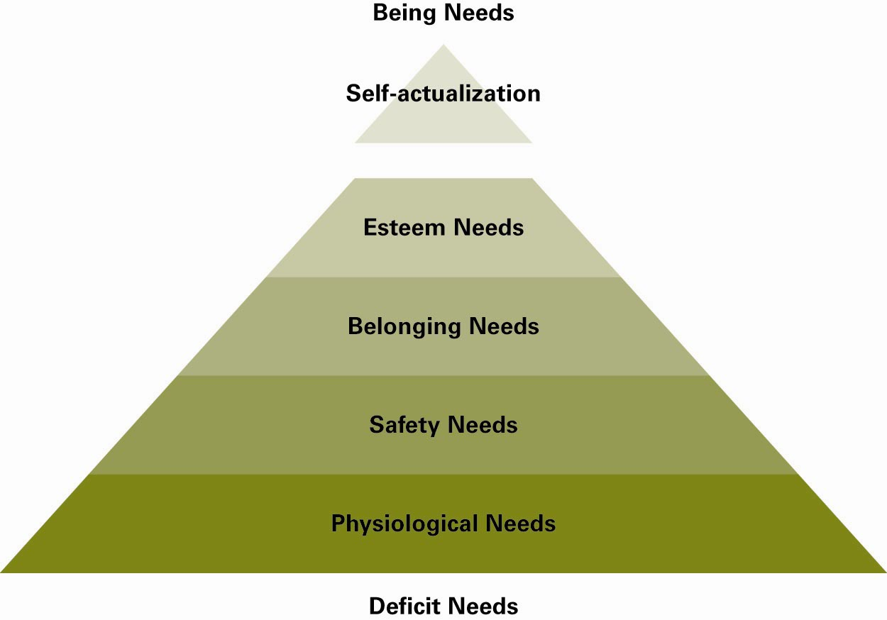
- Behaviour is influenced by desire for personal success, determined by motivation and satisfaction

- Contribution: Considers the role of the environment on development and respects human nature.
- Limitations: To ethnocentric (belief in superiority of a group)

Trait Approach Theory
- Founded by Raymond Cattell
- Theory is based on 35 characteristics used to define personality
- Personality described based on traits possessed by individuals.
- Traits are consistent across a variety of situations.
- Traits make person act a certain way, regardless of situation.
- R (response) = S (situation) * P (personality)
- Contributions: Emphasizes traits and allows for easy and objective measurement of personality through the use of inventories
- Limitations: May fail to consider whole person, since personality is represented by certain traits these traits cannot always predict situations.

October 7, 2011

STRESS AND PERFORMANCE LECTURE

CONCEPT OF STRESS
- Stress response consists of physiological, cognitive, emotional, and behavioural reactions
  - Links between environmental demands and reaction towards potential results
- “Stressors” – events, influences, and/or events that are interpreted as being stressful

DEFINITION: STRESS
- Stress is a process, a sequence of events that will lead to a particular end
- Substantial imbalance between demand (physical and/or psychological) and response capability, under conditions where failure to meet the demand has important consequences
- Sets off the physiologic response “fight or flight”- defense mechanism that is our body’s primitive automatic, inborn response that prepares the body from perceived attack, harm or threat to our survival

NOTE: stressor is anything; created from imbalances in perception leading to fight or flight emotions
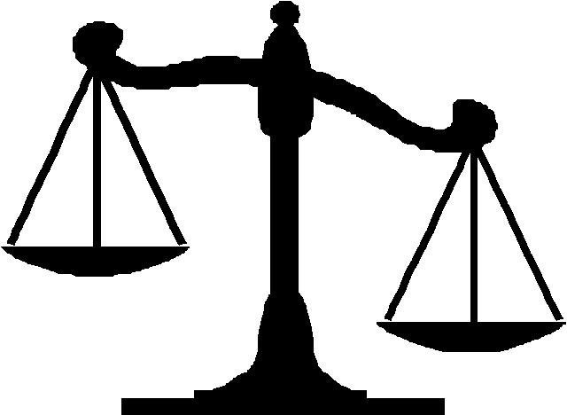
Demands of the situation or task
Potential for completing these demands
Individual’s PERCEPTION

TYPES OF STRESS
- Harm/loss – appraisal of psychological damage and irrevocable loss has occurred (ex. Injury before game, or breakup in sexual relations)
- Threat – anticipating harm that may or is likely to occur
- Challenge – benefits of succeeding in difficulty
- Eustress – good stress
- Distress - bad stress

SOURCES OF STRESS: General Dimensions
- Psychological concerns
- Physical concerns
- Social concerns (people around you)
- Environmental concerns (driving in snow storm)
- Life direction and career transition concerns (what to do after 4th year)

PHASES OF STRESS (**EXAM)
- Stress process consists of four inter-related phases
- Environmental demand
- Perception of this demand
  - Primary evaluation (what are the potential consequences)
  - Secondary evaluation (what can I do about it)
- Stress response
- Behaviour

CATEGORIES OF STRESS
- Acute vs. Chronic Stressors
  - Chronic Stress: occurs over long time periods
  - Acute Stress: occurs over short time periods
- Expected vs. Unexpected
  - Expected Stressor: can plan or prepare for
  - Unexpected Stressor: not anticipated
- Competitive vs. Non-competitive
  - Competitive stressor: experiences prior to, during or after competition
  - Non-competitive stressor: sport related but not directly part of competition (going to a tournament but have an exam right when you get back)

STRESS AND EMOTIONS
- Stress and emotion are closely related
- Emotion is more complex than stress
- Emotion often influences significance of experience and response
- Specific emotions influences athlete’s reactions
- Core Relational Theme: Relationship between athlete and environment

DEFINTION: MOOD STATES
- Psychological responses are mostly short-lived in the presence of environmental stimulus from a given situation
    - Our humour can change as quickly as situations vary
  - Influences our behaviours more so than do our personality traits
mood is rapid change, it is not an imbalance, just a short lived rapid emotional response

NOTE: - personality traits are not emotions
- traits are fixed, based on values and psychological core (something that sticks with you)
- Mood is not personality

POSITIVE MENTAL HEALTH
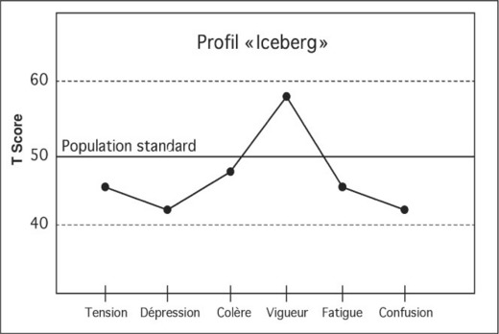
Positive mental health model
- Most often used
  - Tension (-)
  - Depression (-)
  - Anger (-)
  - Vigor (+)
  - Fatigue (-)
  - Confusion (-)

Morgan (1979) –
Successful athletes exhibit greater positive mental health (vigor) and less negative traits (under the norm)

NOTE: KNOW BLURB ^ AND WHERE EACH EMOTION LIES ON THE GRAPH (I.E. TENSION NEGATIVE, VIGOR POSITIVE, ETC) FOR EXAM***

Associated Notes from Reading:
- Pressures of sporting excellence can lead to disengagement, unhappiness and ultimately sport withdrawal
- DEFINITION: stress refers to process by which individuals perceive and respond to particular events, termed stressors which they appraise as challenging or threatening
- Stress is conceptualized as a transaction between a person and the environment
- Ex. Of stress Andrew Murray (Tennis player) jumped from rank 514 to 65 in 2005 and felt the pressure
- Stressors include excessive pressure, critical comments, spectators/selectors, selection issues, overemphasis on winning, training environment, opponents, coach/teammate relationships, physical and mental errors, self doubts about talent, injury, personal goals, expectations, observing an opponent playing well, lack of role clarity or role structure

Table – SYMPTOMS OF STRESS
Psychological Symptoms | Emotional Symptoms | Physical Symptoms | Behavioural Symptoms
Memory problems | Moody and hypersensitive | Headaches | Eating more or less
Indecisiveness | Restlessness and anxiety | Digestive problems | Too much or too little sleep
Inability to concentrate | Depression | Muscle tension and pain | Self imposed isolation
Confusion | Anger and resentment | Sleep disturbances | Neglecting responsibilities
Catastrophizing/ generalizing | Easily irritated | Fatigue | Increased substance abuse
Repetitive or racing thoughts | Sense of being overwhelmed | Chest pain, irregular heartbeat | Nervous habits (i.e. nail biting, pacing)
Poor judgement | Lack of confidence | High blood pressure | Teeth grinding or jaw clenching
Loss of objectivity | Apathy | Weight gain or loss | Overreacting to unexpected problems
 |  | Skin problems
 |  | Decreased sex drive

ALSO: At the end of class she made us go over T.A.R.G.E.T. and told us about an exam question on personal reflection, THEREFORE….

Task
Authority
Rewards
Group
Evaluate
Time

Personal Reflection: We’ve covered different psych skills, therefore the objective is to pick somewhere psychologically you need to improve on, and after recognizing it, apply theories and shit we’ve studied that applies and is correlated to your issue.

