Module 2: The Scientific Method and Matter

The Scientific Method

In a standard visit to a medical clinic, tests are performed (making observations) that help the physician in diagnosing the probable cause of the problem (proposing a hypothesis). Next, the medication is prescribed and finally, the ailment is checked in due course to ensure that the problem has been solved (testing the hypothesis by experiment).

Step 1: Performing Experiments
- An experiment is a set of steps (procedures) that are performed under controlled conditions to propose or test a hypothesis
Step 2: Making Observations
- Observations (key factor in scientific studies as well as in everyday life) can be classified as:
- Qualitative: does not use #s
    - Ex: The Flower is Purple
Bubbles are produced when lemon juice is added to baking soda.
- Quantitative: is a measurement. Has two components: A measures quantity (numerical value) with an appropriate unit.
    - Ex: Observed temperature (measured using a thermometer) for the liquid was found to be 33 degree celcius. Measured quantity = temperature and appropriate unit is degrees celcius.
Step 3: Proposing a Hypothesis (based upon the observations made)
- A tentative explanation to account for the observations of an experiment. A hypothesis is valid provided that one’s assumptions to explain the observations of an experiment can be tested.
Step 4: Confirming the Hypothesis (by repeated experimentation)
- The validity of the hyp needs to be confirmed via repeated & controlled experiments.
- In order to accept a hyp, there must be no inconsistencies between the hyp & the experimental observations
- If there are inconsistencies, steps 1-4 must be repeated.
Step 5: Proposing a Scientific Law
- By repeatedly performing experiments & modifying the hypothesis to account for the observations from these experiments, one Is able to propose a scientific law.

Numerical Values
Expression of Numerical Value
Certain rules apply to the expression of the numerical value and the system of units used in scientific measurements (each to be discussed further on the following slides).
These include:
Scientific notation
- Convenient way of expressing very large or very small numbers and at the same time provides a method of increasing efficiency in scientific calculations.
- Mathematical expression in which a # in expressed as N x 10^{n}
- Powers of ten must be used (10 raised to a certain power)
- N can be any # other than zero but can only have one digit before the decimal (4.56 but not 76.65 or 0.456). n can be any whole number (without decimal)
- Ex: 598.46 = 5.9846 x 10² and 0.0076 = 7.6 x 10⁻³
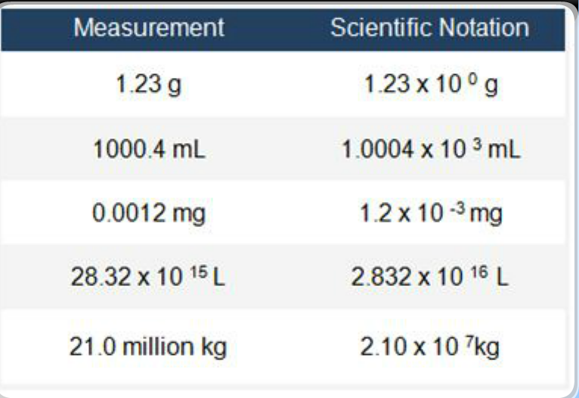

Significant figures (digits)
- Every measurement always has some uncertainty due to experimental error.
- In the case of measuring devices, the last digit of the measurement is uncertain. Significant figures (sig.fig) in a measured number include all certain digits and one uncertain digit.
The concept of significant figure is:
- Used to indicate the precision [reproducibility (closeness) of measurements] of a measurement or that of a calculated result using such measurements.
- Does not apply to counted items such as exact numbers (ex: 5 cards, 3 houses) and defined conversion factors (ex: 1 inch = 2.54 cm, 1 cal = 4.184 J)
- These have an infinite number of significant figures.

Rule #1: All nonzero digits are significant figures.
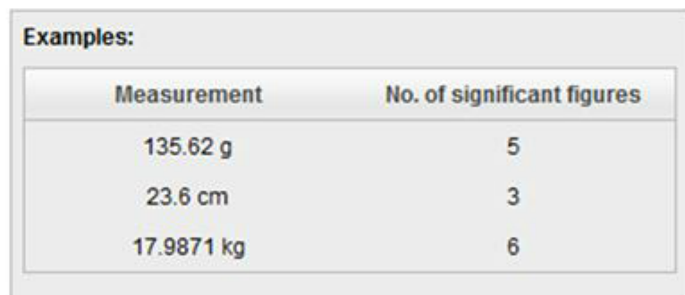

Rule #2: Counting begins from the left with the first nonzero number. (Leading zeros are not significant. )

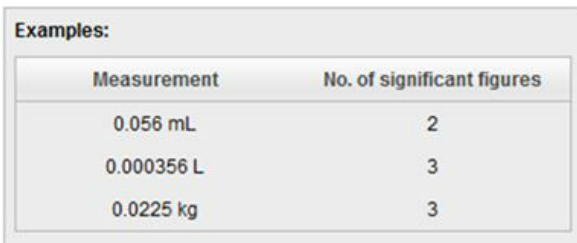
Rule #3: Zeros between nonzero digits are counted as significant figures
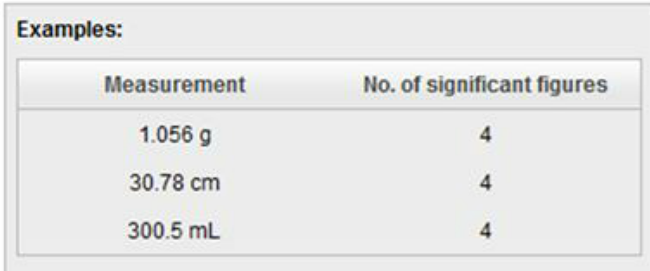

Rule #4: Terminal zeros (zeros to the right of a number)

- These are always significant if the value contains a decimal point (ex 1)
- Terminal zeros in other cases may or may not be significant. For example, a measured value given as 200 cm does not signify anything regarding the # of significant figures. . In such cases, sometimes a decimal point makes the zeros significant, but mostly scientific notation is used (ex 2)
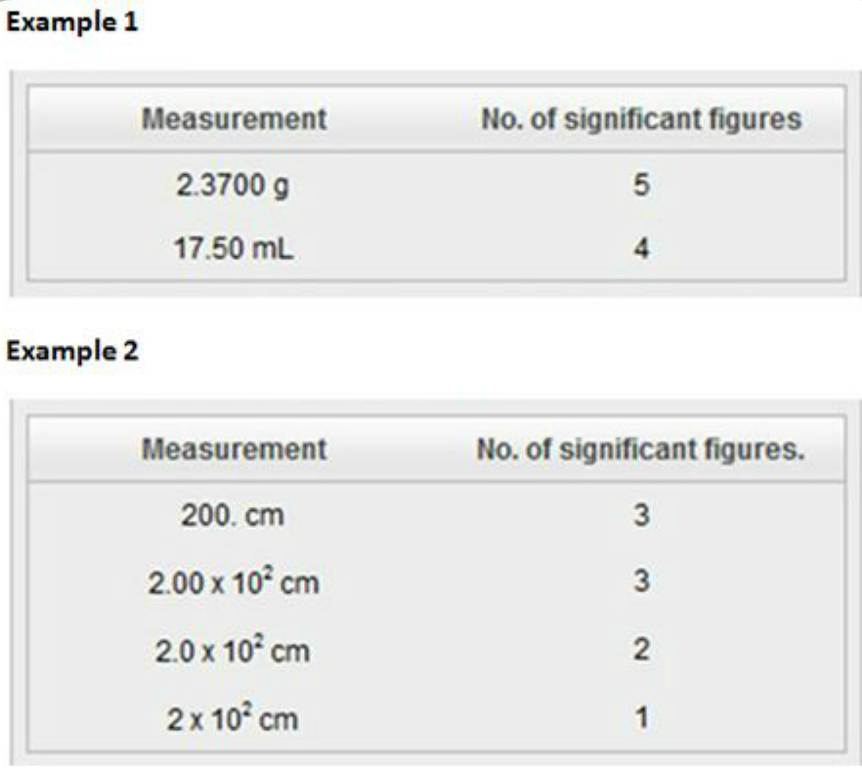

Chemical Calculations

- In calculations involving measured values (with a certain number of significant figures), the number of significant figures in the final answer depends on the operations performed.
Rule #1: In addition and subtraction of measured quantities, the final answer contains the same number of decimal places as are in the measurement with least number of decimal places (least precise measurement)
EX: 25.0 g + 22.41 g + 1.234 g = 48.6 g

Rule #2: in multiplication & division of measured quantities, the final answer contains the same # of significant figures as are in the measurement with the least # of significant figures.
Ex: 9.20 g x 2.450 g = 22.5 g

Rule #3: In the final answer of a calculation involving exact numbers, unit conversion factors & constants, the # of significant figures is dictated by the measured quantity involved.
- Exact numbers, unit conversion factors & constants have no effect on the number of significant figures.
Ex: mass of a steel ball is 2.35 (measured quantity), what will be the total mass of 8 (exact number) identical steel balls? 2.35 g x 8 = 18.8 g
Ex: how many centimeters are there in 31.10 inches (measured quantity)? 31.10 in x 2.54 = 78.99 cm

Rounding off Digits

Rule #1: For multistep calculations
- All numbers are carried to the final result, which is then rounded off to give the correct # of significant figures.

Rule #2: If the digit being rounded off is >5
- If digit being rounded off is >5 you round up by one.
- Ex: 8.379 g =8.38 g

Rule #3: If digit being rounded is <5
- The preceding digit remains the same.
- Ex: 6.371 g = 6.37 g
Rule #4: If digit being rounded = 5
- Preceding digit is rounded up if it is odd and remains the same if It is even.
- Ex: 16.75 mL = 16.8 mL since 7 is an odd number.
- Ex: 16.65 mL = 16.6 mL since 6 is an even number.

SI System of Units (based on the metric system)
- AKA Système International d' Unités (SI)
- The system uses SI base units
- Some SI based and SI derived units include length, volume, mass, density, temperature and time.
- SI unit for length is the meter (m)
- SI derived unit for volume = cubic meter (m³ or m^3)
  - The most common unit for volume is the liter (L) and the milliliter (mL)
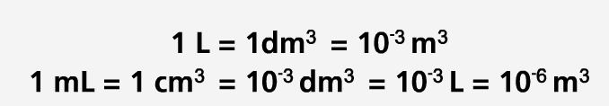
- Volume depends on the size of the object. Some common types of equipment used to measure liquid volume include: Laboratory (buret) and household measuring cups.

- The SI unit for mass is the kilogram (kg). Mass refers to the amount of matter an object contains, thus mass is a constant. Like volume, mass also depends on the size of an object

- The SI unit for density is the kilogram per cubic meter (kg/m^3). Generally, in chemistry, density is expressed in the units of g/mL or g/L. Density is a physical property of a substance.

  - Density = Mass / Volume
  - Larger or smaller units than the base unit can be obtained by combining the base unit with one of the prefixes.


- Ex: combining the base unit second with the prefix nano gives nanosecond (symbol: ns = 10^-9 s
- Micrometer = symbole = um = 10^-6 m
- SI units for other physical quantities:
  - Area = d x d = m x m = m^2 (d = length)
  - Volume = d x d x d = m x m x m = m^3 ( d = length)

Dimensional Analysis
- Method of solving numerical problems using both the numerical value & the unit.
- Involves the use of conversion factors to change the units that a measured quantity is expressed in.
- In this method, the identical units are multiplied or canceled.
- EX: 1.0 cm x 2.1 cm = 2.1 cm^2 (cm gets squared)
- EX: 10.4 g / 2.0 g = 5.2 (g gets canceled)

Step 1: Write the equation(s) relating the units.

- EX1: 1.0 g = 10^3 mg
  - To convert a mass from grams to milligrams, the equation must show the relationship between one gram and the number of milligrams in one gram.
- EX2: 1.0 L = 10^6 uL
  - To convert a volume from liters to microliters, the equation shows the relationship between one liter & the number of microliters in one liter.

Step 2: State the relationship as a fraction (also called conversion factor)
- The conversion factor can be expressed in two different ways:
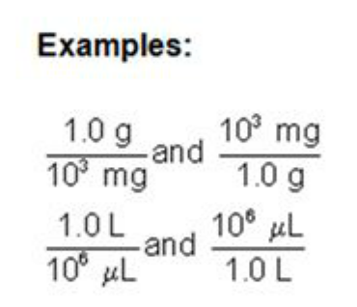

Step 3: Multiply the measured quantity by the conversion factor that cancels unwanted units & gives the final answer in the required unit.
- A conversion factor changes the units of the measured quantity, but the actual quantity does not change.
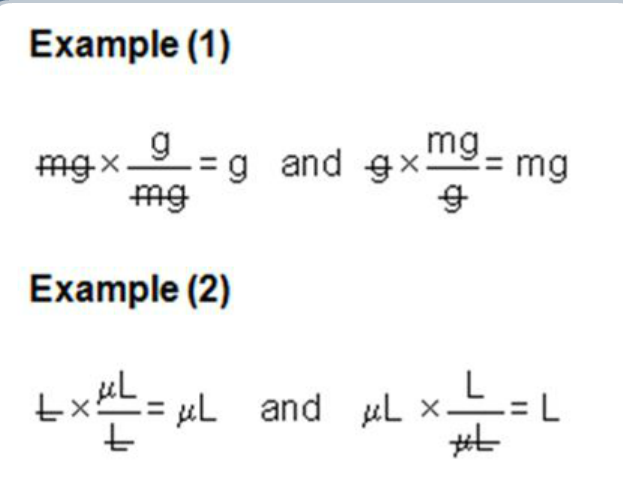

- To convert mg to g (ex 1), the initial unit of quantity is in the denominator (mg) of the conversion factor & the unit of quantity we are converting to (g) is in the numerator of the conversion factor. By multiplying the measured quantity by this conversion factor, the units of measured quantity change from mg to grams.

- For ex 2 (L to microliters)..the initial unit of quantity (L) is in the denominator of conversion factor & new unit is in numerator. By multiplying the measured quantity by the conversion factor, the units of measured quantity change from L to uL.

Example 1: How many Canadian dollars would you have to pay to buy a souvenir costing 251.10 Indian Rupees?

. 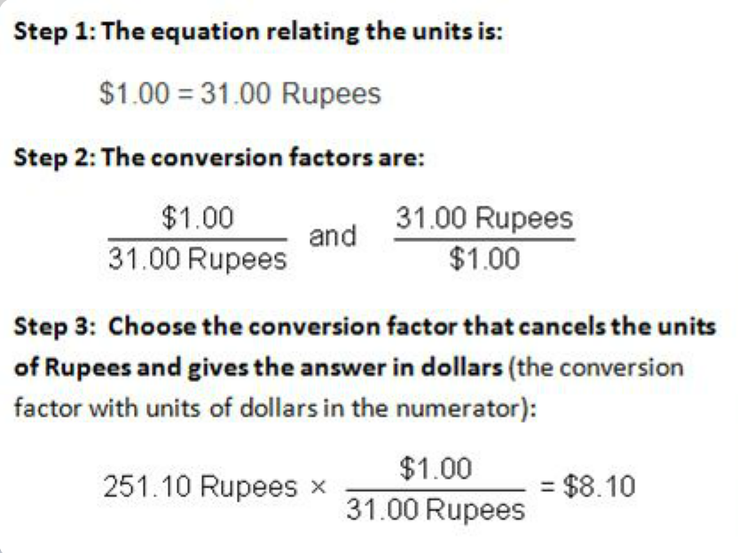

Example 2: What is the mass of an object in mG that weighs 10.31 lbs?

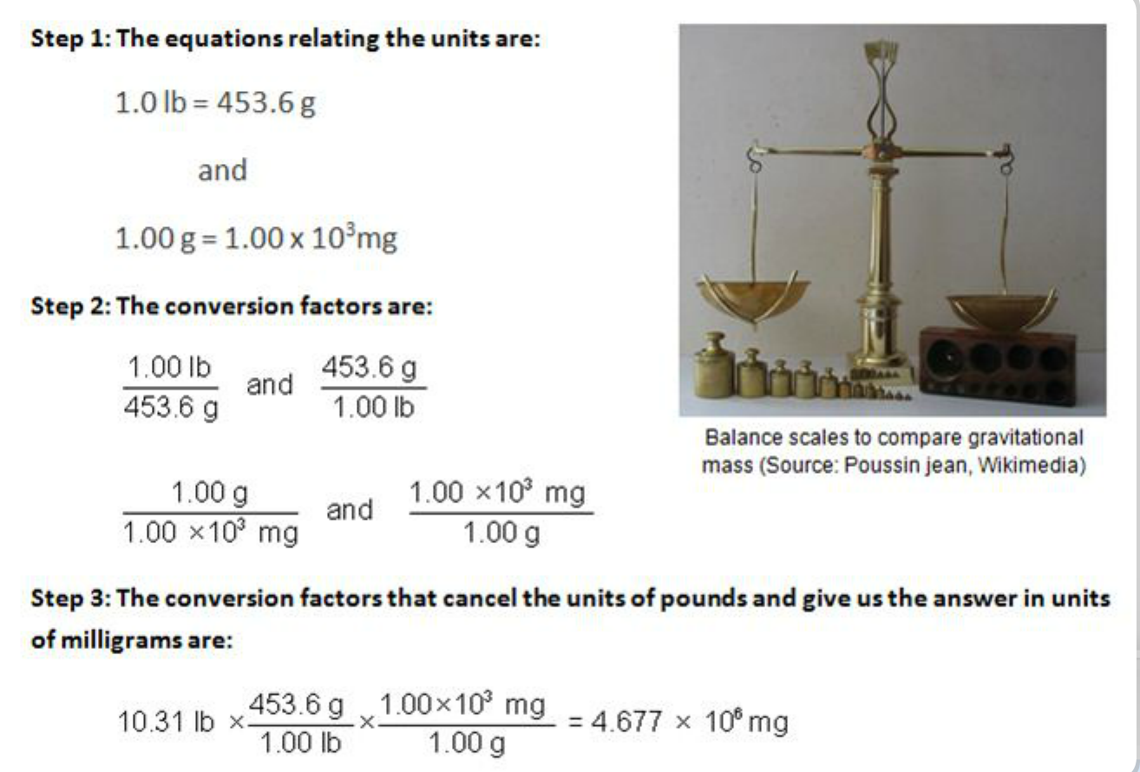

Practice questions:

1. Patrick saw 3 cars in his driveway. The number has: Infinite number of significant figures

2. A quantity of 7.4 mg of a substance can be expressed in scientific notation as: 7.4 x 10⁰ mg

3. A mass of 35.0 million kilograms has to be expressed in scientific notation with two significant figures. Which is the correct answer?

35 000 000 = 3.5 × 10⁷ kg

4. If 5.00 mL of a liquid has a mass of 4.9 g, its density (mass/volume; expressed in scientific notation with appropriate number of significant figures and correct unit) is:

4.9/5.00 = 0.98 = 9.8 x 10⁻¹ g/mL

5. If the density of a substance is 4.14 g/cm³, what is the mass in milligrams of a piece of this substance with a volume of 15.46 mL?

mass = volume x density: 15.46 x 4.14 = 64.0044 g = 64004 = 6.40 x 10⁴ mg

6. A recipe requires 1.4 quarts (qt) of chocolate milk. Using a measuring device marked in milliliters, you would require: [1.057 qt = 1.0 L]
1.3 x 10³ mL

7. At a speed of 66.5 km per hour, how many seconds will it take to cover a distance of 1.00 x 10³ m?

5.41 x 10 s

** 42.06 mL in Scientific notation = 4.2060 x 10 mL **

MATTER

The term “matter” is used to describe things which:

- occupy space (hence possess volume and mass) are perceivable by our sense

Matter can be classified in terms of its:

- physical state: solid (e.g., wood), liquid (e.g., water), or gas (e.g., air)
- chemical composition: element (e.g., copper), compound (e.g., sugar), or mixture (e.g., antifreeze)

Chemical Compositions

Elements (e.g., copper, pure carbon)
- Elements are composed of one type of atom.
- Elements are classified as metal, nonmetal, or metalloid (semi-metal)
Compounds (e.g., sugar)
- Combinations of elements in a definite proportion.
- The atoms of each of the individual elements are chemically combined to form the compound.
- The properties of the compound are different from those of the individual elements that is comprised of.
- A chemical change can break down a compound into its individual elements.
Mixtures (e.g., antifreeze)
- A non-pure substance made of two or more elements or compounds that can be separated by physical, as opposed to chemical, procedures.

What are Atoms?
Atoms are composed of electrons, protons, and neutrons. The nucleus of the atom contains the neutrons and protons. The electrons surround the nucleus and are equal to the number of protons in a neutral atom.
Protons have a positive charge (p⁺)
Neutrons have no charge (nº)
Electrons have a negative charge (e⁻)

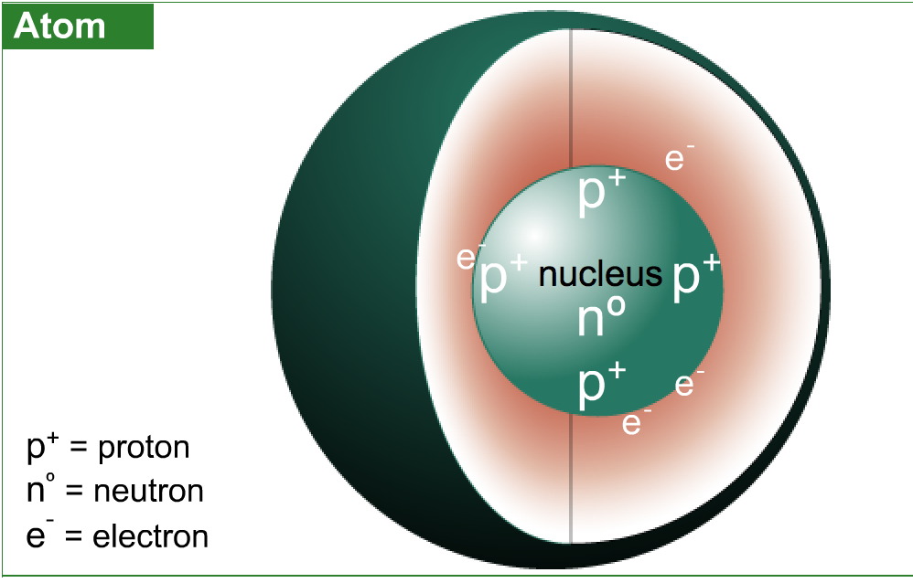

Atomic & Mass Numbers
The atomic number of an element (Z) is equal to the number of protons in the nucleus of its atoms. Each element has a different atomic number.
The mass number (A) is equal to the number of protons and neutrons in the atom. To calculate the number of neutrons, subtract the atomic number from the mass number:
Number of neutrons = A - Z
Every element has an atomic symbol (X). Both the atomic and mass numbers are included with the atomic symbol.
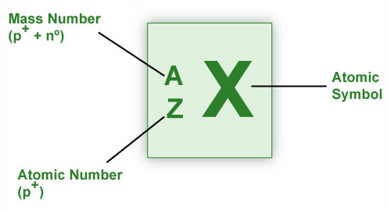

Molecules and Ions
Molecules | - Molecules are a combination of atoms in a definite proportion e.g., molecule of water (H₂O; hydrogen:oxygen = 2:1).
Ions | - Ions are charged species formed by loss or gain of electron(s) from an atom.
Cation | - Cation generation: M (g) M⁺(g) + e- (loss of e⁻) [M = metal; g = gaseous state] [where M⁺, a positively charged ion is the cation]
Anion | - Anion generation: X (g) + e⁻ X⁻ (g) (gain of e⁻) [X = nonmetal] [where X⁻, a negatively charged ion is the anion] Example: NaC(table salt) a compound, consists of Na⁺(cation) & C⁻ (anion) ions.  - Are formed by the gain of electrons.

** If a neutral atom loses one electron it becomes an ion having a charge of +1

Module 3: The Periodic Table and Naming Compounds

Periodic Table, proposed by the Russian scientist Dmitri Mendeleev in 1869
Elements and Groups
The periodic table is a chart (containing symbols) of all the known elements arranged by increasing atomic number (Z) of the element. (The atomic number is numerically equal to the number of protons in the nucleus of its atoms.)

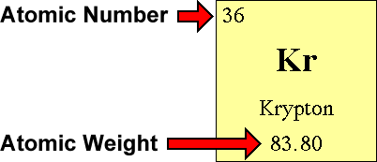

The Number of Protons: The atomic number is the number of protons in an atom of an element. In our example, krypton's atomic number is 36. This tells us that an atom of krypton has 36 protons in its nucleus.

The interesting thing here is that every atom of krypton contains 36 protons. If an atom doesn't have 36 protons, it can't be an atom of krypton. Adding or removing protons from the nucleus of an atom creates a different element. For example, removing one proton from an atom of krypton creates an atom of bromine.
The Number of Electrons: By definition, atoms have no overall electrical charge. That means that there must be a balance between the positively charged protons and the negatively charged electrons. Atoms must have equal numbers of protons and electrons. In our example, an atom of krypton must contain 36 electrons since it contains 36 protons.

An atom can gain or lose electrons, becoming what is known as an ion. An ion is nothing more than an electrically charged atom. Adding or removing electrons from an atom does not change which element it is, just its net charge.
The Number of Neutrons:
The atomic weight is basically a measurement of the total number of particles in an atom's nucleus. In reality, it isn't that clean cut. The atomic weight is actually a weighted average of all of the naturally occurring isotopes of an element relative to the mass of carbon-12. Didn't understand that? Doesn't matter. All you really need to find is something called the mass number. Unfortunately, the mass number isn't listed on the Table of Elements. Happily, to find the mass number, all you need to do is round the atomic weight to the nearest whole number. In our example, krypton's mass number is 84 since its atomic weight, 83.80, rounds up to 84.
The mass number is a count of the number of particles in an atom's nucleus. Remember that the nucleus is made up of protons and neutrons. So, if we want, we can write:
Mass Number = (Number of Protons) + (Number of Neutrons)
Number of neutrons = mass number – atomic number(# of protons)
Classifying Compounds
An Ionic Compound
- sodium chloride, NaCl
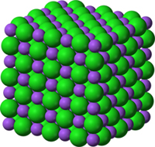
The crystal structure of sodium chloride, NaCl, a typical ionic compound. The purple spheres are sodium cations, Na⁺, and the green spheres are chloride anions, Cl⁻.

Chemical compounds are classified as:
- Organic: Compounds that contain at least one carbon atom.
- Inorganic: Compounds that contain atoms other than carbon. Exceptions are inorganic compounds such as carbon monoxide (CO), carbon dioxide (CO₂), etc.
For the purpose of nomenclature (systematic naming), inorganic compounds are classified as those:
- containing a metal and a nonmetal (ionic compounds)
- containing two nonmetals (covalent compounds)

More about Ionic Compounds
Ionic compounds are composed of ions. They are formed by the electrostatic attraction between a positive ion (cation from the metal) and a negative ion (anion from the nonmetal). Electrons are transferred from the atoms of one element to the atoms of another element.
In general, metals lose electrons and nonmetals gain electrons. Ionic compounds are charge neutral (zero net charge). Charges on ions involved in an ionic compound must be known in order to name the compound formed between them or to derive the formula for the compound.

Rules for Naming & Deriving Formulas of Ionic Compounds

Rule #1:

For metals of groups 1A, 2A, and 3A of the table, the charge on the formed monatomic cation is equal to the group number.

The cation has the same name as that of the metal and is always named first.
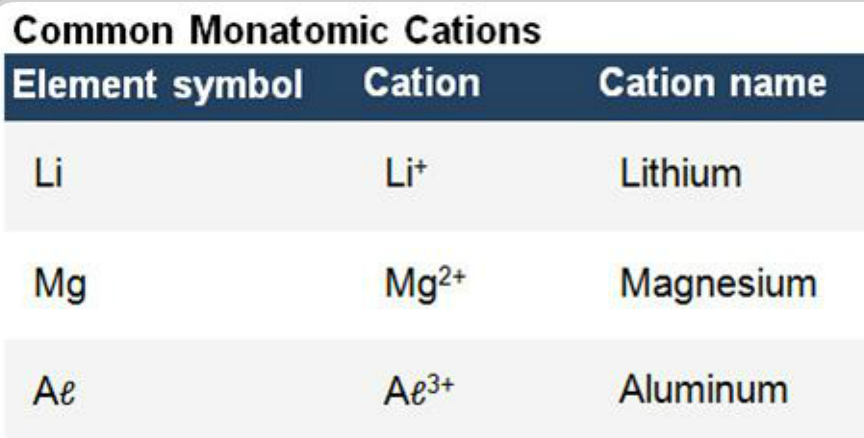
Rule #2

For nonmetals of groups 5A, 6A, and 7A of the table, the charge on the formed monatomic anion is equal to the group number minus 8.

The anion is comprised of the root of the non-metal name and ends with the suffix –ide

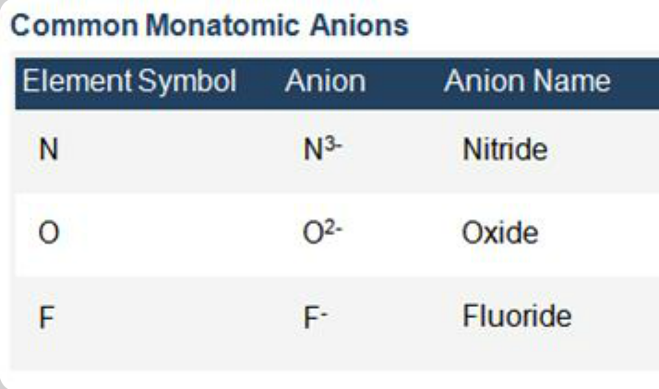

Rule #3

Many metals (particularly transition metals) form more than one cation, thus forming more than one ionic compound with a particular anion. To indicate which ionic compound is formed, the charge on the metal ion is specified by using Roman numerals within parentheses following the name of the metal ion.

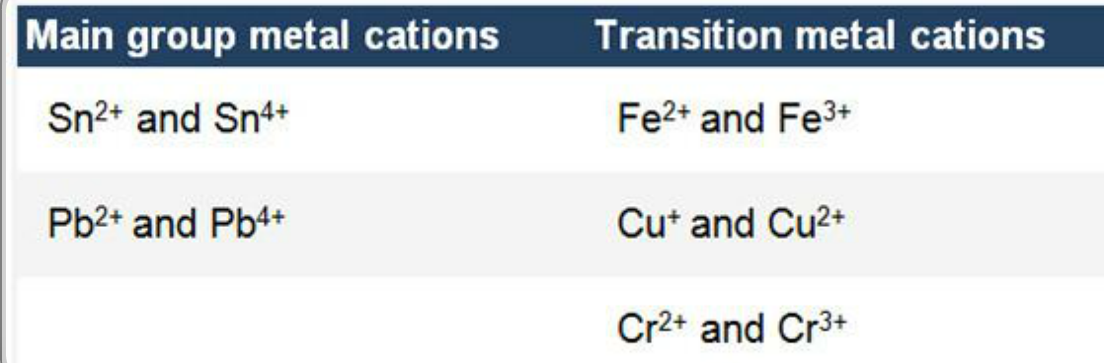

Rule #4

Ions that consist of 2 or more atoms bonded covalently possessing a net positive or negative charge are referred to as polyatomic ions.

Ammonium ion (NH +4) is an example of polyatomic cation.

Carbonate ion (CO3 +2) is an example of a polyatomic anion.

For more than one polyatomic ion, the ion is written in brackets with a subscript indicating how many there are of the same polyatomic ion.

Calcium nitrate contains Ca +2 and two NO3 – ions
Formula is Ca(NO3)2

Rule #5
The name, formula, & charge for some common polyatomic (ions w/ two or more atoms joined together) anions can be derived from common acids (H+ donors) and bases (producing OH-). When an acid dissociates (breaks up) it produces H+ ions and a counter ion of equal but opposite charge.

EX: Sulfuric acid:

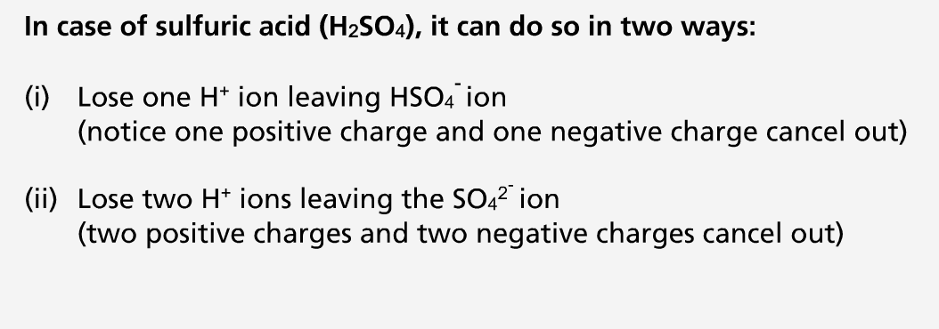

How polyatomic anions are formed:
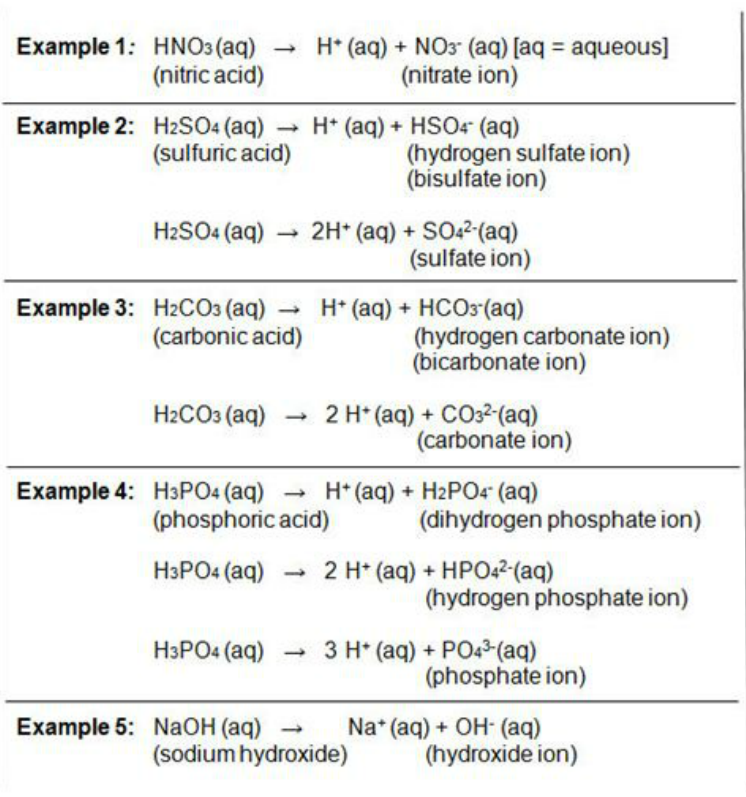

Covalent Compounds
The sharing of electrons between nonmetals forms covalent compounds

Rules for Naming Covalent Compounds
- Rule #1: Name the first element in the formula first.
- Rule #2: Name the second element as an anion.
- Rule #3: Use prefixes to indicate the numbers of atoms of each element.
- Rule #4: Do not use the prefix mono- for the first element.
*** Note: Some compounds are still known by their old names (and not by using the system of nomenclature):
- Water (H₂O) [not dihydrogen monoxide]
- Ammonia (NH₃) [not nitrogen trihydride]
- Hydrogen sulfide (H₂S) [not dihydrogen monosulfide]
- Hydrogen peroxide (H₂O₂) [not dihydrogen dioxide]
- Methane (CH₄) [not carbon tetrahydride]
- Ozone (O₃) [not trioxygen]

Prefixes used in Naming Compounds
Prefix | Number Indicated
Mono- | 1
Di- | 2
Tri- | 3
Tetra- | 4
Penta- | 5
Hexa- | 6

dioxygen difluoride = O₂F₂.

carbon tetrachloride = CCℓ₄

Chemical Reactions

Chemical reactions are expressed as an equation (chemical equation) using chemical formulas. For example, the reaction between calcium metal and oxygen gas is expressed as the balanced chemical equation:

2 Ca (s) + O2 (g) 2 CaO (s)

Balanced Chemical Equation

- Identifies the reactant(s) and product(s)
- Shows the relative amount of the reactant(s) and product(s)
- Indicates the physical state of the reactant(s) and product(s)
[s = solid ; l = liquid ; g = gas ; aq = aqueous]
- The balanced equation above complies w/ the Law of Conservation of Mass & Matter (i.e., atoms & charges on both sides must be balanced)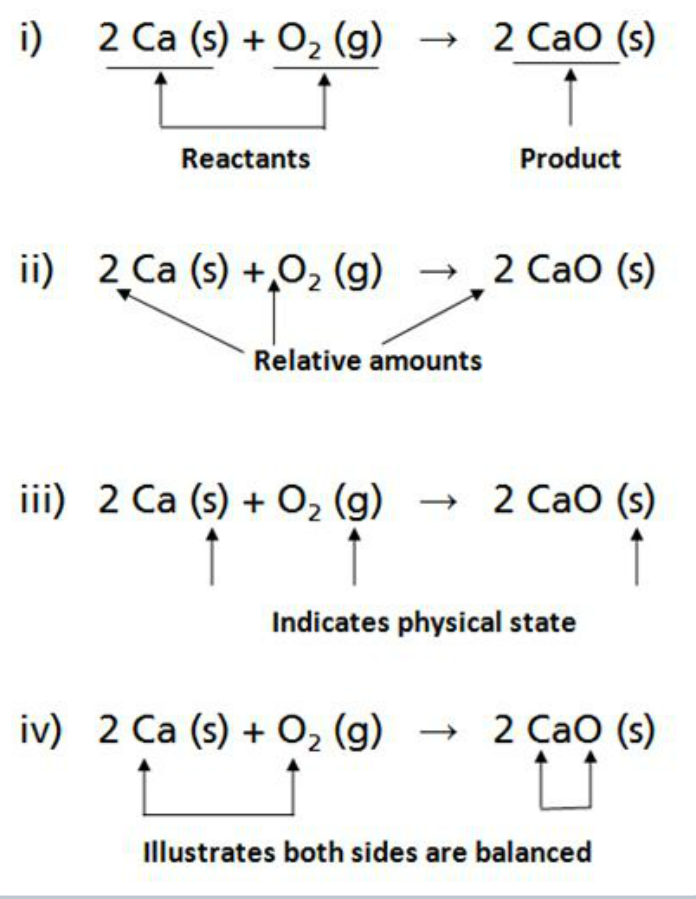
Writing equations:
- fractional coefficients are avoided.
- smallest whole-number coefficients are written.

Coefficient = written in front of each formula. Indicate the moles of reactants & products.

Subscripts = come after and are small print (like the 2 in iv). Show the number of each atom present (02 contains two oxygen atoms)..the coefficient multiplies every atom in the formula.

Example:
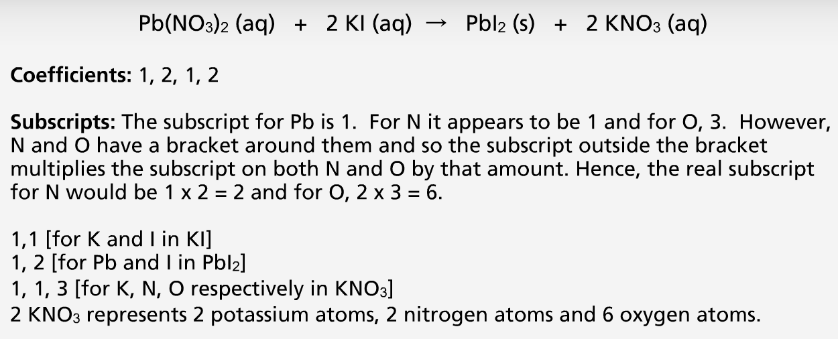

A main point of a balanced equation is that there are the same numbers of atoms appearing in the reactants (left side) and the products (right side)

Elemental form, means that an element is not combined with any other element.

Molecular mass (formula mass) = sum of atomic masses (atomic masses are given in Periodic Table)

Module 4: Hazards in the Work Environment

Occupational Hazards
Types of Hazards
In a workplace, the worker may be exposed to:

Safety hazards

Based on the nature of the work, safety hazards are due to material handling, machines, energy, work practices, and confined spaces.
- Material handling hazards: These can lead to muscle strains due to lifting and carrying materials. The use of devices such as forklifts, cranes, etc. exposes the worker to accidental contact with the moving equipment.
- Machine hazards: Rotating shafts, moving belts, presses, etc. can cause very serious injuries.
- Energy hazards: All energy sources such as electricity, steam, hydraulic pressure, etc. can lead to serious injury.
- Work practice hazards: Failure to follow safe operating procedures may lead to serious injuries.
- Confined space hazards: In such spaces (for example, silos, storage tanks, pipelines etc.) hazards arise due to difficulty of entry and exit, build-up of hazardous materials and oxygen deficiency.

Health hazards

The extent of occupational health hazards varies with the type of activity. However, such hazards may have the potential to cause severe discomfort, illness, and lack of efficiency among workers. Based on the nature of the causative agent (or factor), occupational health hazards can be classified as physical, chemical, biological and ergonomic.
- Physical hazards are due to the presence of physical agents such as pressure and temperature extremes, excessive noise and vibration, and exposure to radiation.
- Chemical hazards are due to the presence of chemical agents such as dust, fume, gas, mist, smoke and vapor.
- Biological hazards are due to the presence of biological agents such as bacteria, molds and viruses.
- Ergonomic hazards are due to ergonomic stresses such as fatigue and repetitious work.
Physical and Chemical
It is very important to note that the mere presence of a causative agent does not necessarily constitute a hazard. A causative agent is classified as hazardous in certain circumstances such as high concentration or intensity and a prolonged exposure.
Workers have the right to:
- Work in a safe and healthy environment
- Know the processes and substances they are working with
Know potential hazards from these processes and substances

Hazard Assessment
In order to recognize and assess the potential impact of occupational hazards, walk-through surveys are performed. Such surveys generally include a study of the following parameters in terms of their impact on the surrounding environment and thus the workers.
Processes, operations and related activities
- Generally various emissions are evaluated because the emission of any physical, chemical or biological agents has the potential to be a health hazard.
Equipment
- Equipment is generally assessed in terms of mechanical and electrical safety and the potential to create excessive noise and vibration.
Properties of substances used and produced
- These include an evaluation of raw materials and finished products in terms of their physical, chemical and toxic properties and effects.
Control measures
All engineering controls in place for proper materials handling, storage, etc. are evaluated. Also considered are the ventilation system and the availability of personal protective equipment.

Physical Agents
Although we are constantly exposed to such agents, their intensity and duration of exposure may be more significant in the workplace. Such agents may cause immediate or cumulative adverse health effects.
Commonly encountered physical conditions with a potential to cause adverse health effects include:
- pressure and temperature extremes
- excessive noise and vibration
- radiation (CANNOT BE DETECTED BY HUMAN SENSES)
The action of physical agents consists of transfer of residual energy through the surrounding air or the equipment the worker is in contact with. Except for radiation, our senses can detect all other physical agents.

Pressure & Temperature

Pressure Extremes
Our bodies are conditioned to work at normal atmospheric pressure. Any extreme can be detrimental to one's health. Two types of abnormal pressure-related conditions are hyperbaric and hypobaric.

Hyperbaric: Hyperbaric is defined as a pressure higher than normal atmospheric pressure. Mining and underwater workers may be exposed to hyperbaric conditions.

Hypobaric: Hypobaric is defined as a pressure lower than atmospheric pressure. Hypobaric conditions are encountered by those working at high elevations such as ski instructors and airline pilots.

Temperature Extremes

The biochemical processes in one’s body take place within a very narrow temperature range and hence the regulation of body temperature is an important function. Temperature extremes affect the working efficiency as well as the health of a worker.

Hot or cold depends on various factors
It is important to realize that apart from the surrounding temperature, sensation of hot or cold depends on some other factors such as:

Air  movement | Hot or cold objects  in the vicinity | Relative  humidity

The terms heat stress and cold stress refer to excessive exposure to very hot or very cold work environments. Both such conditions may interfere with worker’s performance and may even be fatal.

Heat:
Some of the adverse effects in very hot work environments (depending upon the individual worker and the heat intensity) include:
- Heat exhaustion
- Fainting
- Heat stroke
Heat-related problems may arise for:
- Outdoor workers (working in construction)
- Industrial workers (working near furnaces)

Cold:
In very cold work environments (depending upon the individual worker and intensity of cold), the adverse effects include:
- Frostbite
- Hypothermia
Workers at risk include:
- Outdoor workers (divers)
- Meat packers and handlers (working in refrigerated warehouses

Noise & Vibration
Excessive Noise
Noise is a form of irregular vibration. It may be conducted through gases (or vapors), liquids, or solids. Above a certain level, the noise becomes of concern because it may hinder communication between workers, thus leading to annoyance. This in turn may lead to poor job performance and compromise the safety of the worker. In addition, excessive exposure to high noise levels may cause loss of hearing.

Excessive Vibration
It is important to note that exposure to vibration is more than just a nuisance. Whereas exposure to vibration may cause discomfort, intense vibration has been known to cause serious health problems such as back pain, carpal tunnel syndrome (a condition affecting the hand and wrist) and damage to bones and joints.
There are two types of occupational vibration: whole-body and hand-arm vibration. Whereas whole-body vibration is transmitted through the supporting surface (feet, back, etc.), hand-arm vibration is transmitted to the hands and arms. Examples include: Mining equipment (whole-body vibration) and Hand-held power tools (hand-arm vibration).

Radiation
The hazard associated with a particular type of radiation depends on its energy and ability to penetrate the body tissue. Thus, even brief exposure to high energy and highly penetrating x-rays can cause severe damage to the tissue. Infrared, ultraviolet and microwaves on the other hand do not penetrate appreciably below the skin and the damage is mainly restricted to burns to the skin and eyes. Severe damage to eyes may result from excessive exposure to ultraviolet radiation.

Types of Radiation
Radiation is the energy that travels through space from many different natural and human-made sources. Some different types of radiation include: visible light, ultraviolet rays, microwaves, x-rays and radio waves. Thus, it is easy to see that we are exposed to radiation every day.

Depending on its energy, radiation is of two main kinds:
Ionizing radiation: The energy associated with it is high and thus strong enough to damage cells and DNA. Some examples and sources of ionizing radiation include:
- x-rays (from x-ray machines)
- alpha, beta and gamma rays (from radioactive materials),
- high-energy ultraviolet (from germicidal lamps).

Non-ionizing radiation: It is not as strong as ionizing radiation. However, prolonged exposure to some types of non-ionizing radiation can still cause harm. Some examples and sources of non-ionizing radiation include:
- visible light, microwaves (from telecommunications and microwave ovens)
- infrared (from infrared heat lamps)
- radio waves (from broadcasting)
- low-energy ultraviolet (tanning lamps)

Radiation Applications

Some applications of radiation include:
- Industrial: Quality control, non-destructive testing using radiography
- Household: Television, smoke detectors
- Medical: Imaging, treatment
- Science: Material analysis, sterilization

Chemical Agents

A potential risk:

A large variety of chemical agents are encountered in workplaces due to the diversity of raw materials and processes used.

Chemical hazards in such environments arise due to the presence of certain chemical agents whose properties (physical and/or chemical) and/or toxicity may pose a potential risk to the health and safety of the worker coming in contact with it / handling it.

Where do chemical hazards come from?

Chemical hazards may arise in operations involving:
- Compressed gases
- Flammable & combustible materials
- Oxidizing materials
- Poisonous & Infectious materials
- Corrosive materials
- Dangerously reactive materials

Chemical agents may be present in the air as:
- Fine particles
- Gases & vapors
- Both as particles and vapors at the same time
- Adsorbed or absorbed gases and/or vapors on particles

Compressed Gases
- In the workplace many hazardous chemicals (ex: chlorine gas) are compressed & thus stored in cylinders under high pressure. In using such materials the worker is not only subject to the chemical hazard but also the hazards associated w/ pressure extreme.

Flammable & Combustible Materials
- Such materials may burn readily in the presence of sources of ignition

- Many organic compounds such as gasoline, solvents etc. fall in this category.

Oxidizing Materials
- Can contribute strongly to fire hazards, and may possess ability to oxidize, and thus, destroy, the biomolecules in living systems. Some commonly encountered oxidizers in workplace = potassium permanganate, hydrogen peroxide, etc

Poisonous Materials
- Such substances may be dangerous to life in very small amounts.
- Ex: cyanide, mercury salts

Corrosive Materials
- Such chemicals cause deterioration of materials including living tissues on contact. Some examples are: sulfuric acid, potassium hydroxide, etc

Dangerously Reactive Materials
- The chemicals in this category may undergo rapid or violent reactions under certain conditions.

- EX: alkali metals react with water producing highly flammable hydrogen gas.

The problem with Fine Particles

The particles of size less than 5 microns (5 x 10’6m) are potentially the most hazardous because of their effective entry & retention in the lungs. The particles are classified as dust, fume, and smoke (for solids), and mist (for liquids)

Sources of fine particles include: spray painting (mist), welding (fume), incomplete combustion of oil & grease (smoke), ore grinding (dust)

The Problems with Gases and Vapors

- May be generated as a result of various operations & can mix and distribute rapidly throughout the workplace.

- Due to their small size, the gases can readily enter the bloodstream through the lungs.

Some sources of potentially toxic gases & vapors include:
- Solvent degreasing (vapors of solvent used)
- Spray painting (vapors of solvent used)
- Welding (gaseous combustion products)

Biological Agents
Biological agents are living organisms, or substances produced by such organisms, that can cause illness or disease in humans. The adverse health effects due to biological agents may range from allergic reactions to serious medical conditions and even death. Food poisoning, rabies, tuberculosis and hepatitis are some of the infections caused by biological agents.

These include: bacteria, fungi, viruses and other micro-organisms and their associated toxins
Workplace Exposure
Many micro-organisms pose a potential danger in a variety of workplaces due to their ability to:
- Reproduce rapidly
- Survive with minimum resources

Workplace exposure to work-related biological agents such as bacteria, molds, and viruses is limited to certain occupations such as health care workers (i.e., hospital workers and veterinarians), meat handlers (i.e., ranchers, farmers, and meat packers), and those who work in sanitation or sewage operations.

Ergonomic Stresses
Ergonomics can be defined as the science or study of work. It is a way of designing a work environment to fit people.
Over the recent years it has been fully realized that the traditional method of assigning people to jobs without accommodating their needs, limitations, sizes, strengths and weaknesses may lead to certain adverse job safety and health issues such as mental stress, loss of efficiency and accidents.
It has been established that ergonomics, properly applied, can help:
- reduce workplace injuries and illnesses; particularly back injuries and cumulative trauma disorder (CTD) affecting, joints, muscles, nerves and tendons that can cause pain and swelling
- improve productivity and quality of work
- increase job satisfaction
- satisfy government regulations

Module 5: Air and Water

Alveoli
Tiny sac like air spaces in the lungs that are separated from the pulmonary capillaries (i.e., tiny vessels that connect the pulmonary veins and arteries and pass through the lungs) by a very thin layer of epithelial cells. They are the functional part of the lungs and act as gas exchange units.

Atmosphere
The mixture of gases extending from the Earth's surface. It is divided into several distinct layers (troposphere, stratosphere, etc.), each separated by a region known as a pause (e.g., the tropopause separates the troposphere and the stratosphere). While each layer can be related to a particular altitude region, the criterion for separation is actually based on temperature variations.

Concentration
A measure of the amount of a substance within a given volume.

The Air We Breath:
Air (which all of us must breathe) composes the atmosphere and is a complex mixture of gases surrounding the Earth. The atmosphere is a layered structure divided into layers according to a variety of criteria such as gradually changing:

- Altitude  - Pressure  - Temperature | - Electrical nature  - Chemical composition and concentration

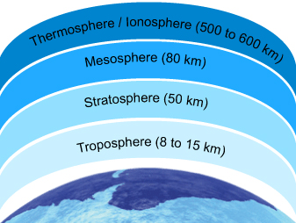

The Atmosphere

According to altitude, the atmosphere is divided into layers:
- Troposphere  - Stratosphere | - Mesosphere  - Ionosphere/Thermosphere
The Composition of Air
The air we breathe is a mixture of several gases, fine particles and vapors.
Dry air consists of 21% oxygen and 78% nitrogen plus traces of other substances that are both natural and human-made.

Major components of air:
- Nitrogen (N₂)
- Oxygen (O₂)
- Water (H₂O)
- Carbon dioxide (CO₂)
Some minor components of air: POLLUTANTS
- Carbon monoxide (CO)
- Ozone (O₃)
- Oxides of Sulfur (SO_{x})
- Oxides of Nitrogen (NO_{x})

The Air Pollutants
Whereas major components are essential for life, the minor components are pollutants,
which under certain conditions may produce adverse environmental and health effects.
These air pollutants are emitted directly into the atmosphere during combustion and
production processes, changing the composition of atmosphere and causing poor air
quality.
The burning of fossil fuels (i.e., petroleum, natural gas and coal) can be used:
- to generate energy (electricity, gas and steam)
- in transportation (combustion engines)
- in industrial processes that use a great deal of energy sources (i.e., pulp and paper mills, ore smelters,
petroleum refineries, power generating stations and incinerators)

These elements are mainly responsible for the presence of minor components. That is, they are the major sources of
human-created air pollution

What is Carbon monoxide (CO)?
An adequate supply of oxygen => complete combustion of fossil fuels, forming carbon dioxide (CO2 = good/non-toxic!!) and water
When there is an insufficient supply of oxygen, there is incomplete combustion of fossil fuels and carbon monoxide gas is released (CO = toxic!). It can also be produced by other processes such as combustion of organic matter during waste incineration. Natural sources include forest fires and volcanoes.
If carbon monoxide is inhaled, it binds to the oxygen-carrying site on the hemoglobin of red blood cells, causing reduction of oxygen transport to the body..resulting in cell and tissue death.
Health consequences of CO exposure: impaired ability to use oxygen, decreased athletic performance, cardiac problems.
What is Ground-level Ozone (O3)?
A naturally occurring gas that forms a protective layer in the atmosphere, present predominantly in the stratosphere.
    - serves to protect the Earth by absorbing harmful ultraviolet radiation from the sun.
Ground-level ozone is produced during photochemical reactions between volatile organic compounds (VOCs) released in automobile exhaust and oxides of nitrogen (NOx) in the presence of sunlight. Ozone is also generated in industrial processes such as arc welding.
Human health effects with exposure: damaged biological tissues and cells, reduced lung function, breathing difficulties and itchy, burning, and watery eyes.
What are Oxides of Sulfur (SOx)?
    - released mainly during processing (smelting) of mineral ores and the combustion of fossil fuels (i.e., burning of coal/petroleum).
    - Industrial processes (such as pulp & paper production and petroleum refining) also generate oxides of sulfur. Such emissions include sulfur dioxide (SO2) and sulfur trioxide (SO3).
    - Most common natural source of sulfur dioxide (S02) is volcanoes.
Human health effects: problems breathing (mostly for asthmatic people) & respiratory illness.
What are oxides of Nitrogen? (NOx)
Sources of emissions: fuel combustion for transportation, home, and industrial use; manufacture of nitric acid; welding, etc.
NOx form in the air because fuel is burnt at high temperatures.
The main oxides of nitrogen present in the atmosphere are nitric oxide (NO), nitrogen dioxide (NO2), and nitrous oxide (N20).
Natural sources include lightning and microbial activity of soil bacteria.
Human health effects: serious lung damage, shortness of breath, chest pains.
Assessing Health Risks
Entry into the Body
The air we breathe (inhalation) is handled by the lungs, which provide an extremely efficient method of getting oxygen (required for metabolic processes) into and carbon dioxide (waste product of metabolic processes) out of the body.
Unfortunately, the lungs also provide an excellent opportunity for minor components (pollutants) to diffuse into the blood stream via gas exchange in the alveoli.
As breathing is a continuous process, considerable amounts of a pollutant (even if present as a minor component) can be inhaled and efficiently transported into the body. Once in the body, they may manifest adverse health effects.
Risk Assessment
In order to assess the health risks due to air pollutants, we require exposure and effects assessment.
- Exposure assessment: estimates concentrations using chemical measurements.
- Effects assessment: relies on toxicity testing (estimates of exposure toxicity) and computer models to extrapolate data from human population, animal, and bacterial toxicity studies. Quantitative analysis of epidemiological, toxicological and exposure data that are based on the accurate scientific evidence estimates exposure toxicity and risk.

Risk characterization integrates the exposure and effects components to estimate the risk.

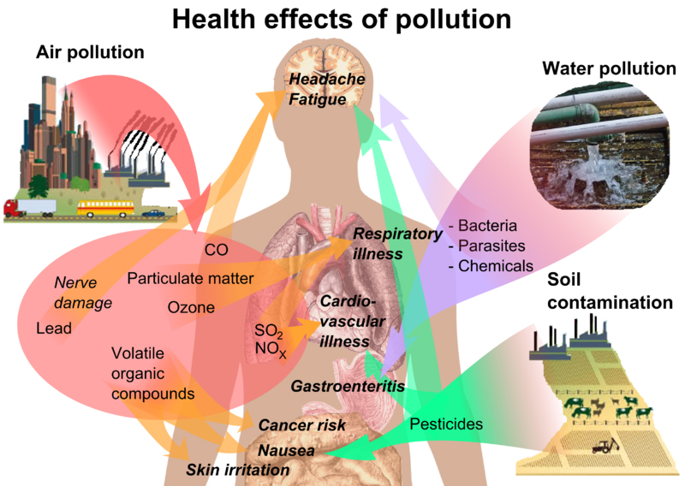
Exposure measurement: measured by determining the pollutant concentration in air. Monitoring methods include:
- Air sampling followed by laboratory analysis of the pollutant(s) using established procedures.
Real time monitoring using direct reading pollutant-specific monitors.
Commonly used concentration units
For gases and vapors: | For particles:
- Parts per million (ppm)  - Parts per billion (ppb)  - Percent (%) | - Milligrams per cubic meter (mg/m³)  - Micrograms per cubic meter (µg/m³)

Keep in mind these useful conversion factors:
- 1% = 10⁴ ppm
- 1 ppm = 10³ ppb
Threshold Limit Values
Thus, for pollutants, Threshold Limit Values (TLVs) have been developed and issued by the
American Conference of Governmental Industrial Hygienists (ACGIH) to assist in the control of workplace health
hazards.
According to ACGIH, Threshold Limit Value-Time-Weighted Average (TLV-TWA), is defined as the time-weighted
average concentration for a normal 8-hour workday and a 40-hour workweek, to which nearly all workers may be
repeatedly, day after day, without adverse effect.
Substance | TLV-TWA
CO | 25 ppm
NO₂ | 3 ppm
O₃ | 0.1 ppm
SO₂ | 2 ppm

Indoor Air Contaminants:
Asbestos fibers:
Asbestos (a mineral fiber) has been used in a variety of building construction materials for insulating and fire proofing. Deteriorating, damaged, or disturbed insulation, fireproofing, etc becomes the source of asbestos fibers in the indoor air.
Biological contaminants
Common biological contaminants include: bacteria, dust mites, insects, mold, pet dander, rodents, viruses, etc
Combustion by-products
These include gases (ex, carbon monoxide/dioxide, unburned hydrocarbons, etc) and small particles. These are created by incomplete burning of fuels (ex, wood, gas, coal, etc) in appliances such as wood stoves, gas stoves, fireplaces, etc
Formaldehyde = WOOD PRODUCTS
Sources in indoor air include: pressed wood products (hardwood plywood wall paneling, particleboard, fiberboard, etc, furniture made with these pressed wood products, combustion sources, tobacco smoke, textiles, and glues.
Pesticides
Originate from the products used to kill household pests (insecticides, disinfectants, etc).
Pesticides used on lawns and gardens can drift or tracked indoors.
Radon gas
It is slowly released from the ground, water, and some building materials that contain very small amounts of uranium, such as concrete, bricks, tiles, etc. radon can enter a house through cracks in the foundation walls and in the floor slabs, floor drains, sumps, etc
Respirable particles
Depending on size these can be inhaled all the way into the lungs. Indoor sources include: fireplaces, wood stoves, oil heaters, tobacco smoke, etc
Volatile Organic Compounds (VOCs)
Originate from a variety of indoor sources such as air fresheners, aerosol sprays, disinfectants, dry-cleaned clothing, hobby supplies, paints, solvents etc
Control Strategies
Over the past two decades, stricter environmental emission control regulations and pollutant(s) mitigation (reduction) technologies have led to considerable reduction in the concentration of many pollutants.
The North American Free Trade Agreement (NAFTA) obliges all the three signatories to enforce environmental laws. There is a move in all the three nations toward tougher and thorough reporting of releases of pollutants to the environment. In Canada, National Pollutant Release Inventory (NPRI) is a publicly-accessible database of pollutants released to the Canadian environment.
Among the global initiatives is the establishment of the International Register of Potentially Toxic Chemicals (IRPTC). It is a computer based database. One of the objectives of the register is to identify the potential hazards of using chemicals and to make people aware of them. The database provides access to information regarding production, distribution, release and disposal of hazardous chemicals. The database also includes information on environmental and health effects of such chemicals.
THE WATER MOLECULE
Water (H₂O) consists of two nonmetals hydrogen and oxygen. The water molecule is
formed by the covalent bonding of two hydrogen atoms to an oxygen atom. Water is a
unique substance that is literally everywhere. A vital substance to our well-being and
very existence, water is intimately linked to our daily life.
Unique properties of water
The polar nature and the capability to form hydrogen bonds are responsible for many of the unique properties of water. Such properties play an important role in making water essential for life and in determining its chemical behavior in the environment.
We use water for various purposes, such as:
- Cooking and Drinking  - Personal hygiene  - Recreation | - Agriculture  - Transportation  - Energy generation

Polarity of Water
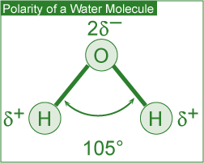
The polar nature of the water molecule is due to its:
- Polar covalent bonds: The electron pair forming the covalent bond (between the oxygen atom and each of the two hydrogen atoms) is more strongly attracted by the oxygen atom due to its higher electronegativity (the ability of an atom in a molecule to attract shared electrons over another atom in the molecule).

- This leads to a partial positive charge on each of the two hydrogen atoms (represented as ⁺ ) and a partial negative charge on the central oxygen atom (represented as ⁻ ) making the water molecule behave like a dipole.
- Molecular shape: A water molecule has a bent (V-shape) shape (H-O-H bond angle of 105°). This, in combination with the polar covalent bonds, leads to a resultant dipole and hence the polarity of the water molecule.

Hydrogen Bonding
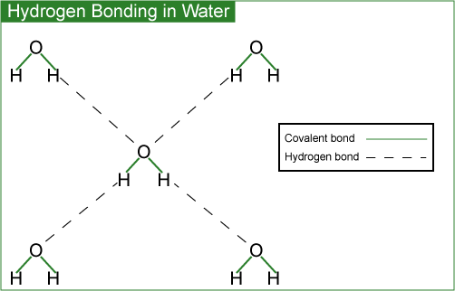
The partial charges present lead to intermolecular attraction between water molecules. A single water molecule can thus attract four other water molecules.
These intermolecular attractive forces are called hydrogen bonds. These are much weaker than the forces holding the atoms in the covalent O-H bond.

Solvent Properties
Water is a powerful solvent due to its high polarity and hydrogen bonding ability.
It is an excellent solvent for ionic (e.g., table salt), polar covalent (e.g., sugar) and non-polar (e.g., oxygen) compounds. In the case of ionic compounds, the ions are separated from the solid and caged (solvated) by polar water molecules, thus keeping them in solution.
Polar covalent compounds (i.e., ethanol and glucose) dissolve in water by the formation of hydrogen bonds.
Water therefore plays an important role in the transportation of nutrients and waste products in biological processes. Aquatic life and plants survive due to dissolved oxygen and carbon dioxide.

Thermal Properties
Steam and liquid water are two different forms of the same chemical substance, water

The presence of hydrogen bonds in water accounts for its exceptionally high boiling point, specific heat, and heat of vaporization. A portion of the heat supplied is used up in breaking the hydrogen bonds.
Specific heat is defined as the amount of heat energy required to increase the temperature of 1 g of a substance by 1°C.
High specific heat of water regulates and stabilizes the temperatures of geographical regions and organisms within a narrow range. This in turn allows our planet to support life.
Heat of vaporization is defined as the quantity of heat required for the conversion of 1 g of a liquid entirely into its vapor at a constant temperature. High heat of vaporization of water helps in regulating the temperature of our body. It is also responsible for powering the winds and storms of our planet.

Water Density
Density of Solid and Liquid Water
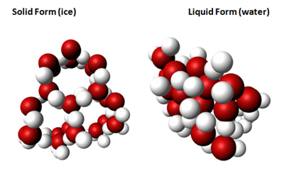
Solid (ice) and liquid form of (water) - hexagonal open structure due to the presence of hydrogen bonds

Ice has a hexagonal open structure due to the presence of hydrogen bonds. When ice melts, the open spaces are filled with liquid water, causing the crystal structure to break down.
This leads to a reduction in volume for the same mass and hence an increase in density (density = mass/volume). The higher density (thus expansion and contraction of volume due to the freeze-thaw cycle) of liquid water than that of ice accounts for phenomena such as:
- Floating of ice on water
- Survival of aquatic life during winter
- Nutrient turnover in bodies of water
- Formation of pebbles, soil and sand
- Bursting of frozen water pipes

Surface Properties
The high surface tension and capillarity of water is due to the presence of hydrogen bonds. Water is the liquid with the highest surface tension. Plant debris rests (rather than sinks) on the surface of water bodies due to its high surface tension. This provides aquatic life with much-needed shelter and nutrients. Capillary action (also due to high surface tension) makes water in soil available to plants.

Module 6: Household Products
Soaps, Detergents and our Health
Soaps and detergents play a very important role in our lives. These chemicals help us in making our surroundings cleaner (i.e., by removing soil and grease), healthier (i.e., by reducing the germs), and pleasant.
In order to make it more effective in the process of cleaning, the water must be made to spread and thus wet surfaces effectively, i.e., its surface tension must be reduced.
This is achieved by using compounds called surfactants.

What are Surfactants?
- Soaps and detergents are composed of surfactants.
- Surfactants are water-soluble and surface-active agents.
Surfactants are composed of a hydrophilic (water-soluble) head and a hydrophobic (fat-soluble, water-hating) tail. The hydrophilic end is stable when solubilized in water and the hydrophobic end consists of a long chain hydrocarbon that is more stable when surrounded by other organic groups.
Classes of Surfactants
There are different classes of surfactants categorized by the charge of the hydrophilic component of the surfactant molecule after dissociation in water:
- Anionic surfactants have a negative charge (EX: SOAP)
- Cationic surfactants have a positive charge.
- Non-ionic surfactants have no charge.
- Amphoteric surfactants have both positive and negative charges.

All About Soap
Advantages of soap
- Soaps are manufactured from combinations of natural and renewable resources.
- Soaps are biodegradable and thus do not pollute bodies of water.
Disadvantages of soap
- Formation of soap film (or scum) in water containing Ca²⁺ and Mg²⁺ ions (hard water). The calcium and magnesium ions react with soap molecules to produce calcium and magnesium salts of fatty acids. These salts are insoluble in water and impair the surfactant properties of soap because the amount of soap available for cleaning is reduced. Soap scum is difficult to rinse away and can be visible, i.e., on fabrics, bathtubs and sinks.
- Poor adaptability to diversity of fibers, washing temperatures and water conditions.
- Tendency to clog sewage systems due to their gelling properties.
What is hard water?
Water containing high concentrations of the divalent alkaline earth metal cations calcium (Ca²⁺) and magnesium (Mg²⁺).
Composition and Limitations of Soap
Soaps (anionic surfactants) consist of the long hydrocarbon tails of fatty acids and the polar heads of sodium or potassium salts of fatty acids (found in fats and oils of animals and plants).
Traditionally, soap was made from animal fat and wood ash (composed of potassium hydroxide and potassium carbonate).

All About Detergent
Advantages
- Detergents are less affected by calcium and magnesium ions in water, thus acting as better cleaning agents and almost eliminating the film formation.
- Detergents perform well under diverse conditions such as adaptability to diversity of fibers, washing temperatures and water conditions.
Disadvantages
- Detergents are made from non-renewable petroleum-based oils.
- Majority of detergents are not biodegradable.

The Cleaning Process
The soap/detergent chemical reaction:
- In process, polar end of the surfactant molecule interacts with water (a polar molecule) and the non-polar end is attracted to oil or grease (non-polar molecules)
Step 1:Chemical interaction (w/ soap /detergent) traps the oily and greasy soil molecules. In aqueous solution, surfactants cluster near the surface.
Step 2: the hydrophobic tails are attracted to the grease and the hydrophilic heads to the water, thereby forcing the grease away from the soiled surface.
Step 3: The grease is then surrounded by the individual surfactant molecules and removed from the soiled surface.
Step 5: Thermal Interaction (with hot water) helps dissolve oil & grease molecules.
Mechanical interaction (machine agitation/ hand rubbing) releases oily & greasy soil from the fabric.
Classifications
Depending upon the function, household soaps and detergents can be classified as those used for:
 | 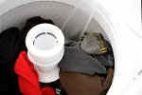 |  | 
Personal hygiene | Laundry | Dishwashing | Household cleaning

It is important to note that in view of the functional diversity, these products are usually formulated by mixing many ingredients. For example, laundry detergents are formulated from the following groups of chemicals:
- Surfactants to bind and suspend grease and dirt in the washing water
- Builders to remove Ca²⁺ and Mg²⁺ from hard water and soil
- Bleaching agents to remove stains and kill bacteria
- Enzymes to catalyze the degradation and elimination of some stains
- Miscellaneous chemicals such as foam stabilizers, fabric brighteners, fragrances, corrosion inhibitors etc. are added in small quantities.

Environmental Impact
Developing Products that are Safe for all of Us
As cleaning products are an integral part of our lives, it is very important to be aware of their impact on our health as well as the impact on the environment once discharged.
Health risks are very real, particularly in the case of some specialty household cleaners. Drain openers, oven cleaners and toilet bowl cleaners may contain reactive and/or corrosive chemicals. It is imperative that adequate safety precautions are taken while using such products.
The manufacturers are obliged by law to evaluate the environmental safety of the ingredients. Most of these products are formulated to work with water and end up in wastewater treatment plants, thus impact on the environment is minimized.
The Safer Detergent Stewardship Initiative (SDSI) program of the U.S. Environmental Protection Agency (EPA) recognizes corporate environmental leaders using safer surfactants which break down quickly into non-polluting chemicals and thus protect aquatic life.
In an effort to handle these products in an environmentally wise way, we as consumers should buy them in usable amounts and dispose of them (if required) properly.

RECENT TRENDS:
In keeping with consumer demand for more efficient and environmentally friendly products, the present trend is to develop home and fabric care products that:
- Contain surface protectors or modifiers that repel soil and stains more effectively.
- Deliver active ingredients in a controlled way.
- Are effective in cold water.
- Contain natural or naturally derived ingredient(s).
- Do not contain chemicals of concern with respect to toxicity.
- Generate less carbon dioxide during production (smaller environmental footprint)

Personal Care Products:
Reducing agent:
A substance that reduces (i.e., donates electrons) another substance and in turn gets oxidized (i.e., accepts electrons).

Oxidizing agent
A substance that oxidizes (i.e., accepts electrons) another substance in a chemical reaction and in turn gets reduced (i.e., donates electrons).

Influencing Factors
Nearly all of us use personal care products for one or more reasons: to make our hair clean and colorful, skin free of wrinkles or to delight the senses. This is an expanding and dynamic field primarily because such products must be developed to take care of the changing needs of society.

Some influencing factors include:
- Aging population  - Changing attitudes of men | - More women in the workplace  - Concerns about exposure to ultraviolet radiation

The chemical ingredients in these products are thus changing at a remarkably fast pace. The availability of biotech products and processes to produce new ingredients is going to revolutionize the development of personal care products in the future.
In addition to rapidly changing chemical ingredients, more efficient delivery systems are being introduced. These include a variety of encapsulation systems to deliver the active ingredients in cosmetics.
Many shampoos, lipsticks, face creams and toothpastes contain these microcapsules. The active ingredient is delivered when the microcapsules rupture on the applied surface (e.g., skin) due to rubbing, presence of moisture, change in pH or the presence of naturally occurring bacteria.

Haircare products: Shampoos, conditioners, styling agents & colorants

Shampoos:

Anionic Surfactant = Sodium dodecylsulfate

Shampoos are cleansing agents containing anionic (-) surfactants to remove oil & dirt from the hair and scalp.

Surfactants produce foam, lifting the oil & dirt from the hair. In addition, fragrances, thickeners, foam boosters and other agents may also be added.

Conditioners:

Cationic (+) Surfactant: Hexadecyltrimethylammonium chloride

These help in rinsing out any residual shampoo & at the same time provide softer and easy-to-mange hair.

Styling agents:
Steps to curling hair:

- Treatment of hair with a reducing agent (electron donor) that breaks certain covalent bonds.
- Setting hair in the desired shape.
- Treating hair w/ an oxidizing agent (an electron acceptor) such as dilute solution of hydrogen peroxide to reform the previously broken covalent bonds in the new shape.

Colorants:
Hair coloring is a two-step process involving:

- Oxidation of natural hair pigments to colorless products using bleaching agent.
- Application of an organic, synthetic dye to obtain desired color.

In addition to the dye (or its precursor), formulations contain ammonia, hydrogen peroxide and a surfactant. In order to reduce the damage to hair during process and reduce smell of ammonia, the chemistry has been modified by replacing ammonia with ammonium carbonate.

Skin Care Products
Moisturizers: used to increase water content of the skin.
Functions:
- Prevent & treat dry skin.
- Protect skin & make it appear smooth by encouraging an orderly shedding process.
- Improve skin tone & texture.
- Protect sensitive skin & mask imperfections.

Active ingredients:
- Humectants: absorb moisture & hold it in the skin. Ex: glycerin, urea

- Emollients: lubricate and smooth the skin. Ex: lanolin, mineral oil.

- Miscellaneous: Antioxidants, fragrances, minerals, plant extracts, vitamins.

Skin care prods (creams, lotions, shampoos, sun care prods) containing plant-derived chemicals are being developed at a fast rate.

Sunscreens:
Protect skin against harmful effects of ultraviolet (UV) radiation. Ultraviolet radiation emitted by the sun consists of UV-A and UV-B.

Although stratospheric ozone layer destroys most of this radiation, UV light that gets through can cause problems. Plus, the depletion of ozone layer due to natural and human made chemicals may increase amount of UV radiation reaching us. Its believed that exposure to UV rays can cause painful sunburn, skin damage, and lead to skin cancer.

Sunscreen products are formulated with additional chemical ingredients that absorb UV radiation.
Two types of active ingredients in Sunscreens:

1. Inorganic: approved for use are titanium dioxide and zinc oxide. These work by reflecting and scattering UV light.

2. Organic: wide varieties are approved for use. These work by absorbing UV light and dissipating it as heat.

Effectiveness of sunscreen in a formulation is rated by its ability to block the UV-B rays that cause skin burns. Its called Sunburn Protection Factor (SPF). Higher SPF = better protection against UV-B rays.

Some misconceptions: You cannot determine the duration of effectiveness of a sunscreen by multiplying SPF by time it takes to suffer a burn without sunscreen.

Protection factors: Protections depends on : Activities (swimming removed sunscreen from the body), amount applied and frequency of re-application, solar intensity, type of skin, amount absorbed by the skin.

In order to achieve high SPF, formulations generally contain a combo of inorganic & organic ingredients.

Safety in the Sun: In an attempt to inform the consumers the level of UV-A protection in sunscreens, the US Food and Drug Administration (US FDA) is proposing a four star rating system to be displayed near the SPF rating on the label. According to this system, one star will represent low UV-A protection and four stars the highest UV-A protection.
Cosmeceuticals
Whereas pharmaceuticals are defined as products that may affect the structure or any function of the body, cosmetics are something superficial to cover a deficiency or defect.
The term cosmeceuticals is used to describe cosmetics containing ingredients which may affect the structure or any function of the body like pharmaceutical ingredients.
During the late 1980s, alpha hydroxy acids (AHAs) became important ingredients in many cosmetic formulations claiming to reduce signs of aging, sun-damaged skin and wrinkles. These work by breaking down and lifting off part of the top layer of dead skin cells in order to get rid of some surface damage and accelerate growth of living cells. The cosmetic industry believed the ingredients to be more than simple cosmetics and hence called them cosmeceuticals.
Some of these products are only available with a doctor's prescription and supervision. They include, among others, Botox (for a more youthful look), Vaniqa (to eliminate unwanted facial hair) and Propecia (for bald men).
Perfumes
Perfumes are alcoholic solutions of organic compounds with pleasant odors (fragrant compounds). Today, a large variety of natural and synthetic compounds are available to create fragrances for perfumes. In creating perfumes, the ingredients are blended based on their molecular size and volatility.
For this reason, the fragrances in perfumes are generally experienced in three different stages referred to as top, middle and base notes. The top notes are the most volatile components and hence experienced immediately after the opening of the package. The middle notes are experienced next followed by the base notes which last longest.
TOP (most volatile, experienced first) MIDDLE BASE (last longest)
A recent trend has been to develop more intense and long-lasting alternatives to the known fragrant compounds. Such low-volume production means less impact on energy, health and the environment.

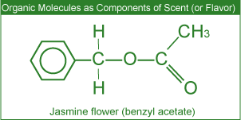
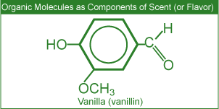

Miscellaneous Products
Deodorants
Body odors are reduced or masked by the use of deodorants. Such odors may originate from the conversion of certain compounds (present in the perspiration) to unpleasant odors by bacteria. Thus the effective chemical ingredients in such products are antibacterial agents and perfumes.
Cosmetics
Facial cosmetics such as lipstick and mascara generally contain oils, waxes, pigments and perfumes. Lipstick manufacturers blend various proportions of oils, waxes and emollients (to soothe the skin) to formulate the base for their unique brand. Fragrances, pigments, preservatives, antioxidants and a variety of other ingredients are then added.
In recent years there has been a concern regarding the presence of low levels of lead in certain cosmetics. A recent testing of a number of brands of lipstick by the US FDA (United States Food and Drug Administration) has shown the presence of low levels of lead. According to the US FDA, the levels observed do not pose a safety concern.

Module 7: Drugs and Medications

- Single bond: A covalent bond in which one pair of electrons (2 electrons) is shared by the two atoms participating in the covalent bond.  - Double bond: A covalent bond between two atoms involving the sharing of two pairs of electrons (four electrons). | - Triple bond: A covalent bond between two atoms involving the sharing of three pairs of electrons (six electrons).  - Functional Group: A specific grouping of atoms that can be considered the chemically functioning part of the molecule. More importantly, though, is that the properties (i.e., how they behave both physically and chemically) of such groups are transferable from one molecule to another.
Overview
Organic chemistry deals with the study of carbon containing compounds and their reactions. Organic molecules are present in living organisms and in many products used in our everyday lives such as foods, household cleaning products, personal care products etc.
As the element carbon is present in the majority of drugs used today, some basic principles of organic chemistry (the study of carbon compounds) are discussed in this section

The Element Carbon
The main characteristics of carbon that lead to the formation of such a large number of organic compounds (over 10 million known) with dramatically different physical and chemical properties include the ability to form:
- Covalent single, double, and triple bonds with some other elements, including carbon.
- Covalent bonds with other carbon atoms to build chains and cyclic structures.
- Covalent bonds with elements such as hydrogen, nitrogen, oxygen and halogens

In the structures shown below, each line (bond) represents a pair of electrons.
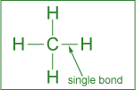 | 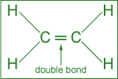 | 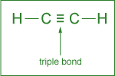
Single bond: formed by the sharing of one pair of electrons. | Double bond: formed by the sharing of two pairs of electrons. | Triple bond: formed by the sharing of  three pairs of electrons.

Arrangement of Atoms
Among the cyclic structures, the arrangement of carbon atoms in 5- or 6-membered rings is quite common.
The hexagonal (6-membered) ring with three single and three double bonds is called a benzene ring.
Various Ways to Represent Benzene (C₆H₆) Ring  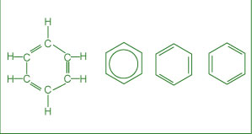 | Other Rings  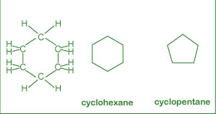

Various Functional Groups
Organic compounds are divided into important families based on their characteristic functional group. A functional group is a small structural unit or arrangement of atoms in a molecule that is the chemically functioning part of the molecule.

For drugs, functional groups are responsible for their action. And functional groups may determine important parameters such as the rate of uptake and reaction as well as the time of residence of drug in body.

Groups include: Alcohol, aldehyde, amine, carboxylic acid, ester, ether, ketone

Overview
From the Sumerians (2200 BC) to the present, the discovery and usage of drugs has gone through a number of phases such as:
- Medicinal preparations and concoctions from plants, minerals and animal sources.
- Isolation and the use of plant ingredients as medications.
- Synthesis and testing of a variety of chemicals as potential cures for ailments.
- New areas of research into marine plants and organisms as potential drugs.
- Molecular modeling in designing drugs.
Extensive research with the available sophistication in the field of medicine has led us to engineer molecules that can be used to improve the quality of life by preventing, moderating, or curing illnesses.
Antibiotics: used to fight (prevention or treatment) bacteria that cause infectious diseases such as meningitis, pneumonia, tuberculosis, etc.
Categories include: Penicillins, Cephalosporins, Tetracylines
The discovery of chemically modified derivatives of these antibiotics led to the control of a large variety of bacterial infections. Antibiotics are isolated from bacterial sources, but can also be human-made. Antibiotics act directly on bacteria and destroy them or inhibit their growth. They will not kill viruses.
How do they work? Their mechanism is to alter or inhibit one of the following cellular structures/processes:
- Cell wall synthesis: prevents new bacterial cells from forming by preventing formation of the cell wall.
- Cell membrane permeability: kills bacteria cells by causing breakdown of the outer cell membrane.
- Protein synthesis: prevents the bacteria from converting proteins to energy, causing starvation and ultimate cell death.
- Nucleic acid synthesis: keeps bacteria cells from growing by interrupting DNA synthesis.
- Competitive inhibitor: mimics bacteria’s growth factors, thus preventing spreading of the bacteria.
Penicillins:
- Treat infections caused by bacteria.
- Do not fight infections caused by viruses.
- Mode of action: affect development & damaging of bacterial cell walls.
Cephalosporins:
- Have similar structure to penicillins but treat a much broader range of infections.
- Mode of action: affect the development of bacterial cell walls.
Tetracyclines:
- Chemical structure consisting of four rings.
- Used to treat penicillin-resistant infections.
- Mode of action: inhibit the synthesis of required bacterial proteins.
Antibiotic resistance: “Superbugs”
To decrease antibiotic resistance: more cautious use of antibiotics, monitor outbreaks of antibiotic resistances, develop new antibiotics
Antiviral Drugs
Antiviral drugs are used to treat (cure or control) viral infections such as flu, polio, herpes and AIDS (Acquired Immune Deficiency Syndrome). A different strategy has to be used to combat viruses, as these do not respond to antibiotics. Two commonly used strategies to fight viral infections include:
Prevention through vaccination
When a vaccine (consisting of inactivated virus) is injected, antibodies to fight off a virus are developed and stored in the body. The stored antibodies become available to fight future infection.
Use of antiviral drugs
Commonly used antiviral drugs (particularly for the treatment of the AIDS virus) fall into three classes:
- Nucleoside derivatives inhibit the synthesis of viral DNA, thus preventing the virus from spreading.
- Protease inhibitors, on the other hand, interfere with the viral protein formation, thus preventing their reproduction.
- A three-drug cocktail consisting of different nucleoside derivatives and protease inhibitors has shown considerable promise in the treatment of AIDS. This triple cocktail treatment is also known as Highly Active Antiretroviral Therapy (HAART). The success of the therapy is probably due to the cocktail's ability to disrupt the viral replication at different stages. It is important to note that the therapy is very expensive and patients must adhere to their dosing schedule.
Some major problems associated with multiple drug therapy are: Moderate effectiveness, lack of response in some cases, serious to severe side effects and drug resistance by the virus. Recent efforts in the fight against AIDS have been directed towards the development of: Viral entry inhibitors (i.e., the drugs that will prevent HIV from attaching and consequently entering into the cell) and Vaccines.
Anticancer Drugs
Cancer involves uncontrolled division of some cells of the body due to mutation of DNA within the healthy cells. These cells invade nearby tissue and spread throughout the body via bloodstream or lymphatic system. Thus the chemical treatment of cancer (chemo) involves drugs targeting rapidly dividing cells to kill the cancerous cells. Some chemotherapeutic agents include:
- Alkylating agents
  - Mode of action: due to their high reactivity, alkylating agents introduce defects in the DNA, thus killing the rapidly growing cells by preventing cell growth & multiplication.
  - Also affect growth of normal cells & cause mutations.

- Antimetabolites
  - A general term for the organic compounds that are synthesized, recycled, or broken down in cells.
  - Inhibit DNA synthesis, thus stopping cell replication.
  - Mode of action: compete for binding sites on the enzymes and are incorporated into nucleic acids.

- Topoisemerase inhibitors
  - Damage DNA which causes cell death.
  - Mode of action: act against the topoisomerase enzymes to prevent cancer cell growth.

- Hormone therapy
  - Used against certain cancers that depend on hormones for their growth.
  - Used primarily for breast cancer & other cancers of sexual organs..since these tissues require hormones for their growth, the chemotherapeutic agents act by inhibiting the hormone supply thus stopping tissue growth.
  - Mode of action: stop the production of certain hormones or change their mode of function
Antidepressants
A deficiency of certain neurotransmitters (any chemical that carries impulses between nerve cells), particularly serotonin in the brain, seems to be partly responsible for causing clinical depression. Neurotransmitters are needed for normal brain function and mood control, in addition to other functions.

Although the effects of antidepressants are not fully understood, there is substantial evidence to show that antidepressants help to restore the brain’s chemical balance.
Commonly used antidepressants include:
- Selective Serotonin Reuptake Inhibitors (SSRIs) (e.g. Prozac, Paxil and Zoloft)
- Monoamine Oxidase Inhibitors (MAOIs) (e.g. Nardil, Marplan and Parnate)
- Serotonin and Norepinephrine Reuptake Inhibitors (e.g. Effexor)
- Norepinephrine and Dopamine Reuptake Inhibitors (e.g. Welbutrin)
- Tricyclics (e.g. Norpramine, Pamelor and Tofranil)
Whereas SSRIs target the serotonin levels only, tricyclics affect the brain levels of other neurotransmitters (including serotonin) as well.
Anti-Inflammatory Drugs (EX: Cortisone)
Inflammation is the first response of the immune system to infection or irritation characterized by pain, swelling,
redness and heat. An inflammation results from the rapid transport of blood proteins and other substances to a
damaged tissue site or an area under attack by a foreign organism.
Certain steroids are used as potent anti-inflammatory drugs. These suppress the inflammatory responses of the body,
thus reducing inflammation.
Over the Counter Drugs (OTC drugs)
OTC drug criteria:
To switch a drug from Rx to OTC involves a benefit-risk comparison and making sure that patients alone can achieve the desired medical result without endangering their safety.
Although OTC drugs allow patients to participate in their own health care, labels must be followed closely because they are not without risk.
Aspirin – the best known OTC drug
Was introduced more than 100 years ago. Has been long used as an:
- Analgesic (relieving minor pain)
- Antipyretic (lowering fever)
- Anti-inflammatory (reducing swelling) drug
Recent studies have shown its usefulness in treating heart attack and stroke.
Effectiveness & Side Effects
Its effectiveness is due to its ability to reduce the production of prostaglandis (a hormone like substance that promotes inflammation, fever, and pain) and thromboxanes (responsible for platelet aggregation in the formation of blood clots) in the body
Side effects include:
- Stomach irritation
- Ringing in the ears
- Allergy
- Reye syndrome (brain disorder) in children
Drug Delivery Systems
Active pharmaceutical ingredient (API) in a medicine is delivered to the body in many forms, such as tablets, gelcaps, liquids and so on. Some newer alternate methods for drug delivery have been developed with three major advantages:
- User convenience
- Improved drug performance
- Better patient compliance
Some of these methods include:
- Pulmonary delivery: The system is non-invasive and facilitates the rapid absorption of the drug on the large surface area of the lungs followed by rapid desorption into the bloodstream.
- Skin absorption: Skin patches are being used to deliver the medication via skin absorption.
- Nanocrystals: This method reduces the drug particle size to nanoscale (<400 nm) making it more soluble in body fluids
Effects & Trends
Environmental Effects of Pharmaceuticals
Recent research has led scientists to be concerned about the environmental impact of old and/or expired medications that are discarded. The pharmaceuticals enter the environment mostly through raw or treated sewage.
Some of the effects observed include:
- Feminization of male fish due to estrogenic compounds: The signs of feminization in male fish have been concluded as a response to estrogen (in birth control pills) exposure.
- Slow development of fish and frogs due to certain antidepressants: Profound effects on spawning and other behaviors in shellfish can occur with antidepressants such as Selective Serotonin Reuptake Inhibitors (SSRIs).
Recent Trends in Pharmaceutical Development
In the field of pharmaceutical development the present trends include:
- A shift from blockbuster drugs (drugs that work for a large number of patients) to personalized medicine: In personalized medicine, therapies are catered towards genetic profiles of patients and their diseased cells.
- Exploring marine organisms in an attempt to obtain new compounds with therapeutic potential: Several of these compounds are being investigated as potential anticancer agents, analgesics and anti-inflammatory drugs.

Medications & Health
Drugs should not be considered risk-free chemical substances. It is strongly recommended by health professionals
that patients should always bear in mind the fact that medications have side effects and may have serious
interactions with other medications, dietary supplements, food and beverages consumed.
In order to reduce risks, it is strongly recommended that all individuals:
- Read drug labels carefully.
- Learn about the warnings of all drugs taken.
- Inform health care providers of all prescription and OTC drugs and dietary supplements taken.
- Keep a record of all medications taken.

Module 8: Some Environmental Concerns
Acid rain
Rain that is more acidic than expected. The increased acidity is attributed to oxides of sulfur and nitrogen (SOx and NOx), which dissolve in rain droplets and react with the water to form strong acids.
Fossil fuel
Fuel that is believed to originate from the natural decomposition of organisms and trapped in sedimentary rock. Such fuels consist of carbon containing compounds such as coal, petroleum and natural gas.
The acidity (a measure of hydrogen ion concentration) of a solution is conveniently described in terms of pH scale.
According to this scale, if:
pH < 7: solution is acidic (EX: Lemon Juice)
pH > 7: solution is basic
pH = 7: solution is neutral

Acid Rain How does it happen?
When atmospheric carbon dioxide dissolves in water it forms carbonic acid.
CO₂ (g) + H₂O (ℓ) H₂CO₃ (aq)
The acid formed dissociates partially generating small amounts of hydrogen ions.
H₂CO₃ (aq) H⁺ (aq) + HCO₃⁻ (aq)
The hydrogen ions formed are responsible for the acidic nature of rain.

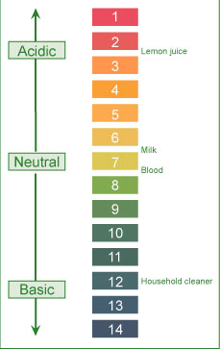
Acid Rain
↑ Acidity = ↓ pH
Based on the concentration of carbonic acid and small amounts of other natural acids, the estimated pH of rain (as well as fog, dew and snow) under normal atmospheric conditions should be around 5.3.
Field measurements in many areas, on the other hand, show much lower pH values (4.1- 4.5).
Higher acidity (lower pH) is due to the reactions of NO_{x} and SO_{x} present in the atmosphere.
Various reactions of these oxides lead to the formation of acids. The dissociation of formed acids generates hydrogen ions and hence higher acidity (or lower pH).
2 SO₂ (g) + O₂ (g) + 2 H₂O (ℓ) 2 H₂SO₄ (aq)
H₂SO₄ (aq) H⁺ (aq) + HSO₄⁻ (aq)
HSO₄⁻ (aq) H⁺ (aq) + SO₄²⁻ (aq)
4 NO₂ (g) + O₂ (g) + 2 H₂O (ℓ) 4 HNO₃ (aq)
HNO₃ (aq) H⁺ (aq) + NO₃⁻ (aq)
Environmental Effects
Material damage:
Marble & limestone (CaCO3) used in many history & irreplaceable statues & buildings react with acid in the rain, leading to the formation of calcium salts. The solubility of these salts in water is much greater than that or marble in water. The dissolution of formed calcium salts leads to roughened surfaces, removal of material and loss of carved details from the buildings and statues.
Forest damage:
Leads to slower growth, injury and destruction of forests and has been attributed to be a contributing factor to the declining health of trees by damaging their leaves, limiting the nutrients available to them or exposing them to toxic substances released from the soil du to the change in pH.
Acid rain is implicated in depleting the nutrient supply to trees by:
- Attacking the leaves whose protective coating has already been destroyed due to attack by other atmospheric pollutants such as O3 and NOx.
Corrosion of Metals:
Corrosion process is accelerated in the presence of acid. Iron structures, bridges, railroads, etc. show a faster rate of corrosion (rusting) in acid rain areas. Even painted/plated iron corrodes faster.
The reaction occurs in 2 steps with hydrogen ions (formed from the dissociation of acid) being involved in the first step of the reaction. The overall reaction, conversion of iron to its oxide (rust), can be represented by:
4Fe (s) + 3 O2 (g) -> 2Fe2O3 (s)
Aquatic life:
Quite susceptible to changes in pH. Reduced pH leads to lakes with no fish/living beings. Acid rain reduces fish population, kills individual fish, and may eliminate fish species entirely from body of water.
Adverse effects include:
- Lowering pH well below required value of about 6.5 for healthy aquatic life.
- Increasing aqueous concentration of metals (Al, Pb, etc) in water bodies due to their higher solubility at lowered pH.
Both low pH & increased aluminum levels are directly toxic to fish. In addition, low pH and increased aluminum levels cause chronic stress leading to smaller size and lower body weight…making fish less able to compete for food and habitat.
Control Strategies
Reduction of SOx (oxides of sulfur) emissions by emission control technologies:
    - Using coal with low sulfur content
    - Removing sulfur from coal before using
    - Using chemicals to neutralize acidic sulfur dioxide. (aka scrubbers)..has helped a lot in Japan.
Reduction of NOx (oxides of nitrogen) emissions by emission control technologies:
Catalyctic converters are now in use in automobiles to reduce the emission of oxides of nitrogen.
Using cleaner energy sources (such as alcohol and hydrogen) in transportation:
In some parts of US, there is limited use of alcohol to replace gasoline in cars. The use of hydrogen as fuels is currently being investigated.
Developing/using alternate energy (hydro, nuclear, wind) sources:
Hydroelectric, nuclear, and wind power are being used in many places. However, slow progress in their development due to high initial costs and environmental issues.
Global warming: How does it happen?
Global warming refers to an increase in the Earth’s average temperature. This warming is the result of increased absorption by the atmosphere of infrared (IR), a major source of heat, radiated back from Earth's surface. This is due to an increase in concentration of gases that trap heat in the atmosphere. These gases are often called greenhouse gases.
The principal greenhouse gases that enter the atmosphere due to human activities include:
Carbon dioxide (CO₂) | Methane (CH₄) | Nitrous oxide (N₂O) | Fluorinated gases
It enters the atmosphere due to the burning of fossil fuels (oil, natural gas, and coal), waste materials, and as a result of other chemical reactions. | Main sources of emission are the production and transport of fossil fuels, livestock, agricultural practices and organic waste decay. | It is emitted during agricultural and industrial activities as well as during the combustion of fossil fuels and waste materials. | These fluorine containing compounds are emitted from a variety of industrial processes and are sometimes called High Global Warming Potential (GWP) gases.

(Cont. from above) Fluorinated gases: These fluorine-containing compounds are emitted from a variety of industrial processes and are sometimes called High Global Warming Potential (GWP) gases.
Based on measured concentrations of various greenhouse gases, computer models have been developed to predict the extent of global warming. It is estimated that the temperature of the atmosphere may increase anywhere from 1.5 º C to 3.5 ºC during the next fifty years.
Environmental effects:
Climatic changes: release of greenhouse gases trap energy in the atmosphere causing it to warm.
Changes in sea level due to melting of polar ice caps: north pole is warming up faster than the rest of the world. The arctic sea is in a state of ongoing decline as shown by data from National Snow and Ice Data Center (NSIDC) in the US.
Possibility of droughts & increased frequency of heat waves due to warming: increasingly dry conditions may be encountered across much of the globe.
Changes in ecosystem: some animal species are shifting towards higher elevations. Many species face extinction. As ocean temperatures rise, the coral reefs will continue to decline.
Human health: global warming may lead to increased temperature-related illnesses, air pollution due to higher temperatures, and possible spread of some infectious diseases.

Control Strategies
Some of the suggested control strategies include:
Reduction in CO₂ emissions: The governments all over the globe are working to reduce their country's carbon dioxide emissions by:
- Promoting that alternate non-fossil sources such as hydroelectric, solar, nuclear and wind are developed and used
- Capturing the carbon dioxide generated by burning fossil fuels
- Supporting new fuels and technologies (like electric cars) to reduce carbon dioxide emissions from transport
- Setting 'carbon budgets' to cap overall carbon dioxide emissions.
- Encouraging energy conservation: This will lead to lesser energy consumption and hence lower production and reduced emissions.
Using carbon dioxide sinks: A carbon dioxide sink is any resource (natural or artificial) that captures and stores atmospheric carbon dioxide. Natural carbon dioxide sinks include forests, oceans, and soil. Thus replanting forests is being encouraged globally.
- Some of the artificial carbon dioxide sinks being studied involve removing carbon dioxide from the atmosphere and storing it in rocks, injecting it deep into the oceans, or trapping it via chemical reactions.
Ozone Depletion
How does this happen?
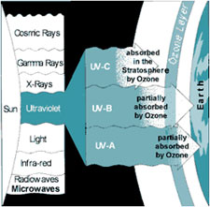

Ozone plays a double role in our environment:
- In our immediate atmosphere, it acts as an air pollutant contributing to photochemical smog
- In the stratosphere (in conjunction with oxygen), it filters the solar ultraviolet (UV) radiation, thus protecting us against its harmful effects

In our immediate atmosphere exposure to ozone may occur in operations involving:

- High-intensity UV lights such as mercury vapor lamps, plasma torches, glass blowing, etc.
- High-voltage electrical equipment
- Welding
In all the above operations, the interaction of high energy with oxygen in the surrounding atmosphere leads to the formation of O₃:
3 O₂ (g) + Energy 2 O₃ (g)
Ozone Formation
In the stratosphere, oxygen and ozone interact with energy (ultraviolet radiation) from solar radiation to form a dynamic system involving the following reactions:
When ultraviolet light strikes oxygen molecule, individual oxygen atoms are produced. | O₂ + Energy 2 O
The combination of atomic oxygen with oxygen molecule leads to the formation of ozone. | O₂ + O O₃
The interaction of ozone molecule with ultraviolet light splits it into a molecule of oxygen and an atom of oxygen. | O₃ + Energy O₂ + O
Re-combination of ozone molecule with an oxygen atom leads to the formation of oxygen molecule. | O₃ + O 2 O₂

The above processes occur repeatedly and are together called ozone-oxygen cycle or Chapman cycle. This constitutes the O₂/O₃ screen that filters out the ultraviolet component of the solar radiation.
Environmental Concern
The environmental concern in the case of ozone is its stratospheric depletion, which leads to less efficient filtration of harmful solar UV rays. The depletion is caused by both natural (water vapour, nitric oxide) as well as human-made (chlorofluorocarbons (CFCs), halons) sources.
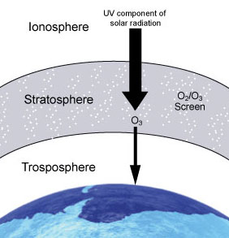
These manufactured chemicals (chlorofluorocarbons (CFCs), halons), containing chlorine and/or bromine are called "ozone-depleting substances" (ODS). The use and popularity of these chemicals is due to their stability and low toxicity.
“Certain chemicals (such as CFCs, hydrochlorofluorocarbons, and halons) are recognized as ozone-depleting substances (ODS) because they breakdown in the stratosphere and release chlorine or bromine, which destroy the stratospheric ozone layer. Most ODS are also greenhouse gases.”
Chloroflurocarbons (CFCs) and halons
have been used as:
- Foam-blowing agents  - Solvents | - Fire-extinguishing agents  - Refrigerants

However, their stability and long lifetime (up to several centuries) allows them to reach the stratosphere. The interaction of these molecules with ultraviolet light in the stratosphere leads to the generation of chlorine and bromine which in turn destroy stratospheric ozone.
Effects of Depletion
Effects of increased intensity of ground-level UV radiation:
Stratospheric ozone depletion leading to less efficient filtration of the UV radiation from the sun, will increase the intensity of ground-level UV radiation. This may have adverse effects on:
- Humans (sunburns, skin cancer, premature skin aging, more cataracts, eye diseases and blindness, immunosuppression (weakening of human immune system)

- Agriculture & forestry (physiological and developmental processes of major crop species (such as barley, rice, wheat) may be affected)

- Materials (increased intensity of UV radiation may accelerate degradation of materials such as fabrics, plastics, rubber, and wood)
- Marine ecosystems (damage marine life by decreasing the plankton which could disrupt the food chains leading to a shift in marine species in global waters. Could also lead to decreased reproductive capacity, reducing fish yields.
Control Strategies
In North America, the use of CFCs (as propellants in spray cans) was banned in 1978 in response to the threat of ozone depletion. The global response to the threat of ozone depletion came with the signing of the Montreal Protocol (in 1987). It set out to reduce and ultimately ban the manufacture and use of CFCs and other ozone depleting substances.
The international agreement has been effective in reducing risks in the long term; ultraviolet radiation remains a health hazard. In view of this, we as individuals should protect ourselves against it.

NASA projections of stratospheric ozone concentrations from 1974 to 2060 if chlorofluorocarbons (CFCs) had not been banned

