ELG4125
Case Study 3:Electric Power Transmission, Distribution & Utilization
Kareim EL Attar, 6221386
Professor: Riadh Habash
12/10/2013

- Power system block diagram
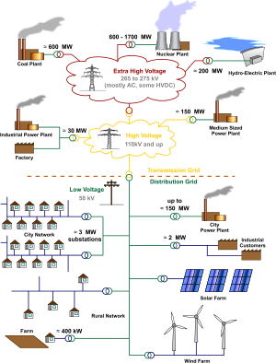
- Design specifications of power plant
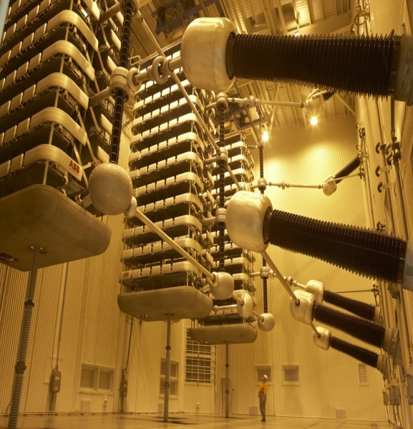
The Itaipu HVDC in Brazil:
Variables/Specifications | Value
Speed | 92.3 rpm
Power Output | 20 x 700 MW
Volt-Amps | 737 MVA
Frequency | 60 Hz
Poles | 2 x bi-poles
Type of turbine | Francis
Poles rating | 3,150 MW

**A hydroelectric generator was used to match the criteria given for us in the question.
- Transmission Line & Conductor:
Guyed cross-rope: Cost is a key factor as well as weight, hence the Guyed cross-rope seems like the ideal transmission tower. With a voltage range of 230 – 735 kV, and an average weight of 5000 kg, it suits our criteria well.
ACSR conductor – Finch
Specifications | Value
Current capacity | 1110 A
Weight | 7544 lbs./miles
Inductance | 0.380 $Ω$
Reactance | 0.0969 $Ω$
Shunt capacitance | 0.867 x ${10}^{6}$ F
Number of strands | 54
Strength | 40200 lbs.
- Numbers of conductors/bundle: 3 (bundles are used to have low electric field strength at the conductor surface)
- 3-phase conductors
- 4 number of strings per phase
- 450 mm sub conductor spacing

- Calculations
Parameter | Equation | Value
A | $$\frac{Z.Y}{2}+1$$ | $$0.86∠2.1°$$
B | Z | $$313.4∠77.5°$$
C | $$\frac{Z.Y}{4}+1$$ | 8.64 ×${10}^{-4}∠91°$
D | A | $$0.86∠2.1°$$
Where, $$z=R+jL=0.134+j0.612 Ω/km$$
And
$$y= \frac{1}{C}=1.86 ×{10}^{-6}∠90°$$
To find Z and Y, we multiply the above values by the total distance (500 Km)
$Z=313.4∠77.5°$ & $Y=0.00093∠90°$
Using the matrix
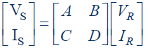
Therefore
$$Vr=\frac{\left(D.Vs-B.Is\right)}{D.A-B.C}=497 kV$$
$$Ir=\frac{Is-C.Vr}{D}=1775 A$$
Using the equation
$$\%Power Efficiency=\frac{Vr×Ir}{Vs×Is}=98 \%$$

- Substations
Which? ACSR conductor – Eagle
Specifications | Value
Current capacity | 730 A
Weight | 4588 lbs./miles
Inductance | 0.415 $Ω$
Resistance | 0.1859 $Ω$
Capacitive reactance | 0.0957 $Ω$
Number of strands | 30
Conductors/Bundle | 1
Calculations?
Parameter | Value
Z | 28.88 + j64.47 Ω
Y | j0.0016 S
A | $$0.95+j0.02$$
B | 28.88 + j64.47 Ω
C | -0.000018+j0.0016
D | 0.95+j0.02
Vs | 591 ∠6.97°
Is | 1894 ∠26°

Primary and secondary of the distribution system utilize either the Wye-connected 3-phase circuits with multi-grounded neutrals, or the Center tapped single-phase circuits with multi-grounded neutrals. For this report we will focus on the center tapped single-phase circuit.
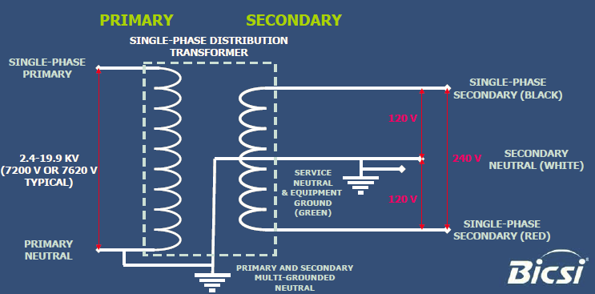

- Protection
For general power system configurations, a fundamental concept is the division of a system into protective zones. If a fault occurs anywhere in a zone, action will be taken to isolate that zone from the rest of the system.
- Generator Protection:
Generator Fault: | Stator Faults: | Protection against both
- Winding faults | - Phase to earth faults | - Differential Protection
- Field winding/Rotor | - Phase to phase faults | - Stator inter-turn  protection
Circuit Faults | - Inter-turn faults | - Stator inter-turn  protection

- Bus Protection:
Area | Type of Protection(Relays) | Rating: (V)  Voltage Ratio | Rating: (A)  Current Ratio
Buses | Differential Relays | 3000 : 1 | 1000 : 5

- Transformer Protection:- Differential Relays are used.
- Transmission Line Protection:
Area | Type of Protection(Relays) | Rating: (V)  Voltage Ratio | Rating: (A)  Current Ratio
Transmission Line | Impedance Relays | 3000 : 1 | 1000 : 5

- Sizing Transformers
- 1st current & voltage sizing
Variable | Equation + Result | Ratio
MVA Output | (500 kV)*(900 A)= 450 MVA | 4:1
I_{RATED(PRIMARY)} | $$\left(\frac{450×{10}^{6}}{500×1000}\right)×\left(\sqrt{3}\right)=519A$$ | 600:5.
I_{RATED(SECONDARY)} | $$\left(\frac{450×{10}^{6}}{491×1000}\right)×\left(\sqrt{3}\right)=529A$$ | 600:5.
I1 | $$\left(519\right)×\left(\frac{5}{600}\right)=4.3 A$$ | ____
I2 | $$\left(529\right)×\left(\frac{5}{600}\right)=4.4 A$$ | ____

- 2nd current & voltage sizing
Variable | Equation + Result | Ratio
MVA Output | (500 kV)*(900 A)= 450 MVA | 4:1
I_{RATED(PRIMARY)} | $$\left(\frac{450×{10}^{6}}{491×1000}\right)×\left(\sqrt{3}\right)=529A$$ | 600:5.
I_{RATED(SECONDARY)} | $$\left(\frac{450×{10}^{6}}{480×1000}\right)×\left(\sqrt{3}\right)=541A$$ | 600:5.

- Circuit Breaker sizing
$$\left(\frac{1250}{0.8}\right)*\left(\frac{125}{100}\right)=195.3 kA$$

- Distribution System:
Specifications for distribution substation system
Variable | Comment/Data
Medium voltage Vegeta distribution transformer | 25 MVA
Conversion for sub transmission | 69 kV – 13.8 kV
Rated Power | 50 kVA – 25 MVA
Rated insulation level | Up to 72.5 kV
Rated Frequency | 60 Hz
Insulating liquid | Natural Ester
High fire point insulating liquid of K-class
Protection | Neutral grounding
Hermetically sealed with conservator conventional
Topology used | Loop topology – high service reliability & good for commercial use

Protection devices | Specifications | Comment
Circuit Breaker (14.4 Nominal KV) |  | Type:  SPS2-15.5-31.5
  Rated Max KV | 15.5
  Rated Voltage | 1 V
  Rated Current | 1200 A
Fuse (20 MVA) |  | Type:  Electronically controlled  VSO
  Rated Max KV | 20
  Max Current | 1000 A
Recloser (25 MVA) |  | Type:  CMU702003
  Rated Current | 1000 A
  Max Voltage | 27 kV

