Quiz 2
Question 1 |  | 1 / 1 point
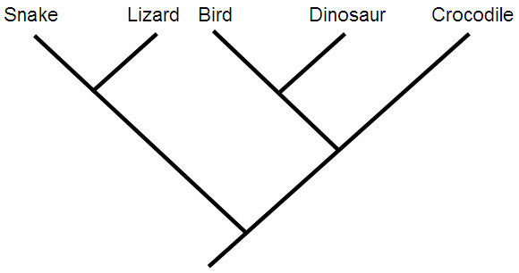
Look carefully at the evolutionary tree. Which of the following statements is true about this phylogeny?
 |  |  | A snake is more closely related to a bird than to a crocodile.
 |  |  | A bird and a crocodile are equally closely related to a lizard.
 |  |  | The common ancestor of birds and dinosaurs was a crocodile.
 |  |  | Dinosaurs are equally closely related to birds and crocodiles.
 |  |  | Birds and lizards are more closely related to each other than dinosaurs and snakes are.
 | Question 2 |  |  | 1 / 1 point
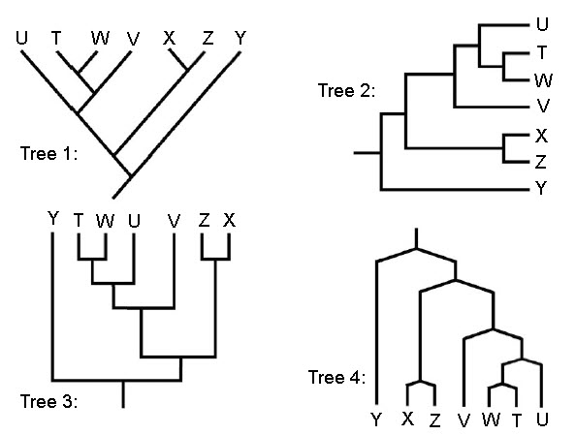
Based on these four evolutionary trees, which of the following statements is true?
 |  |  | Tree 1 is different from the others.
 |  |  | Tree 2 is different from the others.
 |  |  | Tree 3 is different from the others.
 |  |  | Tree 4 is different from the others.
 |  |  | All four trees show the same thing.
 | Question 3 |  |  |  | 1 / 1 point
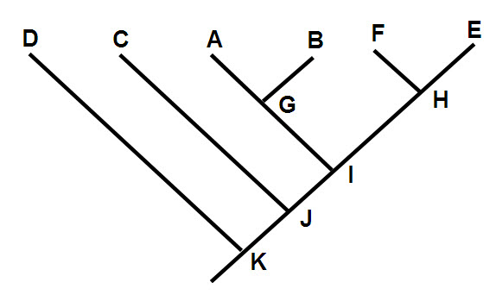
For each combination of species, indicate whether the group they form would be monophyletic or paraphyletic.
   | __1__ |  | A, G, B
   | __1__ |  | C, J, A, B, G, I, E, H, F
   | __2__ |  | D, C, A, B, G, K, J, I
   | __2__ |  | A, B, G, I, H, E
  1. | Monophyletic (i.e., a clade)
  2. | Paraphyletic (i.e., not a clade)
 | Question 4 |  |  | 1 / 1 point
Match each definition with the correct term.
   | __4__ |  | A measure of the number of species in a taxonomic group or geographical area.
   | __3__ |  | The presence of similar traits in two species who inherited them from their common ancestor.
   | __1__ |  | Different morphological traits produced by the same genotype in different environments.
   | __5__ |  | A level in the hierarchical classification system used in biology.
   | __2__ |  | A measure of how physically different two species are.
  1. | Phenotypic plasticity
  2. | Disparity
  3. | Homology
  4. | Diversity
  5. | Phylum
Question 5 |  | 1 / 1 point
Which of the following was NOT a cause of differences within species that we observed in the mussels?
 |  |  | Phenotypic plasticity resulting from mussels growing up in slow versus fast running water.
 |  |  | Genetic differences revealed using microsatellites.
 |  |  | Sexual dimorphism.
 |  |  | Pollution from farms causing individuals in some areas to become sick and lose their colour.
 |  |  | Differences among individuals at different stages in their ontogeny.
 |  |  | Quiz 3
 | Question 1 |  |  | 1 / 1 point
For each statement below, indicate whether it is true or false.
   | __2__ |  | If 100 flies are exposed to a pesticide, it is likely that at least one of them will become resistant to the chemical.
   | __1__ |  | The biological species concept defines species on the basis of whether interbreeding is possible or not.
   | __2__ |  | For species that do not reproduce sexually, it is necessary to use the budding species concept.
   | __2__ |  | Genetic drift is the main source of new variation on which natural selection acts.
   | __1__ |  | Natural selection is the only known mechanism that can produce adaptations.
  1. | True
  2. | False
Question 2 |  | 1 / 1 point
Which one of the following statements about natural selection is TRUE?
 |  |  | Natural selection can only occur if individual organisms differ in how well they survive in a particular environment.
 |  |  | Natural selection occurs because of differences among organisms in their ability to respond to challenges.
 |  |  | Natural selection changes the proportion of existing variation in the population from one generation to the next.
 |  |  | Natural selection chooses individual organisms that are the most well adapted so that eventually complex adaptations will evolve.
 |  |  | The goal of natural selection is to eliminate the weakest members of a species so that it does not go extinct.
 | Question 3 |  |  | 1 / 1 point
Match each term with the appropriate description.
   | __1__ |  | A shift in function or taking on a new function.
   | __2__ |  | Mass extinction occurring currently.
   | __4__ |  | Replacement of a previously common type of organism with a different type, often following a mass extinction.
   | __3__ |  | Tissue that forms the shell in mussels.
   | __5__ |  | Loss of a species in a portion of its former range.
  1. | Co-option
  2. | Holocene event
  3. | Mantle
  4. | Faunal turnover
  5. | Extirpation
Question 4 |  | 1 / 1 point
Which one of the following statements is FALSE?
 |  |  | Mass extinctions may take hundreds of thousands of years to occur.
 |  |  | Current estimates suggest that there are somewhere between 10 and 100 million species on Earth currently.
 |  |  | The largest extinction event to date occurred 250 million years ago, and is known as "The Great Dying" because 95% of species dissappeared.
 |  |  | Dinosaurs went extinct because they were unable to compete with mammals.
 |  |  | Mass extinctions involve the loss of 50% or more of existing biodiversity in a geologically short period of time.
 | Question 5 |  |  | 1 / 1 point
For each statement, indicate whether it is true or false.
 | __2__ |  | Bivalve molluscs are descended from an older group of shelled organisms known as brachiopods.
 | __1__ |  | Anthropogenic impacts represent the largest threat to biodiversity today.
 | __1__ |  | 2010 is the International Year of Biodiversity.
 | __1__ |  | It took 100 million years for global biodiversity levels to recover after The Great Dying.
 | __2__ |  | More species exist now than have existed in the past.

Quiz 4
Question 1 |  | 1 / 1 point
Which of ONE the following statements is FALSE about the woodlots described in the Inquiry Case on Forest Biodiversity?
 |  |  | Old Field Woods is the headwaters of a local watershed.
 |  |  | Majestic Pine Woods has a shallow water table.
 |  |  | Maple Ridge Woods has shallow soils.
 |  |  | Majestic Pine Woods has large pine trees.
 |  |  | Maple Ridge Woods contains several very rare species.
 | Question 2 |  |  | 1 / 1 point
Indicate whether each of the statements below is true or false. Enter 1 for true and 2 for false.
   | __2__ |  | The three levels of biodiversity are: Population Diversity, Community Diversity, and Ecosystem Diversity.
   | __2__ |  | The Canadian Biodiversity Strategy defines biodiversity as the variety of species in Canada.
   | __2__ |  | The four levels of biodiversity are: Genetic Diversity, Species Diversity, Habitat Diversity, and Ecosystem Diversity.
   | __1__ |  | The three levels of biodiversity are: Genetic Diversity, Species Diversity, and Ecosystem Diversity.
   | __2__ |  | The "Convention on Biological Diversity" defines biodiversity as "the variability among terrestrial living organisms.
  1. | True
  2. | False
Question 3 |  | 1 / 1 point
Match each of the definitions below with the corresponding biological term.
   | __2__ |  | Number of species in an ecosystem or sample.
   | __1__ |  | The number of individuals of a species within some area at some point in time.
   | __5__ |  | Number of individuals per species.
   | __3__ |  | A group of species in an ecosystem at some point in time.
   | __4__ |  | Distribution of individuals among species in a community.
  1. | Population
  2. | Species richness
  3. | Community
  4. | Species evenness
  5. | Species abundance
Question 4 |  | 1 / 1 point
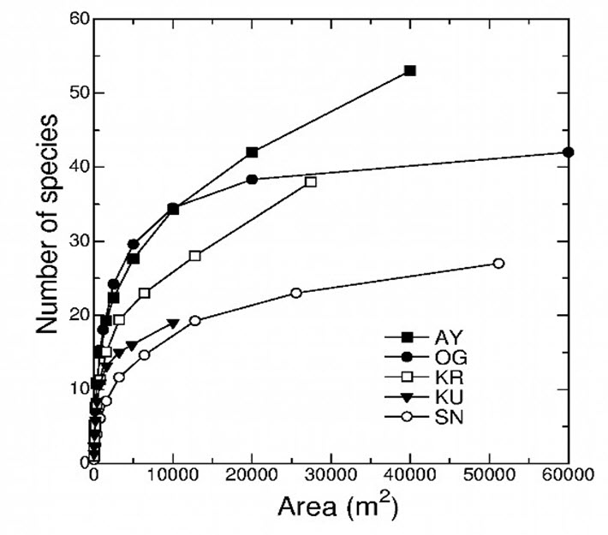
Look carefully at these species area curves. Which of the following statements is TRUE about the diversity in the five areas (AY, OG, KR, KU, SN)?
 |  |  | Sampling intensity is almost saturated at OG.
 |  |  | Diversity is highest in AY.
 |  |  | KR is likely to be over sampled.
 |  |  | Richness is lowest in SN.
 |  |  | Sampling intensity is saturated at AY.
 | Question 5 |  |  |  | 1 / 1 point
Which of the following does NOT represent an abiotic factor?
Pollutants.
Climatic variables.
Nutrient availability.
Soil porosity.
Species competition.
Quiz 5
Question 1 |  | 1 / 1 point
For each statement below, indicate whether it is true or false. (Enter 1 for true and 2 for false).
   | __1__ |  | Carrying capacity refers to the number of individuals who can be supported in a given area within natural resource limits, and without degrading the natural social, cultural and economic environment for present and future generations.
   | __2__ |  | Facultative mutualists must live with a partner species.
   | __1__ |  | Population growth is the change in the number of individuals during some period of time.
   | __1__ |  | Ecosystem processes include energy flows and the cycling of materials.
   | __2__ |  | The carrying capacity for any given area is fixed.
  1. | True
  2. | False
Question 2 |  | 1 / 1 point
Which of the following equations defines population size?
 |  |  | (Pt1) = N2 + I - D + B – E
 |  |  | (Pt) = B - I + D – E
 |  |  | (Pt+1) = B - I + D + I – E
 |  |  | (Pt2) = Pt1 + B - D + I – E
 |  |  | (Pt+1) = B - I + D + I – E
 | Question 3 |  |  |  | 1 / 1 point
Match each term with the appropriate description.
   | __3__ |  | An interaction between organisms or species, in which one species benefits at the expense of another.
   | __5__ |  | An interaction that benefits one organism and the other organism is neither benefited nor harmed.
   | __2__ |  | An interaction between two species that involves one impeding or restricting the success of the other while the other species has no effect on it.
   | __4__ |  | An interaction between organisms or species, in which the fitness of one is lowered by the presence of another.
   | __1__ |  | An interaction between two or more species, where species derive a mutual benefit, for example an increased carrying capacity.
  1. | Mutualism
  2. | Amensalism
  3. | Antagonism
  4. | Competition
  5. | Commensalism
Question 4 |  | 1 / 1 point
Which one of the following statements is FALSE?
Spatial scale can be decreased to microhabitats (point diversity) or increased to include multiple woodlots in a township at a broader landscape scale (gamma diversity).
The number of species within local woodlot local scale is called alpha diversity.
Physiognomy refers to the least dominant vegetation in a forest.
The physical traits of shade tolerant plants may include broad, thin leaves and high levels of foliar nutrients.
Communities in early succession will be dominated by fast-growing, well-dispersed species.

