Expectations for Kastrup’s Section (January and Early February)

* Everything you need to know for the exam is in the lecture notes and presented in class. The lecture notes will be posted online, typically before the class starts. Some extra material required to be known may be posted after the class. If you see some slides in class that doesn’t appear to be in the notes: don’t panic. This is supplementary material which is meant for illustration purposes or to help you understand things differently. Any extra material required to be known will be posted online.
* Numbers of constants (e.g. Boltzmann constant, Planck’s constant…) do not need to be memorized. These will be provided on the exam if necessary.

* Textbook reading:
Lehninger Principles of Biochemistry
Reading Chapter 6, sections 6.1, 6.2, and 6.3 carefully is highly recommended. Please keep in mind that only introductory material is given in this textbook, and the lecture notes contain additional required information. Most UBC BIOC students own this textbook. If you do not, these readings are not required, and it is not necessary to purchase this textbook. Other equivalent texts, such as Biochemistry by Stryer, Berg and Tymoczko (Chapter 8) can be substituted for Lehninger.

* Some reasons why class will be useful:
- Extra information, not in the notes, may pop up on the exam as part of bonus questions.
- Alternative ways of explaining the material and different examples to illustrate a concept will be shown. These may help you in understanding the material better.
- Some problem sets (practice exam questions) will be worked out step-by-step during class.

*Examination:
- the bulk of the questions will consist of applications on a given enzyme, using problem sets which will require some calculations (bring a calculator !)
- one complete derivation
- a series of multiple-choice questions will ask specifics about particular kinetic parameters and plots and some of the case studies.

* Office hours:
Wednesdays 10:30-11:30 am, except Wed Jan 8th.
Fridays 11:30-12:30.
Office hours location: Michael Smith Laboratories (MSL), room 211
ckastrup@msl.ubc.ca

*Errors? Incomplete?
It is my aim to make these notes ‘perfect’; i.e. that you can understand everything through what’s in here. I welcome any suggestions about sections that are harder to read.
If these notes contain typographical errors or worse (wrong references to equations, plain errors,...) please let me know.
Midterm Outline
- Protein-ligand binding and kinetics (math) 70%
- Problem sets (many similar sets will be solved in class or posted online) – maybe mcs
- One full derivation
- Short answers about echniques
- Enzyme classification/case studies/historical facts (~30%)
- Mcs/ short answers
Feb 3rd – Mt starts at 8am
LECTURE JAN. 6, 2014
I. Enzymes: history and classification
An enzyme is a biological catalyst for making and/or breaking chemical bonds
Why important?
- need to break bonds to convert food to biological mass and energy
- need to control the rate of reactions to control biological functions
* enzyme = “in yeast” (old Greek)
* enzymes have been used for centuries, long before they were discovered:
e.g. production of cheese from milk by use of stomach extracts
Caseinogen –rennin-> casein (insoluble)
* 1850s: Louis Pasteur concluded that fermentation of sugar into alcohol by yeast is catalyzed by ‘ferments’, thought to be inseparable from living material (“vitalism”).
- Spontaneous generation of life? (using meat broth)
- Racemic mixture of tartrate (biological form, bends light, non-biological, didn’t bend light) – based on optical activity
What particles in the extract have catalytic activity?
* 1926: James Sumner showed that the enzyme urease is a protein(crystallized urease)

(NH₂)₂CO + H₂O → CO₂ + 2NH₃

* 1948: Linus Pauling proposed that enzymes stabilize the transition state
* 1965: Blake and Philips solved the crystal structure of an enzyme (Lysozyme) in complex with substrate

Classification of enzymes
The Enzyme Commision (EC) classification of enzymes consists of four numbers:
Class . subclass . sub-subclass . entry (x.y.z.a)
Class: one of 6 major types of reactions
Subclass: type of bond acted upon
Sub-subclass: further designation of bonds or groups acted upon
Entry: a serial number

In addition, most enzymes also have a common name, as well as a complex scientific name, which completely describes what the enzyme is doing.
E.g: alcohol dehydrogenase (common name)
= alcohol:NAD⁺ oxidoreductase
= EC 1.1.1.1
class 1: oxidoreductases
subclass 1: acts on C-OH as donor
sub-subclass 1: with NAD(P) as acceptor
Entry: the first entry

The 6 classes of enzymes

1. Oxidoreductases(dehydrogenases)

These enzymes catalyze oxidation-reduction reactions
e.g.: lactate dehydrogenase
Losing a H2

2. Transferases

These catalyze the transfer of a group from a donor to an acceptor

Transfer of hydride (groups/peptides)

3. Hydrolases
Such enzymes catalyze hydrolysis reactions, i.e. water is the acceptor of the transferred group (cleavage reactions mediated by water)

Add 2 hydrogens
4. Lyases

Catalyze lysis of a substrate, generating a double bond in a nonhydrolytic, non-oxidative elimination

5. Isomerases

These enzymes transfer groups within molecules, thus yielding isomeric forms (isomerization reactions)

6. Ligases (synthetases)
These catalyze the ligation of 2 substrates. They typically require chemical energy ATP or a similar cofactor.

Note: You’ll be expected to know the 6 classes of enzymes. A typical question may consist of being given a reaction catalyzed by an enzyme, and you’ll be expected to tell which of these six it is.

* Servers are available to help with the classification of enzymes, or to retrieve information about an enzyme. Have a look at:

http://www.expasy.ch/enzyme/

http://www.brenda-enzymes.info/

PROBLEM SETS:

1.The enzyme glucose-1-phosphatase catalyzes the following reaction:
Alpha-D-glucose 1-phosphate + H₂O <=> D-glucose + phosphate
What enzyme class (EC classification) does this enzyme belong to?

3. hydrolase

2. An enzyme catalyzes the following reaction. What is the class number?
D-glyceraldehyde 3-phosphate + NADP(+) + H(2)O <=> 3-phospho-D-glycerate + NADPH

- oxidoreductase

3. Alanine racemase catalyzes the conversion of L-alanine to D-alanine. What class does this enzyme belong to?

5. isomerase

LECTURE JAN. 8, 2014
II. A brief review of chemical kinetics

Enzyme kinetics is a branch of chemical kinetics. Much of the terminology is therefore the same.

II.A Elementary reactions

* Consider an overall reaction

A → P

This reaction could occur through a sequence of several elementary reactions:

A → I₁ → I₂ → ... →I_{n} → P

With A reactant, P product, and I₁ ... I_{n} reaction intermediates.

* Consider the general elementary reaction:

aA + bB + ... + nN → P

The rate of this process is proportional to the frequency with which the reacting molecules simultaneously come together, i.e. to the products of the reactant concentrations. The rate equation for this reaction is therefore:

Rate = velocity = k.[A]ª.[B]^{b}...[N]^{n} (II.1)

Where k = rate constant.
K = equilibrium constant

The order of the reaction is defined as (a+b+...+n). For an elementary reaction, the order refers to the number of molecules that must simultaneously collide.

A → P (elementary reaction) is a first-order reaction, also a unimolecular reaction.
2A →P and A+B →P are second-order reactions (bimolecular reactions).
A+B+C -> P (Termolecular reaction)
Rate = k [A]
Rate = k [A]^2
Rate = k [A][B]
Unimolecular and bimolecular reactions are common. Termolecular reactions are unusual and higher order elementary reactions have not been found, as it is very improbable for many molecules to collide simultaneously. If a reaction can occur through sequential (not simultaneous) collisions of more molecules, then this is not an elementary reaction.

II.B Reaction rates

The order of a reaction can be measured. By monitoring [A] and [P] as a function of time:

$v=\frac{d\left[P\right]}{dt}= -\frac{d\left[A\right]}{dt}$ changing of [product] or [reactant] over time

With v the velocity or rate. For the first-order reaction A → P, this is also:

$v=-\frac{d\left[A\right]}{dt}=k\left[A\right]$ (II.2)

For the second-order reaction A+B → P:

$v=-\frac{d\left[A\right]}{dt}= -\frac{d\left[B\right]}{dt}=k\left[A\right].\left[B\right]$ (II.3)

The rate constants for the first- and second order reactions have different units. For first order, k has the unit s⁻¹, whereas for the second-order reaction, this is M⁻¹s⁻¹. (check this for yourself!)
V: Ms^-1
K: dependent on reaction
0 order reaction
V = k[A]^0 = k

1) First-order rate equation

v = $–\frac{d\left[A\right]}{dt}=k \left[A\right]$ (II.2)

=> $\frac{d\left[A\right]}{\left[A\right]}= -k dt$

or
dx/x = dlnx
$d\ln\left[A\right]= -k dt$

Over time, integration from [A]₀ (which is the initial concentration of A) to [A] (the concentration of A at time t):
$\int_{\left[A\right]0}^{[A]}{d\ln\left[A\right]= -k \int_{0}^{t}{dt}}$
Which gives:
ln[A] = ln[A]₀ – kt (II.4)
taking the antilogs gives:
[A] = [A]₀ . e^{-kt} (II.5)

Equation (II.4) corresponds to the general equation y = a + bx with y=ln[A] and x=t. Plotting of ln[A] versus t therefore gives a linear diagram. This immediately gives a test to figure out whether a reaction is first order: it should produce a linear line. The slope of the line is –k, and the intercept on the ln[A] axis is ln[A]₀ :

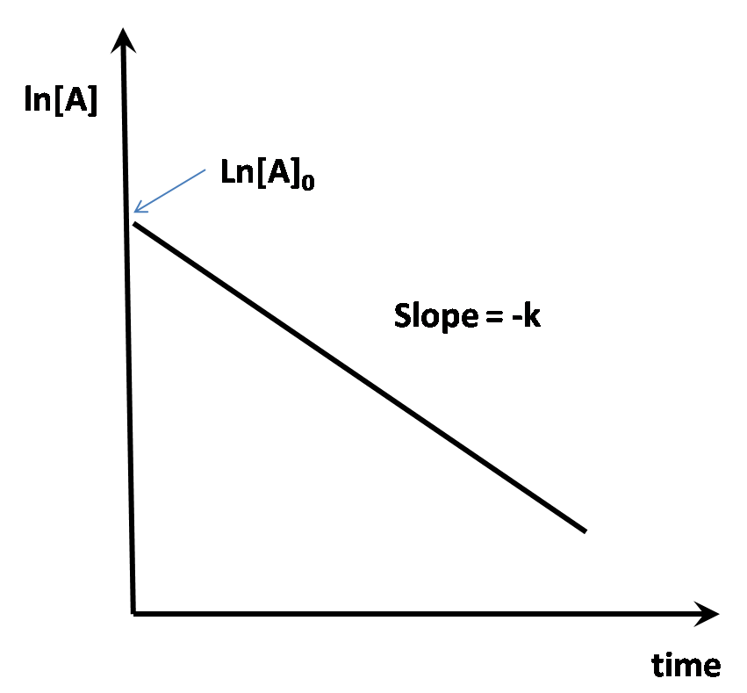

When [A] = [A]₀/2 (i.e. half of the reactant has disappeared), the corresponding time t_{1/2} is called the half-life or half-time. Substituting this in equation (II.4) gives:

$\ln\left(\frac{\frac{\left[A\right]0}{2}}{\left[A\right]0}\right)= -kt$_{1/2}

Therefore
t_{1/2} = $\frac{ln 2}{k}=\frac{0.693}{k}$ (II.6)

For first-order reactions, t_{1/2} is therefore a constant. The constant value of t_{1/2} is diagnostic for first-order reactions.

2) Second-order rate equation for one reactant

For the second-order reaction 2A→P, the reaction rate is:

$v= -\frac{d\left[A\right]}{dt}=k{[A]}^{2}$

Rearranging and integrating delivers:

$\int_{\left[A\right]0}^{[A]}{\frac{d\left[A\right]}{{\left[A\right]}^{2}}=}-k\int_{0}^{t}{dt}$

Solving this gives:

$\frac{1}{\left[A\right]}=\frac{1}{{\left[A\right]}_{0}}+ kt$ (II.7)

This equation is also of the form y=a+bx, but this time with y=1/[A] and x = t. Therefore, such a plot will also deliver a straight line. If you want to find out if an elementary reaction is according to 2A→P or A→P, you could plot ln[A] and 1/[A] as a function of t, and figure out which one of these forms a straight line.

Exercise: calculate the t_{1/2} in terms of k, [A] and/or [A]₀
First order:
Plot of ln[A] versus time is linear
T1/2 is a constant value independent of [A]0

2nd order: (only 1 reactant)
Plot of 1/[A] versus time

Pseudo First –Order Kinetics
A+B -> P (bimolecular) k
Can be simplified to a first order process if [B]0 >> [A]0
(because [B] won’t change much during the reaction)
A-> P kobs
Rate equation can be expressed as a first-order rate equation (the integrated form):
Ln[A] = ln[A]0 –kobst kobs is a first order rate constant (units of s^-1)
True rate constant can be obtained by k =kobs/[B]0
A protein spontaneously denatures over time => half life is constant

1M of compound A is put into a test tube. After a brief UV exposure, a spontaneous reaction occurs, forming compound B. After 20 min, 0.5M A left. In another test tube, 2M of A is used. After 40 min, the remaining concentration is 1M

Which reaction mechanism (reaction order) is true?
None of the above!!! Not first or 2nd order.
LECTURE JAN. 10, 2014
II.C Transition state theory

V=k[A][B]

(Ms^-1)
Mol/L * 1/s => use 1 mole in 1 litre per second

1948: enzyme stabilize transition state

* Consider the following reaction:
H_{A}-H_{B} + H_{C} → H_{A} + H_{B}-H_{c}
Rbc = distance of the bond between atom b and c
C = transition state
An enzyme can change which of the follow:
- Velocity of reactions (does not change ratio of products to reactants at equilibrium)

This is a bimolecular (or second order) elementary reaction involving 3 hydrogen atoms. At some point, atom H_{c} must approach atom H_{b}, so that an intermediate complex H_{A} •H_{B}• H_{C} occurs. Neither of the two bonds are truly covalent, so that the intermediate complex is unstable. The energy of this triatomic system as a function of the relative positions of its component atoms would be:

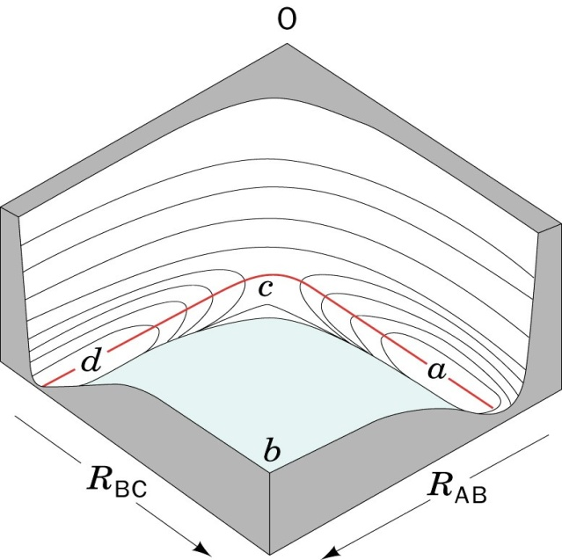

Points a and d represent energy minima, and point c a saddle point in this 3D diagram. The height corresponds to the potential energy. The position in the horizontal plane corresponds to the H_{B} – H_{c} and H_{A} – H_{B} interatomic distances. During a collision, the preferred trajectory in the energy diagram will be according to the line a-c-d, because other trajectories would require more energy. If the energy at point c is too high for the three atoms, at some point the approaching single H_{C} atom will be repelled. Only if there is sufficient kinetic energy, the approaching H_{c} atom will cause the covalent bond of the H₂ molecule to weaken until it reaches the saddle point! At that point, there’s an equal probability that the reaction will occur, or go back to the original state. The saddle point is called the transition state, also called an activated complex.

The preferred trajectory a-c-d, the minimum free energy pathway, is also known as the reaction coordinate. The following diagram shows the free energy as a function of the position on the reaction coordinate:

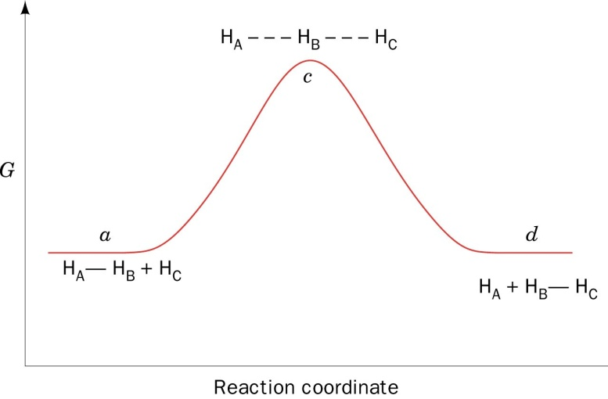

The transition state is the point with the highest free energy on the reaction coordinate. In this case, the beginning and end state have the same free energy. If beginning and end product are different, there usually is asymmetry in the free energy diagram:

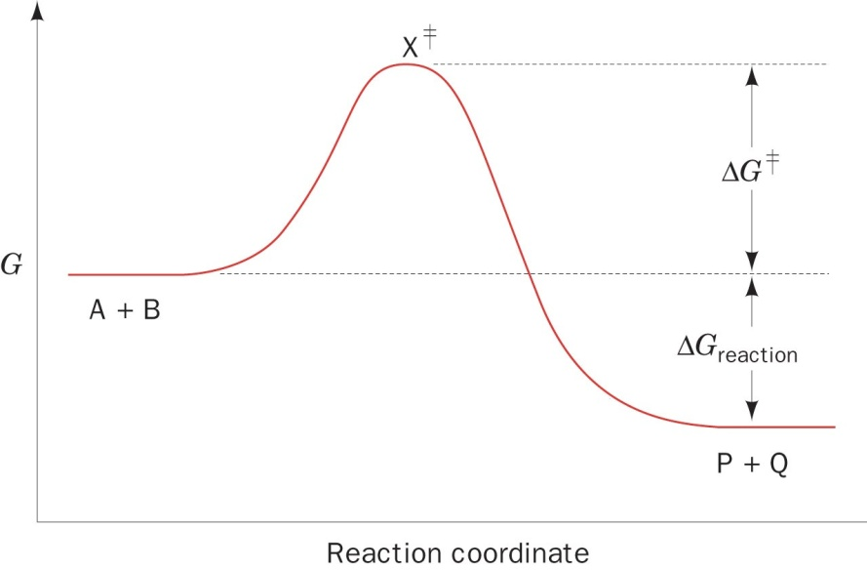

deltaG in transition state (dictates the rate of reaction)
if transition state is low (if product and reactant flipping back and forth really quickly) – kinetic energy

* Let’s consider the following reaction, corresponding to the figure above, where we explicitly consider the presence of an intermediate transition state:

A+B –k> P + Q
A + B X≠ P + Q
K≠
k’

X≠ represents the activated complex(transition state)
Large K (equilibrium constant) concentration of transition state very low comparing to reactant

The reaction rate (formation of product P) is:

$\frac{d\left[P\right]}{dt}=k\left[A\right].\left[B\right]=k^{'}[X^{≠}]$ (II.8) IMPORTANT, memorize

In this case, k is the ordinary reaction constant of the elementary reaction, whereas k’ is the rate constant for the decomposition of the activated complex. The activated complex is very unstable, but is nevertheless assumed to be in rapid equilibrium with the reactants. The corresponding equilibrium constant is defined as:

K≠ = $\frac{[X^{≠}]}{\left[A\right].\left[B\right]}$ (II.9)

This particular assumption allows us to apply thermodynamics to kinetics. Being an equilibrium constant, K≠ is related to ΔG via:

-RT ln K≠ = ΔG≠ (II.10)

Where T = the absolute temperature in Kelvin
R (=8.3145 J.K⁻¹.mol⁻¹) = the gas constant
ΔG≠ = the Gibbs free energy of the activated complex less that of the reactants

Combining the above 3 equations gives:

$\frac{d\left[P\right]}{dt}=k^{'}e^{-ΔG≠/RT}\left[A\right].[B]$ (II.11)

This has the following implication: The rate depends on the concentrations of the reactants, but also decreases exponentially with ΔG≠. So the less stable the transition state, the slower the reaction will proceed.
As delta G increases, exponentially slower
If [A] increases, linearly faster
If T increases, exponentially faster

* k’ is the rate constant for passage of the activated complex over the maximum in the transition state diagram. Assumption: the activated complex is held together by a bond that is so weak that it breaks apart during the first vibrational excursion:

k’= κν (II.12)

ν (Greek letter ‘nu’) is the vibrational frequency of the bond that breaks
κ (‘kappa’), aka the transmission coefficient, is the probability that the breakdown of the activated complex, X≠, is in the direction of product formation (as opposed to simply going back to the reactants). For most spontaneous reactions in solution, κ is between 0.5 and 1.0. For the reaction H_{A}-H_{B} + H_{C} → H_{A} + H_{B}-H_{c} , κ is obviously 0.5.

According to Planck’s law:

ν = ε/h (II.13)

ε is the average energy of the vibration that leads to the decomposition of X≠
h = Planck’s constant = 6.6261 x 10⁻³⁴ J.s

According to statistical mechanics:

ε = k_{B}T (II.14)

T= absolute temperature in Kelvin
k_{B}= Boltzmann constant (=1.3807 x 10⁻²³ J.K⁻¹)

Combining the above 3 equations gives:

$k^{'}= κ\frac{k_{B}T}{h}$ (don’t need to remember this)

Since κ can rarely be calculated with any confidence, it is mostly assumed to be equal to 1. Throwing in equations II.8, 11.9 and II.10 gives:

$k=\frac{k_{B}T}{h}e^{\frac{-ΔG^{≠}}{RT}}$ (II.15)

In simple words, equation II.15 shows that the rate of reaction decreases as its free energy of activation, ΔG≠, increases. As the temperature rises, there is increased thermal energy, which will speed up the activation.

Calculate this for yourself: the value for the absolute temperature is present twice in equation II.15. Which one predominates?

* Multi-step reactions:
Many reactions consist of individual elementary reaction steps.

A $→^{k1}$ I ${→ }^{k2}$ P

In this case, I is an intermediate of the reaction. For both elementary reaction steps, there will be an activated complex, leading to two local maxima in the transition state diagram:

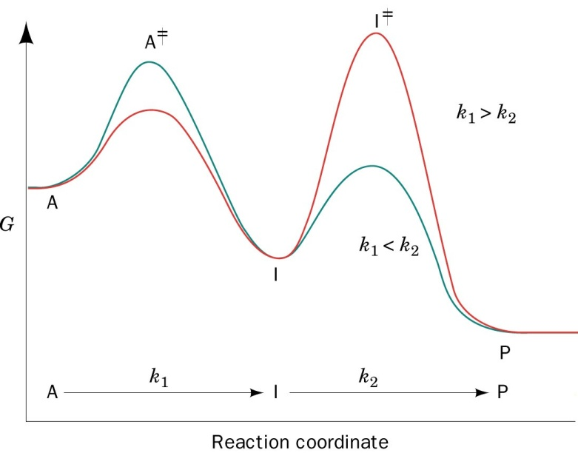
Rate determining for blue curve Rate determining peak for red curve

If the first reaction step is slower than the second reaction step (k₁ < k₂), then the activation barrier of the first step must be higher than that of the second step (blue-green curve above). The opposite is true if the second reaction step is slower (red curve above). The overall rate of a reaction can only be as fast as the slowest elementary reaction, and therefore the slow step is called the rate-determining step.

* Catalysts, such as enzymes, act by lowering the activation barrier for the reaction being catalyzed. Suppose a catalyst lowers the activation barrier of a reaction by an amount of ΔΔG≠_{cat}. According to equation II.15, this will enhance the rate of the reaction by a factor of $e^{\frac{ΔΔ{G_{cat}^{≠}}^{}}{RT}}$. For example, for a 10-fold enhancement of the reaction rate, you would require ΔΔG≠_{cat} = 5.71kJ.mol⁻¹. This is less than half the energy of a typical hydrogen bond ! The rate enhancement is therefore a sensitive function of ΔΔG≠_{cat.}

Note that the energy barrier is lowered for both the forward and the reverse reaction. Catalysts therefore equally accelerate both reactions, and leave the equilibrium unchanged.

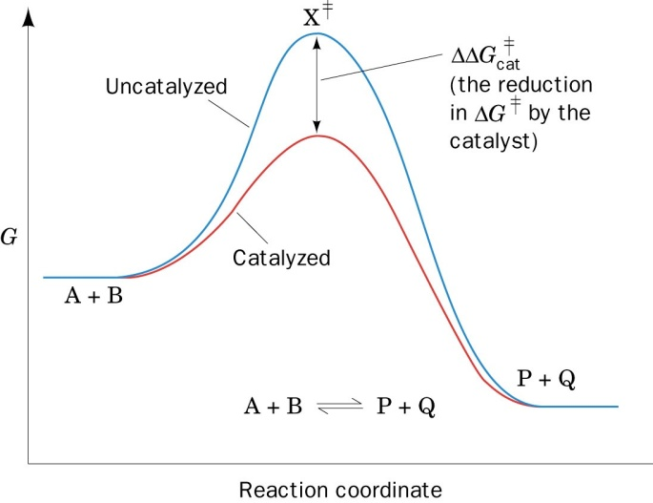
Stabilize transition state, lower energy required to cross the peak
Gt = G for transition state
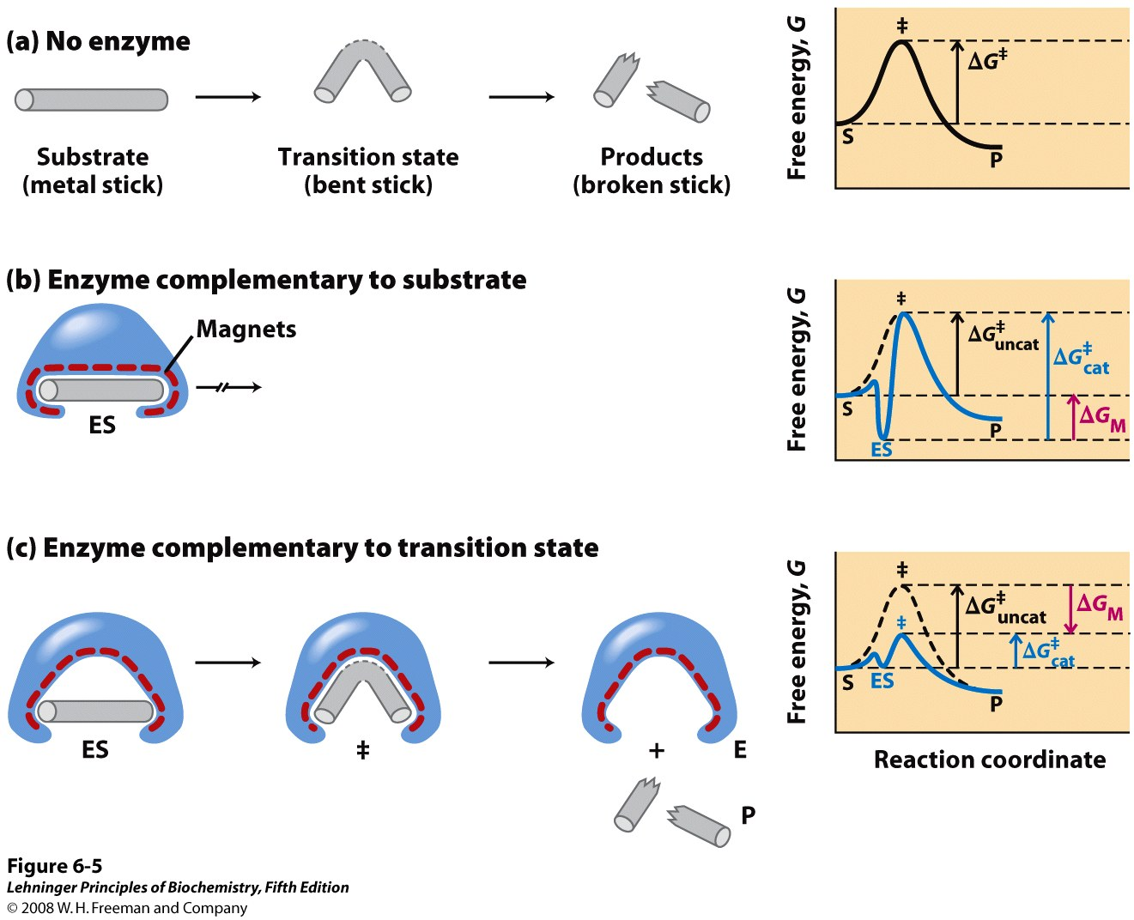
Create negative delta delta Gt, lower transition state
If only stabilize substrate, the delta G catalysis is larger than before (+ delta delta Gt)
Problem
Consider the chemical reaction A+B -> P. In a first reaction [A] = 0.5M, [B] = 2M. In a second reaction, [A]=1M, [B] = 0.5M. How does reaction 2 compare to reaction 1?
Use d[P]/dt = k’e^-deltaGt/RT[A][B]
2nd reaction 2x slower (multiply the concentration)
A particular enzyme acts by forming a hydrogen bond with the transition state, a bond that is completely absent with either reactant or product. If the hydrogen bond stabilizes the TS by 20kJ/mol, calculate how much reaction would be accelerated at 25 degrees Celsius
V1(uncatalyzed) = k’e^-deltaGt/RT[A][B]
V2 (catalyzed = k’e&-deltaGcatt/RT[A][B]
V2/V1 = e^-(deltaGcatt-deltaGt)/RT
R=8.3145
T=298K
V2/V1 = e^20 000/(8.314*298) = 3204.8
LECTURE JAN. 13, 2014
III. Protein-ligand binding

- General theory
- Thermodynamics
- Plotting
- Cooperativity

- Methods

The action of an enzyme usually starts with binding of one or more substrates. In addition, certain drugs or inhibitors act by simply binding to the enzyme, preventing access for the normal substrate or abolishing the catalytic activity. In this section, we will review the parameters that underlie binding of ligands to receptors. Obviously, these parameters also underlie other interactions (protein-protein, protein – DNA, etc).

Consider the general binding of a ligand (L) to a protein (P): (binding is reversible)

P + L PL

The equilibrium constants describing this interaction are:

$K_{a}=\frac{\left[PL\right]}{\left[P\right]\left[L\right]}$ (III.1)

K_{a} is the association constant, unit M⁻¹

$K_{d}=\frac{\left[P][L\right]}{\left[PL\right]}=\frac{1}{K_{a}}$ (III.2)

K_{d} is the dissociation constant, unit M

It is important to note that [P], [L], and [PL] are the concentrations at equilibrium. They are NOT the total amounts of each.

The smaller the dissociation constant, the ‘better’ the binding. For typical biological interactions, K_{d} in the order of nM or below are considered strong binders. Some biological interactions however may have only weak binding, in the high µM to even mM range.

- When Kd decreases => stronger binding!!

Note: the ‘real’ definition of K_{d} and K_{a} uses activities, rather than concentrations. For simplicity, we will just make use of concentrations.

The next section shows how to relate the equilibrium constants to the Gibbs free energy changes. It is necessary to review previous course material on thermodynamics. Section III.A summarizes the essential information. Although this is for reference only (i.e. no exam questions directly from III.A), it is highly recommended that you review it in order to understand following sections. Section III.A is quite condensed. If this is too hard to follow, I’d recommend reviewing basic thermodynamics from a physical chemistry course.

deltaG0 – free energy change of binding under standard conditions = -RTlnKa
where Ka = [PL]eq / [P][L]eq
III.A. A review of basic thermodynamics

* The first law of thermodynamics is a mathematical statement of the law of conservation of energy:

ΔU = U_{final} – U_{initial} = q – w (III.3)

Where U = energy,
q = heat absorbed by the system from the surroundings
w = work done by the systems on the surroundings

Processes in which the systems release heat are exothermic and have a negative q
If the system absorbs heat, the process is endothermic (positive q)
* Enthalpy (H) is defined by:

H = U + PV (III.4)

Where U = energy
P = pressure
V = volume

Because most biological systems operate under constant pressure, the enthalpy change (ΔH) is easily measured as the heat that it generates or absorbs. This can be shown as follows. Let’s divide the work into two categories: pressure-volume (P-V) work, which is performed by expansion against an external pressure (PΔV), and all other work (w’):

w = PΔV + w’ (III.5)

combining the above 3 equations gives:

ΔH = ΔU + PΔV = q_{p} – w + PΔV

or ΔH =q_{p} – w’ (III.6)

where q_{p} is the heat transferred at constant pressure.

For most chemical reactions, w’ = 0, so ΔH = q_{p}. Since the volume changes in most biochemical processes are negligible, the differences between ΔH and ΔU are usually insignificant.

* The 2nd law of thermodynamics states that spontaneous processes occur in directions that increase the overall disorder of the universe. The quantity entropy (S) is defined as:

S = K_{B} ln W (III.7)

Where S = entropy
K_{B} = Boltzmann constant
W = the number of equivalent ways of arranging a system in a particular state

For any constant energy process (ΔU = 0), a spontaneous process is characterized by ΔS > 0. Because the energy of the universe is considered constant, a spontaneous process must cause the entropy of the universe to increase:
ΔS_{system} + ΔS_{surroundings} = ΔS_{universe} >0 (III.8)

It can be proven that:

ΔS ≥$\int_{initial}^{final}{\frac{dq}{T}}$

Where T is the absolute temperature at which the change in heat occurs. For constant temperature conditions (most biological reactions), this reduces to:

ΔS ≥ $\frac{q}{T}$ (III.9)

* The Gibbs free energy (G) is an indicator of spontaneity for constant temperature and pressure processes:

G = H – TS (III.10)

For systems that can only do pressure-volume work (w’ = 0), combining equations III.6 and III.10, while holding T and P constant, gives:

ΔG = ΔH – TΔS = q_{p} – TΔS (III.11)

Because equation III.9 states that TΔS ≥ q for spontaneous reactions at constant T, this means that ΔG ≤ 0 for spontaneous reactions.

ΔG ≤ 0 is therefore the criterium for spontaneity for constant T and P conditions that are typical of biochemical processes. However, ‘spontaneous’ does not mean the reaction will actually occur. This is determined by the kinetic parameters! Conversely, an enzyme (or general catalysts), which is unchanged by the reaction, cannot affect ΔG of a reaction. An enzyme can only accelerate the formation of a thermodynamic equilibrium. It does not change the equilibrium.

* The relationship between the concentration and the free energy of a substance A is approximated by:

$\overline{G_{A}}- \overline{G_{A}^{0}}$ = RT ln[A] (III.12)

$\overline{G_{A}}$ = partial molar free energy or the chemical potential of A. (The bar indicates the quantity per mole).
$\overline{G_{A}^{0}}$ = partial molar free energy in the standard state
R = gas constant
[A] = molar concentration of [A]

This can be shown as follows. Consider first the case of an ideal gas. Combining equations III.3 and III.4 with III.10, along with differentiation, gives:

G = H – TS
= U + PV – TS

dG = dU + PdV + VdP –TdS
= dq –dw + PdV + VdP - TdS

Since w = PΔV + w’ or dw = PdV +dw’
And ΔS ≥ $\frac{q}{T}$ or dS ≥ $\frac{dq}{T}$

=> for dS = $\frac{dq}{T}$
This becomes:

dG = TdS – PdV + dw’ + PdV + VdP – TdS = VdP + dw’

Considering again the case where w’ = 0

dG = VdP (III.13)

For an ideal gas, PV = nRT, where n is the number of moles of gas, so:

dG = nRT $\frac{dP}{P}$ = nRT d lnP (III.14)

This can be extended to more biochemically relevant solution chemistry by making use of Henry’s law. This law applies to a solution containing the volatile solute A in equilibrium with the gas phase:

P_{A} = K_{A} X_{A} (III.15)

Where P_{A} = partial pressure of A
X_{A} = mole fraction of A in the solution
K_{A} = Henry’s law constant of A in the solvent being used
(do not confuse this with the association constant K_{a}; these are two entirely different constants)

The term mole fraction is inconvenient, but in relatively dilute solutions, where the concentration of e.g. water predominates:

X_{A} ≈ $\frac{n_{A}}{n_{solvent}}=\frac{\left[A\right]}{\left[solvent\right]}$ (III.16)

Because [solvent] is relatively constant,
P_{A} ≈ K_{A}’ [A] (III.17)

Where K_{A}’ = K_{A} / [solvent].

Substituting III.17 into equation III.14 gives:

dG = n_{A}RT d lnP
= n_{A}RT d ln (K_{A}’[A])
= n_{A}RT d (ln K_{A}’ + ln[A])
= n_{A}RT d ln [A] (III.18)

The free energy is a relative quantity than can only be defined with respect to an arbitrary standard state. Integration from the standard state (where [A] = 1 by convention), to the final state (where [A] = [A]), gives:

G_{A} - G_{A}° = n_{A} RT ln [A] (III.19)

Where G_{A}° is the free energy of A in the standard state, and [A] really represent [A]/1M. Because Henry’s law is valid for real solutions only in the limit of infinite dilution, the standard state is defined as the entirely hypothetical state of 1M solute with the properties that it has at infinite dilution.

Dividing III.19 by n_{A} gives:

$\overline{G_{A}}- \overline{G_{A}^{0}}$ = RT ln[A] (III.12)

Which is the equation we wanted to prove.

Note: since this is only true for infinite dilutions and if the solute is volatile (not a property of proteins in a living cell…), one has to make use of activities, rather than concentrations:

a_{A} =γ_{A} [A]

Where a_{A} =activity of A
γ_{A} = the activity coefficient of A.

The activity coefficient γ_{A} contains all departures from ideal behaviour, including the provision that the system may perform non-P-V work. It is an experimentally measurable quantity, but hard to determine inside a cellular compartment, where even determining the concentration can be an issue.

III.B. Thermodynamics of protein-ligand binding

*Equation III.12 can be applied to a protein-ligand interaction.
Consider the binding of one ligand L to protein P:

P + L P.L

Because free energies are additive, and because the free energy change of a reaction is the sum of the free energies of the products less those of the reactants, the free energy change for this reaction is:

ΔG=$\overline{{ G}_{P.L}}$ - $\overline{G_{P}}$ - $\overline{G_{L}}$ (III.20)

Where $\overline{G_{x}}$ represents the partial molar free energy or the chemical potential of compound X (see the review section on thermodynamics).

Substituting this in equation III.12 gives:

ΔG = ΔG⁰ + RT ln$(\frac{\left[PL\right]}{\left[P][L\right]})$ (III.21).

Where ΔG⁰ is the free energy change of binding under standard conditions (i.e. 1 atm, 25°C, 1M concentration of all components)

At equilibrium, ΔG=0, and therefore:

ΔG⁰ = -RT ln $(\frac{\left[PL\right]eq}{\left[P\right]eq\left[L\right]eq})$

or ΔG⁰ = -RT lnK_{a} (III.22)

ΔG⁰ = +RT lnK_{d} (III.23)

(the subscript ‘eq’ refers to the equilibrium values)

This shows that the equilibrium constant of a reaction can be calculated from standard free energy data and vice versa.
Delta G more negative when delta H<0 and delta S > 0 => spontaneous
III.C.Binding curves

* From the definition of the K_{d}, it is possible to obtain an expression that defines the average fraction of occupied sites per protein, as a function of the ligand concentration. This fraction is:

ν = $\frac{\left[PL\right]}{\left[P\right]+ [PL]}$ (Greek letter ‘nu’) (III.24)

$K_{d}=\frac{\left[P][L\right]}{\left[PL\right]}$

=> [PL] = [P][L]/K_{d}

=> ν = $\frac{\left[P][L\right]/Kd}{\left[P\right]+ [P]\left[L\right]/Kd}$

= $\frac{\left[L\right]}{Kd+[L]}$ (III.25)

This is also known as the Langmuir equation. (for protein with 1 binding site)
Occupancy fraction: average number of sites occupied per protein or probability that site is occupied

For a binding event with n equivalent sites ( P + nL P.nL), where the sites do not influence one another, the individual K_{d} values are obviously the same:

K_{d} K_{d} K_{d} K_{d}
P + nL P.L + (n-1) L P.L₂ + (n-2) L .... P.L_{n}
When Kd is same for all steps

In this case, the definition of the K_{d} has the form :

$K_{d}=\frac{\left[Px\right][L]}{[PxL]}$

Where Px now represents a site on protein P.
The fraction of these occupied sites is then:

Y = $\frac{\left[L\right]}{Kd+[L]}$

The average number of occupied sites per protein is:
Y = probability that a site is occupied
ν = Y.n = $\frac{n\left[L\right]}{Kd+[L]}$ (III.26)
average number of sites occupied per protein

Exercise: Given the K_{d} and free ligand concentration [L] at equilibrium, what is the fraction of protein receptors that have ligand bound?

A protein is mixed with ligand. After binding, the remaining concentration of free ligand is 2uM. If the stoichiometry of interaction is 2 ligands/protein, and the Kd is 100 nM, then what is the fraction of enzyme that is not bound? (assume that both binding sites are independent)

Y = [L]/Kd + [L]
Y = 2uM/(100nm + 2uM)
=2uM/2.1uM
=0.9524 – This is the fraction of sites occupied = probability of a site being occupied
1-Y = 0.0476 (probability that a site is not occupied)
Probability that neither of both sites on protein are occupied = (1-Y)(1-Y) = 0.002268 (fraction of proteins without ligand bound)

* Direct plot:
According to equation III.26, the direct plot of ν versus [L] is hyperbolic. At high concentration of [L] (K_{d} << [L]), the curve will strive towards a limit of n[L] / [L] = n.

When half of the sites are saturated (Y=0.5), K_{d} + [L] = 2[L], or K_{d} = [L]. The K_{d} is therefore the concentration of free ligand (at equilibrium) where half of the binding sites are occupied!.
ν
[L]

n
n/2
K_{d}

* Titration plot: Plot v as a function of log [L]
Can determine n and Kd from midpoint
Another way of graphically analysing the data is to plot the occupancy ν as a function of log [L]. In this case, the occupancy becomes:

ν = $\frac{n\left[L\right]}{Kd+[L]}$

substitute [L] with 10^{log[L]} (=10^{x} with x = log [L]):

ν = $\frac{n{10}^{x}}{Kd+{10}^{x}}$

Such ν - x relationship describes a sigmoidal curve.

For high [L], K_{d} becomes negligible compared to 10^{x}, and therefore
ν ≈ n 10^{x}/10^{x} = n

At half saturation, ν = 0.5n or Y=0.5, and therefore
$\frac{{10}^{x}}{Kd+{10}^{x}}=0.5$ , or K_{d} = 10^{x} = [L].

Log [L] is therefore = log K_{d}

Or p[L] = pK_{d} (with p[L] = -log[L])

Note: for pH titration curves, this corresponds to pH=pK_{a} for the midpoint of the titration

ν
Log[L]
n
n/2
logK_{d}

* Scatchard plot
Obtaining the value of n in such a plot is not always practical, as it requires obtaining a concentration of free ligand [L] that is orders of magnitude higher than the K_{d}. In the absence of PC-based algorithms, non-linear regression is also not straightforward. Therefore, these types of plots were often reverted to a linear plot, and concomitant linear regression. To this end, a simple trick is to rearrange the expression for ν as follows:

ν = Y.n = $\frac{n\left[L\right]}{Kd+[L]}$ (III.26)

ν K_{d} + ν[L] = n[L]

dividing by [L] gives:

$\frac{ν}{\left[L\right]}$ K_{d} + ν =n

or $\frac{ν}{\left[L\right]}$ = $\frac{n}{Kd}- \frac{ν}{Kd}$ (III.27)

This equation is in the form of y = a – bx, with y = $\frac{ν}{\left[L\right]}$ and x = ν. Such an equation defines a straight line.

Plotting $\frac{ν}{\left[L\right]}$ as a function of ν defines a straight line and is known as a Scatchard plot.
The intercept with the y-axis (ν =0) is n/K_{d}
The intercept with the x axis (where $\frac{ν}{\left[L\right]}=0)$ yields n.
The slope of the line is -1/K_{d}.

ν/[L]
[ν]
n/K_{d}
Slope = -1/K_{d}
n
ν/[L]
[ν]

Positive cooperativity
Negative cooperativity

When a Scatchard plot is not linear, this means that the initial assumption - that all binding sites in the receptor are equal and do not influence one another - is not true. It could thus simply be that there are two entirely different binding sites with different K_{d} values, or it could mean that there is cooperativity(Kd is changing)
: the binding of ligand in one site alters the affinity of the receptor for an identical ligand in an otherwise identical site. If the curve extends towards the right and above, this means the initial slope (proportional to 1/K_{d}) is more shallow, and thus 1/K_{d} is small, or K_{d} is relatively high (and the affinity thus relatively low). As the occupancy increases, the curve becomes steeper, which means K_{d} becomes smaller (or the affinity increases). This is called positive cooperativity: the affinity increases as more and more ligand is bound. Following similar reasoning, a Scatchard plot curving to the left is a telltale sign for negative cooperativity.

III.D The Hill equation

In many cases, the binding of a ligand to a macromolecule can influence the affinity of binding of another ligand to the same macromolecule. This is known as cooperative binding. The Hill coefficient is a factor that quantifies the amount of cooperativity. The factor was first described by Archibald Hill to describe the degree of cooperativity of O₂ binding to haemoglobin.

One can define an apparent dissociation constant K_{d} for the overall reaction:

For the reaction P + nL P.nL,

K_{d} = $\frac{\left[P\right]{[L]}^{h}}{\left[PL_{n}\right]}$ (III.27)

Note that this is not a real dissociation constant, as it would imply the simultaneous collision of n ligands and 1 receptor, which is very improbable. We are using [L]^{h}, rather than [L]^{n}, simply to underline this.

In this case, let us again use the fractional occupancy (Y), which is normalized for binding stoichiometry (Y = ν /n).

Y = $\frac{\left[PL_{n}\right]}{\left[P\right]+ [PL_{n}]}$

= $\frac{{\left[L\right]}^{h}}{Kd+[{L]}^{h}}$ (III.28)

When we rearrange and take the logarithm in equation III.28, we obtain:

1-Y = 1- $\frac{{\left[L\right]}^{h}}{Kd+[{L]}^{h}}$ = $\frac{Kd}{Kd+[{L]}^{h}}$

$\frac{Y}{1-Y}$ = $\frac{{\left[L\right]}^{h}}{Kd}$

log $\frac{Y}{1-Y}$ = h log[L] – log K_{d} (III.29)

Equation III.29 This is known as the Hill equation (!), and h is the Hill coefficient. The plot of log Y/(1-Y) versus log[L]is known as the Hill plot and yields a straight line with slope h. Note that the K_{d} is really the result of several individual K_{d}s, and should only be considered here as an apparent K_{d} for the overall binding.

For h = 1, there is no cooperativity. This reduces the situation to the one described in the previous section.
For h > 1, there is positive cooperativity; once a ligand binds to the receptor, the affinity for other ligands increases
For h <1, there is negative cooperativity; once a ligand binds to the receptor, the affinity for other ligands decreases.
For h=n, there is infinite positive cooperativity; this situation will never arise.

